Study of the Influence of Reinforcement Direction and Fiber Quantity on Composite Material
Shukhrat Khalimov^{a)}, Adkham Qidirov, Makhmudjon Mansurov,
Vasila Rakhmonova
Namangan State Technical University, Namangan, Uzbekistan

^{a)}Corresponding author: shuxratxalimov1978@gmail.com
Abstract. The article describes the study of the influence of the direction and amount of reinforcing fiber on the strength of a concrete. Behavior of stresses and strains was considered for the case when the stress is applied in the longitudinal direction, along the direction of fiber reinforcement. Influence of the length of reinforcing fibers on the strength of concrete composites was studied. The influence of the combination of polyacrylonitrile fiber and fillers on the strength properties of composite polymer materials was studied. It was found that the strength properties of epoxy composites depend on the composition of fillers and polyacrylonitrile fibers.
Keywords. Polymer, glass fiber, basalt fiber, carbon fiber, strength, crushing, cement concrete, fiber concrete, technology.
INTRODUCTION
In recent years, the number of deadly earthquakes in the world has increased, which have a serious impact on human life and the socio-economic infrastructure of countries, so it is important to constantly improve the field of seismic safety. Therefore, the introduction of modern approaches to ensuring seismic safety, development of new methods of seismic resistance of buildings and structures, and the production of new types of innovative building materials are becoming increasingly relevant [1].
To overcome these problems, it is advisable to develop a technology for the production of concrete structures with dispersed reinforcement. Concrete structures reinforced with glass, basalt, polypropylene and metal fibers are promising for the creation of earthquake-resistant, lightweight and energy-efficient materials for multi-story buildings.
Cement concrete composites, widely used in construction, are widespread coarse-grained composites in which the matrix and dispersed phase are ceramic materials. Gravel and sand are used as fillers, and cement concrete structures are widely used as a building material. In order for the cement concrete mixture to achieve sufficient strength, the ingredients must be added in the correct proportions. In order for the mixture with two different sized particles to be tightly packed and achieve a strong bond, the fine sand particles must fill the space between the gravel particles. This is usually 60% to 80% of the total volume of the mixture. The amount of cement-water mixture must be sufficient to cover all the sand and gravel particles, otherwise the cement bond will not be strong. In addition, all components must be thoroughly mixed.
Further increase in the strength of cement concrete allows obtaining earthquake-resistant, durable and elastic cement concrete composites. This is a completely new and promising direction, which is achieved by mixing synthetic fibers into concrete. As a result, fiber-reinforced concrete structures have high strength, resistance to compression and rupture, and also increase their seismic resistance.
METHODS
There are many methods of reinforcing materials with fibers, and when reinforcing cement concrete structures with fibers, it is advisable to take into account the physical-mechanical, physical-chemical and deformation properties of binders and fillers in the composition of cement concrete. The arrangement of fibers along the surface of fiber-reinforced composite materials is shown in Fig.1-2.
The mechanical properties of fiber-reinforced composites are influenced by several factors, such as the stress-strain relationship within the fiber and matrix phases, the volume fraction of each phase, and the direction in which the load or stress is applied. Moreover, fiber-reinforced composites exhibit strong anisotropy, meaning their properties vary depending on the measurement direction [2]. To begin with, let us examine the stress-strain behavior when the applied stress acts in the longitudinal direction — that is, along the axis of fiber reinforcement, as illustrated in Fig.1.
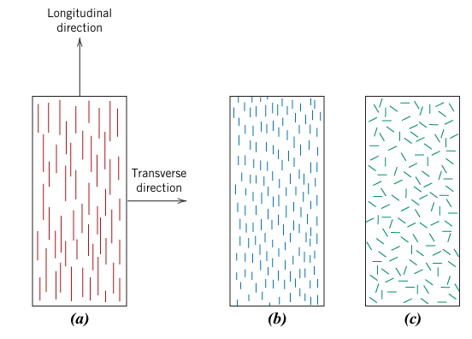
FIGURE 1. Schematic representation of fiber-reinforced composites. a - continuous unidirectional fiber, b - short unidirectional fiber, c - short randomly oriented fiber
Figure 2 presents a schematic illustration of the stress–strain curves for both the fiber and matrix phases. In this case, it is assumed that the fiber behaves as a completely brittle material, while the matrix exhibits elastic behavior. The diagram also indicates the tensile strengths of the fiber and matrix, denoted by σf and σm, as well as their corresponding strain values, ϵf and ϵm. It is further assumed that ϵm > ϵf, which is generally true for most cases [3,4].
A composite material composed of these fibers and matrix exhibits a uniaxial stress–strain response, as illustrated in Fig.2. During the initial stage (Stage I), both the fiber and matrix deform elastically, producing a nearly linear portion of the curve. In typical fiber-reinforced composites, the matrix begins to yield and undergo plastic deformation, while the fibers continue to deform elastically because their strength is much higher than the matrix’s yield strength. This process represents Stage II of the curve. Stage II also tends to be linear but with a reduced slope compared to Stage I. As the transition occurs from Stage I to Stage II, the load carried by the fibers increases.
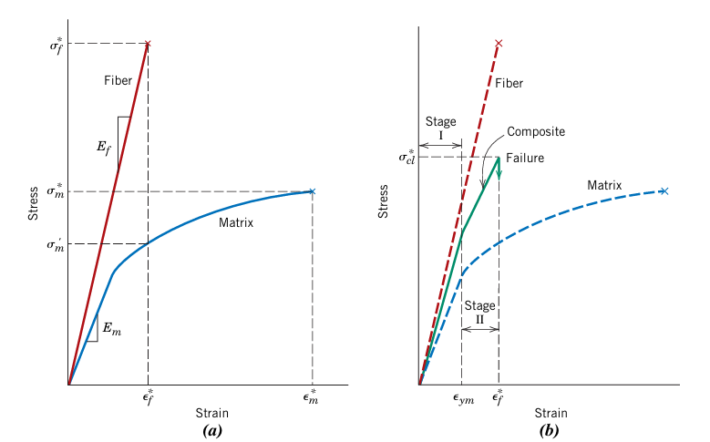
FIGURE 2. (a) Schematic stress-strain curves for fibers and flexible matrix materials. (b) Schematic stress-strain curve for a fiber-reinforced composite subjected to uniaxial stress applied in the reinforcement direction
Composite failure starts when fiber fracture occurs, corresponding to a strain level close to ϵf, as depicted in Fig.2. However, this failure is not catastrophic for several reasons. Firstly, not all fibers break simultaneously, since their tensile strengths naturally vary. Secondly, even after some fibers fracture, the matrix continues to deform plastically and remains at ϵm > ϵf. Consequently, the broken fibers, though shorter than the original ones, stay embedded in the intact matrix and can still carry part of the load because the surrounding matrix continues to sustain deformation [5,6].
Fiber-reinforced concrete structures reinforced with glass, basalt, polypropylene and metal fibers are promising for creating earthquake-resistant, lightweight and energy-efficient materials for multi-story buildings.
By strengthening the strength of cement concrete with fibers, it is possible to obtain earthquake-resistant, durable and elastic cement concrete composites. This is generally a new and promising direction, which is achieved by mixing high-modulus fibers such as glass, basalt and polyethylene into cement concrete. As a result, fiber-reinforced concrete structures have high strength, resistance to compression and rupture, and also increase their seismic resistance.
There are many ways to reinforce materials with fibers, and when reinforcing cement concrete structures with fibers, it is advisable to take into account the physical, mechanical, physical, chemical and deformation properties of binders and fillers in the composition of cement concrete. The mechanical properties of fiber-reinforced concrete composites depend not only on the fiber properties but also on the degree of transfer of the applied load to the fibers through the matrix phase[7]. At this level of load-bearing capacity, the magnitude of the cross-links between the fibers and the matrix phases is important. Under tension, the bond between the fiber and the matrix is broken at the ends of the fiber, which leads to deformation of the matrix, as shown schematically in Fig.3. In other words, the load from the matrix is not transferred to each end of the fiber. The length of the fiber is important for the effective reinforcement of cement concrete composites. This critical length l_{c} depends on the fiber diameter d and its relative stiffness ${\text{σ}}_{f}^{*}$ as well as the strength of the fiber-matrix bond τ_{c}.
$l_{c}=\frac{{\text{σ}}_{f}^{*}}{2τ_{c}}$ (1)
When a stress equal to $σ_{f}^{*}$is applied to a fiber of critical length, a stress–position distribution as illustrated in Fig. 2a is obtained—indicating that the maximum fiber stress occurs only at the midpoint along the fiber axis. As the fiber length $l$increases, the effectiveness of the fiber reinforcement also improves. This is depicted in Fig. 2b, which shows the stress–axial position profile for $l>l_{c}$, where the applied stress reaches the fiber’s ultimate strength. In contrast, Fig. 2c presents the stress–position profile for $l<l_{c}$. Fibers whose lengths satisfy $l≥l_{c}$(typically $l>1.5 l_{c}$) are generally classified as continuous fibers, whereas those shorter than this threshold are referred to as short fibers [8,9].

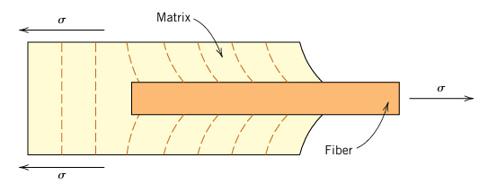
FIGURE 3. Schematic diagram of deformations in the matrix surrounding a fiber subjected to an applied tensile load
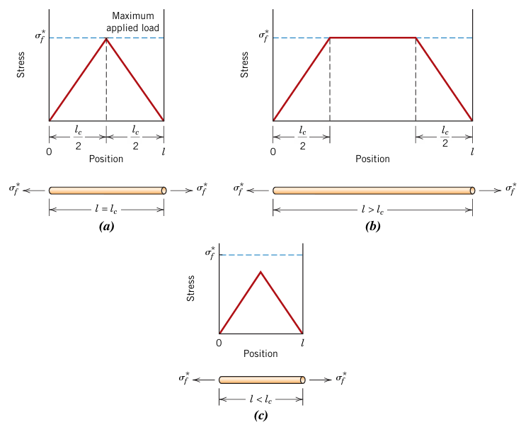
FIGURE 4. Stress distribution profiles for a fiber-reinforced composite when the fiber length $l$: (a) is equal to the critical length $l_{c}$, (b) exceeds the critical length, and (c) is shorter than the critical length. In each case, the fiber is exposed to a tensile load corresponding to its ultimate tensile strength $σ_{f}$.

For continuous fibers with a length significantly shorter than l_{c}, the matrix deforms around the fiber in such a way that virtually no stress is transmitted and the fiber provides only minor reinforcement. As mentioned above, these are mainly dispersed composites. To significantly increase the strength of the composite, the fibers must be continuous.
High-strength composite polymer materials are multicomponent systems in which the total number of ingredients in the formulation reaches 6 or more. In general, the ingredients and binders used can be divided into three main groups: a reinforcing component - synthetic and natural fibers, powdered and other fillers of inorganic and organic origin, polymer binders - synthetic resins.
The relationship between the connected connecting parts determines the properties of the composite material - its physical and mechanical properties. An increase in the amount of resin leads to an increase in the hardness, brittleness, and heat resistance of the material. An increase in the amount of plasticizer reduces the rigidity and increases the magnitude and stability of the dynamic properties. The use of a combined binder opens up wide possibilities for the creation of high-strength reinforced composite polymer materials.
To obtain a reinforced structure, various fibers are introduced into polymer composite materials, since reinforced composite polymer materials have high mechanical strength. Along with natural fillers, the shape and size of its particles significantly affect the properties of composites [10,11]. The shape and size of the filler particles in many cases have a certain effect on the strength properties of composite materials. In accordance with this formulation of the problem, we studied the effect of short PAN fiber, mechanically activated sand, wollastonite and their combinations on the strength properties of reinforced composite polymer materials. The mechanism of reinforcing polymers with powder fillers is an extremely complex phenomenon. Depending on their nature, fillers can increase or decrease the strength properties of polymer composites. This is confirmed by the results of our study of the effect of the content of mechanically activated sand and wollastonite on the strength of epoxy composites.
RESULTS AND DISCUSSION
The dependence of the strength properties of epoxy composites on the content of fillers - powdered ingredients and PAN fibers is shown in Fig.5. As can be seen from Fig.5, mineral fillers - mechanically activated sand and wollastonite in epoxy composites - improve the mechanical properties of composite materials. In particular, in a composite material containing 6% by weight of mechanically activated sand and wollastonite, the tensile strength increases to 50 MPa with an increase in the amount of fillers.
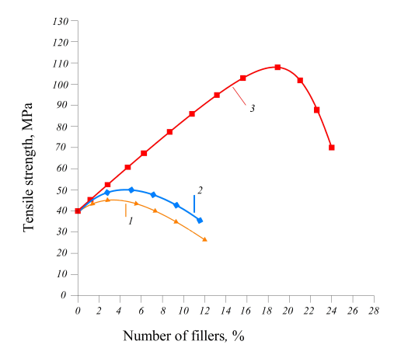
FIGURE 5. Dependence of the strength properties of epoxy composites on the composition of fibers. 1 - mechanically activated sand, 2 - wollastonite, 3 - short PAN fiber
With a further increase in the filler content, a slight decrease in the tensile strength of epoxy composites is observed. This is explained by the fact that the epoxy resin affects the processes of interaction with mechanically activated sand and wollastonite, promoting wetting and spreading over the filler surface, which is a necessary condition for the adhesion of sand and wollastonite particles [12].

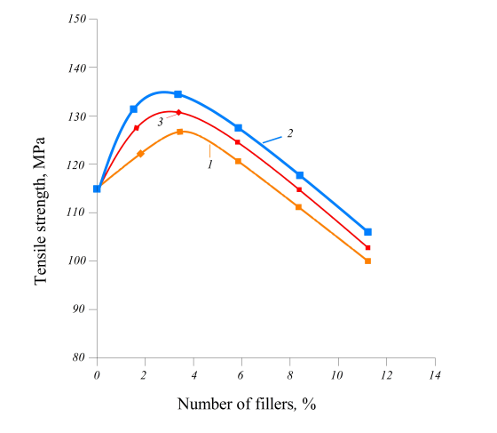
FIGURE 6. Dependence of tensile strength of epoxy composites on the amount of short PAN fiber and mechanically activated fillers. 1 - PAN fiber + mechanically activated sand; 2 - PAN fiber + wollastonite; 3 - short PAN fiber + mechanically activated sand + wollastonite
In addition, the increase in the tensile strength of epoxy composites is explained by the fact that during mechanical activation of sand and wollastonite, a change in their specific surface area and activation of the particle surface are observed. This creates conditions for the formation of strong and complex bonds between the epoxy binder and the filler.
CONCLUSION
The same pattern of change in the tensile strength of epoxy composites was observed when using short PAN fiber in an amount of 15-20% by weight. Fig.5 shows that the tensile strength of epoxy composites strongly depends on the content of short PAN fibers and changes depending on the maximum fiber content compared to composites using mechanically activated sand and wollastonite. In this case, the maximum value of filling the curve with short PAN fiber is 20% by weight. Thus, the optimal composition of mechanically activated sand and wollastonite, short PAN fiber is 3-5 and 15-20%, respectively.
Fig.6 shows the dependence of the strength properties of filled epoxy composites on the composition of short PAN fibers, mechanically activated fillers and their composition in composites. As can be seen from Figure 6, the tensile strength of reinforced composite polymer materials based on short PAN fibers and mechanically activated fillers in various ratios increases with an increase in short PAN fibers and their composition [13,14]. Thus, in composite polymer materials reinforced on the basis of short PAN fibers with la = 1-3 mm and their composites, the strength increases with an increase in its content by 20% by weight, reaching a maximum of 138 MPa. With a further increase in the content of short PAN fibers and their composites, a decrease in the strength properties of the materials is observed.
Thus, the obtained data on the study of the effect of short PAN fibers and their composites with mechanically activated sand and wollastonite on the tensile strength of epoxy composites allow us to recommend the optimal composition of short and mineral fillers for further research.
REFERENCES
- Babatunde Olatunbosun, Allan Manalo, Thiru Aravinthan, Guangnan Chen, Shanika Kiriella, Wahid Ferdous, Libo Yan. Optimising fibre-to-resin ratios and post-curing parameters for enhanced mechanical properties of sunn hemp bio-composites. Journal of Building Engineering. Volume 112, 15 October 2025, 113745. https://doi.org/10.1016/j.jobe.2025.113745
- Subhabrata Saha, Vipin Kumar, Bhagyashree Prabhune, Madhura Limaye, Brittany Rodriguez, Nik hil Garg, Seokpum Kim, Ahmed A. Hassen, Nikolaos Tsiamis, Yalchin Meraki, Uday Vaidya, Marc - Henri Wakim, Stive Ouendag, Oskar Sjogren. Development of fiber orientation in injection molding: Comparison of glass fiber, carbon fiber and their hybrid composites. Composites Communications. Volume 58, October 2025, 102496. https://doi.org/10.1016/j.coco.2025.102496
- Ashiqul Islam, Wahid Ferdous, Paulomi (Polly) Burey, Kamrun Nahar, Libo Yan, Allan Manalo. Polymer Composite Sandwich Panels Composed of Hemp and Plastic Skins and Composite Wood, Recycled Plastic, and Styrofoam Cores. Polymers 2025, 17(10), 1359; https://doi.org/10.3390/polym17101359
- Ziyamukhamedova, U., Evlen, H., Nafasov, J., Jalolova, Z., Turgunaliyev, E., & Rakhmatov, E. (2023). Modeling of the process of mechano activation of filler particles in polymer composites. In E3S Web of Conferences (Vol. 401, p. 05027). DOI: 10.1051/e3sconf/202340105027
- Ziyamukhamedova, U., Bakirov, L., Donaev, S., Miradullaeva, G., & Turgunaliev, E. (2023). Study of structure formation processes in matrices of mixed components with reinforcing natural fillers. In E3S Web of Conferences (Vol. 401, p. 05074). DOI: 10.1051/e3sconf/202340105074
- Sanjay Kumar, Rakesh Sehgal, M.F.Wani, Mukund Dutt Sharma, Umida Ziyamukhamedova. Next-generation ecofriendly MR fluid: Hybrid GO/ Fe2O3 encapsulated carbonyl iron microparticles with improved magnetorheological, tribological, and corrosion resistance properties. Carbon Volume 214, October 2023, DOI: 10.1016/j.carbon.2023.118331
- Khalimov, S.; Nishonov, F.; Begmatov, D.; Wani Mohammad, F.; Ziyamukhamedova, U. Study of the physico-chemical characteristics of reinforced composite polymer materials //E3S Web of Conferences. – EDP Sciences, 2023. – Т. 401. – С. 05039. DOI:10.1051/e3sconf/202340105039
- Umida Ziyamukhamedova, Alijon Djumabaev, Bakhtiyor Urinov, Tojiboy Almatayev. Features of structural adaptability of polymer composite coatings. International Scientific Conference “Construction Mechanics, Hydraulics and Water Resources Engineering” (CONMECHYDRO - 2021). Volume 264, 2021. DOI: 10.1051/e3sconf/202126405011
- Hamza Khallaf, Mohamed Lakbida, Hassan Chehouani, Brahim Benhamou. Impact of fiber size and poly (vinyl acetate) adhesive ratio on the hygrothermal properties of non-industrial hemp-based insulation composites. Construction and Building Materials. Volume 494, 10 October 2025, 143462 https://doi.org/10.1016/j.conbuildmat.2025.143462
- Govor, G.A. Demidenko, O.F. Normirzaev, A.R. Tukhtabayev, M.A. Properties of a composite magnetically soft material based on coated iron powders. IV International Scientific Conference “Construction Mechanics, Hydraulics and Water Resources Engineering” (CONMECHYDRO - 2022). Volume 365, 2023. DOI: 10.1051/e3sconf/202336505001
- Munavvarkhanov, Z.; Soliyev, R.; Boydadayev, M.The chemical reagents influence on the regulation of the powder composite materials setting time for construction purposes. International Scientific Conference “Construction Mechanics, Hydraulics and Water Resources Engineering” (CONMECHYDRO - 2021). Volume 264, 2021. DOI: 10.1051/e3sconf/202126402006
- Norkulov, A.A.; Khalimov, S.A. Features of the forming of the viscoelastic and strength properties of reinforced epoxy heterocomposites for high-pressure gas cylinders. International Polymer Science and Technology, 2011. 4. 43-45. DOI:10.1177/0307174x1103800613

