Increasing the Efficiency of Belt Conveyor Rollers Used in Mining Enterprises
Nurbek Polvonov, Lazizjon Atakulov, Temur Nazarov^{a)}
Navoi State University of Mining and Technologies, Navoi, Uzbekistan

^{a)}Corresponding author temur12101999@gmail.com
Abstract: This article emphasizes the relevance and importance of using belt conveyor transport in the processes of transporting minerals in the mining industry. The designs of belt conveyors used in open-pit mines are analyzed in detail, along with the durability and reliability of conveyor rollers, which are characterized by various overloads, dynamic impacts, and different mechanical influences and acting forces. It is known that roller shafts may break, and bearings can seize, preventing rotation.. In this regard, we conducted studies aimed at reducing the forces acting on the rollers and bearings, ensuring timely replacement of worn rollers, and extending their service life through bearing lubrication. The forces acting on the roller supports located at the loading point have been determined.
Keywords: conveyor transport, bearing, roller, support, deformation, dynamic impact, metal spring, threaded cap, roller bearings, lubrication.
INTRODUCTION
At present, the transportation of minerals in mining industry processes accounts for 70% of the total mining costs, which increases the focus on transportation systems. The use of belt conveyor transport reduces transportation distances, decreases environmental pollution, and improves energy efficiency [1-2].
The occurrence of stresses caused by forces acting on rollers, idlers, and their components in the loading zones of belt conveyors leads to rapid roller failure in these areas and negatively affects conveyor performance, resulting in an increased number of scheduled and unscheduled conveyor shutdowns [3-7]. The occurrence of stresses caused by forces acting on rollers, idlers, and their components in the loading zones of belt conveyors leads to rapid roller failure in these areas and negatively affects conveyor performance, resulting in an increased number of scheduled and unscheduled conveyor shutdowns. This process requires modernization, localization, re-equipment, and improvement, as well as increased efficiency of rollers and roller supports of belt conveyors [5-6].
The most common direction is vibrodiagnostics based on the analysis of vibration spectra of conveyor units. Works [7-10] show that by changing the amplitude-frequency characteristics, it is possible to detect bearing defects, imbalance of drums, roller misalignment, and other mechanical malfunctions. Hrabovský L. and Skoczylas [5-6], a study on the detection of forces acting on the rollers of a laboratory device is presented, and an innovative approach to diagnosing the state of the belt conveyor rollers based on acoustic signals collected using an autonomous walking robot is proposed. The research results demonstrate that the work allows for the improvement of conveyor designs and optimization of their operational characteristics and ensures high accuracy in detecting defects, reduces the need for manual maintenance, and increases the operational safety of conveyor systems [11-17].
METHODS
In ensuring the efficient and long-term operation of the working elements of a belt conveyor, the role of rollers and roller supports is incomparable. The damping of forces acting on the rollers and roller supports, as well as the proper distribution of these forces, ensures high-quality, reliable, and durable conveyor operation [12]. Figure 1 shows the conveyor support rollers, consisting of a metal structure designed using the SolidWorks software. The diameter of the conveyor rollers is 159 mm, and the distance between the roller supports is set at 0.5 m. Based on the width of the load applied to the conveyor (B = 1.2 m), a load ranging from 500 N to 4500 N per 1 m² was applied. As a result, a load occurred on the supporting part of the reinforced support rollers and on the roller bearings, with the tension force equal to 2.7×10⁴ N (Fig. 1).

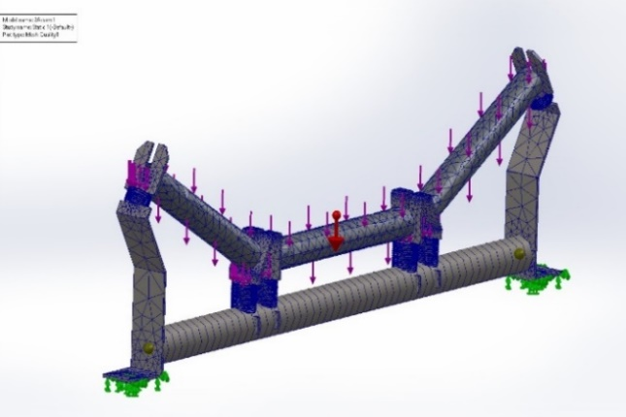 | 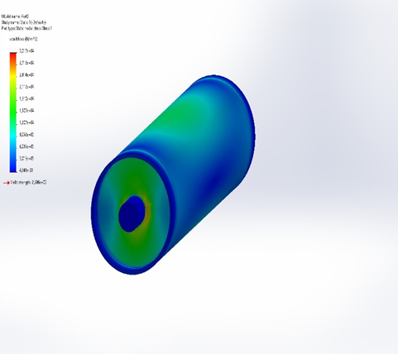
a) | b)
a — stress in the load condition of the support roller,
b — stress in the load condition of the roller
FIGURE 1. Diagram of tension of the reinforced support roller under load conditions
Under the influence of these tension forces, negative effects arise that impact the performance of the conveyor, such as premature roller failure, bearing seizure, and roller axis misalignment (Fig. 1b).
Modifications were made to the design of the existing roller supports: a metal spring, serving to distribute the forces acting on them, was installed on the roller supports on both sides as well as in the center (Fig. 2).

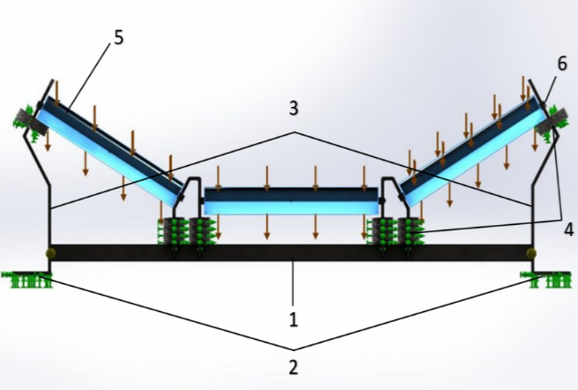
FIGURE 2. Rollers with metal spring support
RESULTS AND DISCUSSION
The metal spring is made of 65G steel with a diameter of 14 mm, a stiffness of 0.95, and a height of 70 mm To prevent the flow of the incoming load from bending the spring-supported bearings in the direction of movement, a shaft with a 5 mm thick rubber coating is placed in the center. This shaft is made of high-strength duralumin alloy D16, consisting mainly of aluminum, with 3.8–4.5% copper, 1.2–1.6% magnesium, 0.3–0.7% manganese, and up to 0.5% iron and silicon. To prevent the flow of the incoming load from bending the spring-supported bearings in the direction of movement, a shaft with a 5 mm thick rubber coating is placed in the center. The design of the metal spring support for the belt conveyor system consists of the roller base (1), legs attached to the frame (2), roller supports (3), springs installed on the rollers (4), rollers (5), and roller shafts (6 The load described above was also applied to the belt conveyor system with the metal spring-supported structure, resulting in a reduction of the load on the conveyor support rollers. The results obtained using an imitation model of the gravitational force acting on the rollers show that the metal spring absorbs the applied stress on the part (Fig. 3a) and evenly distributes the applied stress on the rollers along the width and surface of the roller (Fig. 3b). It was established that the load falling on the axis and bearing of the rollers and the support rollers of the conveyor platform decreases from 2.7*104 N to 1.6*104 N, i.e., the force effect decreases by 41%.

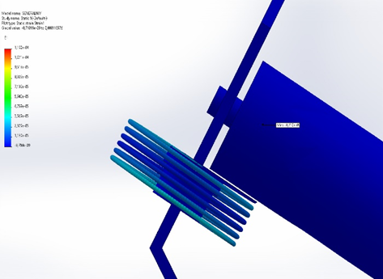 | 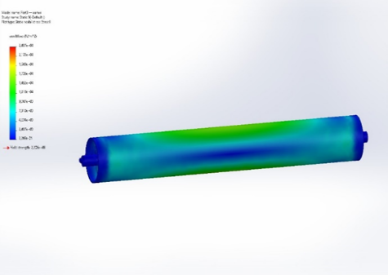
a) | b)
FIGURE 3. Results obtained using an imitation model of the gravity force acting on the rollers
The repair of belt conveyor rollers is the most frequently performed process compared to other elements, and the time spent on maintenance and repair affects the efficiency of the conveyor.
Changes have been made to the design of the belt conveyor rollers, and the design view of the roller with the threaded cover is shown in Figure 4. Such a design is distinguished by its simplicity, low cost, and the fact that it does not add extra weight to the roller, does not require service personnel to undergo advanced training or retraining. The main task of the threaded roller design is to reduce the repair preparation time, as well as to increase the service life of the rollers.
a)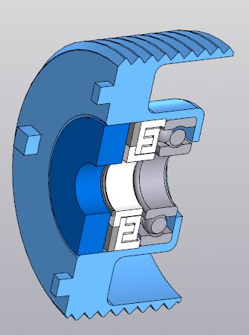 | b)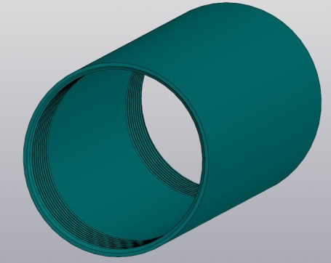 | v)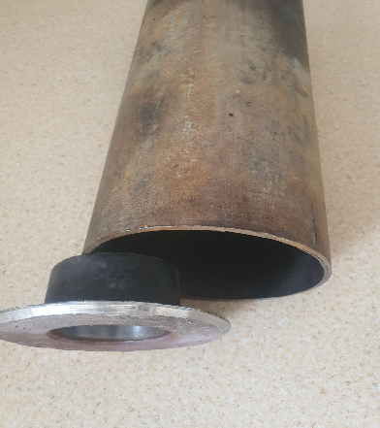
a - external and b - internal opening of the roller thread;
v - external appearance of the roller with a threaded coating in production.
FIGURE 4. Belt conveyor roller with a threaded cover
To install the threaded cover on the roller, a 6 mm thread is opened on the inner wall of the roller housing, after which the right and left threads on the outer wall relative to the cover are also opened with a 6 mm thread. The open right and left threads were used to prevent the cover installed on the roller body from loosening during rotation. Figure 5 shows the results of research on the use of a roller with a threaded cover when replacing non-rotating bearings on conveyor rollers, reducing the time spent on the repair process, facilitating manual labor, and increasing the service life of the roller. To facilitate the repair process of rollers used on belt conveyors, a mathematical analysis of both the initial and current repair times was conducted to determine the type of service and the service life during which they will be serviced.
The time spent on repairing the roller with the installation of the roller with a threaded cover is determined as follows.
$\sum_{i=1}^{m}{t}=t_{2},$ (3)
Here: n and m are the working processes during the current repair and the repair after the improvement.

a)

b)
FIGURE 5. Normative indicators of a roller with a threaded cover. a) mechanical hours during conveyor repair b) electric hours for conveyor repair
We find the duration of work according to the improved repair method due to the fact that the repair process consists of several stages.
$\sum_{i=1}^{m}{t}=t_{1}+t_{2}+...+t_{m}.$ (4)
To repair and return the belt conveyor roller to working condition, assignment $t_{a}$, delivery $t_{d}$, replacement $t_{rep}$, start $t_{s}$, and additional time $t_{add}$ occur. Therefore, the total time will look like this::
$\sum_{i=1}^{m}{t}=t_{a2}+t_{d2}+t_{rep2}+t_{s2}+t_{add2}$ i=1, m=5. (5)
Let's compare the total time with each other, taking into account the mutual inequality in downtime arising during the repair process.
$\sum_{i=1}^{n}{t}>\sum_{i=1}^{m}{t};$ (6)
$$t_{1} >t_{2}.$$
The difference coefficient of the repair time was found so that the repair time is based on the mutual equality:
$t_{1}∙k=t_{2}=>k=\frac{t_{1}}{t_{2}}$ ; (7)
$k=1.05÷1.1$.
By expressing the difference in time between the previous repair and the improvement mathematically, the difference was found to be 10%.
$η=\frac{\sum_{i=1}^{n}{t}-\sum_{i=1}^{m}{t}}{\sum_{i=1}^{m}{t}}∙100\%=\frac{1,1-1}{1}∙100\%=10\%.$ (8)
The conducted research showed that the use of a roller-type design with a threaded cover led to a 10% reduction in annual repair work, which theoretically saved 70.4 mechanical hours of annual repair work.
When assembling the rollers of belt conveyors, the welding method of hardening, which was discussed above, is widely used. In the process of using the welding method of hardening when assembling rollers, it is very difficult to place the roller axis in the center based on the correct dimensions. Also, during roller operation, rapid wear of the rollers occurs as a result of the roller axis shifting from the center. Theoretical research and practical tests of belt conveyor rollers using welding and a threaded cover design were conducted on belt conveyors at the "Mining Electromechanics" Department of Navoi State Mining and Technology University, "Qizilqumsement" JSC, and at the "Navoiy sheben xom-ashyo" quarries. Experimental work was carried out using the example of rollers in 2 different positions. The belt conveyor is made using the VIBXpert// device when installing a welded and threaded roller, in which the rollers at the loading point are used in their working position. The VIBXpert// device is a device designed to obtain test results, in which, as a result of welding in the side part of the rollers and installing the threaded cover, the degree of displacement and deviation of the axis is studied.

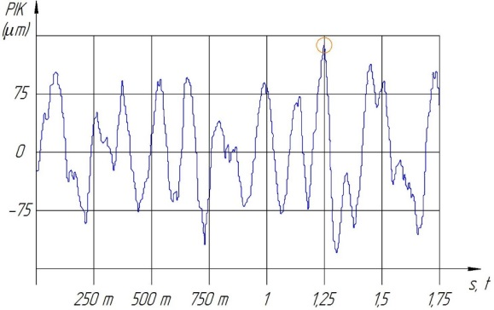 | 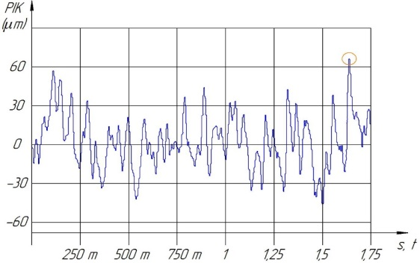
a) | b)
a – effective method b – proposed method
FIGURE 6. Time-dependence graph of rollers on displacement
As can be seen from the graphs, during the welding of the roller covers (Fig. 6a), it was established that the beginning of displacement occurs shortly after the load is applied to the rollers fixed on the supports at the loading point, i.e., the displacement of the roller axis located on the y axis, located on the x axis of the graph, was 142 μm per unit time of 1.25 s. This state indicates that during the roller operation process, a large displacement is formed in a very short time, which negatively affects the roller operation, in this case, increasing the time and reducing the displacement serve to increase the service life of the conveyor rollers. This experiment was also conducted throughout the operation of the rollers with threaded covers. The greatest displacement of the roller axis over a period of 1.65 s was 63 μm. Here, positive changes occurred in the shift time and step (Fig. 6b). The conducted research shows that in the welding-based method of installing roller covers, the highest displacement of 142 μm was reduced to 63 μm on the roller axis due to the use of a roller design with a threaded cover, i.e., displacements were reduced by 2.25 times. Furthermore, since the displacements on the roller axis were performed per unit of time, the peak displacement indicators on the roller axis reached 1.25 s, while in the welding-based method of installing roller covers, the peak displacement indicators on the roller axis reached 1.65 s using the threaded cover roller design method. Achieved a 32% increase in time.

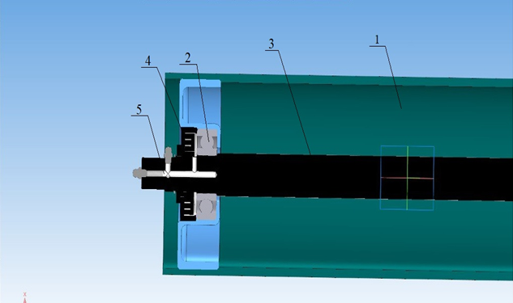
FIGURE 7. Lubrication of roller bearings through a tube
For long-term operation of belt conveyors used in mining enterprises, it is necessary to maintain lubrication of the roller bearings and prevent them from stopping. Oversized, abrasive rocks, uneven load flow, untimely lubrication of bearings, roller output from the roller shaft, and the impact of dust, moisture, and other factors on the roller's impact are difficult to prevent, leading to the stoppage of the conveyor rollers, necessitating the development of a planned lubrication method to enhance roller reliability.
As a result of the conducted research, the shortcomings were eliminated by creating a method for lubricating bearings through a tube passing through the roller shaft. At the same time, the tube passed a distance from the roller shaft in a stationary state to the bearing, and oil was supplied to the roller bearings at the moment the conveyor stopped for scheduled repair. The design of the belt conveyor roller for lubrication through a tubular scheme, passed through the roller shaft during the planned lubrication method, consists of a housing for protecting the bearing and shaft from external mechanical influences (1), a bearing designed to ensure the rotation of the roller without overloading the conveyor belts (2), a shaft for attaching the roller to the supports and holding the bearing in place (3), bearings from dust and moisture (4), and a bearing lubrication tube (5) (Fig.7).
Depending on the location of the conveyor rollers, the location of the oil outlet tube changes, the side rollers are located within 0-36 degrees, the tube passes along the axis, to the axis of the middle roller at an angle of 90 degrees from the upper side, the reason for this is that the arrangement of the rollers does not allow oil to be directed in the direction of the horizontal axis to the axis of the middle roller. Figure 8 shows the cross-sections of tubes designed for both methods of oil supply.

a) 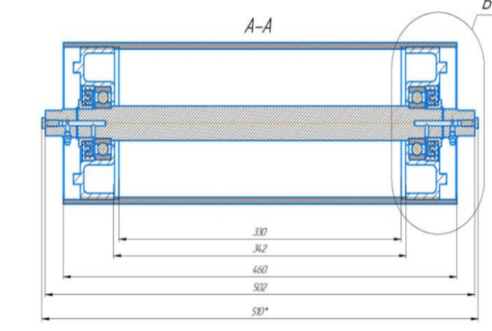b)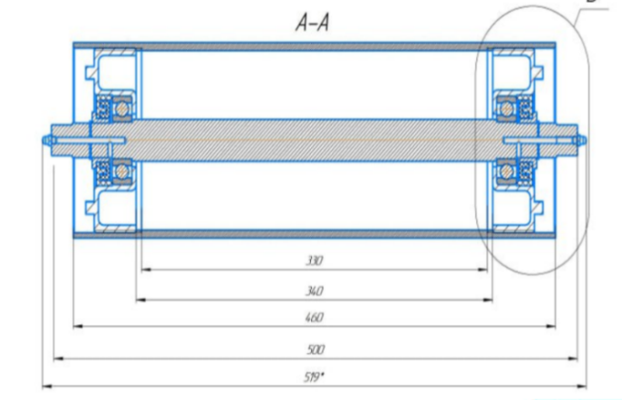
Tubular method designed for lubricating a-middle and b-side rollers
FIGURE 8. Cut of the roller where the tube is installed
When loading oil into roller bearings, first, a low-viscosity oil is taken into the syringe used in lubrication work, which at the moment of introducing the syringe into the tube, being a cap with reciprocating properties, touches the tube wall, after which the oil is directed through the tube. The oil sent through the tube channel reaches the positioning point. As a result, the oil entering between the roller bearings and the inner and outer rings reduces the friction forces between them, the rotational speed of the conveyor rollers due to the reduction of friction forces also works according to the indicators given in its technical characteristics.
Along the straight line to the roller conveyor axis, a tube with a diameter of 6 mm passes, designed to supply oil to the point of contact of the bearing and the seal with a length of 70 mm. There will be a second tube with a diameter of 4 mm, located at an angle of 90 degrees to the passing tube, due to the small diameter of the second tube, the oil velocity will accelerate, reaching the intended point when the oil pressure changes. Lubrication work through tubes from the roller axis is performed with a separate design for rollers located in two homogeneous positions. To determine the efficiency of the conveyor roller bearings, experimental work was carried out in 2 different states: using the VIBXpert// device, designed to check the technical condition of lubricated roller bearings using the roller in working condition and the installed tube. The obtained results were tested on three axes in the coordinate system for high accuracy, i.e., experiments were conducted in straight, horizontal, and vertical directions relative to the roller axis.
The results of the experimental work using the method of lubricating bearings on the rollers of the belt conveyor in their current state and through a tubular circuit were obtained (Fig. 9). The graph of the dependence of the rotational speed of the belt conveyor rollers on time during the roller's operation before lubrication is presented, where the roller receives a maximum displacement of 9 mm per unit time of 65 mm/s (Fig. 9a).
And the graph of the dependence of the rotational speed of the rollers on time in the planned lubricated state (Fig. 9b) shows that the maximum displacement, unlike the above, is 5 mm per 15 mm/s. It has been established that in this case, the time is reduced by 5 times, and the vibrations of the roller axis are reduced by 45%.

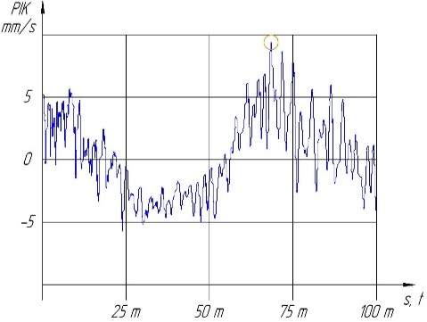 | 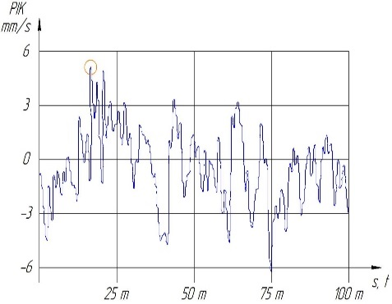
a) | b)
FIGURE 9. Graph of the dependence of the time velocity in the unlubricated (a) and planned lubricated (b) state of the rollers
When calculating the economic efficiency of belt conveyors, the costs incurred during their operating state are determined. In this case, based on the reliability indicators of the belt conveyor, its downtime, repair costs, and overhead costs are taken into account.
CONCLUSION
The conducted theoretical and experimental studies have shown that modernizing the roller design of belt conveyors used in the mining industry significantly increases their operational reliability and durability. Installation of metal springs in the supporting units contributes to the reduction of dynamic loads and the uniform distribution of forces on the surface of the rollers, which reduces the impact on the bearings and extends their service life. The use of rollers with threaded covers made it possible to simplify the repair process, reduce maintenance time, and reduce labor intensity. The use of the tubular lubrication method ensured the timely delivery of oil to the bearings, reduced vibration and wear, and increased the stability of roller rotation. Based on the developed technical solutions, by installing a spring on the supports of the belt conveyor rollers, a threaded cap on the roller body, and a lubricating tube on the axis, it was possible to increase the service life of the rollers by 47-50%, reduce downtime caused by the rollers by 35-38%, reduce the total downtime of the conveyor by 5-8%, and reduce the costs of replacing or repairing the belt conveyor rollers by 23-29%. Thus, the proposed methods and designs can be recommended for widespread use at mining enterprises to improve the reliability, productivity, and energy efficiency of belt conveyors.
REFERENCES
- Bajda, M., Hardygóra, M., & Marasová, D. (2022). Energy efficiency of conveyor belts in raw materials industry. Energies, 15(9), 3080. https://doi.org/10.3390/en15093080
- Kiriia, R., & Shyrin, L. (2019). Reducing the energy consumption of the conveyor transport system of mining enterprises. E3S Web of Conferences, 109, 00036. https://doi.org/10.1051/e3sconf/201910900036
- Kawalec, W., Suchorab, N., Konieczna-Fuławka, M., & Król, R. (2020). Specific energy consumption of a belt conveyor system in a continuous surface mine. Energies, 13(19), 5214. https://doi.org/10.3390/en13195214
- Bobojanov, M. K., Ziyodulla, O. E., Ismoilov, M. T. U., Arziev, E. I. U., & Togaeva, G. Z. (2020). Study of the efficiency of conveyors of mining transport systems of mining complexes. E3S Web of Conferences, 177, 03023. https://doi.org/10.1051/e3sconf/202017703023
- Skoczylas, A., Stefaniak, P., Anufriiev, S., & Jachnik, B. (2021). Belt conveyors rollers diagnostics based on acoustic signal collected using autonomous legged inspection robot. Applied Sciences, 11(5), 2299. https://doi.org/10.3390/app11052299
- Hrabovský, L., Blata, J., Hrabec, L., & Fries, J. (2022). The detection of forces acting on conveyor rollers of a laboratory device simulating the vertical section of a Sandwich Belt Conveyor. Measurement, 207, 112376. https://doi.org/10.1016/j.measurement.2022.112376
- Jumaev, A., Istablaev, F., & Dustova, M. (2022). Development of the theory of calculation of constructive and rational parameters of belt conveyor roller mechanisms. AIP Conference Proceedings. https://doi.org/10.1063/5.0093687
- Yang, M., Zhou, W., & Song, T. (2020). Audio-based fault diagnosis for belt conveyor rollers. Neurocomputing, 397, 447–456. https://doi.org/10.1016/j.neucom.2019.09.109
- Liu J. et al. Intelligent fault diagnosis of belt conveyor rollers using a polar KNN algorithm with audio features //Engineering Failure Analysis. – 2025. – Т. 168. – С. 109101.https://doi.org/10.1016/j.engfailanal.2024.109101
- Peng C. et al. An audio-based intelligent fault diagnosis method for belt conveyor rollers in sand carrier //Control Engineering Practice. – 2020. – Т. 105. – С. 104650.https://doi.org/10.1016/j.conengprac.2020.104650
- Kozłowski, T., Wodecki, J., Zimroz, R., Błażej, R., & Hardygóra, M. (2020). A diagnostics of conveyor belt splices. Applied Sciences, 10(18), 6259.https://doi.org/10.3390/app10186259
- Kholboev, Z., Matkarimov, P., & Mirzamakhmudov, A. (2023). Investigation of dynamic behavior and stress-strain state of soil dams taking into account physically Non-linear properties of soils. E3S Web of Conferences, 452, 02009. https://doi.org/10.1051/e3sconf/202345202009
- Il’ichev, V. A., Yuldashev, S. S., & Matkarimov, P. Z. (1999). Forced vibrations of an inhomogeneous planar system with passive vibrational insulation. Soil Mechanics and Foundation Engineering, 36(2), 50–54. https://doi.org/10.1007/bf02469084
- Beknazarova, S., Joldasov, S., Abdullayeva, O., & Mamasoatov, D. (2023). Control mechanism of eliminate noise and improve visual perception of the image. AIP Conference Proceedings. https://doi.org/10.1063/5.0145732
- Beknazarova, S., Abdullayev, S., Abdullayeva, O., & Abdullayev, Z. (2024). Machine learning method for predicting human movements. AIP Conference Proceedings, 3244, 030036. https://doi.org/10.1063/5.0242100
- Dąbek, P., Krot, P., Wodecki, J., Zimroz, P., Szrek, J., & Zimroz, R. (2022). Measurement of idlers rotation speed in belt conveyors based on image data analysis for diagnostic purposes. Measurement, 202, 111869.https://doi.org/10.1016/j.measurement.2022.111869
- Chunyu, Y., Boshi, C., Xin, Z., & Mingjun, J. I. (2023). Summary of fault diagnosis methods for belt conveyor systems. Journal of Mine Automation, 49(6), 149-158. doi: 10.13272/j.issn.1671-251x.2023030099

