Experimental Research Results on Increasing the Service Life of Ribs by Vibrational Mounting on the Support
Xalimjon Xashimov^{a)}, Karimjon Qosimov, Zafarbek Mamjonov,
Javoxir Ruziboyev, Saidasror Moʻminov
Andijan State Technical Institute, Andijan, Uzbekistan

^{a)}Corresponding author: xoshimov1989bk.ru@gmail.com
Abstract: The efficiency of technological machines used in cotton ginning enterprises for separating cotton from fiber largely depends on the reliability and service life of their working bodies. One of the most important parts of these machines is the grate, which freely passes the saw discs through the grate into the working chamber and freely removes the fibers caught on the saw teeth after separation from the seeds. Under the influence of various forces arising during the ginning process, the uniform rotation of the saw is disrupted, the grate touches the working surface, and the grate is worn by factors such as fiber friction. It is required to replace worn rings with new ones. This is economically inefficient. Therefore, in these studies, a recommendation was developed to extend the service life of the grate by fastening the grate bars to the support in an oscillatory manner. In the proposed design, the grate bars are attached to the support in a vibrating manner. This, in turn, absorbs and reduces the pressure force acting when the saw disc touches the grate surface. Experimental studies were conducted on a laboratory stand of the DP-30 model. In this case, dynamic forces, coefficients of friction, and wear characteristics under rigid and spring (vibration) conditions were analyzed. The results showed that when installing the ribs with a spring mechanism, the maximum force, impulse, and acceleration are significantly reduced compared to the existing method - up to 40%. In addition, the depth of wear and mass loss decreased by 1.5 times. The obtained results confirm that vibration installation effectively reduces grate wear, increases durability, and increases overall operational reliability and economic efficiency.
Keywords: Saw gin, rib gin, spring, vibration, wear, saw blade and experimental studies.
INTRODUCTION
During the years of independence, all spheres of the national economy of our republic have grown noticeably. In particular, the spheres of metalworking, casting, and restoration of worn parts in mechanical engineering have significantly improved. Most of the renewable parts are the working parts of machines used in cotton ginning enterprises [1]. The grate bars of the fiber separation machine can be included in this category of parts. The grate bars are arranged in a row adjacent to each other in the working chamber of the fiber separation machine, forming a grid [2]. Disc-shaped saws are installed in each gap of the grate, which, during rotation, catches the fiber on its teeth, tears it off the seed surface, and carries it through the grate. Since the cotton seeds do not fit between the grates, they do not pass through the grates [3]. However, under the influence of various forces arising during the separation of fiber from cotton seeds, the uniform rotation of the saw is disrupted, it touches the working surface of the grate as a ribbed grate, and under the influence of such factors as fiber friction, the saw and grate wear out. As a result of wear, the gap between the grate bars widenes, leading to the passage of cotton seeds along with the fiber and deterioration of fiber quality. Therefore, the development of new designs that increase the service life of working grates is one of the important tasks of today [4].
One such method is the oscillatory fastening of the grate to the support. In this work, experimental studies were conducted on the issue of increasing the service life of grate bars by fastening them to supports using the oscillatory method [3-5]. As a result of the research, the factors influencing the wear rate, deformation state, service life, and technical indicators of the grate bars were analyzed. Based on the obtained results, practical recommendations for improving the grate design were developed [4-6].
METHODS
To solve the set task, the grate bars are installed at their ends on the upper and lower grate supports with a compression-operating spring. The spring, in turn, is placed on the saw side of the support between the grate bar and the threaded support. Due to the fact that the lower support of the grate bars, installed on the spring, is interconnected through the grate bars with the upper grate support, it oscillates under the action of a force relative to the gin body[6-8].
The saw gin consists of a working chamber (1), inside which a rib grid is mounted. The grid is formed by ribs (3) that are suspended by bolts (2) and installed with their ends (4 and 5) on the upper and lower supports (6 and 7). Inside the chamber, there is also a curved transverse support (8), a front apron (9) with replaceable ribs (10), and a saw cylinder (11).
The saw cylinder is composed of circular saw blades (13) fixed on a rotating horizontal shaft (12). The blades freely pass through the gaps between the ribs. Between the saw blades and saw spacers (15), smooth separating discs (14) are alternately installed, the diameter of which is smaller than that of the saw blades.
The lower rib support (7) is mounted on a compression spring (16) located between the rear side of the support and a threaded base (17). The curved transverse support (8), which is connected to the upper rib support (6), is elastically mounted relative to the gin housing (19) by means of a spring (18). The ribs (3) are fixed to the upper and lower supports (6 and 7) using special head bolts (20).

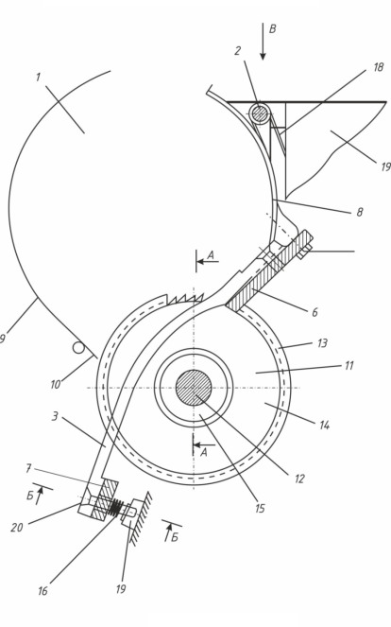 | 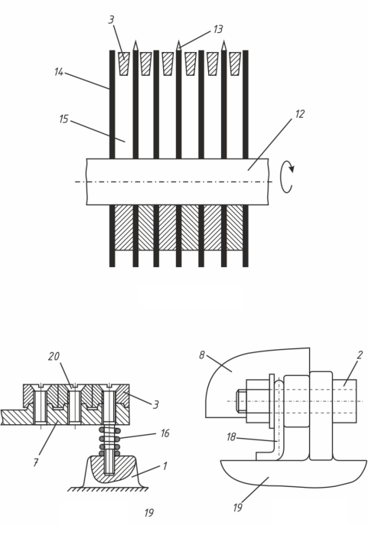
FIGURE 1. Overview of the improved working chamber
1 — Working chamber; 2 — Bolt; 3 — Rib grid; 4–5 — Rib ends (heels); 6–7 — Upper and lower beams; 8 — Curved transverse support; 9 — Front apron; 10 — Replaceable rib; 11 — Saw cylinder; 12 — Shaft; 13 — Saw blades (discs); 14 — Smooth separating disc; 15 — Spacer between saw blades; 16 — Lower compression spring; 17 — Threaded support; 18 — Upper spring; 19 — Gin housing; 20 — Head bolt.
During the ginning process, the saw cylinder (11) interacts with the cotton material uniformly fed onto the rib grid. Due to the slight vibrations of springs (16) and (18), the pressure of the cotton fiber mass pressing the saw disks against the working surfaces of the ribs is reduced. As a result, the wear of the ribs decreases and their service life increases.
In the research process, the dynamic properties of mechanical stresses, the coefficient of friction, and the load arising in the contact zone are studied in depth. By analyzing these parameters, an accurate assessment of the wear process, its speed, and nature, manifested under the operating conditions of the grate, is made. In particular, the wear processes arising from the rigid or oscillatory fastening of the grate bars are compared with each other, and the main differences between them are determined [8].
The main goal of the research is the development of optimal design solutions for practical application, increasing the service life of the grate and increasing the overall efficiency of the device. This will ensure the reliability and stability of technological equipment in the production process and improve technical and economic indicators.
RESULTS AND DISCUSSION

A DP-30 laboratory stand was used for conducting the experiments. In these studies, the stresses arising from the collision of the saw blade with the grate were analyzed. The experimental results were compared in the rigid and spring states. The results show that when using a spring, the maximum force, impulse of force, and acceleration are significantly reduced, which increases the service life of the mechanism and slows down the wear process [4-6].

TABLE 1. Comparison of forces in Rigid and Spring mounting conditions
Condition | Maximum Force, F<sub>max</sub> (N) | Force Impulse (N·s) | Maximum Acceleration (m/s²)
Rigid | 1020 | 12.5 | 150.2
Spring | 610 | 7.3 | 95.6

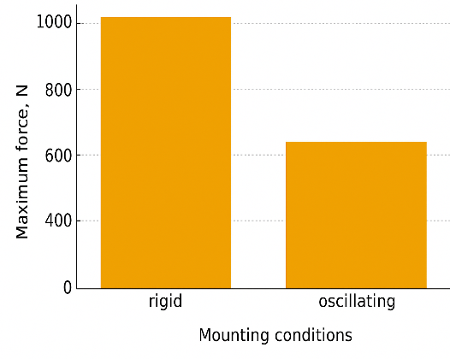 | 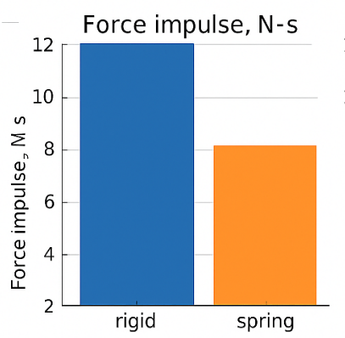 | 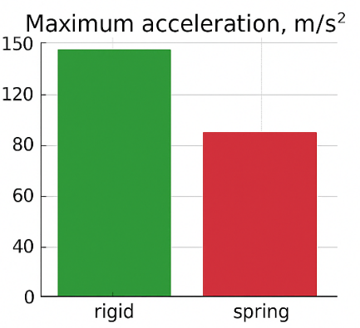
FIGURE 2. Maximum force in rigid and spring states | FIGURE 3. Force impulse in the rigid and spring states | FIGURE 4. Maximum acceleration in the rigid and spring states
In subsequent studies, the process of grate wear was studied. In this case, the grate was fixed on the support in a vibrating and rigid (non-vibrating) way. Thanks to these two different design solutions, it became possible to identify and compare the differences in the wear process.
In both conditions, the rotational speed of the saw disc, the amount of load, and the number of working cycles were set the same. This approach made it possible to conduct a comparative analysis of the results, ensuring that only the position of the grate fastening differed under experimental conditions.
To determine the degree of wear, the dimensions of the grate were determined every 72 hours using a caliper. From the measurement results, the depth of wear and mass loss were calculated. Microscopically, micro-depressions and irregularities formed on the surface were also observed. This helped to determine the nature of wear, i.e., the predominance of abrasive, adhesive, or fatigue mechanisms.

TABLE 2. Wear test results under different conditions
Test condition | Average contact pressure (MPa) | Number of cycles (×10³) | Wear depth (mm) | Mass loss (mg)
Non-vibrating | 4,2 | 50 | 0,18 | 42,6
Non-vibrating | 4,2 | 100 | 0,32 | 77,4
Vibrating | 4,2 | 50 | 0,11 | 25,3
Vibrating | 4,2 | 100 | 0,21 | 49,2

In order to ensure the accuracy and reliability of the results, each experiment was repeated 5 times. Statistical stability was achieved through repeated experiments, and the differences between the obtained values were analyzed. Thus, the collected experimental data subsequently served as the main source for calculating the wear rate, assessing the service life of the grate bars, and developing optimal design solutions.
Analysis of the results showed that the wear rate of the grate, fixed in the vibrating position, was significantly lower. For example, if during 100 thousand cycles the depth of wear in the stationary state was 0.32 mm, then in the oscillating state this indicator was equal to 0.21 mm. The mass loss was similarly different: 77.4 mg in the stationary state and 49.2 mg in the oscillatory state. Consequently, the wear process slowed down due to the fact that the vibration partially distributed contact loads on the grate surface and reduced local pressure.

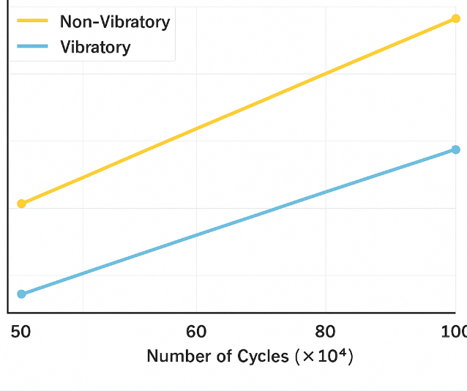 | 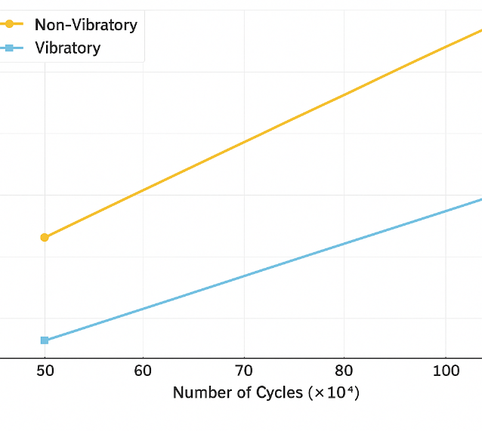
FIGURE 5. Depth of wear depending on the number of cycles. | FIGURE 6. Mass loss by number of cycles
CONCLUSION
The graphs constructed as a result of the experiments clearly depict the wear process under conditions of vibrational and non-vibrational (rigid) fastening of the grate bars. As can be seen from the graphs, with an increase in the number of cycles, the depth of wear and mass loss in both cases gradually increased. However, in the vibrating state, the degree of wear was significantly lower, and a significant difference was observed compared to the solid state. For example, the wear depth in the stationary state reached 0.32 mm in 100 thousand cycles, while in the oscillatory state this indicator was 0.21 mm. A similar result was recorded for mass loss, where a mass loss of 77.4 mg was detected in a rigidly fixed grate, while a mass loss of 49.2 mg was observed in the vibrating state.
Based on the results of the experiment, it can be said that fastening the grate in a vibrating position significantly slows down the wear process, i.e., by 1.5 times. The main reason for this is that vibration partially distributes loads on the contact surface, reducing local pressure and, as a result, reducing the intensity of friction. Therefore, the service life of the oscillating grate is longer, and it is technically and economically more efficient for practical application.

REFERENCES
- Yang, W., Xue, S., He, Y., & Li, W. (2017). Experimental study on the heat transfer characteristics of high blockage ribs channel. Experimental Thermal and Fluid Science, 83, 248–259. https://doi.org/10.1016/j.expthermflusci.2017.01.016
- Hughs, N. S. E. (2002). GINNING RIB MODIFICATIONS TO REDUCE SEEDCOAT FRAGMENTS. Applied Engineering in Agriculture, 18(1). https://doi.org/10.13031/2013.7703
- Siddiqui, M. Q., Wang, H., & Memon, H. (2020). Cotton fiber testing. In Textile science and clothing technology (pp. 99–119). https://doi.org/10.1007/978-981-15-9169-3_6
- Deshmukh, P., Lahane, S., Sumant, H., Patange, A. D., & Gnanasekaran, S. (2023). Experimental Thermohydraulic assessment of novel curved ribs for heat exchanger tubes: a machine learning approach. Aerospace, 10(7), 658. https://doi.org/10.3390/aerospace10070658
- Kong, D., Zhang, X., Lu, B., Li, C., & Liu, Y. (2022). Identifying dominant components of vibrational energy flow in U-rib plates of bridge based on structural intensity. Journal of Low Frequency Noise, Vibration and Active Control, 42(1), 192–208. https://doi.org/10.1177/14613484221122732
- Xoshimov, X., Yuldashev, S., Muydinov, A., & Kosimov, K. (2024). Analysis and results of the conducted research work to increase the resource of the ginning rib. AIP Conference Proceedings, 3045, 040029. https://doi.org/10.1063/5.0197316
- Amonov, A. et al. (2023). Determination of the friction force between the roller of the polymer composition coating equipment on the seams of tarpaulin materials and the surface of the tarpaulin. AIP Conference Proceedings, 2789, 040053. https://doi.org/10.1063/5.0145792
- Luo, X., Wang, X., Fan, Q., Wang, J., Shi, Y., Liu, J., & Huang, Y. (2025). Research on Vibration Reduction Characteristics and Optimization of an embedded Symmetric Distribution Multi-Level Acoustic Black Hole Floating Raft Isolation System. Symmetry, 17(8), 1196. https://doi.org/10.3390/sym17081196

