Influence of Heat Treatment on the Microstructure and Strength Characteristics of Grade 45g Steel
Kh. G. Abdulkhayev^{1, a)}, M. T. Mansurov^{1, a)}, K. Z. Kosimov^{2, b)},
Sh.H.Yuldashev^{2, b)} O. F. Minchukova^{3, c)}
¹Namangan State Technical University, Namangan, Uzbekistan
²Andijan State Technical Institute, Andijan, Uzbekistan
³GO "Scientific and Practical Center of the National Academy of Sciences of Belarus for Materials Science", Minsk, Belarus

^{a)}Corresponding author: axscience@gmail.com
Abstract. Modification of 45G steel was carried out by heat treatment and subsequent quenching to improve its physical and mechanical properties. The structural components of the steel before and after heat treatment and quenching were analyzed using X-ray diffraction. It was found that quenching in water leads to a decrease in the amount of austenite phase in the steel matrix, and quenching in oil leads to an increase. The microstructure of the steel was studied using a metallographic microscope, and an analysis of the effect of the modification on the hardness of the steel was carried out. Analysis of the experimental data indicates that changes in morphology should be associated primarily with changes in the fine structure of the steel, as well as with carbide formation and redistribution of alloying elements between the α-solid solution and the carbide phase.
Keywords: grade 45G steel, heat treatment, modification, microstructure, quenching, hardness, carbide formation.

Introduction
For high yields in agricultural production, the efficiency and quality of soil cultivation are very important, which depend on the technical and mechanical characteristics and condition of the working parts of the machines. The working parts of the machines used in soil cultivation change their size and shape when working in an abrasive soil environment as a result of wear. This has a negative impact on the agrotechnical and energy indicators of soil-cultivating machines [1, 2]. Therefore, one of the most pressing issues is to increase the durability of quickly wearing parts of agricultural machines, which make up the majority of them. Issues of increasing the resource and performance of the main quickly wearing parts are being dealt with in many leading centers around the world. Research analysis shows that blunting of ploughshares, wear and deformation of the moldboard, wear of the field board by up to 50% increase the traction resistance of the plow, which reduces plowing productivity by up to 60%. This, in turn, leads to an increase in fuel consumption by up to 20%, deterioration in the quality of soil cultivation, poor soil compaction and poor incorporation of plant residues.
The main areas of increasing the service life of plowshares are the selection of material for their manufacture and improvement of manufacturing technology using modern promising technologies, wear-resistant composite materials and heat treatment. Analysis of literary data allowed us to identify a number of theoretical and practical problems in finding such materials, which remain unresolved to date [3, 4]. The hardness of the material is within 37...43 HRC units, and the corrosion resistance is low. Thus, the use of strengthening treatments is relevant. The properties of steels can be improved by using heat treatment with a variation of hardening methods. To improve the physical and mechanical properties of 45G steel, various heat treatment modes are used, during which a structural reorganization of the crystal lattice occurs [5-13]. During heat treatment, it is very important to choose the correct temperature regime, prevent overheating and scale formation. The heating rate determines what characteristics the metal acquires, and the quality of the product depends on the environment in which it was cooled. Based on the above, the purpose of this work is to study the influence of various heat treatment modes on the microstructure of grade 45G steel.
Experimental methods. The object of the study was the widely used 45G steel, the main alloying elements of which are carbon, silicon and manganese. In terms of mechanical properties, it surpasses many known structural alloys. Due to its characteristics, the use of 45G steel affects many areas, in particular, mechanical engineering. The properties of 45G steel determine its advantages: with great functionality, the material is quite affordable; due to its low density, the structures are quite light; it lends itself well to mechanical processing; it is characterized by a high wear resistance and strength limit.
The metal was heated in special continuous electric furnaces. The heating temperature did not exceed 860 °C, and the heating rate was no more than 3 °C per second. In order for the structure of the metal to be leveled, it was kept in the furnace for about 50 minutes. To conduct comparative studies of the physical properties, 45G steel was cooled after heating by quenching in water or oil.
The structure was studied using a modified and automated DRON-2 setup in CuKα radiation in the angular range of 20° ≤ 2θ ≤ 90° at room temperature. X-ray diffraction patterns were processed using the FullProf Suite program based on the Rietveld method for refining the parameters of the crystal cell. The morphology of grade 45G steel before and after heat treatment and hardening was studied using a metallographic complex based on an MI1T microscope according to GOST 8233-56. Before the study, the surface of the samples was etched to reveal the microstructure. The strength characteristics were estimated by analyzing the hardness of the steel grade under study before and after heat treatment. The measurements were carried out using the Vickers method using a specialized Krautkramer TIV hardness tester for non-destructive testing at a load of 5 kg.
Experimental results and discussion. It was found that the initial sample of 45G steel (Fig. 1) consists of two phases of iron – the γ-phase (austenite) sp. gr. Fm\overline{3}m and the α-phase (ferrite) sp. gr. Im\overline{3}m. The unit cell parameter is 0.3605 nm for the γ-phase and 0.2866 nm for the α-phase of iron. When quenched in water, the intensity of the diffraction peaks of γ – Fe decreases, and when quenched in oil, it increases, which indicates that in the first case the amount of austenite in the steel matrix decreases, and in the second case it increases. The parameters of the austenite and ferrite phases of 45G steel before and after heat treatment are presented in Table 1.

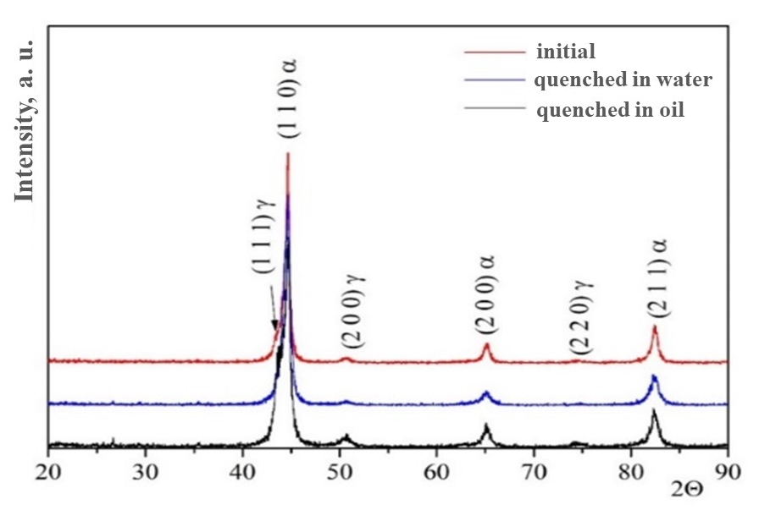
FIGURE 1. X-ray diffraction patterns of 45G steel before and after heat treatment and quenching from 860 °C in water and oil.

TABLE 1. Parameters of the austenitic and ferrite phases of steel 45G before and after heat treatment
Heat-treatment condition | γ-Fe (austenite)  a, nm | α-Fe (ferrite)  a, nm
Steel 45G | 0,3599 | 0,2878
Quenching in oil | 0,3605 | 0,2869
Hardening in water | 0,3609 | 0,2866

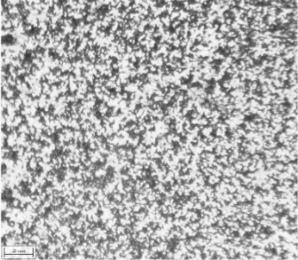 | 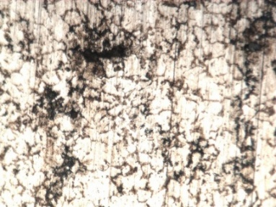 | 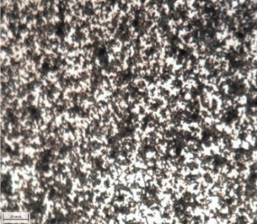
× 500 | × 500 | × 500
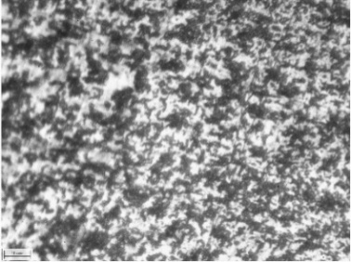 | 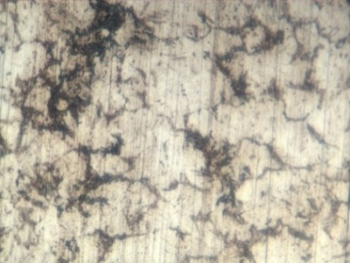 | 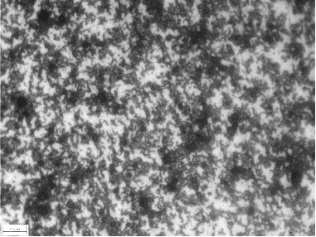
× 1000 | × 1000 | × 1000
а) | b) | c)
a – 45G steel before heat treatment, b – annealing at 860 °C and quenching in water,
c – annealing at 860 °C in oil

FIGURE 2. Images of the surface of the studied samples before and after heat treatment

Figure 2 shows images of the surface of the original and heat-treated samples of 45G steel.
The microstructure of the original 45G steel sample (Fig. 2, a) is characterized by white, mesh ferrite and small pearlite flakes. Quenching in water (Fig. 2, b) leads to the fact that the microstructure of the steel becomes almost balanced, and pearlite occupies about 15% of the entire area of ​​the field of view. Quenching in oil (Fig. 2, c) leads to a thicker lamellar structure of pearlite compared to the sample quenched in water, an increase in the amount of pearlite and a relatively smaller grain size. As a result, the grains are refined, small and homogeneous ferrite and pearlite are formed, which increases the strength, hardness and toughness of the steel. It was found that as a result of high-temperature treatment, first of all, a change in the grain sizes occurs towards refinement in a thin, depending on the type of quenching, surface structure of steel, as well as the process of carbide formation and redistribution of alloying elements between the α-solid solution and the carbide phase.
Fig. 3 shows the images of the surface of all the studied samples with the obtained prints after conducting experiments to determine hardness using the Vickers method. The images were obtained using an MI-1 microscope with AXALIT software.

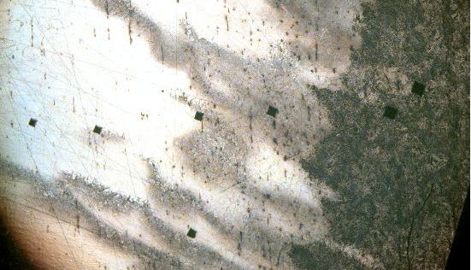 | 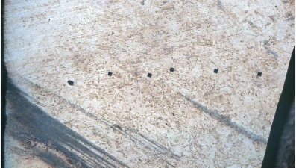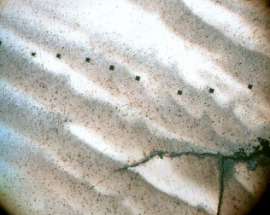
а) | b) c)
a – original sample steel 45G; b – steel after quenching in oil; c – steel after quenching in water

FIGURE 3. General view of the surface of samples with imprints after hardness measurements (magnification ×5)

TABLE 2. Hardness of steel 45G before and after heat treatment
 | Vickers hardness, HV
Experimental points | 1 | 2 | 3 | 4 | 5 | 6 | Avg. value.
Steel 45G | 51,0 | 50,3 | 51,8 | 51,6 | 56,3 | 52,7 | 52,38
Hardening in water | 63 | 62,2 | 62,4 | 62,2 | 62,9 | 57,4 | 61,68
Quenching in oil | 65,7 | 65,3 | 65,6 | 65,3 | 65,2 | 65,0 | 65,35

Table 2 presents the results of calculating the strength characteristics for all the samples under study. The table values show that quenching of 45G steel in water leads to an increase in hardness from 52.38 HV to 61.68 HV, but microcracks are observed in the samples after quenching in water (Figure 3, c). Quenching in oil increases the hardness of steel to 65.35 HV, and the section of the polished sections showed a homogeneous structure and the absence of defects and microcracks.
The difference in hardness of quenched steels is explained by the fact that when quenching steel in oil, the thickness of the hardened layer is greater than that of steel quenched in water. At the same time, the accepted method of measuring hardness measures the hardness of a steel layer of a certain thickness, and therefore the average hardness of the layer quenched in oil was higher than that of the layer quenched in water. Although the microhardness of the thin surface layer of water quenched steel is usually higher than that of steel quenched in oil.

Conclusion
Modification of grade 45G steel was carried out by heat treatment using quenching in water and oil. It was found that the structural components of the original sample of grade 45G steel are two phases of iron - γ-phase (austenite) and α-phase (ferrite). The microstructure of the original sample of grade 45G steel is characterized by white, mesh ferrite and small pearlite flakes. The effect of various high-temperature treatment modes on the microstructure of steel should be associated primarily with changes in the surface structural structure of steel, as well as with carbide formation and redistribution of alloying elements between the α-solid solution and the carbide phase. The analysis of the effect of heat treatment on the hardness of the studied steel grades showed that quenching of grade 45G steel in water leads to an increase in hardness of 52.38-61.68 HV (48-54HRC), however, microcracks are observed in the samples after quenching in water. Quenching in oil increases the hardness of steel to 65.35 HV (≈56HRC), and the section of the polished sections showed the homogeneity of the structure and the absence of defects and microcracks. According to the obtained results, it is recommended to manufacture ploughshares from 45G steel with quenching in oil.

references
- Seharing, A., Azman, A. H., & Abdullah, S. (2014). A review on integration of lightweight gradient lattice structures in additive manufacturing parts. Advances in Mechanical Engineering, 12(6). https://doi.org/10.1177/1687814020916951
- Gümrük, R., & Mines, R. (2013). Compressive behaviour of stainless steel micro-lattice structures. International Journal of Mechanical Sciences, 68, 125–139. https://doi.org/10.1016/j.ijmecsci.2013.01.006
- Crupi, V., Kara, E., Epasto, G., Guglielmino, E., & Aykul, H. (2017). Static behavior of lattice structures produced via direct metal laser sintering technology. Materials & Design, 135, 246–256. https://doi.org/10.1016/j.matdes.2017.09.003
- Abdusalim, T., Gafurovich, A. K., & Nakibbekovich, B. S. (2020). Determining the appropriate values of compactor paramaters of the enhanced Harrow Leveller. Civil Engineering and Architecture, 8(3), 218–223. https://doi.org/10.13189/cea.2020.080304
- Xoshimov, X., Yuldashev, S., Muydinov, A., & Kosimov, K. (2024b). Analysis and results of the conducted research work to increase the resource of the ginning rib. AIP Conference Proceedings, 3045, 040029. https://doi.org/10.1063/5.0197316
- Azizov, S., Ibrohimov, M., Uzoqov, F., & Mirzakarimov, M. (2021). The modelling and introductions of new type ribs of lattice of the two cylinder of gin. E3S Web of Conferences, 273, 07020. https://doi.org/10.1051/e3sconf/202127307020
- Zhang, W., Gao, Z., Zhang, H., Wei, H., Chen, Z., Xue, W., & Liu, Z. (2024). The influence of heat treatment on the microstructure and properties of a Cu-Bearing Ultra-Low carbon steel. Materials, 17(12), 3031. https://doi.org/10.3390/ma17123031
- Shin, S., Oh, D., & Hwang, B. (2023). Influence of heat treatment on microstructure and mechanical properties of Direct-Quenched FE-0.06C-0.2SI-2.0MN steel. Metals, 13(12), 1912. https://doi.org/10.3390/met13121912
- Abdulkhaev, K. G., & Barlibaev, S. N. (2023). Substantiation of the parameters of the rotary ripper of the machine for pre-seeding treatment of ridges. IOP Conference Series Earth and Environmental Science, 1154(1), 012058. https://doi.org/10.1088/1755-1315/1154/1/012058
- Mukhammadiev, D., & Ergashev, I. (2023). Investigation of seeds mechanical extraction through the seed-removing device from saw gin. E3S Web of Conferences, 390, 06011. https://doi.org/10.1051/e3sconf/202339006011
- Ergashev, I., Primov, B., & Abdusalomov, M. (2023). Study of the 125 mm diameter seed-removing tube performance. E3S Web of Conferences, 390, 06017. https://doi.org/10.1051/e3sconf/202339006017
- Mukhamadieev, D. M., & Ergashev, I. O. (2023). Calculation of radial and tangential velocities of the raw cotton roller in the working chamber of a saw gin. Izvestiya Vysshikh Uchebnykh Zavedeniĭ. Seriya Tekhnologiya Tekstil'noi Promyshlennosti, (2), 191–195. https://doi.org/10.47367/0021-3497_2023_2_191
- Karimova, K., Ismailov, K., Shermukhamedov, A., & Yuldashev, S. (2024). Influence of particles formed resulting from wear of automobile brake mechanisms on human health. E3S Web of Conferences, 508, 07013. https://doi.org/10.1051/e3sconf/202450807013

