Development and Characterization of Complex Structured Functional Fabrics: Physical and Mechanical Properties for Engineering Applications
Sevara Khamraeva^{a)}, Khamza Rasulov, Dilfuza Kadirova
Tashkent Institute of Textile and Light Industry, Tashkent, Uzbekistan

^{a)}Corresponding author: sevarahamrayeva42@gmail.com
Abstract: The growing demand for specialized textile products in medical and rehabilitation contexts highlights the need for advanced functional fabrics with enhanced properties. This research focuses on developing functional fabrics with complex structures, utilizing modern weaving technologies and innovative fiber blends, such as cotton and Modal. By optimizing geometric and technological parameters, the study achieves fabrics with variable thickness, improved air permeability, and massage properties, meeting the requirements of bedridden patients. Experimental results demonstrate that fabrics with complex structures ensure better blood circulation, superior moisture management, and enhanced comfort. Two weaving methods were applied: varying yarn linear densities and layering fabric structures, resulting in distinct surface reliefs that contribute to functional effects. Mathematical modeling and regression analysis helped determine the optimal fiber compositions and processing conditions to minimize warp breakage and enhance fabric durability and breathability. The proposed technology was successfully implemented on modern weaving machines using local raw materials. The resulting fabrics not only meet hygiene and comfort standards but are also suitable for large-scale production aimed at medical applications such as orthopedic mattress covers. This research supports the advancement of high-performance textile materials in healthcare and provides a scientific foundation for their industrial integration.
Keywords: functional fabrics, complex structures, weaving technology
INTRODUCTION
Research of Functional Fabrics with Complex Structures. Due to the use of new technologies, the world is experiencing a growing demand for textile products with special functions. The innovative strategy for economic development announced by the country's leadership is based on the modernization of local production and the development and use of new technologies and materials. Thanks to modern scientific achievements, new types of textile products are being developed that have special protective, therapeutic, functional, and rehabilitation properties.
One of the promising areas of design and development of special-purpose fabrics worldwide is the construction of fabrics with complex structures. Such fabrics have good elasticity, increased heat resistance, and protective and soundproofing properties. Due to these properties, fabrics with a complex structure and certain functional properties are widely used in all areas of human activity [1-4].
The main part of the range of fabrics produced at the textile industry enterprises of our republic (Uzbekistan) is fabrics for household purposes. But for the textile industry, fabrics used for medical purposes are important, they affect the quality of medical services provided, the psychological state, and the health of the patient. Fabrics with complex structures are in demand in modern conditions, and the physical and mechanical properties of fabrics mainly depend on the technological conditions of weaving, types of raw materials, and their formation on machines There are many unsolved problems associated with the selection of equipment for the production of fabrics of complex structure, the development of production technologies and the mass production of this type of textile products. One of the main ways to expand the range of fabrics of complex structures is weaving, the number of layers, and the content of fibers in the raw material [5-8].
F.U. Nigmatova [5], are conducting several scientific studies to expand the technology and methods of producing materials for textile medical clothing, bed linen, and medical products from various textile fibers and yarns. The aim of the study: is to develop a technology for producing functional fabrics of complex structures on a modern weaving machine.
Research objectives:
-Development of technology for producing fabrics with complex structures and functional characteristics on a weaving machine
-To determine the technological and design factors of a fabric of complex structure with different geometric parameters;
-Development of a method for designing functional fabrics of variable thickness;
-Determination of alternative technological factors for the production of fabrics of complex structures on a weaving machine.
The objects of the study were modern electronic weaving machines, cotton and Modal blended yarns, and fabrics with functional properties of complex structure. The subject of the research is the technology of producing fabrics with a complex structure and functional properties from blended yarns.
Research methods. In the process of researching the technology of woven fabrics of complex structure, theoretical and experimental assessment, rules of mathematical calculation of research results, formation of functional fabric on a weaving machine, and determination of the influence and dependence of structural factors on its structure of properties, methods of full factorial experimental analysis of the construction of regression models and methods specified in existing regulatory documents were used.
The scientific novelty of the study: based on the specified characteristics and technological factors, a structure of functional fabrics of complex structure of various thicknesses and different sizes was developed.
-A calculation method for determining the geometric and technological parameters of functional fabrics of variable thickness has been developed.
-A technology for forming a functional fabric of complex structures on a weaving loom has been developed.
-Regression equations have been developed that influence the technological factors of forming functional fabrics of complex structure on a weaving machine. The practical results of the study are as follows: - based on the study of the existing spectrum of functional fabrics, new combinations with a complex structure were developed;
-Samples of functional fabric were developed and selected on a weaving machine with variable thickness and various technological and geometric parameters;
-Technological and geometric factors and physical and mechanical properties of functional fabrics of complex structures were determined;
-The possibilities for producing fabrics of complex structures with new functional properties have been expanded, using different raw material compositions and weaving patterns.
Reliability of research results is ensured by compatibility of theoretical and experimental studies, positive results of approval and implementation, as well as comparability of results according to evaluation criteria and their adequacy, positive research results are compared with data obtained in this area of scientific research.
The scientific significance of the research results is that a technology for the production of functional fabric of complex structures using existing weaving machines has been created, a calculation method has been developed to determine the geometric and technological factors of functional fabric fabrics of variable thickness, a design of a functional fabric of complex structure was developed and geometric factors, as well as physical and mechanical properties, were determined. This is explained by the theoretical justification of the functional structure of the fabric, and variable thickness with various technological and geometric parameters [9-14].
The practical significance of the research results lies in the fact that a technology for producing functional fabrics on weaving machines of variable thickness with different technological parameters has been developed, and samples of fabrics of complex structure with functional properties have been obtained. Implementation of research results. Based on the results achieved in the development of the functional structure of fabrics and production technology:
-A fabric structure with a complex structure and functional properties has been created, intended for sheets.
-The technology for obtaining functional fabrics of complex structures, produced from local raw materials, has been tested and implemented into production on a modern weaving machine of RealTexTashkent LLC, SunTex LLC in Tashkent, and Al Hakimplus LLC in Bukhara. As a result, a technology was developed for obtaining functional fabrics of complex structure, on existing modern weaving machines of textile enterprises, which made it possible to produce new ranges of functional fabrics oriented to the requirements of the domestic and foreign markets.
The introduction substantiates the relevance and necessity of the study, describes the purpose and objectives, object and subject of the study, and shows its compatibility with the previous areas of development of science and technology of the republic (Uzbekistan), and scientific value.
“Analysis of the literature on the technology of production of complex structure fabrics” examines the technologies of production and methods of production of functional fabrics of complex structure and the areas of their application, the use of functional fabrics in medicine, the analysis of the ranges used and technologies for their production in the world and in our Republic (Uzbekistan).
Based on the Republican Center for Rehabilitation and Prosthetics in Uzbekistan, scientists and specialists of the Department of “Technology of Garments” and “Technology of Textile Fabrics” of the Tashkent Institute of Textile and Light Industry are conducting research work on the development of a range of products for patients with pathological changes in the human support system, severely immobilized patients, aimed at developing a technology for obtaining functional fabrics of complex structure with requirements for hygiene, air permeability, hygroscopicity, aesthetics and service life.
According to the analysis of the literature review and research, several combinations of functional fabrics of complex structures were developed to solve the identified problem, Figure 2 shows the combinations with different fabric thicknesses.
Combination with different rapport of variable thicknesses, part 1 and 2 fabric connected with a large rapport of thicknesses (Figure 1 a), combination with the arrangement of variable thicknesses 1 and 2 connected with different rapport of fabric thicknesses (Figure 1 b), combination with the arrangement of the same rapport of fabric cavities (Figure 1 c), combination connected with small cavities (Figure 1 d). The choice of varieties with variable fabric structure depends on the requirement and area of application.

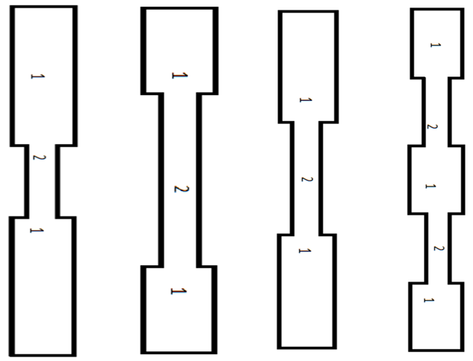
a) b) c) d)
FIGURE 1. Combination with different rapport of variable thicknesses
METHODS
This section describes the experimental methods employed to develop functional fabrics with complex woven structures for medical applications. Two approaches were adopted: fabrics were constructed using warp and weft yarns of different linear densities, and multilayer fabrics were produced on a weaving loom to achieve complex structural combinations. All experiments were carried out in accordance with textile testing standards to ensure reliability and reproducibility of the results.
Fig. 2 (a) shows a geometric model for producing a single-layer fabric from weft yarns of different linear densities (first method). The warp rapport is 2, and the weft rapport is 12. The fabric obtained has a complex structure: a is the part of the fabric where the weft yarn has a high linear density and creates projections on the fabric surface; b is the part of the fabric where the weft yarn has a lower linear density and creates notches on the fabric surface.

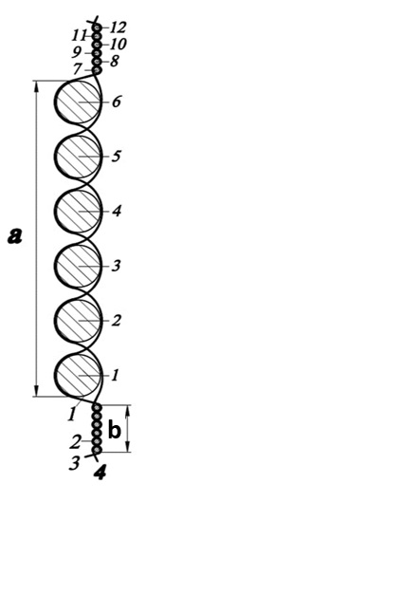 | 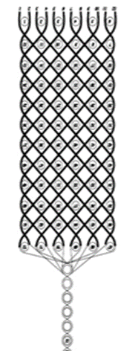
a) | b)
FIGURE 3. a-Cutting off a single-layer fabric of complex structure based on alternating layers; b-Cutting off a multilayer fabric of complex structure based on alternating layers
Figure 3 (b) shows a geometric model of alternating layers of fabric in a complex structure (the second method), when forming a fabric of a complex structure, when making a multilayer part of the fabric, the thickness of the fabric increases, and the thickness of the
fabric decreases when making a multilayer part. Bumps and recesses are formed on the surface of the fabric. The variable thickness of the complex structure fabric obtained by this method depends on the application and requirements of the fabric.
The thickness of a fabric of a complex structure obtained under equal technological conditions depends on the number of layers, is constant, and is limited only by the technical capabilities of the machine.
The development of technology for obtaining functional fabric with a complex structure is carried out by forming a new fabric structure on a weaving machine. It should be noted that the adopted technological chain for the production of functional fabric with a complex structure has standard technological processes for the production of household fabrics.
A special feature of the process of obtaining functional fabrics of complex structures on a weaving loom is that the fabric has variable thicknesses along the warp.
The fabrics with variable linear yarn density were produced on modern R9500 weaving machines by Itema (Italy). Taking into account the above, the following technological conditions were adopted for the production of pilot samples with variable functional structure: base fabric “Mattress tick” art. 3939 st. The density of the warp yarns of the samples is 240 yarns per 10 cm, and the density of the weft yarns is 150 yarns per 10 cm; For all options, 100% cotton with a linear density of 25x2 tex is used as the warp yarn, 100% cotton is used as the weft yarn for options I, 100% Modal for options II, 50% cotton
+ 50% Modal for options III. All fabric samples are produced in plain weave.
For the production of a new structure of fabrics with variable layers of functional purpose, the Somet Thema Super Excel-190 weaving machine (Italy) was chosen. The Somet Thema Super Excel-190 weaving machine with rapier insertion of the weft yarn into the shed, filled with plain fabric weaves. Functional fabrics of complex structures I, II, and III have a fabric structure with alternating layers of fabric in a ratio of 6:1.
When producing fabric on a loom, a six-layer part is formed, and then a single- layer part of the fabric. This ratio of layers creates a convexity and recesses on the surface of the fabric, which not only provides good air exchange and moisture removal, and the product remains dry, but also has massage properties due to the uneven surface of the fabric. Where better air exchange and contact with airflow from the patient's body leads to improved blood flow in the capillaries of the skin. The size of the resulting grooves and reliefs depends on the number and thickness of the weft yarns. Due to the fact that samples of fabric of complex structure are made on a machine with a warp rapport of Po =12, weft rapport of Ry1 = 72 in the six-layer part of the fabric, and Ry2 = 2 in the single- layer part.

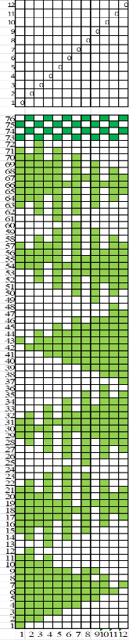 | 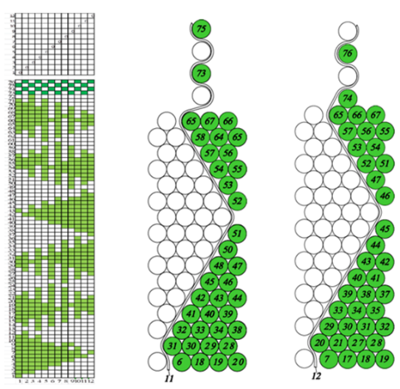
a) | b)
FIGURE 4. Geometric model of fabric obtained based on alternating layers of complex structure. a) Weave diagram of complex fabric structure b) Schematics of a six-layer forming fabric design
Figures 4 (a) and 4 (b) show the weave of the 11th and 12th warp yarns with the weft yarns in the fabric rapport. To determine the technological indicators of multilayer samples, a technical calculation of the fabric was carried out in Table 2.
Since functional fabric samples have a complex structure, the calculations using the existing method of filling and technological parameters do not provide an objective assessment, since the existing method of technical calculation does not take into account the structure of the fabric
Design of functional fabrics of complex structure. To objectively evaluate the newly designed fabric, its main geometric parameters were determined: the diameter of warp and weft yarns, the wave height of the warp and weft yarns, the half wavelength of the yarns, the shrinkage of the warp and weft yarns, the surface density of the fabric, the filling degree of the fabric with warp and weft yarns, etc.
Theoretical methods of studying functional fabrics of complex structures were carried out using the theory of the structure and design of multilayer fabrics. As can be seen from Figure 4 in sections, 11 and 12 warp yarns are intertwined with the weft, the connections of the six-layer part with the single-layer part of the rapport by the weft - Ry, which in turn depends on the density of the connection area - Py1 and the density of the formation of the part Py2.
For a six-layer part of a fabric with layers connected by warp yarns, the fabric rapport along the warp is equal to:
𝑅𝑜1 = 𝑅𝑜.𝑐 ⋅ 𝑛𝑐 = 2 ⋅ 6 = 12
weft pattern rapport:
𝑅𝑦1 = 𝑅𝑦.𝑐 ⋅ 𝑛𝑐 = 12 ⋅ 6 = 72
Where: Roc, Ry.c - weave pattern rapport in the fabric for warp and weft; nc – number of layers in the designed fabric
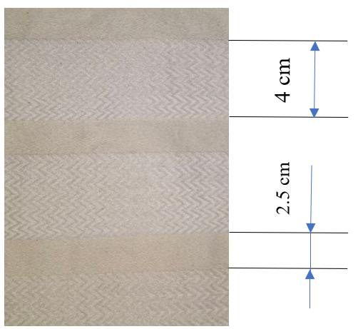
FIGURE 5. External appearance of functional textile of a complex structure
The picture (Fig. 5) shows that the thickness of the fabric is variable, in this case, the six-layer part of the fabric has a width along the base of 4.0 cm, and the single-layer part of the fabric is 2.5 cm. This method forms projections and recesses on the surface of the fabric.
In this case, it is necessary to determine the pattern repeat on the warp for the six-layer part:
$${{R_{o}}_{уz}}_{1}=P_{o}⋅B_{yz}$$
pattern repeat by weft:
$${{R_{у}}_{уz}}_{1}=P_{у}⋅l_{yз}$$
P_{o}- density of warp yarns,yarn/dm
P_{y}- density of weft yarns, yarn/dm
It is also necessary to determine the pattern repeat of the fabric on the warp for the single-layer part of the fabric sample:
$${R_{o_{уz}}}_{2}=Р_{о}⋅В_{yz}$$
by weft:
$${{R_{у}}_{уz}}_{2}={P_{у}}_{2}⋅l_{yz}$$
Where: Py₁, Py₂ - density of weft yarns in the fabric of complex structure, yarn/dm;
B_{yz} – pattern width, equal to the working width of the loom, cm;
l_{yz} – pattern width along the base, cm
For fabrics with a complex structure, having a different number of weft yarns in the rapport of each layer, the weft rapport is determined by adding the number of weft yarns in each rapport:
$${R_{у_{уz}}}_{}={{R_{y}}_{1}}_{уz}+{{R_{y}}_{2}}_{уz}$$
The weave of the fabric is plain, the binding of the fabric layers is combined, and the ratio of warp and weft yarns in the layers is 1:1.
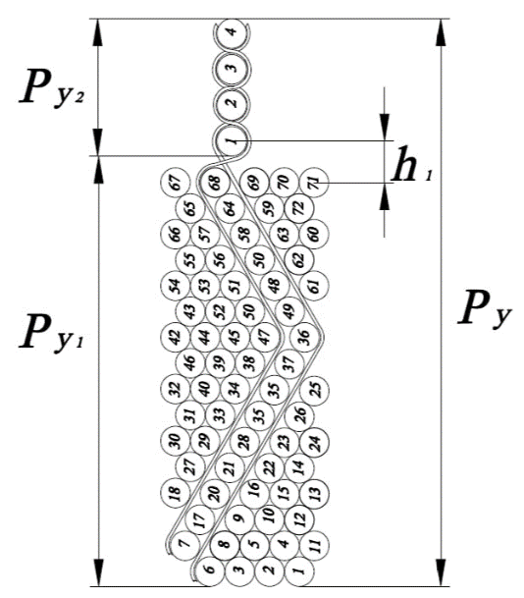
FIGURE 6. Technological parameters of fabric with variable layers
h₁ warp bending wave height;
C is fiber content of yarn. Let's define C for the yarn before weaving
where: δ₁ is the average density of cotton yarn = 1.25;
δ₂ – average density of chemical yarn Modal = 1.1;
n₁ – proportion of cotton fiber in yarn;
n₂ – proportion of Modal fiber in yarn.
Considering that the thickness of the fabric depends on the diameter of the warp and weft yarns of each part, it is calculated using the following formulas:
Yarn diameter before weaving for a six-layer fabric section
$${d_{р}}_{o1..n}=\frac{n\left(d_{o1}+d_{y1}\right)}{2}$$

$${d_{р}}_{у1..n}=\frac{n\left(d_{o1}+d_{y1}\right)}{2}$$
where: n is the number of layers of fabric

TABLE 1. Geometrical parameters of yarns in the functional fabric of complex structure
№ | Factors | Samples with alternating layers of textile fabric
№ | Factors | Specimen I | Specimen II | Specimen III
1. | Fiber composition:  Warp  Weft | 100% cotton  100% cotton | 100% cotton  100% Modal | 100% cotton  50% cotton+50% Modal
2 | Linear thickness of raw material: tex  Warp  Weft | 25х2  30 | 25х2  30 | 25х2  30
3 | Bending wave of yarns mm  Warp-Weft | for 6:1  1.12-0,280  1.86-0.216 | for 6:1  1.06-0.280  1.76-0.19 | for 6:1  1.09-0.280  1.815-0.204
4 | Yarn diameter, mm  Warp-Weft | 1.488-0.280  1.488-0.216 | 1.41-0.280  1.41-0.191 | 1.452-0.280  1.452-0.204
5 | Geometric density, mm  Warp-Weft | 2.76-0.41  2.32-0.45 | 2.613-0.377  2.203-0.43 | 2.69-0.39  2.267-0.439
6 | Thickness of textile fabric, mm  thickened part  thin part | 1.700  0.700 | 1.700  0.700 | 1.900  0.800
7 | Density of yarn in the fabric, yarn/dm  Warp  Weft | 357-357  443-433 | 357-357  501-488 | 357-357  468-457
8 | Yarn shrinkage, %  Warp  Weft | 17.9-5.29  26.5-4.6 | 14.0-4,31  26.4-4.14 | 15.8-4.93  26.5-4.47
9 | Surface density of textile fabric, g/m² | 636 | 668 | 650
RESULTS AND DISCUSSIONS
Due to the use of different fiber compositions for the weft yarn, the yarn diameter in the II variant of the six-layer part by warp and weft is 1.41 mm. As is known, the yarn diameter directly proportionally affects the height of the yarn bending waves, namely, it decreases. The yarn density in the fabric increases, in the II variant, the weft density in the six-layer part is 501 yarns/dm. An increase in the weft density in turn leads to an increase in the surface density of the fabric.
According to calculations, 100% cotton was used as weft yarns for variant I, 100% Modal in variant II, and 50% cotton +50% for the production of variant III. Considering that the designed fabric should have properties, option I is more suitable for the consumer's requirements. The thickness of the fabric of sample III is 11% higher than the I and II samples.
Based on the analysis of a previous data and the results of preliminary experiments, the following factors were determined to have a significant impact on the output indicator: X₁ - percentage content of cotton fiber in the raw material, %, X₂ - fabric thickness, mm, X₃ - twist number, twist/m.
Based on the analysis of a previous data, the results of preliminary experiments, and the technical capabilities of the weaving machine, the values and ranges of action of the main factors were selected, and the variations of the factors were determined and presented in Table 2.
TABLE 2. Levels of variation of factors
Factors | Levels of variation |  |  |  |  | Interval
Factors | -1.682 | -1.0 | 0 | +1.0 | +1.682 | Interval
х₁-% content in cotton yarn | 33 | 40 | 50 | 60 | 67 | 10
х₂-fabric thickness, mm | 0,4 | 1 | 2 | 3 | 4 | 1
х₃-yarn twist, t/m | 616 | 650 | 700 | 750 | 784 | 50

According to the Student's criterion, not all coefficients are significant, in particular, the coefficients for X₂ and X₃, and the coefficient of pairwise interaction X₁ and X₂ have smaller values, that is, t_{T} > t_{R}. Therefore, we do not take these parameters into account in further data processing. The mathematical model describing the dependence of discontinuity on the selected factors is as follows:

Yr=0.5704-0.0272x1-0.0117x2-0.0549x3+0.0515x12+0.064x13-0.1327x12-0.2977x22-0.3337x32

Regression equation for air permeability of fabrics

Yr=$96.6802-0.8784x1-5.2704x2-3.3672x3+8.125x12+0.25x13-23.4339x_{1}^{2}-23.0589 x_{2}^{2}- 23.2464x_{3}^{2 }$

To test the hypothesis about the adequacy of the obtained model, we use the Fisher criterion, the calculated value of which is compared with the table value of F_{T}. Since F_{R} < F_{T}, then with a confidence probability of P_{D} = 0.95,

$F_{T}\left[P_{D}=0.95; f_{1}=N_{Ц}-1=6-1=5; f_{1}=N-N_{кзн}-{(N}_{Ц}-1)=20-(6-1)=15\right]$ = 1.92
the hypothesis about the adequacy of the obtained models is not rejected, that is, 3.96 < 4.77
The solutions of the above regression equations were calculated in the Mathcad computer program and the resulting constants were analyzed.
The analysis of the obtained results shows that the minimum breakage of the warp yarns per 1 meter of fabric with natural values of the parameters are: Fibrous composition of the raw material:
X₁ = 40% cotton and 60% modal fiber; fabric thickness, X₂ = 3 mm; yarn twist X₃ = 700 t/m. With these values, the yarn breakage during the production of functional fabric on a weaving machine does not exceed 0.361 breaks per meter. In the process of weaving a functional fabric of a complex structure on a weaving loom, the air permeability of the fabric is Yr=92m³/m²/s. Further, samples of functional fabrics of complex structures were studied and analyzed, physical and mechanical, consumer properties: breaking load and breaking elongation; air permeability; abrasion resistance; hygroscopicity (Table 4).
In terms of the use of fabrics with complex structures, samples I, II, and III, selected by this method, meet the requirements for air permeability, structure, and manufacture of a mattress for bedridden patients.
Based on the research results, it is recommended to produce functional fabrics of complex structures from local raw materials for orthopedic mattresses intended for bedridden patients. The research work examines the issues of economic efficiency of the use of technology for the production of functional fabrics of complex structures and the creation of technology for obtaining products from it, as well as its implementation.

TABLE 5. Results of tests of physical, mechanical, and consumer properties of samples with variable fabric thickness
№ | Indicators | Specimen I | Specimen II | Specimen III
1 | Fabric thickness, mm  for 6 layers  for 1 layer | 2.0  1.0 | 2.0  0.9 | 2.1  0.9
2 | Surface density g/m² | 798 | 733 | 774
3 | Breaking load on the base, N | 598 | 616,6 | 882,2
4 | Weft breaking load, N | 1800 | 1903 | 2114
5 | Breaking elongation on the base,% | 38 | 40 | 37
6 | Breaking elongation of the weft, % | 22 | 42 | 31
7 | Hygroscopicity, % | 13 | 13 | 13
8 | Abrasion, cycle | 6300 | 7800 | 7800
9 | Breathability, L/m²/s | 48 | 60 | 70
CONCLUSION
This study presents a comprehensive investigation into the development of functional fabrics with complex structures, specifically designed to meet the requirements of medical applications. By utilizing advanced weaving technologies and optimizing key structural parameters, we successfully engineered multi-layered fabrics with variable thicknesses, enhancing their mechanical and functional properties.
The research findings indicate that the introduction of alternating layer structures in a 6:1 ratio leads to the formation of relief patterns on the fabric surface. These patterns contribute to improved air permeability, enhanced blood circulation, and a massage effect, making the fabric particularly suitable for bedridden patients. Moreover, the selection of fiber compositions, including 100% cotton, 100% Modal, and a 50:50 cotton-modal blend, significantly influenced the physical and mechanical characteristics of the fabrics. Experimental results demonstrated that the optimized fiber blend enhances fabric durability, reduces warp breakage, and improves air permeability.
Mathematical modeling and second-order rototilling experimental planning enabled the identification of optimal weaving conditions. The study determined that at a weft fiber composition of 40% cotton and 60% Modal, a fabric thickness of 2 mm, and a twist level of 700 twist/m, the warp breakage rate was minimized to 0.361 breaks per meter, while air permeability reached 92 m³/m²·s. These findings validate the reliability of the proposed manufacturing approach and provide a solid foundation for large-scale production.
The practical implications of this research are substantial. The developed functional fabrics exhibit superior performance compared to conventional textile materials, making them highly suitable for use in orthopedic mattress covers and other medical applications. Additionally, the implementation of this technology in industrial textile production has the potential to enhance the quality and efficiency of functional fabric manufacturing, meeting both domestic and international market demands.
Future research should focus on further refining the structural design of functional fabrics by incorporating alternative fiber compositions and advanced weaving techniques. Investigations into the long-term durability, biocompatibility, and sustainability of these fabrics will also be critical for expanding their applicability in medical and technical textiles.
REFERENCES
- Ferrándiz, M., Fages, E., Rojas-Lema, S., Ivorra-Martinez, J., Gomez-Caturla, J., & Torres-Giner, S. (2021). Development and characterization of Weft-Knitted fabrics of naturally occurring polymer fibers for sustainable and functional textiles. Polymers, 13(4), 665. https://doi.org/10.3390/polym13040665
- Akramov, A., et al. (2025). Evaluation of the yarn deformation in its contact zone with a cylindrical surface. AIP Conference Proceedings, 3304, 030067. https://doi.org/10.1063/5.0269091
- Fan, L., Du, Y., Zhang, B., Yang, J., Cai, J., Zhang, L., & Zhou, J. (2005). Preparation and Properties of Alginate/Water‐Soluble Chitin Blend Fibers. Journal of Macromolecular Science, Part A, 42(6), 723–732. https://doi.org/10.1081/MA-200058635
- Jariyapunya, N., Musilová, B., & Koldinská, M. (2016). Evaluating the influence of fiber composition and structure of knitting fabrics on total hand value (THV). Applied Mechanics and Materials, 848, 211–215. https://doi.org/10.4028/www.scientific.net/amm.848.211
- Nigmatova, F. U., Shomansurova, M. S., Siddikov, I. K., & Musakhonov, A. A. (2014). Design technique for organizational-process flowsheet in clothing manufacture. Automation and Remote Control, 75(6), 1130–1136. https://doi.org/10.1134/s0005117914060125
- Higgins, L., Anand, S. C., Hall, M. E., & Holmes, D. A. (2003). Effect of Tumble-drying on Selected Properties of Knitted and Woven Cotton Fabrics: Part I: Experimental Overview and the Relationship between Temperature Setting, Time in the Dryer and Moisture Content. Journal of the Textile Institute, 94(1–2), 119–128. https://doi.org/10.1080/00405000308630600
- Mamadalieva, D., Karimov, R., Alieva, D., Mirzakasimov, S., & Sheraliyeva, S. (2024). Analysis of the international standards for the determination of ring strength of pile fabrics. AIP Conference Proceedings, 3045, 030038. https://doi.org/10.1063/5.0197341
- Alieva, D., & Karimov, R. (2024). Information about the yung modulus for cotton yarn. AIP Conference Proceedings, 3045, 030034. https://doi.org/10.1063/5.0197606
- Il’ichev, V. A., Yuldashev, S. S., & Matkarimov, P. Z. (1999). Forced vibrations of an inhomogeneous planar system with passive vibrational insulation. Soil Mechanics and Foundation Engineering, 36(2), 50–54. https://doi.org/10.1007/bf02469084
- Xamrayeva, S., Daminov, A., & Kadirova, D. (2024). Study of the influence of polyurethane thread on technological parameters and physical-mechanical properties of elastic fabric. AIP Conference Proceedings, 3045, 030020. https://doi.org/10.1063/5.0198813
- Kadirova, D., Daminov, A., & Rakhimkhodjaev, S. (2019). Technology of production of technical belts and the study of their properties. International Journal of Recent Technology and Engineering (IJRTE), 8(3), 549–552. https://doi.org/10.35940/ijrte.b1555.098319
- Mirzabayev, B., et al. (2025). Controlling tensile strength in yarn using an ultrasonic water vaporizer. AIP Conference Proceedings, 3304, 030047. https://doi.org/10.1063/5.0269506
- Jumaniyazov, K., Tojimirzaev, S., & Muminov. (2022). Research and evaluation of cotton fiber properties in technological processes. Proceedings of Higher Education Institutions Textile Industry Technology, 1, 162–170. https://doi.org/10.47367/0021-3497_2022_1_162
- Djumaniyazov, K., Djumabaev, G., Juraeva, N., & Xurramov, A. (2021). Analysis of vibrations of the rings of the internal spinning machine. AIP Conference Proceedings, 2402, 070046. https://doi.org/10.1063/5.0072022

