Advanced Hybrid Stator Winding Design for Next-Generation DFIG Wind Turbines
Ibragim Askarov, Shahobiddin Kirgizov, Maxsadbek Xojimatov, Mirjalol Muminjonov, Nargiza Atakulova^{a)}
Andijan State University, Andijan, Uzbekistan

^{a)}Corresponding author: nargizaatakulova456@gmail.com
Abstract: In this paper we offer a review of generator technologies in general for wind turbine applications, from typical synchronous and asynchronous machines to advanced generator technologies such as low-speed direct-drive (DD) generators, axial-flux topologies and superconducting generators based on either low-temperature superconductors (LTS) or high-temperature superconductors (HTS). Each design is assessed in terms of efficiency, weight, reliability, scalability and offshore operational suitability. Focus will be on HTS-powered generator systems that provide higher power density and lower losses, and are challenging due to cryogenic cooling and materials engineering. Secondly, the paper evaluates specific architectures of contemporary generators and notes their benefits in boosting grid-synchronized hybrid microgrids with solar PV, wind, battery energy storage, and HTS-augmented generators, etc. Academics and developers are expected through the review to adopt next generation wind energy systems for greater optimization and integration.
Keywords: evaluates, weight, reliability, scalability, superconducting generators, lower losses, low-speed high-power generators, generator technologies.
INTRODUCTION
And so there has been the steady increase in the high demand for electric power. The expansion of electric vehicles and the adoption of charging infrastructure for them has made the transportation sector, among others, dependent on electricity. Modern transportation solutions, including high-speed electric railways, autonomous vehicles, and the emergence of electric aircraft, are also contributing significantly to rising energy consumption [1-3]. Simultaneously, there is quick progress in areas such as artificial intelligence (AI) and data centers, supporting increasingly large amounts of information, complex algorithms in the form of advanced AI algorithms, and the provision of cloud-based digital services. Then we also have about the increase of automation and the Internet of Things (IoT). High-functioning smart buildings, energy management systems, and modern day gadgets all depend on running electricity at all times. Similarly, in the industrial industry, you may already see the impact of the Fourth Industrial Revolution—robotization, digital process control, and the introduction of advanced technologies into manufacturing processes is creating a significantly higher demand for energy [4, 5].
Modern energy generation is concerned about maximizing efficiency and minimizing losses and emissions. Such integrated approaches are described in recent power engineering literature by adopting various energy types, such as fossil fuels, nuclear energy, hydroelectric, solar, or wind power. From the availability of energy resources (power), climate policies, production costs & energy-security considerations, electricity generation options depending on the nation/region are determined [6]. Those countries with the most natural resources, such as coal or natural gas, are also the most likely to continue to rely on fossil fuels for a long time. In contrast, countries seeking ambitious climate goals are more inclined to invest in renewable technologies and breakthroughs. Global energy development as a whole moves slowly toward decarbonization, which suggests that less and less are being used for the energy of life (to maintain the energy system) by burning fossil fuels and more and more for greener forms (wind, solar, nuclear, and hydrogen) [7]. Renewably and ecologically, wind energy is essential to the paradigm shift in the energy future. Wind turbines harness kinetic energy from the wind and can convert it to mechanical energy to be used as electricity when turning it into electricity through the generator. Modern-day wind turbines can achieve greater aerodynamic efficiency through improved materials, better aerodynamics in blade design, and control systems that modulate mechanical, or adaptive turbine performance in response to changing weather conditions. The benefits and potential of wind are great; no carbon dioxide gas emissions, low running costs, and a big potential for scaling up. Wind farms can be established either offshore or onshore—in the end, offshore places are usually more suitable for the wind. One distinctive behaviour is the height and diameter of the turbine and rotor to induce a higher amount of electricity generation [8]. Nonetheless, wind energy faces a daunting task in the current and forthcoming developments, which includes generation fluctuations depending on the weather, manufacturing capacity and supply chain, energy generation constraints, as well as the need to upgrade the existing electrical grid infrastructure, which affect landscapes and ecosystems. Modern energy storage systems, such as those using hydrogen as an intermediary, are seen as promising technologies to greatly enhance the flexibility and stability of the grid [9]. These systems support good supply-demand equilibrium and are essential for the integration of renewable sources, such as wind and solar energy in combination with these two technologies for the production and processing of energy. Energy storage improves supply chain management of renewables related intermittency and increases grid inertia [10].
Hydrogen can be utilized as both fuel and storage gas for fueling and storing in a zero emissions-free infrastructure for energy [11]. This is made possible by technological advancement and growing investments in storage solutions and smart grid deployments, while also contributing to the growing wind as a strategic enabler of wind power’s integration in the global energy profile. Wind technology is still one of the mainstays of strategies for decarbonization and frameworks to assure energy security—with the development of such roles becoming significant (even more so) in the next decade [12, 13]. Movement of air masses with kinetic forces can then be transformed into mechanical and electrical energy using wind turbines, capturing the power existing in the wind that can be described by the following equation:
$$P_{ω}=0.5ρAv^{3}$$
where ρ is the air density, A is the swept area of the rotor, and υ is the wind velocity. Because this cubic dependence is dependent on wind speed, suitable siting of the turbine combined with optimized aerodynamic design are relevant.
Yet not all of the kinetic energy contained in the wind can be converted into useful power. The efficiency of this energy conversion is described by the power coefficient 𝐶𝑝, a dimensionless parameter defined as the ratio of the actual power extracted by the turbine to the total power available in the wind stream. Betz’s law establishes a theoretical maximum of 𝐶𝑝 of 16/27, meaning that no wind turbine can capture more than 59.3% of the kinetic energy in the wind. Specifically, contemporary wind turbines generally reach 𝐶𝑝 values between 0.35 and 0.45, depending on rotor design (Figure 1), operating conditions, and control strategies [14,15,16].

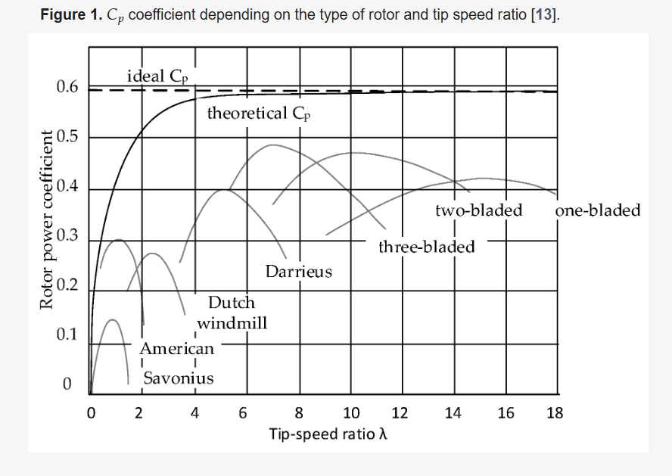
FIGURE 1. 𝐶𝑝 coefficient depending on the type of rotor and tip speed ratio
The increasing energy utilization and the demand for high efficiency, compactness, and minimum maintenance—especially offshore has prompted advancements in wind turbine generator technology. Traditional synchronous and asynchronous generator systems, though excellent and dependable, frequently suffer from issues of scalability, mass-to-torque ratio, and energy losses at varying speeds. These limitations, together with the increasing need for direct-drive systems and larger turbine ratings, have given rise to modern generator designs. These are permanent magnet synchronous generators (PMSGs), superconducting machines, axial-flux topologies, etc creating innovative solutions that can fulfill the needs of next-gen wind energy systems technologically, economically and environmentally. Subsequent sections provide a systematic review of these generator types and technological rationale with regards to their adoption [17].
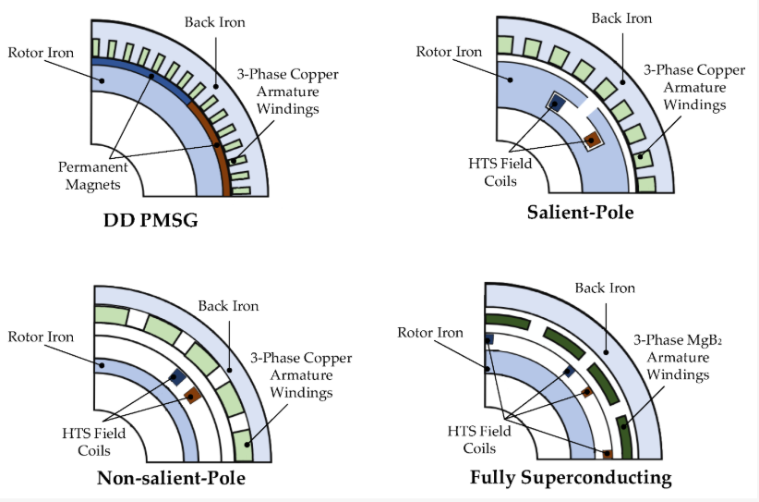
FIGURE 2. Examples of configurations of superconducting synchronous generators used in wind turbines.
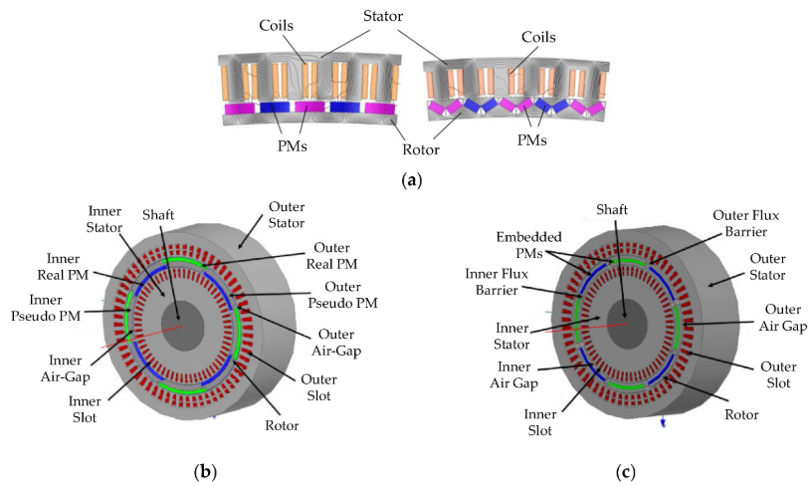
FIGURE 3. Different design approaches for PMSGs: (a) PMSG with single stator and rotor featuring surface-mounted and interior-mounted permanent magnets; (b) dual-stator pseudo-pole five-phase PMSG; (c) dual-stator embedded-pole five-phase PMSG.
EXPERIMENTAL RESEARCH
Superconductivity, or the expulsion of magnetic fields from the interior of a material, is a physical phenomenon that consists of electrical resistance totally disappearing (Meissner effect). Superconductivity can be achieved under certain conditions, which are determined through three parameters such as (a) critical temperature 𝑇𝐶, (b) critical magnetic flux density 𝐵𝐶, and (c) the critical current density 𝐽𝐶. If any of these parameters are exceeded, the material is converted from a superconducting state to a normal conducting state, with the corresponding loss of zero electrical resistance and the Meissner effect [18]. The critical temperature 𝑇𝐶 is the maximum temperature below which a material can exhibit superconducting behavior. Below this threshold, electrons in the superconductor form Cooper pairs, which move in unison without dissipation of energy, thus producing zero electrical resistance. According to critical temperature, the class of superconductors is divided into two parts, as LTS and HTS.
The critical magnetic flux density 𝐵𝐶 is the maximum magnetic flux density a superconductor can endure before losing its superconducting properties. Compared to Type I superconductors, this critical flux density is comparatively low, with an excess of it yielding a complete suppression of superconductivity. By comparison, Type II superconductors show two critical magnetic flux densities: 𝐵𝐶1, the point at which magnetic flux starts to penetrate the material in the shape of Abrikosov vortices, and 𝐵𝐶2, the limit beyond which superconductivity is entirely destroyed. This property enables Type II superconductors to function at strong magnetic flux densities, which opens them up to superconducting magnets and electrical machinery with HTS excitation, etc. [19]. The critical current density 𝐽𝐶 refers to the maximum current that a superconductor can carry without losing its superconducting state. Above 𝐽𝐶, a Lorentz force acting on the magnetic flux vortices causes them to travel, energy dissipation can occur and resistance is higher. This is a major drawback, which is difficult in practical situations, for example in superconducting transmission lines and high current magnets [20]. Currently, the objective is to optimize the material and structural properties of superconductors to increase their critical current density in the operating system, reduce the AC losses, and better keep their performance stability under dynamic electromagnetic, thermal, and mechanical operating environments [21, 22, 23].
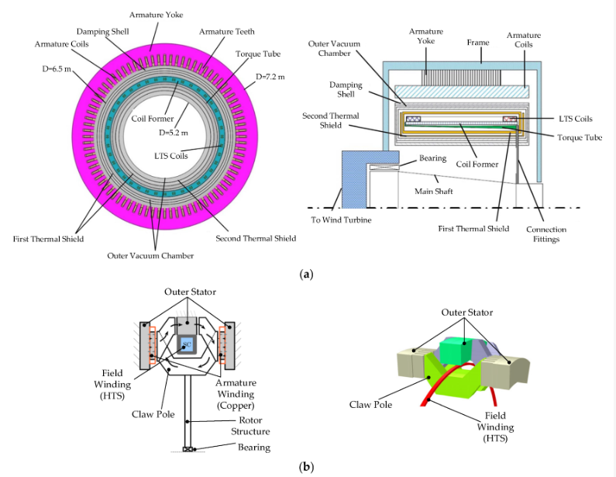
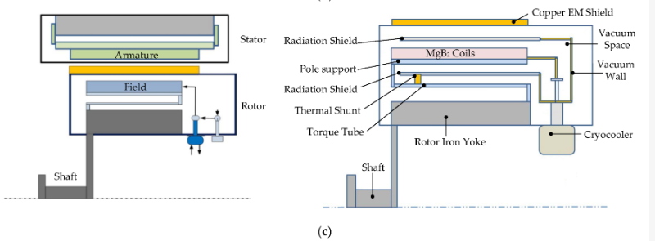
FIGURE 4. Generator configurations with superconducting windings: (a) transverse and longitudinal cross-sections of a generator with LTS rotor winding and a copper stator winding; (b) transverse cross-section and sectional view of an axial-flux claw-pole generator featuring a superconducting stator coil; (c) general layout of a generator featuring superconducting windings on both stator and rotor, with detailed rotor component arrangement

RESEARCH RESULTS
Current energy generation systems focus on efficiency, loss reduction, and emission reduction. Currently, power engineering also adopts a wide range of energy sources such as fossil fuels, nuclear, hydroelectric, solar, and wind. Energy resource availability, climate policies and cost of production, as well as factors related to energy security affect the choice of energy sources to generate electricity in one state or geographical region. Countries that are built on such abundant natural resources as coal or natural gas often end up relying on fossil fuels for long periods of time [24]. In contrast, countries working toward serious climate goals tend to put more resources toward renewable energy technologies and inventions. The global energy development movement more generally is aimed at decarbonization that reflects a gradual shift away from fossil fuels along with growing dependence on clean energy such as wind, solar, nuclear and hydrogen energy. Wind energy has been a particularly important component of the revolution in modern energy transition which comes with its renewable and green properties. Wind turbines convert their kinetic energy produced by the wind into mechanical energy from which it is converted to electricity by generators. Technologies for higher efficiencies in wind turbines by using materials and aerodynamics in blade construction, and by control that adapts turbine operation to different weather conditions, have emerged as key features; modern wind turbines show significant improvement [25].
Wind energy has numerous advantages; it emits no carbon dioxide, low running costs and can be easily scaled. As long as the wind is on the way to somewhere off the coast, offshore is more windy and the wind conditions are better for the offshore site. One noticeable trend is the height of the turbine and the diameter of the rotor are increased to increase the generation of electricity. Nonetheless, challenges in the development of wind energy remain: variable sources of power resulting from the variability of wind in climatic conditions and wind power generation itself, limitations in the manufacture capacity and supply chain, the need for improvements and new electrical grid infrastructure, and its impact on landscapes and ecosystems. More recent energy storage technologies including hydrogen as intermediary offer the potential to dramatically enhance grid flexibility and stability [26]. Such systems allow for efficient demand-supply balancing and can help to leverage those that allow for the addition of renewables such as wind and solar power. Energy storage enables better management of the intermittency inherent in renewables and builds grid inertia. Hydrogen can serve as both fuel and an energy storage medium in this zero-emission context. It is becoming increasingly obvious the integrated use of wind power on the world level because of continued technological development and increasing investments in storage and intelligent grid infrastructure. Wind technology has always played a central role in decarbonization interventions and also frameworks for energy security an activity that is further anticipated to grow in the coming decades. The motion of air masses from a moving medium will generate kinetic force, which can be converted to mechanical energy and then into electrical energy by using wind turbines, with available wind energy capturing by a defined equation.
The study showed that HTS-based generators present the most favourable efficiency, dimension and offshore applicability even as they become more complex and more expensive. PM generators, on the other hand, are a more sophisticated compromise that offers good performance at the cost of considerable rare-earth materials. Copper-excited devices have greater simplicity and lower costs but they are less feasible for offshore operation in general due to their large shape and relatively low working performance compared to other types. Table 6 shows the specifications of the innovative generators studied in different scientific studies.

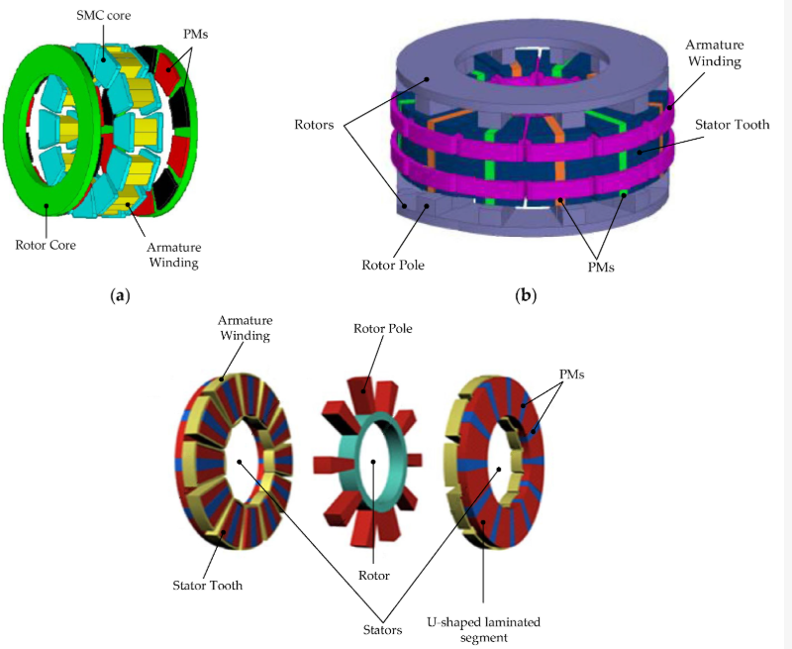
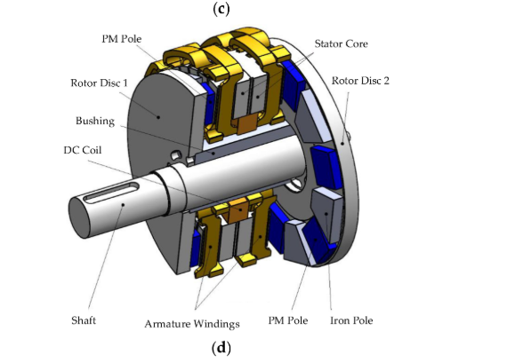
FIGURE 5. Selected axial-flux machine designs and topologies: (a) topology of a YASA axial-flux machine with an SMC core; (b) design of an axial-flux switched machine with dual outer rotors and a stator containing permanent magnets and copper armature windings; (c) structure of an axial-flux machine with a central rotor and segmented U-core stators with embedded permanent magnets; (d) design of a field-controlled AFPM machine with stator core-integrated DC field winding.

TABLE 1. Comparison of the main types of synchronous generators used in high-power wind turbines.
Parameter | Superconducting Generator | PM Generator | EESG
Efficiency | Highest (>98%, incl. cryogenic losses) | High (~96–97%) | Lowest (~94–95%)
Mass | Lowest (very compact for 10 MW class) | Moderate | Highest
Torque Density | Very high | High | Moderate to low
Cooling Requirements | Cryogenic (20–77 K), complex | Passive or air/water cooling | Air or water cooling
Use of Critical Materials | Superconducting wire (e.g., YBCO, MgB₂) | Rare-earth magnets (e.g., NdFeB) | Copper only
System Complexity | High (cryogenics, insulation, monitoring) | Moderate | Low
Commercial Readiness (TRL) | Medium (TRL 6–7) | High (TRL 8–9) | Very high (TRL 9)
Maintenance Requirements | Specialized, low frequency | Low to moderate | High (brushes, field windings)
Offshore Suitability | Excellent (low mass, high efficiency, modularity) | Good | Poor (weight and logistics issues)
Cost (CAPEX) | High (materials + cryogenics) | High (magnet cost) | Lowest (simple construction)
Design Flexibility | High (field controllability, compactness) | Limited (fixed field from magnets) | High (field regulation possible)
Risk of Demagnetization | None (field generated electrically) | Present (temperature, short circuits) | None
Commercial Status (2025) | Prototype (EcoSwing, SupraPower) | Commercial (Siemens, GE, Vestas) | Commercial (Enercon; mainly onshore)

Based on the work, the analysis of specific innovative generators in the literature highlights clear trends in energy conversion system design for current wind turbines. Superconducting generators provide very high efficiency (up to 98%) with much lower active part mass compared to conventional DD solutions. But this also entails high costs—largely caused by the cost of superconducting materials and the difficulty of the cryogenic cooling system—which need to be mitigated. However, their ability to decrease nacelle mass as well as improve system reliability (by eliminating the gearbox) makes them appealing for future large offshore wind turbines. In comparison, PMSG generators with gearboxes offer a rather good mass and volume-to-power ratio with significant efficiency in excess of 98%, and relatively low costs. At the moment, they are the most cost-effective alternative for large turbines despite the gearbox that may influence reliability on the whole system. While mechanically simpler, DD PMSG solutions are nonetheless bulky and expensive, which hinders their implementation on large-scale assemblies. Very high efficiency and high miniaturization can be achieved for smaller-power generators (<1 MW) and they are very suitable for deployed and distributed or individual use. The selection of generator technology should be performed based on a trade-off among efficiency, mass, cost, reliability, and maintenance-friendliness, which have been clearly illustrated in the comparisons illustrated in the literature.
CONCLUSION
Comparative studies of synchronous generators for high-power wind turbines show that all technologies present their own advantages and disadvantages depending on the system usage. Superconducting generators for example have the greatest efficiency, torque density, and offshore operation, since they are small and with lower risk of demagnetization, but use cryogenic cooling and expensive superconducting materials, leading to high system complexity and high capital expenditure, limiting quick deployment on a large scale. Permanent-magnet (PM) generators are a developed and well utilised solution with high efficiency and moderate complexity. While they depend significantly on rare-earth materials and are subject to demagnetization and have several drawbacks, their performance makes them a viable alternative for onshore and offshore wind turbines. Conversely, electrically excited synchronous generators (EESGs) remain the most robust, the least expensive technology with commercial readiness and independent usage of critical materials. However, the high mass, low efficiency, and maintenance requirements limit their availability for use in offshore installations underweight & logistic limitations. On the whole, the study suggests that superconducting machines have potential for next-generation large-scale offshore turbines in the future, PM generators currently offer the best trade-off between performance and practicality and EESGs are also a competitive and a low-cost option for onshore wind deployments.
REFERENCES
- Chang, F., Khoo, R., Ongel, A., & Lienkamp, M. (2018). Rapid Energy Consumption Assessment of Vehicle Concepts for Public Transport Systems without Detailed Deployment Data. Proceedings of the 2018 IEEE Innovative Smart Grid Technologies—Asia (ISGT Asia), Singapore, 452–455. https://doi.org/10.1109/isgt-asia.2018.8467911
- Valeriy, K., Viktor, S., Petro, H., Myamlin, S., Yevhen, K., & Vitalij, L. (2020). Hybrid railway traction power supply system. Proceedings of the 2020 IEEE 4th International Conference on Intelligent Energy and Power Systems (IEPS), Istanbul, Turkey, 208–211. https://doi.org/10.1109/ieps51250.2020.9263194
- Gyurov, V., & Bezhanov, N. (2019, September). Study on electric consumption regimes in rectifier stations of trolleybus transport. In 2019 11th Electrical Engineering Faculty Conference (BulEF) (pp. 1-4). IEEE.
- Sharibaev, N., et al. (2024). A new method for digital processing cardio signals using the wavelet function. BIO Web of Conferences, 130, 04008. https://doi.org/10.1051/bioconf/202413004008
- Dash, S. (2025). Green AI: Enhancing sustainability and energy efficiency in AI-Integrated enterprise systems. IEEE Access, 13, 21216–21228. https://doi.org/10.1109/access.2025.3532838
- Lund, H., Østergaard, P. A., Connolly, D., & Mathiesen, B. V. (2017). Smart energy and smart energy systems. Energy, 137, 556–565. https://doi.org/10.1016/j.energy.2017.05.123
- Xu, Y., Yan, C., Liu, H., Wang, J., Yang, Z., & Jiang, Y. (2020). Smart energy systems: A critical review on design and operation optimization. Sustainable Cities and Society, 62, 102369. https://doi.org/10.1016/j.scs.2020.102369
- Nejad, A.R.; Keller, J.; Guo, Y.; Sheng, S.; Polinder, H.; Watson, S.; Dong, J.; Qin, Z.; Ebrahimi, A.; Schelenz, R.; et al. Wind Turbine Drivetrains: State-of-the-Art Technologies and Future Development Trends. Wind. Energ. Sci. 2022, 7, 387–411. https://doi.org/10.5194/wes-2021-63
- Rajendran, S., Diaz, M., Cárdenas, R., Espina, E., Contreras, E., & Rodriguez, J. (2022). A Review of Generators and Power Converters for Multi-MW Wind Energy Conversion Systems. Processes, 10(11), 2302. https://doi.org/10.3390/pr10112302
- Global Wind Energy Council. (2025, April 23). Global Wind Report 2025. GWEC. https://gwec.net
- Lasemi, M. A., Arabkoohsar, A., & Hajizadeh, A. (2022). Optimal Design of Green Energy Hub considering Multi-Generation Energy Storage System. Proceedings of the 2022 IEEE International Conference on Power Systems Technology (POWERCON), Kunming, China, 1–6. https://doi.org/10.1109/powercon53406.2022.9929923
- Lawder, M. T., Suthar, B., Northrop, P. W. C., De, S., Hoff, C. M., Leitermann, O., Crow, M. L., Santhanagopalan, S., & Subramanian, V. R. (2014). Battery Energy Storage System (BESS) and Battery Management System (BMS) for Grid-Scale applications. Proceedings of the IEEE, 102(6), 1014–1030. https://doi.org/10.1109/jproc.2014.2317451
- Lubosny, Z. (2003). Wind turbine operation in electric power systems. In Power systems. https://doi.org/10.1007/978-3-662-10944-1
- Castillo, O. C., Andrade, V. R., Rivas, J. J. R., & González, R. O. (2023). Comparison of Power Coefficients in Wind Turbines Considering the Tip Speed Ratio and Blade Pitch Angle. Energies, 16(6), 2774. https://doi.org/10.3390/en16062774
- Bensalah, A., Barakat, G., & Amara, Y. (2022). Electrical Generators for Large Wind Turbine: Trends and Challenges. Energies, 15(18), 6700. https://doi.org/10.3390/en15186700
- Chang, C. C. W., Ding, T. J., Ping, T. J., Chao, K. C., & Bhuiyan, M. a. S. (2022). Getting more from the wind: Recent advancements and challenges in generators development for wind turbines. Sustainable Energy Technologies and Assessments, 53, 102731. https://doi.org/10.1016/j.seta.2022.102731
- Udosen, D., Kalengo, K., Akuru, U. B., Popoola, O., & Munda, J. L. (2022). Non-Conventional, Non-Permanent Magnet Wind Generator Candidates. Wind, 2(3), 429-450. https://doi.org/10.3390/wind2030023
- Alkul, O., Syed, D., & Demirbas, S. (2022). A Review of Wind Energy Conversion Systems. Proceedings of the 2022 10th International Conference on Smart Grid (icSmartGrid), Istanbul, Turkey, 72–77. https://doi.org/10.1109/icsmartgrid55722.2022.9848755
- Sartori, L., Bellini, F., Croce, A., & Bottasso, C. (2018). Preliminary design and optimization of a 20MW reference wind turbine. Journal of Physics Conference Series, 1037, 042003. https://doi.org/10.1088/1742-6596/1037/4/042003
- Raouf, A., Tawfiq, K. B., Eldin, E. T., Youssef, H., & El-Kholy, E. E. (2023). Wind Energy Conversion Systems Based on a Synchronous Generator: Comparative Review of Control Methods and Performance. Energies, 16(5), 2147. https://doi.org/10.3390/en16052147
- Mourabit, Y. E., Salime, H., Bossoufi, B., Motahhir, S., Derouich, A., Mobayen, S., & Zhilenkov, A. (2023). Enhanced Performance in PMSG-Based Wind Turbine Systems: Experimental Validation of Adaptive Backstepping Control Design. Energies, 16(22), 7481. https://doi.org/10.3390/en16227481
- Moghadam, F. K., & Nejad, A. R. (2020). Evaluation of PMSG‐based drivetrain technologies for 10‐MW floating offshore wind turbines: Pros and cons in a life cycle perspective. Wind Energy, 23(7), 1542–1563. https://doi.org/10.1002/we.2499
- Ge, C., Liu, M., & Chen, J. (2022). Modeling of Direct-Drive Permanent Magnet Synchronous Wind Power Generation System Considering the Power System Analysis in Multi-Timescales. Energies, 15(20), 7471. https://doi.org/10.3390/en15207471
- Palomo, R. E. Q., & Gwozdziewicz, M. (2020). Effect of Demagnetization on a Consequent Pole IPM Synchronous Generator. Energies, 13(23), 6371. https://doi.org/10.3390/en13236371
- Chen, Y., Xiong, C., & Li, Y. (2024). Additive Manufacturing of Rare Earth Permanent Magnetic Materials: Research Status and Prospects. Metals, 14(4), 446. https://doi.org/10.3390/met14040446
- Lee, O. M., & Abbasian, M. (2025). Reducing Rare-Earth Magnet Reliance in Modern Traction Electric Machines. Energies, 18(9), 2274. https://doi.org/10.3390/en18092274

