Hot Air Extraction through a Parabolacylindrical Concentrator for Drying Natural Fibers
Nosir Sharibaev^{1, a)}, B. Makhmudov¹, X. Mahmudova¹,
Feruzakhon A’zamjonova², A’zamjon Turdiboyev³
¹Namangan State Technical University, Namangan, Uzbekistan
² Kokand University Andijan branch, Andijan, Uzbekistan
³ Fergana State University, Fergana, Uzbekistan

^{a)}Corresponding author: pretp.2024@gmail.com
Abstract: In this study, a hot air extraction method for drying natural fibers – cotton and silk – was developed and tested based on a parabolic cylindrical solar concentrator and a vacuum tube. Two different materials – standard glass and reflective film – were tested on the reflector surface of the device. According to the experimental results, it was possible to generate hot air in the range of 80–100 °C using the reflector during daytime hours. The glass reflector showed high efficiency with a maximum temperature (100 °C), while the film reflector, despite being lightweight and economically viable, had a thermal efficiency lower by 5–10 °C. The moisture content of cotton and silk fibers decreased from 20% to 8–10% and from 60% to 15–20%, respectively, within 4 hours. The results showed that the parabolic solar concentrator has the potential to be an energy-efficient and environmentally friendly drying option in off-grid areas.
Keywords: Parabolic concentrator, Solar energy, Natural fiber drying, Cotton and silk, Reflector, Vacuum tube.
INTRODUCTION
Drying natural fibers is an important step in preserving the quality of raw materials such as cotton and silk and preparing them for further technological processing. In traditional methods, cotton raw materials are often dried in heated air in large heat generators, ensuring that the fibers do not overheat [1]. This approach requires a large amount of fuel and is less energy efficient. For example, it has been scientifically shown that it is possible to dry cocoons from 60% humidity to 12% humidity in a forced convection solar dryer at air temperatures of 60–85 °C [2]. It has been noted that the quality of silk obtained from silk cocoons dried using this method is equivalent to that obtained from silk dried in an electric oven [3]. In recent years, technologies for generating heat using solar energy have been developing rapidly. In particular, methods for heating the heat agent using parabolic cylindrical solar concentrators are used in drying agricultural products [4]. Parabolic cylindrical reflectors concentrate radiation into a linear focus, creating a relatively simple and efficient heat collector. Studies have shown that the combination of such concentrators with vacuum tubes (pipes) gives favorable results - for example, the combination of a parabolic reflector and a vacuum tube can effectively heat air or water, allowing it to be used in various drying processes [5]. In particular, a previous study showed that raw cotton can be dried using solar energy by heating the air in a concentrator with a surface area of ​​about 4 m² to ~90–100 °C, while maintaining the properties of the cotton fiber [6]. At the same time, in addition to traditional glass, special reflective films are used as reflector materials in parabolic concentrators. Such films are lightweight and inexpensive, and their optical efficiency is close to that of glass, but under certain conditions (for example, when the angle of sunlight is small) their heat generation coefficient may be lower than that of a glass system [7]. TB Galikaev – In his scientific research entitled “Analysis of parabolic solar concentrators in Uzbekistan”, it is noted that the sunny climate of Uzbekistan (~300 sunny days per year, ~1700 kWh/m² radiation) is very favorable for parabolic concentrators. It is noted that the proposed hybrid system was able to achieve a high concentration level (150–200 times) and raise the temperature of the heat transfer fluid to ~300 °C. The experiment showed that 10 liters of water can be boiled in 28.4 minutes (at 800 W/m² of irradiation). Thus, it was calculated that it is possible to reduce annual CO₂ emissions by ~765 kg. It was found that parabolic concentrators can show high thermal efficiency of up to ~75% in Uzbek conditions [8]. Therefore, it is of practical importance to study the comparative efficiency of standard glass and special reflective films as reflectors in concentrating radiation.
The aim of this work is to obtain the hot air required for drying natural fibers (in particular, cotton and silk) using a parabolic cylindrical solar concentrator and a vacuum tube and to evaluate the efficiency of this drying method. For this purpose, a small prototype device with a surface area of ​​~4 m² was created, in which cases of covering the reflector surface with two different materials (mirror and reflective film) were tested. The hot air obtained during the drying process was used only during daylight hours (when solar radiation was available), and the drying rate and final moisture content of cotton fiber and silk cocoons were measured. The results allow us to make practical recommendations for fiber drying using solar energy in rural areas or in decentralized conditions.
METHODS
Apparatus and equipment: The study used a parabolic cylindrical concentrator device that focuses solar radiation. The concentrator reflector was mounted on a metal frame bent along its length in the form of a parabolic arc.
The total area of the sunlight incident on the reflector is ~4 m², which serves to concentrate the sunlight onto the focal line of the concentrator. Along the focal line, opposite the reflector, a vacuum tube with a diameter of 47 mm and a length of ~1.8 m was installed. This tube is a double-layered glass tube with a selective coating on the inner surface, which is usually used in solar water heaters, and the vacuum between the two layers reduces heat loss. Inside the vacuum tube, a metal absorber heated with a heat-absorbing coating and an air channel for transferring hot air were arranged.

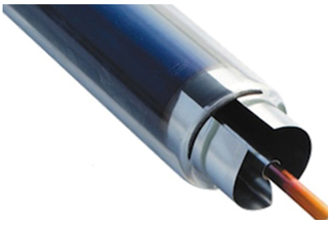
FIGURE 1. Vacuum tube mounted on the focal line
The concentrator device is mounted on an adjustable stand so that it is pointed at the sun at a high level relative to the ground, and is automatically oriented according to the angle of the sun during the experiments.
We tested the light-reflecting surface of the concentrator reflector in two cases: (1) a standard glass reflector - that is, a metal frame covered with high-quality glass along a parabolic curved surface; (2) a reflector with a reflective film - the parabolic surface was covered with a special mirror-like metallized film. In both cases, the geometric dimensions and radius of curvature of the reflector are the same, the only difference is the type of reflective material.
The reflectivity of the mirror reflector surface was estimated to be ~90–95% (in a new, clean state), while that of the film reflector was expected to be around ~85–90%. Before the experiments, both types of reflector surfaces were tested in a clean state, under the same sunny weather conditions. Cotton and silk cocoons were selected for drying. The selected cocoons were cocoons grown in season 2 (August-September). They are cocoon samples collected before the silkworm matures and turns into a spider mite.

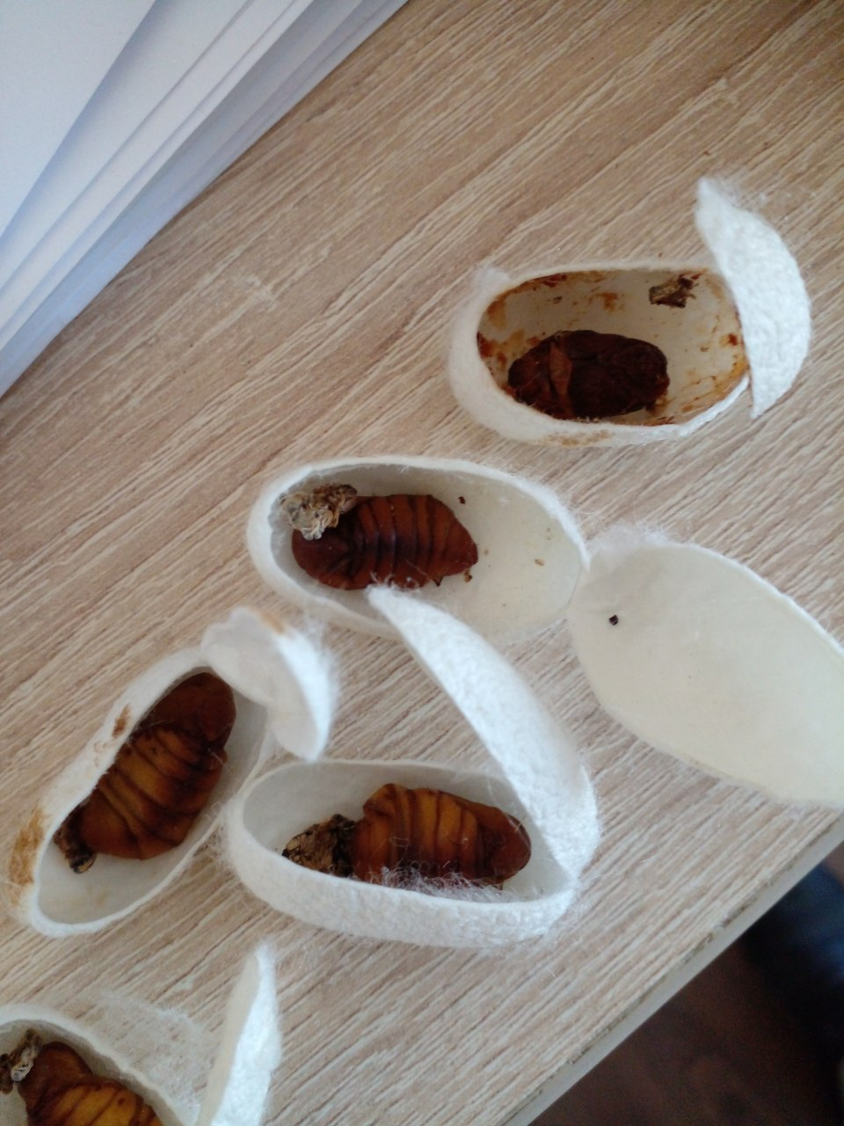
FIGURE 2. Cocoon samples selected for drying
Both materials were initially weighed and their initial moisture content (wet to dry mass, %) was determined in the laboratory by drying the sample. The initial moisture content of cotton fiber was approximately 20%, and that of silk cocoons was ~60%.
The experiment for each reflector condition was conducted as follows: The concentrator device was installed outdoors, in a place where sunlight would fall directly. Air was periodically blown through the vacuum tube using a small electric fan – the fan sucked air from the outside atmosphere and sent it into the tube, and the heated air was directed out of the end of the tube into the drying chamber. The drying chamber was a thermally insulated box with a mesh inside to place the fiber samples, ensuring that the hot air could pass through the fibers. At the beginning of each experiment, the fibers in the chamber were placed so that they did not receive direct sunlight (the walls of the chamber protected the fibers from direct radiation). Drying was carried out only during daylight hours: the duration of the experiments was usually from 10:00 to 16:00 (6 hours), especially taking advantage of the maximum solar radiation between 12:00 and 15:00. The hot air temperature was measured using thermocouple sensors at the outlet of the vacuum tube and inside the drying chamber and recorded every hour.
Based on the data obtained, the following indicators were calculated for cotton and silk: (1) Drying efficiency - where the amount of moisture removed from the sample during a certain drying time (for example, 4 hours) was expressed as a percentage of its initial total moisture content; (2) Drying rate - estimated based on the mass of moisture removed from the sample per hour (kg/h); (3) Final drying degree - the amount of moisture reached by the fibers at the end of drying (%). These indicators were compared for the glass and film reflector cases. The optical efficiency of the reflectors was also indirectly compared through the maximum air temperature and average temperature indicators they generated.
During the experiment, weather conditions were kept constant, with sunny and cloudless days selected. Temperature and humidity variations, as well as the influence of wind, were kept as uniform as possible. All measurements were repeated several times for each reflector type, and average values were obtained and presented in the Results section below.
RESULTS
Yellow solid line – standard glass reflector; orange (dashed) line – reflector with reflective film. As can be seen from the graph, at 10:00 in the morning the hot air temperature was around ~60 °C, but it increased rapidly as the sun rose, reaching a maximum of ~100 °C at 13:00 with a glass reflector. The maximum temperature was also reached at the same time with a film reflector, but its value was ~90 °C. By the end of the day (at 16:00), the temperature dropped back to ~60 °C in both cases. Thus, due to the glass reflector, the air temperature was 5–10 °C higher than that of the film during the day, which means that the optical efficiency was found to be better than that of the film. At the same time, in both cases it was possible to obtain hot air in the range of 80–100 °C through the concentrator (at maximum solar radiation).
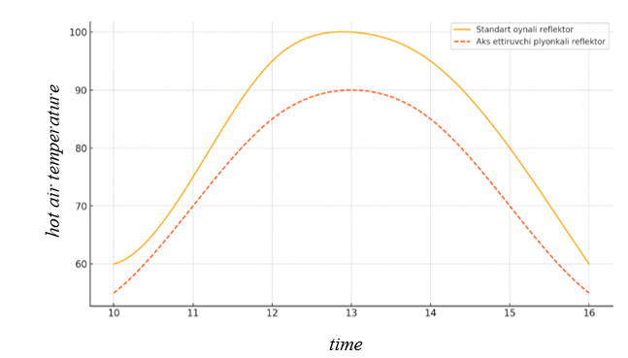
FIGURE 3. Daily variation of hot air temperature obtained through a vacuum tube when the
concentrator reflector material is different
These temperatures are considered sufficient for drying the fiber.
The drying results of cotton fiber and silk cocoons are presented in Table 1. When dried for 4 hours with hot air generated by a standard glass reflector, the moisture content of cotton fiber decreased from 20% to ~8%, i.e., about 60% of the moisture was removed. Under the same conditions, when a reflective film was used, the final moisture content was ~10%, i.e., 50% of the initial moisture was removed. In the case of silk cocoons, the initial moisture content of ~60% decreased to ~15% with a glass reflector within 4 hours (75% of the moisture was removed), and with a film reflector it decreased to ~20% (67% of the moisture was removed). Thus, it seems that the glass reflector provides faster and more thorough drying for both materials. In the case of cotton fiber, the final moisture content is around 8–10%, which is considered an acceptable level for cotton storage and primary processing (ginning) [1, 8] Although 15–20% moisture content is achieved in a single day in silk cocoons, it is known that the optimum final moisture content for silk is around ~12% [2]; this means that for complete drying, another period of sunshine is required, or drying is continued the next day. However, the main part of the drying process is carried out during the first day, and most of the moisture is removed.
TABLE 1. Moisture content and drying efficiency of cotton and silk samples after drying for 4 hours
(depending on the reflector type).
Fiber type | Reflector type | Initial moisture, % | Final moisture, % | Drying efficiency, %
Cotton | Standard glass | 20 ± 1 | 8 ± 1 | ~60
Cotton | Reflective | 20 ± 1 | 10 ± 1 | ~50
Silk | Standard glass | 60 ± 2 | 15 ± 2 | ~75
Silk | Reflective film | 60 ± 2 | 20 ± 3 | ~67

The above results show that cotton and silk fibers can be effectively dried using hot air from a parabolic solar concentrator. With the mirror reflector, the maximum temperature is high, so the drying process is accelerated, and the moisture content of the fibers is reduced to the required level in one day. Although the film reflector provides a slightly lower temperature, it results in a significant reduction in the moisture content of both cotton and silk. No visible changes in the color or structure of the fibers were observed during drying; that is, there are no signs of overheating or burning. This indicates that the drying process took place within the normal temperature range.
DISCUSSION
The analysis of the results shows that the hot air obtained using a parabolic cylindrical solar concentrator can provide sufficient temperature and drying speed for the drying requirements of natural fibers. The maximum air temperature obtained, around 100 °C, is at the level of hot air dryers used in industry (for example, the air entering the drying cylinders in cotton mills is around ~100 °C). However, in the industrial process, it is strictly controlled that the fibers themselves are not heated above 50 °C, otherwise the quality will deteriorate. Although the hot air temperature in our device reaches 90–100 °C, the actual temperature of the fibers is much lower - because moisture evaporates from the fibers and keeps them cool. The temperature of the cotton fiber does not exceed approximately 40–50 °C until the moisture content drops below 10%. This is consistent with previous studies: for example, it was observed that when raw cotton is dried in the sun at ~90 °C, the cotton fiber does not lose its properties [6]. Our drying chamber was also enclosed, protecting the fibers from direct ultraviolet radiation from the sun; this is especially important for silk cocoons, as cocoons exposed to direct sunlight can deteriorate the quality of the silk thread. Our method, on the other hand, used indirect drying with hot air, which is said in the scientific literature to be a factor in maintaining the quality of the silk [3,10].
A comparative analysis of the reflector material showed that the standard glass reflector had a high efficiency in heat generation. It was able to reflect almost completely (≥90%) the sun's rays, maximally heating the vacuum tube, and as a result, heated the air to 100 °C. The reflector with a reflective film showed a slightly lower efficiency: the peak temperature of the air passing through its surface was ~10 °C lower. This difference is, we assume, due to the lower reflectance coefficient of the film than that of the glass, and possibly to the difference in spectral properties. It is worth noting that, according to some studies, the efficiency of film reflectors can decrease sharply at high latitudes or when sunlight is deflected - for example, in winter, when the sun is at a low angle, the thermal efficiency of the film system is significantly lower than that of the glass system [7]. In our experiments, however, in summer conditions (when the sun is high and the radiation is strong), there was no such big difference, the film showed ~90% efficiency of the glass. This means that if the film material is of good quality, it can be practically used. The film reflector also has advantages that have been confirmed in our experience: firstly, it is light and flexible, that is, it is easily installed on the parabolic surface of the concentrator; secondly, it does not form sharp fragments when broken and is safer during transportation and installation; thirdly, its cost is cheaper than glass and is easily found in local conditions. Therefore, if we do not take into account some loss of efficiency, the film reflector may be economically viable for the construction of large-scale drying plants in rural areas. The glass reflector, in turn, has high durability (weather resistance) in long-term use and retains its optical properties for a long time with regular cleaning [11]. Therefore, these factors should be taken into account when making a choice - whether to achieve high efficiency in the short term or stable performance in the long term, whether it is cheap or high quality.
Practical significance of the drying process: The device design tested in this study has great potential for the primary drying of textile and agricultural products in rural areas, off-grid areas. Solar drying of cotton raw materials in the field or at collection points reduces the risk of moisture damage during storage before the factory and leads to energy savings during the drying stage at the factory [12-16]. In silkworm breeding areas, drying cocoons using solar dryers saves fuel and electricity, and helps to obtain environmentally friendly products. Compared to traditional drying in the open sun, concentrator dryers speed up the process and better preserve product quality - because the product is dried in a stream of high-temperature air, protected from dust and harmful radiation. In our experiments, for example, cotton fiber was brought to the required moisture level in one day, while in the open sun it would have taken several days to achieve such a result (due to nighttime moisture reabsorption, weather changes, etc.). Silk cocoons also dried almost completely in one day in a concentrator dryer (humidity dropped from 60% to 15–20%); at the same time, the appearance of the cocoons and the strength of the silk thread were well preserved, since drying occurs in a uniform manner [3].
It should also be noted that this method has some limitations. First of all, the drying process continues only when the sun is up - at night or in cloudy weather, drying stops. As a solution to this problem, it is possible to install heat storage systems (for example, heat-accumulating stone or paraffin modules) during the sunny season. Another direction is to simply use the concentrator to the maximum at every hour of the day, without connecting it to large-scale heat storage devices: for example, during the peak solar radiation, the main part of the moisture in the product is removed within a few hours and the process continues on the following days. In addition, it is necessary to ensure that the parabolic concentrator is constantly oriented towards the sun; if an automatic tracking system is introduced, the efficiency of the device will increase, but this will require additional costs. Our prototype is a small-scale model, and in real production, to dry a larger volume of fibers, it will be necessary to use several concentrator modules in parallel or to build a larger concentrator. This raises important issues such as structural strength and resistance to wind loads. Therefore, future research should continue to explore areas such as multi-module solar dryer systems, the addition of heat storage elements, and automation.
CONCLUSION
A parabolic trough solar concentrator and a vacuum tube were used to successfully generate the 80–100 °C hot air required for drying natural fibers. A small prototype device with a 4 m² reflector surface was able to efficiently dry cotton fiber and silk cocoons using only solar energy. A standard glass reflector provided maximum thermal efficiency, heating the air to about 100 °C and reducing the fiber moisture content to levels suitable for industrial requirements. Although a reflector with a reflective film gave slightly lower results, it also successfully carried out the drying process using hot air at 80–90 °C. The results obtained show that a solar concentrator-based dryer can be a sustainable solution that reduces traditional fuel consumption in the primary drying of cotton raw materials and silk cocoons in rural areas. This method helps to preserve the quality of the fibers, since the drying process takes place at controlled temperatures and without direct sunlight. In the future, there are opportunities for larger-scale implementation of such devices, integration with thermal storage systems, and the addition of automatic control. The results of this research serve as a scientific and practical basis for creating an effective technology for drying agricultural and textile products using solar energy.
REFERENCES
- Bafoev, D., Tolaganov, R., Mirzayev, S., & Haydarov, O. (2020). Maintenance of physical and mechanical properties of cotton fiber during storage of raw cotton. International Journal of Emerging Trends in Engineering Research, 8(10), 4986–4990. https://www.warse.org/IJETER/static/pdf/file/ijeter998102020.pdf
- Singh, PL (2011). Silk cocoon drying in forced convection type solar dryer. Applied Energy, 88(5), 1720–1726. https://doi.org/10.1016/j.apenergy.2010.11.038
- Khan, MA, Ahmed, S., & Siddiqui, MU (2013). Development of a small scale concentrating parabolic trough solar collector for drying purposes. Engineering International, 1(1), 26–33. https://abc.us.org/ojs/index.php/ei/article/view/213
- Mhase, SE, Jadhav, DA, & Nalavade, SM (2018). Solar air heater using evacuated tube and parabolic mirror reflector. International Journal of Advanced Research in Science, Engineering and Technology, 5(4), 39–42. https://iarjset.com/upload/2018/april-18/IARJSET%205.pdf
- Chen, W., & Li, J. (2003). Optical performance analysis for parabolic-trough focusing collector. Acta Energiae Solaris Sinica, 24(4), 383–387.
- Galikaev, TB (2025). Parabolic solar concentrator in Uzbekistan: scientific and technical analysis and innovative solutions. Molodoy uchyonyi, 41(475), 65–69. https://moluch.ru/archive/475/
- Liu, B., Mbabazi, W., & Huang, W. (2023). Performance simulation and optimization of cylindrical mirror spliced parabolic trough solar collector. ResearchGate.https://www.researchgate.net/publication/385389356
- Miller, D.C., Bouaicha, A., & Kennedy, C.E. (2021). Soiling comparison of mirror film and glass concentrating solar power reflectors in Southwest Louisiana. Sustainability, 13(10), 5727. https://doi.org/10.3390/su13105727
- Rashidov, NR, & Ibragimov, RB (2020). Solar energy collector for water heating. ACADEMICIA: An International Multidisciplinary Research Journal, 10(3), 584–588. https://doi.org/10.5958/2249-7137.2020.00096.X
- Donga, RK, Kumar, S., & Velidi, G. (2024). Numerical investigation and exergy analysis of parabolic trough collector with various absorber shapes. Renewable Energy, 223, 120–132. https://doi.org/10.1016/j.renene.2023.06.034
- Yusupov, Yo. A., Otakulov, OH, Ergashev, SF, & Kuchkarov, AA (2021). Experimental study of the thermal performance of a parabolic trough solar collector in Uzbekistan. Journal of Advanced Research in Fluid Mechanics and Thermal Sciences, 89(2), 293–304. https://www.akademiabaru.com/submit/index.php/arfmts/article/view/3417
- Hameed, HG, Diabil, HAN, & Al-Fahham, MA (2023). Solar water distillation system performance using nanofluids in solar concentrator. Energy Reports, 9, 304–313. https://doi.org/10.1016/j.egyr.2022.11.092
- Bi, BEB, Yeo, KAK, Coffey, EPM, & Gbaha, P. (2025). Mathematical modeling and simulation of a parabolic cylindrical solar concentrator. Solar Energy, 273, 40–52. https://doi.org/10.1016/j.solener.2023.09.034
- Mirzamaxmudov, U. et al., (2025). Control of chemical preparation concentrations in deresuscitation of mulberry silkworm larvae in cocoons. AIP Conference Proceedings, 3304, 030088. https://doi.org/10.1063/5.0269251
- Mamadalieva, D., Korabayev, S., Mahsudov, S. A., Sovutov, M., Adashev, B., & Axmadjanov, S. (2025). Evaluation and enhancement of ring strength in ring pile fabrics. AIP Conference Proceedings, 3304, 030072. https://doi.org/10.1063/5.0269374
- Sharibaev, N., et al. (2024). A new method for digital processing cardio signals using the wavelet function. BIO Web of Conferences, 130, 04008. https://doi.org/10.1051/bioconf/202413004008

