Model-Based Analysis of Hysteresis Effects in Electromagnetic Materials
Ibragim Askarov¹, Nasrulla Khakimov², Manzura Madaminova², Madina Atabaeva², Khabibullo Kodirov^{2, a)}
¹Andijan State University, Andijan, Uzbekistan
²Andijan State Medical Institute, Andijan, Uzbekistan

^{a)}Corresponding author: kodirovkhabibullo6@gmail.com
Abstract: In the present study, we perform a comprehensive model-based analysis on hysteresis effects in ferromagnetic electrotechnical materials. We will concentrate on the correct mathematical representation of magnetic hysteresis loops. Because the nonlinear magnetization characteristic of ferromagnetic materials very greatly affects power losses and magnetic field distribution in electrical equipment, choosing an appropriate approximation function should be ensured for reliable simulation. This work examines several classical hysteresis modeling techniques, such as the Relay model, Zatsepin’s arctangent-based approximation, Panamaryov’s corrected model, and Melguy’s extended correction method. The analytical comparison shows that expression (4) estimated from the Panamaryov approximation yields acceptable accuracy with respect to low precision engineering, but it demonstrates important uncertainties for residual magnetization, being unreliable for detailed analysis. In comparison, expression (5) derived from Melguy’s formulation of correction has nearly identical results to the experimental hysteresis contours of soft magnetic electrotechnical steels, mainly materials showing coercive forces from 32 to 72 A/m; numerical simulations in Mathcad have shown the Melguy approximation to reduce pointwise errors to 0–11%, making it a better candidate than the Panamaryov-based approximation. Therefore, expression (5) is recommended for high-accuracy hysteresis modeling, while expression (4) is suitable for simplified or preliminary calculations.
Keywords: Magnetic hysteresis, ferromagnetic materials, hysteresis loop modeling, magnetic field, power loss, electrotechnical steel, nonlinear behavior, approximation function.
INTRODUCTION
Ferromagnetic electrotechnical materials are widely used in the production of electrical devices. In terms of practical application of these electrotechnical materials, technical characteristics must be informed. The problem is how to determine what type of power loss occurs inside the core of electromagnetic devices, such as magnetic devices and steel suspension structures and in various ferromagnetic bodies, and the distribution of the cumulative current and magnetic field in ferromagnetic material when this normal operating mode of this object is selected. In this level, it is necessary to consider the nonlinearity of any ferromagnetic material when solving problems of this nature. Especially, it is important to be aware of the magnetic hysteresis surface of the used electrotechnical steel to undertake the corresponding calculations for practical operation. But it may not be possible to obtain the necessary curves from the right references. Thus, several functions are employed when designing the hysteresis surface of electrotechnical magnetic material. In the process of the calculation, a convenient function (formula) is chosen according to the nature of the material and the precision of the computation result [1-5].

METHODS
The approximation function selected for modeling needed to satisfy the following conditions:
• results should approximate the actual hysteresis surface of the material;
• since differentiation is employed in the computation process, the derivative of the function needs to adequately reflect the hysteresis behavior of the material;
• the function must yield mathematically useful results, not overly complex for numerical computations;
• the function must be odd;
• it should include parameters for universal and material-specific hysteresis properties;
• the model should have a minimum number of constants.
- perform computations on the approximating function should not be difficult;
- the approximating function must be odd;
- the approximating function contains the parameters of the universal and material hysteresis surface;
- as few constants as possible should be part of the algorithm. In this study, widely used Relay formula and arctangent functions are used for the definition of the magnetic hysteresis curve of ferromagnetic materials [6-10].
RESULTS AND DISCUSSION
In most cases, the following Relay formula is used to describe the magnetic hysteresis surface in areas of weak magnetic field ($H≪H_{k})$:
$M=\left(γ_{b}+k_{R}H_{m}\right)H±\frac{k_{R}}{2}\left(H^{2}-H_{m}^{2}\right) ;$ (1)
where is $γ_{b}$ – initial magnetic susceptibility; $k_{R}$ – Relay coefficient; $H$ – the strength of the magnetic field; $H_{m}$ – maximum strength of the magnetic field; $H_{k}$- coercive force in the limit cycle.
In the given expression, the "+" sign is appropriate for the rising part of the hysteresis surface, and the "-" sign is appropriate for the falling part. Using this expression, the results of the generated hysteresis contour coincide only with the edge points of the real contour of the ferromagnetic material, and deviations are observed in the remaining parts. Therefore, trigonometric functions, harmonic series of Lissage figures, ellipses (Arkadev's method), Hooke's law, S-shaped curves (Akulov's method), line expansion methods, polar coordinates and other methods were used to describe the magnetic hysteresis surface. But these methods were not widely used in practice for various reasons [1-3].
An expression consisting of an arctangent function is most often used to describe the magnetic hysteresis surface and has the form:
$$M\left(H\right)=k_{1}arctg\left\{k_{2}\left[H+H_{g}\left(M,H\right)\right]\right\}+M_{T}\left(M,H\right) ;$$ | (2)
where is $H_{g}\left(M,H\right)$ – Hysteresis field can be a function of simultaneous or separate magnetic field strength or instantaneous value of material magnetization and their direction change; $M_{T}\left(M,H\right)$ – correction function of magnetization or magnetic field strength; $k_{1}, k_{2}$ – The approximation parameters are determined using the point selection method.
In expression 2, we determine the approximation parameters by solving the system of equations formed when the following conditions are met:
1) $M_{T}=0;H→∞;M=M_{t}$;
2) $M_{T}=0;H=0;M=M_{q}$;
3) $M_{T}=0;H={±H}_{k}; M=0;$
where is $M_{t}$ – saturation magnetization; $M_{q}$ – residual magnetization.
$$k_{1}=\frac{2}{π}M_{t}; H_{g}={±H}_{k}; k_{2}=\frac{1}{H_{k}}tg\left(\frac{π}{2}∙\frac{M_{q}}{M_{t}}\right).$$
Putting the determined parameters into the 2nd expression, we create the following formula of magnetization:
$$M=\frac{2}{π}M_{t}arctg\left[\frac{H{±H}_{k}}{H_{k}}tg\left(\frac{π}{2}∙\frac{M_{q}}{M_{t}}\right)\right];$$ | (3)
here, the "-" sign is appropriate for the rising part of the hysteresis surface, and the "+" sign is appropriate for the falling part.
Expression 3 is called the Zatsepin approximation, and it is possible to describe only the outer limits of the magnetic hysteresis surface. Also, to describe the specific hysteresis loop using this expression, it is necessary to change the saturation magnetization, remanent magnetization, and coercive force to the maximum values of these quantities, and in this case, expression 3 has the following form:
$$M=\frac{2}{π}M_{m}arctg(\frac{H{±H}_{km}}{H_{km}}tg\left(\frac{π}{2}∙\frac{M_{qm}}{M_{m}}\right).$$
But it is observed that the hysteresis surface approximated by this expression has jump-changing parts. This, in turn, causes the result to be erroneous.
Y.F. Panamaryov proposed to introduce the following expression as a correction function to eliminate the shortcomings of the Zatsepin approximation [4-8]:
$$M_{T}=∓\frac{k_{1}}{2}\left[arctgk_{2}(H_{m}+H_{k}\right]-arctgk_{2}\left(H_{m}-H_{k}\right),$$
From the approximation parameters $k_{1}$ for expression 2 $M_{T}=0, H→∞,$
$M=M_{t}$ is the same as the coefficient determined when the condition is met. $k_{2}$ the coefficient is determined by differential magnetic susceptibility according to the conditions $γ_{d}=k_{1}k_{2}$, ${H=H}_{k}$ and has the following form:
$$k_{3}=\frac{π}{2H_{k}}.$$
Substituting the expressions for the approximation parameters and the correction coefficient in expression 2, we form the following equation:
$$M=\frac{M_{t}}{π}\left\{2arctg\frac{π}{2}\left(\frac{H{±H}_{k}}{H_{k}}\right)∓\left[arctg\frac{π}{2}\left(\frac{H_{m}{+H}_{k}}{H_{k}}\right)-arctg\frac{π}{2}\left(\frac{H_{m}{-H}_{k}}{H_{k}}\right)\right]\right\};$$
where the lower sign is appropriate for the rising part of the hysteresis surface, and the upper sign is appropriate for the falling part.
By inserting the condition $H_{m}→∞$ into the last expression, the following expression for the magnetic hysteresis boundary surface is formed:
$$M=\frac{2}{π}M_{t}arctg\frac{π}{2}\left(\frac{H{±H}_{k}}{H_{k}}\right).$$ | (4)
N.S. Akulov and B.A. Luchevskii proposed to include a non-standard expression for the correction function in expression 2 to describe the magnetic hysteresis surface of magnetoelectric materials. This expression is not widely used in practice due to the presence of residual magnetization, differential and reversible magnetic susceptibilities, as well as large errors in the experimental determination of the above-mentioned parameters [5-6].
M.A. Melguy proposed to introduce the following expression as a correction function to describe the magnetic hysteresis surface of magnetoelectric materials:
$$M_{T}=\frac{γ_{b}H_{k}^{2}H}{H^{2}+H_{k}^{2}}±\frac{M_{t}}{π}\frac{H_{m}^{2}}{H_{m}^{2}+k_{0}H_{k}^{2}}\{2arctg\left[\frac{H_{k}±H}{H_{k}}tg\left(\frac{π}{2}\frac{M_{q}}{M_{t}}\right)\right]∙ \\ ∙\left[1-\frac{H_{m}^{2}+k_{0}H_{k}^{2}}{H_{m}^{2}}\right]-arctg\left[\frac{H_{k}+H_{m}}{H_{k}}tg\left(\frac{π}{2}\frac{M_{q}}{M_{t}}\right)\right]+arctg\left[\frac{H_{k}-H_{m}}{H_{k}}tg\left(\frac{π}{2}\frac{M_{q}}{M_{t}}\right)\right]\};$$
where $k_{0}$ is the coefficient determined by the condition $H=H_{m}=H_{k}, M=M_{eksp.}$.

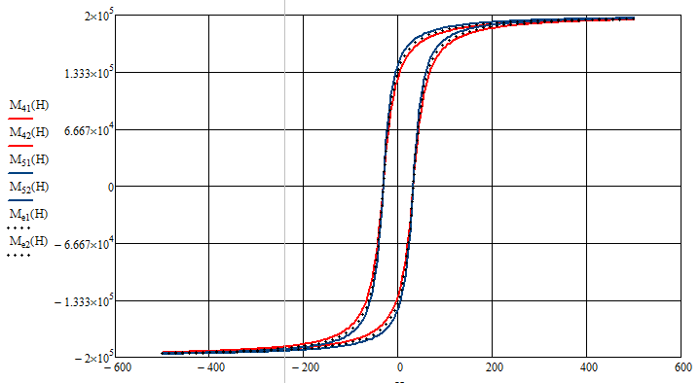
FIGURE 1. Magnetic hysteresis contour calculated using expressions 4 and 5

($H_{k}=32\frac{А}{м}; M_{t}=0.2∙{10}^{6}\frac{А}{м}; M_{q}=0.1432∙{10}^{6}\frac{А}{м}$)
Among the proposed approximation methods for describing the hysteresis surface, it is possible to obtain the closest result to the experiment through the Panamaryov approximation. But the Melguy approximation, which is easy to determine the approximation parameters to achieve a relatively close result in a simple way, is widely used in practice.
Since the results of expressions 3 and 5 coincide with each other, it is sufficient to compare the results of expressions 4 and 5 with the experiment. Taking into account that the value of the coercive force of soft magnetic materials is in the range of 32-72 A/m, we compare the hysteresis surface for electrotechnical materials in this range with the experiment.
By comparing the results obtained using expression 4 with the experiment, we can see that the degree of accuracy of the magnetic hysteresis is several percent. In other cases, the error of calculation results is higher than 20%. It should be noted that when the hysteresis surface is calculated with the help of the 4th expression, an excess value of residual magnetization occurs. This condition should be taken into account when using the expression.
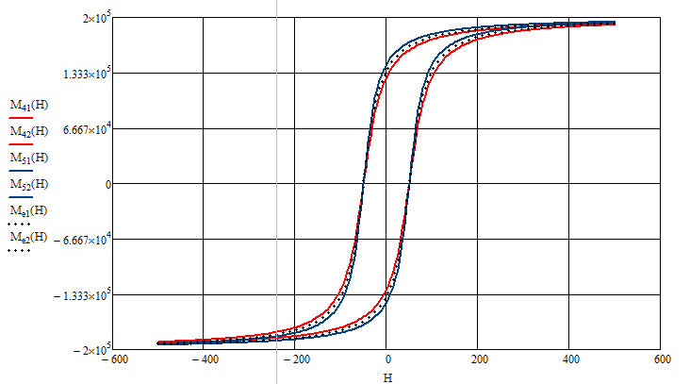
FIGURE 2. Magnetic hysteresis contour calculated using expressions 4 and 5
($H_{k}=50\frac{А}{м}; M_{t}=0.2∙{10}^{6}\frac{А}{м}; M_{q}=0.1432∙{10}^{6}\frac{А}{м}$)
CONCLUSION
The magnetic hysteresis curves of 4 and 5 were defined by MathCad program. The hysteresis contours obtained can be concluded from that the results of using these two expressions for the coercive force value at different times are 0÷24% for each point in the contour, and 1÷1.5% for the total result. In this example and to find out which expression is closest to the experiment, we compare the hysteresis contour in expression 4 and the hysteresis contour of the cold-worked magnetic soft electrotechnical material of brand 3413. As expected, the results produced are the value of 0÷13% (by each point represented against the contour), and 3.5÷5.5% (by the total result). The hysteresis contour formed by expression 5 and the hysteresis contour of the 3413 brand of electrotechnical material were compared according to the range between 0÷11% and 3÷5% depending on each point along the contour, and therefore show a difference of 0÷11% and 3÷5% depending on the total score of the experiment. According to the result by comparing the expression 5 compared to the 4th expression, the hysteresis surface results obtained using the 5th expression are similar with the experimental results obtained. When the hysteresis surface is modeled in magnetic systems, high-precision calculations are not required, use expression 4, so high-precision calculations are needed, utilize expression 5.
REFERENCES
- Jiang, H., Su, Z., Wang, D., Chen, J., & Li, Z. (2022). Analysis and compensation of hysteresis effect on electromagnetic force in axial magnetic bearings. IEEE Transactions on Energy Conversion, 38(2), 1143–1154. https://doi.org/10.1109/tec.2022.3232228
- Henrotte, F., Nicolet, A., & Hameyer, K. (2006). An energy-based vector hysteresis model for ferromagnetic materials. COMPEL the International Journal for Computation and Mathematics in Electrical and Electronic Engineering, 25(1), 71–80. https://doi.org/10.1108/03321640610634344
- Petrun, M., Steentjes, S., Hameyer, K., Ritonja, J., & Dolinar, D. (2015). Effects of saturation and hysteresis on magnetisation dynamics. COMPEL the International Journal for Computation and Mathematics in Electrical and Electronic Engineering, 34(3), 710–723. https://doi.org/10.1108/compel-10-2014-0286
- Mörée, G., & Leijon, M. (2023). Review of Hysteresis Models for Magnetic Materials. Energies, 16(9), 3908. https://doi.org/10.3390/en16093908
- Egorov, D., Petrov, I., Link, J., Stern, R., & Pyrhonen, J. J. (2017). Model-Based Hysteresis Loss Assessment in PMSMs with ferrite magnets. IEEE Transactions on Industrial Electronics, 65(1), 179–188. https://doi.org/10.1109/tie.2017.2714121
- Prigozhin, L., Sokolovsky, V., Barrett, J. W., Zirka, S. E., Prigozhin, L., Sokolovsky, V., Barrett, J. W., & Zirka, S. E. (2016). On the Energy-Based Variational Model for Vector Magnetic Hysteresis. IEEE Transactions on Magnetics, 52(12), 1–11. https://doi.org/10.1109/tmag.2016.2599143
- Andreev, M., Askarov, A., & Suvorov, A. (2018). Design of the magnetic hysteresis mathematical model based on Preisach theory. Electrical Engineering, 101(1), 3–9. https://doi.org/10.1007/s00202-018-0751-3
- Sergeant, P., & Dupre, L. (2009). Modeling the electromagnetic behavior of nanocrystalline soft materials. IEEE Transactions on Magnetics, 45(2), 678–686. https://doi.org/10.1109/tmag.2008.2008109
- Akramov, A., et al. (2025). Evaluation of the yarn deformation in its contact zone with a cylindrical surface. AIP Conference Proceedings, 3304, 030067. https://doi.org/10.1063/5.0269091
- Sharibaev, N., et al. (2024). A new method for digital processing cardio signals using the wavelet function. BIO Web of Conferences, 130, 04008. https://doi.org/10.1051/bioconf/202413004008

