The Impact of New Seed Comb Construction on the Working Camera Technological Process
Abdunabi Mamasharipov^{a)}
Andijan State Technical Institute, Andijan, Uzbekistan

^{a)}Corresponding author: abdunabi.mamasharipov@gmail.com
Abstract. This article analyzes the updated models of the design of the seed comb in the working chamber of the fiber separation unit. During the research, in order to increase the seed exit rate, new seed combs of three different designs (rectilinear, elliptical, and rectangular) were developed, and their efficiency was tested experimentally at the cotton ginning plant of the “Alyortex” textile cluster in the Andijan region. According to the experiments, it was found that the elliptical seed comb significantly increased the amount of seed exiting the working chamber, allowing the productivity of the machine to increase by 15–18%. The results obtained reveal the possibilities of increasing resource efficiency and reducing product costs in the cotton ginning industry.
Keywords: fiber separator, working camera, seed comb, commodity roller, grid bar, density, compressive strength.
INTRODUCTION
Ensuring the efficiency of cotton fiber production on a global scale, identifying factors that negatively affect product quality at all stages of cotton production, and creating resource-efficient technologies that reduce product costs remain important tasks in the field. As a result, the technological process at all stages of the initial processing of raw cotton was studied, and it was observed that the negative factors affecting the quality indicators of the products occur in the working camera of the ginning machine, that is, separating the cotton from the seed. In turn, the seed is separated from the fibers in the working camera in 72 seconds. But it takes 5-6 minutes for the seeds, whose fiber is completely separated, to come out of the camera. The reason for this is that the size of the slot for ejecting fully separated seeds from the camera is 18-21 mm, which is not sufficient.
Therefore, in order to increase or maintain quality indicators, it is possible to maintain the initial quality indicators of fiber and seed by reducing the force acting on cotton, for this purpose, accelerating the technological process in the working camera, reducing or softening the mechanical shocks acting on cotton, and revising and improving the shape and structure of the details in the equipment design. [1- 4⁆
One of these ways is to study and eliminate factors that negatively affect the process in the working camera of the collection equipment. To do this, it is necessary to study the characteristics of the grains moving along the surfaces of the grate and grain combs in the working camera, which ensure that the grains with completely separated fibers exit the camera.
During the ginning process, the grains, which are completely stripped of their fibers, are ejected from the raw material shaft and slide along the surface of the grate bars towards the grain comb, passing through the gap between the comb teeth and the grate and exiting the machine. The condition of the grain bundle during the passage through the gap plays a major role. That is, its density, hardness, fineness, the pressure exerted by the grain layers on each other, etc.
A number of scientific research works have been carried out to maintain product quality and increase machine productivity in the fiber separation technological process. In the conducted scientific research works, the effect of changing the volume and shape of the working camera of the fiber separation machine on the machine's productivity and product quality was studied, and optimal parameters were proposed. In the conducted scientific research works, accelerators were recommended to accelerate the rotation of the raw material shaft, and the machine's productivity was increased by reducing the density of the raw material shaft. In the research conducted by the researcher, it was recommended to install an air blower in the working camera, and the machine's productivity was increased by increasing the ability of the saw teeth to catch the fiber and accelerating the exit of the fully separated fibers from the working camera. However, placing excessive mechanisms in the working camera, in turn, complicates the maintenance of the machine. As is known, the fully separated seeds exit the working camera of the fiber separation machine through the gap between the seed comb and the grate [5-7].
[4] showed in their research that one of the most important parameters of the harvesting process is the time the seeds remain in the working camera.
METHODS
In the research work [1, 5] dedicated to the creation of a method for determining the dynamic and technological indicators of seeding at different densities of raw material, the importance of reducing the time of seed retention in the working camera was studied, and the effect on productivity was shown.
The influence of cotton stretching unevenness on the density of the raw material [1, 3, 6] and the stability of the operation by installing a flexible element that forcibly changes the density of the raw material were considered in theoretical and experimental studies.
In order to speed up the extraction of fully separated seeds from the working camera, three versions of the seed comb construction were prepared and experiments were conducted at the “Alyorteks” cotton ginning factory, Jalakuduk district, Andijan region.

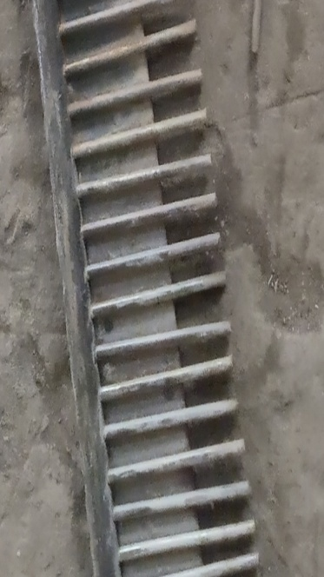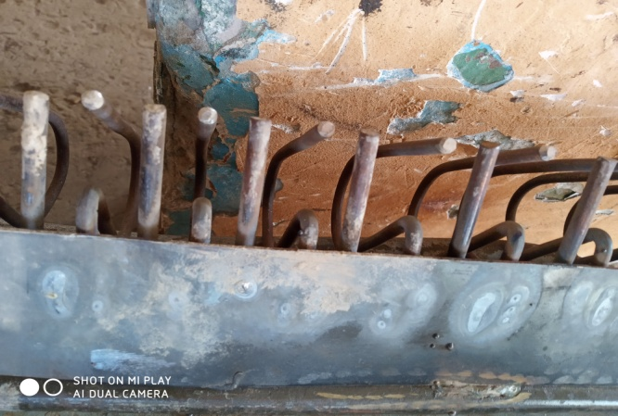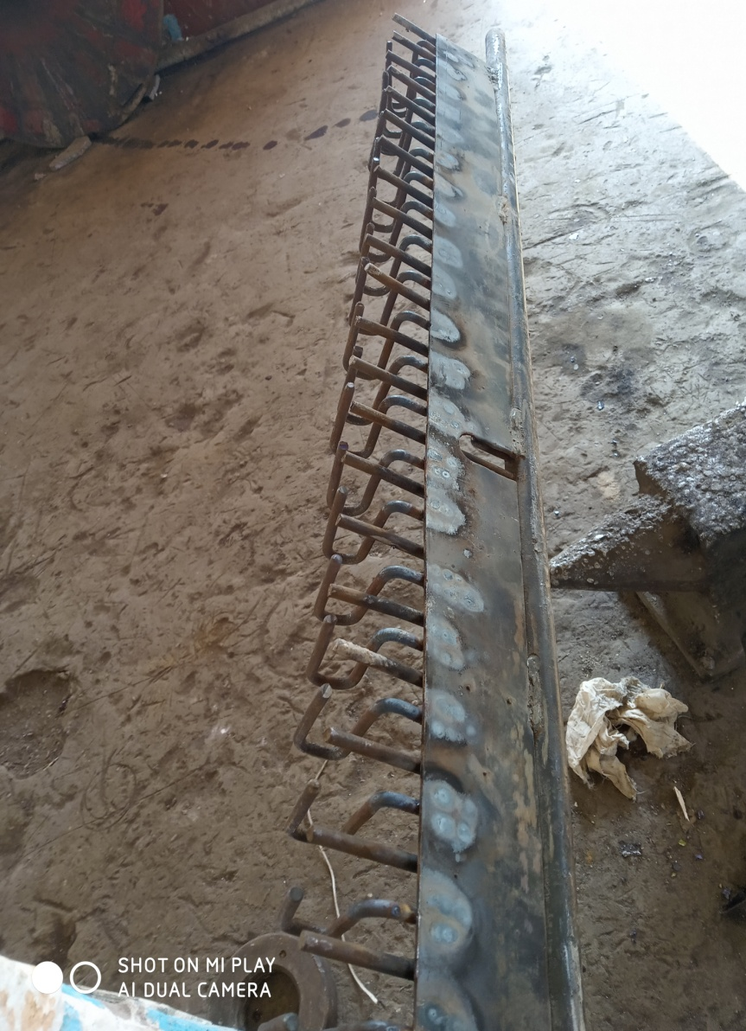
a) b) c)
FIGURE 1. Improved seed comb constructions: a) rectilinear, b) elliptical, and c) rectangular

As can be seen from the figure, the new seed comb constructions prepared in variants 2 and 3 were designed with an additional spacing to allow the seeds with fully separated fibers to be removed from the working camera more quickly.
RESULTS AND DISCUSION
The newly designed comb was installed on the fiber sorting machine, and after the machine started working normally, the seeds coming out of the working camera were weighed for 5 minutes, and the effect of the newly designed comb on the amount of seeds coming out of the working camera and their fullness was determined. The experiments were conducted in triplicate on cotton of the An-36 selection sort, sort 1, class 2, and sort 4, class 1.
The obtained results are included in the table below.

TABLE 1. Obtained results
5 min | Unit of measurement | α=0⁰ |  |  | α=15⁰ |  |  | α=30⁰
The form of grid bars |  | straight | ellipse | quadrangular | straight | ellipse | quadrangular | straight | ellipse | quadrangular
Number of saws | number | 44 | 43 | 43 | 44 | 43 | 43 | 44 | 43 | 43
Seed mass | Kg | 58,5 | 65,5 | 69 | 60 | 66 | 70 | 61 | 68 | 71
For 1 saw |  | 1,33 | 1,52 | 1,6 | 1,36 | 1,53 | 1,62 | 1,38 | 1,58 | 1,65
1s for 1 sa | Kg | 15,9 | 18,3 | 19,1 | 16,37 | 18,5 | 19,5 | 16,5 | 18,9 | 19,8
Machine productivity in 1 hour | Kg | 2080 | 2380 | 2490 | 2130 | 2410 | 2542 | 2145 | 2456 | 2570
Machine productivity of fiber in 1 hour | Kg | 1040 | 1190 | 1245 | 1065 | 1205 | 1271 | 1072 | 1228 | 1285
Machine productivity in cotton per hour | Kg | 3120 | 3570 | 3735 | 3195 | 3615 | 3813 | 3217 | 3684 | 3855
Difference | % |  | 14,4 | 19,7 |  | 13 | 19,3 |  | 14,5 | 19,8

TABLE 2. Obtained results
5 min | Unit of measurement | α=0⁰ |  |  | α=15⁰ |  |  | α=30⁰
The form of grid bars |  | straight | ellipse | quadrangular | straight | ellipse | quadrangular | straight | ellipse | quadrangular
Number of saws | number | 44 | 43 | 43 | 44 | 43 | 43 | 44 | 43 | 43
Seed mass | Kg | 30,4 | 34,6 | 36,4 | 31 | 35 | 39 | 31,7 | 36 | 40
For 1 saw |  | 0,69 | 0,80 | 0,85 | 0,7 | 0,81 | 0,91 | 0,72 | 0,84 | 0,93
In relation to 1 saw | Kg | 8,28 | 9,6 | 10,2 | 8,4 | 9,72 | 10,9 | 8,64 | 10,08 | 11,16
Machine productivity in 1 hour | Kg | 1076 | 1287 | 1326 | 1092 | 1263 | 1417 | 1123 | 1310 | 1451
1 hour of fiber mass production | Kg | 538 | 643 | 662 | 546 | 631 | 708 | 561 | 655 | 745
Machine productivity in cotton per hour | Kg | 1614 | 1930 | 1988 | 1638 | 1894 | 2125 | 1684 | 1965 | 2196
Difference | %

The results of the experiments are shown in the form of a histogram in Figure 2. The histogram in Figure 2 shows that in the technological process of separating fiber from sort 1 and class 2 cotton, in option 1, the amount of seeds coming out of the working camera in 5 minutes from the comb used at the factory was 34.6 kg, and in options 2 and 3, the amount of seeds coming out of the working camera was 39.1 kg and 41.2 kg, respectively. Similarly, the experiments conducted on sort 4 cottons of class 1 showed that the amount of seeds coming out of the working camera in 5 minutes was 30.4 kg in option 1, 34.6 kg in option 2, and 36.4 kg in option 3.

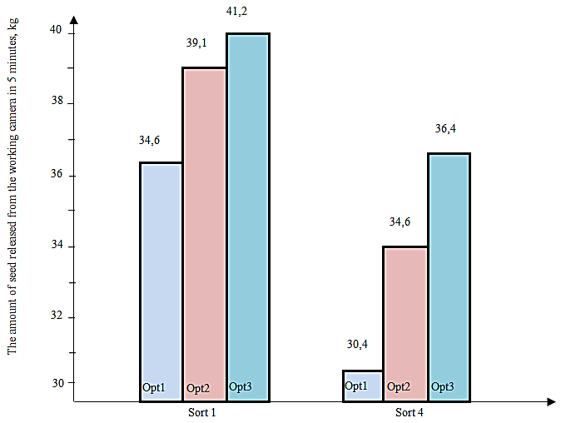
FIGURE 2. Histogram of the dependence of the amount of seed coming out of the working camera on the construction of the seed comb

During the experiments, when using seed combs with quadrangular and ellipse-shaped teeth, it became clear that the oval-shaped seed comb was less durable than the square-shaped seed comb. That is, the dimensions of the 18-21 mm distances between the two side teeth of the seed comb changed due to the inclination of the teeth. Changing the spacing did not give the expected result. Because theoretically, the seeds passing through the quadrangular -shaped seed comb would encounter resistance from the walls of the quadrangular in their subsequent movement. In the ellipse-shaped form, the seeds passing through the gap are free from the above shortcomings. Because if we determine the shape surfaces:
Quadrangular seed comb surface
$S_{1}=l×h$
Here: l is the intermediate length of the new tooth, mm (18-21).
h is the depth of the Quadrangular, mm 50mm
$S_{1}=18,5×50=925$mm²
Ellipse seed comb surface
$S_{2}=π×a×b=3,14×35×25=2747,5$mm²
Here: a - the length of the large pole, 35mm
b - small pole length, 25mm
According to calculations, the difference in surface area is approximately 3 times. That is, the ellipse-shaped comb is 2.5-3 times larger than the quadrangular one. Taking this into account, the amount of fibers removed from the working camera increases accordingly.
It can be seen that when using a seed comb with an ellipse shape, the output of fiber-removed seeds from the working chamber is much more than that of a quadrangular construction.
We get the results of the above experiment, taking into account the movement of the ginned seeds along the teeth of the seed comb and the friction between the seeds.

CONCLUSION
Experiments conducted at “So cotton ginning factory of the “Alyortex” cluster in the Andijan region show that when using a new construction of the ginning comb, the amount of ginning coming out of the working camera increases by 15-18% compared to the amount of ginning coming out of the existing construction of the ginning comb, which in turn leads to an increase in the efficiency of the ginning machine by 15-18% for cotton. As a result, the economic efficiency of the factory increases.
REFERENCES
- Mamasharipov, A. (2025). Design changes effect of the seed comb on the seed total hairiness. AIP Conference Proceedings, 3304, 030075. https://doi.org/10.1063/5.0270069
- Mamasharipov, A., Esanova, S., Satvoldiyev, A., Mamasharipov, S., & Kasimova, D. (2024). A study of the effect of changes in seed comb construction on the quality of cotton seed. BIO Web of Conferences, 105, 03004. https://doi.org/10.1051/bioconf/202410503004
- Miroshnichenko, G. I. (1972). Fundamentals of designing machines for primary processing of cotton. Mechanical engineering, 335.
- Jumaniyazov, K., Tojimirzaev, S., & Muminov. (2022). Research and evaluation of cotton fiber properties in technological processes. Proceedings of Higher Education Institutions Textile Industry Technology, 1, 162–170. https://doi.org/10.47367/0021-3497_2022_1_162
- Yuldashev, A., et al. K. (2023). Theoretical study of yarn tension in the spindle work of two-for-one twisting. AIP Conference Proceedings, 2789, 040117. https://doi.org/10.1063/5.0145422
- Singh, S. K., Jha, R., Pandey, S., Mohan, C., Chetna, N., Ghosh, S., Singh, S. K., Kumari, S., & Singh, A. (2025). Artificial intelligence-based tools for next-generation seed quality analysis. Crop Design, 4(1), 100094. https://doi.org/10.1016/j.cropd.2024.100094
- Dell’Aquila, A. (2007). Towards new computer imaging techniques applied to seed quality testing and sorting. Seed Science and Technology, 35(3), 519–538. https://doi.org/10.15258/sst.2007.35.3.01

