Surface Modification of Cotton Fabrics Using Chitosan for Enhanced Dyeability and Color Fastness
Kumush Rasulova^{1, a)}, Iroda Nabiyeva¹, Shuhrat Khudoyberdiyev²,
Zulayho Islamova¹, Saodat Khasanova¹, Feruza Usmanova¹
¹Tashkent Institute of Textile and Light Industry, Tashkent, 100100, Uzbekistan
²Bukhara State University, Bukhara, 200114, Uzbekistan

^{a)}Corresponding author: kumush.rasulova@mail.ru
Abstract. Chitosan is a natural biopolymer obtained by deacetylating chitin (derived from the outer shells of insects and marine animals), it is widely used in various industries due to its non-toxicity, film-forming properties, and a number of other properties. One of its most important advantages in the textile industry is its ability to bind effectively to cellulose fibers. In this case, the cellulose fiber is modified by the -NH2 and -OH functional groups of chitosan. As a result, ionic interactions are formed that enhance the dye uptake. The modified cellulose fiber forms a greater number of covalent bonds with reactive dyes. This can be a very effective technology for obtaining stable colors. In this study, chitosan extracted from the silkworm cocoon "Bombxy mory" with a molecular weight of 198 × 10³ was used to improve the efficiency of the dyeing process of 100% cotton fiber fabric with reactive dyes. The cotton samples were pretreated with a 1% chitosan solution and then dyed with Epsilon blue ERGL reactive dye under controlled conditions. The dyeing process was carried out at varying durations (20–80 minutes), and the colorimetric properties were analyzed using an X-Rite Ci 7800 spectrophotometer under standard D65 illumination. The study compared the dye uptake, color saturation (C*), color difference (∆E*), and brightness (B*) between traditionally dyed samples and those treated with chitosan. The results demonstrated a significant improvement in dye fixation and color depth in chitosan-treated samples, with optimal dyeing performance achieved at 60 minutes. These findings highlight the potential of chitosan as a stable and sustainable dyeing modifier in cotton textile processing.
Keywords: surface engineering, biopolymers, chitosan, textile coatings, sustainable materials cellulose, cotton, reactive dye, dyeing duration, color parameters.
INTRODUCTION
The color and design of textile materials increase their demand. Reactive dyes are widely used in the textile industry due to their wide range of colors and shades, convenient application methods, and high production volumes to meet the needs of a constantly growing population [1]. However, they undergo extensive hydrolysis in aqueous processes and are released into wastewater in hydrolyzed form. The hydrolyzed dye does not bind to the fiber and must be removed during the washing process. This requires a lot of water. This leads to high consumption of dye in finishing plants and high pollution of wastewater [2, 3].
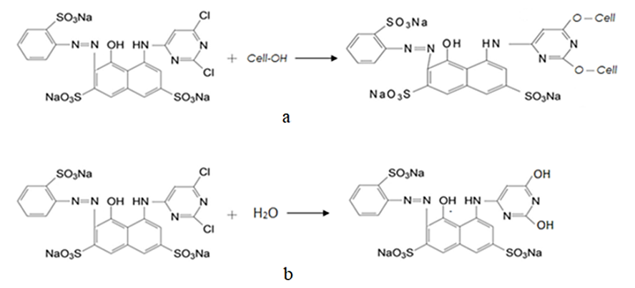
FIGURE 1. Reactions of a reactive dye in the dye solution in the active (a) and hydrolyzed (b) states
In reaction a, the functional groups of the fiber and the dye interact to form a covalent bond. In reaction b, the active dye reacts with water and becomes hydrolyzed in the dyeing solution, i.e., it becomes inactive and does not bind to the fiber, but is removed with water during washing.
The scientists of the world are studying ways to increase the chemically bound part of the reactive dyestuff, i.e., the level of use of the dyestuff in the dyeing of cotton textile materials [4]. In these areas, chemical, biological and physical methods of accelerating the dyeing process are proposed. There are methods of chemical acceleration by oxidation-reduction dyeing [5, 6], through the use of various textile auxiliaries [7, 8], and acceleration methods to improving the efficiency of the dyeing process using surfactants [9]. Another way to increase fixation is to cationize the cotton fiber and create conditions for the sorption of the dye. Accelerating the process of cationic cotton fiber dyeing means exploring and implementing dyeing processes, in particular, resource-efficient, zero-waste production, transition to technologies that enable waste recycling and safe chemicals, and the use of renewable energy technologies. In this case, the creation of biopolymers for various sectors of the national economy from the non-fiber waste of the silk industry, that is, chitosan, is relevant. The presence of an ionogenic amino group in chitosan determines its many positive properties, allowing it to be widely used in various fields.
In previous research, [5] explored innovative approaches for the discoloration and bleaching of textile waste, highlighting environmentally friendly treatment methods aimed at reducing pollution and improving sustainability in textile processing. Their findings provide a foundational perspective for current studies focusing on optimizing dyeing processes. The present study builds upon this direction by investigating the use of chitosan as a bio-based intensifier in reactive dyeing, further contributing to sustainable textile technologies through improved dye fixation and reduced wastewater contamination.
Recent studies [6] addressed the technological challenges and environmental implications associated with the finishing of wool fibers, proposing eco-friendly alternatives to traditional treatment methods. Their work emphasizes the importance of sustainable practices in textile processing, particularly in the context of natural fibers. The present research aligns with this approach by applying bio-based materials—specifically chitosan—to enhance the dyeing process of cotton fabrics. Both studies contribute to the broader objective of reducing ecological impact while maintaining or improving the quality of textile materials.
Chitosan is a diacetylated water-soluble derivative of chitin that has been widely used in medicine, agriculture, wastewater treatment, and the food industry in recent years. Chitosan is a water-soluble derivative of chitin that is soluble in water in a weakly acidic environment and is positively charged. The structural formula of chitosan is given in Figure 2 below.

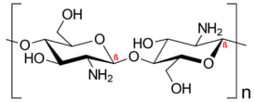
FIGURE 2. Structural formula of chitosan.
Chitosan is an aminopolysaccharide composed of β-(1→4)-linked D-glucosamine residues and N-acetyl-D-glucosamine, which is isolated from chitin, which is part of the shells of clams, or from chitin obtained from fungi, mollusks, and other insects. This biopolymer is environmentally safe, has special film-forming, and antimicrobial properties, and is increasingly used in the textile industry in dyeing, printing, and finishing technologies. In particularly, chitosan is an important material in surface engineering to create antimicrobial fabrics and coatings.
Chitosan is a promising smart material with a wide range of applications due to its unique properties and modifier properties. More than 100 areas of use of chitosan are known and various preparations and compositions are prepared on its basis. In the textile industry, chitosan is used to increase the dyeability of fabrics, in dyeing, and in the final finishing processes. In 2005-2006, Safonov V.V. and his students discovered the formation of an amorphous film of chitosan on the surface of textile materials, which, as a result, improves their hygienic and physicomechanical properties. Despite the wide application of chitosan in various fields, it lags behind due to the lack of technology for its use in dyeing and dyeing processes of textile materials.
Chitosan synthesized at the Institute of Polymer Chemistry and Physics of the Russian Academy of Sciences of Uzbekistan was used in the research. This chitosan is "Bombxy mory" chitosan obtained by deacetylating chitin from mulberry silkworm cocoons.A technological line for the separation of chitosan from chitin by deproteinization with sodium hydroxide solution, deacetylation of the obtained chitin with a concentrated solution of NaOH was proposed by scientists of our Republic. The optimal time for the synthesis of chitosan was determined to be 3 hours. The process temperature was T=120-130ºC, the NaOH concentration was 50%. The formation of polymers was determined by IR spectroscopy and elemental analysis methods.
Studies have shown that the dyeing process of cotton textile materials with reactive dyes has improved compared to the samples dyed using the traditional method and the fabric dyed with chitosan. For example, the dye utilization rate increased from 68.36% to 78.90%, the color intensity increased from 13.03 to 18.72, and the washing fastness reached 4/5 points. In the works of world scientists, the duration of the process in the dyeing process with natural dyes obtained from plants with the participation of chitosan was studied and a duration of 60 minutes was proposed. In our previous works, the effect of various natural chitosan on the dyeing process, and its role in the flowering process were studied. Now, in order to study the dyeing durability, the dyeing technology of cotton fiber with reactive dyes was studied and analyzed by first treating it with chitosan and then dyeing it. In this study, chitosan was used as an intensifier in the dyeing of cotton fabrics with reactive dyes, and the dyeing durability was optimized to achieve the maximum color intensity value.
МЕTHODS
The object of the study was a fabric made of 100% cotton fiber, with a surface density of 114 g/m² and a whiteness level of 80%. The biopolymer “Bombxy mory” is chitosan obtained by deacetylating chitin from the cocoon of the mulberry silkworm, in the form of a 1% solution. For dyeing the cotton fiber fabric, Epsilon blue ergl (Active blue), sodium carbonate (GOST ISO 5100-85), sodium chloride (GOST ISO 6353-2-83), and a non-ionic surfactant - Cottoclarin OK, proposed by the “Pulcra” company, were used.
Cotton fabric was pretreated with chitosan concentration 1.0 were employed for pre treatment weight by volume method. Chitosan solution was prepared by dissolving required amount of chitosan powder in 2% (v/v) acetic acid at room temperature. The fabric was treated in the solutions for 30 min at 60°C temperature. Excess solution was squeezed and the samples were dried at 80°C. The technology of dyeing with reactive dyes was carried out as follows: a fabric sample pre-treated with chitosan was dyed in a neutral solution of 2% by weight of the reactive dye at a temperature of 30⁰C for 30 minutes. Then (2.0 g/l) Na₂CO₃ and (30.0 g/l) NaCl were added to the dyeing solution and dyed again at a temperature of 60⁰C for 20, 40, 60, 80 minutes. The bath module was 1:50. The samples were washed in a solution of 2 g/l of the surfactant, with hot and cold water, and dried. The technological sequence of the dyeing process of the fabric with an reactive dye (29) is given below:

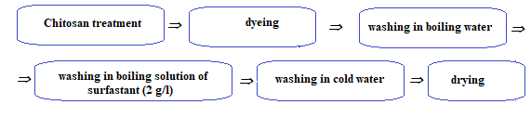
FIGURE 3. Sequence of dyeing cotton fabric with reactive dye.

The colorimetric properties of the stained samples were evaluated using a spectrophotometer.
A spectrophotometer is a laboratory device designed to measure, control, and transmit color data, operating at standard illuminance D₆₅. The color quality parameters of the samples were expressed based on the color model developed by the International Commission on Illumination (CIE).
Determination of color strength (K/S). To accelerate the dyeing process of cellulose fiber fabrics with reactive dyes, color intensity and color quality indicators were analyzed. When light falls on a certain sample, part of the light is reflected, part is absorbed, and part is scattered. If the transparency of the sample is more than 70%, the relationship between the reflection, scattering, and absorption of light according to the Kubelka-Munk theory is defined as absorption "K" and scattering "S", then the color intensity can be calculated from the reflection coefficient "R" of the sample according to the Kubelka-Munk equation:
$\frac{K}{S}=\frac{{(1-0,01R)}^{2}}{(2*(0,01R))}$ (1)
The system of Kubelka-Munk equations for color matching is the mathematical basis of all programs. These equations show that for opaque samples such as textile materials, the total ratio of light absorbed and scattered by a mixture of colors is equal to the sum of the ratios of light absorbed and scattered by the colors measured separately.
Based on the results of a previous study, the effect of a selected chitosan concentration of 1%, a dye concentration of 2%, pH=7, a temperature of 60 °C, and a dyeing time of 20 to 80 minutes on the color intensity of the dyed sample considired.
Determining color saturation(C*). Due to the additional bonds formed between the active group in the Epsilon blue ergl chromophore system, the hydroxyl groups of cellulose, and the amino groups of chitosan, the color saturation (C*) in the studied samples was higher than that achieved by the traditional method.
$C^{* }= {\left({\left(a\right)}^{2}+{\left(b\right)}^{2}\right)}^{1/2}$ (2)
Here: a*, b* are color coordinates.
Determining color brightness (B*). The movement of a color towards the edge of the color wheel indicates that its brightness and purity increase. The numerical value of the color brightness (B*) can be calculated using the Y coordinate using the following formula.
$B^{*}=683*Y,$(${kd}/{m^{2}}$) (3)
Here, the Y coordinate is found by formula (2) according to CIELAB:
$Y=\sqrt[\frac{1}{3}]{\frac{L+16}{116}}*Y_{0}$ (4)
L – lightness; Y₀ – white color coordinate in the XYZ system. At D₆₅ standard irradiance, Y₀= 100.
Using the L* value of the samples, the Y coordinate value was determined, from which the color brightness (B*) was calculated.
Determining color difference deviation. The color difference (∆E*- color difference deviation) of the stained samples is calculated using the following formula.
${{∆E}^{*}}_{ab}=\sqrt{{\left(L_{2}-L_{1}\right)}^{2}+{\left(a_{2}-a_{1}\right)}^{2}+{\left(b_{2}-b_{1}\right)}^{2}}$ (5)
Here: L-lightness, a*, b*-color coordinates.
The CIE 1976 color difference formula relates the measured color difference to a set of known CIELab coordinates. It measures these colors with very high accuracy in the CIELab space.
RESULTS AND DISCUSSION
Chitosan treatment increased the dye uptake of the fabric depending on the dyeing time with reactive dyes. The active groups of the reactive dye react with nucleophilic groups in the fiber, including the hydroxyl groups of chitosan and cellulose, forming covalent bonds. Chitosan treatment led to cationization of the surface of the cellulose fibers, thereby creating conditions for maximum binding in the dye solution. The surface cationization of cellulose allows achieving high color quality parameters due to the ionic bonding effect between the cationic group of chitosan and the anionic group of the dye (see Fig. 4).

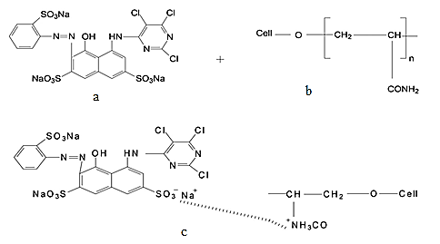
FIGURE 4. Bonding between dye, chitosan and fabric: a- reactive dye, b-chitosan-treated fabric,
c-sample treated with chitosan and dyed with reactive dye.

The CIELAB system compares a sample with a standard and makes a numerical determination based on the perceived color difference. In other words, it gives meaning to the color difference and plots the result on a diagram in terms of chromaticity.
The letters L*, a*, and b* represent each of the three values of the CIELAB XYZ-based nonlinear color space used to measure objective color and calculate color differences. L* represents the lightness from black to white on a scale of zero to 100, while the a* and b* opposite color measurements of red-greenness and blue-yellowness are expressed in numbers with specific numerical limits (from -128 to 128). CIELab D₆₅ = Average daylight (6500 K) in a standard illuminant A-10 tungsten (incandescent) light (2854 K), such as fluorescent lamps: F2 = Cool white fluorescent CWF (4200 K) standard light sources are used.
The change in color intensity with increasing dyeing duration is depicted by the curved lines in Figure 5.

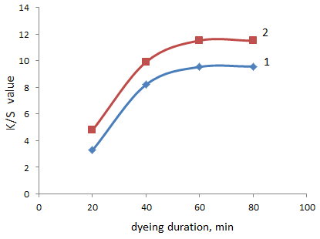
FIGURE 5. Dependence of color intensity on dyeing duration: 1-Sample dyed using the traditional method,
2- samples pre-treatment with chitosan.

From Figure 5, it can be seen that the color intensity of the dyed samples increased with increasing treatment duration. However, when the treatment duration reached 60 minutes, the dyeing efficiency of cationized cotton fiber with reactive dyestuff stabilized (see Fig. 6). During this period of dyeing, the binding of the active dye, which belongs to the class of anionic dyes, with the positively charged cellulose fiber gives the greatest result and further increasing the dyeing duration increases the cost of the product. Thus, it was found that a rational dyeing duration of 60 minutes is sufficient for dyeing cationized cotton fabric with reactive dyes. The results of spectrocolorimetric analysis show that saturated (C*) colors were formed in the samples with increasing dyeing duration. From the results, we can see that C* - color saturation reached a high value at a duration of 60 minutes, and remained almost unchanged at 80 minutes.

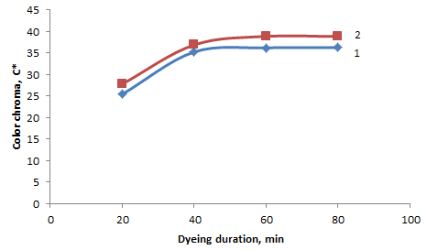
FIGURE 6. Effect of dyeing duration on color saturation: 1- sample dyed using the traditional method,
2- samples pre-treatment with chitosan.

The change in the a* and b* coordinates with increasing duration in the dye solution indicates that the blue and green colors in the resulting colors increase and the yellow and red colors decrease, that is, in the color range, these coordinates shift from red to green and from yellow to blue (see Fig 7 and 8).
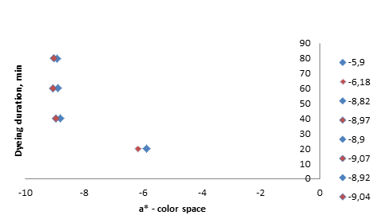
FIGURE 7. Dependence of the color field a* on the duration of the dyeing process.
In blue-samples dyed using the traditional method and samples pre-treatment with chitosan.

In the color field, red/green colors are represented by a horizontal plane from east to west. If a* is positive, the color appears in the red region of the color field. If it is negative, it appears in the green region. The a* indicator also indicates that the duration has reached stability at 60 minutes.
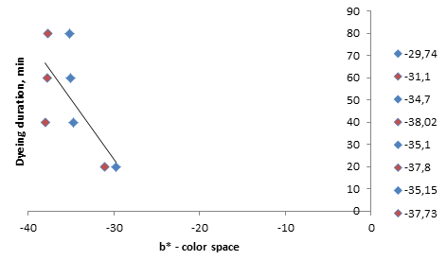
FIGURE 8. Dependence of the b* color field on the duration of the dyeing process. In blue-sample dyed using the traditional method, in red-samples pre-treatment with chitosan.

In the b* color space, a (+) value of the color coordinate indicates a yellow color, and a (-) value indicates a blue color. In this diagram, the relationship between the b* color coordinate and the duration is shown by a straight line of correspondence. The results show that the color coordinate does not change much during the 80-minute dyeing period.
The color brightness (B*) and color difference deviation (∆E*) of the samples were also analyzed.
The chromaticity scale is used to systematize the change in color under the influence of various technological factors. A decrease in the L* value within the chromaticity scale indicates that the color is approaching the center of the circle and, accordingly, the color brightness decreases. In the conducted studies, the decrease in the color brightness value in accordance with the duration of dyeing indicates that the resulting colors are deepening.

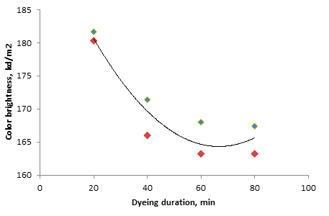
FIGURE 9. Relationship between dyeing duration and color brightness. In blue-samples dyed using the traditional
method, in red-samples pre-treatment with chitosan.
Polynomial trending describes a curve that is used when data changes. This is useful, for example, for analyzing the benefits and harms of a large data set. The degree of the polynomial is determined by the number of extremes (maximum and minimum) of the curve.
The results are shown by a polynomial trending curve. From the diagram, it is seen that the color brightness of the sample dyed after chitosan treatment changed the most at 60 minutes. At 80 minutes, the color brightness remained almost unchanged. This indicator also stabilized at 60 minutes of duration.
The figure below shows the color difference deviation (∆E*) of samples stained with chitosan treatment compared to the traditional method.

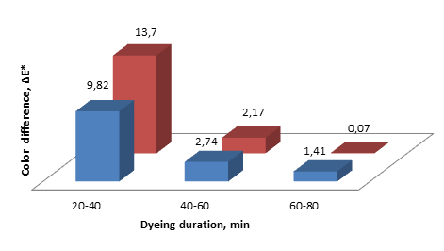
FIGURE 10. Relationship between dyeing duration and color difference. Samples dyed using the
traditional method, samples pre-treatment with chitosan

The ∆E* function is used to ensure that the displayed color matches what the human eye sees accurately. It is also the difference between two colors expressed as two points in the CIELab color space. The lower the color difference deviation value, the higher the color accuracy. The deviation in color change indicates that the color does not change when the dyeing time is increased by another 20 minutes when compared to the traditional method with chitosan treatment.

CONCLUSION
The aim of this research was to determine the effect of pre-treatment with chitosan before dyeing cotton fabric. All coloristic parameters of samples treated with chitosan and dyed by traditional method were compared with each other when the duration of the dyeing process was changed. The results showed that all coloristic parameters increased. In particular: color strength increased by 20.75%, color brightness by 2.93%, color difference deviation by 26.3%, and color chroma showed that the result achieved in 90 minutes compared to the traditional method can be achieved in 40 minutes. In the traditional technology, dyeing in an alkaline solution takes 90 minutes, while in the proposed technology it takes 60 minutes at 60°C. This is due to the low electricity and labor consumption, and also facilitates the washing process due to the relatively liquid nature of the residual solution. From an ecological point of view, it can be an environmentally friendly technology. Treatment with chitosan led to a change in the surface of the cellulose fabric, and at the same time created conditions for maximum binding in the dye solution. Surface cat ionization of cellulose made it possible to achieve high color quality indicators due to the ionic bonding effect between the cationic group of chitosan and the anionic group of the dye. It is crucial to integrate this promising biopolymer with other functional coatings or nanocomposite materials to expand its application scope.
REFERENCES
- Slama, H. B., Bouket, A. C., Pourhassan, Z., Alenezi, F. N., Silini, A., Cherif-Silini, H., Oszako, T., Luptakova, L., Golińska, P., & Belbahri, L. (2021). Diversity of Synthetic Dyes from Textile Industries, Discharge Impacts and Treatment Methods. Applied Sciences, 11(14), 6255. https://doi.org/10.3390/app11146255
- Vickerstaff, T. (1957). Reactive dyes for textiles. Journal of the Society of Dyers and Colourists, 73(6), 237–245. https://doi.org/10.1111/j.1478-4408.1957.tb02195.x
- Sadikova, G. K., Khudayberdiyeva, D. B., Mamadjanova, S. A. M. Sh., & Akhmedova, M. Sh. (2023). Continuous method of coloring cotton and silk fabrics. Uzbekistan Textile Journal, (4), 52–62.
- Božič, M., & Kokol, V. (2007). Ecological alternatives to the reduction and oxidation processes in dyeing with vat and sulphur dyes. Dyes and Pigments, 76(2), 299–309. https://doi.org/10.1016/j.dyepig.2006.05.041
- Li, R., Yang, J., Zhang, G., & Zhu, P. (2022). Decolorization of dark-colored waste cotton fabric using redox decoloring agents. RSC Advances, 12(28), 17689–17700. https://doi.org/10.1039/d2ra02071h
- Burkinshaw, S. M., & Salihu, G. (2017). The role of auxiliaries in the immersion dyeing of textile fibres: Part 1 an overview. Dyes and Pigments, 161, 519–530. https://doi.org/10.1016/j.dyepig.2017.08.016
- Younis, S., Usman, M., ul Haq, A., Akram, N., Saeed, M., Raza, S., Siddiq, M., & Bukhtawar, F. (2020). Solubilization of reactive dyes by mixed micellar system: Synergistic effect of nonionic surfactant on solubilizing power of cationic surfactant. Chemical Physics Letters, 738, 136890. https://doi.org/10.1016/j.cplett.2019.136890
- Rashidova, S.Sh. and Millusheva, R.Yu. (2009) Chitin and Chitosan Bombyx mori. Synthesis, Properties and Application. Tashkent, FAN, 246.
- Abdumajidov, A., Nishanova, S., Miratayev, A., & Nabiyeva, I. (2023). Development of methods for discoloration and bleaching of textile waste. E3S Web of Conferences, 401, 03063. https://doi.org/10.1051/e3sconf/202340103063

