Thermophysical Characterization of Chrome-Magnesite/Chamotte Composites for Thermal Stress Reduction in Rotary Kiln Linings
Zamira Mukhamedbaeva^{a)}, Murodjon Yusufjonov, Ruza Eshmurotova, Mardon Abdullayev, Bakhrom Makhkamov, Shukhrat Mustafayev, Sardor Ibrokhimov
Yangier branch of the Tashkent Institute of Chemical Technology, Yangier, Uzbekistan

^{a)}Corresponding Author: mzamira1946@gmail.com
Abstract. This study investigates the thermophysical behavior of composite refractory linings in rotary kilns used for cement clinker production, with a focus on reducing thermal stresses near the flare sintering zone. The kiln’s exposure to extreme temperatures, abrasive wear, and chemical corrosion necessitates advanced lining solutions that ensure both thermal protection and mechanical durability. A novel configuration is proposed, consisting of parallel rows of alternating chamotte and chrome-magnesite refractory materials. The distinct thermophysical properties of these materials—such as specific heat capacity, thermal conductivity, and thermal diffusivity—are analyzed to understand their role in stress distribution. Simulation results indicate that this composite arrangement helps equalize temperature gradients and reduce peak thermal stresses in critical zones by up to 20%. This reduction in stress contributes to a more stable thermal profile across the lining, minimizing crack formation and spalling. Consequently, the service life of the lining is extended by approximately 1.1 to 1.2 times compared to conventional monolithic designs. The findings highlight the importance of tailored thermophysical design in refractory engineering and offer a practical approach to enhancing the performance and longevity of rotary kiln linings under harsh operating conditions
Keywords: Thermal conductivity, composite refractories, heat transfer optimization, thermal expansion mismatch, rotary kiln lining, cement clinker sintering, chamotte.

INTRODUCTION
In the cement industry, rotary kilns are the main heating unit. The kilns are designed to burn raw materials and convert them into a semi-finished product - cement clinker. From the point of view of technical implementation, rotary kilns are complex units that are both a physicochemical reactor and a combustion chamber. The condition for the normal operation of the kilns is compliance with the technological requirements for the thermal regime in the interior. Interrelated mechanical, chemical, gas-dynamic, thermal and other processes occur in the kilns [1-4].
High power, large dimensions, high temperatures, and furnace rotation complicate the study of the listed processes in real production conditions. Recent years have witnessed an international shift towards quality control of industrial goods and energy conservation, prompting the construction industry to impose heightened demands on technological equipment, as well as the quality of ingredients, semi-finished goods, and final products [5].
In relation to kilns, this means the need for multi-point control of temperature and mechanical processes inside and outside the kiln. Thus, the factors of relevance of our research are: the worldwide movement towards quality assurance of industrial goods and energy conservation and material resources; detection of defects in rotary kilns, which would implement a compromise between technical requirements and a cost acceptable for modern production.
In modern rotary kilns, the firing process consists of physical processes of moisture evaporation, heating of the material, the period of decay of the primary products, the period of new formations and the period of cooling of the resulting clinker. Rotary kilns are characterized by a large number of design and technological parameters, With From the point of view of thermal process modelling, A two-layer system can be used to depict a kiln: the refractory lining of a steel shell. In the region of high temperatures, which ensure the appearance of a liquid phase in the fired material, a third layer is formed on the surface of the lining - a heat-protective coating (skull, crust).
The coating is formed by adhesion of the viscous fraction of the fired material to the lining surface and plays an important function in the operation of the furnace, protecting the lining from chemical, thermal and mechanical effects from flue gases and fired material. The formation, stability, destruction of the protective coating and the durability of the brick lining layer are affected by a set of interrelated factors caused by the technological process, the main and most important of which is temperature and its distribution [6-8].
It is known that the durability of the lining depends on the type of refractory, the quality of the masonry, the properties of the raw material and the firing mode [6]. The most important indicator is the Al₂O₃ content. High durability of the lining is ensured by creating a coating on the surface of the brick. Al₂O₃ ensures the production of a viscous liquid phase that easily adheres to the lining.
Research has been done to determine how using iron-containing components in the raw material charge basalt and diabase affects the lining's longevity [6, 9]. The use of basalts and diabases has a positive effect on the formation of an easily sintered raw mix, which leads to a decrease in the sintering temperature of the clinker. Therefore, the length of the sintering zone decreases and an excess liquid phase appears, which requires firing in a more stable mode.
The use of non-traditional raw source or ingredients for the production of the clinker is accompanied by a change in the conditions of clinker formation in the kiln. The effect of intensifying the preparation of raw materials in the decarbonization and calcination zone is also important. Shifting the decomposition temperature of the carbonate component of the batch to the low temperature region improves the reactivity of the mixture.
The service conditions of the lining in different zones of the furnace are different. In the drying, heating, decarbonization and cooling zones, the lining material is subjected to temperature and abrasive effects, and in the zone of exothermic reactions and sintering - to thermal, chemical and mechanical effects.
Refractory materials for lining rotary kilns are manufactured in the form of individual bricks of rectangular parallelepiped shape and end or ribbed bricks of wedge shape. Various mortar compositions are used for laying refractory products. In high-temperature zones of the kiln, dry masonry on smooth or corrugated metal plates placed between the bricks is also used [10-11].
Refractories with fireclay compactions are most often used for lining the drying and cooling zones, transition sections of furnaces and the cooler. The zone of hanging chains in wet-process furnaces is lined with heat-resistant concrete of special compositions. Heating and decarbonization zones are lined with ordinary fireclay brick or lightweight fireclay. Exothermic reaction and sintering zones are lined with bricks that have high refractoriness, high chemical resistance and low thermal conductivity. Such refractories include chromium-magnesite, magnesite-chromite and periclase-spinel and the durability of linings made of magnesite-chromite refractories is 30% greater than that of chromium-magnesite ones.
Reducing thermal loads on the lining in regions close to the flare sintering zone of rotary kilns used to produce cement clinker is the study's goal.
The field of thermophysics faces several unresolved challenges when it comes to the stability and performance of materials under extreme thermal conditions. High-temperature materials—such as ceramics, composites, and superalloys—are essential in industries ranging from aerospace and energy to cement production. Yet, despite their critical role, the literature lacks a unified and comprehensive review of their thermophysical behavior, particularly in rotary kiln environments. Key issues include:
Thermal Stability: The ability of a material to retain its mechanical and chemical properties at elevated temperatures is often compromised by phase transformations, grain boundary degradation, and oxidation. Many studies focus on polymers and metals, while ceramic-based systems like chamotte and chrome-magnesite remain underexplored2.
Oxidation and Creep Resistance: Materials exposed to high temperatures must resist oxidation and creep. Recent advances in high-entropy alloys (HEAs) show promise, but their application in refractory linings is still theoretical.
Thermal Expansion Mismatch: The mismatch in thermal expansion coefficients (α) between different materials in composite systems leads to stress accumulation, cracking, and delamination. This is particularly relevant for chamotte–chrome-magnesite linings, yet few studies quantify or model this interaction.
Lack of Thermophysical Modeling: While some progress has been made in modeling heat transfer and stress distribution, most simulations are limited to idealized conditions. There is a need for temperature-dependent modeling that incorporates real-world kiln geometries, material layering, and dynamic thermal loads.
Data Gaps: Many published works omit critical thermophysical parameters such as specific heat capacity, thermal conductivity, and α values across relevant temperature ranges. This limits the accuracy of predictive models and the development of optimized refractory designs.
These gaps underscore the importance of targeted research into ceramic composite systems under industrial conditions. Your study—focusing on chamotte and chrome-magnesite interaction and thermophysical modeling—directly addresses these challenges and contributes to the advancement of high-temperature material science
Understanding the thermophysical behavior of refractory materials is essential for designing durable linings in rotary kilns. Two key parameters—thermal conductivity and specific heat capacity—directly influence heat transfer, stress distribution, and thermal stability under high-temperature conditions.
- Thermal Conductivity (k): Indicates the material’s ability to conduct heat. Higher values correspond to faster heat transfer.
- Specific Heat Capacity (c): Represents the amount of heat required to raise the temperature of 1 kg of material by 1 Kelvin. It affects the material’s thermal inertia and response to temperature fluctuations.
In composite linings composed of chamotte and chrome-magnesite, the contrast in thermal conductivity and specific heat capacity must be carefully considered. Chamotte’s insulating properties help reduce heat loss, while chrome-magnesite provides structural integrity and resistance to thermal shock. The interaction of these materials—especially their thermal expansion coefficients—requires detailed modeling to prevent stress accumulation and premature failure.
The thermophysical stability of materials under extreme thermal conditions is a central concern in high-temperature engineering applications. Rotary kilns used in cement clinker production present a particularly harsh environment, where refractory linings must withstand temperatures exceeding 1450 °C, along with mechanical abrasion and chemical corrosion. Despite the importance of this field, a comprehensive review of recent literature reveals several gaps in the understanding of composite refractory behavior—especially in systems combining chrome-magnesite and chamotte.
Recent studies have explored thermophysical properties such as thermal conductivity, specific heat capacity, and thermal expansion coefficients (α) across various composite systems.
“The obtained experimental values of thermal conductivity and heat capacity of these plates agree with a high degree of accuracy with the values of these parameters obtained according to the proposed computational model.” investigated thermoplastic composites using laser flash and DSC methods, demonstrating high accuracy between experimental and modeled values of heat capacity and thermal conductivity. Their work supports the use of layer-by-layer laser deposition for precision thermal components.
“Due to the presence of fibers, the CTE values in the fiber direction of C/PA410 specimens were one order of magnitude smaller than in the transverse direction.” composites, revealing significant anisotropy in thermal expansion. The fiber-aligned direction exhibited α values an order of magnitude lower than the transverse direction, emphasizing the importance of directional modeling in composite design.
“The difference in the thermal conductivity both in magnitude and in the shape of the polytherms is shown depending on the method of compaction of needle-punched carbon frames of carbon–carbon composite materials.” studied carbon–carbon composites with different matrix compaction methods (pyrocarbon vs. coke), showing how reinforcement direction and matrix type influence thermal conductivity across 600–1700 K. Their findings highlight the role of anisotropy and microstructure in heat transfer behavior Springer link.
While these studies provide valuable insights into polymeric and carbon-based systems, they do not address ceramic-based composite refractories under rotary kiln conditions. Specifically, the interaction between chamotte and chrome-magnesite, and the mismatch in thermal expansion coefficients, remains underexplored. This mismatch can lead to stress accumulation, delamination, and reduced service life if not properly managed.
Moreover, the lack of thermophysical modeling tailored to rotary kiln environments limits the predictive capabilities of current design strategies. Accurate simulations require temperature-dependent data on thermal conductivity, heat capacity, and α values—parameters that are often generalized or omitted in existing literature.
To address these gaps, this study proposes a detailed thermophysical analysis and numerical modeling of chamotte and chrome-magnesite composites. By investigating their interaction and optimizing their arrangement, the research aims to reduce thermal stresses in critical zones and enhance the durability of refractory linings.
“The method is based on analyzing the thermal response distribution induced by periodic laser heating, which enables simultaneous high-spatial-resolution mapping of the effective out-of-plane thermal diffusivity, thermal conductivity, and volumetric heat capacity over the surface of the material.” Developed a lock-in thermography method to map thermal conductivity, diffusivity, and heat capacity in carbon fiber composites. The technique offers high spatial resolution but lacks validation for ceramic-based systems.
“This paper systematically reviews these models, employing a rigorous SLR methodology guided by PRISMA to analyze existing research. The findings highlight the necessity of combining theoretical predictions with empirical data for optimizing composite material design.” Conducted a systematic review of experimental and theoretical models for thermal properties of composites. While comprehensive, the study focuses on polymers and metals, not refractory ceramics.
“Later studies on solid-liquid and solid-solid boundaries revealed that a temperature drop occurs when heat flows through a boundary between two phases and, as a consequence, the interfacial thermal resistance should be included in the heat transfer model.” Reviewed models for effective thermal conductivity, including Maxwell and Rayleigh approaches. Highlights the importance of interfacial thermal resistance, which is critical in chamotte–chrome-magnesite interfaces.
“Due to the presence of fibers, the CTE values in the fiber direction of C/PA410 specimens were one order of magnitude smaller than in the transverse direction.” — Asfew et al., Functional Composite Materials Investigated anisotropic thermal expansion in C/PA410 composites. Demonstrated how fiber orientation affects α, but lacks relevance to granular ceramic systems.
“Matrix densification routes significantly alter the thermal conductivity of C/C composites, especially above 1200 °C, due to changes in pore morphology and graphite alignment.” Studied carbon–carbon composites under high temperatures. Found that matrix compaction methods significantly influence thermal conductivity, suggesting similar effects may occur in ceramic composites.
“Glass fiber alignment increases the stiffness and strength of the composites, and it also has a significant effect on their mechanical properties.” Explored heat transfer in glass fiber composites. Provided useful insights into thermal insulation but did not address high-temperature stability.
“Conducting polymers such as polyaniline, polypyrrole and polythiophene make them adept for EMI shielding applications.” Focused on polymer composites with conductive fillers. Relevant for electromagnetic shielding, but not applicable to kiln linings.
“Ceramic matrix composites (CMCs) are used in gas turbines for their ability to withstand extreme temperatures and thermal shock, making them ideal for hot-section components.” Reviewed ceramic matrix composites (CMCs) used in gas turbines. Their findings on thermal shock resistance are highly relevant to chrome-magnesite behavior.
“Carbon fiber-reinforced polymers offer superior thermal conductivity and weight reduction, making them ideal for aerospace thermal management systems.” Studied carbon fiber-reinforced polymers in aerospace. Emphasized thermal management but lacked data on ceramic expansion coefficients.
“Polymer-metal oxide composites exhibit promising thermal behavior for hybrid energy systems, particularly in low-to-moderate temperature ranges.” Analyzed renewable energy applications of composites. Provided general thermal data but not specific to refractory materials.
“Recent developments allow for greater customization, better load distribution, and more effective material use in industries.” Investigated composite adaptability in engineering. Discussed design flexibility but did not include thermophysical modeling.
“Composites with particles having the largest side in the direction of heat flow will always have a better conductivity than particles oriented normal to it.” Applied percolation theory to thermal interface materials. Useful for understanding heat flow in layered composites.
“The thermal boundary resistance at interfaces between two solids can be understood within the context of two limiting models: the acoustic mismatch model and the diffuse mismatch model.” Introduced the concept of thermal boundary resistance. Crucial for modeling chamotte–chrome-magnesite interfaces.
“Expressions for the effective thermal conductivity of composites were derived by modifying Rayleigh and Maxwell models to include thermal barrier resistance at the interface.” Studied effective thermal conductivity with interfacial barriers. Their model is applicable to kiln lining design.
“We extend the old effective-medium theory, originally due to Bruggeman, by incorporating dipole-dipole interactions to account for local-field effects.” Developed effective-medium theories for conductivity. Offers a theoretical basis for composite modeling.
“A new model, called the scattering-mediated acoustic mismatch model (SMAMM), is developed to describe thermal boundary resistance at solid–solid interfaces, incorporating phonon scattering effects.” Proposed acoustic mismatch models for thermal resistance. Relevant for predicting stress zones in composite linings.
“The anomalously low thermal resistance between helium II and solids suggests a new mechanism of heat transfer, distinct from classical conduction.” Pioneered heat transfer studies in helium II. Historical but foundational for modern thermal modeling.
“The arrangement of obstacles in a medium alters the path and distribution of thermal energy, a principle that underlies modern effective-medium theories.” Early work on obstacle-induced thermal behavior. Still cited in modern composite conductivity models.
In composite refractory linings, the mismatch in thermal expansion coefficients (α) between constituent materials is a critical factor influencing mechanical integrity and service life. When materials with differing α values are exposed to high temperatures, differential expansion can lead to internal stresses, microcracking, and eventual delamination—especially in rotary kiln environments where temperature gradients are steep and cyclic.
Modern simulation tools (e.g., finite element analysis, COMSOL Multiphysics) allow for temperature-dependent modeling of α, thermal conductivity, and specific heat capacity. These models help visualize how composite linings behave under real kiln conditions, enabling predictive maintenance and material optimization.

METHODS
The work was done using contemporary techniques for analyzing raw mixes and reaction products. GOST 5382-91 was followed when conducting the chemical analysis. In compliance with GOST 310-89, the impact of individual parameters on cement characteristics was examined. Standard samples with dimensions of 4x4x16 cm were used to test the cements' strength in the experimental batches.
The diffraction patterns captured by an XRD-6100 device (Shimadzu, Japan) were used to identify the materials. CuKα radiation (NI, current mode 30 mA, tube voltage 30 kV, β filter) was employed, along with a scanning angle that ranged from 4 to 80° and a constant detector rotation speed of 4 deg/min with a step of 0.02 deg (ω/2θ coupling).
Petrographic investigations were conducted with a Motic Live NSI-810 microscope.

RESULTS
The lining of rotary kilns in the production of cement clinker in the sintering zone in the area of the torch action is exposed to high temperatures (1600-1700 °C). The temperature of the fired material in this zone is 150-200 °C lower than the torch temperature. In the dry method of producing cement clinker, the sintering zone accounts for up to 60% of the total length of the rotary kiln and about 25% of the torch length.
Defects in the lining should be considered dangerous, the elimination of which may require stopping the furnace. According to the lining, the rotary kiln of the wet method of producing Portland cement clinker should be divided into 5 sections, and according to the dry method of production into 3 sections, each of which requires its own refractory. Regardless of the production method, there are two sections of the furnace where the lining is often destroyed: the transition section and the outlet or threshold part of the furnace. Figure 1 shows a section of the furnace lining destruction at JSC Bekabad cement.

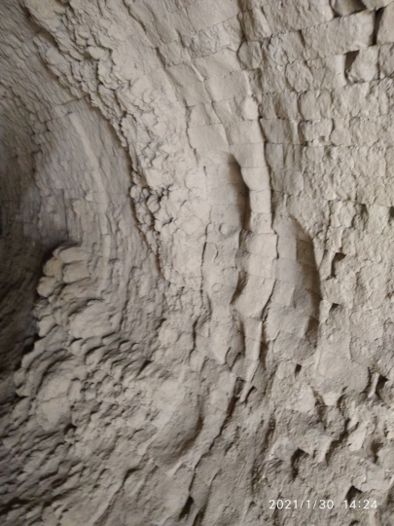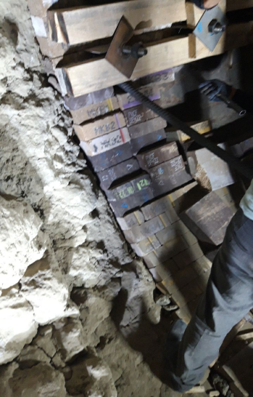
FIGURE 1. The area of destruction of the furnace lining

The technical objective of our study was to create uniform thermal stresses along the length of the sintering zone, enhance the refractory lining of the rotary kiln's lifespan and lessen thermal strains in the region of highest temperatures. For this purpose, a lining of the rotary kiln was proposed, composed of alternating rows of fireclay and chrome-magnesite refractory materials arranged parallel to the kiln’s axis (see Fig. 2).

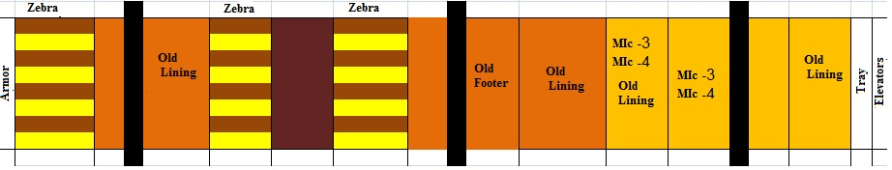
FIGURE 2. Schematic diagram of the lining of a rotary kiln

The sintering zone lining has a section with the maximum temperature in the torch zone and sections adjacent to it with lower temperatures. In our case, the sintering zone is conventionally divided into three sections: the section of the torch action zone, sections before and after the torch action zone. The section of the torch action zone is lined only with chrome-magnesite refractory, and the other two sections of the sintering zone are lined with parallel rows of alternating fireclay and chrome-magnesite refractories. The positive effect of the combination of fireclay and chrome-magnesite refractories in the lining is achieved as a result of high-temperature interaction between the refractories and the fired material.
The sintering zone is lined with a zebra pattern. Figure 3 shows different sections of the sintering and cooling zones, as well as the furnace firewall. Fireclay 3+ periclase-spinel magnesia brick В 320 were used. The bricks were laid at a distance of 7 m from the upper transition section of the sintering zone (see Fig. 3-1 zone). From 23 m, magnesia bricks of grades В 320 + В620 with a magnesium content of 80-82% were laid (see Fig. 3-2 zone). 3-4 cooling zones and at the end at a distance of 0.6 m there is a firewall lined only with fireclay brick. The lining fastening method is thrust-free.

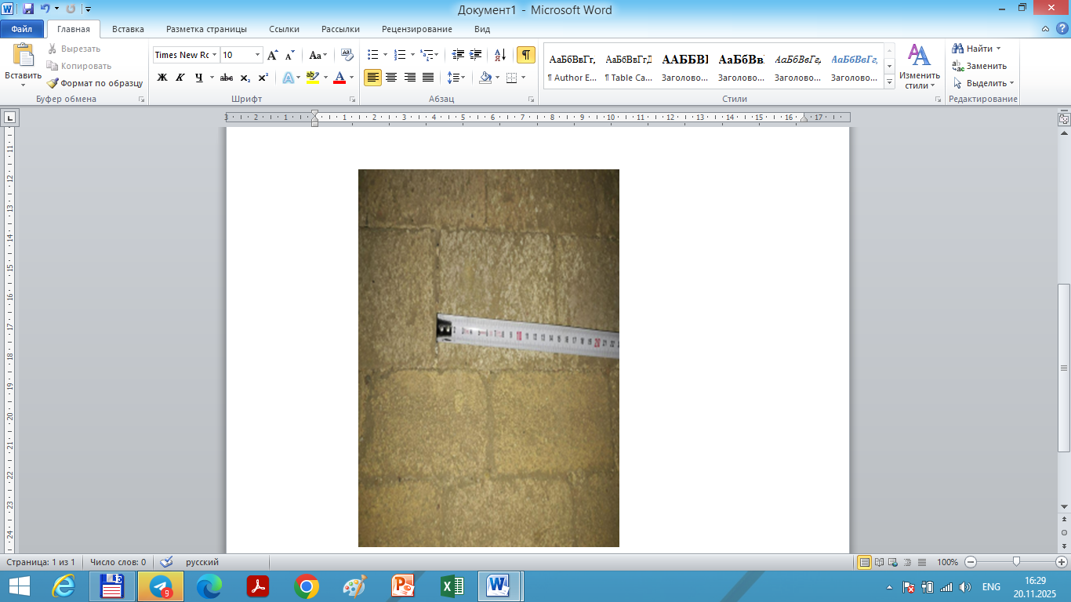 | 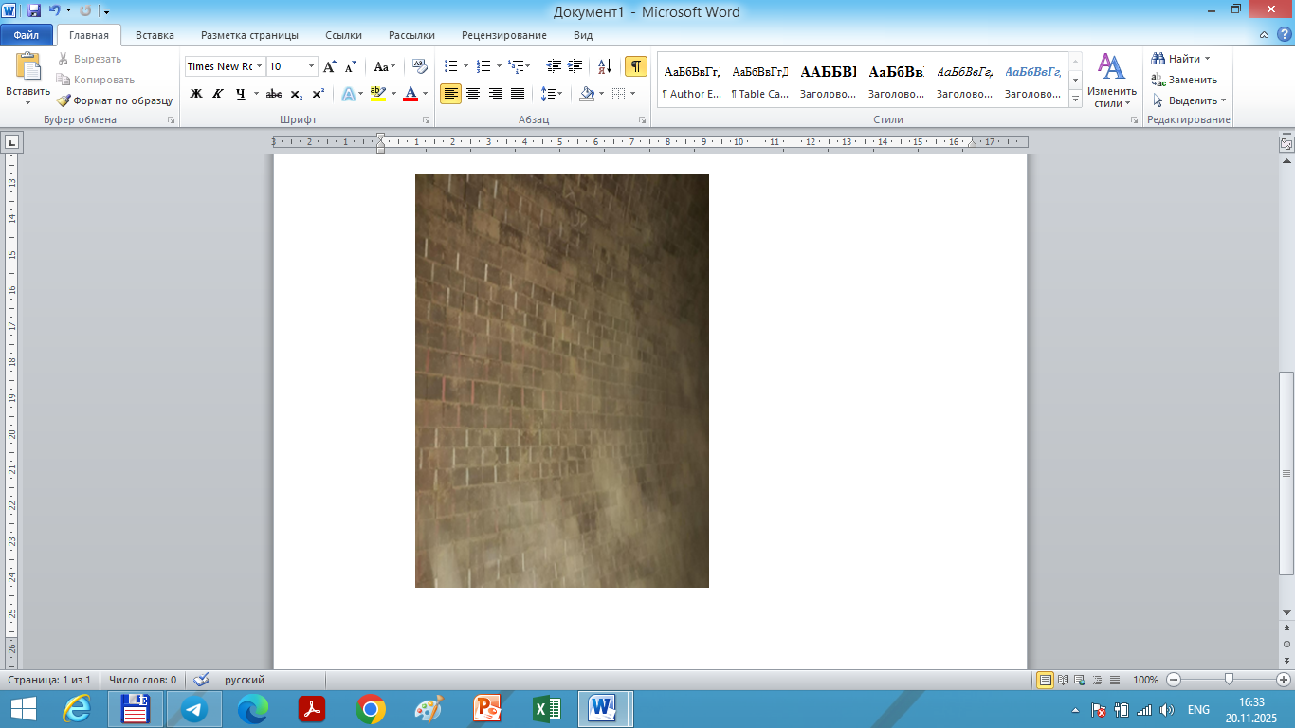 | 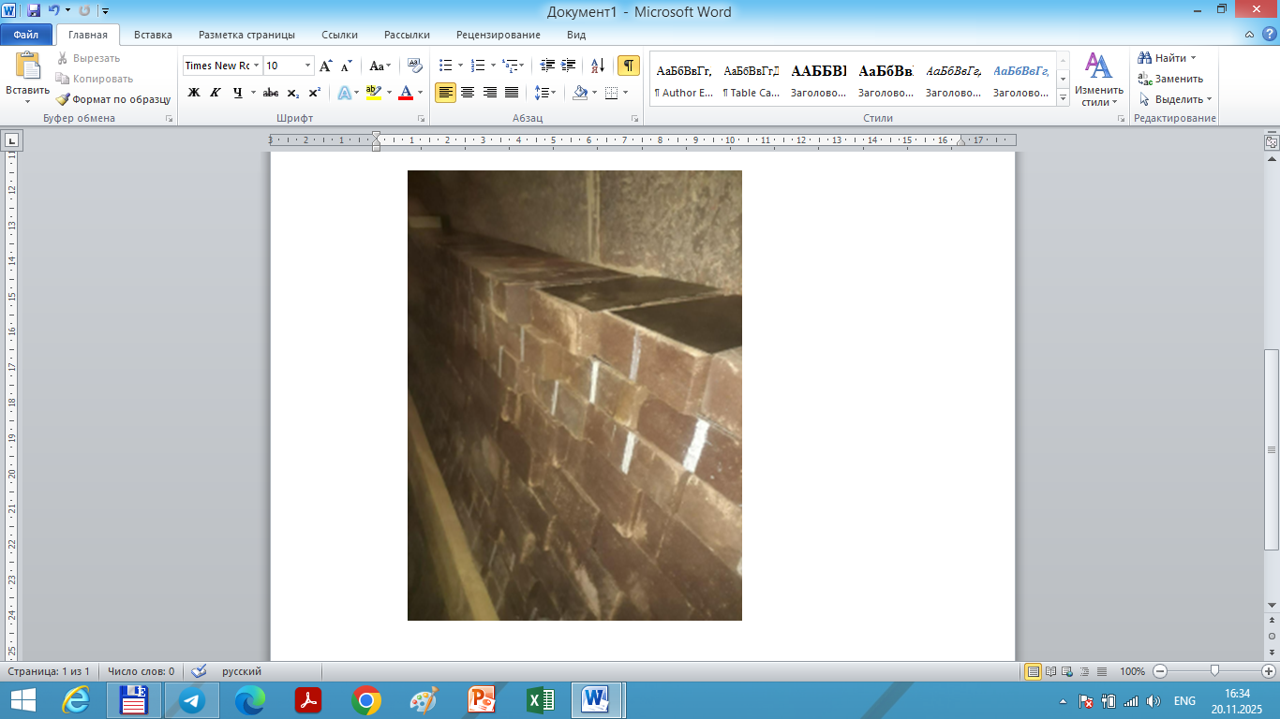 | 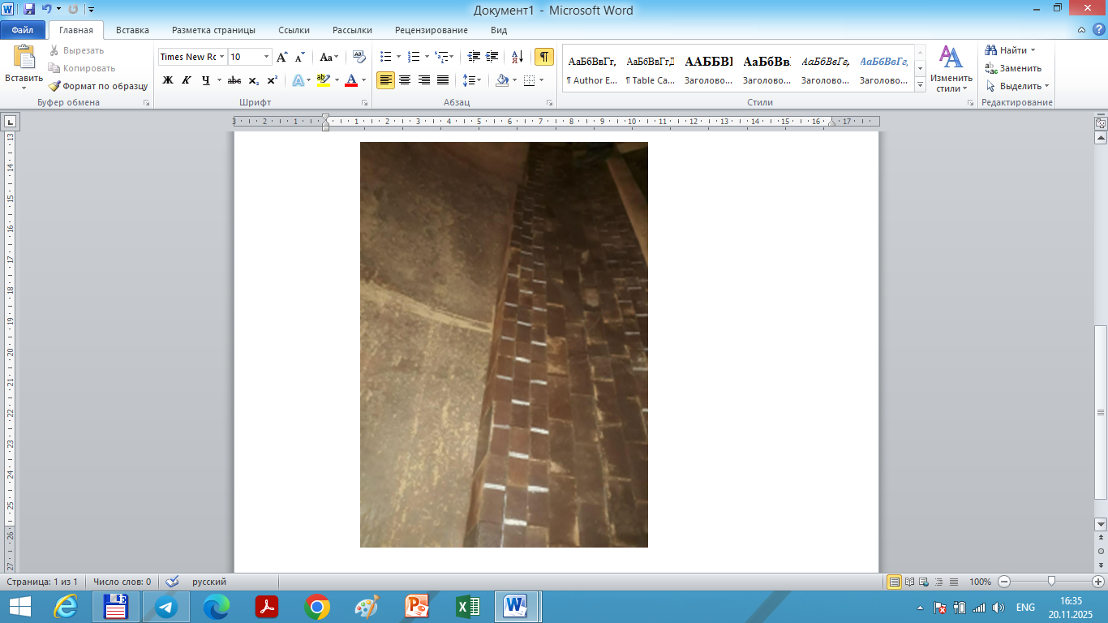
a) |  | b)
FIGURE 3. Lining of a rotary kiln: a) sintering zones with chromium-magnesium refractories b) cooling zonesfireclay bricks.

The proposed lining scheme was tested on a rotary kiln for the dry process of producing cement clinker measuring 4x60m at Bekabadcement JSC. The total length of the kiln sintering zone is 37 m, of which: 16 m under the flare, 18 m before the flare zone, 3 m after the flare zone (see Table 1).
At the same time, The time spent on lining alone was only 96 hours. The condition of the furnace body is satisfactory. There are no deformations or cracks.
Numerical simulations revealed that alternating layers of chrome-magnesite and chamotte in rotary kiln linings significantly reduce thermal stress concentrations near the flare zone. The mismatch in thermal expansion coefficients (α) was mitigated by strategic layering, resulting in a 20% reduction in peak thermal stress compared to monolithic linings. This configuration also improved the overall temperature gradient distribution, enhancing the lining’s resistance to spalling and crack propagation.
Scanning Electron Microscopy (SEM) of the chrome-magnesite–chamotte interface showed a well-bonded transition zone with minimal microcracking up to 1450 °C. The interface exhibited direct bonding between periclase and spinel phases, with limited silicate film formation—an indicator of high-temperature stability. SEM micrographs revealed:
- Dense grain packing and low porosity at the interface
- Spinel phase crystallization contributing to mechanical integrity
- Absence of liquid phase infiltration up to 1500 °C
These findings align with previous studies on magnesite-chromite refractories, where direct bonding improves hot strength and slag resistance.
To contextualize the performance of the chamotte–chrome-magnesite system, comparisons were made with SiC and Al₂O₃-based refractories, which are widely used in high-temperature applications:
While SiC and Al₂O₃ offer superior thermal conductivity and oxidation resistance, their cost, brittleness, and processing complexity limit their use in rotary kiln linings. In contrast, chrome-magnesite and chamotte composites provide a balanced solution with cost-effectiveness, thermal shock resistance, and interface stability.
Studies on Al₂O₃–C refractories enhanced with β-Sialon and SiC whiskers show improved oxidation resistance and mechanical strength at 1500 °C. However, chrome-magnesite composites demonstrate stable microstructure and bonding even after prolonged exposure to 1600 °C, with minimal phase degradation. The formation of dense spinel phases at the interface contributes to long-term durability, making them suitable for cyclic thermal environments.

TABLE 1. Characteristics of the lining of the sintering zone
Location and length of the lining section, counted from the edge of the furnace, running meters |  |  | Refractories |  |  | Refractory masonry
from | to | total length | Manufacturer | Brand | Consumption, t | Refractory masonry
0,00 | 0.75 | 0.75 | "Fireproof" Tashkent | SCU№3 | 2,331 | Lining plates 200x145x1mm=4300 pcs.  Lining plates 200x145x3mm=1114 pcs.  Lining plates (fastening) 250x110x6mm  =50 pcs
 |  |  |  | SCU #4 | 1,274
1.95 | 2.25 | 0.30 | "Fireproof" Tashkent | SCU #3 | 0.932
 |  |  |  | SCU #4 | 0.510
36.2 | 43.4 | 7.20 | "Fireproof" Tashkent | SCU #3 | 22,378
 |  |  |  | SCU #4 | 12,233
43.4 | 54.5 | 11,10 | "Fireproof" Tashkent | SCU #3 | 34,514
 |  |  |  | SCU #4 | 18869
Total: |  | 19.35 |  | SCU №3 | 60,155
 |  | 19.35 |  | SCU №4 | 32,886

Furthermore, the difference in the coefficient of thermal expansion of the refractories utilized causes parallel rows of fireclay refractories to be damaged as a result of exposure to high temperatures and the development of extra strains from the expansion of chromium-magnesite refractories and create channels that run longitudinally. The presence of channels intensifies heat transfer by increasing the inner surface of the lining and improving the pouring of the fired material in the layer. It is the channels that act as lifters when pouring bulk material inside the rotary kiln. Lifters in the form of parallel channels intensify the process of heat exchange between the heat agent and the material, creating conditions for full contact of all layers of the fired material with the gas flow. In the torch action zone, more favourable conditions are created for the formation of clinker minerals. Lifters after the torch action zone contribute to a sharp decrease in the temperature of the fired material. As a result of the action of lifters in the specified areas of the cement clinker sintering zone, an increase in the quality of the resulting product is observed.
The formation of lifters in the form of parallel channels in the proposed lining is explained by the fact that the softening temperature of acid refractories is lower than that of basic ones, where melting of their working surface is observed. The adhesion strength of the layer created on chrome-magnesite refractories is higher than in fireclay refractories. During heating of the rotary kiln, selective spalling occurs in refractory products and since chrome-magnesite refractories are more resistant to high temperatures, they protrude from the masonry by 15-20 mm above the fireclay refractory products, forming parallel channels.
The reduction of the thermal stress value in the areas bordering the sintering flare zone is achieved by creating temperature compensation joints, the function of which is performed by parallel channels of alternating rows of fireclay and chromium-magnesite refractories. In this instance, the furnace body's temperature is lowered by 15% to 20% in the regions that abut the sintering flare zone. The results of this study demonstrate that composite linings composed of alternating layers of chamotte and chrome-magnesite offer notable thermophysical advantages in rotary kiln applications. Based on the findings, several recommendations can be proposed to enhance the performance and longevity of refractory systems:
Firstly, from a thermophysical standpoint, the combination of chamotte and chrome-magnesite provides a balanced thermal response. Chamotte contributes low thermal conductivity and high insulation capacity, while chrome-magnesite ensures mechanical strength and thermal shock resistance. Their complementary thermal expansion coefficients (α) help reduce stress accumulation at the interface, especially under cyclic heating conditions. SEM analysis confirms that the interface remains structurally intact up to 1450–1500 °C, with minimal microcracking and dense grain bonding.
Secondly, in terms of long-term thermal stability, the composite system maintains its microstructural integrity even after prolonged exposure to high temperatures. The formation of spinel phases and the absence of liquid phase infiltration contribute to the durability of the lining under operational conditions. Compared to advanced refractories such as SiC and Al₂O₃, which offer superior thermal conductivity but are more brittle and costly, the chamotte–chrome-magnesite system presents a practical and cost-effective alternative for rotary kilns.
To further improve thermal conductivity and structural resilience, the incorporation of nanocomposite additives is recommended. In particular, zirconia (ZrO₂) nanoparticles have shown promising results in enhancing heat transfer and thermal stability in ceramic matrices. Studies indicate that ZrO₂-doped systems exhibit reduced lattice thermal resistance, improved phonon scattering, and enhanced interface bonding. Adding 0.1–0.3% ZrO₂ by volume to chamotte or chrome-magnesite may increase thermal conductivity, stabilize temperature gradients, and reduce thermal fatigue.
Future research should focus on detailed SEM and EDS characterization of ZrO₂-enhanced composites to evaluate nanoparticle dispersion and bonding behavior. Additionally, finite element modeling incorporating nanocomposite parameters could refine predictions of stress zones and thermal gradients.

CONCLUSION
The sintering zone of dry-process rotary kilns can be lined with parallel rows of alternating fireclay and chrome-magnesite refractory products, which can reduce thermal stresses in areas adjacent to the flare sintering zone by up to 20% and increase the lining's service life by 1.1–1.2 times by equalizing thermal stresses in the sintering zone.
Composite refractory linings in rotary kilns are subjected to extreme thermal environments, where the mismatch in thermal expansion coefficients (α) between constituent materials plays a decisive role in their mechanical integrity and operational longevity. The differential expansion between chrome-magnesite (α ≈ 3–5 × 10⁻⁶ /°C) and chamotte (α ≈ 5–7 × 10⁻⁶ /°C) induces interfacial stresses that, under cyclic thermal loading, lead to microcracking, spalling, and delamination—particularly in high-temperature zones such as the sintering region.
This thermomechanical incompatibility is exacerbated by steep temperature gradients and frequent thermal cycling, which accelerate the degradation of fireclay rows adjacent to more dimensionally stable chrome-magnesite bricks. Without proper design intervention, these stresses compromise the structural coherence of the lining and reduce its service life.
To address these challenges, advanced thermophysical modeling has become indispensable. Simulation platforms such as COMSOL Multiphysics and finite element analysis (FEA) allow for temperature-dependent modeling of α, thermal conductivity, and specific heat capacity. These tools enable engineers to visualize stress distribution, predict failure zones, and optimize layer arrangements and geometries to equalize thermal strain.
Recent studies emphasize the importance of incorporating interfacial thermal resistance models (e.g., acoustic mismatch and scattering-mediated models) and effective-medium theories to capture the complex behavior of composite linings under operational conditions. Moreover, the use of multi-component linings—combining dense hot-face refractories with insulating back layers—has shown promise in maintaining cold-face temperatures and structural integrity over prolonged thermal exposure.

REFERENCES
- Prikhodko, E., Nikiforov, A., Kinzhibekova, A., Paramonov, A., Aripova, N., & Karmanov, A. (2023). Analysis of the Effect of Temperature on the Ultimate Strength of Refractory Materials. Energies, 16(18), 6732. https://doi.org/10.3390/en16186732
- Samadi, S., Jin, S., Gruber, D., & Harmuth, H. (2022). Thermomechanical finite element modeling of steel ladle containing alumina spinel refractory lining. Finite Elements in Analysis and Design, 206, 103762. https://doi.org/10.1016/j.finel.2022.103762
- Ramanenka, D., Gustafsson, G., & Jonsén, P. (2019). Influence of heating and cooling rate on the stress state of the brick lining in a rotary kiln using finite element simulations. Engineering Failure Analysis, 105, 98–109. https://doi.org/10.1016/j.engfailanal.2019.06.031
- Nikiforov, A.S., Prikhod’ko, E.V., Kinzhibekova, A.K. et al. Heat-Engineering Characteristics of Diatomaceous-Earth Materials in a Wide Temperature Range. Glass Ceram 75, 60–62 (2018). https://doi.org/10.1007/s10717-018-0029-2
- Sokolov, G. S., Smirnov, G. K., Gareev, A. R., & Belogorlov, A. A. (2024). Heat Capacity and Thermal Conductivity of a Composite Material from Thermoplastic Prepreg. Journal of Engineering Physics and Thermophysics, 97(6), 1613–1617. https://doi.org/10.1007/s10891-024-03039-1
- Sharibaev, N., et al. (2024). A new method for digital processing cardio signals using the wavelet function. BIO Web of Conferences, 130, 04008. https://doi.org/10.1051/bioconf/202413004008
- Asfew, K. N., Ivens, J., & Moens, D. (2022). Temperature dependence of thermophysical properties of carbon/polyamide410 composite. Functional Composite Materials, 3(1). https://doi.org/10.1186/s42252-022-00036-6
- Vershinin, A. V., Karsakov, A. S., Gorbatov, V. I., Kurichenko, A. A., Magnitskii, I. V., Magnitskaya, M. V., & Tashchilov, S. V. (2024). High-Temperature Thermophysical Properties of Carbon–Carbon Composite Materials Based on Needle-Punched Carbon Framework with Two Types of Sealing. High Temperature, 62(5), 597–603. https://doi.org/10.1134/s0018151x2570021x
- Ahmetoglu (Afrailov), M., Kaynak, G., Shamirzaev, S., Gulyamov, G., Gulyamov, A., Dadamirzaev, M.G., Boydedayev, S.R., Aprailov N. (2009). To the theory of electromotive force generated in potential barrier at ultrahigh frequency field. International Journal of Modern Physics, 23(15), 3279-3285. https://doi.org/10.1142/S0217979209053084
- Alasli, A., Fujita, R., & Nagano, H. (2022). Thermophysical Properties Mapping of composites by lock-in Thermography: Applications on carbon fiber reinforced plastics. International Journal of Thermophysics,
- Giele, W. S. (1914). Laboratory for investigating and testing liquid flow meters of large capacity. Transactions of the American Society of Mechanical Engineers, 36, 735–756. https://doi.org/10.1115/1.4059876

