Thermophysical and Mechanical Properties of Expanded Clay Concrete Modified with Industrial Waste
Rasul Ametov^{1,} ^{a)}, Khusnitdin Akramov¹, Shavkat Raximov¹, Bektosh Botirov¹, Elbek Urishbayev¹, Javokhir Mustafakulov¹, Zavkiddinjon Kurbonov²,
Nuriddin Eshkulov³, Elbek Tilavov⁴
¹Tashkent Architecture and Civil Engineering, Tashkent, Uzbekistan
²Jizzakh Polytechnic Institute, Jizzakh, Uzbekistan
³Navoi State University of Mining and Technologies, Navoi, Uzbekistan
⁴Institute of General and Inorganic Chemistry of the Academy of sciences of Uzbekistan, Tashkent, Uzbekistan

^{a)}Corresponding author: ametovrasul44@gmail.com
Abstract. In today’s construction industry, the production of environmentally friendly, cost-effective and energy-saving construction materials is becoming a very important issue to address. In particular, the effective recycling of industrial and construction waste into secondary raw materials has become an urgent problem. This study used experimental methods to investigate the physical and mechanical properties of keramzite concrete modified with industrial waste materials. It was aimed at determining how these waste additives affected the density, compressive strength, water absorption and thermal conductivity of fresh concrete samples. The results of this study showed that when industrial waste materials are included in the mix for manufacturing keramzite concrete, its physical-mechanical and heat insulating properties are significantly affected. It was observed that adding mineral additives in the raw mixture curbed cement consumption and reduced water demand. Also, the intensity indicators stayed within reasonable limits making it reasonable to think this sort of waste material could be used for production of lightweight concrete.
Keywords: Thermal conductivity, Lightweight concrete, Waste materials, Thermal insulation, Energy-efficient construction, Composite materials, Expanded clay concrete, Peroxenite.
INTRODUCTION
Recent research has shown that the construction materials industry is one of the fastest-growing sectors around today. The main goal of this research is to achieve high quality, reliable environmentally friendly and cheap materials which save energy. Modern construction technology also brings with it the need for lightweight, durable and thermally insulating structural materials. Keramzite concrete is just such a material.
One major advantage of keramzite concrete is its low thermal conductivity which provides excellent insulation. According to calculation results, the conductivity coefficient (λ) for concrete mixtures incorporating industrial waste materials such as: slag, microsilica, peroxenite slag ranges between 0.25–0.27 W/m·K. This is 5–6 times less than that of conventional heavy concrete (λ ≈1.4–1.7 W/m·K). Benefits that come with this low thermal conductivity are as follows: keeping indoor temperature from outside cold during winter months; cutting down on heat entering a building in summer; reducing the load on heating and air conditioning systems so as to lower energy consumption by 30–40%.At present the light weight and thermal properties of keramzite concrete make it especially suitable for the following construction components: lightweight wall blocks – used as heat-retaining layers on the outside of walls thermal insulation panels – ideal for industrial buildings, warehouses, and refrigerated buildingsPassive zero-energy houses – its light weight is a key material that can help in saving energy fire resisting structures – keramzite’s resistance to high temperatures makes it a safe choice for fireproofing applications [1-2].
What we are talking about here is the use of industrial wastes in keramzite concrete – it contributes to environmental sustainability. Raw material recycling, through such waste products as slag microsilica peroxenite and what else? Reduces environmental pollution and increases the number of such waste products that can be reused in making new products Lowers production costs because it uses again secondary raw materials And, when all is said and done, reduces the overall cost of the concrete products made.
Keramzite activity concreate is characteristic of lightweight, good heat insulation and high strength material. It is made up almost entirely of keramzite (expanded clay), a porous aggregate obtained by firing natural clay raw materials at high temperatures (1100-1200 °C). The benefits of keramzite lie in that it is light, of low environmental impact, has good fireproof properties and low heat conductivity [3].
Along with the development of modern industry, the amount of waste is growing steadily. In particular, such waste from major industries as construction, metallurgy and power pollutes the environment on a large scale. Instead of just collecting and disposing of this sort of waste, recycling and bringing it into the economy are some of most pressing issues today.
Recycling industrial waste not only fulfills environmental responsibility, it also represents an economic opportunity. By incorporating waste materials such as slag, microsilica and peroxenite [4] into building products, environmental cleanliness achieves economic efficiency and production of materials contributing to energy conservation, material renewal. Thus, the recycling of waste is an important aspect of sustainable industrial development.
In recent years, the world is focusing on new types of building materials made from recycled industrial and domestic waste that is discharged directly. Three main aims drive our efforts: to reduce the volume of garbage, to lessen pollution by this rubbish, and to actually raise a rational ratio for how much waste is useful in sorting through one's life or business materials. Particularly, the use of waste materials in construction compositions guarantees not only their safe disposal but also serves to lower the costs of final products.
Through research it has been found that by adding substances like perlite, fly ash, or microsilica into the formulation of light concrete with expanded clay in certain proportions, change also comes about in its physical and strength-making properties. In other words, if these waste materials are added at an optimum ratio, such as the quantity needed in order to ensure that a construction reaches its standard of hardness, important indicators like strength of compression, water absorption rate and density for this sort of light concrete can be well controlled.
In Uzbekistan, particularly in regions where keramzite production plants are situated, such industrial wastes are available and after classification and granulometric analysis, can be included in concrete mixes. This will bring about locally available materials for the processing of imports and reduce costs in order to produce high-quality, inexpensive construction materials [5].
The present article uses physical and mechanical properties such as density, strength and thermal conductivity as parameters for testing and researching keramzite concrete samples altered with various kinds of waste. According to the survey, when adding waste in amounts ranging from 5% to 25%, both thermal isolation level and eco-functionality of the material are enhanced. What's more, the type of waste and amount used have an appreciable influence on overall quality of final products.
This is where the significance of this research piece lies: its possible results would tackle several important aims, such as resolving environmental problems, saving natural resources, and promoting Green construction technologies [6].
Today, the thermal performance of domestic building materials, whose thermal conductivity, λ and heat capacity, C are studied in depth plays a key role in scientific and technological progress. On the basis of these indicators, generally speaking, what materials should be used is also determined. Thus these are truly key factors that determine the energy efficiency, environmental safety and operational life of all materials. Thermo-physical properties are especially important when it comes to the heat flow of multi-component materials such as keramzite concrete. And the thermal conductivity coefficient depends on factors such as structural density and porosity, particle size distribution. Those are the scientific grounds for the material's internal structure and spatial transformation. Materials with low thermal conductivity save energy and can decrease heating bills for buildings. The benefit of this reduction in heat-loss energy wasting not only applies to rural homes but also to schools or other buildings for everyday use. Thermo-physical properties such as thermal conductivity and heat capacity are the most important parameters that determine the performance of construction materials. By making an in-depth study of these characteristics it is possible to develop scientific methods and create energy-saving, environmentally safe new materials of modern technology era. As a result, not only is there great theoretical benefit from finding out about them, which explains our need for determination and analysis of these things.

MATERIALS AND METHODS

In this scientific study, a number of laboratory testing methods based on established standards were used to evaluate the physical and mechanical properties of keramzite concrete samples containing waste materials (see Fig. 1). The main focus of the research was to determine the effects of various waste additives on the density, compressive strength, water absorption, and thermal conductivity of the concrete. The main methods used are described below.

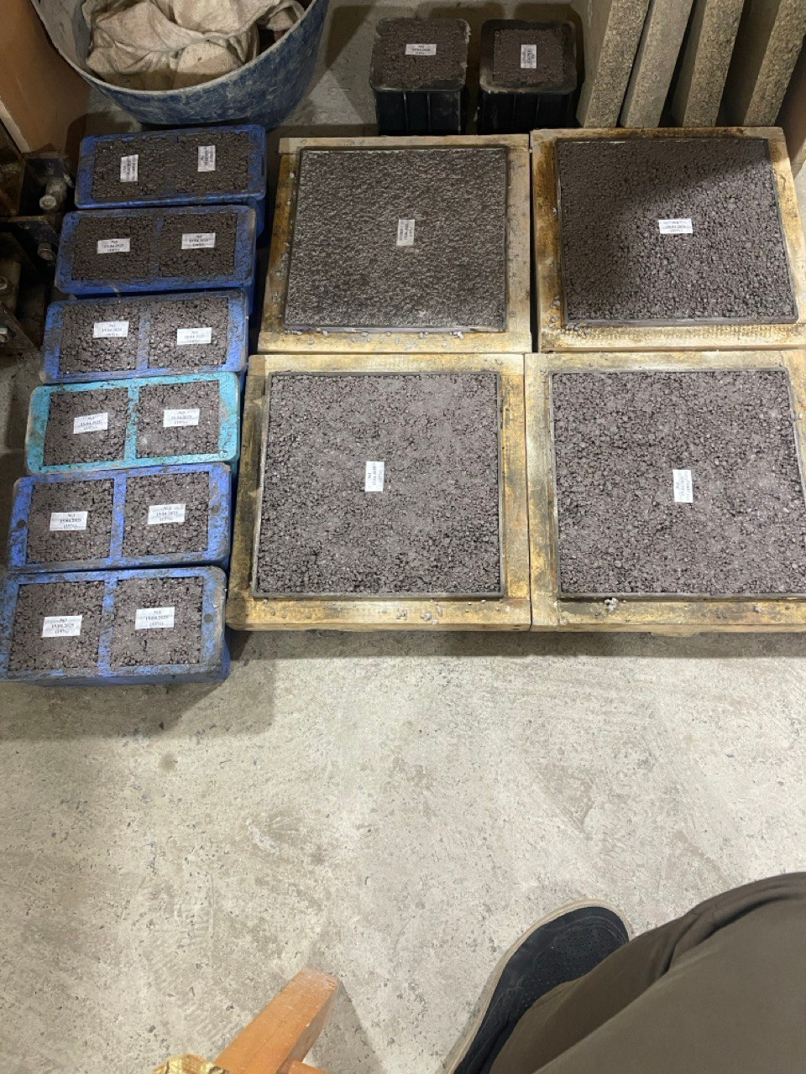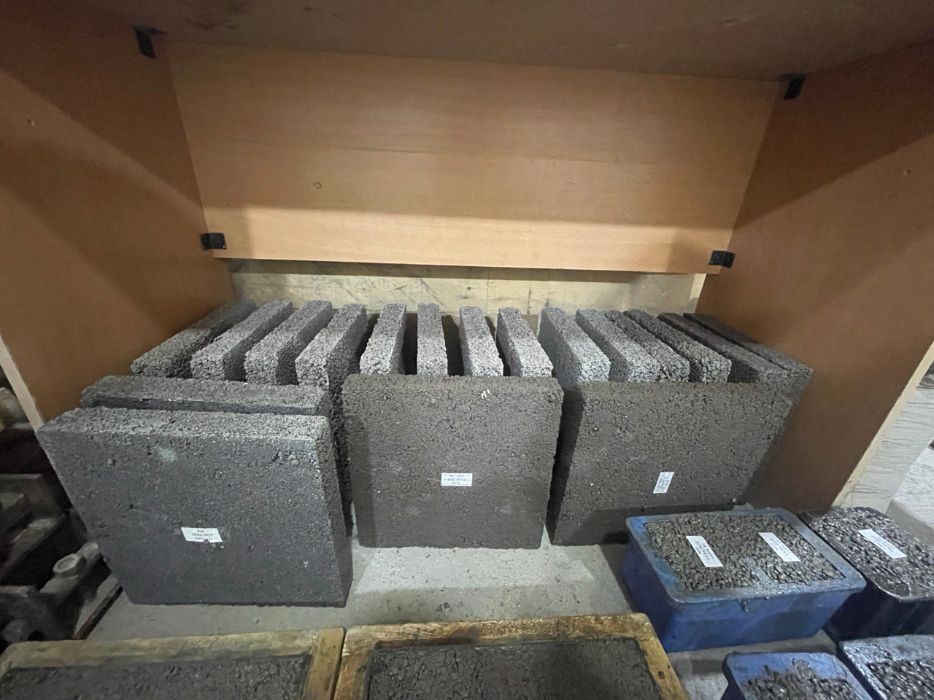

a) b)

FIGURE 1. Molded a) and demolded b) samples.

1. Method for Determining Density: The average density of the concrete samples was determined in accordance with the requirements of the Russian GOST 12730.1-78. For this purpose, each test specimen was weighed in a dry state using a laboratory scale, and its volume was calculated based on its dimensions. The density was calculated using the following formula (1):

$ρ = \frac{m}{V}$ (1)
Where: ρ - density (kg/m³), m – mass of the sample (kg), V – volume of the sample (m³).

2. Compressive Strength Test: The compressive strength of the concrete was determined according to the Russian GOST 10180-2012. Three cube-shaped samples (100×100×100 mm) prepared from each composition were tested using a hydraulic press after 28 days of curing. The test results were calculated in megapascals (MPa) (2).
$R = \frac{P}{A}$ (2)
Where: R – compressive strength (MPa), P – maximum load at failure (N), A – surface area of the cube (mm²).

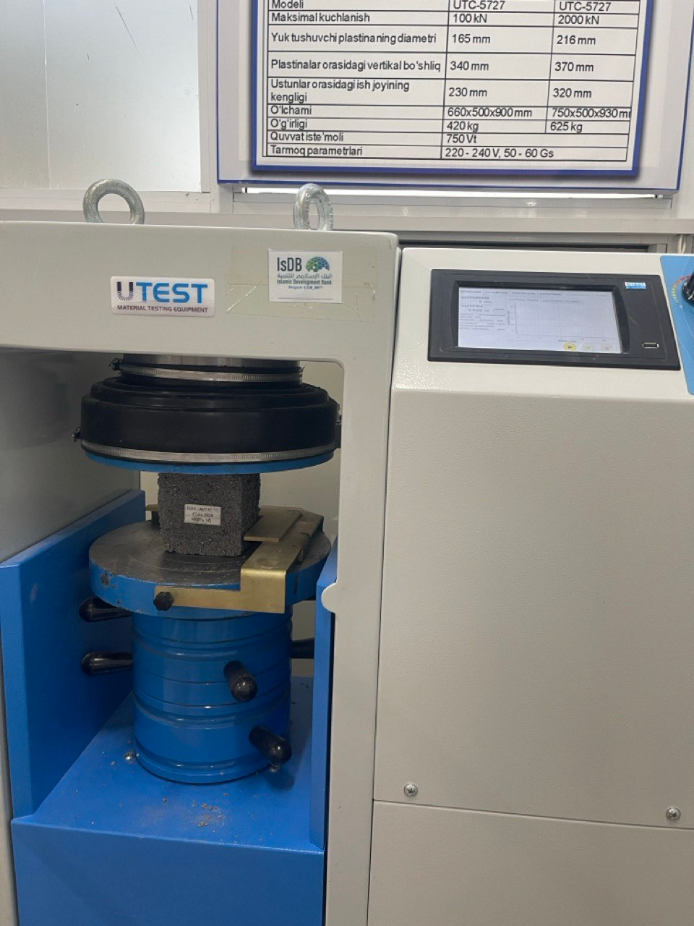

FIGURE 2. 28 day strength testing process for samples.

3. Water absorption test: Water absorption was determined according to the Russian GOST 12730.3-78 standards. First, the sample was dried for 24 hours and its mass was measured (m₁). Then it was submerged in water for 48 hours, after which the saturated mass was measured again (m₂). The water absorption percentage was calculated using the following formula (3):
$W = \frac{m_{2}-m_{1}}{m_{1}} ×100\%$ (3)
m₁ – mass of the dried sample (g or kg), m₂ – mass after water absorption (g or kg)
4. Determination of Thermal Conductivity: The thermal conductivity coefficient was determined in accordance with GOST 7076-99. For this purpose, a special laboratory device for measuring thermal conductivity-such as a plate-type thermal conductivity meter (e.g., FP-1, TKM-M, etc.)-was used.
After complete drying, the concrete samples were placed in the measuring device, and readings were taken by passing a heat flow through the sample. The results were recorded in W/(m·K) units (watts per meter-kelvin).

5. Statistical Analysis Method: The obtained experimental results were processed using Microsoft Excel and statistical software tools such as OriginLab and SPSS. The data were analyzed in the form of mean values, standard deviations, and graphical representations. Each data point was measured at least three times and then averaged to ensure accuracy.

6. Research Approach: Waste materials were added in proportions of 10%, 15%, 20%, and 25% relative to the mass of cement, and their effects were evaluated sequentially. Each type of waste material (fly ash, microsilica, peroxenite) was treated as a separate test group. The obtained results were compared with a control group (concrete without any waste additives) (see Table 1).

TABLE 1. Types and description of raw materials used.
Component | Description
Portland cement | Grade M450. Quality indicators meet the requirements of GOST 10178-85
Expanded clay | Lightweight aggregate with a 5–20 mm fraction. Supplied by a local manufacturer
Water | Technical water of potable quality. Used for the hydration reaction with cement
 |  | Waste additives
 | Slag – obtained from the hydroelectric power plant filter.
 | Microsilica – an inorganic powder by-product of the silicate industry.
 | Peroxenite is an igneous rock belonging to the gabbro-gneiss group, typically formed around tungsten ore deposits. In this study, it was used in powdered form after grinding.
EXPERIMENTAL PART
According to the experimental results, the density of expanded clay concrete samples with added waste materials ranged from 1260 to 1300 kg/m³. These values confirm the suitability of the concrete as a lightweight construction material. Increasing the amount of waste additives up to 20% reduced the concrete mass compared to the control samples, which had a positive effect in terms of thermal insulation and load reduction.

The compressive strength of the expanded clay concrete was determined using a hydraulic press after 28 days of curing (see Table 2).

TABLE 2. The compressive strength of the expanded clay concrete.
Additional type | Quantity (relative to cement) | Durability (28 days) | Force (kN) | Rated pressure (MPa)
Peroxynite | 20% | The best | 120 kN | 13.33 MPa
Slag | 20% | Average | 86 kN | 9.55 MPa
Microsilica | 20% | Relatively low | 71 kN | 7.88 MPa

Analysis: The highest compressive strength was observed in the sample with 20% peroxenite addition (13.33 MPa). This indicates that the minerals in peroxenite formed strong chemical bonds with the cement.
A relatively good result (9.55 MPa) was also observed when slag was added, which can be attributed to its pozzolanic properties.
The samples with microsilica showed the lowest strength (7.88 MPa), suggesting that this additive primarily fills micro-voids but does not actively participate in chemical reactions.
During the determination of the thermal conductivity coefficient, the following results were obtained:
In the course of the study, the thermal conductivity coefficient λ (lambda) and thermal resistance R were determined for keramzite concrete samples with 20% waste additives (slag, microsilica, and peroxenite) (Table 3).
Analysis: Samples containing microsilica and peroxenite exhibited the lowest thermal conductivity coefficient (λ = 0.25 W/m·K), indicating their poor heat transfer capability-i.e., they possess good thermal insulation properties.
In terms of thermal resistance (R), the same samples (with microsilica and peroxenite) showed values of 0.19 m²·K/W, which is considered favorable for insulation purposes.

TABLE 3. Determining the thermal conductivity and thermal resistance of samples
Additional type | λ (W/m·K) – Thermal conductivity | R (m²·K/W) – Thermal resistance
Slag | 0.27 | 0.18
Microsilica | 0.25 | 0.19
Peroxynite | 0.25 | 0.19

The sample with slag (zola) had a slightly higher thermal conductivity of 0.27 W/m·K, meaning it conducts more heat compared to the other two additives, resulting in somewhat lower insulation performance.
As seen in Figures 1 and 2, we prepared the samples in 30×30×5 cm molds, with two samples for each batch. After 28 days, the samples were placed in a drying oven and dried for 48 hours at a temperature of 105 ±5°C, then tested using appropriate equipment.
Among the samples prepared with 20% additions of slag, microsilica, and peroxenite, the results of the samples containing microsilica and peroxenite were nearly identical (see Figures 3 and 4).

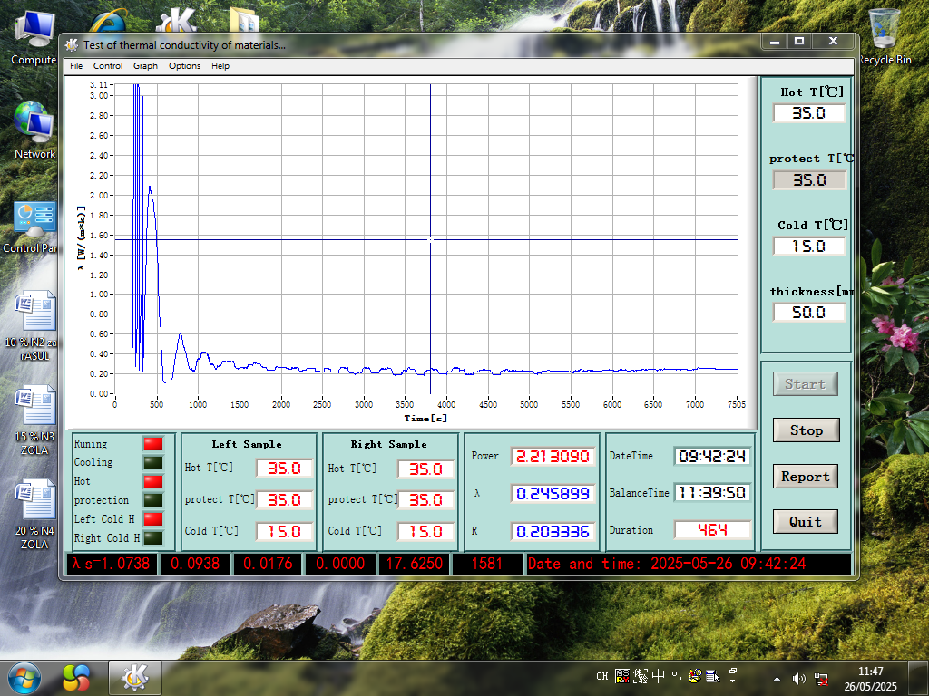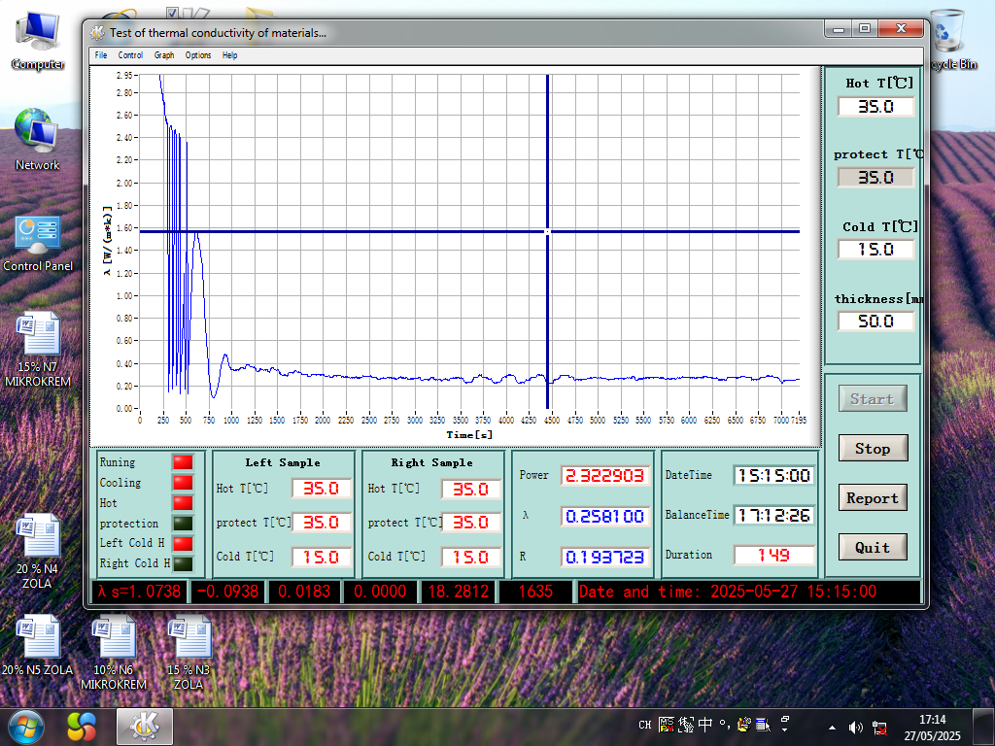
a) b)
FIGURE 3. Determination of the thermal conductivity coefficient of concrete samples containing slag a) and microsilica b).

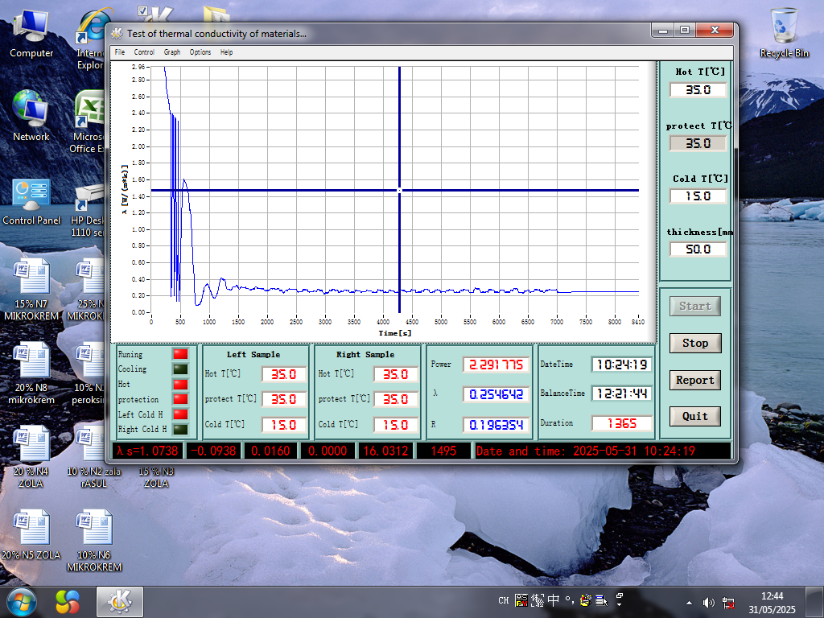
FIGURE 4. Determination of the thermal conductivity coefficient of the sample prepared with peroxenite.

The research results indicate that, from the perspective of thermophysical properties, the keramzite concrete samples with added microsilica and peroxenite have high thermal insulation capabilities. Their thermal conductivity coefficient is around 0.25 W/m·K, which is 5 to 7 times lower than that of conventional heavy concrete (λ = 1.4–1.7 W/m·K).
Based on this, it is advisable to use these materials in the following construction applications:
- In buildings where minimizing heat loss is required;
- In building components that require both thermal insulation and structural load-bearing capacity (such as wall blocks and panels);
- In building structures designed for high energy efficiency (e.g., passive houses).
The addition of waste-based materials to the keramzite concrete mix significantly improves its thermophysical properties. In particular, compositions with 20% microsilica or peroxenite stand out as optimal materials due to their low thermal conductivity, relatively low density, yet adequate strength.
CONCLUSION
In this study, expanded clay concrete mixtures incorporating industrial waste materials - ash microsilica and peroxenite - were prepared, and their physical-mechanical and thermal-technical properties were thoroughly investigated. During the experiments, these waste additives were introduced at 10%, 15%, 20%, and 25% relative to the mass of cement, and the samples were tested for 28-day compressive strength.
The highest compressive strength was observed in the sample with 20% peroxenite addition, reaching 120 kN, indicating that peroxenite enhances the material’s resistance to stress.
In the ash-added sample, the best result was 86 kN, while the microsilica sample reached 71 kN, reflecting the varying reinforcement characteristics of the different additives.
All three waste-based samples exhibited optimal density values in the range of 1260-1300 kg/m³, confirming their potential for use in lightweight, low-thermal-conductivity structural and insulation concretes.
Regarding thermal conductivity, the samples with microsilica and peroxenite performed best (λ = 0.25 W/m·K, R = 0.19 m²·K/W), demonstrating their superior insulating properties due to poor heat conduction.
Overall, the expanded clay concrete mixture containing 20% peroxenite was identified as the most optimal composition. This formulation shows high potential for the production of structural-thermal insulating construction materials.
REFERENCES
- Berdiyev, O., Kurbanov, Z., Tilavov, E., Rasulova, N., Boboqulova, S., Jumanov, I., Ametov, R., O‘Roqboyev, O., Parsaeva, N., & Botirov, B. (2024). The calculation of reinforced concrete conical dome shells considering concrete creep. E3S Web of Conferences, 587, 03001. https://doi.org/10.1051/e3sconf/202458703001
- Shaik, S. B., Karthikeyan, J., & Jayabalan, P. (2020). Influence of using agro-waste as a partial replacement in cement on the compressive strength of concrete – A statistical approach. Construction and Building Materials, 250, 118746. https://doi.org/10.1016/j.conbuildmat.2020.118746
- Kocherov, Y., Kolesnikov, A., Makulbekova, G., Mamitova, A., Ramatullaeva, L., Medeshev, B., & Kolesnikova, O. (2024). Investigation of the Physico-Chemical and Mechanical Properties of Expanded Ceramsite Granules Made on the Basis of Coal Mining Waste. Journal of Composites Science, 8(8), 306. https://doi.org/10.3390/jcs8080306
- Demetrious, A., Verghese, K., Stasinopoulos, P., & Crossin, E. (2018). Comparison of alternative methods for managing the residual of material recovery facilities using life cycle assessment. Resources Conservation and Recycling, 136, 33–45. https://doi.org/10.1016/j.resconrec.2018.03.024
- Wang, H., Zhang, G., & Wang, J. (2019). Quasi-Static Rheological Properties of Lithium-Based Magnetorheological Grease under Large Deformation. Materials, 12(15), 2431. https://doi.org/10.3390/ma12152431
- Brady, L., & Abdellatif, M. (2017b). Assessment of energy consumption in existing buildings. Energy and Buildings, 149, 142–150. https://doi.org/10.1016/j.enbuild.2017.05.051

