Enzyme and Silicone-Based Modification of Wool Fiber Morphology: a Smart Materials Approach for Softness Enhancement
Zulaykho Islamova^{1, a)}, Iroda Nabieva¹, Atham Nuriddinov², Anvar Abdumajidov¹, Nabijon Nabiev³, Abdumalik Mirataev¹, Dilnoza Matkarimova⁴
¹Tashkent Institute of Textile and Light Industry, Tashkent, Uzbekistan
²Center for Quality Control and Scientific Research under the Scientific Testing and Quality Control Center of Uzbekistan, Tashkent, Uzbekistan
³Raw materials cellulose LLC, Tashkent, Uzbekistan
⁴Urgench State University named after Abu Raykhon Beruniy, Urgench, Uzbekistan

^{a)}Corresponding author: zulayho.islamova@mail.ru
Abstract. In this article, coarse wool fiber of the “Hisori” breed, grown in the climatic conditions of Uzbekistan, with a diameter of 65.38 μm and a length of 12-14 mm, was taken as an object. The treatment with the “MEJLUMEN” enzyme was carried out at a temperature of 40⁰C in a solution containing 0.1 g/l of enzyme and 1.3 g/l of SAM. According to the results of the experiment, the primary treatment of wool fiber was carried out in two and three stages, as well as a 20 g/l silicone solution was used to soften the fiber. In the process of softening coarse wool fiber, the enzyme reacts with the wool fiber and decomposes it 100% compared to chemical reagents. In addition, enzymes can perform their activity in an acidic environment and at relatively low temperatures. Research has also shown that wool fiber can be modified with silicone softeners to impart softness to the fiber. According to the results of the experiment, when treating wool with enzymes, its softness index increased to 6 mN/cm², and when treated with silicone solutions, the softness improved to 12 mN/cm². According to the analysis of the experimental results, it was found that a complex treatment method is effective in softening coarse wool fiber - first enzyme modification, then treatment with silicone solution.
Keywords: coarse wool, biotechnology, softening, softening, enzyme, silicone, fineness property, washing process, wettability, processing, environment, stability, appret solution.

INTRODUCTION

Abroad, 25% of textile finishing processes for outerwear are devoted to “softening,” 17% to desizing using enzymes, and 14% to bleaching. Biotechnological treatments of textile materials are carried out to impart luster, smoothness, and softness [1–3], to increase hydrophilicity [4–6], and during shrink-resist finishing and carbonization processes. Modern microbiological industry offers producers environmentally safe enzymes with diverse properties and functionalities, capable of performing various tasks while minimizing adverse effects on fibrous materials.
One of the main reasons for the use of enzymes in biotechnological processing is their complete biodegradability compared to chemical reagents. In addition, enzymes can perform their functions in a neutral medium at relatively low temperatures [7]. Under the influence of amylase [8–10], the whiteness and absorbency of textile materials further increase. Studies have shown that at present, wool fibers can be treated not only with enzymes [11] but also with lignosulfonates [12], which not only improves the physicochemical properties of the fibers but also produces even coloration during the dyeing process. Furthermore, wool fibers can be modified with silicone softeners and acrylic emulsions to impart softness [13–17]. Enzymatic and plasma treatments can reduce fiber brittleness. Polymer coatings have been studied by researchers for their ability to improve shrink resistance and finishing properties of fibers. The possibilities of imparting antistatic properties to wool fibers by subsequent treatment with aqueous solutions of two types of polyurethane—cationic (CWPU) and anionic polyurethane—as well as with graphene–cellulose nanocrystals, have also been explored [18–20].
Research has shown [21] that the use of enzymes at high concentrations has a negative effect on wool fibers, in particular, deteriorating their physicochemical properties and making the fibers brittle. Due to the complex histological structure and epidermal origin of wool, it consists of a scaly layer of keratin proteins in a horny form. These proteins contain 19 types of amino acids, which undergo destruction under the influence of alkalis [22]. For this reason, strong alkaline treatment of wool is not advisable.
In this study, for the first time, enzymes and silicone agents are applied in combination, testing an innovative approach to impart softness to wool fibers. The main objective of the research is to investigate the possibility of nano-level modification of wool with silicone solutions after biological treatment, thereby enhancing its softness.
Research has shown [21] that the use of highly concentrated enzymatic methods has certain drawbacks, leading to deterioration of the fiber’s physicochemical properties and increased brittleness. Due to its complex histological structure and epidermal origin, wool has a horny appearance and consists of a scaly layer, with keratin proteins forming its basis. These proteins, in turn, contain 19 different types of amino acids [22]. Since the fiber undergoes destruction under the influence of alkalis, treatment in a strongly alkaline environment is not feasible.

METHODOLOGY
In the study, coarse “Hisori” breed wool fibers grown under the climatic conditions of Uzbekistan, with a diameter of 65.38 μm and a length of 12–14 mm, were used as the object. The wool contained 11.2% grease, 2.4% impurities, and 5.3% moisture.
Before the softening process, the coarse wool fibers were washed in a solution containing a surfactant (1 g/L), sodium carbonate (to pH 9), and soap (1.5 g/L) at a temperature of 45–50 °C for 50–60 minutes. The second washing stage was carried out in a solution containing 12 g/L hydrogen peroxide and 2 g/L ammonium hydroxide at 60 °C for 45–60 minutes.
Although the washed wool fibers became wettable, their brown color did not allow for achieving the desired shade and color tones. In the next stage of the experiments, the washed brown wool fibers were treated with the enzyme “MEZHLUMEN” at 40 °C for 160 minutes. Afterwards, they were subjected to treatment for 60 minutes at 40 °C in a solution containing 20 g/L softener using a “Water bath shaker DL-2003” device. The samples were then dried, and the softness degree was assessed organoleptically by comparing the fibers before and after softening.
The moisture content of the coarse wool fibers was determined according to GOST 18080-95, the fiber diameter according to GOST 17514-93, and the staple length according to GOST 21244-75. The residual grease content in the fibers was determined using a Soxhlet apparatus in accordance with GOST 21008-93 and GOST ISO 3074–2017 by extraction with perchloroethylene.
The processes of biological treatment and softening of the samples were carried out at the “Kor-Uz Textile Technopark” scientific laboratory using a Water bath shaker DL-2003. The pH values of the solutions were measured with a Wissenschaftlich-Technische Werkstatten (WTW) pH3210 SET2 device, and the morphological analysis of the wool fiber surface structure was performed with a Scanning Electron Microscope system “SEM – Veritas-3100” (Korea). For carrying out biochemical reactions with coarse wool, the “Mezhlumen” enzyme synthesized by the “Institute of Plant Substances Chemistry” was used.

RESULTS AND DISCUSSION
The research was conducted on coarse “Hisori” wool fibers, which, compared to Merino fibers, are harder and less elastic. Therefore, the main objective was to soften the fibers and improve their frictional properties through biotechnological treatment.
Currently, technologies for the artificial synthesis of protein fibers are also being developed worldwide. All protein substances are called proteins, and they are natural or synthetic macromolecules with high molecular weight.
TABLE 1. Main elements in the composition of proteins
Element name | Symbol | Quantitative share (% in the molecule)
Carbon | C | ~50–55%
Hydrogen | H | ~6–7%
Oxygen | O | ~20–23%
Sulfur | S | ≤2%
All protein substances are called proteins, and they are macromolecules with high molecular weight. Proteins mainly contain the elements listed in Table 1.
According to research, some proteins may also contain additional elements—iron (Fe), phosphorus (P), iodine (I), and other halogens—especially when proteins are influenced by enzymes [2].
Proteins are composed of 20 types of natural amino acids, which, when linked together in various sequences and repetitions, form polypeptide chains with different functions (see Fig. 1). It can be observed that protein amino acids are connected to each other through peptide bonds.

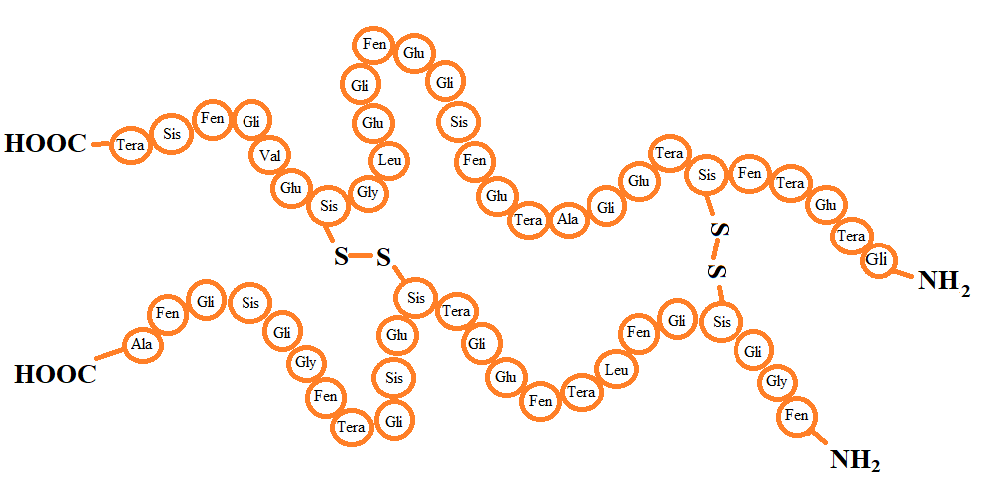
FIGURE 1. Structural organization of a protein

Proteins have a four-level structure. The primary structure is the sequence of amino acids along the chain. The secondary structure refers to the arrangement of the peptide chain in the form of an α-helix or β-sheet, stabilized by hydrogen bonds. The tertiary structure is formed when the peptide chain folds in space to create a globular or fibrillar shape. The quaternary structure occurs when several polypeptide chains combine to form a complex protein molecule (see Fig. 2).
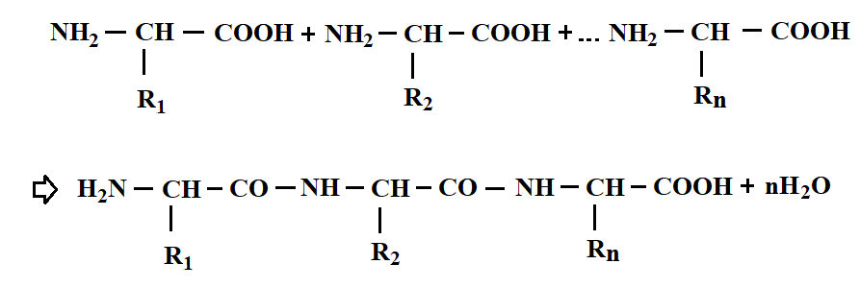
FIGURE 2. Spatial structure of protein macromolecules

The properties of proteins depend on their amino acid composition, molecular sequence, and spatial structure of protein macromolecules. The physicochemical, mechanical, and technological properties of natural protein fibers, including wool, are directly related to their amino acid composition, the sequence of amino acid chains, and the spatial structure of macromolecules. These structures determine the stability of fiber properties, resistance to chemical influences, and variability in processing processes. Therefore, it was considered important to preserve the natural structure and functional properties of wool fibers when chemically treating them. This, in turn, requires the use of advanced finishing technologies that improve the aesthetic and functional indicators of the fibers without adversely affecting their mechanical strength, that is, without damaging them. Such an approach allows to increase the quality of textile products made of wool, to ensure long-term usability and to produce products with high added value.
Results of enzyme treatment
At the next stage of the research work, a series of step-by-step processing processes were carried out in order to improve the softness properties of coarse wool fibers, as well as to give them a sense of softness and elegance. The technological sequence of the processes is presented in Figure 3 below.
In the first stage, the fiber was washed and cleaned, using a nonionic type of SAM and soda to remove natural impurities, oils and waxy substances from the fibers. Under the influence of an environment with a pH of 9, oily waxy substances are released from the fiber into the solution, ensuring the fiber's softness. The silicate substances in the soap emulsify the dirt and ensure that it is not reabsorbed into the fiber. First, the fibers were washed with detergents at a temperature of 50°C.
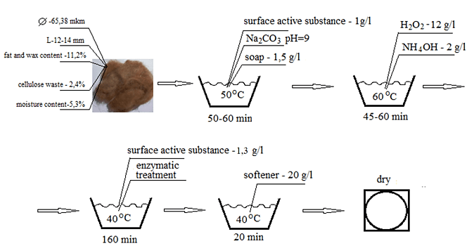
FIGURE 3. Coarse wool fiber softening technology

This process lasted 50–60 minutes. Since the fat content in the fiber was -11.2%, and the amount of impurities was 2.4%, the second wash was carried out for additional cleaning, which was carried out at a temperature of 60°C. At this stage, all fats and impurities were completely removed from the surface structure of the fibers. The next treatment was enzymatic treatment, which was carried out with the enzyme “MEJLUMEN” for 160 minutes at a temperature of 40°C (see Fig. 4).

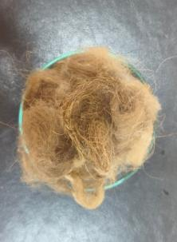 | 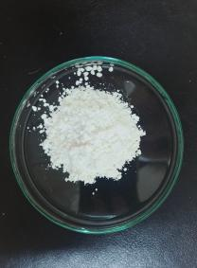 | 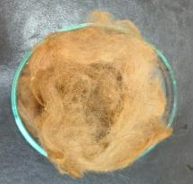
a | b | c
FIGURE 4. Photographs of coarse wool before and after enzymatic treatment: a – untreated, b – Mezhlumen enzyme, c – after enzymatic treatment

Keratin-based proteins located in the cuticle layer undergo destructive changes under the influence of specific enzymes. As a result of this process, the “structure–function” relationship of fibrous proteins—both fibril and globular structures—is disrupted. Such biochemical changes lead to the breaking of hydrophobic and hydrogen bonds in protein molecules, changes in conformation, and the disturbance of physicochemical equilibrium in both amorphous and crystalline regions of the protein. Consequently, significant changes in the functional and mechanical properties of the fiber structure were observed.
In the next stage of the experimental work, treatment with enzyme at various concentrations was performed, the results of which are presented in Table 2.

TABLE 2. Concentration dependence of enzyme treatment of coarse wool fiber
Enzyme concentration, g/L | - | 0,01 | 0,05 | 0,1 | 0,5
Extracted grease content, % | 18 | 2 | 4,5 | 10,8 | 16,2

The results of the study showed that during the enzymatic treatment of wool fiber, up to 80–90% of the fatty substances in its composition were effectively washed out and the degree of fiber purification increased significantly.
Although the amount of fat released from wool fiber increased with increasing enzyme concentration, organoleptic analysis of the fiber revealed that it became brittle. This phenomenon was especially noticeable at an enzyme concentration of 0.5 g/l (see Fig. 5).

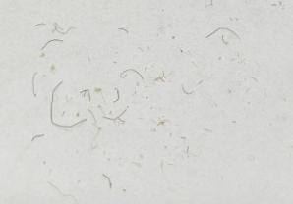 | 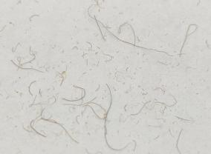
a | b
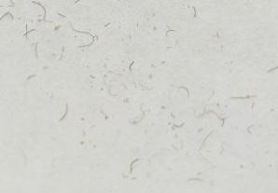 | 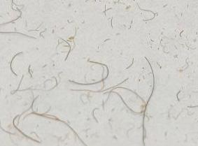
c | d
FIGURE 5. Dependence of organoleptic analysis of fibers on enzyme concentration (indirect method): Enzyme concentration: a) – 0.01 g/L; b) – 0.05 g/L; c) – 0.1 g/L; d) – 0.5 g/L

According to the results of the organoleptic analysis of the fibers, for further studies, an enzyme concentration of 0.1 g/L was selected for the wool washing process, and the effect of treatment duration on the washability of wool fibers was investigated (see Table 3).

TABLE 3. Effect of enzymatic treatment duration on the washability of wool fibers
Process duration, min | 20 | 40 | 60 | 80 | 100 | 120 | 160
Extracted grease content, % | 2,5 | 8,6 | 10,2 | 10,2 | 10,6 | 10,8 | 10,8
Note: treatment temperature – 40 °C.

The analysis of the presented experimental results showed that extending the enzymatic treatment process beyond 60 minutes did not change the amount of grease removed from the wool fibers.
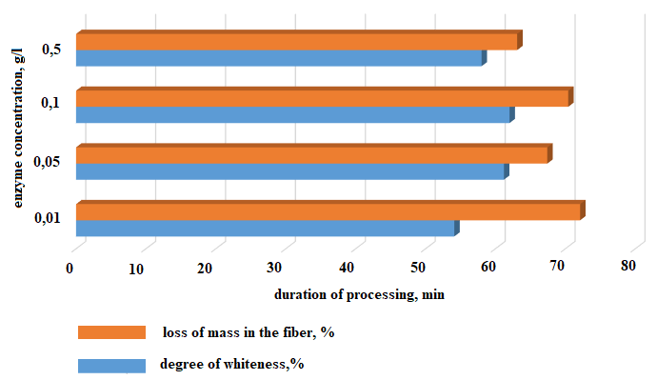
FIGURE 6. Effect of enzyme concentration and chemical reagents on the whiteness and destruction of wool fibers.

When studying the effect of temperature on enzyme activity, it was observed that increasing the temperature above 50 °C led to a decrease in the amount of grease removed from the fibers. Therefore, the optimal activity of the enzyme used in the experiments was determined to be at 40 °C.
The changes in the properties of wool fibers after enzymatic treatment are presented in above diagram (see Fig. 6).
From the presented diagram, it can be seen that when enzymes are applied, the whiteness of the wool fibers increases; however, at the same time, their mechanical properties—specifically, fiber strength—decrease.
Results of scanning electron microscope (SEM) analysis of the effect of enzyme concentration on fiber surface (destruction)
In the subsequent studies, the effect of enzyme concentration on the fiber surface (destruction) was investigated, and morphological changes in the cuticle layer of the fibers were analyzed using a scanning electron microscope (SEM). The microscopic results showed that the scale layers on the fiber surface were partially or completely degraded, and the surface structure had changed. The analysis results are presented in Figure 7.

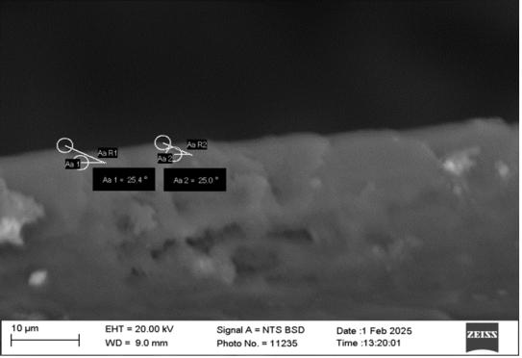 | 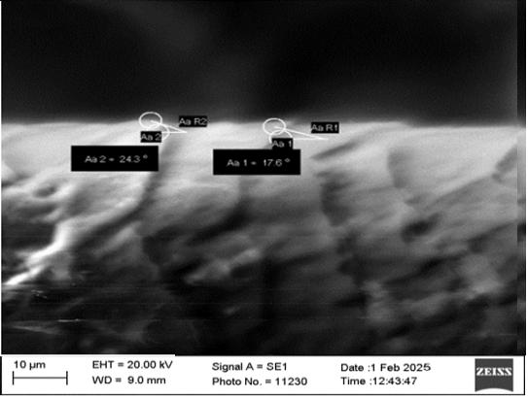
a | b
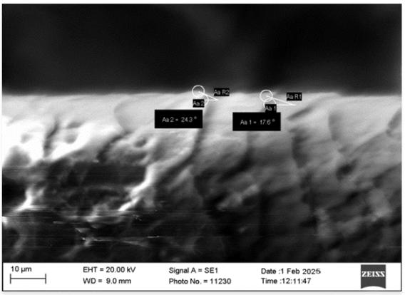 | 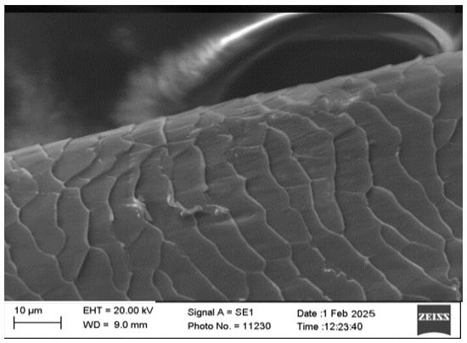
c | d
FIGURE 7. Changes in the surface of wool fibers under the influence of enzyme concentration: Enzyme concentration, g/L: a) – 0.5; b) – 0.1; c) – 0.05; d) – 0.01
The results showed that at an enzyme concentration of 0.01 g/L, the cuticle layer was partially degraded; at concentrations of 0.05 g/L and 0.1 g/L, the scales located in the cuticle layer had roughness parameters of R1 = 17.6° – R2 = 24.3°, indicating that the fiber surface became smoother and acquired a softer handle. At 0.5 g/L, however, the values were R1 = 25.4° – R2 = 25.0°, which corresponded to structural damage to the epicuticle layer. This indicates that the wool fibers became brittle and their mechanical strength decreased.
Based on the experimental results, it was shown that carrying out the primary treatment process of wool fibers in two or three stages had a positive effect on fiber whiteness and strength. In the first stage, chemical reagents and surfactants (SAM) are used. As a chemical reagent, a weak soda solution can be applied. Under such conditions, easily removable impurities are eliminated from the wool fiber.
In the second stage, the wool fiber is treated for a prolonged period in a solution containing washing agents and enzymes. The removal of residual impurities from the fiber and the deactivation of enzyme activity are carried out by washing the wool fibers. Enzymatic treatment of wool fibers is performed at 40 °C in a solution containing 0.1 g/L of enzyme and 1.3 g/L of surfactant (SAM).
Treatment of coarse wool fibers with silicone compounds
To soften coarse wool fibers, various silicone compounds, surfactants (SAM), oil emulsions, and chemical modifiers based on condensation products of fatty acids are used. Such modifiers form a thin coating layer on the surface of the wool fiber, improving its physicomechanical properties—particularly increasing fiber fineness and softness.
However, during wet processing of wool products (including washing, dyeing, or other technological operations in a moist environment), these modifiers can be washed off from the fiber surface. This, in turn, causes the wool fibers to revert to their original coarse state, reducing the effectiveness of the modification.
In the conducted studies, a treatment process was carried out using a 20 g/L solution of “Belfasin 2597 CONC” silicone. The obtained results are shown in Figure 8, which compares the condition of wool fibers before and after modification.

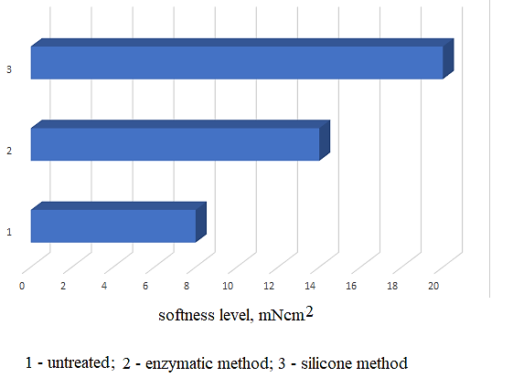
FIGURE 8. Softness level of wool fibers
According to the analysis of the results, softening of coarse wool fibers can be achieved by applying silicone solution treatment after enzymatic processing. Silicone treatment was carried out at 40 °C for 20 minutes.
The softness of wool fibers varies depending on different processing methods, and according to the results of the experiment, when wool was treated with enzymes, its softness index increased to 6 mN/cm², which indicates that the softness increased as a result of the effective decomposition of natural oils and dirt on the surface of the fiber. At the same time, when treated with silicone solutions, the softness improved to 12 mN/cm². Silicones form a thin, oily layer on the surface of the fiber, which, due to the liquefaction effect, ensures easy movement of adjacent fibers relative to each other and increases the overall feeling of softness. According to the analysis of the results of the experiment, it was found that a complex processing method is effective in softening coarse wool fibers - first enzyme modification, then treatment with a silicone solution. In particular, silicone treatment was carried out at a temperature of 40 °C for 20 minutes.
The degree of softness of wool fibers varied significantly depending on the treatment method used. For example, in fibers treated with enzymes, the softness index increased to 6 mN/cm², which indicates that the enzymes were able to eliminate surface irregularities by breaking down natural oils, dirt and keratin-based substances on the surface of the wool fiber.
In samples treated with a silicone solution, the softness index improved to 12 mN/cm². This is explained by the fact that silicone molecules form a thin oily layer on the surface of the wool fiber and, due to the thinning effect of this layer, facilitate the friction of adjacent fibers, increasing the overall softness effect.

CONCLUSION
According to the results of the conducted studies, it was found that enzyme and silicone treatment methods have their place in softening coarse wool fibers. Enzymes have biological properties compared to chemical reagents and, interacting with the wool fiber, effectively break down surface grease, dirt, and keratin in the outer shell that gives the fiber roughness. Also, one of their technological advantages is that enzymes can effectively perform their function even at low temperatures (30–40 °C) and in acidic environments. On the other hand, silicone-based softening modifiers form a thin, liquefying, and protective polymer layer on the surface of the wool fiber, facilitating the movement of the fiber, reducing its fragility, and increasing the feeling of softness. Polymer coatings, at the same time, reduce the permeability of the fiber to water and dirt. According to the experimental results, the softness level of wool fibers treated with enzymes increased to 6 mN/cm², while in samples treated with silicone modifiers this indicator reached 12 mN/cm². This indicates that the softening effect of silicone modifiers is higher than that of enzymes. It was also found that the sequential use of enzymes and silicone modifiers improves the physicochemical properties of coarse wool fibers, increasing the softness and aesthetic qualities of the product.
Based on these results, treatments based on enzymes and silicone modifiers create the possibility of forming wool fibers as "smart materials" with an active surface and a modified structure. In the future, the thermal stability, hydrophobicity and high mechanical properties of nano-layers formed in such modified fibers are recommended for the production of functional material clothing.

REFERENCES
- Cardamone, J. M., Yao, J., & Phillips, J. G. (2005). Combined bleaching, shrinkage prevention, and biopolishing of wool fabrics. Textile Research Journal, 75(2), 169–174. https://doi.org/10.1177/004051750507500215
- Kim, J., Kwon, M. Y., & Kim, S. (2016). Biological Degumming of Silk Fabrics with Proteolytic Enzymes. Journal of Natural Fibers, 13, 629-639.
- Peng, S., Jin, Y., Cheng, X., Sun, T., Qi, R., & Fan, B. (2015). A new method to synthesize high solid content waterborne polyurethanes by strict control of bimodal particle size distribution. Progress in Organic Coatings, 86, 1–10. https://doi.org/10.1016/j.porgcoat.2015.03.013
- Lee, S.H., Yeo, S.Y. Improvement of hydrophilicity of polylactic acid (PLA) fabrics by means of a proteolytic enzyme from Bacillus licheniformis . Fibers Polym 17, 1154–1161 (2016). https://doi.org/10.1007/s12221-016-5923-z
- Cardamone, J. M., Yao, J., & Nuńez, A. (2004). Controlling shrinkage in wool fabrics: effective hydrogen peroxide systems. Textile Research Journal, 74(10), 887–898. https://doi.org/10.1177/004051750407401008
- Cardamone, J. M., Nuñez, A., Ashby, R., & Dudley, R. (2006). Activated peroxide for enzymatic control of wool shrinkage Part I: Elucidation. Textile Research Journal, 76(2), 99–108. https://doi.org/10.1177/0040517506061030
- Quliyev, T. M., Maqsudov, E. T., Jumaniyazov, Q., Djumabayev, G. X., Korabayev, Sh. A., & another author. (2025). Optimization of twist triangle geometry and drafting system for enhanced yarn quality in ring spinning. Izvestiya Vysshikh Uchebnykh Zavedenii, Seriya Teknologiya Tekstil'noi Promyshlennosti, (3), 157–164. https://doi.org/10.47367/0021-3497_2025_3_157
- Toprak, T., & Anis, P. (2016). Combined one-bath desizing–scouring–depilling enzymatic process and effect of some process parameters. Cellulose, 24(1), 383–394. https://doi.org/10.1007/s10570-016-1095-7
- Dagenais, J. (2019). Cotton: History, properties and uses. Nova Science Publishers, Inc. (pp. 1–151)
- Shen, J. (2010). Enzymatic treatment of wool and silk fibres. In Elsevier eBooks (pp. 171–192). https://doi.org/10.1533/9780857090232.2.171
- Shen, J. (2019). Enzymatic treatment of wool and silk fibers. In Elsevier eBooks (pp. 77–105). https://doi.org/10.1016/b978-0-08-102632-8.00005-0
- Smirnova, S. V. (2015). Application of lignosulfonates in wool finishing. In Physicochemistry of Plant Polymers [Proceedings of the 6th International Conference, Arkhangelsk, June 22–25, 2015] (pp. 303–304). Arkhangelsk.
- Khusainova, M. O. (2015). The use of acrylic emulsions in shape retention finishing of garments. Bulletin of Kazan Technological University, 18(22), 119–120.
- Slepneva, E. V. (2015). Study of the optical properties of wool fibers modified during primary processing. Bulletin of Kazan Technological University, 18(15), 159–160.
- Novoradovsky, A. (1998). Application of Clariant enzymes in the finishing of textile materials. Textile Chemistry, (2), 73–84.
- Gao, Y., & Cranston, R. (2010). An effective antimicrobial treatment for wool using polyhexamethylene biguanide as the biocide, part 2: Further characterizations of the fabrics. Journal of Applied Polymer Science, 117(5), 2882–2887. https://doi.org/10.1002/app.32199
- Zhumaniyazov, M. Z., Beglov, B. M., Khodzhaev, O. F., & Yuldashev, N. K. (2004). Solubility Polytherm of the Ternary system Hexamethylenetetramine-Ammonium dihydrogen Phosphate-Water. Russian Journal of General Chemistry, 74(7), 1001–1004. https://doi.org/10.1023/b:rugc.0000045855.52134.25
- Hassan, M. M. (2019). A review of the sustainable methods in imparting shrink resistance to wool fabrics. Bioproduct & Fiber Technology Team, AgResearch Ltd. Christchurch, New Zealand.
- Lijie, H., Yongtao, D., Zhiliang, Z., Zhongsheng, S., & Zhihua, S. (2014). Synergistic effect of anionic and nonionic monomers on the synthesis of high solid content waterborne polyurethane. Colloids and Surfaces a Physicochemical and Engineering Aspects, 467, 46–56. https://doi.org/10.1016/j.colsurfa.2014.11.014
- Koksharov, S. A., Kuznetsov, O. Yu., & Oleeva, S. V. (2003). Biochemical technologies in textile production: Realities and prospects. Textile Industry, (4), 51–53.
- Nabiyeva, I., Matkarimova, D., Islamova, Z., & Abdumajidov, A. (2024). RETRACTED: Properties of wool fiber, and environmental problems and solutions of its finishing. E3S Web of Conferences, 538, 04006. https://doi.org/10.1051/e3sconf/202453804006
- Deravi, L. F., Golecki, H. M., & Parker, K. K. (2013b). Protein-Based Textiles: Bio-Inspired and Bio-Derived materials for medical and Non-Medical applications. Journal of Chemical and Biological Interfaces, 1(1), 25–34. https://doi.org/10.1166/jcbi.2013.1009

