Method for Producing Yarn for Smart Textiles
Dilfuza Zakirova¹, Khalima Umurzakova^{1, a)}, Kuziboy Sabirov²,
Ulug‘bek Gulbayev³
¹Tashkent Institute of Textile and Light Industry, Tashkent, Uzbekistan
²Urgench State University, Urgench, Uzbekistan
³Jizzakh Polytechnic Institute, Jizzakh, Uzbekistan

^{a)}Corresponding author: umurzaqova_h@mail.ru
Abstract. The article provides information on smart and nanostructured textile materials, which are a promising direction for the development of the textile industry. To obtain smart products, polyester fiber with changing mechanical and thermal properties was used, and a technological sequence based on their study was recommended. Based on these properties, a new range of polyester fiber shaped threads was recommended for obtaining smart textiles. Polyester threads of different linear densities were selected for the research, and shrinkage during heat treatment was studied. The experiments were carried out at temperatures of 400C, 500C, 600C, 700C, 800C and 900C and processing times of 2, 5, 10, 15 and 20 min. The most satisfactory shrinkage results were shown by polyester thread with a linear density of 17.4 and 19.8 tex at a temperature of 800C-900C and a processing time of 15-20 min, and amounted to 35-53% shrinkage along the length of the thread. A study of the heat treatment of raw silk showed significantly less shrinkage or elongation compared to polyester thread. Therefore, the possibility of obtaining smart textiles from raw silk and polyester thread was established. To obtain twisted thread variants, raw silk and polyester thread were combined and twisted thread variants with a twist of 100, 150, 200 and 250 cr/m were obtained. By boiling, the sericin content in the silk thread was reduced to 7-9% and shrinkage was achieved up to 41-47%. The results obtained proved the possibility of producing smart textiles from natural silk and polyester thread.
Keywords: nanostructured textile fiber, smart fiber, polyester thread, raw silk, fancy thread, heat treatment, temperature, twisting, rewinding, emulsion, shrinkage.
INTRODUCTION
Knowledge of the properties of materials allows us to ensure the quality of manufactured products, reduce their labor intensity and material consumption - the main economic tasks, the solution of which allows us to increase the competitiveness of light industry products. Currently, more and more attention is paid to nanostructured and smart fibers, since by modifying fibers, the possibilities of obtaining products with specified properties that meet modern requirements are expanding. To create new nanostructured threads, filiform nanomaterials with controlled structure and properties are developed and produced. These threads, having dimensions in the nanometer range, have unique mechanical, electrical, optical and other characteristics, which makes them promising for a wide range of applications [1].
The main aspects of creating nanostructured threads are diverse. For example, electrospinning, chemical vapor deposition (CVD), hydrothermal synthesis, mechanochemical processing and others. Nanostructured textile fiber refers to fibers modified at the nanoscale to improve their properties. "Smart" textile fiber is a fiber that can respond to environmental changes, such as temperature, humidity or mechanical impact, and change its properties accordingly. To study new types of textile threads, respectively, fancy threads, we used polyester fiber as a nanostructured and smart fiber. The reason is that polyester fiber has a number of properties, such as strength, wear resistance, resistance to chemicals and stretching. Its modification includes various nanotechnology methods, such as applying nanoparticles, creating nanostructures on the surface or inside the fiber [2].
When its properties are improved, it can have increased strength, water-repellent properties, antimicrobial properties, improved thermal insulation and other characteristics. Smart textile fiber has such functionality as the content of sensors, drives or other components that allow it to respond to external stimuli. It is used in the production of clothing, home textiles, fillings for pillows and blankets, as well as for technical purposes. It can also be used to create heated clothing, color-changing fabrics, health monitoring and other innovative products [3].
Modern chemical fibers and threads have almost come close to natural materials in terms of hygiene and comfort. At the same time, the main advantages of synthetic textiles have remained unchanged - elasticity, practicality, strength, resistance to deformation, to the action of high temperatures, aggressive substances, as well as the ability to impart qualitatively new properties that determine new areas of its application. Today, polyester fiber is one of the most popular types of synthetic fibers. Polyester fibers and threads currently occupy a leading position among chemical fibers. The production of chemical fibers in 2023 amounted to more than 90 thousand tons. Such a rapid growth in the production and consumption of polyester fibers is explained by their versatility and high physical and mechanical properties [4].
Polyester fiber can be used as a basis for creating both nanostructured and smart textile fibers by adding nanoparticles or integrating electronic components. For example, nanostructured polyester fiber can include silver nanoparticles to impart antimicrobial properties; smart polyester fiber can contain heat-sensitive dyes that change color in response to temperature changes; in the medical field, nanostructured polyester fibers can be used to create biocompatible implants. Textile polyester threads, especially textured, patterned ones, are widely used to make various fabrics and knitwear, interior fabrics, cars, etc. Polyester fibers are also used in pure or mixed form, and are used to produce fabrics and knitwear, interior fabrics, artificial fur, carpets. Even today, as a result of the use of the latest technologies, textile materials with improved performance and are safe for the environment are offered. Polyester fiber materials are pleasant to the touch, dry quickly, are easy to clean from various types of dirt, do not wrinkle, are light-resistant and have a high density. Polyester fiber is produced in the form of a complex thread, monofilament, staple fiber, bundle, pile of various forms of manufacture, appearance and color, with various additives. Today, modern manufacturers of polyester fiber, using the latest technology and high-quality equipment, offer products with many advantages and a minimum of disadvantages [5].
Hollow polyester fiber is used to make non-woven materials, which, due to its exceptional properties, have practically replaced feathers and down as fillers in textile products. Siliconized fiber made of polyester fibers, which is produced taking into account the latest developments, is also actively used for textile materials. Polyester fibers with special properties are being developed. For example, antibacterial polyester fiber serves as the basis for a functional material with a permanent antibacterial effect. Highly shrinkable polyester fiber allows non-woven materials to maintain a smooth surface and a high level of shrinkage, which must be taken into account when designing garments that retain their shape for a long time. The development of resource-saving technologies that improve the moldability of clothing is an urgent task. Great importance is attached to the processes of fabric shaping in modern clothing and shape retention. Improved polyester materials and technological developments help to solve one of the important problems that arise when using polyester materials for the production of knitwear, fabrics and interlining material - the defect of "pilling". Microfiber fabrics are light in weight, elastic and do not have the defect of rolling fibers into lumps (pilling). They are also quite durable compared to other fabrics of similar weight. Also, due to the fact that the fibers can closely adhere to each other, microfiber can be successfully used to make waterproof and windproof clothing. Short-cut polyester fiber has improved dispersive properties compared to other conventional polyester fibers. The best fiber for use in cases where moisture penetration is required. High-strength polyester fiber is used to make special high-strength sewing thread.
Further development of chemical and physical methods in production technology led to the creation of second-generation fibers that had modified properties. Another possibility for creating new fibers is to obtain copolymers or mix different polymers immediately before leaving the forming head. Fiber crimping can be achieved in various ways, the most well-known of which are texturing and heat treatment. This uses the property of synthetic fibers to fix the shape given to them. If the fiber is curled in any way, then after straightening it will again tend to form curls.
In this regard, the conducted research is aimed at expanding the range of textile industry, namely, for obtaining fancy threads. Fancy threads are very diverse in structure, linear density, surface character, color, etc. The possibilities of combining various properties of the original components in a fancy thread are almost unlimited. Fancy threads are used in the production of suit and dress, upholstery and curtain fabrics and curtain-tulle products. They can be used both for decorating fabrics and for giving them a special structure and useful performance properties. Fancy threads used for decorating fabrics belong to the decorative type. This type includes threads with roving effects, knotted, with twists and spread. Such threads are used both in the warp and in the weft. When using them, the weaves should be such that the effects are evenly distributed on the front side of the fabric, without forming any regular combinations of effects.
Most types of fancy yarns are made in two stages. First, the warp of the yarn is prepared on twisting machines, then the knots, loops and other effects on the surface of the formed yarn are connected to the reinforcing yarn so that the yarns do not move along the warp and do not form large knots and twists, and then the yarn is subjected to the weaving process. A number of studies have been conducted around the world to develop new methods for producing fancy yarns. These methods are studied in three directions: creating different effects in yarns by adding yarns with different properties depending on the composition of the raw material and the properties of the added yarns; on special twisting machines for the production of fancy yarns; on all spinning and ordinary twisting machines.
In the first direction, the fancy thread is produced using threads with different physical, chemical and chemical properties, selected as constituent elements of the fancy threads. This is achieved due to the fact that the connected threads shrink in length due to an increase in temperature or due to the elongation of another thread. During production, such threads included in their composition have different linear density, different origin, as well as elastic or inelastic properties. In addition, fancy threads can also be obtained by a chemical method. In this method, the thread is first twisted, then rewound from bobbins into skeins and prepared for chemical treatment. Depending on the properties of the threads, it is treated in an acidic or alkaline environment. The treated threads are washed and neutralized. In Europe, a method for obtaining a knotted thread from threads with different stretchability has also been proposed. In the second direction, fancy threads are obtained from complex and textured threads. In this group, fancy threads can be obtained by false twisting, pressing, mechanical and other methods. With such methods, fancy threads are obtained by installing special devices on machines. Since the machines used to produce fancy threads are very expensive, it is advisable to create new assortments by obtaining them from existing machines at textile enterprises or by improving existing machines and technologies. Therefore, the purpose of the study was to expand the range of fancy threads from local raw materials using existing machines at textile enterprises [6].
METHODS
Fancy threads obtained in the textile industry are mainly made of chemical threads. Therefore, several types of local chemical threads were selected for the study and the effect of heat treatment on the threads was studied. Heat treatment was carried out in two ways: dry and wet hot environment. The shrinkage of the thread selected as raw material was studied depending on time and temperature. The experiments were conducted at temperatures of 40ºC, 50ºC, 60ºC, 70ºC, 80ºC and 90ºC and processing times of 2, 5, 10, 15 and 20 min. Shrinkage of the threads was found in all the selected raw materials. However, the greatest shrinkage was observed in polyester threads. The results suitable for obtaining fancy threads were achieved at a temperature of 80ºC-90ºC and a processing time of 15-20 min. The results are shown in Figures 1-2.
Fig. 1 shows the results of shrinkage of threads along the length during processing in a dry and humid hot environment at temperatures of 40ºC, 50ºC, 60ºC, 70ºC, 80ºC and 90ºC of polyester thread with a linear density of 17,4 tex, selected as a raw material for the production of new ranges of fancy threads obtained by improving the technology for the production of fancy threads [9]. When processed in a dry hot environment at a temperature of 40ºC for different periods of time, the polyester thread showed shrinkage of 3-7%, at a temperature of 50°C 2-9%, at a temperature of 60°C 2-12%, at a temperature of 70°C 5-16%, at a temperature of 80°C 15-38% and at a temperature of 90°C 20-48%. When processed in a humid hot environment at a temperature of 40ºC, it showed shrinkage of 3-9%, at a temperature of 50°C 4-11%, at a temperature of 60°C 3-14%, at a temperature of 70°C 7-21%, at a temperature of 80°C 17-41% and at a temperature of 90°C 22-53%.
Fig. 2 shows the results of shrinkage of threads along the length during processing in a dry and humid hot environment at temperatures of 40ºC, 50ºC, 60ºC, 70ºC, 80ºC and 90ºC of polyester thread with a linear density of 19,8 tex, selected as a raw material for the production of new ranges of fancy threads obtained by improving the technology for the production of fancy threads. When processed in a dry hot environment at a temperature of 40ºC at different intervals of time, the polyester thread showed shrinkage of 1-3%, at a temperature of 50°C 2-5%, at a temperature of 60°C 2-10%, at a temperature of 70°C 4-12%, at a temperature of 80°C 12-29% and at a temperature of 90°C 17-39%. When processed in a humid hot environment at a temperature of 40ºC, the polyester thread showed shrinkage of 3-7%, at a temperature of 50°C 3-9%, at a temperature of 60°C 3-10%, at a temperature of 70°C 5-19%, at a temperature of 80°C 14-35% and at a temperature of 90°C 19-48%. Based on the results of the studies on the selection and justification of raw materials for fancy threads, it can be concluded that the maximum shrinkage of polyester threads was observed during processing in a dry and humid hot environment at a temperature of 80-90ºC and by heat treatment it was proven that it is possible to obtain fancy threads from polyester threads with a linear density of 17,4 tex and 19.8 tex. Accordingly, for the production of fancy threads by the method of heat treatment by improving the technology for obtaining fancy threads from chemical threads, a processing temperature of 80-90ºC with a duration of 15-20 min was recommended.
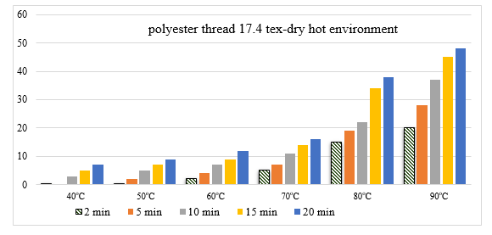
a)
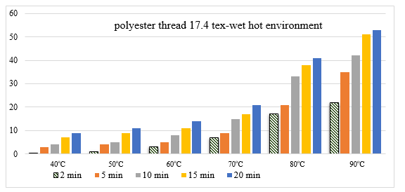
b)
FIGURE 1. Diagrams of the shrinkage of polyester threads with a linear density of 17,4 tex on the time of processing in a dry and humid hot environment at temperatures of 40ºC, 50ºC, 60ºC, 70ºC, 80ºC, 90ºC

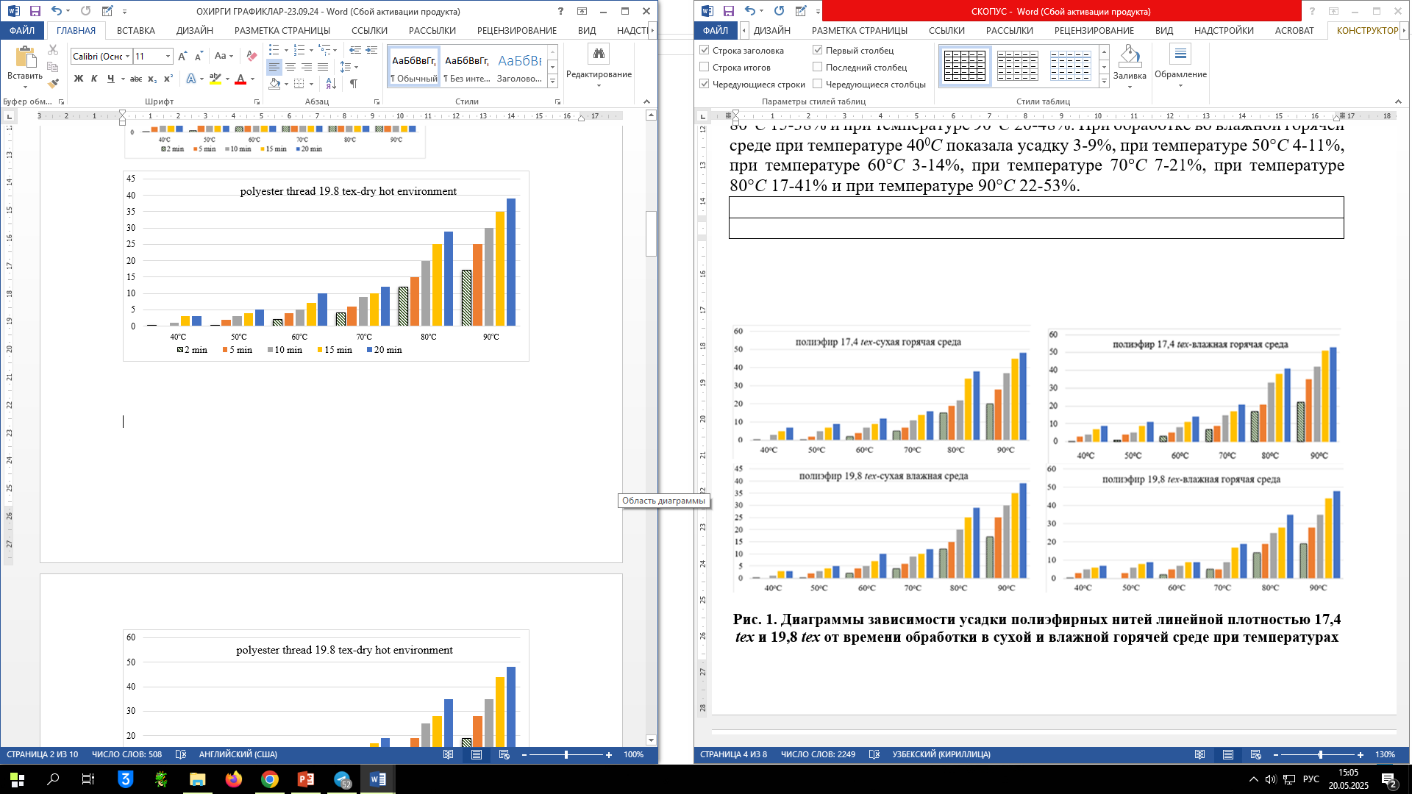
a)
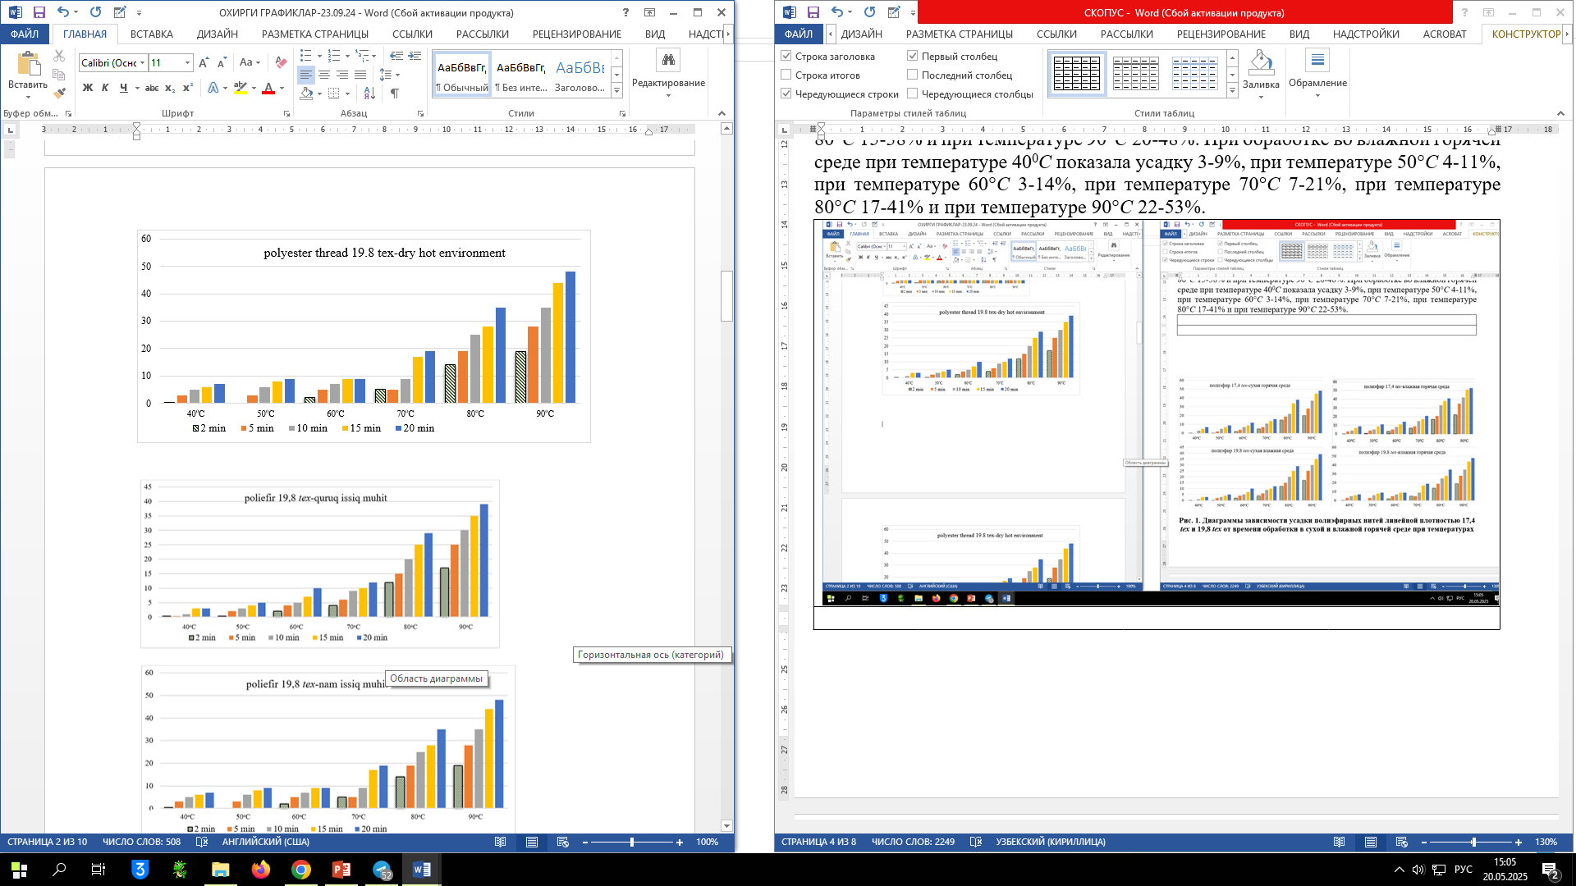
b)
FIGURE 2. Diagrams of the shrinkage of polyester threads with a linear density of 19,8 tex on the time of processing in a dry and humid hot environment at temperatures of 40ºC, 50ºC, 60ºC, 70ºC, 80ºC, 90ºC
It is known that the cultivation of cotton, silk and wool fibers in our republic is very developed, and their share among natural textile fibers is significantly higher than other natural fibers. Based on the conducted research and analysis of literary sources, it was found that assortments of fancy threads from natural threads are practically not produced. This determined the tasks of conducting research on obtaining fancy threads from natural threads.
Due to the fact that shrinkage or elongation of natural silk when processed in a hot environment and water is much less compared to chemical threads, the possibility of obtaining fancy threads by mixing it with other threads, which gives higher shrinkage, was determined. Since polyester threads showed high shrinkage during heat treatment, raw silk with a linear density of 3,23 tex and polyester thread with a linear density of 17,4 tex were selected as raw materials for obtaining fancy thread by mixing natural fibers, and a twisting plan was drawn up.

TABLE 1. Plan of twisting of production of fancy thread from raw silk and polyester thread
Technological processes | Equipment brand | Technological parameters
Sorting and consolidation | Manually | -
Lock | Spray | T=40-42 ºC; t=4-6 hours
Loosening and straightening | Manually | -
Maturation | In the room | T=22-24ºC; W=65-75%;  t=4-6 hours
Rewind | Rewinding equipment MT-85 | $ϑ$ =160 m/min
Construction | FADIS cone winding machine | $ϑ$ =140-160 m/min
Torsion | Twisting machine VTS-07-08-09 | K, TPM, Z and S | V, m/min | n_{ts}, rpm
Torsion | Twisting machine VTS-07-08-09 | 50 | 100 | 5000
Torsion | Twisting machine VTS-07-08-09 | 100 | 50 | 5000
Torsion | Twisting machine VTS-07-08-09 | 150 | 40 | 6000
Torsion | Twisting machine VTS-07-08-09 | 200 | 40 | 8000
Rewinding from bobbin to skeins | Rewinding equipment FY-118 | $ϑ$ =180-200 m/min
Decoction | Container for boiling | T=92-98⁰C;  t=40 min
Spin | Centrifuge C-120 | t=15 min
Drying | Drying chamber KS-2 | T=40-45⁰C;  t=20-25 min
Control and storage | Manually | Warehouse

Raw silk arrives at spinning factories in bales. In spinning factories, raw silk is prepared for spinning, i.e., it is rewound and rewinded from skeins onto spools. Raw silk is soaked by splashing and left to rest. Since fancy threads are given a low twist, i.e. 50, 100, 150, 200 TPM, the splashing method is sufficient for soaking raw silk. Soap and fatty substances in different proportions are used to prepare the emulsion. An emulsion of sunflower oil and triethanolamine, which are local raw materials, was also prepared for soaking raw silk.
When preparing raw silk for rewinding, raw silk in skeins is emulsified. The purpose of emulsification is to soften the glued areas in the skeins to improve the rewinding process and reduce breakage. Raw silk is emulsified by splashing. Raw silk is soaked in an emulsion diluted with water, consisting of soap, oil or fats. In some cases, glycerin, antiseptic and antistatic agents are added to the emulsion. The main indicators of the quality of the emulsion are its homogeneity and durability (absence of delamination), depending on the ratio of fat and soap. The optimal ratio of fat and soap is from 1:2.5 to 1:3. For heavily glued silk, ratios of up to 1:6 are allowed.
Soap is used to soften sericin and as a substance that promotes the emulsification of oils. Soap should contain 60% fatty acids and no more than 0.1% free alkalis, as well as no more than 0,5% water-insoluble residues. Soap should be odorless, and the color of the soap should be from white to light brown. Usually oleic oil, boiled on oleic acid, or cottonseed oil, boiled on cottonseed oil, are used.
Oils are used to impart flexibility and smoothness to raw silk threads. Vegetable or mineral oils can be used for this.
Glycerin can be used as a softening agent, which also has a gluing effect on the thread.
Antiseptics are used only if it is necessary to store twisted products for a long time at high humidity, which promotes bacterial processes - rotting and mold. The best antiseptic is borax (sodium salt), which also neutralizes the remains of organic acids. Betanaphthol also has an antiseptic effect. The following recipe is recommended for spraying 100 kg of raw silk:
Sunflower oil - 2,0 kg;
Triethanolamine - 0,6 kg.
Soaking is done in special tables by spraying. Then the skeins are wrapped in napkins and left to rest for 4-6 hours. After resting, the raw silk is straightened and plucked. The process of rewinding raw silk onto two-flanged spools is performed on the MT-85 rewinding equipment. Raw silk in skeins is put on the reel of the rewinding equipment and rewound at a speed of 180-200 m/min. The setting of the rewinding speed of raw silk depends on the linear density and unevenness of the raw silk. The thread tension is also set for uniform and dense winding of the raw silk. During rewinding, the rewinding capacity of the raw silk is checked. The rewinding capacity of raw silk is estimated by the number of breaks within 45 minutes. On the MT-85 rewinding machine, raw silk threads were rewound at a speed of 170 m/min and a tension of 10 cN.
Raw silk in spools and polyester thread are rewound together with different ratios in a FADIS brand winding machine. Table 2 shows the technological parameters for preparing threads for twisting.
TABLE 2. Technological parameters for preparing the thread for twisting on the FADIS winding machine
Indicators | Raw silk + polyester thread (2+1) | Raw silk + polyester thread (4+1) | Raw silk + polyester thread (6+1)
Number of additions | 2+1 | 4+1 | 6+1
Linear density, tex | 22,06 | 26,72 | 31,38
Winding speed, m/min | 180 | 180 | 180
Package weight, g | 250 | 250 | 250
Type of packaging | spool | spool | spool

The obtained variants of twisted threads were subjected to twisting on the twisting machine VTS-07/-08/-09. In order for certain spirals, knots, loops to form in the fancy thread, a twist of no more than 250 TPM was given to the thread.
RESULTS AND DISCUSSION
Twisted threads were obtained in three variants with a twist of 100, 150, 200 and 250 TPM. As the conducted studies have shown, the more the number of twists increases, the lesser the effects on the threads that form the fancy thread. Table 3 shows the physical and mechanical properties of twisted threads with different twist numbers.

TABLE 3. Physical and mechanical properties of twisted threads obtained from polyester and raw silk
Indicators | Linear density, tex | Number of twists, TPM | Breaking load, cN/tex
Raw silk + polyester thread (2+1) | 22,09 | 100 | 9,74
Raw silk + polyester thread (2+1) | 22,14 | 150 | 9,82
Raw silk + polyester thread (2+1) | 22,38 | 200 | 9,91
Raw silk + polyester thread (2+1) | 22,61 | 250 | 9,94
Raw silk + polyester thread (4+1) | 26,78 | 100 | 9,93
Raw silk + polyester thread (4+1) | 26,81 | 150 | 9,98
Raw silk + polyester thread (4+1) | 26,87 | 200 | 10,31
Raw silk + polyester thread (4+1) | 26,90 | 250 | 10,45
Raw silk + polyester thread (6+1) | 31,41 | 100 | 10,42
Raw silk + polyester thread (6+1) | 31,68 | 150 | 10,51
Raw silk + polyester thread (6+1) | 31,87 | 200 | 10,69
Raw silk + polyester thread (6+1) | 32,04 | 250 | 10,74

The resulting twisted threads are rewound into skeins for boiling. The rewinding process was performed on the MG-1 equipment rewinding from a spool or bobbin into skeins with a perimeter of 1,5 m.
After the rewinding process, the skeins are sewn together in 5 places and sent for heat treatment to form fancy threads. When preparing threads for fancy threads, you can use equipment from other brands. It is known that natural silk fiber consists of sericin and fibroin. The substance sericin plays an important role in the formation of raw silk. However, sericin gives the thread hardness and rigidity. A certain amount of sericin is usually washed off to achieve softness, elasticity and shine of the thread. To achieve these properties, twisted thread made from raw silk and polyester thread must be boiled.

TABLE 4. Technological parameters of the twisted thread rewinding process on the FY-118 rewinding equipment
Indicators | Raw silk + polyester thread (2+1) | Raw silk + polyester thread (4+1) | Raw silk + polyester thread (6+1)
Type of incoming packaging | spool | spool | spool
Rewinding speed, m/min | 160-180 | 160-180 | 160-180
Reel perimeter, mm | 1500 | 1500 | 1500
Number of working places in the section | 5 | 5 | 5
Weight of skeins, g | 150 | 150 | 150
Type of packaging | skein | skein | skein

TABLE 5. Results of boiling twisted threads obtained from raw silk and polyester threads
with a twist of 50, 100, 150 and 200 TPM
Indicators | Temperature, ºC | Boiling time, min | Thread shrinkage, % | Linear density, tex | Number of torsions, TPM | Breaking load, sN/tex
50, TPM
Raw silk (3,23 tex x 2) +  polyester thread (17,4 tex) | 92-98 | 40 | 45 | 23,89 | 50 | 16,65
Raw silk (3,23 tex x 4) +  polyester thread (17,4 tex) | 92-98 | 40 | 47 | 30,34 | 50 | 18,13
Raw silk (3,23 tex x 6)+  polyester thread (17,4 tex) | 92-98 | 40 | 47 | 36,81 | 50 | 19,61
100, TPM
Raw silk (3,23 tex x 2) +  polyester thread (17,4 tex) | 92-98 | 40 | 43 | 23,89 | 100 | 16,65
Raw silk (3,23 tex x 4) +  polyester thread (17,4 tex) | 92-98 | 40 | 45 | 30,34 | 100 | 18,13
Raw silk (3,23 tex x 6) +  polyester thread (17,4 tex) | 92-98 | 40 | 46 | 36,81 | 100 | 19,61
150, TPM
Raw silk (3,23 tex x 2) +  polyester thread (17,4 tex) | 92-98 | 40 | 41 | 23,97 | 150 | 16,78
Raw silk (3,23 tex x 4) +  polyester thread (17,4 tex) | 92-98 | 40 | 43 | 30,65 | 150 | 18,62
Raw silk (3,23 tex x 6) +  polyester thread (17,4 tex) | 92-98 | 40 | 44 | 37,18 | 150 | 19,87
200, TPM
Raw silk (3,23 tex x 2) +  polyester thread (17,4 tex) | 92-98 | 40 | 38 | 24,19 | 200 | 17,19
Raw silk (3,23 tex x 4) +  polyester thread (17,4 tex) | 92-98 | 40 | 40 | 31,06 | 200 | 19,14
Raw silk (3,23 tex x 6) +  polyester thread (17,4 tex) | 92-98 | 40 | 41 | 37,54 | 200 | 20,18

Improving the technology for obtaining fancy thread from local raw materials, it is necessary to reduce the amount of sericin in raw silk for using fancy thread in knitwear production. This process is carried out by boiling twisted threads. Heat treatment of the threads is also carried out at the same time. To carry out these two processes, the twisted thread was rewound into skeins weighing 120-150 g and at a speed of 160-180 m/min on the FY-118 rewinding machine (see Table 4).
Variants of twisted threads were boiled in soap and soda water to remove a certain amount of sericin and form effects on the surface of the thread. The process of fixing the twist of the threads was also carried out directly during the boiling process. As was studied above, polyester thread shrinks when processed in both a wet and a dry hot environment. Thus, by boiling variants of twisted threads, the sericin content in raw silk was simultaneously reduced to 7-9% and shrinkage of the polyester thread was achieved.
Soap and soda were used to boil the twisted threads. The boiling recipe: water - 5 l, laundry soap - 100 g, soda - 10 g and boiling time of 40 minutes. After boiling, the twisted threads were wrung out in a C-120 centrifuge and dried in a KS-2 dryer. The results obtained after boiling are given in Table 5.
As a result of the analysis of the obtained results for three variants, it was established that when boiling twisted threads of different linear density for 40 minutes, twisted threads made of natural silk and polyester showed shrinkage in length by 45-47% with a twist of 50 TPM, by 43-46% with a twist of 100 TPM, by 41-44% with a twist of 150 TPM and by 40-41% with a twist of 200 TPM.
CONCLUSION
The production of new ranges of fancy threads leads to the expansion of the sphere of smart textiles, the creation of modern ranges of finished nanostructured products and competition. To solve these problems, it is urgent to create a new technology by improving the method of heat treatment for the production of fancy threads, using nanostructured raw materials and machines and equipment operating in textile enterprises. Based on the analysis of existing technologies and methods for producing fancy threads, new methods for producing fancy threads for smart textiles have been studied and created, and this allows reducing the cost of production and increasing the competitiveness of products. The use of yarn of various origins in the production of fancy thread made it possible to create various effects on the surface and improve the method of heat treatment. Obtaining new types of fancy thread from raw silk threads and polyester threads was achieved due to different shrinkage rates during heat treatment of threads.
It was also found that the number of yarn twists is of great importance for obtaining fancy yarn. It was found that an increase in the number of twists in the threads negatively affects the formation of fancy effects and it is necessary to ensure that the twists do not exceed 200 TPM. New assortments of fancy threads from raw silk and polyester thread were produced for the first time, and a new assortment of fancy thread for smart textiles was obtained by boiling and its rational parameters were developed. According to the analysis of the results obtained for three options, the sericin content was 7-9% when boiling twisted threads of different linear density for 40 min and showed significant shrinkage of the thread. Fancy threads made of natural silk and polyester with a twist of 50 TPM showed shrinkage of 45-47%, with a twist of 100 TPM 43-46%, with a twist of 150 TPM 41-44% and with a twist of 200 TPM 40-41%, and it was also proven that fancy thread for smart textiles can be obtained from raw silk and polyester thread by boiling.
REFERENCES
- Chen, J., Mahajan, S., Gupta, M., Ayranci, C., & Tang, T. (2025). Yarn-electrospun PVDF-HFP/CNC smart textiles for self-powered sensor in wearable electronics. Energy Conversion and Management X, 26, 100982. https://doi.org/10.1016/j.ecmx.2025.100982
- Ojstršek, A., Plohl, O., Gorgieva, S., Kurečič, M., Jančič, U., Hribernik, S., & Fakin, D. (2021). Metallisation of Textiles and Protection of Conductive Layers: An Overview of Application Techniques. Sensors, 21(10), 3508. https://doi.org/10.3390/s21103508
- Nigmatova, F., Nabiyeva, I., Artikbayeva, N., & Usmanova, F. (2023). METHOD FOR FORMING CLOTHING PARTS WITH POLYMER COMPOSITION. Mechanics and Technologies, 3, 66–80. https://doi.org/10.55956/guzu6100
- Chen, Y., Hart, J., Suh, M., Mathur, K., & Yin, R. (2023). Electromechanical Characterization of Commercial Conductive Yarns for E-Textiles. Textiles, 3(3), 294-306. https://doi.org/10.3390/textiles3030020
- Alimova, K., Bobatov, U., Akhmedov, J. A., Sobirov, Q. E., & Umurzakova, K. K. (2021). The formation of defects during the reeling of raw silk. Journal of Physics Conference Series, 1889(4), 042049. https://doi.org/10.1088/1742-6596/1889/4/042049
- Karmon, A., Topaz, O., Tandon, R., Weck, A., Tiurin, O., Rafaeli, S., & Weissman, Z. (2025). Ultralong Carbon Nanotube Yarns Integrated as Electronic Functional Elements in Smart Textiles. Textiles, 5(2), 13. https://doi.org/10.3390/textiles5020013
- Yuldashev, A., et al. K. (2023). Theoretical study of yarn tension in the spindle work of two-for-one twisting. AIP Conference Proceedings, 2789, 040117. https://doi.org/10.1063/5.0145422
- Lewis, E. (2022). Between yarns and electrons: A method for designing electromagnetic expressions in woven smart textiles. Artifact, 9(1), 23.1-23.25. https://doi.org/10.1386/art_00023_1
- Shekhar, R., Choudhry, N. A., Islam, S., Ahnood, A., Pirogova, E., & Troynikov, O. (2023). A novel elastic conductive yarn for smart textile applications. Advanced Engineering Materials, 25(22). https://doi.org/10.1002/adem.202300572

