Obtaining PVA-Magnetite Granules Using PVA-20 and Studying Some of its Kinetic Properties
Khamza Trobov¹, Khusniddin Karimov^{2, a)}, Gulnoza Tursunova¹, Dilshod Yulliev², Nikolai Ferapontov^{1, 3}, Alisher Rakhimov¹
¹Samarkand State University, Samarkand, Uzbekistan
²Denau Entrepreneurship and Pedagogy Institute, Denau, Uzbekistan
³Moscow State University, Moscow, Russian Federation

^{a)}Corresponding author: khusniddin_rustamovich@mail.ru
Abstract: This scientific article investigates the synthesis of composite materials based on polyvinyl alcohol (PVS-20) granules with the addition of magnetite and examines their kinetic properties. The preparation conditions for PVS-magnetite granules obtained through the precipitation method are described, and the composition and structure of the resulting materials are determined using scanning electron microscopy and spectrography. The results reveal a uniform distribution of magnetite within the granules, and their magnetic properties are confirmed using a permanent magnet. Additionally, the swelling process of PVS and PVS-magnetite composites in Na₂CO₃ solutions is studied using optical micrometry. The swelling rate and equilibrium time of the granules in solutions of varying concentrations are determined, and kinetic coefficients are calculated based on the results. Calculations were performed using the “Polymer_swelling_kinetics 5.1” program, and theoretical curves and 3D surface graphs were generated. The obtained data allow for a deeper understanding of the physicochemical properties of composites and their application in determining solution concentrations. Specifically, it was found that as the solution concentration increases, the time for the swelling process to reach equilibrium rises significantly. The research results demonstrate the potential use of PVS-magnetite granules as a reinforcing composite material and create new scientific opportunities for studying ion exchange processes and polymer gel kinetics.
Keywords: polymer gel, polyvinyl alcohol, magnetite, composite, scanning electron microscopy, swelling, swelling kinetics.
INTRODUCTION
Materials obtained from high-molecular-weight compounds are currently the main raw material for producing many materials used in industrial and food enterprises [1-4], in medicine [5-7], and in everyday life. One of the applications of these compounds is the synthesis of composite, or reinforcing, materials. The main part of these substances' composition is made up of polymers and gels, which serve as matrices in reinforcing materials. Depending on the ratio of filler and matrix in the composite material, its properties can be significantly modified.
Composite materials are heterophase materials consisting of a combination of two or more materials, with each component making up at least 1% of the composition. The unique characteristic of a composite is that during its formation, not only is a “sum” of the qualities of the composite's components created, but also new properties emerge that are not inherent to its individual parts. Structurally, composite materials are divided into fibrous, layered, dispersion-reinforced, particle-reinforced, and nanocomposites. One such composite material is based on polyvinyl alcohol. This type of composite material is currently widely used. Various chemical methods can be used to obtain nanoparticles containing magnetic particles. For example: microemulsion synthesis [8], sol-gel synthesis [9], sonochemical reactions [10], hydrothermal reactions [11], hydrolysis of precursors [12], thermolysis [13], and others [14-17]. The synthesis using such methods involves rather complex and multifactorial processes. The most easily applied method for synthesizing magnetic nanoparticles is chemical precipitation from iron and iron salt solutions in the presence of a basic matrix [18]. Based on this, the present work discusses the synthesis process of a composite based on polyvinyl alcohol and magnetite.
THEORETICAL PART
30 g of polyvinyl alcohol was placed in a 250 ml beaker, 150 ml of distilled water was poured over it, and it was left for 12 hours for complete swelling. The obtained mixture was continuously stirred in a water bath for 30 minutes until a homogeneous mixture was formed and heated to a temperature of 100°C. The resulting solution was cooled in open air, the mixture in the beaker was weighed, and an amount of water equal to the condensed water during the heating process was added. Then, 30 ml of an alkaline solution was added to the PVA and water mixture, stirred continuously in a water bath for 5 minutes, and heated to 95°C. 30 ml of epichlorohydrin was added to the resulting mixture, stirred continuously for 5 minutes, and cooled to a temperature of 60°C. The obtained granules were then cooled to room temperature. As a result, the spherical and oval-shaped cross-linked PVA granules were separated into fractions and prepared for the production of composite materials. Next, 6 samples of 4 grams each of PVA-20 granules were taken. Solutions of Fe³⁺/Fe²⁺ iron salts were prepared as fillers in a 2:1 molar ratio: for this purpose, FeCl₃•6H₂O and (NH₄)₂Fe(SO₄)₂•6H₂O salts were used. A suspension of PVA-20 with a solution of iron salts was prepared. The prepared suspension was placed in a Petri dish, numbered, divided into two parts, and placed on the upper platform of two desiccators, the lower part of which contained concentrated and two-fold diluted aqueous solutions of ammonia, respectively (Figure 1). The samples in the desiccators were kept for 6, 12, and 24 hours. Afterwards, the samples were removed from the desiccators, washed with distilled water, and dried. The prepared suspension was placed in a Petri dish and numbered, divided into two parts, placed on the upper platform of two exhibitors, the lower part of which was filled with a concentrated and two-fold diluted aqueous solution of ammonia, respectively (Fig. 1). The samples in the exhibitors were held for 6, 12, and 24 hours. After that, the samples were removed from the exhibitors and washed and dried with distilled water.

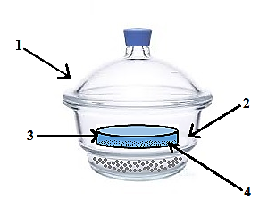
FIGURE 1. Process diagram for ammonia vapor: 1 - desiccator, 2 - table, 3 - Petri dish, 4 – precursor

The reaction equation for the process of obtaining a composite material can be written in the following form:
Fe²⁺ + 2Fe³⁺ + 8NH₃·H₂O = Fe₃O₄ + 8NH₄⁺ + 4H₂O
The color of the samples changed from colorless to brown-black, indicating the precipitation of iron oxide (Table 1). It is known that magnetite belongs to the ferromagnetic materials, meaning it possesses the property of spontaneous magnetization. Therefore, the simplest way to verify the presence of magnetite in the obtained samples is to test the experimental results with a permanent magnet. Data on the presence of magnetic properties in the obtained samples are presented in Table 1.

TABLE 1. Analysis of PVS-magnetite composite results
Petri dish number | NH₃ concentration | Time in the desiccator | Magnetic properties or the presence of magnetic attraction | Color | Photographs of the obtained samples
1 | Conc. | 24 hour | + | Black | 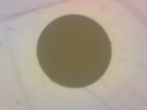
2 | Conc. | 12 hour | + | Black | 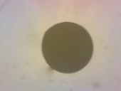
3 | Conc. | 6 hour | + | Black | 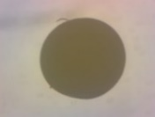
4 | 1:1 | 24 hour | + | Brown-black | 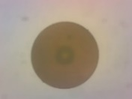
5 | 1:1 | 12 hour | + | Black | 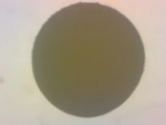
6 | 1:1 | 6 hour | + | Brown | 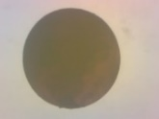
EXPERIMENTAL PART
Scanning electron microscopy and spectrography methods were used in the experiments to determine the presence of magnetite in the synthesized composites [19]. The obtained samples were analyzed using a JCM-6000 electron microscope. The cross-sectional image of the granule, obtained using this device at a voltage of 15 kV for 36.57 seconds (Fig. 2), and the data obtained from the scanning electron microscope’s spectrograph allowed for the prediction of uniform magnetite distribution within the granule volume [20].

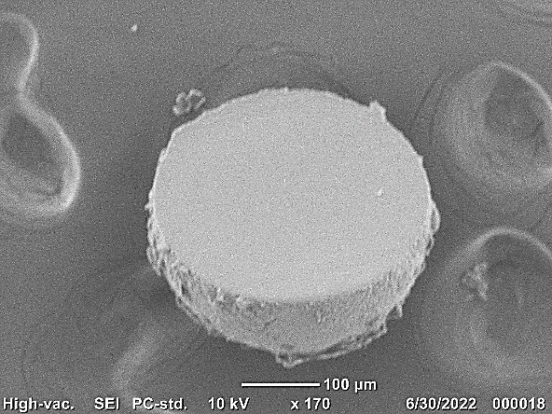
FIGURE 2. The cross-sectional surface of a mutually cross-linked PVA-magnetite granule.

The kinetics of the swelling process of the aforementioned magnetite-PVA composite in aqueous solutions were studied using Na₂CO₃ solutions of various concentrations (0.05, 0.15, 0.25, 0.50, 0.75 mol/l). Spherical granules of the magnetite-PVA composite were used in the experiments. Their diameters measured 0.74 ± 0.01 mm. Granules of this size were determined to be the most suitable for these experiments. The process was conducted using optical micrometry. Using the results obtained from the experiments, the kinetic parameters of the physico-mathematical, heterophase model of polymer gel structures were calculated using the "Polymer_swelling_kinetics 5.1" program. The results of the calculations are presented in Tables 2 and 3.

TABLE 2. Kinetic coefficients of the swelling process of magnetite-PVS composite granules in
Na₂CO₃ solutions of various concentrations
№ | Concentration, M | k₁, 10⁻⁵ m/c·(l/mol)^{1/3} | k₂, 10⁻²c⁻¹ | k₃, (l/mol)^{1/2}
Na₂CO₃ | 0,05 | 25,20 | 0,16 | 12,50
Na₂CO₃ | 0,15 | 26,00 | 0,16 | 13,65
Na₂CO₃ | 0,25 | 26,80 | 0,16 | 14,80
Na₂CO₃ | 0,50 | 29,00 | 0,16 | 17,50
Na₂CO₃ | 0,75 | 31,20 | 0,16 | 20,20

The accuracy of the calculation results was verified through four repeated experiments. Based on the obtained values of the kinetic coefficients, theoretical curves were plotted for each studied concentration (see Fig. 3).

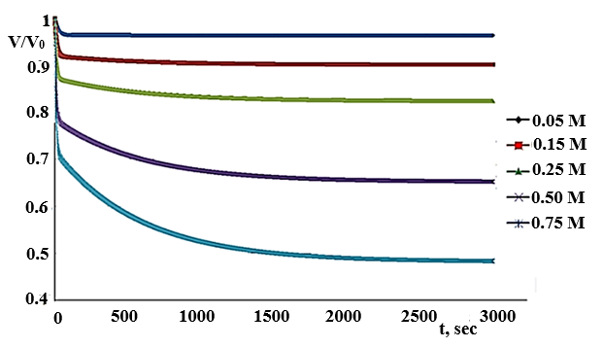
FIGURE 3. Theoretical kinetic curves of the swelling process of magnetite-PVA composite granules in Na₂CO₃ solutions of various concentrations.

TABLE 3. Results of processing the swelling process values in Na₂CO₃ solution
C, mol/l | C, mol/l | t, sec | d, % | maxΔ, % | σ, %
0,75±0,03 | 0,74 | 120 | -1,33 | 0,98 | 0,53
0,75±0,03 | 0,78 | 300 | 4.00 | 2.245 | 0,64
0,75±0,03 | 0,77 | 600 | 2.67 | 1.93 | 0,52
0,75±0,03 | 0,76 | 900 | 1.33 | 1.93 | 0,60
0,75±0,03 | 0,76 | 1200 | 1.33 | 1.93 | 0,66
0,75±0,03 | 0,76 | 1800 | 1.33 | 2.12 | 0,76
0,75±0,03 | 0,75 | 3000 | 0,00 | 2.30 | 0,75
0,50±0,02 | 0,50 | 120 | 0,00 | 1.12 | 0,41
0,50±0,02 | 0,52 | 300 | 4.00 | 1.64 | 0,36
0,50±0,02 | 0,51 | 600 | 2.00 | 1.47 | 0,34
0,50±0,02 | 0,51 | 900 | 2.00 | 1.30 | 0,44
0,50±0,02 | 0,50 | 1200 | 0,00 | 1.12 | 0,52
0,50±0,02 | 0,50 | 1800 | 0,00 | 1.16 | 0,65
0,50±0,02 | 0,49 | 3000 | -2.00 | 1.38 | 0,64
0,25±0,02 | 0,25 | 120 | 0,00 | 1.29 | 0,79
0,25±0,02 | 0,27 | 300 | 8.00 | 2.05 | 0,64
0,25±0,02 | 0,27 | 600 | 8.00 | 1.84 | 0,46
0,25±0,02 | 0,27 | 900 | 8.00 | 1.84 | 0,46
0,25±0,02 | 0,26 | 1200 | 4.00 | 1.64 | 0,43
0,25±0,02 | 0,26 | 1800 | 4.00 | 1.43 | 0,47
0,25±0,02 | 0,25 | 3000 | 0,00 | 1.29 | 0,48
0,15±0,03 | 0,12 | 120 | -21.43 | 0,76 | 0,42
0,15±0,03 | 0,13 | 300 | -14.29 | 1.43 | 0,64
0,15±0,03 | 0,14 | 600 | -7.14 | 1.92 | 0,64
0,15±0,03 | 0,15 | 900 | 0,00 | 2.15 | 0,64
0,15±0,03 | 0,15 | 1200 | 0,00 | 2.15 | 0,63
0,15±0,03 | 0,15 | 1800 | 0,00 | 2.15 | 0,63
0,15±0,03 | 0,15 | 3000 | 0,00 | 2.39 | 0,62
0,05±0,02 | 0,03 | 120 | -40.00 | 0,48 | 0,25
0,05±0,02 | 0,04 | 300 | -20.00 | 0,89 | 0,45
0,05±0,02 | 0,05 | 600 | 0,00 | 1.19 | 0,39
0,05±0,02 | 0,05 | 900 | 0,00 | 1.19 | 0,32
0,05±0,02 | 0,05 | 1200 | 0,00 | 1.19 | 0,28
0,05±0,02 | 0,05 | 1800 | 0,00 | 1.19 | 0,24
0,05±0,02 | 0,05 | 3000 | 0,00 | 1.19 | 0,19

Three-dimensional (3D) surface array graphs were constructed using the calculated kinetic curves for Na₂CO₃ (see Fig. 4). These surface arrays represent a dataset characterizing the swelling kinetics of the magnetite-PVA composite in solutions of this compound at various concentrations. The surface arrays enable the determination of unknown solution concentrations based on known kinetic curves.

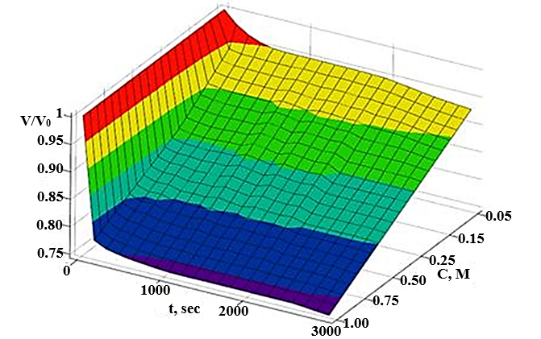
FIGURE 4. The 3D surface of kinetic curves illustrating the swelling process of magnetite-PVA composite granules in Na₂CO₃ solutions.
CONCLUSION
A specific composition of PVA-magnetite composite was synthesized by precipitation method using PVA-20 granules. The presence of magnetite in the synthesized composites was qualitatively confirmed using scanning electron microscopy and spectrography methods, and quantitatively proven using X-ray phase analysis. The swelling process of the PVA-magnetite composite was studied using optical micrometry. Using the results obtained from the experiments, the kinetic parameters of the physico-mathematical, heterophase model of polymer gel structure were calculated based on the "Polymer_swelling_kinetics 5.1" program. Additionally, composites obtained from PVS and magnetite enable strengthening of polymer gel granules and facilitate the determination of solution properties. It was observed that with increasing concentration of Na₂CO₃ solution, the time to reach equilibrium increased (approximately 600 seconds for a 0.05 M solution and 3000 seconds for a 0.75 M solution). It was demonstrated that the concentration of an unknown solution can be determined by knowing the kinetic curve of 3D surface arrays.
REFERENCES
- Ion exchange materials. (2007). In Elsevier eBooks. https://doi.org/10.1016/b978-0-08-044552-6.x5000-x
- Sarkar, S., SenGupta, A. K., & Prakash, P. (2010). The Donnan membrane principle: opportunities for sustainable engineered processes and materials. Environmental Science & Technology, 44(4), 1161–1166. https://doi.org/10.1021/es9024029
- Akash Debnath, Ashraful Alam, Ajoy Kanti Mondal, Tushar Uddin, Aftab Ali Shaikh, Asaduzzaman Sujan Development of Flexible Composite Sheet with Chrome Shavings Using Polyvinyl Alcohol as a Cross-Linker International Journal of Polymer Science Volume 2023, https://doi.org/10.1155/2023/6694850
- Poboży, E., Czarkowska, W., & Trojanowicz, M. (2006). Determination of amino acids in saliva using capillary electrophoresis with fluorimetric detection. Journal of Biochemical and Biophysical Methods, 67(1), 37–47. https://doi.org/10.1016/j.jbbm.2006.01.001
- Zhang, Q., Du, Q., Hua, M., Jiao, T., Gao, F., & Pan, B. (2013). Sorption Enhancement of Lead Ions from Water by Surface Charged Polystyrene-Supported Nano-Zirconium Oxide Composites. Environmental Science & Technology, 47(12), 6536–6544. https://doi.org/10.1021/es400919t
- Tang, Z.; Yang, J.; Li, S.; Wu, Z.; Mondal, A. K. Anti-Swellable, Stretchable, Self-Healable, Shape-Memory and Supramolecular Conductive TA-Based Hydrogels for Amphibious Motion Sensors. Eur. Polym. J. 2024, 211, 113034. https://doi.org/https://doi.org/10.1016/j.eurpolymj.2024.113034.
- Tang, Z.; Yu, M.; Mondal, A. K.; Lin, X. Porous Scaffolds Based on Polydopamine/Chondroitin Sulfate/Polyvinyl Alcohol Composite Hydrogels. Polymers (Basel). 2023, 15 (2), 271. https://doi.org/https://doi.org/10.3390/polym15020271.
- German, M., SenGupta, A. K., & Greenleaf, J. (2013). Hydrogen ion (H+) in waste acid as a driver for environmentally sustainable processes: Opportunities and challenges. Environmental Science & Technology, 47(5), 2145–2150. https://doi.org/10.1021/es304260u
- Shabanova, N. A., & Sarkisov, P. D. (2012). Zol-gel technology: Nanodisperse silica. Moscow, Russia: BINOM. Knowledge Laboratory.
- Suslick, K. S. (1998). Sonochemistry. In Kirk-Othmer encyclopedia of chemical technology (4th ed., Vol. 26, pp. 517–541). New York, NY: John Wiley & Sons.
- Gritsenko, L., Kalkozova, J., Kedruk, E., Marhabaeva, A., & Abdullin, H. (2019). Hydrothermal synthesis of ZnO nanoparticles and their photocatalytic properties. Bulletin of L. N. Gumilev Eurasian National University, 128(3), 215–222.
- Yang, Y., & Chjou, Y. (1995). [Article title not specified]. Journal of Electroanalytical Chemistry, 397, 271–278.
- 3. Gulyamov, G., Dadamirzaev, M.G., Kosimova, M.O., Boydedayev, S.R. (2023). Influence of deformation and light on the diffusion capacity and differential resistance of the p-n junction of a strong electromagnetic field. AIP Conference Proceedings, 2700(1),050013. https://doi.org/10.1063/5.0124926
- Rong, L., Guan, T., Fan, X., Zhi, W., Zhou, R., Li, F., & Liu, Y. (2025). Fe3+-Modulated In Situ Formation of Hydrogels with Tunable Mechanical Properties. Gels, 11(8), 586. https://doi.org/10.3390/gels11080586
- Bouklas, N., & Huang, R. (2012). Swelling kinetics of polymer gels: comparison of linear and nonlinear theories. Soft Matter, 8(31), 8194. https://doi.org/10.1039/c2sm25467k
- Wang, Z., Zheng, H., Chen, J., Wang, W., Sun, F., & Cao, Y. (2023). Effect of crosslinking conditions on the transport of protons and methanol in crosslinked polyvinyl alcohol membranes containing the phosphoric acid group. Polymers, 15(21), 4198. https://doi.org/10.3390/polym15214198
- Nascimento, F. C. D., De Aguiar, L. C. V., Costa, L. a. T., Fernandes, M. T., Marassi, R. J., De Souza Gomes, A., & De Castro, J. A. (2020). Formulation and characterization of crosslinked polyvinyl alcohol (PVA) membranes: effects of the crosslinking agents. Polymer Bulletin, 78(2), 917–929. https://doi.org/10.1007/s00289-020-03142-2
- Djuraev, S., & Tursunov, A. (2025). Effect of particle size and concentration on multicyclone device efficiency. AIP Conference Proceedings, 3304, 030049. https://doi.org/10.1063/5.0269110
- Atavullayeva, S., Tursunova, G., Trobov, K., & Karimov, K. (2024). Thermodynamics of the decomposition process of adsorbed polyelectrolyte from solutions of various salts. AIP Conference Proceedings, 3244, 050006. https://doi.org/10.1063/5.0241618
- Bouklas, N., & Huang, R. (2012b). Swelling kinetics of polymer gels: comparison of linear and nonlinear theories. Soft Matter, 8(31), 8194. https://doi.org/10.1039/c2sm25467k

