Enhancing the Mechanical Properties of Cotton Fiber through an Optimized Grid Bar Design in Cleaning Equipment
M.K. Saparov^{1, a)}, R.I. Ro‘zmetov², T.O. Tuychiyev², B.Baykhanov², A.B.Avazmuratov³
¹Urgench State University, Urgench, Uzbekistan
²Tashkent Institute of Textile and Light Industry, Tashkent, Uzbekistan
³UrgTex LLC, Urgench, Uzbekistan

^{a)}Corresponding author: jahongirsalohiddinov4943@gmail.com
Abstract. This study examines the impact of an enhanced grid bar design in cotton cleaning machines on the mechanical integrity and quality of the resulting technical textile fibre. Cleaning methods that are commonly used can hurt the mechanical properties of fibres by causing too much wear and tear and impact. We made and used a new grid design with bars of different sizes and spaces between them to change how cotton reacts to mechanical forces. The study was done at the "Textile Finance Khorezm" LLC facility, which was fully open for business. We checked the quality of the fibre by looking at how much trash it had and what grade it was in, which is a good way to tell how much mechanical damage it had. The new grid design made it less likely that the fibres would break, as the results show. For instance, first-grade cotton went from "medium" to "good," and third-grade cotton went from "ordinary" to "medium." You need to clean more gently to make it better. This keeps the fibre long and strong. The study shows that changing how cleaning surfaces are made can improve the mechanical performance of cotton fibres, leading to better technical textiles.
INTRODUCTION
Cleaning the cotton is a very important step in the process that has a direct impact on the quality of the fibre that is made [1]. Cleaning machines with different working parts are used to get rid of impurities that stick to cotton fibres with different bond strengths. If you don't get rid of impurities in cotton before ginning, they will stick to the fibre and cause more problems [2], which will lower the grade of the cotton fibre. In cotton cleaning businesses, the cleaning process happens after the cotton has dried [3].
Many researchers have done both theoretical and practical studies on how to make cotton cleaning equipment better [4–5]. These studies have looked at how different things affect the cleaning process and the quality of the product. Some of these things are the diameter and speed of the saw drum, the shape of the saw teeth, the shape and size of the grate bars, the distance between the saw drum and grate bars, the angle at which the grate bars cover the saw drum arc, the types and tilt angles of the cleaning brushes, the diameter and speed of the separating brush drum, and the types of brushes used [6].
In both domestic and foreign cotton cleaning enterprises, the main working parts of equipment used for removing large impurities are constructed almost identically, consisting of a saw drum, grate grid, cleaning brush, and separating transmission brushes, differing only slightly in their dimensions [7].
It has been found that the grate grids installed in foreign cotton cleaning equipment, which have grate bars of various diameters and spacing, are effective in rapidly cleaning impurities from cotton. The main reason for this is the variation in impact and friction forces applied to the cotton due to the differing diameters and spacing of the grate bars on the cleaning surfaces, which also affects the movement of cotton particles differently [8].
Although using grate bars of various shapes increases cleaning efficiency, it has also been observed that this negatively affects the natural properties of cotton. It was determined that using only one uniform shape of grate bars does not yield effective results. There are reserves to improve the large impurity cleaning equipment currently used in enterprises.
One of the main working parts in the cleaning process, the grate bars installed in cleaners in a uniform shape, when combined with the saw drum striking cotton particles against the grate bars with equal force, leads to a decrease in impurity removal after a certain cleaning stage. This is considered a drawback of such equipment [9].
The primary purpose of the proposed equipment is to increase the efficiency of the cleaning process by using grate bars of various diameters and different spacing with the saw drum, thereby varying the forces acting on the cotton.
The task is implemented as follows: in the section of cotton cleaning equipment responsible for removing large impurities, round grate bars with reduced diameter and increased quantity are arranged on the grids, and grate grids are placed at varying spacing with the saw drums.
EXPERIMENTAL METHODOLOGY
The research was conducted under production conditions in the cleaning section of the “Textile Finance Khorezm” LLC, Shovot cotton cleaning enterprise, located in Khorezm region, where the UCCC (Universal cotton cleaner combined) cleaning line is installed. To compare the experimental results, improved grate grids—developed based on theoretical and practical research—were installed in the large impurity cleaning sections of the first row of the dual-line UCCC cleaning flow.
The improved grate grid was manufactured in the mechanical workshop of the Shovot cotton cleaning enterprise based on detailed working drawings and was mounted in the large impurity removal section of the cleaning flow.
Before beginning the experiments on the improved cleaning technology, the saw segments of the saw drum were inspected (see Figure 1), and any broken or missing segments were replaced. The spacing between the saw drum and the grate grid was also adjusted. A general view of the UCCC - type cleaning unit equipped with the improved grate grid is shown in Figure 2.
The availability of electronic weighing scales at the cotton cleaning plant allowed accurate measurement of the cotton supplied to production. This made it possible to distribute equal amounts of cotton to both rows of the cleaning line and enhanced measurement precision.
The cotton processing technology installed at the cotton cleaning plant operates in the following sequence:
Raw cotton is transferred from storage yards to a 2SB-10 type drying drum using an SS-15A cotton separator. Depending on the initial moisture content of the cotton, a thermal agent is supplied to the drying drum from a heat generator at the required temperature, reducing the moisture content to approximately 8–8.5%. The dried cotton is then fed through a cotton separator to the distribution screw located in the cleaning section.
The distribution screw evenly distributes the raw cotton to both rows of the UCCC cleaning line. The cleaning line consists of:
One 1XK cleaner with four spiked drums,
Four sequential UCCC cleaning units,
And another set of UCCC cleaners, also with four spiked drums.

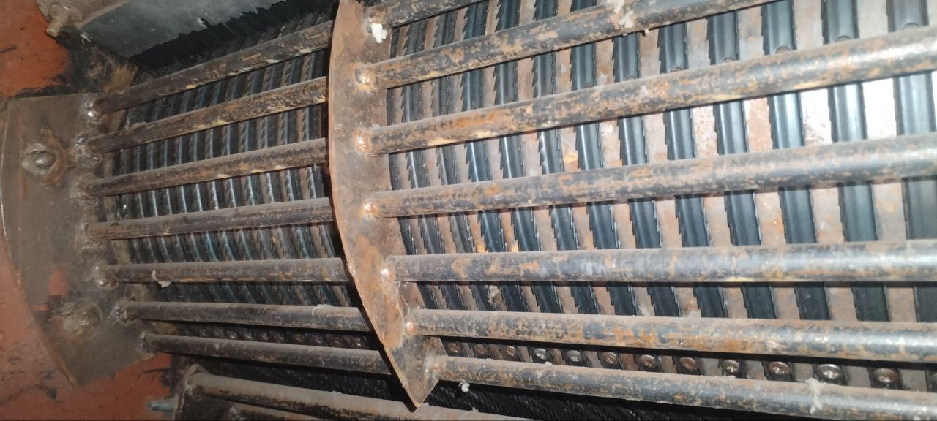
FIGURE 1. General view of the UCCC cleaner equipped with the improved grate grid

After the raw cotton is cleaned from fine and large impurities in the cleaning line, it is sent to the ginning section through a separator. Before ginning, the cotton is moistened, which helps preserve the natural properties of the fiber. In the ginning section, two 130-saw gins are used to separate the fiber from the seed.
A portion of the separated fiber is further cleaned in the saw gin and then conveyed via an air duct to the fiber cleaner. In the fiber cleaner, the fiber is cleaned from impurities and defects, then it is drawn through an air duct to the 5KV condenser.
In the condenser, the fiber is separated from the air and directed into the chute of a hydraulic press unit, where it is moistened using fiber humidifiers to a moisture level of 1.5–2%. After that, the fiber is compacted and pressed into bales, which are pushed out of the press unit, packaged, weighed using an electronic scale, and sent to the finished goods warehouse via an overhead conveyor system.
From each produced fiber bale, samples are taken by laboratory staff to determine quality indicators.

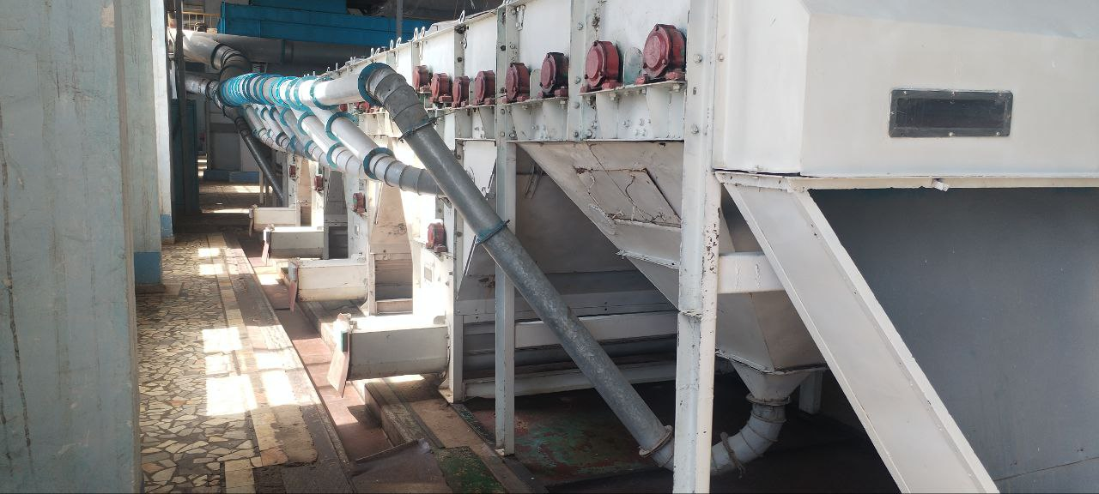
FIGURE 2. General view of the cleaning line equipped with the improved grate grid

Cotton quality indicators were assessed at multiple stages of processing: in the storage yard, at the cotton separator, after the drying drum, after the cleaning process, at the saw gin feeder chute, from the fiber produced in the saw gin, from the fiber cleaned by the fiber cleaning equipment, and from the press unit. At each of these points, samples were collected to determine the cotton's moisture and impurity levels, seed damage, and the amount of impurities and defects in the fiber.
These parameters were evaluated based on the methodologies outlined in the following Uzbek national standards:
- O‘z DSt 643:2006 “Cotton. Sampling methods”
- O‘z DSt 644:2006 “Cotton. Methods for determining moisture”
- O‘z DSt 592:2008 “Cotton. Methods for determining impurities”
- O‘z DSt 614:2009 “Cotton fiber. Sampling methods”
In the experiments conducted under production conditions, the initial moisture and impurity levels of the Xorazm-127 cotton variety used were:
- For the first industrial grade: 9.1% moisture and 6.5% impurities
- For the third industrial grade: 12.7% moisture and 10.4% impurities.
EXPERIMENTAL RESULTS
The results of the practical research conducted under production conditions at the “Textile Finance Khorezm” LLC, Shovot cotton cleaning enterprise, are presented in Table 1.
For first-grade cotton, moisture decreased from 9.1% in the storage yard to 8.0% after the 2SB-10 drying drum (−1.1 percentage points; ≈12.1% relative reduction), and to 7.9% after the UCCC cleaning line (a further ≈1.25% relative decrease from the dryer outlet). For third-grade cotton, moisture declined from 12.7% to 8.4% after the 2SB-10 (−4.3 p.p.; ≈33.9% relative), and then to 8.3% after the UCCC section (≈1.19% relative decrease).
In first-grade cotton, the impurity level fell from 6.5% in the storage yard to 6.4% after the SS-15A separator and 6.2% after the 2SB-10 dryer. With the conventional grate-grid cleaning line, impurities in seed cotton were reduced to 0.92% at the line outlet and 0.91% at the saw-gin feeder chute. After ginning, impurities and defects in fiber measured 3.61%, which decreased to 2.78% after fiber cleaning.
For third-grade cotton, impurities decreased from 10.4% in the yard to 10.3% after the SS-15A and 10.1% after the 2SB-10. At the cleaning-line outlet the impurity content was 1.27% (1.25% at the saw-gin feeder chute). Fiber impurities and defects were 8.38% after ginning and 6.45% after fiber cleaning.
TABLE 1. Results of the cleaning flow equipped with an improved grate-type screen

Indicators | Existing UCCC Cleaner |  | Improved UCCC Cleaner
Indicators | Grade I | Grade III | Grade I | Grade III
Initial moisture content of cotton, % | 9,1 | 12,7 | 9,1 | 12,7
Initial trash content of cotton, % | 6,5 | 10,4 | 6,5 | 10,4
Trash content of cotton after the separator, % | 6,4 | 10,3 | 6,4 | 10,3
Moisture content of cotton after the drying drum, % | 8,0 | 8,4 | 8,0 | 8,4
Trash content of cotton after the drying drum, % | 6,2 | 10,1 | 6,2 | 10,1
“Moisture content of cotton after the cleaning unit, %” | 7,9 | 8,3 | 8,0 | 8,3
“Trash content of cotton after the cleaning unit, %” | 0,92/  85,2 | 1,27/  87,4 | 0,58/  90,7 | 0,68/  93,3
Trash content of cotton in the saw gin feeder, % | 0,91 | 1,25 | 0,56 | 0,67
Amount of trash and defects in fiber after the saw gin, % | 3,61 | 8,38 | 2,78 | 6,95
Amount of trash and defects in fiber after the lint cleaner, % | 2,78 | 6,45 | 2,14 | 5,35
Grade and class of fiber according to the national standard | Grade I, medium | “Grade III, ordinary | Grade I, good | Grade III, medium

Relative to the post-drying condition, the cleaning line reduced seed-cotton impurities by ≈85.2% in first-grade (6.2% → 0.92%) and ≈87.4% in third-grade cotton (10.1% → 1.27%). The fiber-cleaning stage provided an additional ≈23% reduction in fiber impurities and defects (first-grade: 3.61% → 2.78%; third-grade: 8.38% → 6.45%). These findings confirm that the main moisture decrease occurs in the drying drum, while sequential mechanical cleaning delivers the dominant reduction in trash, with fiber cleaning after ginning further improving fiber quality.
In the UXK cleaning flow equipped with the improved tooth grid, the impurity level of the raw cotton of the first industrial grade, which was 6.2% before processing (after the 2SB-10 drying drum), decreased to 0.58% after processing, 0.56% at the 4DP-130 toothed gin rack, 2.78% in the fiber after the toothed gin, and 2.14% after the fiber cleaner.
In the same cleaning flow with the improved tooth grid, the impurity level of the third industrial grade raw cotton, which was 10.1% before processing (after the 2SB-10 drying drum), decreased to 0.68% after processing, 0.67% at the 4DP-130 toothed gin rack, 6.95% in the fiber after the toothed gin, and 5.35% after the fiber cleaner.
Analyzing the cleaning efficiencies of the flows equipped with the existing and improved tooth grids, it was found that for the first industrial grade raw cotton, the cleaning efficiency was 85.2% when using the existing grids, and 90.7% when using the improved design grids, achieving a 6% increase in cleaning efficiency.
Analyzing the cleaning efficiencies of cleaning flows equipped with existing and improved tooth grids, it was found that for the third industrial grade raw cotton, the cleaning efficiency was 87.9% when using the existing tooth grids, and 93.1% when using the improved design tooth grids, achieving an increase of 5.2% in cleaning efficiency.
When using the existing tooth grids, the first industrial grade raw cotton produced fiber classified as first grade “medium” quality, while the third industrial grade raw cotton produced fiber classified as third grade “ordinary” quality. When using the improved design tooth grids, the first industrial grade raw cotton produced fiber classified as first grade “good” quality, and the third industrial grade raw cotton produced fiber classified as third grade “medium” quality.
The results show that instead of producing “medium” quality fiber of the first grade, “good” quality fiber of the first grade is obtained; and instead of producing “ordinary” quality fiber of the third grade, “medium” quality fiber of the fourth grade is produced.
CONCLUSION
The study indicated that the mechanical behaviour of cotton fibers—a key factor in technical textiles— can be positively influenced by redesigning the primary components in the cleaning process. The introduction of an optimised grid layout led to two main results:
The high-quality level of the produced fibre confirmed a significant reduction in mechanical fibre damage. The increase from "average" to "good" and from "normal" to "average" indicates an improvement in fibre length and strength.
The study suggests that the goal of cotton cleaning should not be limited to removing trash but also to preserving the inherent mechanical properties of the fibre. The proposed design provides a simple but effective solution for the production of high-quality raw materials for the technical textile industry, and as a result, outstanding economic efficiency can be achieved. Future work will involve direct measurement of the mechanical properties (e.g., tensile elongation) of the purified fibres using conventional and optimised systems to quantitatively confirm these findings.
REFERENCES
- Wanjura, J.D., Holt, G.A., Carroll, J.A. 2009. Influence of grid bar shape on field cleaner performance - Screening tests. In: Proceedings of the Beltwide Cotton Conferences, January 5-7, 2009, San Antonio, Texas. 2009 CDROM. p. 439-448.
- Mishra, P. K., Singh, M., Dixit, A., Patel, B., Gautam, A., Pandey, S. K., & Sharma, K. (2023). Effect of cleaning methods on trash contents and fibre quality for seed cotton. International Journal of Bio-resource and Stress Management, 14(Feb, 2), 338–346. https://doi.org/10.23910/1.2023.3281a
- Quliyev, T. M., Maqsudov, E. T., Jumaniyazov, Q., Djumabayev, G. X., Korabayev, Sh. A., & another author. (2025). Optimization of twist triangle geometry and drafting system for enhanced yarn quality in ring spinning. Izvestiya Vysshikh Uchebnykh Zavedenii, Seriya Teknologiya Tekstil'noi Promyshlennosti, (3), 157–164. https://doi.org/10.47367/0021-3497_2025_3_157
- Kayumov, A., Parpiev, A., & Mardonov, B. (2022). Simulation of heat exchange processes in the moving raw cotton pipeline. AIP Conference Proceedings, 2650, 030010. https://doi.org/10.1063/5.0105467
- Whitelock, N. D. P., & Anthony, N. W. S. (2003). Evaluation of cylinder cleaner grid bar configuration and cylinder speed for cleaning of seed cotton, lint, and lint cleaner waste. Applied Engineering in Agriculture, 19(1). https://doi.org/10.13031/2013.12732
- Madumarov, I., Mardonov, B., Ruzmetov, R., & Tuychiev, T. (2018). Movement of the trash inside of fiber material when available elastic force of clutch. Engineering, 10(09), 579–587. https://doi.org/10.4236/eng.2018.109042
- Ray, N. S. J. (2006). Alternative configurations in a cylinder-type cleaner for seed cotton. Applied Engineering in Agriculture, 22(5), 643–649. https://doi.org/10.13031/2013.21996
- Akramov, A., et al. (2025). Evaluation of the yarn deformation in its contact zone with a cylindrical surface. AIP Conference Proceedings, 3304, 030067. https://doi.org/10.1063/5.0269091
- Jumaniyazov, K., Tojimirzaev, S., & Muminov. (2022). Research and evaluation of cotton fiber properties in technological processes. Proceedings of Higher Education Institutions Textile Industry Technology, 1, 162–170. https://doi.org/10.47367/0021-3497_2022_1_162

