The Role of Chemically Active Substances in the Contact Zone of the Abrasive and the Workpiece During the Grinding Process
E.A. Narmatov, P.M. Butovskiy, K.P. Avazov^{a)}, M.A. Allamov
Tashkent Institute of Textile and Light Industry, Tashkent, Uzbekistan

^{a)}Corresponding author: komil.avazov@mail.ru
Abstract. This article focuses on the grinding process, which involves interaction between abrasive grains and the workpiece. Thermoactive substances were introduced to improve the process. Based on this, a mathematical model was developed, which is represented as various forces acting during grinding. These studies resulted in the dependence of the friction coefficient between abrasive grains and the workpiece using thermoactive substances used in the grinding process. Experiments also revealed the maximum shear stresses within the grain itself. The effect of thermally active substances on the change in temperature in the cutting zone is proven, which affects the quality of the processed surface, including the appearance of burns. Experimental studies confirmed the reliability of the results of the dependence. The efficiency of using thermally active substances in abrasive processing is substantiated, regardless of the method of their supply to the cutting zone. Practical recommendations are given on the use of crystalline iodine and CrO₂ as thermally active substances in grinding.
Keywords: part, surface, abrasive grain, friction coefficient, stress, temperature.
INTRODUCTION
Modern mechanical engineering requires a significant increase in the productivity and accuracy of technological methods, as well as their automation to ensure intensification, increased efficiency and competitiveness of manufactured products. In modern mechanical engineering, product designs are constantly becoming more complex, their diversity is increasing, partial replacement of objects occurs, and the terms of mastering new products are shortened. The implementation of the measures taken requires the widespread use of flexible manufacturing systems. Abrasive effect machines play a major role in modern mechanical engineering. The main part of such machines are grinding machines designed exclusively for finishing operations of the technological process - finishing and finishing. Grinding machines are used for finishing and finishing of external and internal cylindrical, conical and shaped surfaces, as well as planes, grinding of threads and gear teeth, rough processing of blanks, cutting materials, sharpening of cutting tools [1-4].
Modern scientific and technical progress in mechanical engineering is inextricably linked with the development and improvement of abrasive processing processes, which largely determine the complexity of production and the quality of processing of parts. High temperatures and pressure in the contact zone of the grinding wheel with the processed mechanism cause complex cutting processes that affect the observance of the quality indicators of the surface layer of the part. In this regard, an important direction for improving the finishing of machine parts is the development of technological measures to determine the conditions of contact of abrasive grains with the processed effect by introducing film-forming substances with a low coefficient of friction into the cutting zone. Such a film can be created on the contact surfaces of abrasive grains and the processed material, for example, by using surfactants, among which crystalline iodine and its compounds are very promising [5-8].

STATEMENT OF THE RESEARCH PROBLEM
Considering the relevance of the problem associated with the use of surfactants in the process of grinding machine parts, the main objective of this study is to study the temperature and force characteristics of the contact interaction of abrasive grains of a grinding wheel and the work piece. Based on the data obtained, the most effective strategies for applying surfactants and methods for delivering them to the cutting zone will be developed, taking into account the special conditions and requirements of the grinding process.
ANALYTICAL ANALYSIS OF GRINDING CONDITIONS
USING SURFACTANTS
When studying the contact interaction of an abrasive tool with work pieces, the following assumptions were made:
The grains of the abrasive tool have the same size and shape;
The working abrasive particles are uniformly distributed over the surface of the tool and protrude uniformly from the bonds;
The porosity of the abrasive tool and its saturation with grains by volume are constant;
The film-forming material formed as a result of the action of surfactants has a constant thickness, but is unevenly distributed over the contacting surfaces in open cutting: in some places it may be absent due to the constant processing mode;
The coefficient of friction of the film on the contacting surfaces of the layers of abrasive grain and the work piece is the same and depends on the action of surfactants;
Due to the small size of the cut layers that arise on the working surfaces of the abrasive grain, they are uniformly distributed.
Taking into account the accepted assumptions, the following formula is proposed to determine the temperature Θ for grinding purposes when feeding surfactants:
$Θ=\frac{0,427∙L_{n}∙{ Θ}_{n∙}(1+f∙f_{fric})}{H_{v}∙f_{fric}∙(1-f^{2})}$ (1)
In these numbers:
L_{n} - open heat of fusion in a single contact area;
Θ_{n}. - melting temperature of the work piece;
f - general coefficient of friction, observing the uneven distribution of the film on the contact surface layers in the cutting zone;
f_{ric} - coefficient of friction of the film on the contact surfaces of the layers of abrasive grain and the work piece;
H_{v} - initial hardness of the work piece.
When grinding parts made of iron-carbon alloys, the values are taken as constants: L_{n} = 22.3 kcal/cm²; Θ_{n} = 1539°C; H_{v} = 220.
An analysis of the above formula (1) shows that the temperature Θ in the grinding zone when the surfactant is applied has a complex dependence on the coefficient of friction f , since the generalized coefficient of friction also depends on the coefficient f_{ric} .
Next, an analytical study of the forces occurring on the treated surface of the abrasive grain of the grinding wheel was carried out. The diagram of the power plant on the outer surface of the abrasive grain of the grinding wheel, shown in Figure 1.

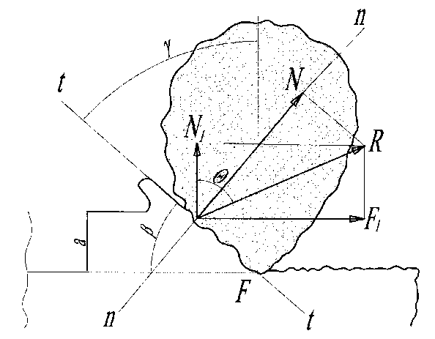
FIGURE 1. Diagram of the forces acting on the working surface of the abrasive particle

The force N creates maximum stresses σ_{max} on the working surface of the abrasive grain of the grinding wheel. The force directed by the opposite component N1 forms technological residual stresses in the surface layer of the material. The force F causes a shear stress σ_{shift} in the cut-off position. The processed material and the powerful F1 component determine the elementary p_{d} force expended during processing with a single abrasive grain, which can be written in the following formula:
$p_{d}=\frac{π∙D_{circ}∙n_{circ}∙F_{1}}{6∙{10}^{4}}$ (2)
where: $D_{circ}$ - outer diameter of the abrasive grinding wheel, mm; $n_{circ}$ - grinding wheel switching frequency, rpm.
Considering that F1 = R •sinΘ, therefore:
$F_{1}=\frac{6∙{10}^{4}∙p_{d}}{ π∙D_{circ}∙n_{circ}∙sinΘ}$ (3)
Then, based on Figure 1, with fundamental Θ = α, the forces N, N1 and F develop using the formulas:
$N=\frac{6∙{10}^{4}∙p_{d}∙sin⁡(γ+β)}{ π∙D_{circ}∙n_{circ}∙sinγ}; N_{1}=F=\frac{6∙{10}^{4}∙p_{d}∙ctgγ}{ π∙D_{circ}∙n_{circ}}$ (4)

For a separate abrasive grain, the stress values σ_{max} and τ_{sdv} are given by economic formulas:
$σ_{max}=\frac{6∙{10}^{4}∙p_{d}∙sin⁡(γ+β)}{ π∙D_{circ}∙n_{circ}∙sinγ∙S_{d}}; τ_{sdv}=\frac{6∙{10}^{4}∙p_{d}∙ctgγ}{ π∙D_{circ}∙n_{circ∙S_{d}}}$ (5)
where: p_{d} - working surface made of one abrasive material.
The formula for calculating the generalized coefficient of friction f can be expressed through the relationship:
$f=\frac{τ_{sdv}}{σ_{max}}=\frac{cosγ}{sin⁡(γ+β)}$ (6)
Analysis of literature data and studies conducted on the study of the cutting zone show that the angle of the abrasive grain γ and the angle β change in the following relationships: γ = (55 – 75)°, β = (15 –35)°.
According to this angle, the friction coefficient f can be within the range f = 0.42–0.65, which corresponds, for example, to the data given in.
To determine the technological residual stresses σ_{res} in the material of the surface layer, it is necessary to have an average number of abrasive grains Z_{d} simultaneously participating in the cutting process, which can be determined using the well-known formula:
$Z_{d}=\frac{4∙B∙S_{circ}∙v∙a}{π∙d_{d}^{2}}$ (7)
where: B is the used height of the round grinding wheel; Sp.p is the feed along the transverse length (of the part); $d_{d}^{2}$ is the average diametrical size of the abrasive grains of the tool; v is the relative volume of the abrasive material in the tool; a is the porosity of the abrasive tool. In this case, the value of the process residual stresses in the material of the surface layer of the treated surface is determined by the following formula:
$σ_{q}=\frac{1.5∙{10}^{3}∙P∙d_{d}∙S∙ctg}{D_{circ}∙n_{circ}∙B^{2}∙S_{k}^{2}∙v∙a}$ (8)
where: P is the grinding power.
Formulas (5), (6) and (8) determine the temperature-force state through the generalized friction coefficient f_{fric} , the observed friction coefficient of the film on the contact surfaces of the abrasive grain and the work piece. They can be used to select the most effective types of surfactants and the method of their delivery to the cutting zone for certain processing conditions during grinding.
Experimental study of the grinding process using thermally active substances. To confirm the reliability of dependencies (1), (8) and the possibility of their practical application, experimental studies of the grinding process were carried out using traditional grinding wheels and wheels impregnated with CrO₂, according to the technology described in the work.
Experimental studies on a surface grinding machine model 3B724 during processing of flat samples in the form of plates measuring 25x20x100 mm, as well as samples made of steel grades 18KhGT and 30KhGSA. A grinding wheel measuring 400x60x127 mm, grade 25A40SM1K with a data exchange rate of 35 m/s was installed on the machine. The longitudinal feed of the machine table was S _{feed} = 0.02 m/s, cross feed S _{cros},_{feed} = 0.01 mm/min, the number of passes m = 3.

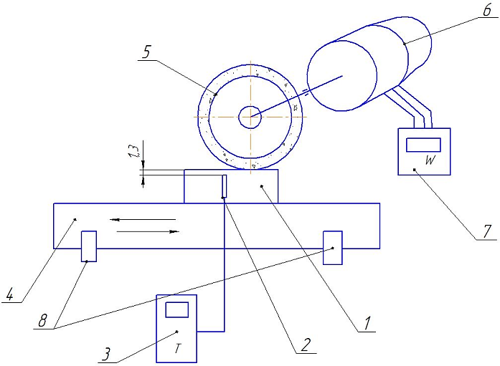
FIGURE 2. Experimental setup diagram: 1-sample; 2-thermocouple; 3-sensor; 4-machine table; 5-abrasive stone; 6-motor; 7-wattmeter; 8-stops.

The surfaces of the samples were pre-treated by clean milling, providing a roughness in the parts of R_{a} = (12.5-6.3) µm.
The following coolants are used:
for grinding with conventional wheels - 8% aqueous solution of Emulsol EGT emulsion;
for grinding with impregnated wheels - a suspension consisting of an 8% aqueous solution of Emulsol EGT emulsion with the addition of 5 g of finely dispersed CrO₂ per liter.
The following grinding parameters are provided during the experiment: exposure temperature by installing thermocouples in the test samples at 0.8 mm from the machined surface; the value of process residual stresses developed by an experimental method.
Grinding power (P) is achieved using a wattmeter connected to the electric motor of the grinding machine headstock, taking into account the gearbox speeds.
Based on literature data and measurement results, the following values of angles γ, β and friction coefficient f_{fric} were adopted: γ = 60°, β = 30°, f_{fric} = 0.08.
RESULTS AND DISCUSSION
The experimentally measured indicators of temperature Θ and technological residual stresses σ_{res} were compared with the calculated values obtained using dependencies (1) and (8), by calculating the deviations ΔΘ and Δσ_{res}.
A comparison of the experimental and calculated grinding results ΔΘ and Δσост is given in Table 1.

TABLE 1. A comparison of the experimental and calculated grinding results ΔΘ and Δσост
Steel Grade | Abrasive Wheel Used | Calculated Values |  | Experimental Values |  | Deviations
Steel Grade | Abrasive Wheel Used | Θ, heat. С | σ res, МПа | Θ, heat | σ res МП | ΔΘ | Δ σ res. d
18ХГТ | Regular | 795,2 | 380 | 752 | 340 | 5 | 11
18ХГТ | Impregnated | 660,1 | 328 | 603 | 290 | 9 | 12
30ХГСА | Regular | 874,5 | 473 | 802 | 380 | 8 | 20
30ХГСА | Impregnated | 721,3 | 721 | 652 | 310 | 10 | 15

Analysis of the data presented in the table shows that the calculated values of temperature Θ and technological residual stresses exceed the experimentally obtained values by (5-15)%, which is associated with assumptions and relaxation processes.
The use of suspension with CrO₂ allows creating a film with a low friction coefficient on the contact surfaces of the grinding wheel's abrasive grains and the processed material, which leads to the following improvements in the grinding process:
- reduction of temperature in the cutting zone by 14-19%, which ensures more effective material processing;
- reduction of technological residual stresses in the surface layer material by more than 14%, which improves processing quality and reduces the risk of deformation;
- reduction of grinding costs by 24-29% compared to processing without surfactants, making this process more efficient and economical.
Maximum effectiveness of surfactants in the grinding process is achieved when considering the technological compatibility of contacting materials, resulting in the recommendation to use the same surfactants both in the tool composition and in their combined use.
The results of experimental studies on the contact interaction of abrasive grains with the processed material show certain features in selecting the type and external impact of surfactants in the cutting zone during grinding.
Studies have shown that the effective use of thermally active substances occurs when they are stabilized at high temperatures, particularly 600-800°C. Therefore, organically-based surfactants are not suitable for use in grinding.
Furthermore, the research showed that the effectiveness of surfactants in creating shell structures on contact surfaces is subject to the grinding wheel grain and processed material. Maximum effectiveness of surfactants is achieved in the process of surface grinding, as well as when considering the technological compatibility of materials. This allows using the same surfactants as in the composition of the medium, through their introduction or impregnation in the abrasive mass, as well as in creating a lubricating-cooling environment by applying surfactants.
CONCLUSION
The obtained determinations for temperature in the cutting zone and technological residual stresses in the surface layer material of the processed part allow determining the most effective surfactants and methods of their application at the stage of technological preparation of production, ensuring their entry into the grinding zone for specified processing conditions. Theoretical and experimental studies have proven that the use of surfactants in grinding parts results in lower cutting temperatures and moderate technological residual stresses in the surface layer material, which favorably affects the increase in productivity of processed machine parts. The technological compatibility and high efficiency of various types of surfactants and the features of their distribution in the cutting zone during surface grinding of parts have been taken into account.
REFERENCES
- Chipakwe, V., Karlkvist, T., Rosenkranz, J., et al. (2022). Beneficial effects of a polysaccharide-based grinding aid on magnetite flotation: a green approach. Scientific Reports, 12, 6502. https://doi.org/10.1038/s41598-022-10304-x
- Chipakwe, V., Semsari, P., Karlkvist, T., Rosenkranz, J., & Chelgani, S. C. (2020). A critical review on the mechanisms of chemical additives used in grinding and their effects on the downstream processes. Journal of Materials Research and Technology, 9(4), 8148–8162. https://doi.org/10.1016/j.jmrt.2020.05.080
- Wang, Z., Tian, P., & Mao, Y. (2023). Effects of grinding aids on the grinding kinetics and surface morphological characterization of quartz. Advanced Powder Technology, 34(10), 104142. https://doi.org/10.1016/j.apt.2023.104142
- Popov, A., & Chernev, G. (2024). Effect of grinding aid on cement properties and grinding process. Journal of Chemical Technology and Metallurgy, 59(6)
- Prziwara, P., & Kwade, A. (2020). Grinding aids for dry fine grinding processes – Part I: Mechanism of action and lab-scale grinding. Powder Technology, 375, 146–160. https://doi.org/10.1016/j.powtec.2020.07.038
- Prziwara, P., & Kwade, A. (2021). Grinding aid additives for dry fine grinding processes – Part II: Continuous and industrial grinding. Powder Technology, 394, 207–213. https://doi.org/10.1016/j.powtec.2021.08.039
- Tawakoli, T., Hadad, M., Sadeghi, M., Daneshi, A., Stöckert, S., & Rasifard, A. (2009). An experimental investigation of the effects of workpiece and grinding parameters on minimum quantity lubrication—MQL grinding. International Journal of Machine Tools and Manufacture, 49(12–13), 924–932. https://doi.org/10.1016/j.ijmachtools.2009.06.015
- Sakakura, M., Tsukamoto, S., Fujiwara, T., & Inasaki, I. (2006). Visual simulation of grinding process. In Elsevier eBooks (pp. 107–112). https://doi.org/10.1016/b978-008045157-2/50025-0

