Thermophysical Properties of Regenerated Antifreeze: Experimental Investigation and Mathematical-Statistical Analysis
Dmitriy Ayrapetov^{a)}, Rovshan Hakimov, Shavkat Alimukhamedov
Tashkent State Transport University, Tashkent, Uzbekistan

^{a)}Corresponding author: ayrapetov92@mail.ru
Abstract. This article presents the results of an experimental study of the thermophysical properties of ethylene glycol-based antifreeze after regeneration. For comparison, three coolant samples were analyzed: used, regenerated, and new factory-produced. The methodology included recording heating and cooling temperature curves using a magnetic stirrer with heating function and a multi-channel thermometer. Based on the experimental data, a mathematical-statistical analysis was carried out, including regression modeling of temperature dynamics. It was established that the regenerated antifreeze, in terms of its thermophysical characteristics (heat capacity, heating and cooling behavior), is comparable to the new factory sample, confirming the effectiveness of preliminary purification and supporting its reuse potential.
Keywords: antifreeze; regeneration; thermophysical properties; heat capacity; thermodynamics; mathematical-statistical analysis; modeling.
INTRODUCTION
Antifreezes based on aqueous solutions of ethylene and propylene glycol are widely used in automotive and energy systems due to their low-temperature performance and anticorrosive properties [1]. However, during operation, the working characteristics of coolants deteriorate: the alkaline reserve decreases, pH changes, oxidation products and deposits are formed, and heat capacity and thermal conductivity are reduced [2, 3]. This leads to impaired heat dissipation and reduced engine lifetime [4, 5].
In recent years, several studies have demonstrated the possibility of antifreeze regeneration through deep purification and chemical composition correction [6-8]. Various methods, such as filtration, adsorption, and the addition of stabilizing additives, have been applied [9]. Experimental data confirm that regeneration can significantly extend the service life of coolants, restore their basic physicochemical properties, and reduce the environmental burden by minimizing hazardous waste generation [10-11].
In our preliminary research, regeneration of antifreezes was carried out using specially selected filtering elements. The obtained samples demonstrated satisfactory physicochemical properties, comparable to those of new fluids. Nevertheless, most published works emphasize chemical analysis and evaluation of operational suitability, while the detailed study of the thermophysical properties of regenerated antifreezes remains insufficiently addressed.
In this study, special attention is paid to the experimental determination of the main thermophysical parameters of antifreeze—heat capacity, thermal conductivity, and density. The obtained data are analyzed using mathematical and statistical methods to ensure the reliability of the results. Such an approach allows us to objectively evaluate the degree of restoration of antifreeze performance and to identify directions for improving the regeneration process.
MATERIALS AND METHODS
To reinforce the scientific basis of this research, recent studies related to antifreeze regeneration and recycling were examined.
In our earlier experiments, the regeneration of used ethylene-glycol antifreeze was carried out through a multi-stage filtration process. The preliminary results showed a noticeable decrease in mechanical and organic impurities, along with a partial restoration of the main physicochemical characteristics of the coolant.
To obtain a quantitative assessment of the recovered parameters and to verify the possibility of reuse, the thermophysical properties of three samples—used, regenerated, and new (factory) antifreeze—were experimentally determined by measuring their effective heat capacity.
The experimental work was performed under controlled laboratory conditions, using the following instruments and materials (see Fig.1):
• Biobase MS7-H550-Pro magnetic stirrer with heating and stirring functions;
• SKT-4000+ multi-channel electronic thermometer with thermocouple for continuous temperature recording;
• 1000-mL glass beakers; a sample volume of 300 mL was used in each run;
• Coolant samples: used antifreeze; regenerated antifreeze (after filtration); new factory ethylene-glycol antifreeze.

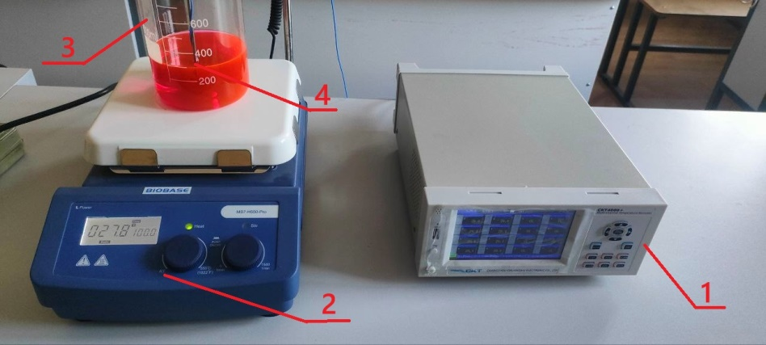
FIGURE 1. Laboratory setup for determining the heat capacity of antifreezes: 1 — SKT 4000+ multi-channel thermometer; 2 — Biobase MS7-H550-Pro magnetic stirrer; 3 — glass beaker; 4 — thermocouple of the SKT 4000+ device.
EXPERIMENTAL PROCEDURE
- Sample preparation. 300 ml of each antifreeze sample was poured into a glass beaker (3).
- Temperature measurement. A thermocouple (4) connected to the SKT 4000+ thermometer (1) was immersed in each sample, while the beaker was placed on the surface of the Biobase MS7-H550-Pro magnetic stirrer (2).
- Heating conditions. All samples were heated to 100 °C under identical temperature settings on the stirrer. The Biobase MS7-H550-Pro magnetic stirrer has a nominal heating power of 550 W. The device automatically adjusted the supplied heating power to reach the target temperature of 100 °C according to the user-defined settings, which ensured controlled and reproducible heating conditions. Stirring during heating was deliberately disabled, since preliminary tests showed that activation of the stirrer led to significant temperature fluctuations (up to ±5 °C), which complicated accurate recording of the heating and cooling dynamics. To ensure reliable measurements and to exclude parasitic oscillations of the thermocouple, stirring was not used in any of the experiments. All samples were investigated under identical conditions.
- Heating time. After reaching 100 °C, heating was switched off. The heating time from the initial temperature (~30 °C) to 100 °C was recorded.
- Cooling time. The cooling time for each sample from ~100 °C down to 40 °C was also measured.
- Controlled conditions. All measurements were conducted under identical experimental conditions, including:
  - sample volume;
  - thermocouple placement;
  - heating power and uniformity;
  - ambient temperature (~30 °C);
  - absence of drafts or additional heat sources.
For each antifreeze sample (used, regenerated, and new factory-produced), at least three independent experimental runs were performed under identical conditions. The obtained heating and cooling curves were averaged, and the variation between runs did not exceed the experimental error margin.
DATA PROCESSING
For each sample, heating and cooling temperature curves were plotted (see Fig. 2). Based on these graphs, the heat transfer time was calculated and differences in heat capacity were analyzed. A higher heat capacity was manifested by longer heating times and slower cooling rates.

TABLE 1. Temperature values during heating of antifreezes (revised version)
№ | Experiment time | Used antifreeze, °C | Regenerated antifreeze, ° | New factory antifreeze, °C
1 | 00:00:00 | 31.0 | 31.0 | 30.1
2 | 00:03:45 | 40.6 | 40.7 | 44.8
3 | 00:07:30 | 57.5 | 57.2 | 60.4
4 | 00:11:15 | 71.8 | 70.6 | 73.5
5 | 00:15:00 | 83.5 | 81.9 | 83.2
6 | 00:18:45 | 92.0 | 88.4 | 88.6
7 | 00:22:30 | 99.7 | 92.8 | 94.6
8 | 00:26:15 | 101.7 | 97.0 | 99.4
9 | 00:30:00 | 99.8 | 98.7 | 98.2
10 | 00:33:45 | 96.3 | 94.9 | 92.5
11 | 00:37:30 | 92.4 | 88.9 | 87.8
12 | 00:41:15 | 87.8 | 85.3 | 83.1
13 | 00:45:00 | 84.4 | 80.3 | 77.7
14 | 00:48:45 | 81.1 | 75.0 | 74.5
15 | 00:52:30 | 77.5 | 71.9 | 70.4
16 | 00:56:15 | 74.3 | 68.6 | 66.4
17 | 01:00:00 | 71.6 | 65.4 | 64.1
18 | 01:03:45 | 69.4 | 62.3 | 62.2
19 | 01:07:30 | 66.8 | 60.0 | 59.1
20 | 01:11:15 | 64.5 | 57.7 | 57.9
21 | 01:15:00 | 62.4 | 55.9 | 55.8
22 | 01:18:45 | 60.7 | 54.5 | 54.0
23 | 01:22:30 | 58.8 | 52.5 | 52.5
24 | 01:26:15 | 57.2 | 51.2 | 50.8
25 | 01:30:00 | 55.7 | 49.4 | 49.1
26 | 01:33:45 | 54.2 | 48.2 | 47.8
27 | 01:37:30 | 52.4 | 47.1 | 46.9
28 | 01:41:15 | 51.3 | 46.1 | 45.7
29 | 01:45:00 | 49.8 | 45.0 | 44.5
30 | 01:48:45 | 49.1 | 43.9 | 43.9
31 | 01:54:50 | 47.4 | 42.6 | 42.5

To investigate the thermal properties of the coolant samples — used, regenerated, and new antifreeze — a series of high-frequency temperature measurements was carried out. For each sample, approximately 1400 temperature data points were recorded at intervals of about 5 seconds under identical heating conditions without stirring.
For better clarity and readability, Table 1 presents a reduced dataset — 31 representative temperature points uniformly distributed throughout the entire duration of the experiment.
Based on the complete dataset, temperature curves were plotted (Fig. 2), illustrating the heating and cooling dynamics of all three antifreeze samples.

FIGURE 2. Comparison of the thermodynamic characteristics of antifreezes during heating to 100 °C and subsequent cooling.

Based on the complete dataset (over 1400 points for each sample with a 5-second interval), a temperature curve was constructed (see Fig. 2) to illustrate the heating and cooling processes of the three antifreeze types. As shown in the graph, the used antifreeze reaches its peak temperature more rapidly but also cools down more slowly, which indicates its higher heat capacity and potentially lower thermal conductivity.
The regenerated antifreeze exhibits behavior similar to that of the new commercial sample, which confirms the effectiveness of the regeneration process and the preservation of the required thermodynamic properties (see Table 2).
TABLE 2. Comparative analysis of the average temperature values of the tested coolant samples
Comparison | Difference, °C | Difference, %
Used vs. Regenerated | +4.61 | +7.08
Used vs. New factory antifreeze | +4.45 | +6.83
Regenerated vs. New factory antifreeze | −0.15 | −0.23
MATHEMATICAL AND STATISTICAL PROCESSING OF THE THERMODYNAMIC CHARACTERISTICS OF ANTIFREEZES
Based on the obtained experimental data (tables and graphs), a mathematical and statistical analysis of the thermodynamic characteristics of the studied antifreezes was carried out. Data processing was performed using regression modeling methods in Microsoft Excel 2021 and the OriginPro 2023 software package, which was applied for plotting graphs and evaluating the determination coefficients.
A third-order polynomial regression was selected as the approximating function, since it provided the best agreement between the experimental and calculated data. Based on these dependencies, graphical models were constructed (see Fig. 3), describing the dynamics of temperature changes. These graphs make it possible not only to visualize the process but also to quantitatively assess the differences between the used, regenerated, and new factory antifreezes.
The obtained models are as follows:
$T(τ)=a_{0}+a_{1}τ+a_{2}τ^{2}+a_{3}τ^{3}$ (1)
where T(τ) is the liquid temperature, °C; τ is the heating/cooling time, s; a₀, a₁, a₂, a₃ are the regression coefficients determined for each sample.
For the dependence of temperature T (°C) on time τ (s), the following equations were obtained:
1 – Used antifreeze
T(τ)=36.95+0.0624τ−2.03⋅10−5τ²+1.70⋅10−9τ³, R2=0.895
Coefficient of determination: R² = 0.895
2 – Regenerated antifreeze
T(τ)=37.12+0.0599τ−2.02⋅10−5τ²+1.72⋅10−9τ³, R2=0.902
Coefficient of determination: R² = 0.902
3 – New factory antifreeze
T(τ)=41.35+0.0564τ−1.94⋅10−5τ2+1.66⋅10−9τ3, R2=0.896
Coefficient of determination: R² = 0.896

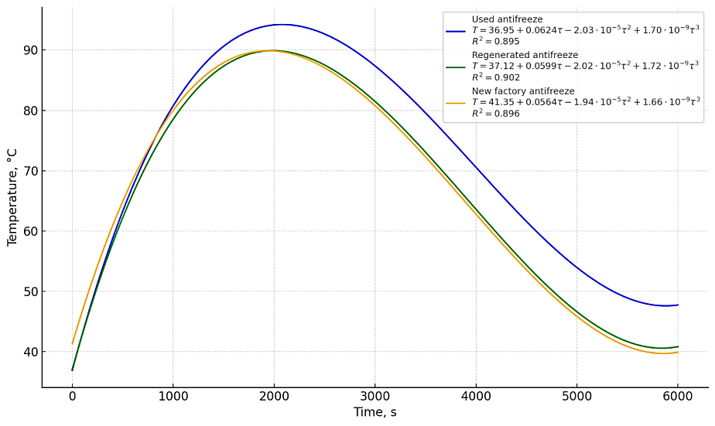
FIGURE 3. Regression models of the temperature characteristics of the studied antifreezes

Conducted mathematical analysis showed that all the studied samples—used, regenerated, and new factory antifreeze—are satisfactorily described by third-degree polynomial models, with determination coefficients ranging from 0.895 to 0.902. This confirms the high reliability of the chosen approximation method. Comparison of the obtained temperature curves showed that the used antifreeze exhibits a more noticeable nonlinearity during cooling. This behavior indicates a reduction in its heat capacity and, consequently, a lower ability to dissipate heat efficiently. In contrast, the regenerated antifreeze demonstrates temperature changes that are almost identical to those of the new factory sample. The form of the curve, as well as the heating and cooling rates, differ only slightly, and the calculated coefficients are close in value. These results suggest that the applied regeneration method is effective, ensuring the recovery of thermophysical characteristics to a level comparable with that of new antifreeze.
CONCLUSION
The results obtained have both scientific and practical importance. Experimental comparisons of heat capacity and overall thermal behavior showed that the applied regeneration method — multi-stage filtration — successfully restores the functional characteristics of antifreeze. The regenerated samples demonstrate performance close to that of the original coolant, confirming the efficiency of the chosen approach. From an environmental perspective, this approach reduces the amount of hazardous waste and minimizes risks associated with the disposal of spent coolants. From an economic standpoint, regeneration enables the reuse of antifreeze without loss of performance, which reduces the cost of purchasing new fluids and promotes more rational resource utilization.
It should be emphasized that this study mainly focused on thermal parameters (heat capacity, heating and cooling dynamics). For a comprehensive assessment, further investigation of density, pH, thermal conductivity, and anticorrosive performance is necessary, as well as comparison with national and international standards (GOST, ASTM, etc.). In the future, it will also be important to conduct long-term operational testing of regenerated antifreeze in real engines to confirm its stability and durability.
Thus, this work demonstrates the feasibility and effectiveness of antifreeze regeneration technologies. It has been proven that properly regenerated coolants can be successfully reused in transport and energy systems, providing performance comparable to new factory samples while simultaneously contributing to ecological safety and economic efficiency.
REFERENCES
- Khakimov, R., & Ayrapetov, D. (2024). Anti-corrosion coatings for the protection of metal parts of transport equipment. AIP Conference Proceedings. https://doi.org/10.1063/5.0197858
- Rossiter, W. J., Godette, M., Brown, P. W., & Galuk, K. G. (1985). An investigation of the degradation of aqueous ethylene glycol and propylene glycol solutions using ion chromatography. Solar Energy Materials, 11(5–6), 455–467. https://doi.org/10.1016/0165-1633(85)90016-4
- Chen, X., Tian, W., Li, S., Yu, M., & Liu, J. (2015). Effect of temperature on corrosion behavior of 3003 aluminum alloy in ethylene glycol–water solution. Chinese Journal of Aeronautics, 29(4), 1142–1150. https://doi.org/10.1016/j.cja.2015.12.017
- Zhang, D. Q., Zhou, L. X., Rao, C. Y., & Gao, L. X. (2012). Effect of pH and glycolic acid on corrosion of AA6061 alloy in ethylene glycol–water solution. Materials and Corrosion, 65(1), 31–37. https://doi.org/10.1002/maco.201206619
- Faber, J., Jurasz, Z., & Brodzik, K. (2019). Effect of aging and interaction of cooling fluid with heat exchangers material in long-lasting durability test. Silniki Spalinowe/Combustion Engines, 177(2), 187–192. https://doi.org/10.19206/ce-2019-232
- Randall, P. M. (1993). Investigation of cleaner technologies to minimize automotive coolant wastes. Journal of Cleaner Production, 1(2), 67–75. https://doi.org/10.1016/0959-6526(93)90044-c
- Pereira, L. A., et al. (2020). Recycling of used ethylene glycol from engine coolants. Waste Management, 102, 944–954. h
- Vaz, C. R., Rauen, T. R. S., & Lezana, Á. G. R. (2017). Sustainability and Innovation in the Automotive Sector: A Structured Content Analysis. Sustainability, 9(6), 880. https://doi.org/10.3390/su9060880
- Biancari, A., Di Palma, L., Ferrantelli, P., & Merli, C. (2003). Ethylene Glycol Recovery from Dilute Aqueous Solution. Environmental Engineering Science, 20(2), 103–110. https://doi.org/10.1089/109287503763336539
- Leth, P. M., & Gregersen, M. (2005). Ethylene glycol poisoning. Forensic Science International, 155(2–3), 179–184.
- Rovshan Khakimov, Dmitriy Ayrapetov; Anti-corrosion coatings for the protection of metal parts of transport equipment. AIP Conf. Proc. 11 March 2024; 3045 (1): 030065. https://doi.org/10.1063/5.0197858

