Determination of Contact Pressure between Two Surfaces Forming a Higher Kinematic Pair with Initial Line Contact
Baxtiyor Kasimov^{1, a)}, Shin Illarion², Dilshodbek Ergashev¹,
Elyorbek Shamsiddinov¹, Vitaliy Kalashnikov¹
¹Andijan State Technical Institute, Andijan, Uzbekistan
²Tashkent Institute of Textile and Light Industry, Tashkent, Uzbekistan

^{a)}Corresponding author: kasimovbaxtiyor.1991@gmail.com
Abstract. This article is dedicated to establishing the rigorous theoretical framework essential for accurately determining the complex distribution of contact pressure between two engaging surfaces. Central to the work is a comprehensive mechanical analysis built upon the classic principles of Hertzian contact theory, providing insights into the mechanics of surface interaction. The research meticulously investigates the dynamic variations in pressure magnitude, the resulting surface and sub-surface deformation, and the location and intensity of maximum stresses developed within the contact zone. Furthermore, the study places critical emphasis on understanding and mitigating wear processes, particularly within cam mechanisms, by analyzing the effects of diverse friction conditions. A significant portion addresses the pivotal influence of surface quality and treatment on the component's overall operational durability (service life) and performance longevity. The advanced and validated results derived from this investigation offer invaluable practical application for engineers. They can be utilized in the precise design optimization and robust reliability assessment of high-performance mechanical pairs and, most notably, in the critical engineering of gear transmissions, aiming for superior efficiency and minimized failure risk.
Keywords: contact pressure, Hertz theory, cam mechanism, wear, mechanical pair, friction, deformation, stress, elasticity, durability, strength.
INTRODUCTION
The pressure arising at the contact of two surfaces, or the contact stresses (σ_{H}), are formed at the point of contact between two bodies in cases where the dimensions of the contact area are small compared to the overall dimensions of the bodies (such as the compression of two spheres, a sphere and a plane, two cylinders, etc.) (see Fig.1).
In the calculation of contact stresses, two characteristic cases are distinguished, which correspond to the formation of higher kinematic pairs according to the theory of mechanisms and machines [1]:

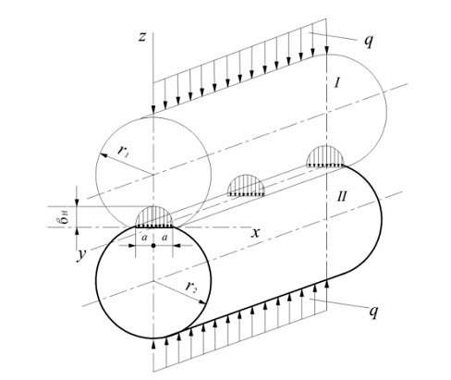
FIGURE 1. Compression of two cylinders I and II with parallel axes.

Figure 1 shows an example of the compression of two cylinders with parallel axes. Before the application of the specific load q, the cylinders were in contact along a line. Under the applied load, this line contact transforms into contact over a narrow area due to the occurrence of elastic deformations. In this case, the points of maximum normal (contact) stresses are located along the longitudinal axis of symmetry of the contact area. The values of these stresses are calculated according to Hertz’s formula [2].
$σ_{н}=\sqrt{\frac{2Е_{1}Е_{2}}{\left[Е_{1}\left(1-μ_{2}^{2}\right)+Е_{2}\left(1-μ_{1}^{2}\right)\right]}∙\frac{q}{ρ_{pr}}, } N/mm^{2}$ (1)
where E1 and E2 are the moduli of elasticity of the cylinder materials, N/mm²; μ1 and μ2 are the Poisson’s ratios of the cylinder materials; q is the calculated specific load (the load per unit length of the contact line), N/mm; ρ_{p}ᵣ is the equivalent (reduced) radius of curvature, determined by the following formula:
$ρ_{пр}={R_{1}R_{2}}/{\left(R_{1}±R_{2}\right)}$ (2)
In formula (2), the “–” sign corresponds to the internal contact of cylindrical surfaces with radii R1 and R2 (that is, to the internal contact case when the surface of one cylinder is concave).
Elastic compression deformations of two-dimensional contacting bodies cannot be calculated solely based on the contact stresses determined by Hertz’s theory. It is also necessary to take into account the shape and dimensions of the solid bodies themselves, as well as the methods of their fixation.
In most practical cases, such calculations are difficult to perform, which has led to the development of a number of approximate formulas for evaluating the elastic compression deformations of bodies in contact under plane-stress conditions (for example, in the case of gear teeth or rolling bearings).
Thus, the calculation of the contact strength of gear teeth is of an approximate nature, since it is based on Hertz’s formula for the maximum contact stresses σ_{H} (1), represented as follows:
$σ_{н}=\sqrt{\frac{E_{pr}}{2π\left(1-μ^{2}\right)}∙\frac{q}{ρ_{pr}}, } N/mm^{2}$ (3)
where E_{pr} = 2E₁E₂ / (E₁ + E₂) is the equivalent (reduced) modulus of elasticity; μ is the Poisson’s ratio: for steel, μ = 0.3; for cast iron, μ = 0.25.
Formula (3) corresponds to the theory of two statically compressed and stationary cylinders, and is considered approximate due to several reasons:
1. The gear teeth are not isolated cylinders, but rather cantilever beams of variable cross-section;
2. The curvature of the tooth profiles in the contact zone is variable, whereas in compressed cylinders it is constant;
3. During meshing, the gear tooth surfaces not only roll but also slide relative to each other, unlike the purely rolling contact of compressed cylinders;
4. The operation of gears in an oil bath affects the nature of load distribution in the contact zone.

METHODS AND MATERIALS
For initial line contact and a Poisson’s ratio μ = 0.3 (for steel and cast iron), the contact stresses are calculated according to formula (4).
$σ_{н}=0,418\sqrt{\frac{NЕ_{pr}}{а} \left(\frac{1}{R_{1}}±\frac{1}{R_{2}}\right)},N/mm^{2}$ (4)
where N is the normal load in the contact zone, N; a is the width of the contact area, mm.
However, the use of such a model is justified, as shown by precise calculations, since the dimensions of the contact area are small compared to the overall dimensions of the tooth.

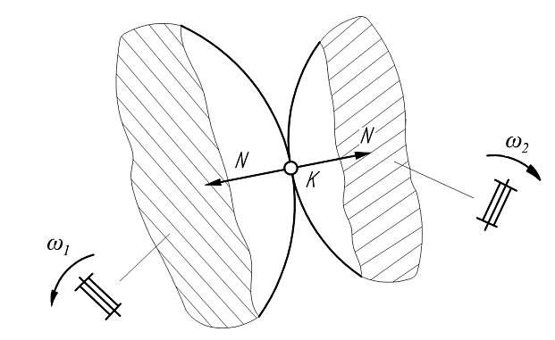
FIGURE 2. General case of contact between surfaces forming a higher kinematic pair.
The analysis of the stress–strain state arising in planar and spatial cam mechanisms can also be carried out by considering the elastic contact of two cylindrical surfaces in those cam mechanisms where the follower is equipped with a roller. Such a cam pair, consisting of a double (paired) cam and a two-arm lever–type follower with rollers, is implemented as a transmission element in the batten mechanism of the STB weaving loom (see Fig. 2) [3].
In the synthesis of cam mechanisms, the main requirement is that the contact pressure should not exceed a specified permissible value, thereby ensuring the operability of the mechanism.
However, this method does not always guarantee the required durability of cam mechanisms due to the wear of the cam and follower profiles.
For a cam mechanism with a roller-type follower, the following surface contact conditions are characteristic:
- The roller of the follower and the cam profile can be considered as isolated cylinders, each rotating about its own axis;
- The curvature of the follower profile (in the form of a roller) in the contact zone is constant, whereas the curvature of the cam profile is variable and depends on the rotation angle as a whole; however, for the angular positions corresponding to the extreme (upper and lower) phases, the curvature of the cam profile remains constant due to the constant radius of the cam;
- The surfaces of the follower roller and the cam profiles, during their relative motion, are involved in rolling with sliding;
- The operation of the cam mechanism takes place in an oil bath.

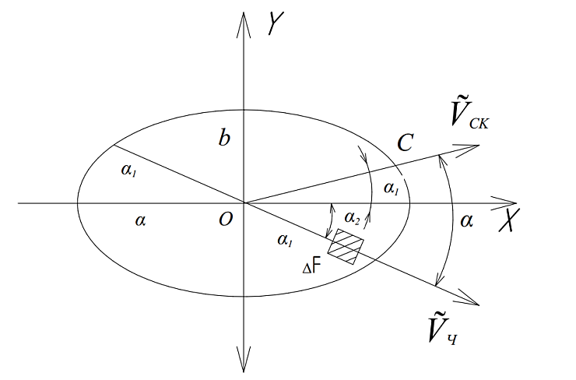
FIGURE 3. Contact zone in the form of an ellipse with semi-axes a and b at the contact of elastic bodies.

Let us consider the general case of contact between two surfaces forming a higher kinematic pair, i.e., having an initial point or line contact.
During motion transmission, a finite contact area is formed at the initial contact point [5, 6].
As a result of the analysis of contact deformations [7, 8], it has been established that in most cases of loaded contact between elastic bodies of double curvature, the shape of the contact area can be approximated by an ellipse with semi-axes a and b (see Fig. 3).
The dimensions of the contact zone depend on the compressive force, the elastic properties of the material, and the curvature of the bodies at the point of contact.
According to the study by I. V. Krachevskiy [5], the general case of relative motion of surfaces is considered, where rolling is accompanied by sliding (as occurs in cam, gear, and other mechanisms).
It is assumed that slippage of the contact spots occurs throughout the entire contact zone.
Let us introduce into consideration the sliding velocity in the contact zone, Vₛₖ, and the velocity of movement of the contact zone along the element of the kinematic pair, Vᵣ.
In the general case, the vectors of these velocities form a certain angle α between each other, and angles α₁ and α₂ with the semi-axes of the ellipse, respectively.
During one loading cycle, we determine the wear of a small area ΔF located on one of the ellipses of the kinematic pair.
It is assumed that the dimensions of this area are such that the basic dependencies for the wear intensity Jh remain valid within it.
During the relative motion of the elements, the contact area ΔF is subjected to a pressure distribution P(x, y) acting in the direction of the velocity Vᵣ.
The time of movement of the entire pressure distribution over the area ΔF is equal to:
$Δt=\frac{2α_{1}}{V_{r}}, s$ (5)
where 2α₁ is the size of the contact area along the direction of the relative velocity Vᵣ, measured in millimeters.
Assuming that during the time interval Δt, the sliding velocity Vₛₖ remains constant and equal to Vₛₖ, the friction path can be determined from Equation (5):
$S_{0}=V_{ск}Δt=2α_{1}\frac{V_{ск}}{V_{r}}=2α_{1}δ$ (6)
where δ = Vₛₖ / Vᵣ is the specific sliding coefficient, introduced in the kinematics of gear transmissions.
The wear of the area ΔF can be determined by the following expression:
$h_{J}=\int_{0}^{S_{0}}{J_{h}\left(S\right)dS}$ (7)
where Jₕ(S) is the wear intensity,
S₀ is the sliding path on the area ΔF during one cycle.
Since the wear intensity depends on the pressure, to determine the wear according to formula (7), it is necessary to find the relationship between pressure and the sliding path.
The pressure in the contact zone is distributed according to the elliptical law, which was first proposed by Hertz, based on his observations of interference rings formed during the contact of two identical cylindrical lenses.
With a small margin of error, the elliptical law can be replaced by a parabolic law.
Thus, the pressure distribution in the contact zone is expressed by the following relationship:
$p\left(x,y\right)= p_{0}\left(1-\frac{x^{2}}{a^{2}}-\frac{y^{2}}{b^{2}}\right)$ (8)
where p₀ is the maximum pressure in the contact zone.
The line OC (Fig. 4) corresponds to the linear relationship y=Rxy = R xy=Rx,
where the slope coefficient R=tan⁡α1R = \tan \alpha_1R=tanα1​.
Then, expression (8) can be transformed into the following form:
$p\left(x,y\right)= p_{0}\left[1-\frac{x^{2}}{a^{2}b^{2}} \left(b^{2}+a^{2}R^{2}\right)\right]$ (9)
In accordance with the work of E. I. Vorobyev [6], the relationship (9) can be expressed as follows:
$p\left(x,y\right)= p_{0}\left(1-\frac{l^{2}}{a_{1}^{2}}\right)$ (10)
To determine the relationship between pressure and the sliding path, let us first establish the following obvious relationships:
the elementary displacement dl=Vrdtdl = V_r dtdl=Vr​dt, hence dt=dlVrdt = \frac{dl}{V_r}dt=Vr​dl​,
then the elementary sliding path will be equal to:
$dS=V_{ск}dt=\frac{V_{ск}}{V_{r}}dl$ (11)
After integrating equation (11), we obtain:
$$S= \int_{0}^{l}{\frac{V_{ск}}{V_{r}}dl=\frac{V_{ск}}{V_{r}}l}$$
from which it follows that
$l=S\frac{V_{r}}{V_{ск}}$ (12)
Then, substituting equation (12) into expression (10), we obtain the relationship for determining the pressure:
$p\left(S\right)=p_{0}\left[1-{\left(\frac{V_{r}}{V_{ск}}\right)}^{2}\frac{S^{2}}{a_{1}^{2}}\right]=p_{0}\left(1-\frac{S^{2}}{S_{0}^{2}}\right)$ (13)
From equation (13), it follows that the relationship between the pressure on an elementary area and the sliding path remains parabolic.
Most early studies on wear calculation of various machine elements were based on the assumption that the amount of wear is proportional to the work done by friction forces. However, further development of the science of friction and wear has shown that this assumption is rarely valid. In the general case, wear is proportional to the sliding distance and the specific friction force raised to the power t (where t — the fatigue curve exponent — ranges from 2 and higher). Thus, there is no direct proportionality between wear and the work of friction forces.
The wear intensity depends on the pressure p raised to a power x greater than one [5]. Moreover, this exponent differs for elastic and plastic contacts, for higher and lower kinematic pairs, and for run-in and non–run-in surfaces, varying within the range from 1 to 2 or slightly higher. Thus, the following relationship holds true:
$J_{h}={cp}^{x}$ (14)
where the coefficient c is determined by the physical and geometric characteristics of the pair and the type of contact.
By substituting expression (13) into (14) and then into formula (7), we obtain the relationship for wear:
$h_{I}=\int_{0}^{s_{0}}{J_{h}\left(S\right)dS}=\int_{0}^{s_{0}}{c{\left[p\left(S\right)\right]}^{x}}dS=\int_{0}^{s_{0}}{c\left[p_{0}^{x}{\left(1-\frac{S^{2}}{S_{0}^{2}}\right)}^{x}\right]dS}$ (15)
To simplify the integration of equation (15), it can be assumed with a small margin of error that
$$\left(1-\frac{S^{2}}{S_{0}^{2}}\right)≅\left(1-\frac{S}{S_{0}}\right) при 0≤S≤S_{0}$$
Thus, finally we obtain the expression for the quantitative evaluation of wear.
$h_{J}=\frac{2}{3}{cp}_{0}^{x}S_{0}=\frac{2}{3}J_{h0}S_{0}=\frac{2}{3}{cp}_{0}^{x}a_{1}б$ (16)
The relationship (16) shows that the wear, when the pressure over the contact area is distributed according to Hertz’s law, amounts to two-thirds of the wear under uniform pressure equal to the maximum value. Further transformation of formula (16) is associated with obtaining an expression for wear through geometric and force parameters by substituting the values of p₀, a₁, and b in terms of load and curvature radii, based on the theory of contact stresses.

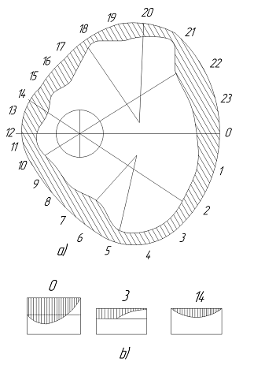
FIGURE 4. Wear of the cam of the shed-forming mechanism of the weaving loom: a) along the profile; b) in cross-section.

For joints with higher kinematic pairs, a non-uniform distribution of wear is characteristic [4], since the wear conditions do not remain constant for all points of both bodies. A typical example of such joints is the cam–follower kinematic pair, where the follower is equipped with a roller or a pointed end.
Non-uniform wear of the cam profile leads to a distortion of the transmitted motion law and the occurrence of additional dynamic loads, which often becomes the main cause of the entire mechanism’s failure.
Thus, Figure 4 shows the results of measuring the wear of the cam profile of the shed-forming mechanism of the AT-100-5M weaving loom after prolonged operation (two years in three shifts) [9].
Non-uniform wear of the cam in the transverse direction may be caused by improper operating practices, when the mating roller, due to wear of its mounting hole, becomes misaligned and requires immediate replacement.
RESULTS AND DISCUSSION
Irregular wear of the cam profile is also associated with the influence of variable factors—such as the pressure angle (α), normal load (N), radius of curvature (ρ), and follower velocity (Vₜ)—at different sections of the cam. These variations lead to changes in the motion law of the roller, which determines the size of the shed between the warp threads through which the shuttle passes.
As a result, the quality of the produced fabric deteriorates due to an increased rate of thread breakage.
In accordance with the work of A. S. Pronikov [4], let us consider the methodology for evaluating profile wear using the example of a cam mechanism with a translational follower having a pointed end (see Fig. 5).
The wear of the follower has little effect on the change in its motion law, since this wear is compensated by the continuous force closure provided by the spring. The main factor influencing the change in the follower’s motion law is the distortion of the initial cam profile that occurs as the cam wears out.

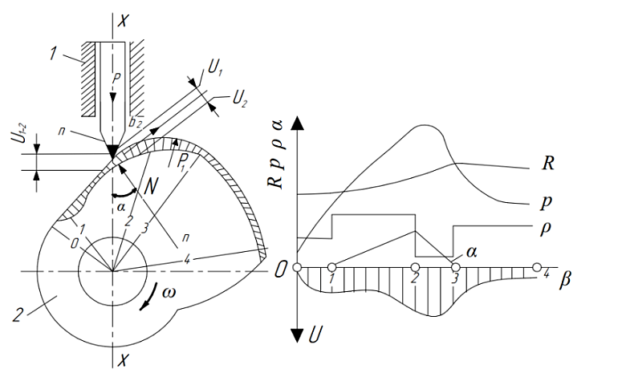
FIGURE 5. Diagram of wear in the cam mechanism.

Let us note some specific features of calculating the cam pair:
- The contact stresses (σₙ) in the contact zone obey Hertz’s law. Thus, for initial line contact (a higher kinematic pair) and a Poisson’s ratio of 0.3 (for steel or cast iron), the contact stresses are calculated using formula (4). Therefore, the fundamental wear laws must correspond to the conditions of initial line contact.
- The normal load N (reaction force) is a function of the load P acting on the follower and the pressure angle α, and is expressed as:
$N=P\frac{cosφ_{2}}{cos\left(α+φ_{1}+φ_{2}\right)}, Н$ (17)
where φ₁ and φ₂ are the friction angles in the cam–follower pair and in the follower guides, respectively.
Since the pressure angle α varies along different sections of the cam profile, even under a constant load P=constP = \text{const}, the reaction force N will fluctuate over a wide range. The range of contact forces in the cam pair can be very large if inertial loads are also considered as a function of the geometric parameters of the profile, which determine the follower’s acceleration and the variability of the operating load PP.
The forces in the pair can be calculated for any point of the cam profile as a function of either the rotation angle β or the profile’s developed length.
- The radii of curvature ρ₁ of the cam profile also vary along different sections and can change due to wear. Even if this variation is neglected in a first approximation for both the cam and the follower, the contact stresses, as follows from formula (4), will still depend on the values of ρ at each point of the profile.
- The sliding velocities of the follower along the cam profile also vary. At a constant cam angular velocity (ω = const), the relative sliding velocity Vₜ, directed tangentially, is given by:
$V_{т}=\frac{ωR}{cosα}$ (18)
where R is the cam radius, which varies in magnitude, i.e., R = Var.
This velocity is precisely the one used in the fundamental wear law. Thus, if the original material wear pattern for this type of friction is represented, for example, as:
$γ=Rσ_{н}V_{т}$ (19)
The determination of the worn cam surface U=γtU = \gamma t is carried out by substituting into this formula the initial values according to (4), (17), and (18), taking into account that the parameters PP, αα, RR, and ρρ vary and are functions of the cam rotation angle β.
Figure 6b shows an example of the graphical representation of the initial parameters and the shape of the worn cam surface for its working section (characteristic profile points 1–4) [4].
The wear of the pairing U₁–₂, which is measured by a single parameter along the x–x direction and is determined by the distortion of the transmitted motion law, can be calculated using the formula:
$U_{1-2}=\frac{U_{1}+U_{2}}{cosα}$ (20)
or by the expression
$γ_{1-2}=\frac{γ_{1}+γ_{2}}{cosα}$ (21)

CONCLUSION
where U₁ and U₂ are the linear wear of the parts at a given point, measured along the normal n–n to the friction surface;
α is the angle between the normal to the friction surface and the direction of possible approach of the parts;
γ₁–₂ is the wear rate of the pairing;
γ₁ and γ₂ are the wear rates of the individual parts at the point.
In formulas (19) and (20), the linear wear U and the angle α are functions of the cam rotation angle β. The evaluation of cam wear in a pair with a roller follower should take into account that theoretically pure rolling is generally accompanied by roller slippage, which significantly affects the wear intensity. In formula (19):
R is the wear coefficient, indicating the magnitude of linear wear (µm) under a pressure of 1 MPa over a friction path of 1 km for the given material pair under the specified wear conditions.
The wear magnitude U in formula (20) is proportional to the friction path S and the pressure p:
$U_{1}=R_{1}pS; U_{2}=R_{2}pS$ (22)
where U₁ and U₂ are the wear of the roller follower and the cam (the mating bodies), respectively.
REFERENCES
- Kasimov, B. (2023). Improvement of the environmental safety of weaving equipment by reducing the wear of contact surfaces. E3S Web of Conferences, 390. https://doi.org/10.1051/e3sconf/202339001025.
- B. Zhou, H. Chen, J. Luo, P. Li, B. Xiang, K. Li, "AEB-YOLO: An efficient multi-scale defect detection algorithm for copper strips", AIP Advances, Vol. 15, 2025 DOI: https://doi.org/10.1063/5.0285324
- Kholmirzaev, N., Turakhodjaev, N., Saidmakhamadov, N., Tadjiev, N., Khasanov, J., Yusupov, B., & Juraev, J. (2024, December). Improvement of the Technology of Melting of Low Alloy Steel Alloy in an Electric Arc Furnace. In Materials Science Forum (Vol. 1139, pp. 3-9). Trans Tech Publications Ltd. https://doi.org/10.4028/p-2AMBsZ
- Urbi Pal, Goutam Mukhopadhyay, Ankush Sharma, Sandip Bhattacharya, Failure analysis of wire rope of ladle crane in steel making shop. International Journal of Fatigue Volume 116, 2018, Pages 149-155. https://doi.org/10.1016/j.ijfatigue.2018.06.019
- İynen, O., Ekşi, A. K., Özdemir, M., & Akyıldız, H. K. (2021). Experimental and numerical investigation of cutting forces during turning of cylindrical AISI 4340 steel specimens. Materials Testing, 63(5), 402–410. https://doi.org/10.1515/mt-2020-0069
- Zhu, Y., Zhang, S., Zhao, R., Lou, J., Zhang, R., Huan, X., & Zhang, Y. (2018). Influences of Na2SiO3 and EDTA-ZnNa2 concentration on properties of zinc-containing coatings on WE43 magnesium alloys. Surface and Coatings Technology, 356, 108–122. https://doi.org/10.1016/j.surfcoat.2018.09.059
- Chang, S., Zhang, K., Tan, J., & Tu, S. (2024). The effect of residual stress on high‐cycle fatigue properties and its evaluation method of Ti‐6Al‐4V alloy. Fatigue & Fracture of Engineering Materials & Structures, 47(10), 3633–3645. https://doi.org/10.1111/ffe.14397
- Fayzimatov, S., & Tojiyev, B. (2023b). Determination of device construction design and parameters for copper wire extending methods. E3S Web of Conferences, 460, 10009. https://doi.org/10.1051/e3sconf/202346010009

