Testing and Comparison of Self-Lubricating Sliding Bearings Made on a Metallopolymer Base
Sohibjon Mukhtorov^{a)}, Dostonbek Nurmatov, Farruxbek Oxunjov,
Sohibjon Rahmonov, Shoxjaxon Tuybozorov
Kakand State University, Kakand, Uzbekistan

^{a)}Corresponding author: sohibjonmuxtorov188@gmail.com
Abstract. In the context of the global development of scientific and technological progress, economic sectors, especially mechanical engineering, which address environmental issues and produce competitive products, are conducting research into the use of modern innovative technologies and the creation of antifriction-wear-resistant composite self-lubricating materials, as well as the necessary spare parts made from them for mechanical engineering purposes. In the Republic, research and development work is being conducted on the development of metal-polymer antifriction materials used in bearings and friction units of machines and mechanisms, the creation of an effective technology for the production of inexpensive, high-quality metal-polymer materials with anisotropic structure using domestic raw materials, and also on increasing the competitiveness of the products being developed, with certain results being achieved. This article is devoted to the selection of fillers with self-lubricating properties inside a porous frame made of metal powder, comparing their mechanical properties with sliding bearings obtained by the traditional method.
Keywords: Impregnation, antifriction, wear resistance, metal polymer, operational, self-lubricating, composition, metal powder, porous frame.
INTRODUCTION
In the work [1-2] the plain bearings of the MCM are conditionally divided into two groups: porous materials on a metal base of iron, bronze, aluminum, copper and graphite, iron-graphite, bronze-graphite, alumino-graphite. The materials of this group contain in some cases solid lubricants (boron nitride – BN) and sulfides (WS2, MoS2, CuS2, FeS, CoS, TiS2, SnS), the content of which can vary from 1.5 to 10% (by weight). The proportion of the base metal is 88–99% (by weight), graphite 0.3–4% (by weight) [1], [2], alloys based on iron, copper and other metals with polymer impregnation, usually polytetrafluoroethylene (PTFE), the content of which is from 1.5 to 10% (by weight) [2].
Materials of the second group are obtained by explosive pressing, where it is impossible to combine one group of metals with another group. For example, iron with bronze or copper. [3], [4]. Not only PTFE, but also ultra-high molecular weight polytetrafluoroethylene (UHMWPE), nylon, capron, etc. can be used as a polymer phase. These polymers act as a solid lubricant during friction, forming a film on the surface of the rubbing parts [5]. The coefficient of friction of UHMWPE (on steel) is~0.1 [6].
The development of metal-polymer plain bearings allows for an increase in the solid lubricant reserve by adding boron nitride (BN) and sulfides (WS2, MoS2, CuS2, FeS, CoS, TiS2, SnS). In [8], it was noted that the development of the BFG-50M bronze-fluoroplastic material for aircraft friction units allowed for an increase in the bronze layer porosity (up to 50%) and the solid lubricant reserve, thereby increasing the wear resistance and antifriction properties of the material. However, the authors of [7], [8] write that the metal-fluoroplastic material does not fully ensure the service life of friction units.
Most of these developments are mainly due to Chinese research scientists [9]. The company Anhui Silver-Ball Bearing Co Ltd (China) has obtained high-strength self-lubricating bearing MCMs, in which nanosized carbon was used as a lubricant [10].
METHODS
As is well known, there are three methods for creating self-lubricating plain bearings. The first is using antifriction polymer materials. The second is applying antifriction polymer materials to a metal base. The third is impregnating the hollow channels of the housing with metal-polymer composites using a vacuum.
It should be noted that after impregnating the porous channels of the blank with polymeric materials containing fillers, the blank's performance characteristics changed significantly.
Therefore, a comprehensive study of the properties of polymers and fillers, as well as their impact on the adhesion, strength, and tribological properties of the frame, is advisable. Given this, the third method is chosen in this article (see Fig. 1).

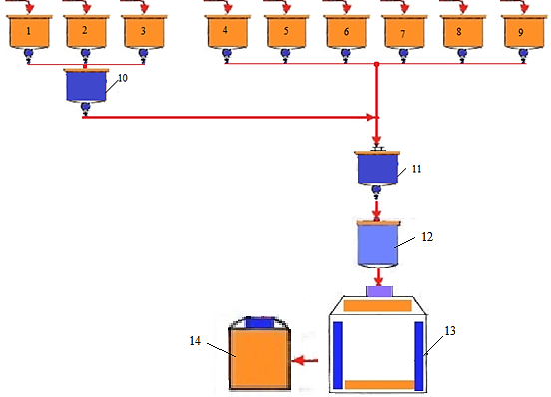
FIGURE 1. Flow chart of the process for producing antifriction, wear-resistant metal-polymer materials obtained by impregnation: 1. Solvent tank; 2. Plasticizer tank; 3. Thermoplastic polymer tank; 4, 5, 6, 7, 8, 9. Filler tank; 10, 11. Mixer; 12. Polymer impregnation device; 13. Oven for preheating metal-polymer materials; 14. Equipment and instruments for determining the performance properties of finished products.
RESULTS AND DISCUSSION
In accordance with the developed technology, 5 metallopolymer laboratory samples of each of the 6 compositions were prepared to study the mechanical, adhesion, and tribotechnical properties of the developed composition (see Table 1). Figure 2 presents the dependence of the friction coefficient on the specific pressure for the filled polymers (BrOF-10-1 + ED-20) lubricated with glycerin (TNPM = 217°C, V-0.5 m/s).

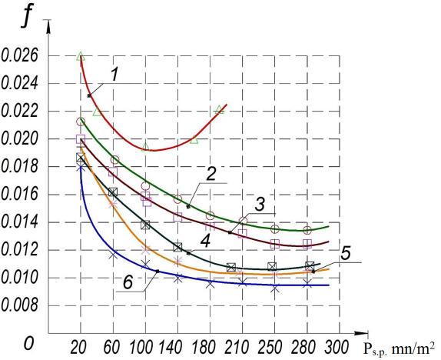
FIGURE 2. Dependence of the coefficient of friction on the specific pressure for filled polymers (BrOF-10-1 + ED-20) in a glycerin environment (TNPM=217°C, V-0.5 m/sec): 1-BrOF-10-1 + ED-20, 2- MP1+Graphite(1.5-3)%, 3-MP1+molybdenum disulfide(1.5-3)%, 4-MP1+copper oxide(8-12)%, 5-MP1+lead oxide(8-12)%, 6-MP1+(1.5-3)% graphite, (1.5-3)% MoS ₂+lead(6-8)%.

Laboratory studies have shown that metal-polymer samples made of BrOF-10-1+(26-31)%ED-20+(1.5-3)% graphite+(1.5-3)%molybdenum disulfide+(6-8)%lead. It was found that its physical-mechanical, adhesive and tribotechnical properties are higher than those of other fillers [11].
Figure 3 shows self-lubricating plain bearings and a frame obtained by the immersion method.

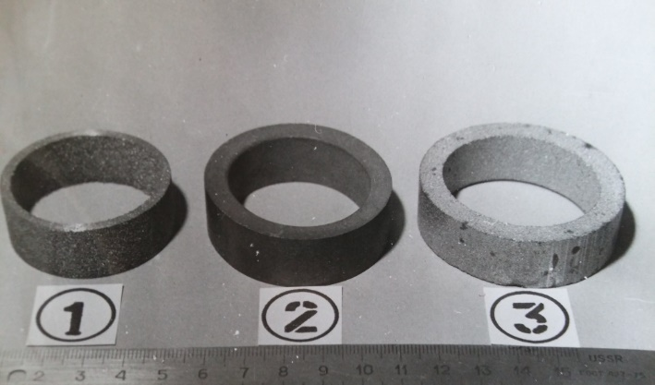
a) | b)
FIGURE 3. A frame made of BrOF-10-1 bronze material (a) and a self-lubricating plain bearing obtained by the impregnation method from BrOF-10-1+(26-31)% ED-20 +(1.5-3)% graphite+(1.5-3)% molybdenum disulfide+(6-8)%lead (b)

Table 1 shows the effect of filler ratios on the friction coefficient of metallopolymer materials during friction (v = 1.0 m/s, P_{s.p.} = 0.75mn/m ²).

TABLE 1. The effect of filler ratios on the friction coefficient of metallopolymer materials during
friction (v=1.0 m/sec, P_{s.p.}=0.75mn/m²)
% Composition fillers | 0 | 5 | 10 | 15 | 20 | 25 | 30 | 40 | 50
MP1+Graphite | 0.48 | 0.48 | 0.49 | 0.52 | 0.56 | 0.6 0 | 0.62 | 0.66 | 0.68
MP1+ molybdenum disulfide | 0.26 | 0.26 | 0.28 | 0.30 | 0.34 | 0.38 | 0.4 | 0.42 | 0.44
MP1+ copper oxide | 0.32 | 0.28 | 0.33 | 0.35 | 0.33 | 0.33 | 0.33 | 0.35 | 0.38
MP1 + black and white oxide | 0.30 | 0.26 | 0.31 | 0.33 | 0.27 | 0.26 | 0.26 | 0.30 | 0.30
MP1 + graphite + molybdenum disulfide + lead oxide | 0.12 | 0.10 | 0.08 | 0.06 | 0.06 | 0.07 | 0.07 | 0.10 | 0.12

It was determined that it was that the most effective materials and filler BrOF-10-1+ ED-20 +(1.5-3)% graphite +(1.5-3)% MoS ₂ +(6-8)% carbon steel consists of are compositions, and their friction coefficient equal to (v=1.0 m/sec, P_{s.p.}=0.75mn/m²) 0.06 ha.
Glycerin in Figure 4 in the environment of fillers eating intensity results shown.
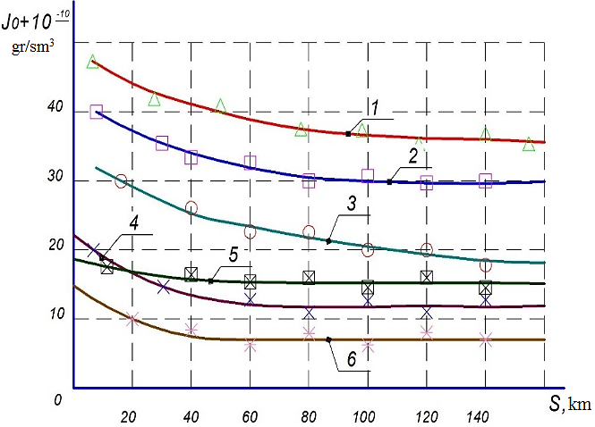
FIGURE 4. When lubricated with glycerin (TPNM-500 K, P_{s.p.}=20mn/m²) The intensity of absorption of different fillers is related to: 1-BrOF-10-1+ED-20, 2- MP1+Graphite(1.5-3)%, 3-MP1+molybdenum disulfide(1.5-3)%, 4-MP1+ copper oxide (8-12)%, 5-MP1+lead oxide(8-12)%, 6-MP1+(1.5-3)% graphite, (1.5-3)% MoS₂+lead(6-8)%.

Figure 3 shows that after 40 mkm, the intensive wear on sample 6 practically does not change, which indicates that a thin wear-resistant film has formed on the surface of the sample, which does not wear away during its further processing.
Thus, as a result of the research, the size of the BrOF-10-1 particles was (+800-1000) microns, and the annealing temperature was 810°C for 1 hour in a hydrogen atmosphere. The optimal composition of the anti-friction and wear-resistant metal-polymer material for friction aggregates was determined, which is: BrOF-10-1+ED-20+ (1.5-3)%graphite+(1.5-3)%MoS₂+lead(6-8)%. A technology for obtaining anti-friction and wear-resistant metal-polymer material for friction parts by impregnating the composition into the hole channels of the frame has been developed, and the optimal process parameters have been determined: mixing temperature of the polymer, plasticizer, solvent and filler T=30-40°C, mixing time 10-15 minutes, vacuum pressure 13.3 Pa, impregnating time 5-7 minutes [12].
56 self-lubricating plain bearings were manufactured using the technology developed for use in agricultural machinery friction units - SChX - 4B cotton seeders - using self-lubricating plain bearings obtained by impregnating polymers into the porous channels of anti-friction and wear - resistant metallopolymer materials.
Figure 5 shows the plain bearings used in the SChX- 4B cotton seeder manufactured by the immersion method.

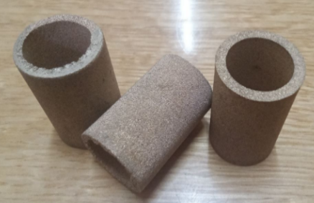
FIGURE 5. SChX-4B brand cotton this guy in the seeder applicable soak in the way working issued slip bearings

Table 2 shows SChX-4B cotton this man seeder attached in the equipment slip the load acting on the bearing h calculation results.

TABLE 2. SChX-4B cotton this man seeder attached in the equipment slip the load acting on the bearing h calculation result
Naming | R, N/mm² | V, m/s | [Pv], H /mm²s | ƒ
Made from St40X in the traditional way | 15 | 0.1 | 13 | 0.08-0.15
Made from MP6 composite according to the proposed technology | 15 | 10 | 15 | 0.009-0.016

Research results Fergana province The moon to the “Kuvamashservis” MTP LLC in the district "SChX-4B " brand cotton seed this man equipment worker parts friction to aggregates self-lubricating slip bearings as I am a worker. Release from tests was held.
Table 3 shows the traditional and new methods of slip bearings work to assess the characteristics The results have been reported.

TABLE 3. Traditional and new methods obtained in slip bearings are exploitative
to assess the characteristics and results
Indicators | Conventional plain bearings | Sliding bearings obtained by the proposed method
Intensive eating, J_{o} x10⁻¹⁰ g/cm ³ | 0.8 | 0.39
Friction coefficient, f | 0.016 | 0.00 9
Working life, service life (season) | 0.5 | 1.3
CONCLUSION
The results of comparing the operational properties of sliding bearings obtained by the traditional method (processing metals under pressure) and the new process (imbibing the composition into the pore channels of the workpiece) showed that the intensive wear and friction coefficient decreased by 2 times, and the durability (service life) increased by 2-2.5 times compared to sliding bearings obtained by the traditional method.
The economic efficiency of the production of sliding bearings for the couplings of SChX-4B cotton seeders was calculated. The annual economic efficiency obtained from the introduction of sliding bearings made of anti-friction and wear-resistant composite metallopolymer materials based on BrOF-10-1+ED-20+(1.5-3)%graphite+ (1.5-3) %MoS₂+(20-30 )%Cu₂O+(20-30)% PbO₂+(15-20)%Pb The expected economic efficiency from the use of (20-25) SChX-4B cotton seeders in friction units at one MTP amounted to 16.974.720 sums.
Thus, the introduction of new self-lubricating plain bearings based on antifriction-wear-resistant composite metallopolymer materials in the friction units of the working bodies of the SChX-4B cotton planter allows:
reduce production and application costs;
increases the durability and reliability of sliding bearings;
A large amount of raw materials are used due to the use of local and secondary raw materials. It saves valuable materials.
The calculation of the economic efficiency of production showed that the introduction of new antifriction- wear-resistant composite metal-polymer materials used in the friction units of the working bodies of the SChX-4B cotton seeder by the method of sintering significantly saves material resources and allows our republic to replace expensive sliding bearings made of imported alloy steel. This will cause a significant decrease in demand.
REFERENCES
- Burkovskaya, N., Sevostyanov, N., Bolsunovskaya, T., & Efimochkin, I. (2020). Improvement of materials for sliding bearings of internal combustion engines (Review). Proceedings of VIAM, 1, 78–91. https://doi.org/10.18577/2307-6046-2020-0-1-78-91
- Sliding bearings. Suspension and steering. (2022). Autocomponents: Business, Technology, Service. Retrieved June 8, 2022, from https://a-kt.ru/articles/opory-skolzheniya
- Sevostyanov, N. V., Rozen, A. E., Buznik, V. M., Loginov, O. N., Usatyy, S. G., & Bolsunovskaya, T. A. (2020). Copper-fluoroplastic electrically conductive composite material obtained by explosive pressing. Trenie i Iznos, 41(1), 55–62.
- Adamenko, N. A., Trykov, Y. P., & Fetisov, A. V. (2004). Polymer and metal–polymer materials produced by explosive treatment. Perspective Materials, 3, 63–68.
- Fedorchenko, I. M., & Pugina, L. I. (1980). Composite sintered antifriction materials. Naukova Dumka.
- Chernavsky, S. A. (1963). Sliding bearings. Mashgiz.
- Kablov, E. N., & Startsev, V. O. (2018). System analysis of the climate impact on mechanical properties of polymer composite materials according to domestic and foreign sources (Review). Aviation Materials and Technologies, 2(51), 47–58. https://doi.org/10.18577/2071-9140-2018-0-2-47-58
- Migtunov, V. P., Chatynyan, L. A., Ivanov, E. V., et al. (1982). Wear-resistant and antifriction materials for friction units. Aviation Industry, 8, 71–73.
- High-strength self-lubricating metal ceramic bearing and preparation method thereof (Patent No. CN 105369146A). (2016, March 2).
- Metal ceramic bearing with good self-lubrication performance and preparation method of metal ceramic bearing (Patent No. CN 105369140A). (2016, March 2).
- Muxtorov, S. A. (2025). Dependence of self-lubrication on surface tension forces. Innovative Research in the Modern World: Theory and Practice, 4(1), 34–35.
- Muxtorov, S. A. (2025). Improving wear resistance by impregnating porous frames for antifriction sliding bearings. Construction and Education, 4(1), 252–254.

