Research on Enhancing the Mechanical Properties
of Car Body Parts by Hardening
Khusanboy Makhammadjanov^{1, a)}, Ikrom Kambarov²,
Makhammadjon Makhammadjonov¹, Ilyos Akbarov¹
¹Central Asian University, Tashkent, Uzbekistan
²Tashkent Turin Polytechnic University, Tashkent, Uzbekistan

^{a)}Corresponding author: k.makhammadjanov@centralasian.uz
Abstract. This article describe the production of car body detail clamps from ASTM A228 spring steel instead of ASTM A313 spring steel in order to reduce the cost. In this case, the mechanical properties of ASTM A228 spring steel are almost equal to ASTM A313 spring steel through heat treatment hardening and the hardness is increased from 41 HRC to 65 HRC. A muffle furnace, a universal hardness tester, an electron microscope, and a drying cabinet are used in the material processing process.
Keywords: Steel, clamp, hardenability, quenching, tempering, temperature, muffle furnace, mechanical property, microstructure.
INTRODUCTION
The automotive industry in our country is developing at a high pace. Within a short period, many joint ventures have been established in the sector, and local enterprises producing spare parts and other materials have been launched under nearly 40 projects. Currently, the production of automobile electronics, seats, bumpers, equipment panels, soundproofing materials, interior trim details, fuel tanks, automotive coatings, and paints has been established. This year, the localization of components has exceeded 75%. In 2005, the second automobile factory in the republic was put into operation. This enterprise manufactures small-capacity buses and various types of trucks and special vehicles with different load capacities.
The cost of producing bodies for light vehicles and buses constitutes 38-52% of the total cost of manufacturing an automobile. Therefore, when we talk about a new car, the first thing that comes to mind is the new body. The production of the body is planned when establishing a new automobile production process [1-3].
The body of light vehicles, buses, and the cabins of trucks protect drivers and passengers from wind, dust, snow, rain, and cold, so high requirements are set for them. Parts like fenders, hoods, cargo compartment bodies, and bumpers are also considered part of the body.
The vehicle layout, the shape, and construction of the body significantly affect the technical characteristics of the car, including its comfort, safety, and durability (long service life). A failure in the body means a failure of the entire vehicle. The body of a car or bus, or the cabin of a truck, must be aesthetically pleasing, have minimal aerodynamic resistance, and provide comfort and safety for the driver and passengers. The body of light vehicles and buses consists of small curves and large, complex-shaped parts.
Considering that the body of a car is exposed to aerodynamic resistance during movement, it is not difficult to understand that the strength of its small parts is of great importance. Therefore, its parts, in particular, clamps, must be strong and rigid. This ensures the safety of the driver and passengers in the car during movement [4-6].
Increasing the mechanical properties of spring steels by heat treatment is one of the most widely used methods in the industry. There are several types of this heat treatment, including normalizing, annealing and quenching. During the normalizing and annealing processes, the internal stresses accumulated in the secondary part are eliminated. These processes are mainly carried out at temperatures below the critical point of A1 (727⁰C). Therefore, after the processes, the plastic and deformation properties of the steel are stabilized. During the quenching process, the mechanical properties of the primary part, such as strength and hardness, are increased. In this process, the part is heated to a temperature above the critical point A3 (768⁰C), held at this temperature for a certain time and then rapidly cooled in water or oil. In this case, the grains of the part are crushed. Ferrite the plastically deformable structure, transforms into austenite at a temperature above the critical point A3 (768⁰C) and, as a result of rapid cooling, transforms into martensite a hard structure. The martensite structure has a needle-like appearance and is considered the hardest structure of steel [7].
In the manufacture of automotive parts, especially clamps, high-alloyed ASTM A313 spring steel is mainly used. This steel grade is superior to ASTM A313 spring steel in terms of price and mechanical properties. The alloying elements Mo and Ni in the part provide its mechanical properties such as high hardness and strength. In order to reduce the cost of the part, we have achieved almost similar hardness and strength to ASTM A228 spring steel by heat treatment, that is, quenching, and have introduced it into production.
METHODS AND ANALYSIS
The car body consists of many parts, one of which is the clamp made of ASTM A228 spring steel. ASTM A228 spring steel has high mechanical properties, the most notable of which is ductility (resistance to deformation). Therefore, clamps in the car body are made of this steel (see Fig. 1).

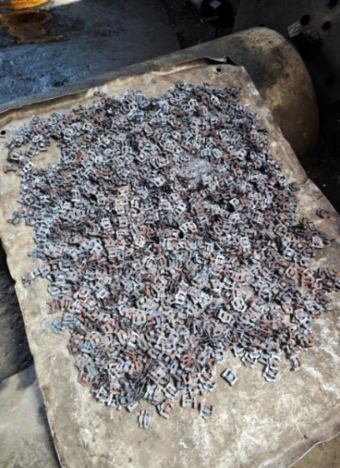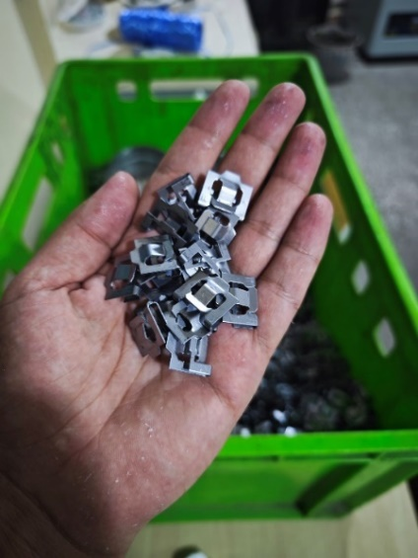
FIGURE 1. Car body clamps made of A228 spring steel

Hardenability refers to a steel alloy's ability to form martensite a hard phase that forms when steel is cooled rapidly (quenched) and is influenced by its alloy composition. Unlike hardness, which is a measure of a material's resistance to indentation, hardenability is a measure of how deeply martensite can form when the alloy undergoes a specific heat treatment.
The cooling rate plays a significant role in hardenability. When a steel alloy is quenched, the outer surface cools more quickly, and martensite forms there first. However, if the alloy has high hardenability, martensite can form not just on the surface but also deeper into the material. In alloys with low hardenability, the cooling rate decreases as you move further into the material, and the interior of the specimen may not form martensite at all. Instead, it may form softer phases like pearlite or bainite.
Therefore, an alloy with high hardenability is one that can be hardened deeply throughout its thickness, making it suitable for applications where strength and hardness are needed not only at the surface but throughout the material [8-10].
To increase the mechanical properties of spring steels, that is, to change their internal microstructure, the method of heat treatment in a muffle furnace is used. After heat treatment at 840-1000⁰C for a certain period of time, the steel is cooled in water and again quenched in a muffle furnace at a temperature of 450-720⁰C (see Fig. 2).
The hardness of car body clamps made of A228 spring steel was increased by testing methods based on GOST 14959-79.

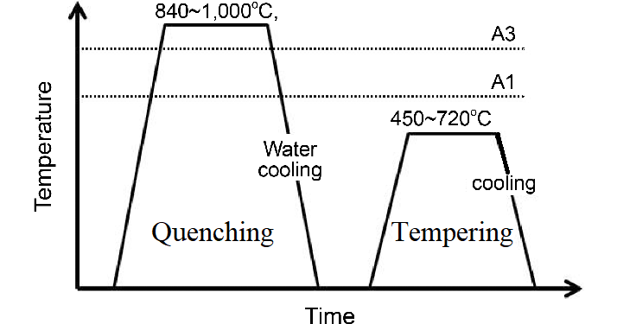
FIGURE 2. Schematic diagram of quenching and tempering process

We used methods based on GOST 14959-79 for quenching car body clamps made of A228 spring steel. In this case, the part was heated in a muffle furnace at a temperature of 850⁰C for 60 minutes. Then it was cooled in water and dried in a drying oven at a temperature of 60⁰C for 15 minutes. During drying, the moisture in the part was completely dried. This ensures that moisture does not accumulate in its structure during the tempering process of the part. After removing the part from the drying oven, it is kept in a muffle furnace at a temperature of 450⁰C for 60 minutes. After the process is completed, the part is cooled in the open air until it reaches room temperature (see Fig. 3) [11].

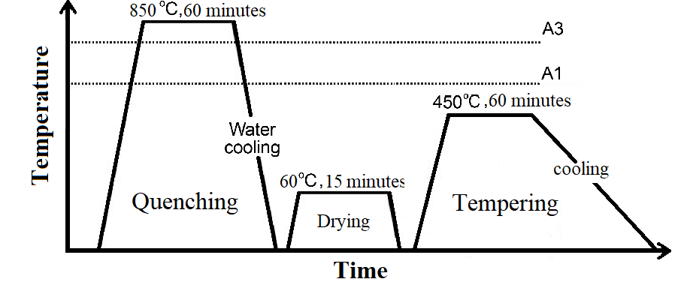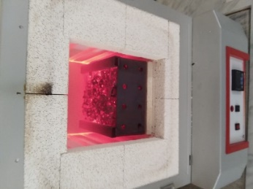
a) b)
FIGURE 3. Schematic diagram of quenching a) and tempering process b).

For the annealing and tempering of car body clamps made of A228 spring steel, we used a “NEVO QTZ” muffle furnace operating at a temperature of 300÷1200⁰C manufactured by the Turkish company “Nevola Muhendislik Mak.Elek. San ve Tic.Ltd. Sti”. For drying the water-tempered part, we used an El-45 drying furnace, and for analyzing the material microstructure, we used an OX.2653-PLM Oxion Inverso Material Science Microscope manufactured by the Chinese company “Euromex”, and for determining the hardness, we used a THBRV-187.5DX Brinell-Rockwell-Vickers universal hardness tester manufactured by the company “Beijing time high technology ltd”.
RESULTS
Mechanical properties stiffness and hardening of car body clamps made of ASTM A228 spring steels were achieved by heat treatment:
The microstructure of the material changed from ferrite to martensite, the grains became finer and acquired a needle-like structure. This improved the hardness and strength properties of the material (see Fig. 4).
It was found that the material hardness before the heat treatment process was HRC 41 according to Rockwell, and after the process it increased to HRC 65;

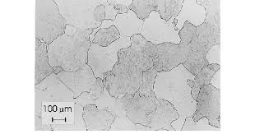  a) | 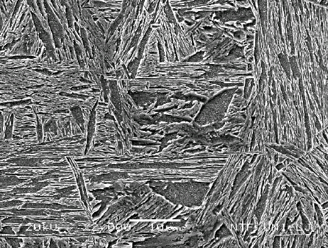  b)
FIGURE 4. Microstructure of car body clamps made of ASTM A228 spring steel before a) and after quenching b)

It was found that harmful additives such as P and S in the material decreased by 10÷15% during the heat treatment process.
DISCUSSION
ASTM A228 spring steels are widely used in mechanical engineering, especially in the automotive industry. Its composition consists of Fe 93-96%, C 0.7÷1%, Mn 02÷0.6%, Si 0.8÷1%. These elements provide its ductility and strength properties. In particular, the Mn element in the material ensures its deformation at high temperatures without breaking, while Si has a positive effect on its resistance and elastic modulus. The C element stabilizes the hardness and strength properties of the material. These properties are also important in the manufacture of car body clamps from this material, but despite this, if this material is not heat treated, the hardness and strength level does not meet the requirements during the operation of the vehicle. In this regard, it is imperative to heat treat the parts made before putting them into production.
From this point of view, the desired result was achieved by heat treating ASTM A228 spring steels using a special method as shown in Figure 3. In this method, the part was held at 850⁰C for 60 minutes. The reason is that at a temperature of 850⁰C, the C, Si and Mn elements in the material completely transform from the ferrite phase to the austenite phase for 60 minutes. For the selected steel grade, there was no phase change in the elements at temperatures below 850⁰C, and at higher temperatures, structural decomposition was observed. The structural grains are fully mobilized and when quenched in water, the grains decompose and become a martensite structure. When the part was dried at 60⁰C for 15 minutes after being removed from the water, our part became completely dry. If the part is placed in a muffle furnace for tempering without drying, as the furnace temperature increases, moisture is released from the wet part and oxygen is added to the furnace walls and the part structure. As a result, the tempering process is not fully completed. This reduces the quality indicators of the part. The dried part was tempered at 450⁰C for 60 minutes. For the selected steel grade, the tempering process must be carried out at exactly this temperature and for this time. During the quenching process, the steel material removed from the water becomes brittle. For these reasons, the tempering process is carried out. In this case, the hardness and strength of the steel material are fully stabilized.
As can be seen from Figure 8, the microstructure of ASTM A228 spring steels before heat treatment had a ferrite plastically deformable structure, but after the process it turned into a hard and durable martensite structure. This fully met the requirements for body parts of automobile bodies. As a result, economic efficiency was achieved in this area by reducing the cost of the part.
CONCLUSION
This scientific article mainly presents the production of car body parts, namely clamps, from ASTM A228 spring steel instead of ASTM A313 spring steel. In it, the mechanical properties of ASTM A228 spring steel were increased by heat treatment in accordance with the quality indicators of the current ASTM A313 spring steel, which is used to produce the part, and as a result, mechanical properties close to ASTM A313 spring steel were obtained. Special heat treatment methods were used.
In conclusion, it is worth noting that instead of expensive ASTM A313 spring steel, it was possible to manufacture clamps for car body parts from relatively inexpensive ASTM A228 spring steel. In this case, ASTM A228 spring steel was heat treated to achieve mechanical properties almost identical to ASTM A313 spring steel, such as high stiffness, strength, and hardness.
REFERENCES
- Russell, A. M., & Lee, K. L. (2005). Structure-property relations in nonferrous metals. John Wiley & Sons, Inc.
- Dong, Y., Li, X., Zhao, Q., Yang, J., & Dao, M. (2017). Modeling of shrinkage during investment casting of thin-walled hollow turbine blades. Journal of Materials Processing Technology, 244, 190–203. https://doi.org/10.1016/j.jmatprotec.2017.01.005
- Olimov, L., & Khojimatov, I. (2023). Thermoelectric properties of silicon oxide. E3S Web of Conferences, 458, 01022. https://doi.org/10.1051/e3sconf/202345801022
- Wang, B., Pan, Y., Liu, Y., Barber, G. C., Qiu, F., & Hu, M. (2019). Wear behavior of composite strengthened gray cast iron by austempering and laser hardening treatment. Journal of Materials Research and Technology, 9(2), 2037–2043. https://doi.org/10.1016/j.jmrt.2019.12.036
- Lynch, P., Hasbrouck, C., Wilck, J., Kay, M., & Manogharan, G. (2020). Challenges and opportunities to integrate the oldest and newest manufacturing processes: metal casting and additive manufacturing. Rapid Prototyping Journal, 26(6), 1145–1154. https://doi.org/10.1108/rpj-10-2019-0277
- Kholmirzaev, N., Khasanov, J., Abdullayev, B., Saidkhodjaeva, S., Bektemirov, A., Sadikova, N., & Nurdinov, Z. (2024). Improving the technology of obtaining high-quality castings from steel in sand-clay molds. E3S Web of Conferences, 525, 03012. https://doi.org/10.1051/e3sconf/202452503012
- Khasanov, J., Kholmirzaev, N., Saidmakhamadov, N., Tojiboev, B., Dilshodbek, E., Makhammadjanov, K., & Otakuziev, A. (2024). Development of technology for obtaining thin-walled details from gray cast iron in sand-clay moulds. International Journal of Mechatronics & Applied Mechanics, 18. https://dx.doi.org/10.17683/ijomam/issue18.24
- Mendes, G., & Lago, B. (2009). Strength of materials. New York.
- Callister, W. D., & Rethwisch, D. G. (2010). Materials science and engineering (8th ed.). Wiley.
- Mardonov, U., Tuyboyov, O., Abdirakhmonov, K., & Tursunbaev, S. (2023). Mathematical approach to the flank wear of high-speed steel turning tool in diverse external cutting environments. International Journal of Mechatronics and Applied Mechanics, 14, 19-26. https://doi.org/10.17683/ijomam/issue14.3
- Garnham, J. E. (1995). The wear of bainitic and pearlitic steels [Doctoral dissertation, University of Leicester]. https://hdl.handle.net/2381/9148

