A Study of Technological Possibilities for Improving the Efficiency of Case Hardening in Low-Alloy Steels
Ibragimjon Domuladjanov^{a)}, Abduvahob Teshaboev, Lutfiyor Jalilov,
Boburbek Tojiyev, Makhzuna Turdialieva
Fergana State Technical University, Fergana, Uzbekistan

^{a)}Corresponding author: domuladjanovi@mail.ru
Abstract. This article presents the results of a study on the hardening of various types of steel used in agricultural engineering for the manufacture of cutting parts for the CLASS combine harvester. The objective of the study is to develop a carburizing technology for agricultural machinery cutting segments. Research objectives is to substantiate and determine the high-temperature carburizing and tempering conditions for the steel under study, to determine the effect of carburizing and subsequent quenching conditions on the structural and phase state of the steel, to determine the effect of carburizing and tempering temperatures on austenite grain size, to determine the composition of a hard-carburizing agent for the high-temperature carburizing process, to develop a technology for polishing the cutting edges of combine harvester segments. The research results have been implemented at the Agricultural Machinery Design and Technology Center Limited Liability Company (LLC).
Keywords: Agricultural machinery, parameters, carburizing, nitriding, nitrocarburizing, methods, boriding, chromium plating, titanizing, combined methods.
INTRODUCTION
Globally, the production of spare parts for agricultural machinery, increasing their durability, and reducing their cost and production costs are important tasks. Therefore, developing manufacturing methods for quickly wearing parts of agricultural machinery, increasing their durability and wear resistance, and developing new technologies for their improvement are of particular importance [1].
Scientific research is being conducted worldwide to extend the service life of wearing parts of agricultural machinery, improve their physical and mechanical properties, develop methods for producing wear-resistant structures, and develop technologies for increasing the efficiency of machine cutting elements. Therefore, special attention is being paid to the development of effective thermochemical treatment technologies, which, among other things, reduce manufacturing costs, increase the strength and service life of parts, and improve the service life and performance of agricultural machinery and equipment. The modern development of agricultural engineering in our country is accompanied by the improvement of wear-resistant components for agricultural machinery. Research is also being conducted to improve their physical and mechanical properties, increase strength and wear resistance, and reduce costs, thereby achieving certain results [2-3].
An analysis of existing research revealed that issues related to the manufacturability, labor intensity, and cost reduction of the finishing process through the development of a technology for finishing the cutting edges of agricultural machinery harvesting segments using high-temperature carburizing followed by high-temperature tempering have not been addressed in detail in existing research [4].
The objectives of this research are as follows:
- to develop a technology for polishing the cutting edges of agricultural machinery;
- substantiate and determine the high-temperature carburizing and tempering modes for the steel under study;
- determine the effect of carburizing and subsequent hardening modes on the structural and phase state of the steel;
- determine the effect of carburizing and tempering temperatures on austenite grain size;
- determine the composition of a solid carburizing agent for the high-temperature carburizing process;
- develop a technology for polishing the cutting edges of combine harvester segments.
METHODS
Low-alloy steels are widely used in mechanical engineering. These steels are relatively inexpensive and exhibit good machinability. These steels are hardened by heat treatment and further strengthened by case hardening. A review of the literature showed that chromium-containing steels are effective for the case hardening process [5]. However, it should be noted that if the chromium content in the steel exceeds 2%, this leads to the formation of nodular carbides. Steels with nodular carbides have lower hardness and wear resistance than steels with dispersed elongated carbides in their structure. It should also be noted that to achieve maximum hardness in steels after the case hardening process, the carbon content should be between 0.4 and 0.55%. Therefore, low-alloy structural steels of grades 40Х, 45ХN, and 55ХGR were selected for the research conducted in this article (see Table 1).

TABLE 1. Chemical composition of the studied steels
Steel grade | Number of elements in steel, in %
Steel grade | C | Si | Mn | Cr | Ni | B | S | P
40 Х | 0,42 | 0,3 | 0,6 | 1.0 | 0,3 | - | 0,025 | 0,025
45XN | 0,45 | 0,3 | 0,7 | 0,75 | 1.0 | - | 0,035 | 0,035
55XGR | 0,55 | 0,3 | 0,9 | 1.2 | - | 0,003 | 0,035 | 0,035

The main alloying element in these steels is nickel, as it leads to the formation of chromium-alloyed cementite and good surface carburization of the steel.
The subject of the study is low-alloy carbon steels grades 40Х, 45ХN, and 55ХGR.
Figure 1 shows a diagram of the furnace used for carburizing under laboratory conditions.

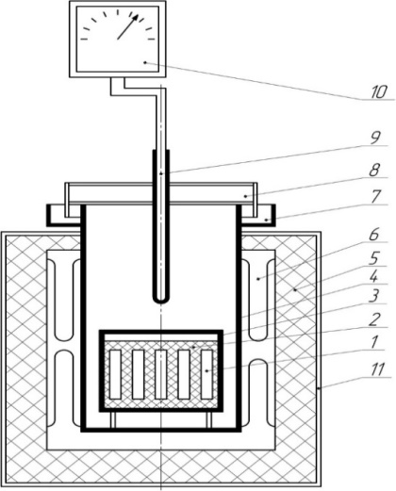
FIGURE 1. Schematic diagram of a laboratory carburizing furnace: 1 - samples; 2 - carbon carburizer; 3 - container with lid; 4 - furnace muffle; 5 - lining; 6 - heaters; 7 - sand seal; 8 - oven lid; 9 - thermocouple; 10 - electronic potentiometer; 11 - oven door

Two groups of steels are used for cutting segments of assembly machine attachments. The first group includes carbon tool steels of grades U8, U9, U10, and U12, which have a hardness of 60-65 HRC through quenching and tempering and exhibit high wear resistance and brittleness. The second group includes low-alloy carbon steels of grades 35, 40Х, 30ХGT, 30ХGCА, 35ХGСА and others.
These steels are characterized by high strength but lack the required wear resistance. To increase the surface hardness and wear resistance of the aforementioned steels, they are case-hardened. In addition to these steels, chromium and tool steels of grades SHKh15, HF, Kh12F1, and others are also used in many cases [6-8].
In agricultural production, plant cutting is a key technological operation, accounting for up to 60% of the total volume of mechanized work. Small blades and cutting elements—sickles—are widely used in combine harvesting, as well as for chopping food processing equipment and agricultural products.
Numerous reliability studies of combine harvesters of various brands have shown that 30% of combine failures are due to the cutting units. Furthermore, 90% of cutting unit failures are due to corrosion. The bending of the cutting segment and tray depends on the condition of the plant stem and the number of abrasive particles in it.
The plant itself consists of silica crystals, and its surface is made of quartz particles.
The topography of the field boundaries, where high yields are obtained, influences harvesting. Thus, it is concluded that the working equipment of a combine harvester operates under conditions of abrasive wear. Abrasive wear is characterized by an erosive effect on the material through micro-cutting and leads to the abrasion of microvolumes of the material's surface as a result of repeated deformation. Furthermore, environmental influences (fertilizers, spraying of various chemicals) during wear also lead to material weakening. The quality of cutting equipment directly depends on the service life and energy performance of its operation. Low wear resistance of these parts leads to increased fuel consumption, the need for additional parts, etc.
Therefore, the issue of increasing the service life of cutting edges in agricultural machinery segments remains relevant today.
RESULTS AND DISCUSSIONS
Relatively common technological processes for improving the working surfaces of parts include chemical-thermal treatment (CHT). CHT methods widely used include carburizing, nitriding, and nitrocarburizing. CHT methods also include boriding, chroming, titanizing, and various combined methods. Combined CHT methods have not been widely adopted due to insufficient study of the processes, the high cost of the equipment, and the strict requirements for their application technologies.
Of all the chemical finishing methods used in finishing agricultural machinery parts, carburizing is widely used in mechanical engineering companies.
Creating carburized layers with high hardness and bending resistance at a sufficient grinding depth (0.8-1.2 mm) allows the use of standard machine tools for grinding.
Several studies on carburization have shown that increasing the carbide layer on the surface of test samples leads to increased wear resistance of quartz abrasives.
In this case, wear occurs due to friction and displacement of agricultural machinery components (under impact loads). The hardness of ordinary cementite is several orders of magnitude lower than that of alloyed cementite, reaching 650 HV. Therefore, low-alloy case-hardened steels wear more intensely than medium-alloy steels. In general, the reduced wear is due to the fact that the hardness of wear-resistant steels is 0.7 times the hardness of the abrasive grain.
In some studies, when the cementite content in the ferrite matrix is approximately 80%, the ferrite matrix virtually loses its ability to deform. In this case, steel wear becomes abrasive, and wear resistance is not very high. Thus, with a cementite content of 80% in steel, the structure of such steel is a cementite-ferrite mixture, i.e., close to the structure of a hard alloy. In this case, it practically does not require further heat treatment. Its only drawback is its low impact toughness.
With a cementite content of 50-60% in steel, heat treatment regimens can be recommended that ensure a high level of ductility with sufficient impact toughness.
The standard carburizing process ensures saturation of the steel surface with carbon (0.8 - 0.9%). The main characteristic of atmospheric saturation during carburizing is the ability to increase the carbon content. The activity of atomic carbon depends on the temperature and pressure in the furnace. There are numerous studies on the thermodynamic analysis of atmospheric saturation.
Based on the data obtained, algorithms for calculating carburizing process parameters are being developed using electronic calculators. Since the solubility of carbon in alloy steels varies depending on the number of alloying elements, defects in the steel's crystal structure also significantly influence diffusion processes.
All defects in the crystal structure—grain and subdrain boundaries, vacancies—affect the diffusion mobility of carbon. Diffusion processes at grain boundaries occur at a higher rate than within the grain. It should be noted that the finer the grain, the greater the diffusion rate and, consequently, the greater the thickness of the diffusion layer. At the same time, during carburization, diffusion also affects the composition of the solid solution, that is, the alloying elements and their compounds. As we know, during deformation, the density of crystal structure defects increases, with these defects practically capturing carbon atoms (dislocations, vacancies), thereby impeding the saturation process. At the same time, due to the increased defect density in deformed steels, the amount of carbon in the surface layer of the steel increases.
According to the theory of diffusion layer formation during carburization, carbon atoms initially accumulate on the steel surface, followed by the formation of new compounds (carbides). Subsequent processes occur via diffusion mechanisms. The formation of the carbide phase itself depends on many factors. First and foremost, the mechanism of carbon diffusion onto the steel surface depends on the formation of the carbide layer structure. In this case, the mechanism of carbide layer formation must actively release a sufficient amount of atomic carbon, while simultaneously saturating the environment. In this case, the primary force of the carburization process lies in the change in the amount of carbon in the resulting carbide layers.
Increasing the amount of carbide phases in steel can only be achieved through the additional formation of cementite. The amount of carbides in alloying elements is limited by the small number of alloying elements. Several studies have investigated the possibility of carbide saturation of steels with carbon contents from 0.4% to 0.9% by carburization. In particular, carburization of SHX15 steel has successfully achieved up to 90% cementite content, ensuring high wear resistance without heat treatment. A study of the case-hardened layer revealed that the composition of cementite depends on the carbon content of the steel and changes with saturation temperature. As shown in the study, the cementite octahedron is arranged with iron atoms at the ends and carbon atoms at the center, and cementite is characterized by anisotropy of its physical properties.
Studies have shown that cementite is capable of undergoing very small plastic deformations. At such high temperatures, cementite deformation occurs in several planes. Furthermore, in some cases, deformation in its structure occurs in the form of dislocation defects and stacking faults. Elements such as chromium and manganese cause lattice distortion in alloyed cementite due to their insolubility in the same plane. The presence of chromium and manganese in alloyed cementite increases its hardness. As the hardness of cementite increases, its wear resistance in abrasive environments also increases.
The standard carburizing process involves carburizing structural steels, which typically contain no more than 1% carbon. Carburizing processes that can increase the cementite content in the surface layers of structural steels to 90% are of great interest.
Gas carburizers are widely used in carburizing processes in many industrial settings. In mechanical engineering plants, gas carburizing is typically carried out in two ways: (20% CO, 40% H₂, 40% N₂) with the addition of up to -5% natural gas (CH₄);
Exo-endogas with an additional CH₄ content of up to -5% (20% CO, 20% H₂, 60% N₂).
The carburizing process is based on endogens, the disadvantage of which is its low carbon potential of ~0.4%C. This deficiency is compensated for by the addition of natural gas, resulting in an increase in the carbon potential to ~1.0% C.
The following reactions occur during carburizing:
$2CO ↔ CO_{2} + C_{(Fe)}$ (1)
$CH_{4} ↔ 2H_{2} + C_{(Fe)}$ (2)
$CO + H_{2} ↔ H_{2}O + C_{(Fe)}$ (3)
The reactions that occur in the furnace cavity with a relatively high probability are shown:
$CH4 + H_{2}O ↔ CO + H_{2}$ (4)
$CH_{4} + CO_{2} ↔ 2CO + 3H_{2}$ (5)
These reactions have a thermodynamic advantage compared to the methane dissociation reaction, which releases free carbon.
In this case, the process prevents the deposition of compressed carbon on the steel surface and maintains the relationship between the carbon potential and the amount of H₂O and CO₂ in the atmosphere.
The carburization process in a CO-CO₂ environment depends primarily on the rate of CO₂ release, which can only be achieved by increasing the gas carburizer flow rate and forcing its circulation. This increases the amount of carbon in the carburized layer. In this case, the carburizer flow rate is approximately 29 l/s. A unique feature of the H₂ system, which differs from the CO–CO₂ system, is that methane release occurs with decreasing temperature and increasing gas volume. The hydrogen released during the reaction has low adsorption capacity for methane and does not affect the main reaction.
The difference between CH₄ and H₂ is that the carburization process is slowed by the release of large amounts of carbon, as this prevents the diffusion process from occurring completely, and excess carbon is deposited on the steel surface as soot or graphite. The presence of a graphite layer slows the carburization process. A thick graphite layer completely stops the process, which in turn leads to decarburization of the steel. Paraffin hydrocarbons are carbon-containing substances that are less prone to soot formation and produce gas well. The most commonly used liquid hydrocarbons are benzene, pyrobenzene, hydrocyanic acid, and kerosene. The greatest soot production occurs with benzenes, which consist of aromatic hydrocarbons (C₆H₆).
Pyro benzene produces better gassing results than benzene and produces less soot and coke. Kerosene is characterized by the presence of paraffin hydrocarbons; the higher their content, the better the gas generation. The optimal content of paraffin hydrocarbons is 60%.
Sinton has relatively good gas recovery rates. The paraffin hydrocarbon content is ~90%.
Compared to other liquid carburizers, the bilge carburizer has a number of advantages:
- a dense coke film does not form;
- minimal soot production;
- higher gas emissions (~0.8 l/sm³);
- 3-4 hours are required to obtain a 1 mm thick carburized layer, compared to 8-10 hours with other liquid carburizers.
During the carburization process, all the gas carburizers reviewed provide the required carbon potential of ~1% C without reducing the carburization rate. To obtain a carburized layer in low-alloy steels, carburizers with a high carbon potential and a fast carburization rate are required.
The carburization temperature (930°C) is approximately ~9 minutes per centimeter of hull size. The carburization time also depends on the hull size and ranges from approximately 6-9 hours. After carburizing, the housings are cooled in air to a temperature of 500°C, after which the housing is opened. The disadvantage of the carburizing process in a solid carburizing medium is its length. The advantage is the versatility and simplicity of carburizing in a solid carburetor, as well as the ability to perform it in various repair shops.
One such option is the vacuum carburizing process.
Special vacuum furnaces are manufactured in a stainless-steel vacuum chamber equipped with a molybdenum heater and a fan. The furnace cavity can be heated to temperatures from 900°C to 2000°C. Parts prepared for carburizing are loaded into the vacuum chamber, where they are heated to a temperature of 1000-1100°C and maintained at this temperature until the parts are fully heated. After the parts are heated, natural gas, propane, or butane is introduced into the chamber. After the saturating gases are introduced into the chamber, a pressure of ~1,5 x 10⁴ Pa is created.
$CH = Fe γ (C) + 2H_{2}$ (6)
As a result of this reaction, a fan is activated, intensifying the saturation of the surface of the parts with atomic carbon. In some cases, vacuum carburizing is performed cyclically, alternating the supply of saturation gas with vacuum. After the carburizing process is complete, nitrogen or argon is introduced into the vacuum chamber to cool the parts to a temperature of 500-600°C. The chamber containing the parts is then heated to the tempering temperature of the steel, and after heating, they are tempered in a tempering bath. After tempering, the part is usually unloaded until the required hardness is reached (see Fig. 2).

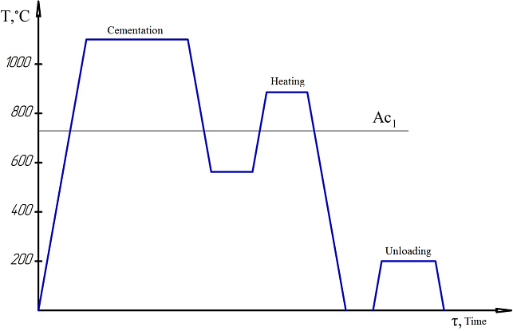
FIGURE 2. Vacuum cementation procedure diagram

Another modern method of vacuum carburizing is explosive flow carburizing, or ion carburizing. An explosive discharge occurs in a gaseous environment; as a result of bombardment of the cathode by gas ions, the cathode emits electrons, and the gas atoms saturate the surface layers of the metal with elements. In vacuum carburizing, the entire process takes place in a vacuum chamber in which the components are placed. These components act as cathodes, and an explosive discharge occurs between the cathode and anode, heating the cathode surface to saturation temperature. Heating of the chamber containing the components occurs in the presence of graphite or molybdenum heaters. Methane in a mixture of propane and nitrogen is used as carburizing gases. The reaction proceeds as follows:
$C_{3}H_{8} = Feγ (C) +{ C}_{2}H_{2} + H_{2}$ (7)
is carried out at a high current of 100 A/m² and a current density of 20 A/m³.
The carburizing process is carried out at temperatures of 1050 - 1100°C. Gas supply and control are determined experimentally. Carburizing in an explosive discharge reduces the time by half compared to gas carburizing. Vacuum carburizing completely eliminates oxidation on the surface of the parts. The process is controlled by electrical parameters and gas components. This process is primarily used in automobile manufacturing for critical machine parts. Highly qualified specialists are required for this application.
For the carburizing process, special samples are made from the steel grades being tested. The samples are cut from rods. These samples are then used to manufacture discs with a diameter of 20 mm and a thickness of 15 mm. The resulting discs are marked with digital stamps.
The carburizing process is carried out in a special steel box. A carburizer consisting of 80% DG-100 gas composition and 20% BaCo₃ salt powder is placed at the bottom of the box.
The carburizing temperature is 860-1200°C. The holding time ranges from 2 to 12 hours.
After carburization, the samples undergo heat treatment, including tempering at the tempering temperature and tempering at a reduced temperature, appropriate for each steel grade. Tempering for each steel grade 40Х, 45ХN and 55ХGR is carried out at temperatures of 860–1200°C.
Samples of these steels are soaked in oil. The tempering temperature at a reduced temperature for all steel grades is 200–400°C.
Microstructural analysis is performed on an MIM-8 microscope. Microsections that have undergone a full carburization and heat treatment cycle are analyzed on this microscope. The surface of the prepared microsections is treated with a 4% nitric acid solution in ethyl alcohol and etched.
X-ray diffraction analysis was performed on a DRON-3 X-ray diffractometer. Case-hardened samples were used. Phase analysis of the matrix of the case-hardened samples was also performed. The amount of retained austenite in the sample matrix was determined. The intensities of the (211) α and (200) γ phase lines were evaluated. The effect of heat treatment on the soft structure of the steel was assessed based on the width of the (220) X-ray lines.
The hardness of the case-hardened layer was determined using a TK-2 Rockwell hardness tester under a load of 150 kg. The microhardness of the case-hardened layer was determined using a PMT-3 microhardness tester. Impact toughness was determined using a pendulum copying device on 10 x 10 x 55 mm samples in accordance with GOST 9454-78.
Wear resistance testing on the X4-B machine was determined using the method developed by M.M. Khrushchev. This method involves testing under abrasive wear conditions. In this case, the tests are selected based on the requirements for cutting tools used in plowing grain fields.
Cylindrical specimens with a diameter of 2 mm and a length of 20 mm are prepared for testing. The cylindrical specimens are mounted vertically in the machine, and radial displacement is achieved by rotating a disk drawn with abrasive sandpaper, at a rate of 1 mm per disk revolution. The specimen essentially moves along an Archimedean spiral. Friction of the specimen occurs on practically new surfaces with a small friction surface area at low sliding speeds and intense wear. A reference material, heat-treated grade U8 steel, is tested under the same conditions. The disk rotation speed is 25 rpm. The test path is 30 m, and the relative load is 9.5 kgf/cm². Type 756M288 paper-backed sandpaper is used as the abrasive material. All tests are conducted using abrasive sandpaper from the same roll.
The experimental results were processed using mathematical statistics methods.
The root mean square error of an individual test is defined as: ${ δ}_{n}$
${ δ}_{n}=\sqrt{\frac{\sum{∆}x^{2}}{n-1}}$ (8)
The mean arithmetic error was determined using the following formula:
$δ_{n}x^{-}=\frac{δ_{n}}{\sqrt{n}}$ (9)
The coefficient of variation was determined using the following formula:
${ ω}_{n}=\frac{δ_{n}}{x^{-}}$ (10)
The main advantage of carburizing a solid carburetor is the ease of operation, including the lack of specialized equipment for various types of production in auto repair shops.
Two types of carburizers are widely used in production: the first is a dispersed carburizer, based on charcoal with barium or sodium carbonate, which causes the activation process, and the second are paste-like carburizers based on a carbon-gas composition, which are applied to parts by spraying or coating.
In a research study, a gas composition was used as a solid carburizer in the nitrocarburizing process. Its advantage over charcoal is its high dispersion and low ash content. In our case, the carburizer was a DG-100 gas mixture, and the activator was barium carbonate BaCO₃, which is used in virtually all industrial carburizing processes.
During carburizing, the use of a solid carburizer results in the formation of CO gas. CO is formed by the reaction of CO present in the carburizing chamber with carbon. Carbon monoxide is formed by the reaction of iron at high temperatures according to the following reaction:
$2CO = CO_{2} + C$ (11)
The activator BaCO₃ causes an increase in CO.
$BaCO_{3} + C = BaO + 2CO$ (12)
$2CO = C + CO_{2}$ (13)
Hence, carbon diffuses into Fe γ-austenite, and CO2 reacts with carbon, leading to the following reaction:
$CO_{2} + C = 2CO$ (14)
It is known that steel carburization in a solid carburizer proceeds intensively at high temperatures.
To determine the optimal carburizing temperature for the steel under study, the dependence of the depth of the carburizing layer on the duration of the process and temperature was studied and constructed.
To prevent carbon oversaturation in the contact zones with carburizer particles, the samples were coated with a paste of chalk powder dissolved in water. The resulting correlation analyses showed that the intensity of the process does increase with increasing carburizing temperature over time (see Figs. 3 and 4). The process is relatively most intense at 12,000°C. For all steel grades studied, the thickness of the carburized layer increases with increasing carburizing time. It should be noted that carburizing at 9,000°C requires more than 12 hours to achieve an effective layer thickness of 1 mm. For all steel grades studied, 8-10 hours of carburizing at 12,000°C are sufficient. For 45XN and 55XGR steels, 8 hours at a carburizing temperature of 11,000°C are sufficient to achieve a layer thickness of 1 mm.
In the standard process of carburizing hardening, after carburizing the steel, it is necessary to carry out a standard heat treatment process, which, in turn, consists of annealing at a temperature usually adopted for each grade of steel and quenching to obtain a specified hardness.

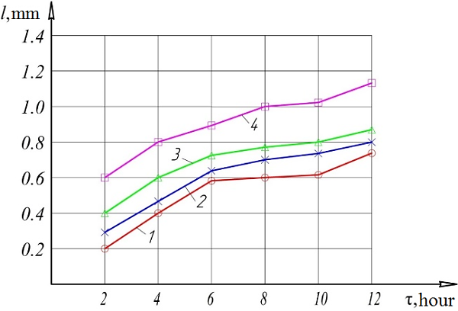
FIGURE 3. Temperature dependence of the duration of maintaining the depth of the carburized layer during carburization of 40X steel in a carburizer with a gas composition of 80% and 20% BaCO₃: 1- carburization temperature - 900⁰C; 2- carburization temperature - 1000⁰C; 3- carburization temperature - 1100⁰C; 4- carburization temperature - 1200⁰C.

In our case, the objective is to intensify the carburization process and, if possible, combine it with quenching. To explore these possibilities, it is necessary to study the effect of the steel heating temperature for quenching on long-term austenitization. To this end, the effect of the initial steel heating temperature for quenching on the austenite grain size was studied (see Fig. 5). The graphs show that as the steel heating temperature increases, the austenite grain size increases rapidly.

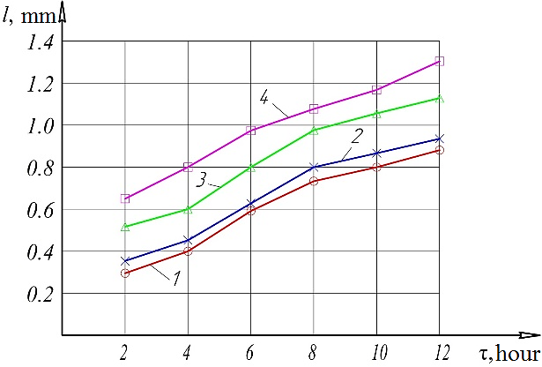
FIGURE 4. Temperature dependence of the duration of maintaining the depth of the carburized layer during carburization of 45X steel in a carburizer with a gas composition of 80% and 20% BaCO₃: 1 - carburization temperature - 900⁰C; 2 - carburization temperature - 1000⁰C; 3 - carburization temperature - 1100⁰C; 4 - carburization temperature - 1200⁰C.

However, repeated annealing at these temperatures eliminates these defects and phenomena. It should be noted that case-hardening after annealing steels at high temperatures is impractical, as this leads to intense grain growth, which is observed after cooling. To refine the grain, the steel must be annealed after cooling the case-hardened samples. With repeated annealing, grain refinement occurs at all austenitizing temperatures, and the time required for this process is minutes rather than hours. Furthermore, previous studies of tool steels have shown that crystal lattice defects increase during annealing at extreme temperatures, which, in turn, ensures the wear resistance of the steels.

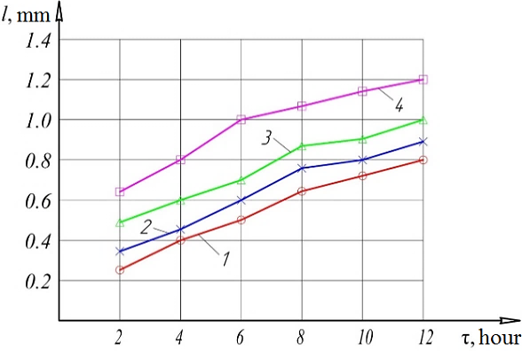
FIGURE 5. Temperature dependence of the duration of maintaining the depth of the carburized layer during carburization of 55 kg steel in a carburizer with a gas composition of 80% and 20% BaCO₃: 1-carburization temperature - 900⁰C; 2- carburization temperature - 1000⁰C; 3- carburization temperature - 1100⁰C; 4- carburization temperature - 1200⁰C.

To determine the degree of imperfection in the steel's crystalline structure, studies were conducted to examine the effect of annealing and tempering temperatures on this degree.
Hardness is the primary indicator of steel hardening. Therefore, the influence of heat treatment conditions on the hardness of the steel was studied. When studying the degree of imperfection in the steel's crystalline structure, heating conditions for annealing were varied from 860°C to 1200°C, and quenching conditions were varied from 200°C to 400°C. The studies showed that hardness increases with any annealing mode as the carbon content of the steel changes (see Figs. 6-7-8). As the annealing temperature increases, hardness decreases slightly. The maximum decrease in hardness is observed during annealing at 1100°C. A decrease in hardness of 2-3 units is not noticeable.

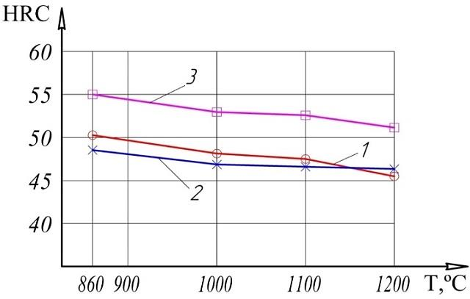
FIGURE 6. Hardness of 40Х, 45ХN, 55ХGR steels changes depending on injection temperature of 200°C: 1 - 40X steel; 2 - 45ХN steel; 3 - 55ХGR steel.

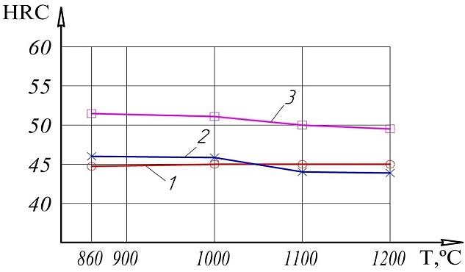
FIGURE 7. Determining the hardness of 40Х, 45ХN, 55ХGR steels depending on the tempering temperature of 350°C: 1 - 40X steel; 2 - 45ХN steel; 3 - 55ХGR steel.

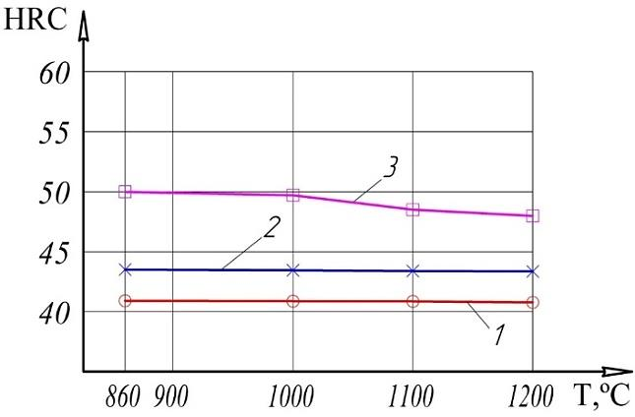
FIGURE 8. Determining the hardness of 40Х, 45ХN, 55ХGR steels depending on the tempering temperature of 400°C: 1 - 40X steel; 2 - 45ХN steel; 3 - 55ХGR steel.

Typical process modes for carburizing in a solid carburizer and subsequent heat treatment are carried out according to the diagram shown in Figure 9. The process itself is carried out as follows: the prepared part is placed in a box with a carburizer, where carburizing takes place.
The parts are typically placed between layers of carburizer. Once the parts are placed in the box, the box is closed with a lid and sealed with refractory clay. The box is then loaded into a furnace preheated to a predetermined temperature. The box containing the parts is then heated to the predetermined temperature and then held in the furnace to complete the carburizing process.

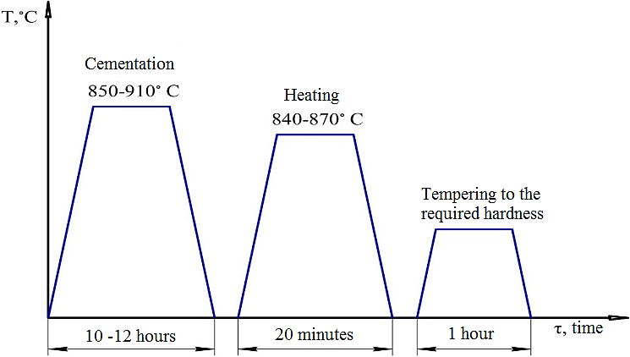
FIGURE 9. Schematic diagram of a typical technological process of carburization and heat treatment in a solid carburizer

The entire process cycle of carburizing and subsequent heat treatment in a solid carburizer takes 20 hours or more, which is quite inconvenient for production processes primarily carried out in two shifts.
During production, the zone beyond the depth of the carburized layer consists of hypereutectoid, eutectoid, and hypoeutectoid zones with a Vickers microhardness of 5000 HV - 6000 HV. 1100°C for 10 hours. The carburized layer, 0,15 mm deep, constitutes up to 60% of the sample. This revealed the presence of carbide phases, which, in turn, provide hardness and wear resistance on the surface (see Fig. 10). Microstructural analysis of the surface layer of 55ХGR steel after heat treatment and carburization revealed the presence of fine-acicular martensite, small areas of residual austenite, and, correspondingly, carbides (see Fig. 11).

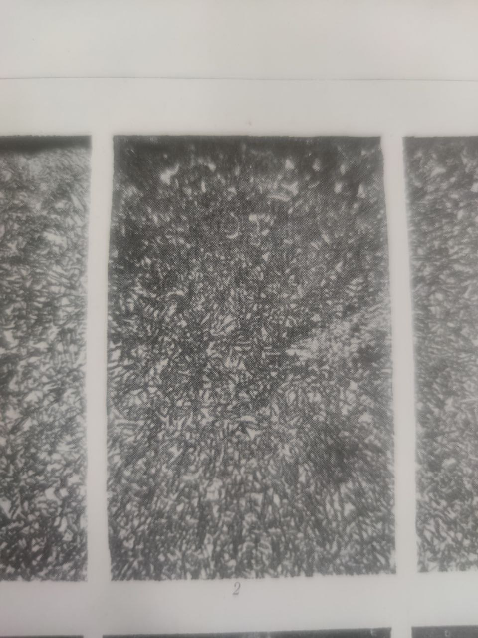
X500
FIGURE 10. Microstructure of 55ХGR steel after carburizing. Carburizing temperature: 1100°C, holding time: 8 hours.

X500
FIGURE 11. Microstructure of 40X and 55ХGR steels after carburizing and subsequent heat treatment. Carburizing temperature 1100°C, holding time 8 hours, setting temperature 1100°C, tempering temperature 200°C. 40X steel; 2 - 55ХGR steel.

With increasing carburizing and tempering temperatures, the hardness of the steel increases, along with its brittleness, which is confirmed by experimental impact toughness results. Overall, it should be noted that the impact toughness of the steels studied, across all hardening conditions, meets the requirements for each steel grade, allowing the developed hardening conditions to be used for all recommended steels used in the manufacture of cutting segments for assembly machines.
IMPLEMENTATION OF THE WORK
In industrialized countries, agricultural machinery is primarily manufactured for use in temperate climates. Uzbekistan’s climate, characterized by sharp temperature fluctuations and high levels of dust, places it in a hot climate zone. Dust contains up to 82% quartz and corundum, which, due to their high hardness, lead to abrasive wear of agricultural machinery parts and mechanisms. Furthermore, the soil contains quartz sand. The cost of purchasing one set of cutting segments for “CLASS” combine harvesters is high. The cutting segment is a triangular-shaped plate made of profiled steel (see Fig. 12).

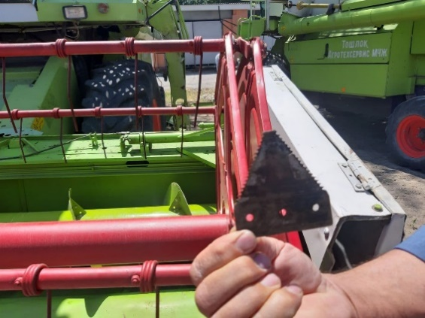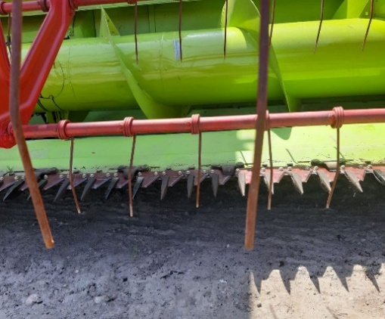
FIGURE 12. Cutting apparatus of the “CLASS” combine

The cutting process is accomplished by reciprocating, accelerated movements in a single plane. The plant is cut when the blade strikes the stem between the sickle's fingers, which is then moved by the finger so that the plate segments face the opposite direction. The cutting segment of the “CLASS” combine harvester is made of steel, specifically U8A grade, which is considered an analogue of this steel, and is heat-treated. Heat treatment of the W108 steel cutting segment involves annealing at 7800°C using high-frequency currents, achieving a surface hardness of 56-57 HRC.
CONCLUSION
A cutting edge grinding process for combine harvester segments has been developed and implemented at the Agricultural Machinery Design and Technology Center, LLC. This process reduces the process cycle of carburizing and subsequent heat treatment to two hours.
Thermal conditions have been developed for 40X, 45XN, and 55ХGR low-alloy carbon steels, increasing the cutting edge allowances of segments by 1,2-1,5 times compared to standard heat treatment conditions.
The optimal composition of a solid carburizer for the carburizing process has been determined. Based on the scientific results obtained in developing a cutting edge polishing technology for agricultural machinery:
-A cutting edge honing technology for agricultural machinery assembly segments has been implemented at “The Agricultural Machinery Design and Technology Center” LLC. As a result, the service life of the assembly segments has increased by 2-3 times;
Thermal regimes for the carburizing process and subsequent heat treatment were developed at “The Agricultural Machinery Design and Technology Center” LLC. The developed regime made it possible to combine the carburizing process with the tempering process, reducing the tempering cycle by 2 hours.
A carburizer consisting of 80% gas composition and 20% barium carbonate was introduced into operation at “The Agricultural Machinery Design and Technology Center” LLC for the carburizing process. As a result, surface hardness increased from 55 HRC to 62 HRC.
It was also found that the magnitude of abrasive deformation decreases during high-temperature tempering at 1000-11000°C and tempering at 200-4000°C.
An increase in the number of crystalline structure defects in the steels studied was observed during tempering at 200-4000°C from 7800°C to 11000°C. Heat treatment of samples made from the studied steels under various conditions revealed that the lowest deflection was observed in U8A and 55ХGR steel grades.
The wear resistance of the studied steels was found to have increased as a result of the use of new strengthening processes, including combined carburizing and high-temperature tempering at 1000-1100°C and tempering at 200-400°C.
Comparative abrasive wear tests of samples made from the studied steels revealed that 55ХGR steel exhibited the lowest abrasion resistance.
A new process flow chart for refining the cutting segments of the “CLASS” grain harvester was developed.

REFERENCES
- Palaniradja K, Alagumurthi N, Soundararajan V (2006) Optimization of process variables in gas carburizing—an experimental investigation with AISI 3310 steel material. Mater Manuf Process 21(Heft 1, S):111–113. https://doi.org/10.1080/AMP-200060671
- Hüsemann, T., Guba, N., Surm, H., & Heinzel, C. (2024). Effect of alloy-specific case-hardening layers on the grindability of gears. CIRP Annals, 73(1), 253–256. https://doi.org/10.1016/j.cirp.2024.04.030
- Śliwiński, P., Wieczorek, A. N., Skołek, E., Szymon, M., Pawlikowski, A., Nuckowski, P., Reimann, Ł., Węglowski, M. S., Dworak, J., & Pogorzelski, P. (2025). Characteristics of the Novel Electron Beam Hardening Technology for Submicron Bainitic Steels in the Context of Its Application in the Production of Gears and Comparison with the Competitive Laser Beam Technology. Coatings, 15(11), 1321. https://doi.org/10.3390/coatings15111321
- Bartels, D., Novotny, T., Hentschel, O. et al. In situ modification of case-hardening steel 16MnCr5 by C and WC addition by means of powder bed fusion with laser beam of metals (PBF-LB/M). Int J Adv Manuf Technol 120, 1729–1745 (2022). https://doi.org/10.1007/s00170-022-08848-3
- Babu, P. D., Buvanashekaran, G., & Balasubramanian, K. R. (2012). Experimental investigation of laser transformation hardening of low alloy steel using response surface methodology. The International Journal of Advanced Manufacturing Technology, 67(5–8), 1883–1897. https://doi.org/10.1007/s00170-012-4616-z
- Ibragimov, O., Domuladjanov, I., & Domuladjonova, S. (2023). Soil fertility in agriculture: Main tasks. E3S Web of Conferences, 431, 01057. https://doi.org/10.1051/e3sconf/202343101057
- Wang, Q., Zeng, X., Chen, C., Lian, G., & Huang, X. (2019). Profile characterisation and response surface modelling of laser surface hardened Cr12 mould steel. Procedia Manufacturing, 34, 168–176. https://doi.org/10.1016/j.promfg.2019.06.135
- Fayzimatov, S., & Tojiyev, B. (2023b). Determination of device construction design and parameters for copper wire extending methods. E3S Web of Conferences, 460, 10009. https://doi.org/10.1051/e3sconf/202346010009

