Recycled Silk Fiber Wastes in Smart Decorative
Paper Production
Azamat Gulamov, Alisher Eshmirzayev, Anvar Abdumajidov^{a)},
Saodat Azamjonova, Gulnoz Yusupkhodjaeva, Ulugbek Bobatov
Tashkent Institute of Textile and Light Industry, Tashkent, Uzbekistan

^{a)}Corresponding author: anvarshohv@mail.ru
Abstract. This article investigates the composition, technological properties, and recycling possibilities of fibrous wastes generated in the natural silk industry, as well as their potential use as raw materials for the production of liquid decorative paper. Research was conducted on various types of natural silk wastes, including primary floss, cotton-like floss from the cleaning process, loop floss, defective cocoons, thread-like floss, surface floss from the shell, and nonwoven sheet (first pass). The study revealed that recycled natural silk wastes contribute to the ecological safety of the liquid decorative paper layer, as well as improve its resistance to detergents and deformation, hygroscopicity, and brightness. Furthermore, enhancements were achieved in the mechanical strength, thermal conductivity, electro-insulating, and antistatic properties of the produced decorative paper. Within the framework of this study, sericin removal from silk fibrous wastes was carried out using two methods: (1) boiling in a soap–soda solution and (2) boiling in pure water without chemical additives. When silk fibrous wastes were treated with the soap–soda method, sericin was completely removed from the fibers. In contrast, when boiled without chemical agents, the residual sericin content in the fibers was 0.6–11.9% higher depending on the type of waste compared to the first method. According to analytical methods, the nominal, given, actual, conditional, and true linear densities were determined. The tensile strength and elongation at break of the silk fibrous wastes were also measured, and since the fibers were longer than 25 mm, they were found suitable for use in decorative paper production. In the subsequent experiments, the fat content in the natural silk wastes was determined. Except for the nonwoven sheet (first pass), all fibrous wastes exhibited nearly similar fat content (5.79–6.63%). Based on the experimental results, it is recommended to use, in one batch, primary floss together with surface floss from the shell; cotton-like floss from the cleaning process with loop floss; and defective cocoons with thread-like floss — considering their residual sericin and fat content — for the preparation of liquid decorative paper compositions.
Keywords: silk, sericin, liquid decorative paper, yarn, composite material, waste-free technologies, flower paper, floss, Nominal linear density, Specified linear density, fiber length.
INTRODUCTION
The textile industry is one of the sectors that generates about 25% waste in relation to the amount of raw materials used. This inevitably leads to both economic and environmental challenges. The natural silk industry is no exception. The largest producer of raw silk is China (accounting for about 50% of global production), followed by India (15%), Uzbekistan (3%), and Brazil (2.5%). On average, global annual silk production amounts to about 80,000 tons. A comparative analysis shows that from one box of silkworm eggs, approximately 48–50 kg of cocoons of various sizes are obtained. Of this quantity, 68.3% belong to grades I and II, 3.04% are non-standard, 16.12% are ungraded, and 12.03% are unsuitable for reeling. In countries with advanced sericulture industries, one box of silkworm eggs yields 58.1–64.6 kg of cocoons, 79.2–79.4% of which are of medium size and 92.1–95.19% of which are grade I [1-4].
During the processes of cocoon cultivation and reeling, large amounts of silk fibrous waste are produced. Such waste mainly arises at cocoon production and preparation bases, in preliminary processing, reeling, raw silk finishing, and yarn and fabric manufacturing — together accounting for about 55% of total waste generation. Recycling these wastes is of great importance to Uzbekistan’s economy, since for each kilogram of raw silk produced, more than one kilogram of waste is generated. The wastes formed at different stages of production vary in their physical, mechanical, and chemical properties.
At present, in countries with developed silk industries, fibrous silk wastes are not only used for producing silk yarns or mixed yarns with natural, artificial, and synthetic fibers, but also efficiently utilized as inexpensive natural resources for manufacturing high-value products. These wastes are widely used to produce filters for purification of water from motor and vegetable oils, films for biomedicine and other applications, membranes for composite materials that combine the properties of carbon fibers with those of silk, and other functional materials [5-8].
The development of waste-free technologies for recycling raw materials and converting production wastes into valuable materials is one of the most urgent tasks and key directions of modern scientific research [9, 10]. Therefore, scientists and engineers in various countries are continuously developing and improving technologies for recycling natural silk wastes for both the textile and other industrial sectors. Only about 40–50% of natural silk raw materials are converted into finished products. Of the unspun silk fibrous wastes, only around 15% are used in fabric production, while the remainder is currently underutilized. The production of nonwoven fabrics from silk fibrous wastes is considered one of the most optimal solutions due to their hypoallergenic and antibacterial properties [9].
A new direction in the field of using natural silk waste can be the production of liquid flower paper. The composition of liquid flower paper consists of fibers, glue, coloring matter and additives that provide various properties. The fibers in the composition of liquid flower paper are required to be strong, environmentally friendly, resistant to abrasion, and retain their shape. These fibers must retain their properties in moisture and have good adhesion to the wall. Cellulose, natural silk and cotton fibers are used as fibers. In order for liquid flower paper to have such properties as ensuring the stability of humidity in the room, the inclusion of synthetic fibers in its composition is not allowed. Cellulose in the composition is the main structural component of liquid flower paper, cotton and natural silk fibers are included in the composition to enhance the appearance of the flower paper, increase its strength and breathability. In this case, natural silk liquid flower provides the luxury, durability and brightness of the paper layer. Adhesive, plasticizer and anti-fungal substances are also added to flower paper.
Short cut fibers in liquid flower paper ensure the stability of the material. Short-cut natural fibers ensure environmental safety, mechanical strength, resistance to deformations and resistance to the effects of washing chemicals. In addition, the shortness of fibers has a positive effect on the hygroscopicity of flower paper, improves air permeability. Natural fiber flower paper absorbs excess moisture in the room and releases moisture when the room is too dry. The fact that liquid flower paper is made from natural fibers also ensures its antistatic property, as a result of which dust and various impurities do not accumulate on the wall. By adding natural silk waste (see Fig. 1) to liquid flower paper, its biodegradability, mechanical strength, thermal conductivity and electrical insulation properties are improved.

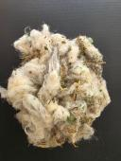 | 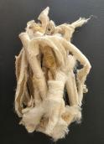 | 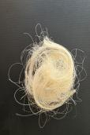 | 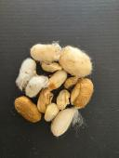 | 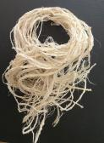 | 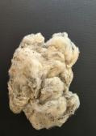 | 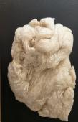
a | b | c | d | e | f | g
FIGURE 1. Natural silk wastes: a) Primary floss; b) Cotton-like floss from the reeling process; c) Loop floss; d) Defective cocoons; e) Thread-like floss; f) Surface floss from the cocoon shell; g) Nonwoven sheet (first pass)

Primary lint – Waste from the cocoon industry - the primary lint of the cocoon is formed during the process of growing and primary processing of the cocoon. Primary lint is formed during the collection of the grown cocoon and makes up 3.2-3.5% of the total amount of cocoon. It contains up to 40% of fibers with a non-uniform linear density (340-350 mg/tex), and the sericin content in it is 45-50%. The length of the fibers in the cocoon lint is 25-140 mm, and is mostly contaminated with plant residues - mulberry leaves and cocoon stalks. Cotton lint during the spinning process is the most valuable waste, accounting for 0.3-0.5% of the dry cocoon mass. Usually, cotton lint contains various impurities and makes up up to 40% sericin. After processing, it is divided into two types and placed in stacks. According to the amount of vegetable waste in its composition, the first type includes cotton lint of the same type, cleaned from cocoons, with vegetable impurities of no more than 1%. The second type includes cotton lint obtained by cleaning cocoons manually and mechanically, with uneven color and vegetable impurities of up to 3%.
Loop Silk Floss – This waste is produced during the reeling process, when raw silk filaments break and become entangled around winding rollers or testing devices (seriplan boards). The loops are carefully collected, untangled, and cleaned of foreign impurities. Raw silk loops may contain up to 0.5% cotton thread, no more than 10% short silk fibers (100 mm in length), and are packed in bales weighing up to 50 kg with a moisture content not exceeding 11%.
Defective Cocoons – These are cocoons obtained during the sorting process that display visible defects (e.g., spotted surfaces, double cocoons, deformed shapes, moldy or perforated cocoons) and constitute 6–12% of the total volume. Stained, stem-marked, slightly deformed, and pointed cocoons can still be reeled to produce raw silk of normal or slightly higher linear density. However, spotted cocoons are reeled separately from other defective types. Double cocoons can be regular (oval or round) or irregular in shape. The former can be used to obtain raw silk of ≥ 5 tex, while the latter are typically processed into spun silk.
Thread-like Floss – This type of floss forms on the reeling machine wheel, where silk filaments wind during the process of finding single filament ends. Every 1.5–2 hours, this thread-like floss is cut off, straightened, and bundled into small hanks tied together. It may contain up to 2% waste cocoons or unreelable cocoons.
Surface Floss from the Cocoon Shell – Belongs to the group of wastes produced during preliminary cocoon processing and reeling preparation. This waste makes up 5–7% of the mass of sorted dry cocoons.
Nonwoven Sheet (First Pass) – After light manual loosening, this waste is sent to the silk waste processing workshop. It may contain up to 2% waste cocoons or unreelable cocoons. The moisture content of the silk floss is around 200%. In the processing workshop, the silk floss is washed and squeezed in a centrifuge, cleaned of impurities, dried, sorted by color, and pressed into bales for further use.
METHODS
Soap-soda boiling. Each type of silk fiber, weighed to an accuracy of 4,000 g on an analytical balance model ZEC 21, dehydrated in a desiccator, was treated for 120 minutes at a temperature of 92-95⁰C in a solution containing 10 g/l of 40% soap and 0.5 g/l of sodium carbonate, M=50. The sample was treated for 5 minutes at 30-35⁰C with a 30% acetic acid solution with a concentration of 4 ml/l, this process is called "Revival". The treated sample was washed 3 times in water obtained from a model BE-4 bidistiller, dried for 15-20 minutes in a drying cabinet model MST-55 and stored in a desiccator for 1 day.
Washing in boiling water. In this method, silk fiber, weighed to an accuracy of 4,000 g on an analytical balance model ZEC 21, was dried in a desiccator, boiled in water from a model BE-4 bidistiller at a temperature of 92-95⁰C for 120 minutes, and washed in cold water. The treated sample was dried in a drying cabinet model MST-55 for 15-20 minutes and stored in a desiccator for 1 day.
Analytical Methods
Nominal linear density – The standard linear density value adopted for yarn classification. This parameter is used in industrial planning, standardization, and in calculating the linear density of textile products.
Specified linear density – The actual linear density of yarn calculated based on the quality characteristics of the raw materials used in production.
$T_{b}=\overline{T_{pi}}∙n_{b}$ (1)
Where: T_{pi} – the average linear density of the processed silk thread, tex; n_{b} – the average number of cocoons in a bundle.
Actual linear density (T_{f}) – the linear density corresponding to the moisture content of the surrounding environment. The actual linear density is determined by weighing and measuring the length of the tested skeins.
Conditional linear density (T_{k}) – the linear density value corresponding to the standard moisture content.
$T_{k}=T_{f}\frac{100-W_{f}}{100+W_{k}}$ (2)
Where: W_{f}– the actual moisture content of the yarn, %; Wk – the standard (conditional) moisture content of the yarn, 11 %.
Actual linear density — the linear density of the yarn without the influence of emulsions, oils, or other substances applied during the reeling process.
$T_{x}=\frac{T_{f}(100-P_{r})}{100}$ (3)
Where: P_{r} – the increase in yarn mass during the emulsification and lubrication process, %; The irregularity of the yarn in terms of linear density is expressed by the coefficient of variation, %.
$C=\frac{σ}{T}100$ (4)
Where: $σ$ — standard deviation.
$σ=\sqrt{\frac{\sum{{(M_{i}-\overline{M})}^{2}}}{n}}$ (5)
Where: $M_{i}$ – mass of the i-th cocoon, g; $\overline{M}$ – average mass of the cocoons, g; n – number of cocoons.
The tensile strength and elongation at break were determined using the Japanese “STATIMAT C” apparatus, an automatic tensile testing machine operating on the principle of constant deformation rate, in accordance with DIN 51 221, DIN 53 834, and ISO 2062 standards.
The connection between the “STATIMAT C” device and the TESTCONTROL system is implemented via a special TEXTECHNO MIO interface. The “STATIMAT C” tensile testing unit measures the tensile strength and elongation at break, and the average values are calculated.
The relative breaking strength is determined according to the following formula:
$P=\frac{\overline{P}}{T_{p}}$ (6)
Where: $\overline{P}$– average breaking force, N; $T_{p}$– average linear density of the broken yarns, tex.
Determination of Fat content in silk fibers using the “Soxhlet” Apparatus. There are several methods for determining the amount of bound fat substances in fibers; among them, the extraction method using the SOXHLET SOX406 apparatus is considered the simplest. In this method, the bound fat substances in the fiber are extracted with organic solvents in the Soxhlet apparatus at elevated temperature.
A silk fiber sample weighing 1.000 g (accurately measured on an analytical balance, model ZEC 21, previously dried in a desiccator) is wrapped in filter paper and placed into a cartridge. The cartridge is then inserted into the Soxhlet apparatus. The mass of the weighing beaker (bux) is determined accurately, 20 mL of solvent is added, and the Soxhlet apparatus is placed on the heating mantle. The upper openings of the apparatus are closed, and extraction is carried out at 120–130 °C.
The solvent vapors pass through the sample, dissolving the fat components, and the extract drips into the beaker. The extraction time is 1.5–2 hours. If no traces of fat remain on the filter paper from the drops flowing from the cartridge to the flask, the extraction process is considered complete. The solvent can be reused after recovery.
After solvent removal, the beaker is dried in a drying oven at 100–105 °C for one hour until a constant weight is reached, then cooled and weighed.
The fat content in the fiber can be determined using the following formula:
$M=\frac{M_{1}-M_{2}∙100}{M_{3}(100-W)}$ (7)
Where: М₁ – mass of the beaker (bux) with extracted fat, g; М₂ – mass of the empty beaker, g; М₃ – mass of the fiber sample before extraction, g; W – moisture content of the sample, %.
RESULTS AND DISCUSSION
The non-spinnable wastes of natural silk usually consist of a mixture of fibers of various lengths, thicknesses, and linear densities. The fiber length is an important parameter that determines the type of product that can be manufactured from the raw material. Fibers with lengths ranging from 6 to 100 mm can be used for the production of nonwoven fabrics using various technologies. Fibers with lengths up to 25 mm are typically utilized as components in paper manufacturing compositions.
The characteristics of the natural silk waste fibers used in this study, according to their length distribution, are presented in Figure 2.

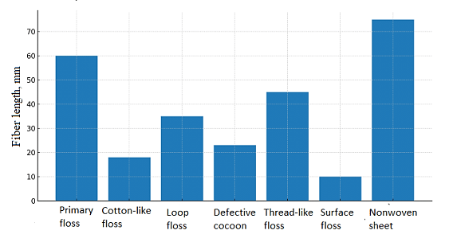
FIGURE 2. Fiber length distribution of natural silk wastes by type

TABLE 1. Characteristics of natural silk wastes and indicators according to fiber length types
Type of waste | Characteristic | Fiber length (mm)
Primary floss | Main floss separated from the cocoon during the cocoon harvesting process | 40–80
Cotton-like floss from reeling process | Formed during silk reeling; resembles cotton fibers | 10–25
Broken-end floss | Silk fibers broken off during twisting or spinning | 20–50
Defective cocoons | Deformed or irregular cocoons that cannot be reeled | 15–30
Ribbon-like floss | Produced during reeling in the form of narrow ribbon-shaped fibers | 30–60
Surface floss | Obtained from the outer layer of the cocoon shell | 5–15
Nonwoven web (first pass) | First layer obtained during the reprocessing of silk waste | 50–100

Based on the provided data, Table 1 shows that the length of silk fiber waste is suitable for producing liquid wallpaper, with an average fiber length of 25–60 mm. Since all of these fibers are longer than 25 mm, they can be used in the production of liquid wallpaper.
In recent years, environmentally friendly materials have been increasingly used in house construction and renovation, particularly those intended for heat insulation, flame resistance, soundproofing, and protection from radioactive gases. The use of liquid wallpaper as such a material is of great importance.
The quality of the final product in liquid wallpaper production depends on the quality of the raw material. In this regard, not only the fiber length, but also the uniformity of the physical and mechanical properties of fibers within a single batch play a crucial role. If fibers of different linear densities and strengths are used, the wall coating will not form a uniform, smooth layer with consistent coloristic properties.
Therefore, in the following studies, the physical and mechanical properties of all investigated fibers were evaluated (look at Table 2).
TABLE 2. Physical and mechanical properties of silk fiber waste
Type of silk fiber waste | Linear density, mg/tex | Breaking strength, cN | Elongation at break, %
Primary silk floss | 378-387 | 6-7 | 14-16
Cotton-like floss formed during reeling | 375-385 | 6-7 | 13-14
Loop floss | 233-323 | 7-9 | 16-18
Defective cocoons | 232-305 | 5-6 | 11-14
Ribbon-like floss | 302-342 | 7-9 | 13-15
Surface floss (from cocoon shell) | 355-370 | 7-9 | 14-16
Nonwoven web (first pass) | 265-302 | 5-6 | 11-13

The analysis of the data presented in Table 1 shows that the characteristics and properties of silk fiber wastes are almost identical. Therefore, these wastes can be processed under the same conditions; however, it is necessary to improve the preliminary treatment technology and prepare the fibers for the production of liquid wallpaper. In order to utilize silk fiber waste in this process, the raw material must meet the technological requirements of liquid wallpaper production, particularly in terms of residual sericin, oil, wax-like substances, and soap content.
Natural silk is known to consist of 72–83% fibroin and 17–28% sericin. Additionally, it contains 0.8–1.0% oily and wax-like substances, 1.0–1.4% mineral components, and about 11% moisture. Since the silk fiber wastes used as research objects were formed at different stages of the cocoon reeling process, their sericin content varies accordingly. Therefore, the sericin content of these wastes was determined experimentally.
Typically, sericin is removed from raw silk during the boiling (degumming) process. The most common degumming methods include the soap–soda method, the soap–bisulfite method, treatment with surface-active agents, and enzymatic degumming. Within the framework of this study, the purification of natural silk fiber waste from sericin was carried out using two approaches: (1) boiling in a soap–soda solution and (2) boiling in a solution without chemical reagents (see Fig. 3).

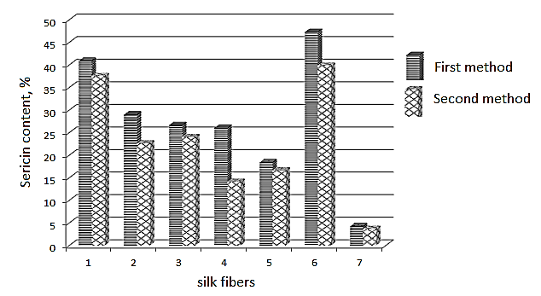
FIGURE 3. Sericin content in silk fiber wastes: 1 – Primary silk floss; 2 – Cotton-like floss formed during reeling; 3 – Loop floss; 4 – Defective cocoons; 5 – Ribbon-like floss; 6 – Surface floss (from cocoon shell); 7 – Nonwoven web (first pass).

The obtained results indicate that, when natural silk fiber wastes are boiled using the soap–soda method, sericin is almost completely removed from the fibers. In contrast, in the samples boiled without chemical reagents, the amount of sericin remaining in the fibers was 0.6–11.9% higher, depending on the fiber type, compared to those treated by the first method.
Since this study investigates the possibility of producing liquid wallpaper from natural silk fiber wastes, the presence of a certain amount of sericin in the fibers is considered a positive factor. Sericin is regarded as a promising material for forming waterproof films due to its unique adhesive properties. Being a natural adhesive component of silk, sericin has a chemical composition that allows its use in various fields. Firstly, sericin is capable of forming elastic, water-resistant films. Secondly, it exhibits excellent adhesion to different surfaces. Another advantageous property is that sericin can be modified with various substances to produce compositions with antibacterial properties.
In subsequent experiments, only natural silk wastes boiled in water (to remove sericin) were used. However, the oil content in the raw material negatively affects the adhesion of liquid wallpaper to the wall surface. The experimental data show that, except for the web (first pass) sample, the oil content in all types of silk fiber wastes was nearly uniform, ranging from 5.79% to 6.63% (see Fig. 4).

TABLE 2. Sericin content of natural silk fiber wastes boiled by the soap–soda method
Primary silk floss | Cotton-like floss formed during reeling | Loop floss | Defective cocoons | Ribbon-like floss | Surface floss (from cocoon shell) | Nonwoven web (first pass)
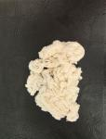 | 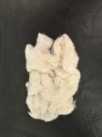 | 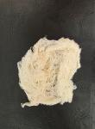 | 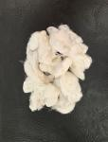 | 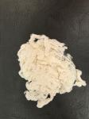 | 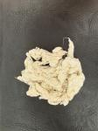 | 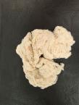
Soap–soda method  Initial weight – 4.0002 g  Final weight – 2.3620 g  Sericin content – 59.05 % | Soap–soda method  Initial weight – 4.0002 g  Final weight – 2.8387 g  Sericin content – 70.96 % | Soap–soda method  Initial weight – 4.0002 g  Final weight – 2.9312 g  Sericin content – 73.27 % | Soap–soda method  Initial weight – 4.0002 g  Final weight – 2.9576 g  Sericin content – 73.93 % | Soap–soda method  Initial weight – 4.0002 g  Final weight – 3.2615 g  Sericin content – 81.53 % | Soap–soda method  Initial weight – 4.0002 g  Final weight – 2.1063 g  Sericin content – 52.65 % | Soap–soda method  Initial weight – 4.0002 g  Final weight – 3.8522 g  Sericin content – 96.30 %
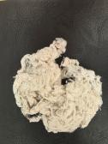 | 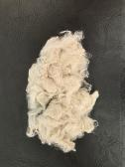 | 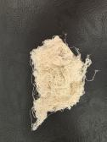 | 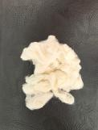 | 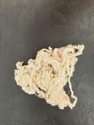 | 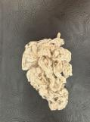 | 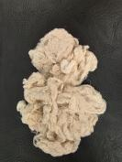
Distilled water method  Initial weight – 4.0002 g  Final weight – 2.4990 g  Sericin content – 65.47 % | Distilled water method  Initial weight – 4.0002 g  Final weight – 3.0940 g  Sericin content – 77.35 % | Distilled water method  Initial weight – 4.0002 g  Final weight – 3.0395 g  Sericin content – 75.98 % | Distilled water method  Initial weight – 4.0002 g  Final weight – 3.4342 g  Sericin content – 85.85 % | Distilled water method  Initial weight – 4.0002 g  Final weight – 3.3347 g  Sericin content – 83.36 % | Distilled water method  Initial weight – 4.0002 g  Final weight – 2.4075 g  Sericin content – 60.18 % | Distilled water method  Initial weight – 4.0002 g  Final weight – 3.8287 g  Sericin content – 95.71 %

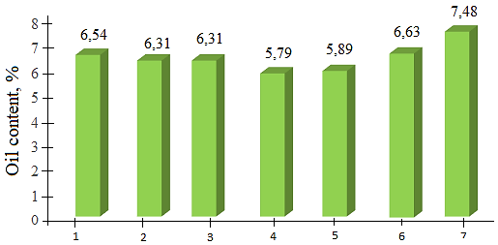
FIGURE 4. Dependence of oil content in silk fiber wastes on the type of waste: 1 – Primary silk floss; 2 – Cotton-like floss formed during reeling; 3 – Loop floss; 4 – Defective cocoons; 5 – Ribbon-like floss; 6 – Surface floss (from cocoon shell); 7 – Nonwoven web (first pass).

The obtained experimental results indicate that the use of web (first pass) silk fiber waste for liquid wallpaper production is not appropriate. This is primarily due to the higher oil content, which exceeds that of other samples by 12.8–29.2%, and secondly because of its very low sericin content (only 3.7–4.3%, depending on the boiling method).
When preparing liquid wallpaper compositions, it is recommended to combine silk fiber wastes in each batch according to their residual sericin and oil contents. Specifically, primary silk floss should be mixed with surface floss, cotton-like floss with loop floss, and defective cocoons with ribbon-like floss.
The advantages of liquid wallpaper compared to other wall finishing materials are presented in Table 3.

TABLE 3. Comparative analysis of various materials used for wall finishing.
Types of materials | Silk-based liquid wallpaper | Conventional wallpaper | Venetian plaster | Oil plaster
Natural eco-friendly material | + | - | - | -
Odorless | + | + | - | -
Elastic and crack-resistant | + | - | - | -
Partially repairable | + | - | - | -
Forming a seamless continuous surface | + | - | + | +
Sound and heat insulating | + | - | - | -
Possibility of application on uneven surfaces | + | - | - | +
Capability to smooth out irregular surfaces | + | - | - | -
Hypoallergenic | + | - | - | -
Mold-resistant | + | - | + | -
Antistatic and dust-repellent. | + | - | - | -
Easily removable from the coated surface | + | - | - | -

The strength of liquid wallpaper can be improved by partially replacing the commonly used cellulose fibers in its composition with natural silk fiber wastes in various proportions. The inclusion of silk fiber waste containing sericin into the liquid wallpaper composition enhances its strength compared to paper made exclusively from cotton fibers. This can be explained by the formation of not only hydrogen bonds between cellulose macromolecules but also much stronger ionic bonds arising from the interaction of positively charged amino acid residues (such as lysine and arginine) and negatively charged functional groups (such as glutamine and asparagine) in the side chains of amino acids.
Due to the cylindrical morphological structure of natural silk fiber wastes, they exhibit a glossier appearance compared to the flat ribbon-like structure of cotton fibers.
CONCLUSION
As a result of the conducted research, it was determined that various types of fiber wastes generated in the natural silk industry – such as primary floss, surface floss, cotton-like floss formed during reeling, loop floss, defective cocoons, and others – can be effectively used as raw materials for the production of liquid wallpaper. The compositional characteristics of these wastes, including the content of sericin and fatty substances, as well as their mechanical and technological properties, were analyzed, and the possibilities of their recycling were substantiated.
The effect of different boiling methods (soap–soda and chemical-free) on the sericin content of the wastes was investigated, which was shown to be an important factor in determining the quality of the resulting wallpaper.
Natural silk fiber wastes are boiled using the soap–soda method, sericin is almost completely removed from the fibers. In contrast, in the samples boiled without chemical reagents, the amount of sericin remaining in the fibers was 0.6–11.9% higher, depending on the fiber type, compared to those treated by the first method.
Also, the use of web (first pass) silk fiber waste for liquid wallpaper production is not appropriate. This is primarily due to the higher oil content, which exceeds that of other samples by 12.8–29.2%, and secondly because of its very low sericin content (only 3.7–4.3%, depending on the boiling method).
It was also demonstrated that combining different types of wastes in the composition improves the environmental safety, mechanical strength, thermal and electrical insulation properties of the final product.
Consequently, the study confirms the feasibility of producing innovative, environmentally friendly, and functional liquid wallpaper from natural silk fiber wastes, providing practical solutions for converting industrial silk waste into valuable products through recycling.
REFERENCES
- Abdumajidov, A., Nishanova, S., Miratayev, A., & Nabiyeva, I. (2023). Development of methods for discoloration and bleaching of textile waste. E3S Web of Conferences, 401, 03063. https://doi.org/10.1051/e3sconf/202340103063
- Sashina, E., & Yakovleva, O. (2023). The Current State and Prospects of Recycling Silk Industry Waste into Nonwoven Materials. Fibers, 11(6), 56. https://doi.org/10.3390/fib11060056
- Jayamaha, H., Schorn, I., & Shepherd, L. M. (2024). Waste Bombyx Mori Silk textiles as efficient and reuseable Bio-Adsorbents for methylene blue dye removal and Oil–Water separation. Fibers, 12(11), 99. https://doi.org/10.3390/fib12110099
- Dhruval, S. R., Pai, N., Dhanwant, S. S., Hussein, B., Nayak, S., Rao, C. V., Kumar, A., & Janakaraj, M. (2020). Rapid synthesis of antimicrobial Fe/Cu alloy nanoparticles using Waste Silkworm Cocoon extract for cement mortar applications. Advances in Natural Sciences Nanoscience and Nanotechnology, 11(2), 025006. https://doi.org/10.1088/2043-6254/ab8790
- Kumar, B. S., & Ramachandran, T. (2018). Influence of knitting process parameters on the thermal comfort properties of ERI silk knitted fabrics. Fibres and Textiles in Eastern Europe, 26(5(131)), 47–53. https://doi.org/10.5604/01.3001.0012.2530
- Corrigendum to Development of silk/polycaprolactone biocomposite for internal bone plate application. (2021). Journal of Industrial Textiles, 51(1_suppl), 1752S. https://doi.org/10.1177/15280837211034768
- Gencel, O., Ustaoglu, A., Sarı, A., Hekimoğlu, G., Sutcu, M., Tozluoglu, A., Tutus, A., Cicekler, M., & Tyagi, V. V. (2023). Developing Wallpaper/Dodecyl alcohol composite phase change materials as new kind of wall covering elements for building interior thermoregulation. Thermal Science and Engineering Progress, 46, 102183. https://doi.org/10.1016/j.tsep.2023.102183
- Li, X., Del Río Sáez, J. S., Vázquez-López, A., Ao, X., Díaz, R. S., & Wang, D. (2023). Eco-friendly functional cellulose paper as a fire alarming via wireless warning transmission for indoor fireproofing. Industrial Crops and Products, 200, 116805. https://doi.org/10.1016/j.indcrop.2023.116805
- Ruvira, B., García-Fayos, B., García-Gimeno, B., Arnal, J., & Verdú, G. (2024). Study of the use of wallpaper to mitigate radon exhalation from building materials in indoor spaces. Radiation Physics and Chemistry, 223, 111916. https://doi.org/10.1016/j.radphyschem.2024.111916

