Optimization of a Novel Twisting Device
for Spinning Machines
Jakhongir Soloxiddinov^{1, a)}, Husanhon Bobojanov¹, Nodira Usmanova¹,
Gulnora Raximova¹, Ugiloy Asqarova², Aziza Kasimova³
¹Namangan State Technical University, Namangan, Uzbekistan
²Namangan State University, Namangan, Uzbekistan
³Tashkent Institute of Textile and Light Industry. Tashkent, Uzbekistan

^{a)}Corresponding author: jahongirsalohiddinov9595@gmail.com
Abstract. This article presents information on the optimization of a newly developed twisting mechanism for spinning machines to improve yarn quality, uniformity, and production efficiency. The study includes practical and theoretical experiments on optimizing the rotation speed, diameter, and length of the cylindrical device through mathematical modeling and statistical analysis. For this purpose, a new design of cylindrical twisting device was developed to replace traditional spindles, and its performance was analyzed using mathematical models and experimental data. According to the results, at the optimal rotation speed (25,000 rpm) and cylinder diameter (32 mm), breakage was minimized and yarn evenness was significantly improved. It is also noted that the mechanism has several advantages over traditional ring spinning, in particular, high productivity and yarn evenness.
Keywords: Yarn formation, twisting mechanism, spinning machine, textile manufacturing, yarn evenness, statistical analysis.

INTRODUCTION
Scientific research is being conducted worldwide to develop new, modern, and improved spinning machines that exhibit high production efficiency, enhance the quality of yarn products, and consume less energy. In this direction, research is considered a priority, including improving the design of the main mechanisms in spinning machines to increase the productivity of spun yarn products, creating new spinning methods by improving the yarn winding mechanism, and adjusting the operating parameters of the machine to match the quality indicators of the product. At the same time, targeted scientific research is being carried out in such areas as producing high-quality yarns, increasing the durability of technological parts of the machine, creating new types with alternative indicators, and introducing reliable changes based on new innovative ideas.
A number of well-known foreign scientists have made a significant contribution to solving issues such as increasing the productivity of spinning machines, optimizing their technological parameters, creating new design of spinning mechanisms, and optimizing the speeds of the main working mechanisms of the machine in accordance with the raw material parameters, including Yang Xiao Zhong Li, Yu Jicheng, Chen Biao, Wang, K., Xue, W., Zhi-cheng, Y. (China), Stolyarov Anatoly Alexandrovich, Pavlov Yuvenaly Vasilyevich, Stolyarov Alexey Anatolyevich, Belyaev Denis Nikolaevich (Russia), Bannot and Balasubramaniam, Basu and Gotipamul, R.Senthil Kumar, Mr. Jagdish D. Patil, Mr. Prafull P. Kolte, Mr. Sujit S. Gulhane, Mr. Sanjeev Bathla, S. M. Ishtiaque, R.S. Rengasamy, Hossain, M., Abdkader, A., Gandhi, A., Abdkader, A., Hossain, M., (India), Caveny and Foster (USA), Din Islam, Rokonuzzaman, Joykrisna Saha, Abdur Razzaque, Lablu Miah, Nusrath Sharmin (Bangladesh), El-Sayed M.A.M. (Egypt), Katarzyna E. Grabowska (Poland), Coskun, E., Oğulata, T. (Turkey) and others [1-12].
The scientific works of prominent scientists in Uzbekistan are devoted to improving the technology of spinning yarn and creating new design mechanisms, optimizing the main parameters of the machine, enhancing the structural and physical properties, and improving the external quality of the yarn. Among them: Jumaniyazov Q.J., Gofurov Q.G., Matismailov S.L., Meliboyev X.U., Bobojanov H.T., Isaqulov V.T., Tolaganova M.V., Rajabov O.O., Ismailov N.T., Dedakhanov N.K., Ruzibayev N.N [13-19]. As a result of the conducted scientific research, significant results have been achieved in solving the problems of improving the designs of the main working parts of spinning machines and optimizing their parameters, developing a new assortment of yarn products using compact and melange methods, and expanding the assortment of yarns for various purposes by changing the structure of yarn products [20-22].
At the same time, even though many studies have been conducted on improving product quality by improving the design of spinning machines and improving yarn quality by optimizing machine parameters, problems such as increasing machine productivity by improving the spinning mechanism, studying the effect of the spinning mechanism rotation speed and the number of twists on the quality of the yarn being formed, and studying the effect of machine input parameters on the quality of the output product have not been sufficiently studied.

ANALYSIS
In the research, a new twisting mechanism was developed to replace the traditional spindle in ring spinning machines. This new mechanism also performs the function of twisting the yarn.
Unlike the twisting-winding system of a traditional ring spinning machine, this new mechanism includes a cylindrical yarn feeding device, a hollow tube, a sliding bearing, a belt conveyor, a bobbin, a pulling roller, and a winding device (see Figure 1).
The diameter of the cylindrical sleeve in the new mechanism was prepared based on the typical ring diameters - specifically, 32 mm, 34 mm, and 36 mm. Their optimal diameter was determined through experiments. The cylindrical sleeve has a 2 mm diameter hole through which the yarn passes; the sleeve acts as a drag for the yarn as it rotates. The 2 mm hole size allows for the potential integration of multiple yarns, allowing the production of different types of twisted yarns.
A hollow yarn-passing tube with a length of 78 mm was also developed to which the cylindrical sleeve is affixed. These two components are firmly connected and move synchronously. The 78 mm length of the tube was determined based on practical considerations such as the thickness of the mounting plate, installation configuration of the sleeve, and the need to mount a pulley at the bottom for motion transmission.
However, by optimizing the parameters influencing the tube length, it may be possible to reduce this length. Such a reduction could shorten the yarn path, which in turn would minimize the risk of twist loss in the yarn.
The proposed new design of the spinning mechanism works as follows: The fiber bundle emerging from the output pairs of the drafting mechanism is twisted by the yarn guide due to the rotation of the yarn-passing cylindrical device mounted on the hollow tube to form a yarn, and is passed between the hollow tube and the cylindrical device rotating with the tube, and is wound onto a bobbin by the winding device. The hollow tube and the cylindrical device are driven by a belt drive.
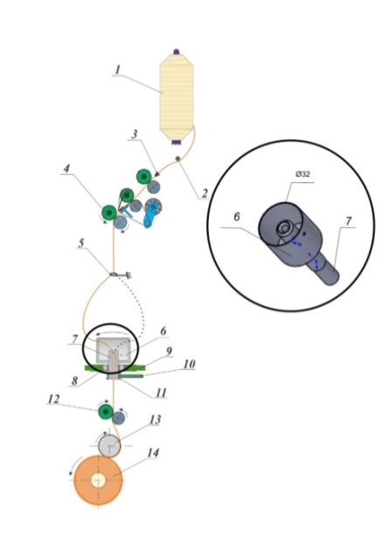
FIGURE 1. Schematic diagram of the proposed new design of the twisting mechanism: 1-roving, 2-the fiber bundle, 3- roving guide, 4-the output pairs of the drafting mechanism, 5-the yarn guide, 6-the yarn-passing cylindrical device, 7-the hollow tube, 8- the sliding bearing, 9-plank, 10-belt drive, 11-pulley, 12- traction roller, 13- winding device, 14-bobbin.

The hollow tube rotates as an axis in a sliding bearing. The cylindrical device assists in the process of twisting and winding the yarn. The fiber bundle coming out of the output pairs of the drafting mechanism is passed through the yarn-passing part of the cylindrical device and the hollow tube and is wound onto a bobbin by a winding device. The cylindrical yarn-passing device fixed to the hollow tube and its upper part moves at high speed through a belt drive, and as a result of the yarn-passing device dragging the fiber bundle and rotating it on its axis, it forms a twist in the fiber bundle and yarn is formed.
If we compare the new design of the twisting mechanism with the twisting mechanism of a traditional ring spinning machine, the working parts of a traditional ring spinning machine consist of a pair of drafting mechanisms, a yarn guide, a ring plate, a spindle, a ring, and a traveler. In contrast, the new design has a plate, a hollow tube, a cylindrical device for passing yarn fixed to it, and sliding bearings mounted on the hollow tube.
The device is made of stainless steel. The hollow tube rotates in a bearing as an axis without a belt drive. The bearings are placed inside the sleeve fixed to the carriage, while the carriage does not move. A cylindrical device for yarn passing, fixed to the upper part of the hollow tube, helps in the process of yarn making. The yarn passes through the hollow tube and the cylindrical device for passing and is wound onto a bobbin through a winding device. The twisting-winding device, unlike previous devices, consists of the following parts. It consists of a sleeve, a hollow tube for passing, a cylindrical device for passing and twisting, an internal stop ring (stopper), a pulley, and a bobbin.
Now, we will consider the effect of the number of twists and linear density on the uniform transmission of yarns in the new twisting mechanism (see Figure 2, a).

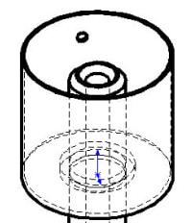 | 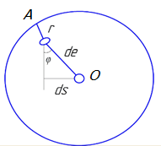
a | b
FIGURE 2. Hollow tube transmission modification diagram.
According to the hollow tube transmission modification diagram (see Figure 2, b), we determine the expressions for the dependence of the speed of the yarn on the number of turns and the tension force of the resulting yarn during the winding process.
In this diagram, the upper part of the cylindrical device is illustrated as a circular shape.
Point A represents the yarn-passing hole located on the cylindrical device.
Point O is the center of the tube.
Point r indicates the slack center that occurs at a distance of AO due to the combined effects of the yarn’s own weight and centrifugal force during its motion.
We determine the speed of the yarn as it passes through a hollow tube and a cylindrical device fixed to its upper part and is wound onto a bobbin by a winding device by taking the derivative of its elongation by time:
$v=\frac{de}{dt}=\frac{dS}{sinφ∙dt}$ (1)
From equation (1), we determine the expression for the dependence of the different speeds of the yarn twists on the angles of yarn formation and the initial speed, in which a cylindrical device pulls the yarn and twists it due to centrifugal force when it rotates.
$v=\frac{v_{0}}{sinφ}$ (2)
Where, v0– cylindrical device speed, φ- the angle at which yarn is formed from the twists.
When creating a twist by passing through a hollow tube and a cylindrical device attached to its top, the following expression is appropriate:
$r∙dα=de∙sinφ$ (3)
By replacing de with the expression de=dS/sinφ, we derive an expression for the dependence of the turns in the formation of a yarn:
$r∙dα=dS$ (4)
In yarn formation, the quality indicators of the yarn can be improved by correctly selecting the optimal values of the influencing parameters. The number of twists (K) in the yarn can be determined using the following formula:
$K=\frac{100∙α_{t}}{\sqrt{T}}$ (5)
Where:
K is the number of twists,
α is the twisting coefficient,
T is the linear density of the yarn.
To derive the relationship of the number of twists with yarn length and mass, the linear density of the yarn is used:
$T=\frac{m}{l}$ (6)
Where:
m is the mass of the yarn (g),
l is the length of the yarn (km).
Substituting equation (6) into equation (5), we obtain an expression that relates the number of twists to the yarn’s mass and length:
$K=\frac{100∙α_{t}∙\sqrt{l}}{\sqrt{m}}$ (7)
The number of twists in the yarn, which is formed as it passes through a hollow tube and a cylindrical device fixed at its upper part and wound onto a bobbin via the winding device, can also be determined as the ratio of the number of rotations to the yarn delivery speed:
$K=\frac{n_{v}}{v_{v}}$ (8)
Where:
n is the number of rotations formed during bobbin winding (min⁻¹),
v is the yarn speed during winding.
By equating expressions (7) and (8), the yarn speed during bobbin winding can be determined:
$\frac{n_{v}}{v_{v}}=\frac{100∙α_{t}∙\sqrt{l}}{\sqrt{m}}$ (9)
From equation (9), the yarn winding speed can be expressed as:
$v_{v}=\frac{\sqrt{m}∙n_{v}}{100∙α_{t}∙\sqrt{l}}$ (10)
By differentiating both sides of equation (4) with respect to dt, we derive the stretching speed of the yarn. Substituting equation (10) into it, we derive a formula to determine the mass of the yarn:
$v=r∙ω$ (11)
Substituting equation (10) into (11), we get:
$r∙ω=\frac{\sqrt{m}∙n_{v}}{100∙α_{t}∙\sqrt{l}}$ (12)
From equation (12), the mass of the yarn formed by twists is calculated as:
$m=\frac{{10}^{4}∙r^{2}∙ω^{2}∙α_{t}^{2}∙l}{n_{v}^{2}}$ (13)
Based on (13), the yarn’s breaking strength is determined by:
$R_{u}=\frac{P_{t}}{T}$ (14)
Substituting expression (6) into equation (14), we derive a relationship that connects breaking strength with the number of twists, yarn mass, and drafting speed. The following parameters were used in the calculations: T = 20 tex; ω = 23000–27000 rpm; αt = 0.3; r = 1.8 mm; K = 700–900 twists/m.
$R_{u}=\frac{P_{t∙l}}{m}=\frac{P_{t}∙n_{v}^{2}}{{10}^{4}∙r^{2}∙ω^{2}∙α_{t}^{2}}$ (15)
Using expressions (13) and (15), and the Maple software, the effect of parameters on twist quality is analyzed using graphical representations. Additionally, using expression (8), the dependency of the number of twists on other parameters is analyzed graphically with Maple program (see Figures 3–5).

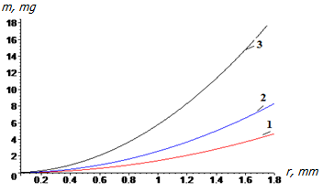
FIGURE 3. Graph showing the yarn mass during drafting in relation to the cylindrical device’s angular speed at ω1 = 23000 rpm, ω2 = 25000 rpm, and ω3 = 27000 rpm.

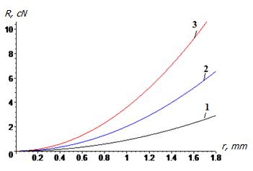
FIGURE 4. Graph showing the drafting force in relation to the angular speed of the cylindrical device at ω1 = 23000 rpm, ω2 = 25000 rpm, and ω3 = 27000 rpm.

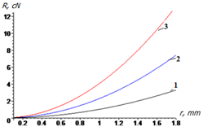
FIGURE 5. Graph showing the drafting force at different twist counts: K1 = 700 twists/m, K2 = 800 twists/m, and K3 = 900 twists/m.

From these graphs, we can conclude that as the yarn mass increases in the section between the hollow tube and the bobbin winding point, the unevenness during winding increases. At an angular speed of ω2 = 25000 rpm and a twist level of K2 = 800 twists/m, the increase in both parameters may lead to a higher frequency of yarn breakages. However, at this same angular speed (ω2 = 25000 rpm), the system can still ensure consistent yarn delivery to the winding device.

METHODS
The study first derives mathematical expressions describing the speed, tension, and twisting behavior of yarn as it passes through a modified cylindrical twisting device. Equations for twist distribution and mass variation are formulated and analyzed using the Maple software. Based on initial practical experiments, an improved twisting mechanism was developed. First, single yarns of two different colors were combined and tested for twist formation in the new mechanism. The formation of twist in the resulting yarn can be seen (see Figure 6).

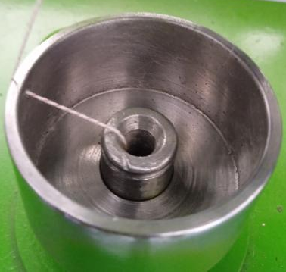
FIGURE 6. Twist formation in the improved twisting mechanism.

Initial results were obtained using the improved design. The influence of the cylindrical device's rotational speed, diameter, number of twists in the supplied roving, length of the back drafting zone, and the number of yarn twists on the yarn quality was analyzed. In this study, secondary-order regression mathematical models were developed and investigated.
TABLE 1. Input Factors, Levels, and Ranges of Variation
Factor Name & Notation | Levels |  |  | Range
Factor Name & Notation | -1 | 0 | 1
x1 – Roving twist (TPM) | 40 | 60 | 80 | 20
x2 – Rotational speed of cylinder (rpm) | 23000 | 25000 | 27000 | 2000
x3 – Cylinder diameter (mm) | 32 | 34 | 36 | 2

TABLE 2. Central non-compositional experience matrix.
Factors |  |  | $$x_{1}x_{2}$$ | $$x_{1}x_{3}$$ | $$x_{2}x_{3}$$ | $$x_{1}^{2}$$ | $$x_{2}^{2}$$ | $$x_{3}^{2}$$ | Y1 | $$S_{u}^{2}(Y_{1})$$
$$x_{1}$$ | $$x_{2}$$ | $$x_{3}$$
+ | + | 0 | + | 0 | 0 | + | + | 0 | 1,92 | 0,001
+ | - | 0 | - | 0 | 0 | + | + | 0 | 1,8 | 0,001
- | + | 0 | - | 0 | 0 | + | + | 0 | 1,8 | 0,002
- | - | 0 | + | 0 | 0 | + | + | 0 | 1,32 | 0,002
+ | 0 | + | 0 | + | 0 | + | 0 | + | 1,28 | 0,001
+ | 0 | - | 0 | - | 0 | + | 0 | + | 1,12 | 0,001
- | 0 | + | 0 | - | 0 | + | 0 | + | 1,24 | 0,001
- | 0 | - | 0 | + | 0 | + | 0 | + | 1,14 | 0,0001
0 | + | + | 0 | 0 | + | 0 | + | + | 1,54 | 0,0001
0 | + | - | 0 | 0 | - | 0 | + | + | 1,76 | 0,0001
0 | - | + | 0 | 0 | - | 0 | + | + | 1,94 | 0,0001
0 | - | - | 0 | 0 | + | 0 | + | + | 1,23 | 0,007
0 | 0 | 0 | 0 | 0 | 0 | 0 | 0 | 0 | 1,08 | 0,001
0 | 0 | 0 | 0 | 0 | 0 | 0 | 0 | 0 | 1,01 | 0,002
0 | 0 | 0 | 0 | 0 | 0 | 0 | 0 | 0 | 0,94 | 0,004

The input factors considered in the study were:
X1 – number of twists in the roving (TPM),
X2 – rotational speed of the cylindrical device (rpm),
X3 – diameter of the cylindrical device (mm).
The selected levels and variation ranges of these input factors are presented below (see Table 1). In spinning processes, multiple factors affect yarn quality. However, since a new twisting mechanism was developed, the study specifically focused on how this mechanism’s parameters affect yarn quality. Therefore, the diameter and rotational speed of the twisting mechanism were selected as key factors.
Since this study represents the initial phase of research into the new design, further multifactorial optimization experiments can be conducted in the future.
Based on experimental results, a second-order regression multi-factor mathematical model was developed. The general regression model can be expressed as:
$Y_{R}=b_{0}+\sum_{i=1}^{M}{b_{i}x_{i}+}\sum_{\begin{aligned}&i=j=1 \\ &j≠1\end{aligned}}^{n}{b_{ij}x_{i}x_{j}+}\sum_{i=1}^{M}{b_{ii}x_{i}^{2}}$ (16)
Where:
bᵢ are regression coefficients,
xᵢ are coded values of the input variables.
Or, since there are three factors involved in our experiment, the above expression takes the form:
$$Y_{R}=b_{0}+b_{1}x_{1}+b_{2}x_{2}+b_{3}x_{3}+b_{12}x_{1}x_{2}+b_{13}x_{1}x_{3}+b_{23}x_{2}x_{3}+b_{11}x_{1}^{2}+b_{22}x_{2}^{2}+b_{33}x_{3}^{2}$$
After determining the coefficients, the equation was refined accordingly:
$$Y_{R}=1,01+0,08x_{1}+0,09x_{2}+0,09x_{3}-0,09x_{1}x_{2}+0,02x_{1}x_{3}-0,23x_{2}x_{3}+0,21x_{1}^{2}+0,42x_{2}^{2}+0,16x_{3}^{2}$$
To evaluate the statistical significance of the regression coefficients for Y1 (yarn unevenness), the variance of the output parameter and the regression coefficient dispersion were calculated.
The standard deviation of the regression coefficients was found, and based on that, the calculated t-values were determined using Student’s criterion:
$t_{R}\left\{b_{i}\right\}=\frac{\left|b_{i}\right|}{S\left\{b_{i}\right\}}$ (17)
After comparing the calculated t-values with the standard t-values, insignificant coefficients were excluded, and the regression equation was rewritten:
$$Y_{R}=1,01+0,08x_{1}+0,09x_{2}+0,09x_{3}-0,09x_{1}x_{2}-0,23x_{2}x_{3}+0,21x_{1}^{2}+0,42x_{2}^{2}+0,16x_{3}^{2}$$
To verify the adequacy of the obtained regression model for Y1, the Fisher criterion was applied. Since the calculated F-value was less than the critical F-value, the model was found to be sufficiently accurate for representing the studied process:
$F_{R}=\frac{S_{reliability}^{2}\left\{Y\right\}}{S^{2}\left\{\overline{Y}\right\}}$ (18)
To visualize the response surface, the regression equation was plotted in 3D models by fixing one input factor at its central value and varying the remaining two, generating three 2D projection graphs:
(a) Unevenness vs. roving twist and cylinder speed
(b) Unevenness vs. cylinder speed and cylinder diameter
(c) Unevenness vs. cylinder diameter and roving twist:
$$Y_{R}=1,01+0,08x_{1}+0,09x_{2}+0,09x_{3}-0,09x_{1}x_{2}-0,23x_{2}x_{3}+0,21x_{1}^{2}+0,42x_{2}^{2}+0,16x_{3}^{2}$$
From the derived equations and graphical analysis based on statistical research, it is evident that the best result in terms of yarn linear density unevenness was achieved at:
Roving twist: K = 60 TPM;
Cylinder rotational speed: n = 25,000 rpm;
Cylinder diameter: d = 32 mm.
These optimal conditions produce the most uniform yarn using the new twisting mechanism.

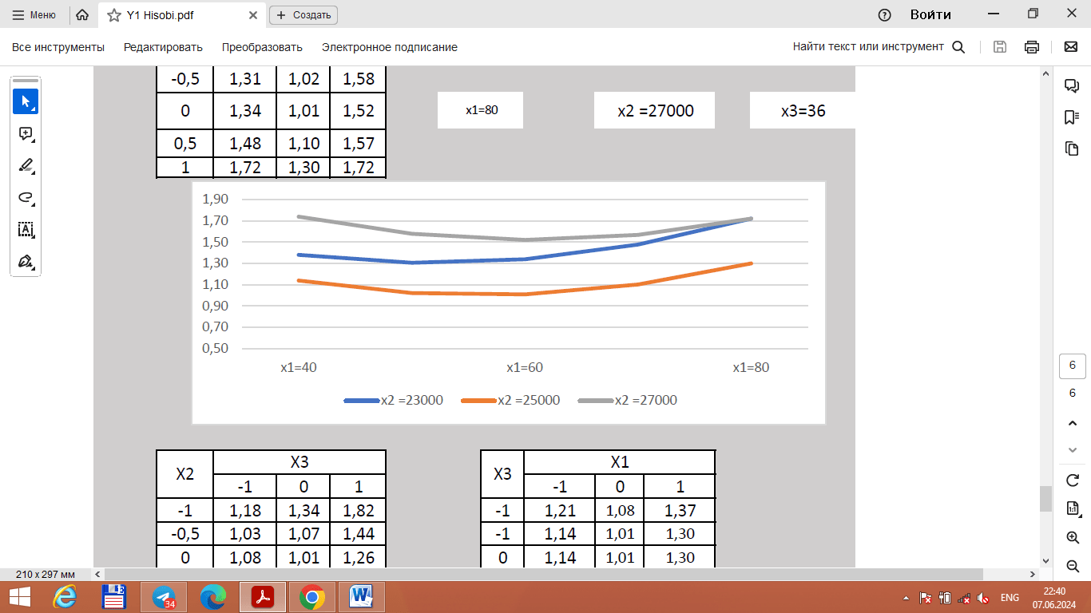
a)
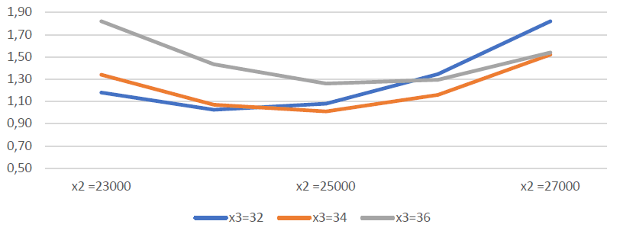
b)
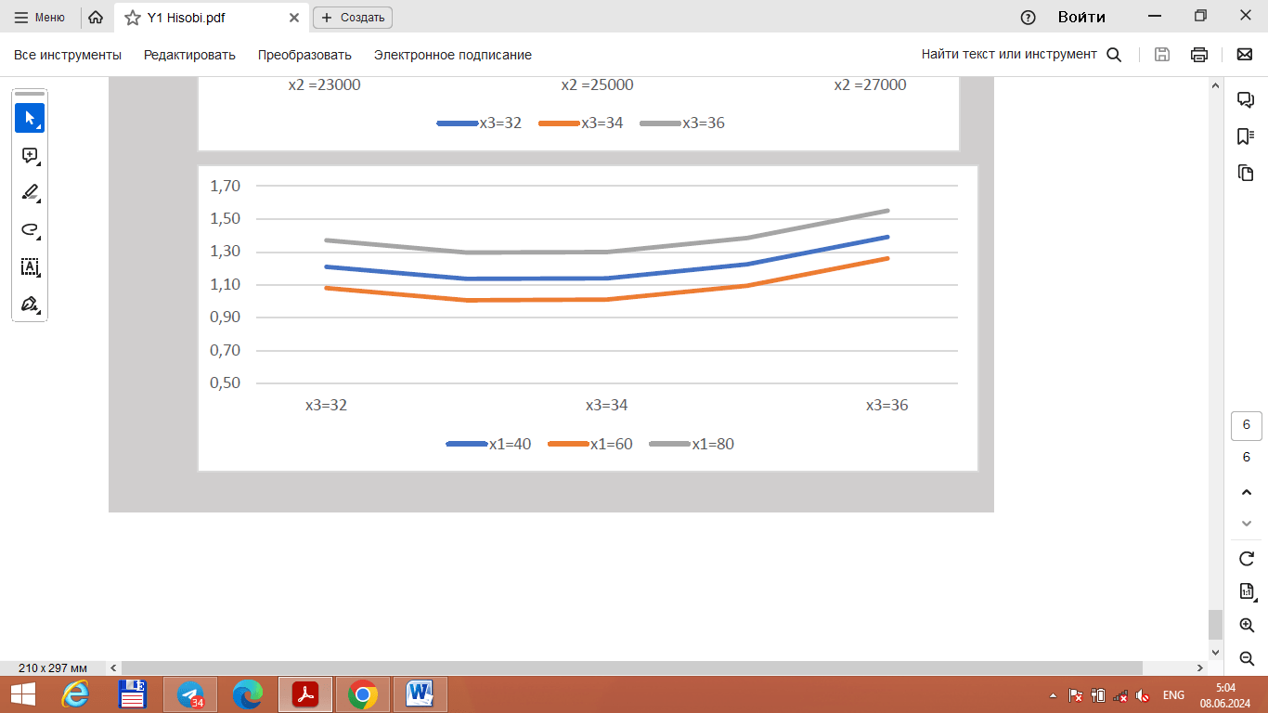
c)
FIGURE 7. Optimization models for yarn linear density unevenness: a) dependence on roving twist and cylinder speed; b) dependence on cylinder speed and diameter; c) dependence on cylinder diameter and roving twist.

RESULTS AND DISCUSSION
Based on theoretical and practical research, the newly developed twisting mechanism significantly differs from previous designs in both structure and functionality.
The quality indicators of yarns produced using the new twisting mechanism were compared with those of yarns produced by traditional ring spinning methods and other standard benchmarks. The technical parameters of the two machine types are listed below (see Table 3).
The yarn quality indicators obtained using the new twisting mechanism are shown below (see Table 4). These results are compared to the yarn quality parameters produced by the factory, Uster Statistics 2023 (50% benchmark) [18], and the Uzbek national standard UzDst 3312-2018 (3rd grade) [19]. The comparisons are presented in table and histogram formats.

TABLE 3. Technical Parameters of Spinning Machines.
Parameters | Traditional Ring Spinning Machine | Spinning Machine with New Mechanism
Twisting mechanism rotation speed (rpm) | 16 000 | 25 000
Cylinder gap distance (mm), | Rear: 65  Front: 43 | Rear: 60  Front: 42
Cylinder speeds (rpm) | Front: 20  Middle: 0.64  Rear: 0.55 | Front: 31.25  Middle: 0.91  Rear: 0.868
Linear density of roving (tex) | 720 | 720
Speed of draft rollers in winding unit (rpm) | 20 | 31,25
Distance from twisting mechanism to drafting rollers (mm) | 85 | 85

TABLE 4. Yarn Quality Indicators Analysis.
Indicators | Factory Version | Recommended Machine | Uster Statistics 2023 (50%) | UzDst 3312-2018 (Grade 3)
Yarn linear density (tex) | 19,6 | 19,6 | 19,6 | 20
Unevenness in yarn linear density, Um% (CV/1.25) | 11,48 | 11, 31 | 12,14 | 12,6
Number of twists (twists/m) | 800 | 800 | 765 | 762
Effective twist (practical) (twists/m) | 830 | 705 | - | -
Number of thin places (Thin/km -50%) | 10 | 11 | 13 | 16,8
Number of thick places (Thick/km +50%) | 190 | 182 | 197 | 212,3
Number of neps (Neps/km +200%) | 361 | 328 | 379 | 282,5
Relative yarn strength (sN/tex) | 15,77 | 14,7 | 14,5 | 16,8
Elongation at break (%) | 4,6 | 5,3 | 5,71 | 6,2
Hairiness (H) | 6,1 | 7,0 | 6,5 | 5,5

According to table results, the new twisting mechanism achieved better or comparable results in yarn linear density, evenness, and twist uniformity compared to both Uster 2023 benchmarks and the traditional method.

CONCLUSION
During the study, following conclusions were taken:
a new design of a hollow tube rotating on its axis and a cylindrical fiber handle fixed to its upper part was developed, which performs the function of forming yarn by twisting it.
An improved design of a spinning mechanism was created, which reduces the unevenness of the yarn quality indicators in the spinning process in a spinning machine and increases the productivity of the machine due to the high rotation speed.
Equations of the dependence of the differential in winding the fiber handle onto the bobbin through the winding device in a spinning machine of an improved design, and the distance to the center of the warping that occurs during the winding process were obtained.
Based on the results of a central composite experiment, an adequate regression equation of the unevenness of the yarn in terms of linear density was obtained based on the optimal values of the warp screw, the speed of the spinning mechanism of the new design of the spinning machine, and its diameter.

REFERENCES
- Chakrabortty, A., Raian, S., Hasan, R., Saha, S. K., Hossen, J., & Khan, S. Q. (2024). Investigating spindle tape aging Effects on ring spun yarn Quality: A regression Analysis approach. Fibers and Polymers. https://doi.org/10.1007/s12221-024-00721-2
- Chakraborty, S., & Mitra, A. (2018). A multivariate quality loss function approach for optimization of spinning processes. Journal of the Institution of Engineers (India) Series E, 99(1), 101–109. https://doi.org/10.1007/s40034-018-0119-2
- Guha, A., Chattopadhyay, R., & Jayadeva. (2001). Predicting yarn tenacity: A comparison of mechanistic, statistical, and neural network models. The Journal of the Textile Institute, 92(2), 139–145. https://doi.org/10.1080/00405000108659564
- Zeidman, M. I., Suh, M. W., & Batra, S. K. (1990). A new perspective on yarn unevenness: Components and determinants of general unevenness. Textile Research Journal, 60(1), 1–6. https://doi.org/10.1177/004051759006000101
- Ramesh, M. C., Rajamanickam, R., & Jayaraman, S. (1995). The prediction of yarn tensile properties by using artificial neural networks. The Journal of the Textile Institute, 86(3), 459–469. https://doi.org/10.1080/00405009508658772
- Rajamanickam, R., Hansen, S. M., & Jayaraman, S. (1997). Analysis of the modeling methodologies for predicting the strength of air-jet spun yarns. Textile Research Journal, 67(1), 39–44. https://doi.org/10.1177/004051759706700109
- Sette, S., & Van Langenhove, L. (2002). Optimizing the fibre-to-yarn production process: Finding a blend of fibre qualities to create an optimal price/quality yarn. AUTEX Research Journal, 2(2), 57–63. https://doi.org/10.1515/aut-2002-020201
- Chakraborty, S., & Diyaley, S. (2018). Multi-objective optimization of yarn characteristics using evolutionary algorithms: A comparative study. Journal of the Institution of Engineers (India): Series E, 99, 129–140. https://doi.org/10.1007/s40034-018-0121-8
- Arain, F. A., Tanwari, A., Hussain, T., et al. (2012). Multiple response optimization of rotor yarn for strength, unevenness, hairiness and imperfections. Fibers and Polymers, 13, 118–122. https://doi.org/10.1007/s12221-012-0118-8
- Ahadi, M. M., Mashroteh, H., Owlia, E., et al. (2023). High-bulking behavior of cotton/acrylic rotor yarn using Taguchi statistical procedure. Fibers and Polymers, 24, 2529–2539. https://doi.org/10.1007/s12221-023-00242-4
- Ray, S., Ghosh, A., & Banerjee, D. (2018). Analyzing the effect of spinning process variables on draw frame blended cotton mélange yarn quality. Journal of the Institution of Engineers (India): Series E, 99, 27–35. https://doi.org/10.1007/s40034-017-0109-9
- Ishtiaque, S. M., Rengasamy, R. S., & Ghosh, A. (2004). Optimization of ring frame process parameters for better yarn quality and production. Indian Journal of Fibre & Textile Research, 29, 190–195.
- Ghosh, A., Das, S., & Banerjee, D. (2013). Multi-objective optimization of yarn quality and fibre quality using evolutionary algorithm. Journal of the Institution of Engineers (India): Series E, 94, 15–21. https://doi.org/10.1007/s40034-013-0015-8
- Belyaev, D., et al. (2015). Device for monitoring yarn twisting and operational parameters in a ring-spinning machine (Patent No. RU, published August 20, 2015, Bulletin No. 23).
- Soloxiddinov, J., Bobojanov, H., Fayzullayev, S., & Korabayev, S. (2022). Analysis of the effect of spindle speed on the quality of yarn on the spinning machine and use of the Android application in the analysis. AIP Conference Proceedings, 2432(1), 030038. https://doi.org/10.1063/5.0089530
- Farooq, A., Khan, N., Irshad, F., & Nasir, U. (2023). Predictive modeling of yarn quality at ring spinning machine using resilient back propagation neural networks. Textile and Apparel, 33(1), 9–14. https://doi.org/10.32710/tekstilvekonfeksiyon.904406
- Meliboev, U. Kh. (2020). Fundamentals of modeling technological processes of the textile industry (pp. 116–122). Namangan, Uzbekistan: Adabiyot Uchkunlari.
- Uster Technologies AG. (2023). Uster statistics 2023: Cotton 100%, carded, ring yarn, package, knitting.
- UzDST 3312-2018. (2018). Yarns for the knitting industry—Technical conditions. State Standard of the Republic of Uzbekistan.
- Quliyev, T. M., Maqsudov, E. T., Jumaniyazov, Q., Djumabayev, G. X., Korabayev, Sh. A., & another author. (2025). Optimization of twist triangle geometry and drafting system for enhanced yarn quality in ring spinning. Izvestiya Vysshikh Uchebnykh Zavedenii, Seriya Teknologiya Tekstil'noi Promyshlennosti, (3), 157–164. https://doi.org/10.47367/0021-3497_2025_3_157
- Soloxiddinov, J., Bobojanov, H., Korabayev, S., & Parpiev, D. (2024). Research on the twisting-winding device of the ring spinning machine and the yarn control. AIP Conference Proceedings, 3045, 030026. https://doi.org/10.1063/5.0197317
- Mamadalieva, D., Korabayev, S., Mahsudov, S. A., Sovutov, M., Adashev, B., & Axmadjanov, S. (2025). Evaluation and enhancement of ring strength in ring pile fabrics. AIP Conference Proceedings, 3304, 030072. https://doi.org/10.1063/5.0269374

