Determination of Tribological and Rheological Indicators
of Tire Composition for Road Surfaces
Sirojiddin Djiyanbaev¹, Maxmud Omonov^{2, a)}
¹Jizzakh Polytechnic Institute, Jizzakh, Uzbekistan
² Samarkand State Architectural and Civil Engineering University, Samarkand, Uzbekistan

^{a)}Corresponding author: maxmudomonov85@gmail.com
Abstract. This paper examines the technology of processing used vehicle tires and developing road surfaces based on them. In addition, the normative requirements of the technologies for the processing of car tires are expressed. Physical-chemises propertied of local raw materials and industrial products for processing for vehicle technology and obtaining road pavements based on were determined. In the modern world, the number of cars is steadily growing, and for all developed countries of the world, the disposal and recycling of tires is becoming of great environmental and economic importance. This is primarily due to the fact that worn tires are a long-term source of environmental pollution. In addition, rubber is flammable and non-biodegradable, and a pile of rubber tires is a very favorable place for the accumulation and habitation of rodents and insects, which are the source of many infectious diseases. Research objective: To recycle used vehicle tires and develop roadbeds based on them. Research objectives: determine the physicochemical properties of local raw materials and industrial products for the processing of used vehicle tires and the production of road surfaces based on them, prove the effect of the components and physicochemical indicators of the processing of used vehicle tires and the production of road surfaces based on them, determine the cold and heat resistance and operational properties of used vehicle tires and the production of road surfaces based on them, create a composition and technology for the processing of used vehicle tires and the production of road surfaces based on them. Object of research: Used secondary tires, processing technology, technology for the production of environmentally friendly products, technical carbon obtained from the pyrolysis of waste automobile tires, its use as a secondary raw material for rubber and technical products.
Keywords: used tires, road pavements, synthetic rubber, recycling, rubber waste.
INTRODUCTION
Currently, in the production of new composites road pavements obtained used secondary tire and interactive phosphonyls, great importance is attached to the research of their thermo-analytical properties, which in turn allow to determines in the physical changes due to the increase in temperature in the friction areas [1-5].
Evaporation and melting of present in the product composition and composition, as well as thermos and thermal oxidation processes, are of great importance. It is important to determine the temperature of the polymorphic changes in the composition, to develop the scientific basis for the production of product components and to evaluate their ability to work effectively in a high temperature environment.
In the works [6], the scientific importance of choosing a new composite composition in obtaining a finished product and the experience shows that the most common way of cutting tires is to cut rubber into smaller pieces using hydraulic guillotines. This method is the most effective and safe for the company's employees. The final stage of tire processing is to reduce them to a grinding state.
The final size of the cut pieces can be from 100x100 mm to 30x30 mm. This parameter depends on the design of the grinder. The weight of the devices is determined by their functionality, power and performance and can vary from 75-150 kg. Guillotines for cutting tires and tires: Fast and safe method cutting presses for solids manufactured in our factory: fast and safe.
Pyrolysis is one of the widely used processes in the petrochemical industry. The choice of raw materials for the pyrolysis process is very important. Because the product formed during the pyrolysis process depends on the raw material. When studying the research conducted by the scientists of the world, it appears that the process can usually be carried out in the low-temperature and high-temperature mode of pyrolysis.
Running at a low temperature ensures that the hydrocarbons are not completely broken down. In addition, if the pyrolysis process is carried out at a low temperature, the formation of aromatic hydrocarbons increases, while at a high temperature, a lot of pyrolysis tar with coke is formed. A low-temperature thermal pyrolysis method was chosen for the car tire pyrolysis process. Thermal pyrolysis is the production of low molecular weight compounds by heating high molecular weight materials in the absence of oxygen.
A scheme was put together using laboratory equipment to obtain fuel from an old car under laboratory conditions. For the implementation of the procedure, the safety of the technique was checked and all the necessary tools were prepared. Temperatures of 400, 500, 600 ºC were chosen for the process. It has been theoretically studied that the low-temperature pyrolysis process is mainly carried out at a temperature of 500-600 ºC.
This size and shape of the rubber molecule indicates its most important property, elasticity. Natural rubber dissolves in oil and aromatic hydrocarbons and their derivatives, such as copper, gasoline, benzene, chloroform, and forms a viscous solution glue. As natural rubber is an unsaturated compound, it reacts with hydrogen, halogens, sulfur and oxygen [4-7].
MATERIALS AND METHODS
As a result, its solubility, strength, elasticity and physical and mechanical properties change. Raw rubber reacts with sulfur to form high-quality rubber. Natural things is on usually in an second state, but can crystallize secondary tire crumb, the cold and heat resistance and operational properties of new road surfaces made from components in a liquid composition were determined, and a State Standard was developed. Indonesia, Malaysia, Thailand, India, China, Sri Lanka and Vietnam produce a lot of natural rubber. Synthetic rubber is an artificially rubberized high polymer material (elastomer). Synthetic rubber is obtained by polymerization and copolymerization of various compounds. Liquid rubbers, their dispersion in water (synthetic latexes), as well as rubber in which oil, pitch and other fillers are used in the polymerization process are also synthetic rubbers. The method of polycondensation of bifunctional derivatives of hydrocarbons is used to obtain some synthetic rubbers.
Determination of physical and chemical properties of local raw materials and industry product for processed using vehicle tires and obtaining road pavements basing on them;
Processing in the used vehicle tires and proof of the effects of the components and physico-chemical indicators of road pavements based on them;
Processed used vehicle tires and determining the cold and heat resistance and operational properties of road surface based on the them;
Creation of a procedure and technology for processing used vehicle tires and obtaining road surfaces based on them.
The scientific significance of the research results is explained by the fact that they demonstrate the scientific basis for creating a technology for obtaining a liquid composition and roadbeds using secondary tire crumb.
The practical significance of the research results is to contribute to the development of roadbeds from local raw materials, secondary tires and industrial products with a new composition, which will ensure the production of high-quality, import-substituting and competitive products based on local raw materials.
Cutting guillotines for cutting rubber are considered the best choice when organizing a processing business. Hydraulic knives for cutting tires have the following advantages.
The scientific research of the scientific result is explained by showing the scientific basis of creating a technology for obtaining a liquid composition and obtaining road surfaces using secondary tire sawdust. The practical significance of the research results is to serve for the development of road surfaces from local raw material, secondary tires and industry products with a new composition, which ensures the production of high-quality, import-substituting and competitive products based on local raw materials.
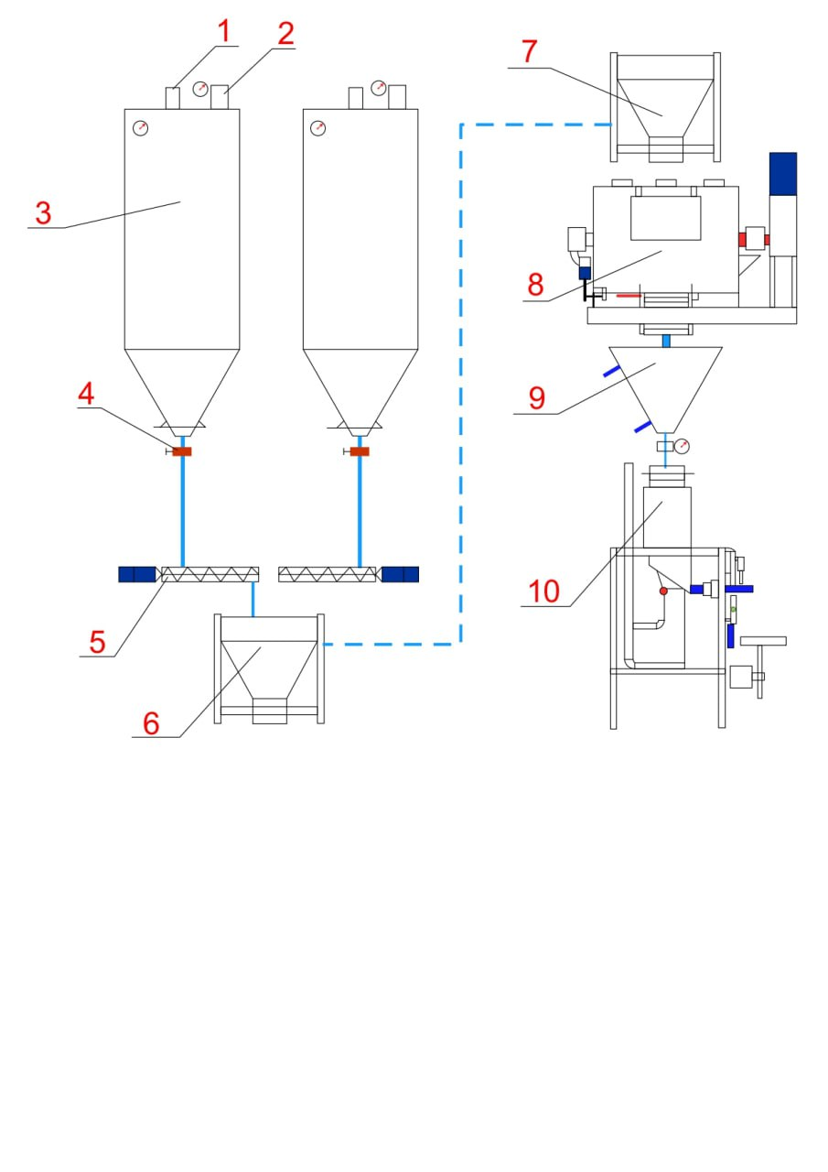
FIGURE 1. The technological principle scheme of obtaining a composition of tire sawdust for road surfaces

In Fig.1, Main shredder (reactor) hole (1); Reactor vibration separator and temperature measurement (2); Thermal reactor, rotor magnetic separator (3); Measuring transmitter, flywheel (4); Magnetic separator for separating the metal part of tires (5); Shredder for solid cutting (Process of converting tire crumb into a dispersed medium) (6); Reactor for forming the bond of phosphogypsum with additional asphaltene substances (7); Thermal reactor hole (8); Reactor temperature measurement and control hole (9); Two-roller crusher (Device for forming a mixture of ingredients) (10).
Obtaining synthetic rubber consists of 2 main processes: preparation of monomers (couchogens) and their polymerization or polycondensation. Butadiene, styrene, isoprene, chloroprene, isobutylene, acrylonitrile (vinyl cyanide), etc. used as cauchogens. Cauchogens themselves are obtained from petroleum cracking gas, natural and road gases, and ethyl alcohol.
In the process of polymerization of cauchogens, monomers are heated in the presence of a catalyst (eg, sodium metal) (monomer itself or solution, aqueous emulsion). During polymerization, the emulsion is coagulated when it turns into a polymer suspension, i.e. synthetic latex. The separated rubber is washed and dried.
Currently, about 20 types of synthetic rubber are produced. Of these, butadiene butadiene nitrile rubber and butyl rubber are of great industrial importance. Many types of synthetic rubber are vulcanized like natural rubber to become a highly elastic or hard material.
Tires are one of the most important and expensive elements that directly affect the operational qualities of cars, providing them with smooth ride, braking classifications. 6-15% of the cost of the transport work is spent on the purchase of tires and their maintenance and repair work, depending on the type, structure, load carrying capacity and operating conditions of the vehicles.
The created composite tire crumb for the road infrastructure was tested in the organizations of the Jizzakh regional transport department and its economic efficiency was proven. At the same time, the experimental testing regulations for the created new composite tire crumb (OPR-42-2022 UNKINL) were approved by the “Ishtikhon trans servis” LLC and introduced for the production of new composite tire crumb (Reference of the Ministry of Transport of the Republic of Uzbekistan dated December 23, 2022 No. 2/8019).
RESULTS AND DISCUSSION
Heavy joint metal in also present (small amounts of jointly and zinc on the surface of the metal surface). Modern tires do not even use lead. The all of these components undergo change during tire recycling and form new substances, many of which are more dangerous than the original substances.
It is known that the analysis of the dispersed phase of new compounds in secondary tire slag and interactive phosphonyls composition materials is a very complex chemical situation. This in turn requires scientific experiments and operational standards. In scientific experiments, it is necessary to study the composition, proportions, phases of chemical groups in obtaining modified products. In order to obtain a new product and test it in an experiment, high-tech chemical laboratories set the task of analyzing the results.

FIGURE 2. IR-spectral analysis of new compounds in the composite materials of
new tire sawdust and interactive phosphonyls composite

According to the IR spectrum analyze of the viscosity ingredient composition, 1464 cm-1; 1383 cm-1; and the vibrations corresponding to 724 cm-1 were found to belong to sulfoxides related to the –CH2–CH3 group.
This viscosity ingredient was analyze jointly due to the fact that it was not clearly visible in the main spectrum due to the small amount in the tire crumb composition.
Results is relevant if the tires are processed in the partial recycle type , i.e. grind only the outer shell of clean rubber (sidewalls and tread). This option is not required for complete tire recycling.

FIGURE 3. Incorporation of new compounds into composite materials of tire jointly and
IR-spectrum analysis of the dispersed phase
The formation of a dispersed phase is mainly carried out by forming a kind of dispersing medium between different types of chemically complex compounds. As we know, the goal of the dissertation is to create a technology for obtaining heavy technical carbon from tire scrap and obtaining a new composite product.
It requires the study of the rheological parameters of the product based on the technology resulting from scientific theories and scientific research. The main purpose of identifying this component with the help of IR spectrum is to determine the anti-oxidation property of the tire crumb composition of the composite, and it also helps us to study its rheological properties.
As a result, it serves to obtain environmentally safe and resource-efficient new materials. In this regard, it is necessary to create new types of import-substituting road tiles from rubber and tire scraps, to create road paving technologies.
CONCLUSION
It is known that the pavement formed on the basis of used vehicle tires is better and more durable than the asphalt pavement due to its micro-reinforcing properties in special environments, namely on water-covered and icy roads. In conclusion, it should be noted that the problem of cracking and short-term deterioration of asphalt pavement in cold temperatures can be solved by the newly proposed pavement formed from used vehicle tires.
In addition, the physic and mechanical properties of the new pavement, resistance to cold and hot temperatures, durability, resistance to harmful substances and a number of other important opreration have a significant positive advantage over the properties of the existing asphalt pavement.
The conclusion is that when this mat is used, the operation process can be eased due to the fact that the currently used asphalt mat will quickly thicken when it is laid at a cold temperature (mainly below 5 C0 degrees) and the labor cost will be reduced by 1.33 times due to the reduction of the current average 8-10 pressing process to 6-8 times. and economic efficiency is achieved.
REFERENCES
- Yanchevsky, V. A. (2005). Technology services: Opportunities and barriers to scrap tire recycling. Technology Services, 6, 37–39.
- Brook, N. (1995, February). AEA Technology/UK: Opportunities and barriers to scrap tire recycling (Study for the Department of Trade and Industry). Environment Canada Publication, 49–50, 59–60.
- Fathi, H., El-Sayegh, Z., Ren, J., & El-Gindy, M. (2024). Analysis of Tire-Road Interaction: A Literature Review. Machines, 12(11), 812. https://doi.org/10.3390/machines12110812
- He, C., Jiang, W., Wang, T., Yuan, D., & Sha, A. (2024). The evolution of tire-road wear particles and road surface texture under rolling friction. Construction and Building Materials, 447, 138167. https://doi.org/10.1016/j.conbuildmat.2024.138167
- Salehi, M., Noordermeer, J.W.M., Reuvekamp, L.A.E.M. et al. Understanding Test Modalities of Tire Grip and Laboratory-Road Correlations with Modeling. Tribol Lett 69, 116 (2021). https://doi.org/10.1007/s11249-021-01490-2
- Mirsaidov, M., Dusmatov, O., & Khodjabekov, M. (2021). Mode Shapes of Transverse Vibrations of Rod Protected from Vibrations in Kinematic Excitations. In Lecture notes in civil engineering (pp. 217–227). https://doi.org/10.1007/978-3-030-79983-0_20
- Khodjabekov, M. U., Buranov, K. M., & Qudratov, A. E. (2022). Modal mass and stiffness of hysteresis type elastic dissipative characteristic plate. AIP Conference Proceedings, 2637, 050004. https://doi.org/10.1063/5.0118292

