Development of New Structured Local Thermal Carpet Technology
Aziz Abdurakhmonov ^{a)}, Patkhillo Siddikov, Nodira Yusupova
Tashkent Institute of Textile and Light Industry, Tashkent, Uzbekistan

^{a)}Corresponding author: abdurakhmonovazizjon@gmail.com
Abstract. The main purpose of this study is to develop an innovative thermal carpet with heating properties that contributes to the protection of human health, particularly by helping to prevent foot-related diseases, and to scientifically substantiate new technological processes for its production. In addition, the research aims to expand the range of carpet products by introducing environmentally friendly, energy-efficient solutions that meet the functional, safety, and comfort requirements of modern consumers. The object of the research is a thermal carpet with integrated heating functionality, along with the materials and technological processes involved in its production. These include the selection of suitable raw materials, structural design, pattern development, cutting methods, machine forming, and final finishing operations. As a result of the study, a new technology for manufacturing a thermal carpet with heating properties was developed and justified. The sequence of production stages, material selection criteria, and constructive and design solutions were defined. The proposed thermal carpet was found to provide improved functional performance, enhanced user comfort, and potential benefits for foot health. Furthermore, the results demonstrate that the product can be manufactured under local industrial conditions, offering practical applicability and prospects for sustainable production.
Keywords: thermal carpet , raw material, pattern sketch, loom, carbon cable, natural wool threads, weaving, relay, external battery, solar panel.
INTRODUCTION
Uzbek "Applied art of carpeting" is a type of folk decorative art and has a long history as a centuries-old national tradition. Carpet weaving is part of the art of weaving. It has been popular among women since ancient times in Central Asia. From ancient times, our ancestors used carpets to decorate the interior of the house, keep warm, and reduce noise. The carpet is placed on the floor, on the mat, and hung on the wall to decorate the room.
In the decision "On measures to develop the field of hand-woven carpets in the Republic" adopted by our President on June 26, 2020, a number of tasks for the development of hand-woven carpets were defined. It is clear that the decision will ensure the employment of women in rural areas through the further development of carpet making, as well as help the disabled and needy people who stay at home in our country. In order to increase the export potential of hand-woven carpets and their attractiveness for tourists, "the history of carpet" will show the weaving process of each carpet, the craftswomen and their working conditions, and development of mobile applications containing such information, organization of carpet-making seminars, fairs and exhibitions, fairs and exhibitions of local carpet-making organizations and artisans held in foreign countries and much attention is paid to the issues of providing practical assistance in participating in exhibitions [1-2].
In order to develop the field of hand-woven silk and woolen carpets in our country, which embodies our historical traditions, is an ancient heritage from our ancestors, and is considered a unique work of art, the measure "Development of the field of hand-woven carpets in the Republic" was established. - on measures" President's decision accepted.
Today, carpet manufacturers offer a wide range of carpet types to the world market. When buying carpets, every customer pays great attention to its quality. Harmonization of carpets to the market requirements, ensuring the employment of unemployed people, especially young people, women and low-income families, is an urgent task for every representative of the textile industry. Production processes are constantly being improved by introducing new developments. In the article, the processes of forming a local thermos-mat with special features created for the first time on a handloom are presented.
RESEARCH METHODOLOGY
The newly created local thermal carpet prevents the appearance of a number of diseases that appear in the human body through its heating, treatment, and ground contact. Also, this thermal carpet can be used for a number of purposes, using different types of patterns, for example, in children's beds or classrooms, using various cartoon characters as images, including a pattern representing a prayer, can be used as a prayer rug. Based on the climatic conditions, believers who come to the mosque to pray on cool days, especially on Eid days, are forced to pray outside the mosque due to the large number of people. A special local thermal carpet is designed to help them perform their prayers to their heart's content, at least partially, in order not to distract them from their earthly thoughts while they are praying.
METHODS
First, raw materials are prepared for forming a local thermal carpet As shown in Figure 1, as raw material, 12-volt carbon cable (1) with a diameter of 1 mm, high-quality and conforming to all standards, made of natural wool fiber, warp (2), pile weft (3) and weft (4) threads. threads of the required texture are used. It is known that woolen yarn has a positive effect on human health, i.e. it is useful for leg and back pains, that is, local woolen yarn was used.
Then the desired pattern is selected. The image of the pattern is chosen according to the purpose and age of the people who will use the rug. This technical pattern sketch is drawn on the design grid. After the drawing of the technical pattern sketch, the colors are selected while maintaining the desired color balance, and the color image work is carried out to further enhance the carpet decoration.
Scissors, a wooden comb, a hook knife, and a carpet brush are required to shape the carpet using a hand-held device. After the raw material is ready, a special manual device is made in accordance with it for the production of a thermal carpet of the required size, and the standard parameters of compaction are developed. Then, in accordance with the developed parameters, the ground yarns are placed on the device and the process of weaving the thermal carpet begins.
After every 11 rows of feather warp threads, the carbon cable along with the ground warp thread is also passed between the ground threads. After one row of carbon cable is thrown, the carbon cable is passed between the gum threads of the thermal carpet to throw the cable to the 11th row, and this process is shown in the diagram (see Fig. 1).

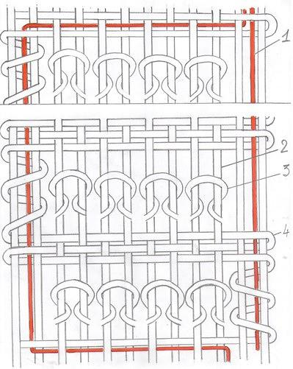
FIGURE 1. An image of the weaving of threads and carbon cable on a thermal carpet

In this way, after the thermal carpet is woven, it is cut from the device and finished. In the process of finishing, the areas of the carpet with defective cuts are removed, and attention is paid to the smoothness of the piles. After the finishing process, as shown in Figure 2, one end of the carbon cable (1) in the thermal carpet is connected to the plus side of the additional two-circuit cable (2), and the other end is connected to the minus side, and insulation (3) is done. After insulation, the other side of the two-circuit cable is connected to the relay (4) (to control the heat in the thermocouple). After leaving the relay (5), the two-circuit cable is connected to the external battery (6), and from this battery, the relay transmits the electric power to the thermal carpet and controls the heat in it. If the power in the external battery is exhausted or running out, the solar panel (7) will charge it, and thus the heating carpet for prayer will have constant heat without being connected to an outlet.
During the operation of the thermal carpet, a special fabric is attached to the bottom of the thermal carpet with the help of adhesive tapes. This special fabric is woven using rubber and polyester. This tissue performs several functions: it keeps the heat in the thermal carpet from under it, prevents it from slipping even if the thermal carpet is used on a tile or smooth surface, and even after the thermal carpet is used on a dusty street, you can take a special tissue under it, wash it, and then re-stick it with the help of adhesive tapes.

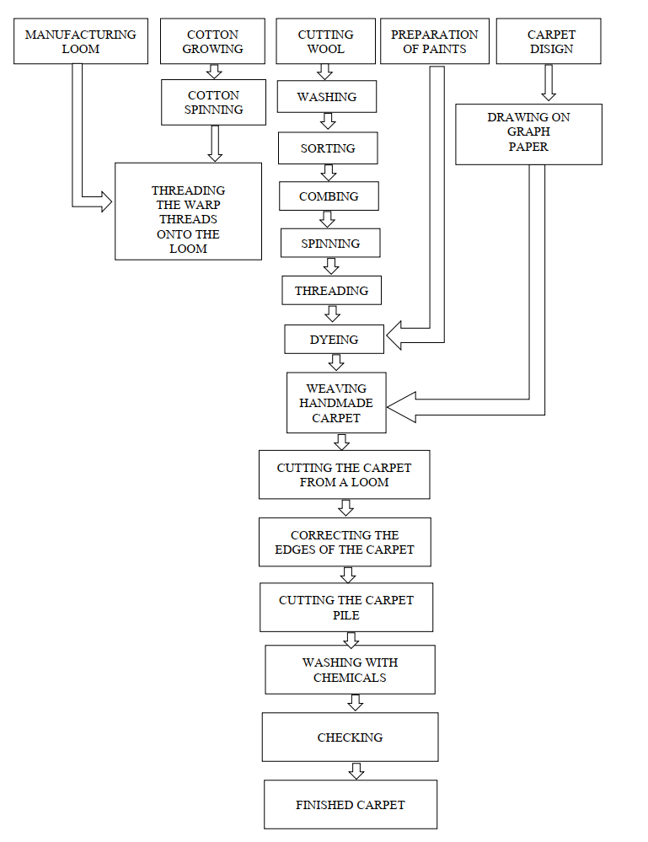
FIGURE 2. The sequence of production of handmade carpets on a loom.

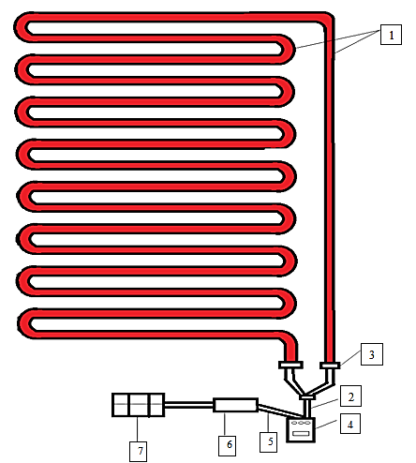
FIGURE 3. Overview of the heating system of the thermal carpet: 1 – carbon cable, 2 – two-circuit cable, 3 – connection point (insulation) of the two-circuit cable with the carbon cable, 4 – relay, 5 – two-circuit cable for connecting the relay with the external battery, 6 – external battery, 7 – solar panel

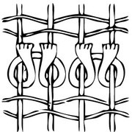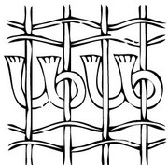
а) b)
FIGURE 4. Different nodes that can be used to form a local thermal carpet: a) Persian knot; b) Turkish knot.

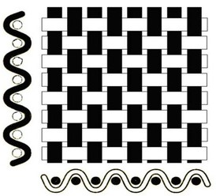
FIGURE 5. An image of plain weave that was its rapport = 2, shift = 1.

The following formulas are used to determine the number and density of pile knots in the technical calculation of the thermal insulation.
The number of knots in one row:
$Nknot = \frac{n_{т}-n_{м}}{2}$ (1)
In this; N_{knot} - the number of knots in one row, $n_{т}$- the number of threads in the ground, $n_{м}$ - the number of thread threads.
After the thermal carpet is woven, the finishing process is carried out. That is, first the finished carpet is carefully cut from the loom. The cutting process is carried out so that all carpet piles cut from the loom are of the same height. Then the condition of the carbon cable in the thermal carpet is checked for heating the thermal carpet and its control. After these processes are carried out, the thermal carpet is put into use [4, 7, 8].
RESULTS AND DISCUSSION
The stresses acting on the thermal carpet carbon cable were analyzed. The main stresses are applied along the two mutually perpendicular surfaces of the element in the state of flat stress. In this case, it is necessary to determine the maximum values of normal and experimental stresses to determine the strength of the carpet mat. For example, let the right-angled parallelepiped surfaces σ₁, σ₂ be under the influence of principal stresses, where σ₃ =0 (see Fig. 6). If one of the values of σ₁ and σ₂ is compressive, then as we assumed above, it is necessary to change the conditional sign indices by taking the sign of the compressive voltage negative, more precisely σ₁, σ₃. If the two stresses acting on it are compressive, then we conditionally accept the smaller value of the stress as δ₂ and the larger one as δ₃. To determine the greatest normal and tensile forces on parallelepiped surfaces, we transfer a normal plane to an inclined plane at an angle of λ ₁. This plane makes an angle 1-1 with the direction λ ₁(see Fig. 7). These surfaces are affected by normal voltages σ_{λ}, effort and τ _{λ}, their values depend on the values of voltage σ₁, σ₂ [5-6].

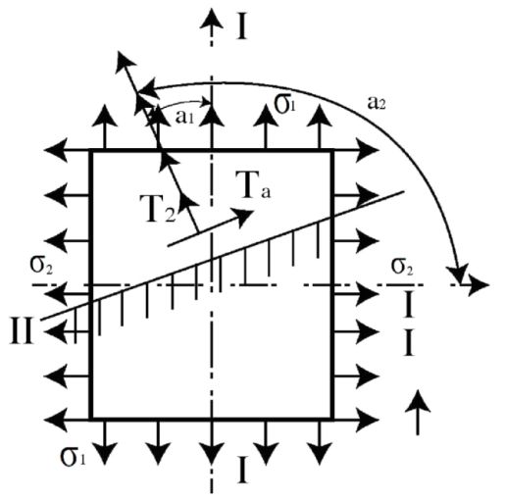
FIGURE 6. Action of principal stresses on the surfaces of a rectangular parallelepiped.

Normal σλ and shear stress τλ values are checked separately in relation to the stress values σ1 and σ2. The stress values formed on the surface (1) under the influence of σ1 and σ2 are given by the formulas , namely, σ1cos² λ1 and σ2cos² λ2. The total stress is defined as follows:
$$σλ = σ1cos² λ1 + σ2cos² λ2 = σ1cos² λ1 + σ2cos² λ2 (λ1 + 90°)$$
$σλ = σ1cos² λ1 + σ2cos² λ2$ (2)
When determining the shear stress τλ value, we also use formula and find that:
$$τλ = 1/2 [σ1sin² λ1 + σ2sin² λ2] = 1/2 [σ1sin² λ1 + σ2sin(λ2 + 90°)]$$
$τλ = (σ1 – σ2) / 2 * sin² λ1$ (3)
In the next formulas, we will substitute σλ, τλ, and the values of λ1 and λ. This λ value is taken opposite to the direction of the maximum normal stress. The given λ is determined for the surfaces. Using formulas (2) and (3), we can also determine the stresses for the v-v surface, which is perpendicular to this surface. The normal on this surface is nβ. The angle β forms with the largest principal normal stress as β = λ + 90°:
$$σβ = σ1cos² β + σ2sin² β = σ1cos²(λ + 90°) + σ2sin²(λ + 90°)$$
$σβ = σ1sin² λ + σ2cos² λ$ (4)
$$τβ = (σ1 - σ2) / 2 * sin 2β = (σ1 - σ2) / 2 * sin(2λ + 180°)$$
$τβ = (σ1 - σ2) / 2 * sin 2λ$ (5)
From formulas 5, it is known that the stress values on mutually perpendicular surfaces are as follows:
$$σλ = σ1cos² λ + σ2sin² λ$$
$σβ = σ1sin² λ + σ2cos² λ$ (6)

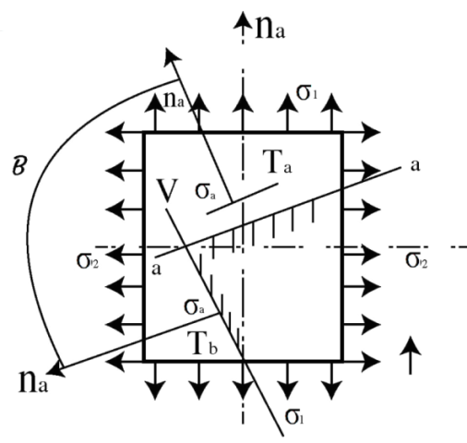
FIGURE 7. Normal and tensile stresses on the surfaces of the parallelepiped.

The sum of these stresses is given by σλ + σβ = σ1 + σ2 = const. Therefore, the values of normal stresses in perpendicular surfaces remain constant and unchanging. For shear stresses, from formulas (5) we have $τβ = - τλ$.
Thus, the values of shear stresses on mutually perpendicular surfaces are equal but have opposite signs.
CONCLUSION
It can be stated that a theoretical analysis was conducted regarding the forces acting on an object when using a thermos-generator. According to this analysis, two principal stresses act along the two mutually perpendicular surfaces of an element under a uniform stress state. Both theoretical and experimental studies show that the two main stresses, σ1 and σ2, significantly affect the strength of the local thermos-generator product. A uniformly (hydrostatically) stressed carbon cable can withstand several times greater stress than its strength limit without failure.
The evolution of carpet technology has had a significant impact on how we perceive our health. From the introduction of new fibers to the development of smart and modular carpets, advances in the carpet industry continue to improve comfort, durability and style. The above innovative carpet product is made from eco-friendly natural raw materials and is perfectly suited to the needs based on modern innovation.
REFERENCES
- Khamraeva, S.A., Yusupova, N.B., Atambaev, D.D., Hasanov, M.H.O (2020). The Importance Of The Extension Tool In Reducing The Inequality Of Yarn. The American Journal of Engineering and Technology. https://doi.org/10.37547/tajet
- Omonbekovna, U. M., Siddikovich, S. P., Uli, A. K. K., & Bakhtiyarovna, Y. N. (2021). Structure of national avry hair tissue and specificity of its production. ACADEMICIA an International Multidisciplinary Research Journal, 11(2), 1132–1138. https://doi.org/10.5958/2249-7137.2021.00479.1
- Normand, X. (2008). Recycling of automotive textiles. In R. Shishoo (Ed.), Textile advances in the automotive industry (pp. 86–109). Woodhead Publishing.
- Kellie, G. (2016). Developments in composite nonwovens and related materials. In Elsevier eBooks (pp. 213–226). https://doi.org/10.1016/b978-0-08-100575-0.00007-3
- Saricam, C., & Okur, N. (2018). Polyester usage for automotive applications. In Tech eBooks. https://doi.org/10.5772/intechopen.74206
- Leshchenko, T. A., & Planida, Z. A. (2006). Techniques of hand carpet weaving. Phoenix.
- Statista. (n.d.). Bienvenue sur Statista – Votre nouvelle expérience sur statista.com. {siteLanguage:websiteTitle}. https://fr.statista.com/infographie/28271/modes-transport-les-plus-utilises-par-pays-mobilite-domicile-travail

