An Analytical Review: The Significance of 3D Textile Structures in Technical Textiles
Sherzod Korabayev^{1, a)}, Husanhon Bobojanov¹, Sanjar Tojimirzaev², Shoira Makhkamova³, Suxrob Axmadjanov¹, Boburshox Adashev¹
¹Namangan State Technical University, Namangan, Uzbekistan
²Urgench State University, Urgench, Uzbekistan
³Tashkent Institute of Textile and Light Industry, Tashkent, Uzbekistan

^{a)}Corresponding author: sherzod.korabayev@gmail.com
Abstract. This analytical review article investigates the pivotal role and increasing significance of three-dimensional (3D) textile structures in technical textiles3D fabrics are quite different from traditional two-dimensional fabrics. In particular, woven, knitted, and nonwoven fabrics exhibit high mechanical properties, structural integrity, and design flexibility. This further underscores the importance of these fabrics in advanced engineering applications. This paper also systematically analyses the primary methods for manufacturing 3D textile products, including 3D fabrics, spacer fabrics, knitted structures, and braids. It comprehensively analyzes the relevance of these products in key industries, including reinforcement of composite materials for aerospace, automotive, and wind energy; fabrics for medical textiles; protective clothing for ballistic and cut-resistant purposes; and products for geotechnical applications such as erosion control and filtration. It also details the main benefits of 3D structures, like how they can better absorb energy, withstand damage, strengthen thickness, and create complex preforms in mesh form. The review talks about problems that are happening now, like how hard it is to make things, how much they cost, and how hard it is to model things. It also talks about what research should focus on in the future, such as making smart 3D textiles, hybrid manufacturing processes, eco-friendly raw materials, and better tools for simulating things. The conclusion emphasises that 3D textiles are a key technology that is leading to new ideas in many areas where performance is important, and that they are a big step forward in materials science and engineering.
Keywords: 3D fabrics, technical textiles, composite materials, spacer fabrics, medical textile, protective textiles.
INTRODUCTION
Technical textiles are one of the fastest-growing industries today, serving as the foundation for modern industrial innovations ranging from functional materials to advanced materials. These engineered textiles are designed to perform a specific function rather than an aesthetic purpose. They are used in a wide range of applications, including aerospace, medical, construction, and personal protection. These processes were initially based primarily on two-dimensional (2D) fabrics, including laminates, coated materials, and simple layered composites. Several drawbacks of two-dimensional structures, such as a tendency to delaminate, insufficient thickness, and inefficiency in forming complex geometries, have increased the demand for products capable of performing even more functions.
Therefore, three-dimensional (3D) textiles have emerged and developed rapidly as flexible materials. The precise and significant dimensions and interconnected fibres characteristic of these fabrics, which are orientated in three Cartesian directions (X, Y, and Z), emerge as a solution to a problem not solved by 2D textiles. The integration of 3D printing has led to significant developments in textiles, yielding products with unique mechanical and functional properties.
The significance of three-dimensional textiles in technical applications arises from their ability to provide customized performance characteristics, such as multidirectional strength, enhanced damage tolerance, increased energy absorption, and suitability for engineering into complex near-net-shape preforms. These properties render 3D textiles essential for applications in which structural failure is unacceptable, such as primary aircraft components, cardiovascular implants, and ballistic armor.
This review article comprehensively examines the importance of 3D textiles in today's industry. The article analyses the methodologies of 3D textile production, identifies their advantages, discusses current problems, and predicts future developments. This work aims to provide a comprehensive resource that traces the development of technical textiles in light of the current research field of 3D textiles.
ANALYSIS
3D weaving represents the most prominent technique for producing solid, thick fabric structures. Modified looms equipped with multiple warp and weft insertion systems enable the interlacing of fibers in three dimensions. The principal architectures are as follows:
Angular woven textiles comprise a plurality of interlaced yarns that extend in the thickness direction of the fabric and are connected by every other. Further, the use of this structure has several advantages compared to conventional orthogonal weaves such as better damage tolerance and impact resistance capability and good permeability for moulding. They also developed simple models for mechanical properties of the weaves that have features which provide advantageous properties with regard to through-thickness strength [1].
Spacer fabrics represents a unique type of 3D textiles, with two outer layers being held apart by the presence of pile or monofilament yarns that sandwiched between by producing an air space. The above mentioned fabrics are mainly manufactured by Raschel-Knitting-Maschines. Their significance arises from their multitasking capacities. It is resistant to crush and abrasion, in addition to being an excellent thermal and acoustical insulator. The low compressive resistance property is utiliz-ed in manufac-ture of car seat and mattress.
In thermal and acoustic insulation, the spandrel gap has an inherent insulating effect.
Moisture control: The open construction allows air to circulate, making it perfect for medical bedding and sportswear applications.
Shock absorption: The collapsible core absorbs shock, so spacer fabrics can be used in protective gear.
3DKs are produced on flat or circular computer machines using weft (flat bed) or warp (circular). In composite applications such as T-joints, I-beams or compound automotive interiors, preforms may be knitted almost to their net-shape, not only saving material but also decreasing the need for labour-intensive cutting and assembly work [2].
3D nonwovens are produced through processes such as needle-punching, stitch-bonding, and chemical bonding, resulting in thick, porous felt structures. These materials are primarily significant for filtration, insulation, and as porous substrates in tissue engineering, where high porosity and interconnectivity are essential.
3D braiding is a process in which yarns are intertwined diagonally to produce tubular or solid structures with high torsional stability and damage tolerance. This technique is extensively employed in the manufacture of composite rods, tubes such as drive shafts and prosthetic limbs, and complex preforms with continuous fibers oriented along multiple bias directions.
RESULTS
This section systematically presents the primary application areas of 3D textile technologies, outlines existing challenges, and highlights their advantages. The main areas are as follows:
Composite Materials and Reinforcement: This represents the most significant application area. 3D woven and braided preforms, when impregnated with polymer resins, result in advanced composite materials.
A 3D textile technology matrix is presented (see Fig. 1), which illustrates solutions for the production of innovative 3D textiles.

TABLE 2. Matrix of critical applications and the corresponding significance of 3D textile properties

Application Sector |  | Specific Application |  | Critical Performance Requirement |  | How 3D Architecture Addresses This |  | Dominant 3D Technology Used
Aerospace Composites | Primary wing / fuselage structures |  | Damage tolerance, delamination resistance, fatigue life |  | Z-direction fibers arrest crack propagation, creating a monolithic, delamination-resistant structure. |  | 3D Weaving (Orthogonal, Interlock)
Medical Textiles |  | Tissue engineering scaffold |  | Biocompatibility, controlled porosity (100-500 µm), pore interconnectivity |  | Three-dimensional knitting and nonwoven fabrication techniques enable precise control over pore architecture, thereby facilitating cell migration, nutrient transport, and vascularization. |  | 3D Knitting, 3D Nonwoven
Protective Clothing |  | Ballistic body armor |  | Energy absorption, multi-hit capability, back-face deformation |  | 3D spacer structure engages more yarns via friction and progressive failure; absorbs energy through-thickness. |  | 3D Spacer Fabrics (often resin/STF infused)
Automotive |  | Lightweight structural components |  | Weight reduction, crashworthiness, complex shape forming |  | Near-net-shape preforms reduce waste; Z-reinforcement improves energy absorption in crashes. |  | 3D Knitting (complex shapes), 3D Weaving (beams)
Geotechnical |  | Erosion control mats |  | Soil stabilization, water permeability, root reinforcement |  | The 3D loft structure retains soil particles while permitting water flow and supporting plant growth, thereby facilitating integration with the surrounding environment. |  | 3D Nonwoven, 3D Woven Geonets
Application Sector |  | Specific Application |  | Critical Performance Requirement |  | How 3D Architecture Addresses This |  | Dominant 3D Technology Used

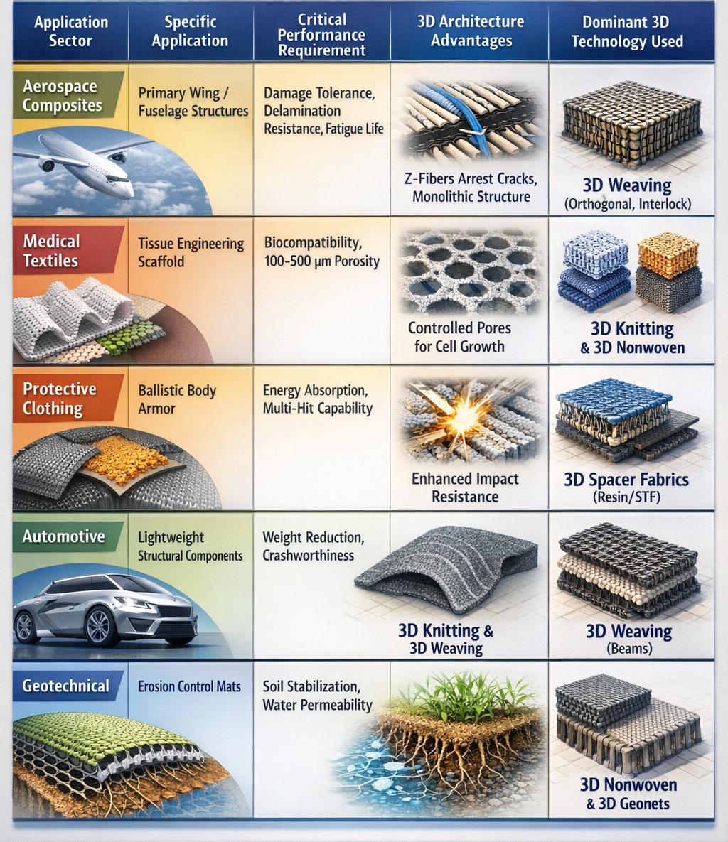
FIGURE 1. 3D textile technology matrix.
Aerospace and Aviation:3D composites are used for the production of aircraft wing ribs, fuselage panels, and engine parts in aerospace & aviation industries. It is crucial for safety and maintenance savings due to their high damage resistance with respect to delamination. Integrated 3D preforms also reduce part count and assembly time.
Automotive: To reduce vehicle weight and enhance fuel efficiency, 3D composites are applied in structural frames, bumper beams, and interior pillars. Near-net-shape 3D knitting and weaving processes minimize post-production waste.
In the renewable energy sector, modern wind turbine blades increasingly utilize 3D woven carbon fiber preforms in spar caps and shear webs. Through-thickness reinforcement addresses substantial shear and fatigue loads, which extends blade lifespan and supports the development of longer, more efficient designs [3-5].
In medical textiles, 3D textile structures function as frameworks that mimic the extracellular matrix (ECM), a component essential for tissue regeneration.
In the field of tissue engineering scaffolds, 3D woven, knitted and nonwoven structures having three-dimensionally controlled porous interconnectivity are generated out of bio-degradable polymers (i.e. Polylactic Acid and Polycaprolactone) together with porosity control are being designed.
Spacer fabrics and 3D knitted fabrics are incorporated in meshes for hernia repair, artificial ligaments, vascular grafts etc as a result of their superior crush resistance and flexibility for soft tissue regeneration purpose of implantable medical devices.
Tissue in-growth and integration is facilitated by the 3D structure, lowering the possibility of implant rejection and encapsulation.
3D Woven Spacer Fabrics for Ballistic Protection: 3D woven spacer fabrics infiltrated with STFs or resins are used to make armor systems compromising of yarn friction, deformation and yarn breakage in the course of impact absorption in the Z-direction. These systems offer protection against fragmentation and blunt force trauma well in excess of that which standard 2D soft armor packs provide.
Cut Resistance: Three-dimensional knitted constructions incorporating high-performance fibers such as ultra-high molecular weight polyethylene (UHMWPE) and aramid provide excellent cut protection for gloves and sleeves.
Geotextiles and Construction: Three-dimensional nonwoven mats and woven geonets are utilized to stabilize soil on slopes and riverbanks. Their three-dimensional structure retains soil particles and allows for vegetation growth.
Reinforcement: Three-dimensional geogrids and woven meshes reinforce embankments, retaining walls, and road bases by distributing loads over a wider area.
Filtration and Drainage: The porous 3D structure of spacer fabric and nonwovens can be used to filter solids out while providing drainage in civil engineering applications.
DISCUSSION
Benefits of 3D woven composites 3D woven composites have a number of advantages. The method of strengthening through the thickness removes a primary disadvantage of delamination in laminated composites. The Z-direction fibers can inhibit crack extension and enhance the structure strength of the fabric. Complexity of geometry is provided by means of the fabric manufacturing process, and many defects are eliminated that would otherwise occur during the labor-intensive operations. Of course, such composites provide great versatility, as they are a unique combination of structural integrity, insulation and fluid transport- all in one fabric.
There are, however, limitations to this approach. Production complexity and costs are high because capital-intensive three-dimensional looms or specialized knitting or braiding machines are necessary, and manufacturing speeds are low compared with two-dimensional textiles. Simulation and prediction of 3D textiles' properties are challenging due to their complex internal geometry; realistic analysis is only possible with advanced finite element models and micro-CT scanning, which places high demands on computer resources. However, limitations remain in regards to materials since not all high-performance fibers are suitable for every 3D weaving or knitting machine (e.g. due to brittleness, friction).
Smart and flexible 3D textile sensors, phase change materials, and shape memory alloys have rapidly developed the technical textile industry by incorporating them directly into the fabric. These technologies allow buildings to monitor strength, control temperature, change shape, or move independently. In addition to smart materials, scientific research is also moving towards hybrid manufacturing methods. Combining various 3D textile fabric techniques with traditional textile weaving processes to create complex, multi-material systems with unique properties will take the direction of construction textile products to a new level. Eco-friendly composites and medical implants should be made from natural fibers such as hemp and flax, as well as biodegradable polymers. This direction is also becoming one of the most relevant topics worldwide [5-10].
CONCLUSION
3D textiles have been one of the most important technology for technical fabrics, rising interest to advanced engineering applications. They are important for industrial applications in materials science and engineering, leading to better energy efficiency, safety, and sustainability. In comparison with the regular 2D fabrics, 3D fabrics exhibit such advantages as better mechanical performance (including strength and modulus), as well as more versatile design. They have a fiber architecture with three-dimensional orientation and hence can accommodate complex geometries as well support to delamination. In aviation and aerospace, they are used in the production of wing and fuselage components, in the production of lightweight components in automotive engineering, in medical textiles, in the production of textile implants, in protective clothing, as a means of ballistic and cut protection, in geotextiles for erosion control and filtration, and in energy, in the production of wind turbine blades. Thus, these fabrics have a very wide range of purposes and demonstrate the development of the technical textile industry. This article serves as a basic guide to visualizing these processes and obtaining analytical data.
REFERENCES
- Chen, N. Q., Fan, N. J. T., Sarkar, N. M. K., & Bal, K. (2011). Plant-based biomimetic branching structures in knitted fabrics for improved comfort-related properties. Textile Research Journal, 81(10), 1039–1048. https://doi.org/10.1177/0040517510397579
- Krauledaitė, J., Ancutienė, K., Krauledas, S., Urbelis, V., & Sacevičienė, V. (2022). Investigation of the influence of high molecular weight polyethylene and basalt content used in three-dimensional weft-knitted fabrics on the mechanical risks. Textile Research Journal, 92(23–24), 4709–4721. https://doi.org/10.1177/00405175221109633
- Fan, W., Li, D., Li, J., Li, J., Yuan, L., Xue, L., Sun, R., & Meng, J. (2017). Electromagnetic properties of three-dimensional woven carbon fiber fabric/epoxy composite. Textile Research Journal, 88(20), 2353–2361. https://doi.org/10.1177/0040517517723022
- Wang, L., Liu, X., Saleemi, S., Zhang, Y., Qiu, Y., & Xu, F. (2019). Bending properties and failure mechanisms of three-dimensional hybrid woven spacer composites with glass and carbon fibers. Textile Research Journal, 89(21–22), 4502–4511. https://doi.org/10.1177/0040517519837730
- Li, J., Fan, W., Liu, T., Yuan, L., Xue, L., Dang, W., & Meng, J. (2020). The temperature effect on the inter-laminar shear properties and failure mechanism of 3D orthogonal woven composites. Textile Research Journal, 90(23–24), 2806–2817. https://doi.org/10.1177/0040517520927009
- Mamadalieva, D., Korabayev, S., Mahsudov, S. A., Sovutov, M., Adashev, B., & Axmadjanov, S. (2025). Evaluation and enhancement of ring strength in ring pile fabrics. AIP Conference Proceedings, 3304, 030072. https://doi.org/10.1063/5.0269374
- Soloxiddinov, J., Bobojanov, H., Fayzullayev, S., & Korabayev, S. (2022). Analysis of the effect of spindle speed on the quality of yarn on the spinning machine and use of the Android application in the analysis. AIP Conference Proceedings, 2471, 030038. https://doi.org/10.1063/5.0089530
- Godau, U., Diestel, O., & Offermann, P. (1998). Biaxially reinforced multilayer knit fabrics for plastic reinforcement. Technical Textiles, 41, 202–204.
- Gries, T., & Roye, A. (2003). Three-dimensional structures for thin-walled concrete elements. In Textile reinforced structures: Proceedings of the 2nd Colloquium on Textile Reinforced Structures (CTRS2). Dresden, Germany: Sonderforschungsbereich 528, Technische Universität Dresden.
- Gries, T., Roye, A., Kolkmann, A., Barlé, M., Hanisch, V., Henkel, F., Laourine, E., & Stüve, J. (2004). New developments on manufacturing and textile structures for technical textiles. In Proceedings of the 2004 International Textile Congress: Innovations in Technical Textiles—World Market and Future Prospects. Barcelona, Spain: Universitat Politècnica de Catalunya (UPC).

