Complex Nitrogen Fertilizers Based on Ammonium Nitrate Melt and Recycled Vermiculite
Madiyar Jabbarbergenov¹, Abdurasul Mamataliyev², Berdimurat Madenov¹, Doniyor Sherkuziev^{3, a)}, Shafoat Namazov²
¹Karakalpak State University, Nukus, Uzbekistan
²Institute of General and Inorganic Chemistry, Tashkent, Uzbekistan
³Namangan State Technical University, Namangan, Uzbekistan

^{a)}Corresponding author: doniyorsherquziev@gmail.com
Abstract: In order to obtain thermostable ammonium nitrate (AN) and reduce its explosive properties, the process of obtaining nitrogen-potassium-magnesium-containing fertilizers on its basis by introducing processed vermiculite mineral (VM) from the Tebinbulak deposit into its melt was studied. The composition and properties of the obtained fertilizers were determined. The main modification indicator is the strength of the granules. If for magnesia AN (N 34.5%; MgO 0.28%) it is 1.6 MPa, then for a fertilizer with the ratio of AN : VM = 100 : 45 it is 10.33 MPa.
Keywords: Ammonium nitrate, processed vermiculite mineral from Tebinbulak deposit, complex nitrogen fertilizers, composition and properties.
INTRODUCTION
In order for agricultural crops to grow well, develop, and produce high yields, they need to be provided with sufficient amounts of mineral fertilizers rich in nutritional components. In particular, very good agrochemical test results have been obtained in foreign countries, and high-quality products have been obtained when complex fertilizers containing macroelements such as nitrogen, phosphorus, potassium, sulfur, calcium, and magnesium in one granule, which are necessary for plant nutrition, are applied to crops [1]. In this case, the higher the number of active macro-elements absorbed by the plant in the composition of complex fertilizers used for agricultural crops, the higher the quality of the mineral fertilizer.
Agricultural crops absorb the nutritionally active nitrogen component, which cannot be replaced by other elements, when nitrogen fertilizers are applied to them. The most important and most widely used solid nitrogen fertilizers include urea, ammonium nitrate (AN), and ammonium sulfate [2].
Among these nitrogen fertilizers, effective and universal is AS. Because granular saltpeter can be used in crops grown on any type of soil. The agrochemical effect is also shown quickly [3].
However, there are two main disadvantages of AN.
The first of these is the sticking together of saltpeter granules packed in bags, and the second is its high explosive properties, which are due to thermal changes during storage [4].
The stickiness of saltpeter granules is eliminated by adding inorganic additives such as sulfate, sulfate-phosphate, magnesite or brucite to its liquid (with an N content of at least 34.5%). [5]. However, the problem of explosiveness, a very serious drawback of saltpeter, has not yet been solved.
It is known from past history that when international GOST requirements were not observed during the production process, during storage in warehouses and during transportation, very powerful explosions occurred with the participation of saltpeter. As a result, many people were injured and, in particular, there were cases that ended in death. In addition, during the explosions, nitrogen gases, which pose an excessive risk to the survival of living organisms, were released into the environment and polluted the atmosphere to a certain extent [6, 7].
That is why today, those involved in the production of AC face the following urgent tasks:
- it is necessary to ensure the transition to the production of ammonium nitrate, which retains its agrochemical effectiveness;
- the granules of which do not stick together;
- in particular, it is necessary to ensure the transition to the production of strong granules, which have significant resistance to external influences and, accordingly, a reduced risk of explosion.
World scientists have recommended adding inorganic modifiers to its concentrated solution or liquid to reduce the detonation potential of saltpeter: calcium carbonate, lime, dolomite, potassium sulfate, potassium chloride, ammonium sulfate, ammonium polyphosphate, gypsum, and phosphogypsum [8].
In order to reduce the risk of flashing of AN, there are scientific research works on adding dolomite mineral, Kyzylkum phosphorite flour and natural gypsum in different weight ratios to its liquefaction. [9, 10]. Good results have been achieved in these cited research studies.
It is worth noting that some European countries use vermiculite, especially vermiculite mineral (VM) processed at high temperature, to improve soil fertility and obtain quality crops from agricultural crops grown in greenhouses. VM mainly consists of magnesium-aluminum, magnesium-iron and aluminum-silicates. VM is composed of layers and belongs to the group of hydromicas, a secondary alteration product of biotite and phlogopite micas. As a result of its breakdown and hydrolysis, VM is formed. Its chemical formula is: (Mg, Fe²⁺, Fe³⁺)[(Si А1)₄O₁₀] [OH]₂·4H₂O. In nature, natural VM is found in a free state in golden yellow and brown colors. When processed by burning at a temperature of 600-1200⁰С, it swells and increases in volume by 8-12 times. As a result, it becomes very porous and becomes a light raw material. In this case, VM appears in the form of silver or gold-colored particles. Burnt VM is odorless and has non-toxic properties for all living organisms [11-13].
Vermiculite is a unique natural mineral with a very high innovative potential in the production process. Also, the development of a new vermiculite deposit in Uzbekistan has opened up opportunities for new areas of industrial development. Today, Tebinbulak vermiculite – VM, with a total reserve of 1,332,620 tons, is used to produce various products in various industries. In particular, vermiculite, processed by burning, is used in the cultivation of agricultural crops, especially in greenhouses, to obtain high yields from them, and to multiply them.
We decided to determine the process, composition, and some properties of complex nitrogen fertilizers with improved commercial properties by adding calcined and processed VM to ammonium nitrate (AN) slurry in a weight ratio of AN : VM = 100 : (5-45).
METHODS
The calcined recycled VM was finely ground to a size of 0.25 microns and its main chemical composition was determined by X-ray studies (Fig. 1).

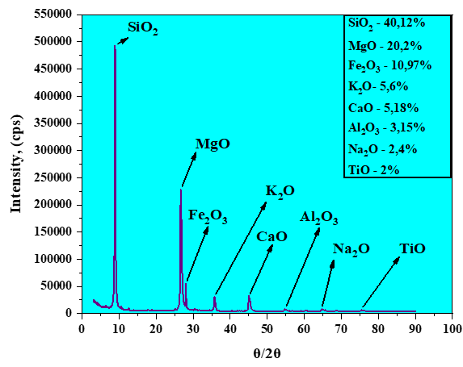
FIGURE 1. XRD analysis of the reprocessed Tebinbulak deposit VM.

The experiments in laboratory conditions were carried out as follows: first, a known weight of AN was placed in a stainless steel beaker and liquefied using an electric hotplate. Then, VM was added to the AN liquid in a weight ratio of AN : VM = 100 : (5-45). Then, the vermiculite-nitrate liquid was stirred for 10 minutes at a temperature of 170-175°C and poured into a granulator with a pore size of 1.2 microns. Starting from the 10th floor, the liquid was sprayed downwards by applying pressure to the upper part of the granulator using a simple hand pump, and granules of 1-5 microns in size were formed on a plastic film spread on the ground floor of the building due to cold air resistance. The granules prepared in this way were collected and the composition and some properties of the product were determined based on certain methods.
The obtained results are presented in Tabl. 1 and Fig. 2.
RESULTS AND DISCUSSION
Table 1 shows that as the mass fraction of VM added to the AN slurry increases, the amount of nitrogen element in the compound fertilizer decreases from 32.74 to 23.08%. However, on the other hand, it was found that the elements potassium, calcium, magnesium and sodium, which are necessary for plant nutrition, increase from 0.257 to 1.706%, from 0.816 to 4.897%, from 0.499 to 1.502% and from 0.109 to 0.739%, respectively.

TABLE 1. Chemical composition of complex nitrogen fertilizers obtained on the basis of melt ammonium nitrate and processed vermiculite mineral

Mass ratio  AN :VM | Content of components, %
Mass ratio  AN :VM | N | K₂O | СаО | MgO | Na₂O | Fe₂O₃ | Al₂O₃
100 : 5 | 32.74 | 0.257 | 0.816 | 0.499 | 0.109 | 1.358 | 1.243
100 : 7 | 32.19 | 0.362 | 1.104 | 0.550 | 0.148 | 1.897 | 1.581
100 : 10 | 31.35 | 0.498 | 1.330 | 0.648 | 0.207 | 2.090 | 1.918
100 : 15 | 29.72 | 0.685 | 2.274 | 0.896 | 0.295 | 3.506 | 2.396
100 : 20 | 28.56 | 0.924 | 2.536 | 0.975 | 0.382 | 3.779 | 2.647
100 : 25 | 27.48 | 1.109 | 3.148 | 1.049 | 0.476 | 4.365 | 2.985
100 : 30 | 26.05 | 1.283 | 3.674 | 1.120 | 0.548 | 4.983 | 3.046
100 : 35 | 25.17 | 1.435 | 4.285 | 1.271 | 0.615 | 5.727 | 3.087
100 : 40 | 24.64 | 1.592 | 4.723 | 1.345 | 0.673 | 6.365 | 3.105
100 : 45 | 23.08 | 1.706 | 4.897 | 1.502 | 0.739 | 6.763 | 3.130

From the analysis of the literature, it is known that all inorganic additives added to the AN slurry reduce its crystallization temperature. Only ammonium sulfate, as well as the addition of VM, were found to increase the crystallization temperature of the nitrate slurry from 160 to 183°C in the weight ratio AN : VM = 100 : (5-45) (Fig. 2 a).
With an increase in the mass fraction of VM added to 100 g of ammonium nitrate solution from 5 to 45 g, it was observed that the strength of the grains of complex nitrogen fertilizers increased from 2.93 to 10.33 MPa and the rate of complete dissolution in water from 72.4 to 148.94 minutes (Fig. 2 b and c).
These indicators are 1.60 MPa and 48.60 minutes for magnesite AN grains. Thus, an increase in the mass fraction of VM significantly affects the strength of the grains of complex nitrogen fertilizers, has a positive effect on reducing the porosity of its grains and the absorption of diesel fuel. It was also found that AN grains in the studied VM additive dissolve in water much slower (3 times less) than in AN with magnesite addition, and the presence of VM in nitrate ensures gradual release of nitrogen from the grains.
The pH value of the samples of complex nitrogen fertilizers obtained in the weight ratios AN : VM = 100 : (5-45) is almost neutral (6.55-7.57), and all of them can be used in agricultural crops grown on any type of soil (Fig. 2 d).

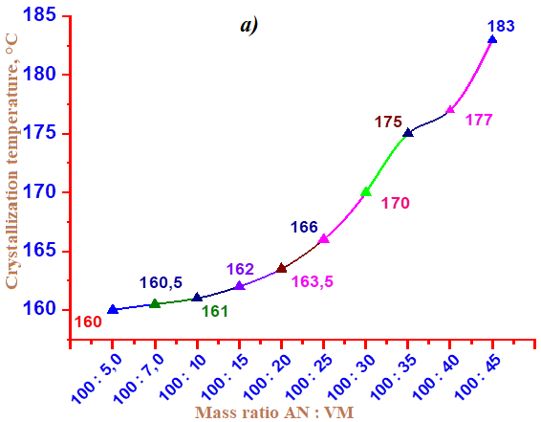 | 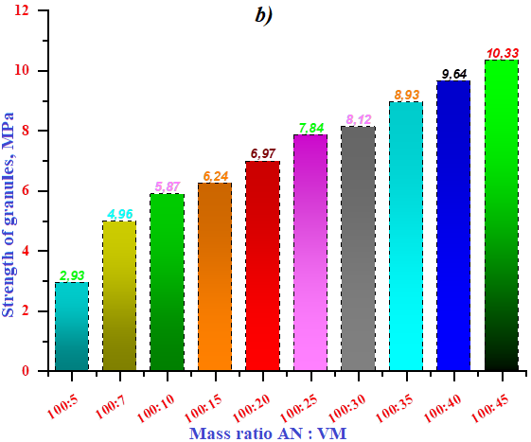
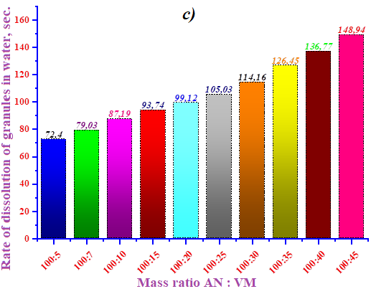 | 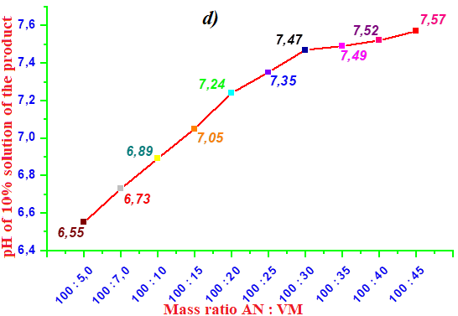

FIGURE 2. Dependence of the change in crystallization temperature (a), pH value of 10% solution (d), strength (b) and dissolution rate (c) of granules of complex nitrogen fertilizers on the ratio of AN:VM
CONCLUSION
According to the results of laboratory studies, the fundamental possibilities of the process of obtaining samples of complex nitrogen fertilizers by granulating vermiculite-nitrate liquids obtained by adding vermiculite mineral from the Tebinbulak deposit to nitrate slurry in a weight ratio of AN : VM = 100 : (5-45) by scattering without any technological difficulties were demonstrated. In this case, ammonium nitrate samples with vermiculite addition were obtained, which had good physicochemical and agrochemical properties.
REFERENCES
- D Sherkuziev, S Zokirov Technology of obtaining liquid complex fertilizers in the presence of monoethanolamine based on phosphorites of the Central Kyzylkum. E3S Web of Conferences 390, 05030 2023. https://doi.org/10.1051/e3sconf/202339005030.
- Volkova, A. V. (2019). Mineral fertilizers market – 2019. National Research University Higher School of Economics Development Center.
- Chernyshov, A. K., Levin, B. V., Tugolukov, A. V., Ogarkov, A. A., & Ilyin, V. A. (2009). Ammonium nitrate: Properties, production, application. Moscow: ZAO INFOHIM.
- Gorbovskiy, K., Kazakov, A., Norov, A., Malyavin, A., & Mikhaylichenko, A. (2017). Properties of complex ammonium nitrate-based fertilizers depending on the degree of phosphoric acid ammoniation. International Journal of Industrial Chemistry, 8(4), 315–327. https://doi.org/10.1007/s40090-017-0120-2
- Olevskiy, V. M. (Ed.). (1978). Technology of ammonium nitrate. Moscow: Chemistry.
- Dechy, N., Bourdeaux, T., Ayrault, N., Kordek, M., & Le Coze, J. (2004). First lessons of the Toulouse ammonium nitrate disaster: 21st September 2001, AZF plant, France. Journal of Hazardous Materials, 111(1–3), 131–138. https://doi.org/10.1016/j.jhazmat.2004.02.029
- Rehman, S. U., Ahmed, R., Ma, K., Xu, S., Aslam, M. A., Bi, H., Liu, J., & Wang, J. (2021). Ammonium nitrate is a risk for environment: A case study of Beirut (Lebanon) chemical explosion and the effects on environment. Ecotoxicology and Environmental Safety, 210, 111834. https://doi.org/10.1016/j.ecoenv.2020.111834
- Levin, B. V., & Sokolov, A. N. (2004). Problems and technical solutions in the production of complex fertilizers based on ammonium nitrate. World of Sulfur, N, P and K, 2, 13–21.
- Namazov, Sh. S., Kushokov, J. M., Mamataliyev, A. A., Buriyev, S. A., & Nabiyev, A. A. (2023). Phosphorus-containing lime-ammonium nitrate for agrochemical efficiency of crops. E3S Web of Conferences, 390, 05021. https://doi.org/10.1051/e3sconf/202339005021
- Bozorov, I. I., Iskandarova, M. I., Mamataliyev, A. A., Usanbayev, N., & Temirov, U. (2022). Nitrogen-sulfur-containing fertilizers based on melt ammonium nitrate and natural gypsum. AIP Conference Proceedings, 2432, 050062. https://doi.org/10.1063/5.0092665
- Aripov, A. R., Kholikulov, D. B., Huseynov, R. K., Akhtamov, F. E., & Mamaraimov, G. F. (2021). Enrichment of vermiculite ores of the Karauzyak deposit of the Republic of Karakalpakistan. Universum: Technical Sciences, 3(84), 78–81.
- Jakhonkulovna, S. M., Kamolovna, G. B., Zokirov, M., Tajimuratovna, B. U., Yumashev, A., Shichiyakh, R., Safarova, N. I., Nusratovna, A. N., Esanmuradova, N., Karimbaevna, T. M., Lazizakhon, A., & Ishankulov, A. (2025). Electrochemical biosensors for early detection of Alzheimer’s disease. Clinica Chimica Acta, 572, 120278. https://doi.org/10.1016/j.cca.2025.120278
- Sherkuziev, D. S., Aripov, K. S., Alimov, U. K., & Maxmudova, M. A. (2020). Research of agrochemical and mechanical properties of soils processed with hydrogel. IOP Conference Series Earth and Environmental Science, 614(1), 012121. https://doi.org/10.1088/1755-1315/614/1/012121

