Preparation NPK- and NPS-Fertilizers Based on Activation of Kyzylkum Phosphorite Ore
Abdurasul Mamataliev¹, Shafaat Namazov¹, Jamoliddin Kushakov¹, Begali Primkulov², Baxtiyorjon Nu’monov³, Doniyor Sherkuziev^{4, a)}
¹General and Inorganic Chemistry Institute of Academy Sciences of the Republic of Uzbekistan, Tashkent, Uzbekistan,
²Denau Institute of Entrepreneurship and Pedagogy, Surkhandarya, Uzbekistan
³Kokand State University, Fergana, Uzbekistan
⁴Namangan State Technical University, Namangan, Uzbekistan

^{a)}Corresponding author: doniyorsherquziev@gmail.com
Abstract: This study investigates the process of producing NPK- and NPS-fertilizers by activating various low-grade Kyzylkum phosphorite raw materials (PRM) in the presence of molten ammonium nitrate (AN), potassium chloride (KCl), and ammonium sulfate ((NH₄)₂SO₄). The experiments were conducted by varying the amount of PRM from 20 to 30 g and KCl from 5.75 to 57.5 g per 100 g of AN melt. Additionally, the molar ratio of (NH₄)₂SO₄ to NH₄NO₃ ranged from 1:1 to 1:8. Key parameters such as the conversion degree of NH₄NO₃, the chemical composition, decomposition onset temperature, mechanical strength, and dissolution rate of the resulting fertilizer granules were determined. The results demonstrate that the melt composed of AN, KCl, and (NH₄)₂SO₄ effectively decarbonizes and activates the PRM, converting the water-insoluble form of P₂O₅ into a plant-available form. The high mechanical strength of the granules and the elevated decomposition onset temperature of the synthesized NPK- and NPS-fertilizers indicate a reduced detonation sensitivity of ammonium nitrate. This provides a promising approach for the safe and efficient production of complex fertilizers. Thermal analysis of selected fertilizer samples was performed using a NETZSCH STA 409 PC/PG thermal analyzer, along with the characterization of sediment compositions.
Keywords: phosphorite activation; ammonium nitrate melt; potassium chloride; thermal analysis; granulation; fertilizer composition.
INTRODUCTION
Phosphate raw material (PRM) is a natural mineral ore necessary for the production of phosphorus and its derivatives, which are widely used in medicine, pharmaceuticals, metallurgy, agriculture and other fields. However, today phosphate is used in agriculture to produce large quantities of phosphate fertilizers. In addition, it is difficult to imagine highly productive livestock farming without feed phosphates. About 5-7% of the extracted PRM is used for their production [1]. Apatites and phosphorites are the main phosphates.
Apatite is a natural ore consisting of minerals. Its general formula is Ca₁₀R₂(PO₄)₆ (where R is fluorine, chlorine, carbonate or hydroxide ion) with a unit cell of 42 particles and nepheline (Na, K), AlSiO₄ ∙ nSiO₂ with an admixture of associated minerals - aegirine NaFe(SiO₄)₂, sphene CaTiSiO₅, titanomagnetite nFe₃O₄ ∙ mFe TiO₃ ∙ qTiO₂, etc [2].
Phosphorite is a sedimentary rock whose main component is calcium phosphate. In addition to calcium phosphate, it contains quartzite, calcite, dolomite, glauconite, limonite, aluminosilicate, clay particles, compounds of heavy metals, iron, magnesium, fluorine, as well as various organic compounds. The amount of P₂O₅ in them ranges from 6-8 to 33-36%, and in the highest quality phosphorites it reaches 38-40.5% [3].
Worldwide, reserves of natural phosphates have been identified in more than 60 countries and their total volume is estimated at 63,067.4 million tons of P₂O₅, including 5,260 million tons of apatite and 57,807.4 million tons of phosphorite. Morocco, USA, China, Russia and Kazakhstan have 49.493 million tons of concentrated P₂O₅, which is almost 80% of the world reserves [4].
Based on the volume of pharmaceutical processing, the countries producing finished products (there were 31 of them in 2001) can be divided into three groups. The first main group of producers includes the USA, Morocco, China and Russia (more than 10 million tons per year) [5].
They account for 67.7% of total world production. In second place are the countries of Tunisia, Jordan, Brazil, Israel, South Africa, Syria, Senegal, Australia, India and Togo, accounting for 26% of world production. Third place went to Kazakhstan, Egypt, Algeria, Mexico, Canada, Finland, Vietnam, Christmas Island, Venezuela, Iraq, Nauru, Uzbekistan, North Korea, Zimbabwe, Colombia, Sri Lanka and Peru. These countries account for only 6.3% of global production of PRM [6].
A base for the production of phosphate fertilizers based on the processing of phosphates has been created in Uzbekistan. Phosphorite occurrences are found in Fergana, Surkhandarya, Pritoshkent, Navoi, Central Kyzylkum, Bukhara-Khiva and the Republic of Karakalpakstan. Among them, the most suitable and promising for industrial production are the phosphorites of the Central Kyzylkum [3].
Phosphorites of the Central Kyzylkum belong to the poor and carbonate phosphate. They are very reactive due to carbonate impurities in three forms: relics of calcite preserved from replacement by phosphate inside phosphatized shells – “endo calcite”; cement calcite – “exo-calcite”; carbonate groups isomorphically included in the crystal lattice of a phosphate mineral. However, raw material calcite closely associates with phosphate material [7].
The average Kyzylkum PRM sample contains (wt.%): 16.2 P₂O₅; 46.2 CaO; CaO: P₂O₅ = 2.85; 17.7 CO₂; 0.6 MgO; 2.9 (Fe₂O₃+Al₂O₃), 1.5 (K₂O+Na₂O); 2.65 SO₃; 0.12 Cl; 1.94 F; 7.8 insoluble residue. This poor PS is not suitable for producing concentrated phosphorus fertilizers without an enrichment step.
The most common enrichment method is flotation. But Kyzylkum phosphorites are not amenable to flotation enrichment due to the close intergrowth of the phosphate mineral with calcium carbonate. The most effective release of phosphate ores from calcite can be achieved by roasting them and subsequent quenching with water. Therefore, in order to obtain washed calcined phosphate concentrate (WCPC – 26% P₂O₅) from Kyzylkum phosphorite, which is the main raw material in the production of phosphate fertilizers, the Engineering Dobersek GmbH company first crushes the phosphate concentrate, then washes it with a large amount of water, and then burns it. WCPC was sent to Ammofos-Maxam JSC for sulfuric acid extraction to produce phosphoric acid and concentrated fertilizers, such as ammophos (10% N and 46% P₂O₅), suprephos-NS (8-15% N and 20-24% P₂O₅) and ammonium sulfate phosphate (15-19% N and 4-23% P₂O₅). Of these, Ammofos-Maxam JSC produces about 70% of the domestic market of phosphate fertilizers. However, due to the insufficient number of WDPC, the production capacity of the enterprise is not fully utilized [8].
In the process of obtaining WCPC from Kyzylkum phosphorite by the Engineering Dobersek GmbH company, four types of phosphate are formed (washed dried phosphorite concentrate, ordinary phosphorite flour, mineralized mass and slurry phosphorite). However, the last two PRM are collected as waste. This phosphate waste is not used, but is transported to the off-balance ore warehouse. In general, 134.77 thousand tons of P₂O₅ are lost with them (42% of P₂O₅ from the mined ore).
In 2016, our industry produced 143 thousand tons of P₂O₅ in the form of phosphate fertilizers. And the agricultural need for them is 525.21 thousand tons of P₂O₅.
In conditions of phosphate deficiency, it is necessary to involve these off-balance phosphate ores in the production of mineral fertilizers. Therefore, along with improving thermal roasting, it is necessary to develop other, more effective methods for enriching carbonate phosphorites. In particular, to find chemical solvents that would selectively dissolve calcium carbonate in phosphorite without affecting the phosphate mineral. Or they need to use unconventional processing methods, which will be discussed in more detail below.
One of the ways to obtain phosphorus-containing fertilizers from low-grade phosphorites is to process finely ground raw materials using solutions of various salts [3, 9-12]. In this direction, the authors [9] studied the process of activation of Yegoryevsk and Bryansk low-grade phosphorites with a solution of ammonium nitrate and found that in this case activation of the phosphate occurs, i.e. converting some amount of P₂O₅, which is difficult to digest, into a form accessible to plants.
The authors of the work [10-12] conducted research on granulating activated phosphate rock in various ways and obtaining complex granular NPK-fertilizers based on it using lignosulfonates and easily soluble mineral fertilizers (potassium chloride, ammonium sulfate, urea, ammonium nitrate, etc.). Therefore, the best results were achieved by granulating the phosphoconcentrate with ammonium sulfate, and then with ammonium nitrate and potassium chloride. Ammonium sulfate ((NH₄)₂SO₄), potassium chloride (KCl) and ammonium nitrate (AN) were chosen as the object of scientific research on the activation of Kyzylkum phosphorite to produce complex phosphorus fertilizers.AN is the most widespread and effective nitrogen fertilizer in the world. In 2007, its global production capacity amounted to 43 million tons per year [13]. In Uzbekistan, the total capacity of three plants producing AN (Maxam-Chirchiq JSC, Navoiyazot and Farg`onaazot) exceeded about 2 million tons per year. It is used in agriculture for all types of crops and on all types of soil. But it has one very serious drawback - explosion hazard [14].
The following are used as additive substances that reduce the level of potential danger of ammonium nitrate: carbonate-containing compounds of natural and man-made origin (chalk, calcium carbonate, dolomite); potassium-containing substances (potassium chloride and potassium sulfate); substances containing the cation of the same name – ammonium (ammonium sulfate, ammonium ortho- and polyphosphates); other ballast substances that do not carry a payload, but determine only the mechanical dilution of the AN (gypsum, phosphogypsum, and others) [15].
We decided to test the process of producing NPK- and NPS-fertilizers based on AN by introducing three promising additives into its melt at once – KCl (60% K₂O) produced by the Dekhkanabad Potash Fertilizer Plant, (NH₄)₂SO₄ (21% N and 24% S) produced JSC "Maxam-Chirchiq" and samples of phosphorites of the Central Kyzylkum: washed dried phosphorus concentrate (WDPC), ordinary phosphate rock (OPR) and mineralized mass (MM), which is a waste of the dry sorting process of phosphate rock ore.
The essence of the method we are developing for producing complex NPK- and NPS-fertilizers is as follows: carbonate phosphate is introduced into the AN melt, where both decarbonization and activation of the phosphate occur, then the nitrate phosphate melt is mixed with KCl or (NH₄)₂SO₄.
METHODS
In laboratory conditions, granulated AN grade “B” (34.5% N, 0.28% MgO) according to GOST 2-2013 was used as the starting material. For the potassium and sulfate components, crystalline KCl and (NH₄)₂SO₄ were used.
The following were used as phosphate additives: washed dried phosphorus concentrate – WDPC, ordinary phosphate rock – OPR and mineralized mass – MM, the chemical composition of which is given in Table 1.

TABLE 1. Chemical composition of phosphorites of the Central Kyzylkum

Types of phosphate raw materials | Component content, weight. % |  |  |  |  |  |  |  |  | Р₂О_{5dig.} ,  Р₂О_{5total,}  %
Types of phosphate raw materials | Р₂О₅ | СаО | Al₂O₃ | Fe₂O₃ | MgO | F | CO₂ | SO₃ | Н.О. | Р₂О_{5dig.} ,  Р₂О_{5total,}  %
WDPC | 26.08 | 51.74 | 1.02 | 0.31 | 0.89 | 3.41 | 9.95 | 1.59 | 2.49 | 13.08
OPR | 17.76 | 47.51 | 0.95 | 0.73 | 1.79 | 2.0 | 17.02 | 3.27 | 5.27 | 17.74
ММ | 14.33 | 43.02 | 1.18 | 1.38 | 1.19 | 1.85 | 14.70 | 2.22 | 13.23 | 9.01

WDPC is a phosphate rock product used to produce washed calcined concentrate by firing at 950-1000°C. The latter is the raw material for the production of ammophos. OPR is obtained through the process of fine grinding of pre-enriched phosphate rock and is the raw material for the production of simple superphosphate. MM is formed during ore sorting and is a waste product. Its volume is one third of the original mass of mined phosphate rock.
At the initial stage of the research, a series of laboratory experiments were conducted to study the process of synthesizing NPK-fertilizers. In these experiments, ammonium nitrate (AN) was first melted by heating it to a temperature of 175°C under controlled conditions. Once a homogeneous melt was obtained, phosphorite raw materials (PRM) was gradually introduced into the molten AN. The mass ratio of AN to PRM was varied within the range of 100:20 to 100:30 to evaluate the influence of phosphorite content on the properties of the resulting nitrate-phosphate melt. The mixture was thoroughly stirred at a constant temperature of 175°C for 15 minutes to ensure uniform dispersion and activation of the phosphorite within the melt. Following this, potassium chloride (KCl) was added to the system in quantities ranging from 5.75 to 57.5 grams per 100 grams of ammonium nitrate. This corresponded to nitrogen-to-potassium oxide (N:K₂O) mass ratios ranging from 1:0.1 to 1:1.0. After the addition of KCl, the resulting NPK-melt was allowed to react for one additional minute to ensure complete incorporation of the components. Subsequently, the hot melt was rapidly cooled and granulated using a pelletizing technique. This approach facilitated the formation of uniform, mechanically stable fertilizer granules suitable for further analysis and application.
The products were analyzed using known methods. Using Automatic Distillation Unit model K9840 and UV-VIS SPECTROPHOTOMETER model UV-1900i, the nitrogen and phosphorus elements were determined from samples of NPK-fertilizers, the sulfur element was determined by the gravimetric method [16], and the amount of potassium and calcium elements was analyzed with a SHERWOOD model 360 flame photometer.

RESULTS AND DISCUSSION
The results of the experiments are given in table. 2. In this case, both decarbonization and activation of phosphate raw materials occur in the AN melt. It shows that melting nitrate for 15 minutes without the participation of KCl significantly activates the PRM, converting the indigestible form of P₂O₅ in it into a form digestible for plants.
So, if at AN : WDPC : KCl = 100 : 30 : 57.5 the relative content of the digestible form of P₂O₅ increases from the initial 70.81%, then at AN : WDCP : KCl = 100 : 20 : 5.75 this figure reaches 78. 13%. At the same time, the relative content of the digestible form of CaO also increases to 82.13 and 85.14%, respectively.

TABLE 2. Composition of nitrogen phosphorus-containing fertilizers based on AN melt, Kyzylkum phosphorites and potassium chloride
Mass ratio  AN: KCl | Component content, weight. % |  |  |  |  |  |  | Р₂О_{5dig.}  Р₂О_{5total.}  for 2 %  lim.acid |  | CaO_{dig.}  CaO_{total}.  for 2 %  lim.acid | CaO _{hydr.},  CaO _{totalal.}  % |  | Decarbonization degree of phosphate raw materials, %
Mass ratio  AN: KCl | N |  | Р₂О_{5total}.. | K₂О |  |  | СаО_{total.}
Mass ratio AN : WDPC = 100 : 20
100 : 5.75 | 27.36 |  | 4.16 | 2.74 |  |  | 8.41 | 78.13 |  | 85.14 | 13.91 |  | 16.81
100 : 11.5 | 26.19 |  | 3.97 | 5.23 |  |  | 8.02 | 78.34 |  | 85.41 | 14.09 |  | 17.30
100 : 23.0 | 24.08 |  | 3.66 | 9.62 |  |  | 7.39 | 78.69 |  | 85.93 | 14.21 |  | 18.34
100 : 34.5 | 22.27 |  | 3.39 | 13.36 |  |  | 6.85 | 79.35 |  | 86.42 | 14.60 |  | 19.46
100 : 46.0 | 20.73 |  | 3.15 | 16.60 |  |  | 6.36 | 80.32 |  | 87.11 | 14.94 |  | 20.47
100 : 57.5 | 19.39 |  | 2.05 | 19.41 |  |  | 5.96 | 81.36 |  | 88.93 | 15.77 |  | 21.36
Mass ratio AN : WDPC = 100 : 25
100 : 5.75 | 26.29 |  | 5.00 | 2.62 |  |  | 10.12 | 73.20 |  | 82.31 | 12.35 |  | 15.08
100 : 11.5 | 25.23 |  | 4.79 | 5.04 |  |  | 9.68 | 73.49 |  | 82.64 | 12.60 |  | 15.64
100 : 23.0 | 23.30 |  | 4.41 | 9.31 |  |  | 8.91 | 74.15 |  | 83.28 | 12.91 |  | 16.70
100 : 34.5 | 21.57 |  | 4.10 | 12.95 |  |  | 8.29 | 75.12 |  | 83.84 | 13.27 |  | 17.79
100 : 46.0 | 20.11 |  | 3.82 | 16.13 |  |  | 7.73 | 75.65 |  | 84.86 | 13.58 |  | 18.86
100 : 57.5 | 18.87 |  | 3.58 | 18.88 |  |  | 7.24 | 76.54 |  | 85.77 | 14.64 |  | 19.92
Mass ratio AN : WDPC = 100 : 30
100 : 5.75 | 26.32 |  | 5.78 | 2.63 |  |  | 11.69 | 68.17 |  | 79.04 | 10.86 |  | 13.86
100 : 11.5 | 24.28 |  | 5.53 | 4.86 |  |  | 11.17 | 68.53 |  | 79.41 | 10.92 |  | 14.28
100 : 23.0 | 22.51 |  | 5.12 | 9.0 |  |  | 10.34 | 69.14 |  | 80.08 | 11.12 |  | 15.14
100 : 34.5 | 20.86 |  | 4.76 | 20.94 |  |  | 9.62 | 69.75 |  | 80.77 | 11.54 |  | 15.93
100 : 46.0 | 19.54 |  | 4.45 | 15.66 |  |  | 8.99 | 70.11 |  | 81.54 | 12.01 |  | 16.80
100 : 57.5 | 18.35 |  | 4.18 | 18.38 |  |  | 8.45 | 70.81 |  | 82.13 | 12.31 |  | 17.64
Mass ratio AN : OPR = 100 : 20
100 : 5.75 |  | 27.43 | 2.85 |  | 2.75 | 7.70 |  | 87.02 | 92.34 |  |  | 19.35 | 27.28
100 : 11.5 |  | 26.22 | 2.68 |  | 5.26 | 7.24 |  | 87.16 | 92.55 |  |  | 19.50 | 27.45
100 : 23.0 |  | 24.14 | 2.47 |  | 9.67 | 6.68 |  | 87.43 | 92.94 |  |  | 19.81 | 27.80
100 : 34.5 |  | 22.30 | 2.30 |  | 13.40 | 6.21 |  | 87.72 | 93.40 |  |  | 20.13 | 28.17
100 : 46.0 |  | 20.76 | 2.14 |  | 16.63 | 5.76 |  | 88.0 | 93.82 |  |  | 20.43 | 28.51
100 : 57.5 |  | 19.42 | 2.02 |  | 19.44 | 5.42 |  | 88.26 | 94.24 |  |  | 20.75 | 28.86
Mass ratio AN : OPR = 100 : 25
100 : 5.75 |  | 26.36 | 3.39 |  | 2.62 | 9.10 |  | 81.12 | 91.21 |  |  | 18.01 | 26.70
100 : 11.5 |  | 25.23 | 3.26 |  | 5.05 | 8.75 |  | 81.36 | 91.40 |  |  | 18.19 | 26.78
100 : 23.0 |  | 23.30 | 3.00 |  | 9.32 | 8.07 |  | 81.85 | 91.86 |  |  | 18.54 | 27.01
100 : 34.5 |  | 21.59 | 2.79 |  | 12.97 | 7.49 |  | 82.33 | 92.24 |  |  | 18.86 | 27.17
100 : 46.0 |  | 20.14 | 2.55 |  | 16.13 | 6.98 |  | 82.87 | 92.67 |  |  | 19.25 | 27.36
100 : 57.5 |  | 18.88 | 2.47 |  | 18.89 | 6.47 |  | 83.35 | 93.08 |  |  | 19.62 | 27.58
Mass ratio AN : OPR = 100 : 30
100 : 5.75 |  | 25.38 | 3.92 |  | 2.53 | 10.66 |  | 74.23 | 88.18 |  |  | 16.60 | 26.04
100 : 11.5 |  | 24.37 | 3.76 |  | 4.88 | 10.12 |  | 74.54 | 88.42 |  |  | 16.72 | 26.16
100 : 23.0 |  | 22.49 | 3.46 |  | 9.03 | 9.34 |  | 75.17 | 88.93 |  |  | 16.96 | 26.40
100 : 34.5 |  | 20.79 | 3.23 |  | 12.58 | 8.68 |  | 75.78 | 89.43 |  |  | 17.21 | 26.64
100 : 46.0 |  | 19.56 | 3.03 |  | 15.66 | 8.13 |  | 76.42 | 89.90 |  |  | 17.47 | 26.89
100 : 57.5 |  | 18.38 | 2.86 |  | 18.41 | 7.63 |  | 77.08 | 90.46 |  |  | 17.75 | 27.12

The high relative content of the water-soluble form of CaO in the products is confirmed by the intensive process of decomposition of calcium carbonate PRM in the nitrate melt, accompanied by the release of ammonia and carbon dioxide into the gas phase:
2NH₄NO₃ + CaCO₃ = Ca(NO₃)₂ + 2NH₃ + CO₂ + H₂O.
This is evidenced by the data in the last column of the (2 Tabel) where, at the studied AN : PRM ratios, the degree of decarbonization for WDPC ranges from 13.86 to 21.36%, for OPR from 26.04 to 28.86%, and for MM from 18.58 to 24.92%. With the same amount of PRM additive, the increase in the mass fraction of KCl does not influences the relative content of digestible forms of P₂O₅ and CaO in products. It only reduces the content of the general form of N and P₂O₅ and increases the content of K₂O.
For example, with a mass ratio of AN : WDPC = 100 : 20, with an increase in the mass fraction of KCl from 5.75 to 57.5 g, the content of N and P₂O₅ decreases, respectively, from 27.36 to 19.39% and from 4.16 to 2.05% , increases the K₂O content from 2.74 to 19.41%. The highest content of P₂O_{5total}. have products based on WDPC, and the smallest ones based on MM.
In another option for producing complex fertilizers, (NH₄)₂SO₄ was used instead of KCl, the purpose of which was to obtain NPS-fertilizers. The advantage of using (NH₄)₂SO₄ in complex fertilizers is the presence of sulfur in it, which is part of proteins and amino acids during crop formation. Sulfur prevents late blight and root rot. In terms of its physiological role in plant nutrition, sulfur should be placed in fourth place after nitrogen, phosphorus and potassium [17, 18-24].
AN granules containing a phosphate sulfate additive are significantly more resistant to variable temperatures than AN granules themselves. This additive slows down the decomposition of AN melt and the increase in its acidity. Works [19] indicate a reduction in the explosion hazard of nuclear reactors in the presence of ammonium sulfate.
We believe that the optimal samples of NPK- and NPS-fertilizers are those whose compositions are given in Table. 3.

TABLE 3. Composition of NPK- and NPS-fertilizers based on AN melt, OPR of Central Kyzylkum, potassium chloride and ammonium sulfate

Mass ratio of starting components | Component content, weight. %
Mass ratio of starting components | W_{humid}. | N | Р₂О₅ | K₂О | P₂O_{5dig}.: P₂O_{5tot}.
АN : KCl | Mass ratio AN : PRM = 100 : 20
100 : 5.75 | 0.92 | 27.43 | 2.85 | 2.75 | 87.02
100 : 34.5 | 0.90 | 22.30 | 2.30 | 13.40 | 87.72
100 : 57.5 | 0.86 | 19.42 | 2.02 | 19.44 | 88.26
АС : KCl | Mass ratio AN : PRM = 100 : 30
100 : 23.0 | 0.89 | 22.49 | 3.46 | 9.03 | 75.17
100 : 57.5 | 0.88 | 18.38 | 2.86 | 18.41 | 77.08
(NH₄)₂SO₄ : NH₄NO₃ | Mass ratio AN : PRM = 100 : 20
(NH₄)₂SO₄ • 8NH₄NO₃ | 0.42 | 27.62 | 2.60 | 3.50 | 87.62
(NH₄)₂SO₄ • 4NH₄NO₃ | 0.48 | 26.53 | 2.35 | 6.13 | 90.08
(NH₄)₂SO₄ • NH₄NO₃ | 0.50 | 24.30 | 1.17 | 13.87 | 91.87
(NH₄)₂SO₄ : NH₄NO₃ | Mass ratio AN : PRM = 100 : 30
(NH₄)₂SO₄ • 8NH₄NO₃ | 0.40 | 25.65 | 3.54 | 3.25 | 74.01
(NH₄)₂SO₄ •NH₄NO₃ | 0.47 | 23.30 | 1.63 | 13.40 | 85.27

Therefore, some properties of these selected samples of NPK- and NPS-fertilizers were determined Table 4.
As stated above, when mixing AN melt with Kyzylkum OPR, depending on the weight ratio of AN : OPR, an exchange decomposition reaction occurs to one degree or another:
2NH₄NO₃ + CaCO₃ = Ca(NO₃)₂ + 2NH₃ + CO₂ + H₂O.
Therefore, we determined the degree of NH₄NO₃ conversion in nitrate-phosphorite-chloride and nitrate-phosphorite-sulfate melts according to the method described in [16].
This technique is based on the selective extraction of unreacted ammonium nitrate in the mixture using acetone, while the remaining components of the fertilizer are not dissolved in acetone.
A sample of a mixture of salts, the amount of ammonium nitrate in which does not exceed 0.2 g, is stirred with a magnetic stirrer in 500 ml of acetone for 3 hours at a temperature of 20°C. At the end of stirring, the precipitate is allowed to settle, after which the liquid is carefully filtered through a Schott filter No. 4.

TABLE 4. Some properties of NPK- and NPS-fertilizers based on AN melt, OPR of the Central Kyzylkum, potassium chloride and ammonium sulfate
Mass ratio of  starting components | pH 10%  solution | Strength of granules  MPa | Time of complete dissolution, sec. | NH₄NO₃ conversion degree, %
АN (0.28% MgO) | 6.17 | 1.60 | 46.8 | -
АС : KCl | Mass ratio AN : OPR = 100 : 20
100 : 5.75 | 7.01 | 6.84 | 85.1 | 5.68
100 : 34.5 | 7.12 | 8.06 | 114.5 | 23.90
100 : 57.5 | 7.23 | 8.80 | 128.9 | 33.51
АС : KCl | Mass ratio AN : OPR = 100 : 30
100 : 23.0 | 7.18 | 7.06 | 111.1 | 22.74
100 : 57.5 | 7.25 | 9.07 | 135.6 | 38.02
(NH₄)₂SO₄ : NH₄NO₃ | Mass ratio AN : OPR = 100 : 20
(NH₄)₂SO₄ • 8NH₄NO₃ | 7.15 | 5.36 | 65.45 | 4.63
(NH₄)₂SO₄ • 4NH₄NO₃ | 7.11 | 6.78 | 92.74 | 25.19
(NH₄)₂SO₄ • NH₄NO₃ | 6.85 | 7.85 | 113.27 | 32.85
(NH₄)₂SO₄ : NH₄NO₃ | Mass ratio AN : OPR = 100 : 30
(NH₄)₂SO₄ • 8NH₄NO₃ | 7.17 | 5.61 | 71.84 | 5.07
(NH₄)₂SO₄ •NH₄NO₃ | 6.94 | 8.04 | 118.36 | 36.21

The precipitate, without transferring to the filter, is washed with two 100 ml portions of acetone. These portions are combined with the filtrate and evaporated to dryness in a water bath. The dry residue is transferred into a flask and the total nitrogen content in it is determined using an Automatic Distillation Unit model K9840. Based on the found amount of total nitrogen, the amount of NH₄NO₃ that has not reacted with potassium chloride is calculated, and from it the degree of conversion of potassium chloride is calculated using the formula: X = (ais. - an.r.) / astech. · 100, (wt. %) where, aish. – amount of NH₄NO₃ in the original melt, g; an.r. – amount of NH₄NO₃ unreacted with KCl, g; astech. – the amount of NH₄NO₃ required for the formation of KNO₃ according to stoichiometry, g. The dissolution rate of granules of samples of NPK- and NPS-fertilizers measuring 2-3 mm was studied. To do this, the granule was dipped into a glass with 100 ml of distilled water, the time of its complete dissolution was visually observed and recorded. Room temperature, tests five times. The pH of a 10% solution of fertilizer samples was determined using a Mettler Toledo instrument. The strength of granules with a diameter of 2-3 mm was measured using an IPG-1M device (measurement range 2-50 N). For comparison, the strength and dissolution rate of magnesium (0.28% MgO) AN granules were measured.
Thus, if the nitrate-phosphate-chloride components taken in the ratio AN : OPR : KCl = 100 : 20 : 5.75, the degree of conversion of NH₄NO₃ was 5.68%, and at 100 : 20 : 57.5 – 33.51%. For nitrate-phosphate-sulfate components taken in the ratio AN : PRM = 20 and molar ratios from (NH₄)₂SO₄ • 8NH₄NO₃ to (NH₄)₂SO₄ : NH₄NO₃, the degree of NH₄NO₃ conversion was in the range of 4.63-32.85% (Table 4).
The results of Table 3 shows that granules of NPK- and NPS-fertilizers dissolve in water much more slowly (up to 135.6 seconds) than granules of standard AN with the addition of 0.28% MgO (46.8 seconds). This means that the presence of PRM and KCl or (NH₄)₂SO₄ in nitrate contributes to the gradual release of nitrogen from the product granule. It can be assumed that both PRM and KCl or (NH₄)₂SO₄ neutralize the acidity of AN (pH from 6.17 to 6.85-7.25).
Table 4 also shows that adding both OPR and KCl or (NH₄)₂SO₄ to the AN melt significantly increases the strength of the AN granules. The strength of AN granules with the addition of 0.28% MgO is only 1.60 MPa. The strength of granules of NPK- and NPS-fertilizers obtained at the studied mass ratios of AN : PRM and AN : KCl or molar ratios (NH₄)₂SO₄ : NH₄NO₃ is within the limits: for NPK-fertilizers – 6.84-9.07 MPa and for NPS-fertilizers – 5.36-8.04 MPa. An increase in the strength of nitrate granules indicates a decrease in its porosity and internal specific surface area, which leads to a decrease in the penetration of diesel fuel into the granules, and, consequently, a decrease in the detonation ability of nitrate. In this regard, PRM, KCl and (NH₄)₂SO₄ showed themselves to be most effective.
Thermal analysis of some complex NPK- and NPS-fertilizers was carried out on a NETZSCHSTA 409 PC/PG device (made in Germany) in aluminum crucibles at a heating rate of 2 degrees/min, a finely ground sample weighed 10-16 mg, the measurement range was from 200 to 300°C. The measurements were carried out in an inert atmospheric environment – a nitrogen purging rate of 50 ml/min. Calibration of the measuring system was carried out using a standard set, including KNO₃, In, Bi, Sn, Zn and CsCl₂. The thermal stability parameters of pure NH₄NO₃ and samples of NPK- and NPS-fertilizers obtained from NH₄NO₃ melt, ordinary phosphate rock, potassium chloride and NH₄NO₃, ordinary phosphate rock, ammonium sulfate – the temperature of the onset of decomposition and the activation energy were determined in the temperature range of 200-300°C. Derivatograms of AN samples and samples of NPK- and NPS-fertilizers are presented in the figure.
The research results show that “pure” NH₄NO₃ (Fig. 1) begins to lose weight already at a temperature of about 50°C; the maximum rate of weight loss is reached at 247.2-262.5°C. The decomposition process of pure NH₄NO₃ begins at a temperature of 211°C, as evidenced by the endothermic effect on the Differential Thermal Analysis (DTA) curve. The temperature indicator of thermal decomposition of AN samples with the addition of OPR and KCl is significantly higher than that of pure AN and is at the level of 235.6 (Fig. 2), 237.3 (Fig. 3) and 238.7°C (Fig. 4.), which increase by 24.6; 26.3 and 27.7°C, respectively. And the temperature indicator of thermal decomposition of AN samples with the addition of OPR and (NH₄)₂SO₄ is at the level of 228.1 (Fig. 5), 229.3 (Fig. 6) and 232.7°C (Fig. 7), which increase by 17.1; 18.3 and 21.7°C, respectively. Thermal decomposition correlates with the maximum weight loss recorded on the thermo gravimetric TG curve.
AN the presented thermo grams show, with the addition of OPR and KCl (NPK-fertilizers) it increases the temperature of the onset of thermal decomposition of AN by 25-28°C, which is significantly higher than with the addition of OPR and (NH₄)₂SO₄ – 17-22°C (NPS-fertilizers).
The activation energy of thermal decomposition of the samples was calculated using the calculation program for thermal analytical studies “NETZSCHPROTEUS” (version 4.8.1).

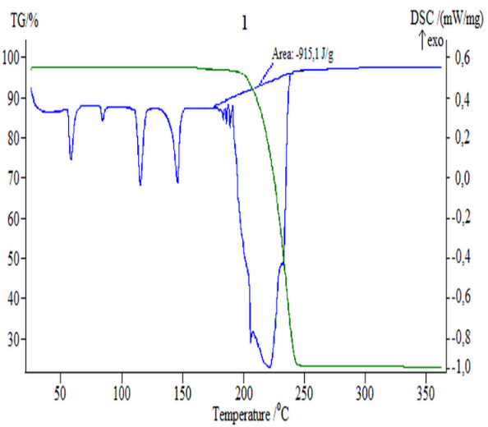 | 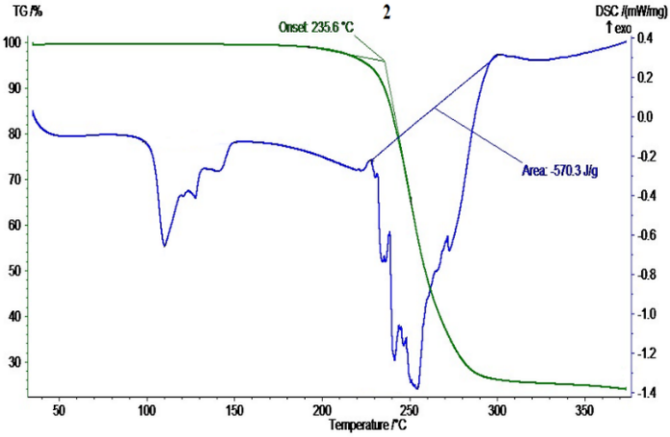
FIGURE 1. NH₄NO₃ "pure" | FIGURE 2. Sample of NPK-fertilizer (AN : KCl = 100 : 5.75)
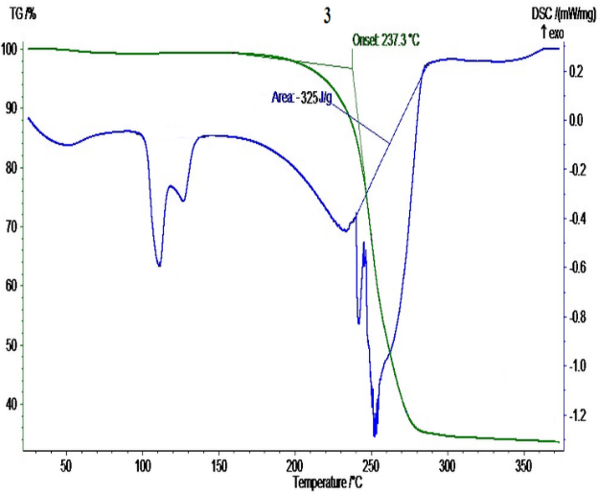 | 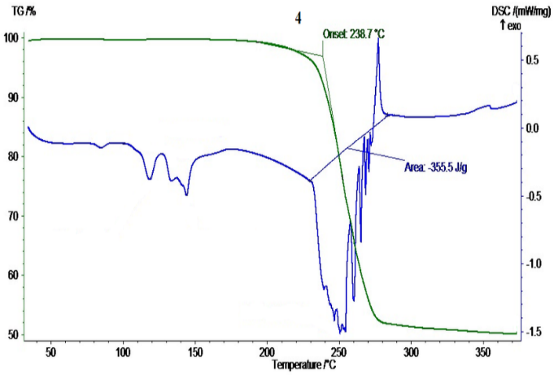
FIGURE 3. Sample of NPK-fertilizer (AN : KCl = 100 : 23) | FIGURE 4. Sample of NPK-fertilizer (AN : KCl = 100 : 57.5)
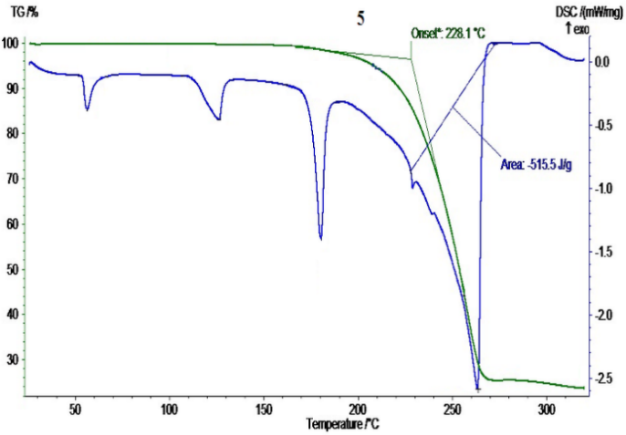 | 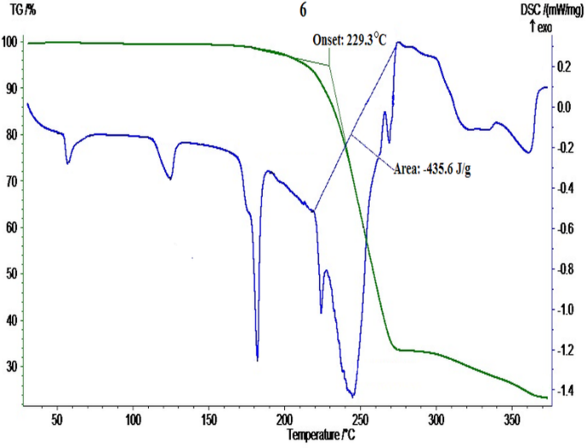
FIGURE 5. Sample of NPS-fertilizer ((NH₄)₂SO₄ : NH₄NO₃ = 1 : 8) | FIGURE 6. Sample of NPS-fertilizer ((NH₄)₂SO₄ : NH₄NO₃ = 1 : 4)
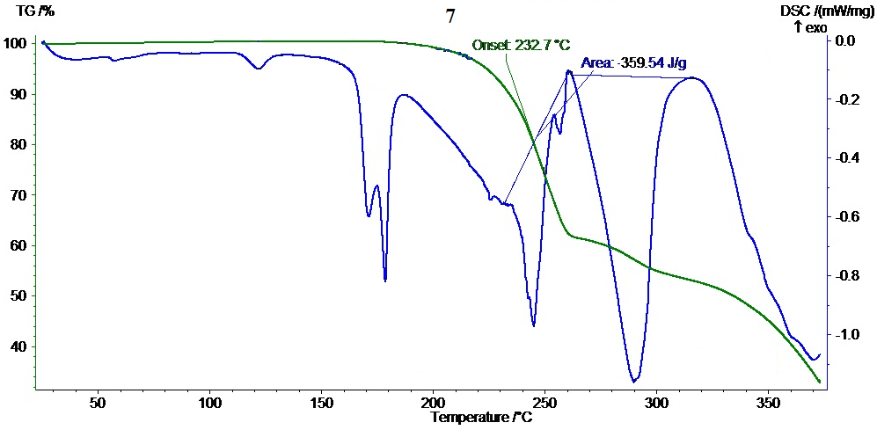
FIGURE 7. Sample of NPS-fertilizer obtained in the ratio (NH₄)₂SO₄ : NH₄NO₃ = 1 : 1

TABLE 5. Beginning of temperature and activation energy value of thermal decomposition of NPK-fertilizer

Image number | Mass ratio AN: KСl | Component content, weight. % |  |  | Decomposition start temperature, °С | Temperature range, °С | Activation energy, J/g
Image number | Mass ratio AN: KСl | N | Р₂О_{5total.} | K₂О | Decomposition start temperature, °С | Temperature range, °С | Activation energy, J/g
1 | NH₄NO₃ «ч» | 34.90 | − | − | 211.0 | 200-300 | -915.1
Mass ratio AN : OPR = 100 : 20
2 | 100 : 5.75 | 27.43 | 2.85 | 2.75 | 235.6 | 200-300 | -570.3
3 | 100 : 23.0 | 24.12 | 2.46 | 9.65 | 237.3 | 200-300 | -325.0
4 | 100 : 57.5 | 19.42 | 2.02 | 19.44 | 238.7 | 200-300 | -355.5

TABLE 6. Beginning of temperature and activation energy value of thermal decomposition of NPS-fertilizer

Image number | Ratio  original  components | Component content, weight. % |  |  | Temperature of the beginning of decomposition,°С | Temperature range,°С | Activation energy,  J/g
Image number | Ratio  original  components | N | P₂O_{5total.} | S | Temperature of the beginning of decomposition,°С | Temperature range,°С | Activation energy,  J/g
Mass ratio AN : OPR = 100 : 20
5 | (NH₄)₂SO₄ • 8NH₄NO₃ | 27.62 | 2.60 | 3.50 | 228.1 | 200-300 | -515.5
6 | (NH₄)₂SO₄ • 4NH₄NO₃ | 26.53 | 2.35 | 6.13 | 229.3 | 200-300 | -435.6
7 | (NH₄)₂SO₄ • NH₄NO₃ | 24.30 | 1.17 | 13.87 | 232.7 | 200-300 | -359.5

The data in Tables V and VI indicate that the thermal decomposition of samples of thermostable AN will require more activation energy when using the addition of RPM, KCl and (NH₄)₂SO₄ from -570.3 to -359.5 J/g than for the decomposition of pure NH₄NO₃ (-915.1 J/g). Thas, it can be argued that the addition of PRM, KCl and (NH₄)₂SO₄ has an inhibitory effect on the decomposition of AN, increasing the temperature of the onset of destruction to 238.7°C, which makes it possible to increase the safety of the process of its production and use in agriculture.
CONCLUSION
WDPC, OPR – as phosphate rock products, MM, slurry phosphorite – SP, as waste from phosphorite enrichment of the Central Kyzylkum region turned out to be suitable for producing NPK- and NPS-fertilizers with high relative contents of digestible forms of CaO and P₂O₅. In this case, both decarbonization and activation of PRM occur in the AN melt, as evidenced by the appearance of a large amount of calcium nitrate as a result of the decomposition of calcium carbonate. The main advantage of the method we have developed is that when implemented, all nutrients will be contained in one granule. And also the introduction of various types of Kyzylkum PRM, KCl and (NH₄)₂SO₄ into the AN melt allows not only to increase its agrochemical efficiency, but also improves its physicochemical and commercial properties: it increases the strength of granules and the temperature at which decomposition begins. The high strength of granules and the temperature at which the decomposition of NPK- and NPS-fertilizers begins indicates a decrease in the detonation ability of the AN.
ACKNOWLEDGEMENT
The authors express their gratitude to the managing committee, the laboratory of phosphorus Fertilizers at the General and Inorganic Chemistry Institute of the Academy of Sciences of Uzbekistan, and the Institute of Plant Substance Chemistry. The collaborative efforts and invaluable support provided by these institutions, particularly in facilitating the conduct of Thermograms analyses, are duly acknowledged. Such collaborative endeavors significantly contributed to the robustness and comprehensiveness of the research findings.
REFERENCES
- Lamghari, K., Taha, Y., Ait-Khouia, Y., Elghali, A., Hakkou, R., & Benzaazoua, M. (2024). Sustainable phosphate mining: Enhancing efficiency in mining and pre-beneficiation processes. Journal of environmental management, 358, 120833. https://doi.org/10.1016/j.jenvman.2024.120833
- Hazrah, K. S., & Antao, S. M. (2022). Apatite, Ca₁₀(PO4)₆(OH,F,Cl)₂: Structural Variations, Natural Solid Solutions, Intergrowths, and Zoning. Minerals, 12(5), 527. https://doi.org/10.3390/min12050527
- Boumaza, B., Chekushina, T. V., Kechiched, R., Benabdeslam, N., Brahmi, L., Kucher, D. E., & Rebouh, N. Y. (2023). Environmental Geochemistry of Potentially Toxic Metals in Phosphate Rocks, Products, and Their Wastes in the Algerian Phosphate Mining Area (Tébessa, NE Algeria). Minerals, 13(7), 853. https://doi.org/10.3390/min13070853
- G. Kodirova, I. Shamshidinov, B. Sultonov, R. Najmiddinov, B. Mamurov, Chem. Sci. Int. J. 30 (2021) 1–10 (https://dx.doi.org/10.9734/CSJI/2021/v30i130209)
- I. E. Khoshimov, S. I. Turdialieva, A. R. Seytnazarov, S. S. Namazov, M. Rifky, Eurasian J. Chem. 29 (2024) 82–91 (https://dx.doi.org/10.31489/2959-0663/4-24-4)
- Walsh, M., Schenk, G. & Schmidt, S. Realising the circular phosphorus economy delivers for sustainable development goals. npj Sustain. Agric. 1, 2 (2023). https://doi.org/10.1038/s44264-023-00002-0
- Otaboeva Kh. A., Sherkuziev, D. Sh., Badalova, O. A., Radjabov, R., Namazov, Sh. S., & Seytnazarov, A. R. (2022). Mineralogical composition of Kyzylkum washed dry concentrate and its processing into simple superphosphate. Russian Journal of General Chemistry, 92(3), 505–517. https://doi.org/10.1134/S1070363222030203
- Yu, L., Yu, P., & Bai, S. (2024). A Critical Review on the Flotation Reagents for Phosphate Ore Beneficiation. Minerals, 14(8), 828. https://doi.org/10.3390/min14080828
- A. A. Brodsky, L. I. Evdokimova, N. V. Buccolini, M. P. Lobacheva, Chem. Ind. 11 (1999) 716–719
- B. Kamshat, Z. Kurmanbek, B. Tynlybek, K. Alexandr, T. Zarina, B. Nurlybek, J. Compos. Sci. 8 (2024) 165 (https://dx.doi.org/10.3390/jcs8050165)
- X. Wang, J. Xiong, Z. He, J. Environ. Manage. 255 (2020) 109872 (https://dx.doi.org/10.1016/j.jenvman.2019.109872)
- A. R. Seitnazarov, U. M. Turdialiev, Sh. S. Namazov, B. M. Beglov, Rep. Acad. Sci. Republic of Uzbekistan 3 (2010) 67–71
- N. A. Kadyrov, A. A. Kadyrov, K. I. Akbarov, M. A. Eshmukhamedov, Chem. Saf. Sci. 4 (2020) 250–264 (https://dx.doi.org/10.25514/CHS.2020.2.18018)
- Baraza, X., Giménez, J., Pey, A., & Rubiales, M. (2022). Lessons learned from the Barracas accident: Ammonium nitrate explosion during road transport. Process Safety Progress, 41(3), 519–530. https://doi.org/10.1002/prs.12396
- A.A.Hoshimov et al., IOP Conf. Ser.: Earth Environ. Sci. 939 (2021) 012034 (https://dx.doi.org/10.1088/1755-1315/939/1/012034)
- Bozorov I.I. Technology of obtaining NS-fertilizer based on ammonium nitrate melt, natural gypsum and phosphogypsum // Dissertation for the degree of Doctor of Philosophy (PhD) in technical sciences. – Tashkent. – 2024. – 120 p.
- Ibatov, F., Mamataliev, A., Namazov, S., & Temirov, U. (2024). Complex nitrogen-phosphorus-sulfur-containing fertilizers based on ammonia salt, phosphate rock and phosphogypsum. E3S Web of Conferences, 563, 03091. https://doi.org/10.1051/e3sconf/202456303091
- Bozorov, I. I., Iskandarova, M. I., Mamataliyev, A. A., Usanbayev, N., & Temirov, U. (2022). Nitrogen sulfur-containing fertilizers based on melt ammonium nitrate and natural gypsum. AIP Conference Proceedings, 2432, 050062. https://doi.org/10.1063/5.0092665
- Kaniewski, M., Biegun, M., & Hoffmann, J. (2023). Thermal stability of systems containing ammonium nitrate and sulfate salts: An experimental study. Journal of Thermal Analysis and Calorimetry, 148(23), 13051–13064. https://doi.org/10.1007/s10973-023-12328-5
- Otaboev, K., Sherkuziev, D., Namazov, S., Radjabov, R., & Seytnazarov, A. (2021). Flow of simple superphosphate using two-stage decomposition of phosphorite. IOP Conference Series Earth and Environmental Science, 939(1), 012055. https://doi.org/10.1088/1755-1315/939/1/012055
- Mamutov, B., Butkov, E., Hamzayev, A., Sherkuziev, D., Aripov, K., Ergasheva, F., & Ismoilova, K. (2021). Application of mineral fertilizers to increasing soil moisture and growth of forest seedlings for creation forest crops in Western Tien-Shan. E3S Web of Conferences, 304, 03007. https://doi.org/10.1051/e3sconf/202130403007
- Farmonovich, I. A. (2020). Synthesis and optical-dimensional properties of hybrid CDSE/ZNS nanocrystals. Journal of Advanced Research in Dynamical and Control Systems, 12(SP7), 2201–2205. https://doi.org/10.5373/jardcs/v12sp7/20202344
- Jumaniyazov, M., Kurambayev, S., Atashev, E., Aitova, S., & Pirnapasova, H. (2025). The extraction of talc from Zinelbulak talc-magnesite raw materials. AIP Conference Proceedings, 3304, 040043. https://doi.org/10.1063/5.0269064
- Masharipova, S., Jumaniyazov, M., & Aitova, S. (2025). Improvement of the technology of obtaining mineral binders from loess-like rocks using mechanoactivation. E3S Web of Conferences, 633, 08004. https://doi.org/10.1051/e3sconf/202563308004

