Physical-Chemical and Texture Characteristics and Application of Sorbent with High Sorption Characteristics from Bentonite
Sohiba Pardayeva^{1, a)}, Jasur Shukurov^{2, b)}, Nargiza Tursunova², Samida Ernazarova², Shamsiddin Kholliyev², Muborak Latipova³
¹Samarkand State Medical University, Samarkand, Uzbekistan
²Samarkand State University, Samarkand, Uzbekistan
³Urgench RANCH Technological University, Urgench, Uzbekistan

^{a)}Corresponding author: pardayevasohiba1930@gmail.com

^{b)}shukjasni@gmail.com
Abstract. The chemical composition, physicochemical properties, and sorption characteristics of bentonite from the Navbakhor region of Uzbekistan were studied, establishing its clayey polymineral nature. X-ray diffraction analysis revealed three montmorillonite fractions: 0.1–0.2 µm, 0.5–0.6 µm (predominant), and 2–4 µm. IR spectroscopy confirmed absorption spectra typical for montmorillonite. Nitrogen adsorption-desorption isotherms at low temperature corresponded to type IV (IUPAC), indicating a pore network primarily formed during desorption. At high relative pressure (P₀/P≈1), sorption sharply increased, suggesting the presence of larger particles. The specific surface area of montmorillonite ranged between 56 and 130 m²/g, averaging 98 m²/g. Particle volume was 0.25 cm³/g with an average diameter of 8.68 nm. A two-stage oil purification process employing bentonite as a sorbent was developed, utilizing nitrogen gas desorption. Consequently, a novel technology was established for effectively removing hydrogen sulfide and mercaptans from oil by gas desorption.
Keywords: bentonite, montmorillonite, hydrogen sulfide, oil, mercaptan, sorption.
INTRODUCTION
In the next decade, pollution of the technological environment with sulfur dioxide poses a global threat. More than 50% of global environmental pollution is caused by sulfur dioxide [1]. Today, the total amount of sulfur in sulfur compounds in the atmosphere, as well as in the hydrosphere, is twice as large as in the period of previous technical development. Currently, environmental analysis shows that the amount of sulfur compounds produced is twice the amount emitted from the atmosphere. It is known that sulfur dioxide is oxidized by atmospheric oxygen under the influence of moisture and light [2-5].
The resulting sulfur dioxide and sulfuric acid are highly reactive and have a negative impact on the environment, affect photosynthesis processes, interfere with photosynthesis processes in plants, disrupt the water regime during photodynamic oxidation of pigments, reduce the photochemical activity of chloroplasts, etc [8-10].
It is known that hydrocarbon gases (along with natural gas and oil) consist mainly of hydrocarbons of the methane series, which contain compounds of varying degrees of aggressiveness. These mainly include carbon dioxide, carbon dioxide, mercaptan, etc [6]. In addition, gases contain varying amounts of water vapor, which increases the aggressiveness of the gas. Since hydrogen sulfide is an acid, it causes chemical or electrochemical (since it is water) corrosion of process devices. In such an environment, the corrosion process occurs in its own way, the degree of corrosion depends on various factors. Therefore, due to the presence of hydrogen sulfide and hydrocarbon raw materials in oil and gas facilities during operation, many problems, accidents, fires or explosions are observed, in many cases cracks appear (when metals are mixed with sulfites), including embrittlement. metals in the presence of water moisture. The peculiarity of sulfide corrosion is that it destroys the compounds of the mixture. Corrosion of heat-resistant compounds is initially local in nature, then delamination into individual metals occurs. But after this, gas corrosion penetrates deep into the metal. Thus, hydrogen sulfide is a catalyst for the destruction of ferrous metals and steel tools [7-9].
It has been established that the main parameters that accelerate the process of corrosion of technological devices, including gas pipelines, are the concentration of hydrogen sulfide in hydrocarbon gas, humidity, temperature, pressure and gas flow rate. Studies have shown that in the presence of hydrogen sulfide, corrosion of metals due to moisture is accelerated a hundred times compared to the absence of moisture. The process of hydrogen sulfide corrosion is significantly affected by humidity and temperature; at low temperatures, the deterioration is greater, since conditions are created for the condensation of water vapor in a gas enriched with hydrogen sulfide at low temperatures. Hydrogen sulfide corrosion also accelerates with increasing pressure.
The adsorption process is divided into two groups: methods based on the oxidation of hydrogen sulfide to simple sulfur, and methods that form sulfur-oxygen compounds. This process is a selective oxidation of sulfur compounds; mixed oxidation does not occur. The adsorption process is rarely used in natural gas purification. This method is used only in some cases for purifying gases with low hydrogen sulfide content, but can also be used for deep gas purification. One of the methods for purifying gas from hydrogen sulfide is the dry cleaning method, in which hydrogen sulfide is adsorbed by activated carbon prepared from coal semi-coke during industrial gas purification. The activity of coal decreases as a result of the deposition of organic resins on its surface and polymer metals on the active part. Therefore, this method is not widely used in production. In addition, the disadvantage of this method is that it is periodic and the cleaning device takes up a lot of space [10].
An analysis of domestic and foreign literature on the purification of hydrocarbon gases from hydrogen sulfide shows that the main direction for the coming decades is the search for new sorbents, elimination of technological shortcomings, improvement of the composition of absorbent solutions, improvement of technological, technical-economic and environmental indicators. Improving the next technological state in chemisorption gas purification is aimed at effective regeneration of absorbers, its improvement from an economic and technological point of view [8-12].
EXPERIMENTAL PART
Using the "sol-gel" method, a high-silicon zeolite was made from Navbakhor bentonite through physicochemical processing. We have come up with methods and synthesis settings that let us identify the best circumstances for making samples of high-silicon zeolites with the right size and structure and better textural properties.
We changed the temperature of the synthesis and the ratio of water to silicon to do this. We employed hexamethylenediamine and citric acid, silicon supplies including SiO₂ and tetraethylorthosilicate, bentonite, sodium hydroxide, ethyl alcohol, hexamethylenediamine, and citric acid to make Zol-gel.
To make high-silica zeolite using different temperatures of sol-gel synthesis and standard synthesis of high-silica zeolite nanocrystals, the gel was made by following these steps: A thin stream of 15.0 ml of tetraethyl orthosilicate, bentonite, sodium hydroxide, ethyl alcohol, hexamethylenediamine, and citric acid and 15.0 ml of ethanol solution was added to 15.0 ml of distilled water and 15.0 ml of hexamethylenediamine solution at 100 °C. The mixture was stirred vigorously for 20 minutes.
To make the gel for the two-step process of making high-silica zeolite, do the following: 50.0 ml of tetraethylorthosilicate, bentonite, sodium hydroxide, ethyl alcohol, hexamethylenediamine, and citric acid were added to 50.0 ml of ethanol solution. A solution of H2O in a thin stream, 12.0 ml of 0.1 M NaOH, and 50.0 ml of hexamethylenediamine was left to agitate vigorously for 10 minutes.
The following steps were taken to make gels from the mother liquor. A thin stream of 15.0 ml of tetraethylorthosilicate, bentonite, sodium hydroxide, ethyl alcohol, hexamethylenediamine, and citric acid was introduced to 38 ml of high-silica zeolite crystals that had been made at 100 °C.
To make microcrystals of high-silica zeolite, the gel was made at room temperature like this: Slowly add 15 g of bentonite and 7.6 g of SiO₂ to a solution of 0.72 g of NaOH and 3.18 g of citric acid in water and stir for 25 minutes.
We filtered the synthesis products from the mother solution based on their size and washed them with distilled water until the pH reached 7. The nanocrystals were cleaned in three steps: adding water, putting them in an ultrasonic bath, centrifuging them, and separating the liquids. After that, the synthesis products were dried for 12 hours at 120 °C. One portion of high-silicon zeolite nanocrystals was in the form of a suspension of nanocrystals, while the other part was in the form of monoliths that were made by centrifugation. These two parts made a set of particles that were both loose and dense.
It was also necessary to heat the dried samples for 6 hours at 550 °C.
A half-magnet mixer with a thermostated reactor activated was used to combine high-siliceous zeolite nanocrystals and microcrystals samples. We mixed high-silica zeolite powders into a 1 M hydrochloric acid solution and agitated it at 60 °C for 40 minutes. After that, the powders were filtered and washed with a lot of water. They were then dried at 120 °C for 10 hours and calcined at 550 °C for 4 hours. We ground the powders in a mortar and then used a sieve to separate the <0.25 mm fraction.
An energy-dispersive X-ray fluorescence spectrometer was used to look at the samples' elemental makeup.
Low-temperature nitrogen adsorption on a high-speed gas adsorption analyzer was used to find pore pattern structural characteristics.
The specific surface area of solid samples was measured using the Brunauer-Emmett-Taylor (BET) method. The BET equation is used in this method:
$$\frac{1}{W∙(\frac{P_{0}}{P}-1)}=\frac{1}{W_{m}∙C}+\frac{C-1}{W_{m}∙C}∙\frac{P}{P_{0}}$$
where W represents the adsorbed mass of gas at a pressure ratio P0/P equal to zero. Wm represents the mass of monolayer adsorbed entities that entirely saturate the sample's surface, the S-BET constant, and the adsorption energy associated with the initial adsorption layer.
The Barrett-Joyner-Halenda (BJH) approach was employed to ascertain the distribution laws of volume and pore size. The calculations employed the pressure values of the desorption and adsorption isotherms within the range of 0.97-0.4 P0/P.
Particle size regulation was ascertained using laser beam diffraction utilizing a laser diffraction analyzer. For spectroscopic analysis, all samples were reduced and dehydrated at a temperature of 80 °C until a consistent weight was achieved.
RESULTS AND DISCUSSION
The chemical composition of bentonite obtained at the Navbakhor mine is presented in Table 1.
TABLE 1. Chemical composition of Navbakhor bentonite
Oxides content %
SiO_{2​} | TiO₂ | Al₂O₃ | Fe₂O_{3​}​​ | FeO | CaO | Mg | Na₂O​​ | K₂O | P₂O₅ | SO₃ | Ba | PPP
57.7 | 1.04 | 13.75 | 5.36 | 0.2 | 2.49 | 3.13 | 1.74 | 0.24 | 0.16 | 0.65 | 0.08 | 13.4

In Fig. Figure 1 shows a diffraction pattern of Navbakhor bentonite.

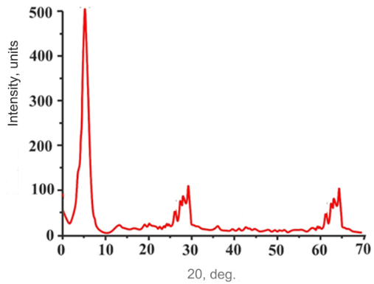

FIGURE 1. X-ray diffraction pattern of Navbakhor bentonite

The results of decoding the diffraction pattern are presented in Table. 2.
TABLE 2. Interpretation of the diffraction pattern of Navbakhor bentonite
2Θ, glad. | d,Å | Mineral
7 | 12.6 | Montmorillonite
20.98 | 4.23 | Cristobalite
26.66 | 3.34 | Silica
28.67 | 3.11 | Plagioclase
29.44 | 3.03 | Calcite
39.66 | 2.27 | Calcite
47.55 | 1.91 | Calcite
56.76 | 1.62 | Plaster

The results obtained indicate that the composition of Navbahor bentonite consists of a clayey wet polymineral. Feldspar as plagioclase ( d =0.311 nm) is present in the dispersed part of the sand-silt fraction.
The montmorillonite sample has 3 fractions: 0.1-0.2 µm, 0.5-0.6 µm (main part) and 2-4 µm. In Fig. Figure 2 shows the IR spectra of montmorillonite.

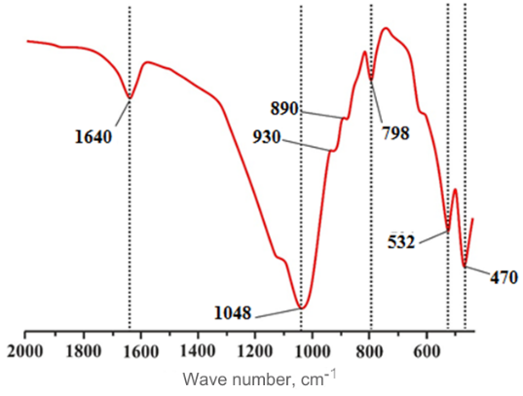
FIGURE 2. IR spectra of montmorillonite

The interpretation of the IR spectra is given in Table. 3.
TABLE 3. Interpretation of IR spectra of montmorillonite
Wave number, cm ⁻¹ | Affiliation
1640 | Water OH-deformation vibrational structure
1048 | Si-O stretching vibration
930 | Al - OH - Al deformation vibration
890 | Al - Fe -OH​ deformation vibration
798 | Vibration of cristobalite Si-O-Al and SiO
532 | Al - O - Si deformation vibration
470 | Si - O- Si deformation vibration

All observed absorption spectra belong to the montmorillonite structure. The maximum of the spectra at 470, 532, 1048 and 1640 cm⁻¹ belongs to the silicon-oxygen tetrahedron Si-O-Si and the bending vibration of aluminum-oxygen Al-O, the stretching vibration of silicon-oxygen Si-O and the bending vibration of the water structure of the OH group . Thermal analyzes (Fig. 3) show that the endothermic effect on the thermogravimetric curve corresponds to the evaporation of water at a temperature of 70 ⁰C, which leads to a decrease in mass by 6.9%.
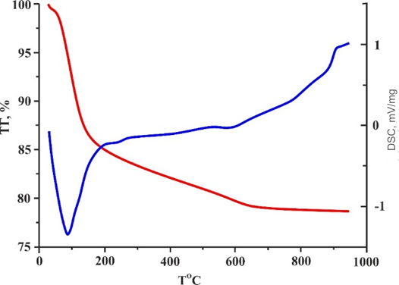
FIGURE 3. DSC/TG curve of montmorillonite

The next endothermic effect is observed at a temperature of about 625 ⁰C. This is directly related to the loss of water, as well as the weakening of the crystal lattice of montmorillonite clay.

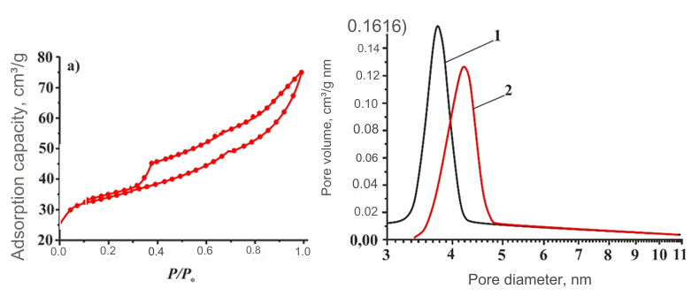
FIGURE 4. Nitrogen adsorption-desorption isotherms (a) and pore size distribution curve (b)

In Fig. Figure 4 shows the isotherm of low-temperature nitrogen adsorption-desorption (a) for ordinary montmorillonite. The adsorption isotherm is classified as type IV according to the IUPAC classification . It follows from this that cracks mainly appear in the desorption network. At P₀/P≈1, the sorption curve on the isotherm increases sharply, which indicates the presence of large particles in montmorillonite, (Fig. 4, b) the curve shows that the particle size has increased. Montmorillonite has a specific surface area of 98 m²/g and a variation range of 56-130 m²/g, which is typical for ordinary montmorillonite clay. The total volume of the particle is 0.25 cm³/g, the particle diameter is 8.68 nm.
Two-stage oil refining process. A method for checking oil purification by gas desorption using an apparatus. By analyzing the test results, as shown in Figures 5-7, the level of H₂S removal from oil by gas desorption was studied . Nitrogen was used as gas. This process depends on the amount of gas and oil consumed in the column t ⁰C.
Under these conditions, light mercaptans, unlike H₂S, are more difficult to remove from oil. Due to the influence of gas, the volume of metalloethyl mercaptans increased from 49-53 million⁻¹ to 40-43 million⁻¹ at the end of desorption. Table 4 presents the results of laboratory tests of oil for H₂S and mercaptan using the gas desorption method.
TABLE 4. Results of laboratory studies of oil purification from H ₂ S and mercaptan using gas desorption method
Experience No | Nitrogen purge process conditions |  | Content of sulfur compounds remaining after oil purging, million⁻¹. |  | Degree of oil purification from sulfur additives, %
Experience No | Gas consumption per nm³/m³ oil | T, ⁰C | H₂S​​ | CH₃SH+C₂H₅SH | H₂S | CH₃SH+C₂H₅SH
1 | 2 | 3 | 4 | 5 | 6 | 7
1 | 3 | 42 | 375 | 48 | 32 | 25
2 | 5 | 42 | 338 | 48 | 38.5 | 25
3 | 7 | 42 | 236 | 47 | 57 | 26.5
4 | 8 | 42 | 184 | 41 | 66.5 | 36
5 | 9 | 42 | 184 | 47 | 66.5 | 26.5
6 | 11 | 42 | 149 | 38 | 73 | 40
7 | 7 | 42 | 136 | 52 | 75 | 18.7
8 | 3 | 52 | 268 | 49 | 51 | 23
9 | 6 | 52 | 212 | 43 | 61.5 | 33
10 | 7 | 52 | 164 | 42 | 70 | 34
11 | 9 | 52 | 104 | 41 | 81 | 36
12 | 10 | 52 | 105 | 39 | 81 | 39
13 | 11 | 52 | 75 | 42 | 86.5 | 34

CONCLUSION
In this study, the chemical composition and physicochemical, textural, and sorption properties of bentonite from the Navbakhor region of Uzbekistan were thoroughly investigated. X-ray diffraction, IR spectroscopy, and BET analysis confirmed that the material consists primarily of montmorillonite, with well-defined pore structures and a high specific surface area, making it an effective sorbent. The average surface area of 98 m²/g and pore diameter of 8.68 nm fall within the expected range for montmorillonite-based clays.
Furthermore, a two-stage oil purification process using nitrogen gas desorption and bentonite-based sorbents was developed and evaluated. The influence of key operational parameters—including temperature, pressure, gas flow rate, and initial H₂S concentration—on the efficiency of hydrogen sulfide and mercaptan removal was systematically analyzed. Results from laboratory-scale tests demonstrated that higher temperatures and optimized gas flow significantly improve desorption efficiency while minimizing oil losses.
The proposed technology offers a promising and environmentally friendly alternative for deep purification of hydrocarbon oils from sulfur-containing compounds, contributing to enhanced process safety, corrosion reduction, and improved environmental sustainability in the oil refining industry.
REFERENCES
- Ivanov, A., Smirnov, Y., Lisay, V., & Borowski, G. (2023). Issues of the impact of granulated sulfur transportation on the environmental components. Journal of Ecological Engineering, 24(6), 86–97. https://doi.org/10.12911/22998993/162558
- Kussainova, B., Tazhkenova, G., Kazarinov, I., Burashnikova, M., Ramazanova, R., Ivashchenko, Y., Saurbayeva, B., Tantybayeva, B., Seitkan, A., Matniyazova, G., Sadiyeva, K., Nurlybayeva, A., & Bazarkhankyzy, A. (2025). Physico-Chemical Properties of Granular Sorbents Based on Natural Bentonite Modified by Polyhydroxocations of Aluminum and Iron (III) by Co-Precipitation. Molecules, 30(1), 195. https://doi.org/10.3390/molecules30010195
- Ranđelović, Purenović, M., Matović, B., Zarubica, A., Momčilović, M., & Purenović, J. (2014). Structural, textural and adsorption characteristics of bentonite-based composite. Microporous and Mesoporous Materials, 195, 67–74. https://doi.org/10.1016/j.micromeso.2014.03.031
- Shukurov, J. (2025). Modeling the production of dimethyl ether from natural gas. AIP Conference Proceedings, 3304, 040062. https://doi.org/10.1063/5.0269234
- Shukurov, J., & Fayzullaev, N. (2024). Direct synthesis of dimethyl ether from synthesis gas. AIP Conference Proceedings, 3045, 060042. https://doi.org/10.1063/5.0197641
- Romadenkina, S. B., Zemlyakov, A. Y., & Pankratov, I. S. (2019). Removal of Sulfur-Containing Compounds from Gas Obtained by the Pyrolysis of Oil Shale. Solid Fuel Chemistry, 53(3), 156–158. https://doi.org/10.3103/s036152191903008x
- Bustonov, M. M. (2024). Priority areas for increasing the competitiveness of small businesses. E3S Web of Conferences, 486, 01015. https://doi.org/10.1051/e3sconf/202448601015
- Satayeva, S., Akhmetova, F., Urazova, A., Ryskaliyev, M., & Iskaliyev, E. (2024). Purification of natural gas from the karachaganak gas condensate field from acidic components. Neft I Gaz, 144(6), 259–265. https://doi.org/10.37878/2708-0080/2024-6.17
- Habibov, O. D. I. H. O. D. I., & Hasanzada, C. a. S. a. I. H. C. a. S. a. I. (2021). Simulation of kinetic curves of thermo-oxidative destruction of prolimers using differential equations of fractional order. ETM Equipment Technologies Materials, 07(03), 52–62. https://doi.org/10.36962/etm0703202152
- Fayzullaev, N., & Pardaeva, S. B. (2024). Cleaning of natural gas from sulphur preservative compounds. AIP Conference Proceedings, 3045, 060041. https://doi.org/10.1063/5.0197686
- Adzhiev, A. Y., & Purtov, P. A. Preparation and processing of associated petroleum gas in Russia: in 2 parts. Krasnodar, 2014, 1284 p.
- Otaboev, K., Sherkuziev, D., Namazov, S., Radjabov, R., & Seytnazarov, A. (2021). Flow of simple superphosphate using two-stage decomposition of phosphorite. IOP Conference Series Earth and Environmental Science, 939(1), 012055. https://doi.org/10.1088/1755-1315/939/1/012055

