Preparation of Nanocatalyst by Sol-Gel Method for Catalytic Synthesis of Dimethyl Ether
Jasur Shukurov^{1, a)}, Normurot Fayzullaev¹, Rustam Muradov¹, Аbidjon Тillyaev¹, Sohiba Pardayeva², Rayxon Abdullayeva³
¹Samarkand State University v, Samarkand, Uzbekistan.
²Samarkand State Medical University, Samarkand, Uzbekistan
³Urgench State Pedagogical Institute, Urgench, Uzbekistan

^{a)}Corresponding author: shukjasni@gmail.com
Abstract. In the course of the study, a complex of physicochemical research methods was applied, including gas chromatography, scanning electron microscopy, IR spectroscopy, X-ray phase analysis, and standard analytical techniques. The technology for preparing catalysts based on local raw materials for dimethyl ether synthesis, as well as the reaction for obtaining methanol and dimethyl ether from a mixture of hydrogen and carbon monoxide, was developed. The qualitative and quantitative compositions of the initial and reaction mixtures were analyzed using a “Kristall 5000.2” gas chromatograph. The results were obtained using a Rigaku NEX-DE X-ray fluorescence spectrometer and a Shimadzu IRAffinity-1S IR-Fourier spectrometer. The results of the elemental analysis of the natural bentonite were examined. A “sol-gel” method was developed to obtain novel bifunctional catalysts with the compositions ZnO·CuO·Al₂O₃/bentonite and CuO·ZnO·Al₂O₃·ZrO₂·CaO/bentonite, characterized by high catalytic activity, thermal stability, productivity, and selectivity in the synthesis of methanol and dimethyl ether from a mixture of synthesis gas and hydrogen based on local raw materials.
Keywords: Dimethyl ether, hydrogen, synthesis gas, bentonite, chromatography, scanning electron microscopy, IR spectroscopy, catalyst.
INTRODUCTION
At present, dimethyl ether and methanol are among the most widely used organic products in the world and are extensively applied as primary intermediates in the chemical and petrochemical industries. Currently, the annual demand for methanol is increasing at a rate of 5.5%, and by 2028, this figure is expected to reach 135 million tons. The current consumption of dimethyl ether amounts to 4.52 million tons, with a projected demand of 6.88 million tons by 2028. Therefore, expanding the raw material base for dimethyl ether and methanol production is an urgent issue. The use of synthesis gas as a feedstock for their production offers the advantage of reducing the cost of the final product. In this regard, the localization of imported raw material sources, introduction of new types of catalysts into practice, and improvement of dimethyl ether synthesis technology are of great significance [1-2].
A review of the literature on dimethyl ether synthesis technologies shows that there is still no ideal technology in this field. An efficient and energy-saving scheme for producing dimethyl ether from methanol and synthesis gas has not yet been developed, and all existing technologies have drawbacks. The interest in dimethyl ether as an alternative transportation fuel is linked to its high cetane number (55–60), which is considerably higher than that of conventional diesel fuel (40–55). The use of dimethyl ether in diesel engines was first introduced by Haldor Topsøe. Dimethyl ether burns very cleanly, producing neither soot nor SO₂ or NOₓ gases, and although only a small amount of exhaust gases is formed during combustion, purification is not required. According to the ecological classification of European researchers, dimethyl ether emissions meet the EURO-4 standards, and vehicles equipped with NOₓ purification systems satisfy the strict requirements of EURO-5. From both economic and environmental perspectives, the physicochemical study of the process of producing dimethyl ether from a mixture of synthesis gas and hydrogen using industrial catalysts is promising.
Natural bentonite is an important local raw material in Uzbekistan, widely used in various sectors of the chemical industry and the national economy. Bentonite is not an expensive raw material, yet it is an effective material broadly applied in many technological processes, for example, in the purification of wastewater, oil, and petroleum products, and most importantly in catalyst synthesis.
Cu-Zn-Al–containing catalysts are considered the main type for the synthesis of dimethyl ether and methanol. The dehydration of methanol (obtained from synthesis gas and hydrogen mixtures) to dimethyl ether in the gas phase is most effectively catalyzed by γ-Al₂O₃, as it prevents the sequential transformation of the formed dimethyl ether into olefins. However, an efficient energy-saving technological scheme for dimethyl ether synthesis from a mixture of synthesis gas and hydrogen has not yet been developed, and an effective catalyst has not been obtained.
MATERIALS AND METHODS
The principle of operation of the catalytic setup is as follows: the system was purged with N₂, and the working pressure was created using valves. The pressure is controlled by manometers using a pressure regulator. Operational safety is monitored using a signaling device. Synthesis gas and hydrogen were supplied from cylinders through two separate pipelines, passing through pressure regulators and dust filters in the gas flow regulators, and then delivered to the reactor designed for the synthesis of dimethyl ether [3-5].
In continuation of our previous research on the development of selective electrodes for drug detection [6], the sol-gel approach was further employed here for the preparation of nanocatalysts, highlighting its versatility in tailoring functional materials. This study is conceptually related to our previous work on the creation and investigation of a semiconductor sensor for methane control, as both approaches focus on the design of functional materials with improved performance for environmental and energy-related applications [7-10].
Subsequently, hydrogen and synthesis gas enter the catalytic unit reactor intended for dimethyl ether production through shut-off and non-return valves, where they are mixed at the reactor inlet and heated to the required temperature. The reactor block for dimethyl ether synthesis from a mixture of synthesis gas and hydrogen consists of non-return valves, an electric furnace and the system. The reactor was composed of stainless-steel tubes with an internal diameter of 12 mm. It is heated by a single-zone electric furnace, which allows the catalyst bed temperature to be maintained with an accuracy of ±5 °C.
The reactor block contained the catalyst bed, which was connected to a programmed four-channel temperature controller (HAT) and a chromel-alumel thermocouple thermometer (0–1200 °C). At the lower part of the reactor, a fiberglass grid was used as the catalyst support. The height of the catalyst bed was 4.4 cm. The furnace and evaporator temperatures were controlled simultaneously.
After the reaction, the mixture of products – water, methanol, dimethyl ether, CO, H₂, CO₂, CH₄, and methanol vapor – passes through a single-pass cooler and then through a high-pressure separator with circulating water at room temperature. After phase separation in the high-pressure separator, the liquid products are discharged into the condensate collector via the condensate control valve, whereas the gaseous reaction products are sent through the pressure regulator to the chromatograph.
Catalytic studies were carried out on a catalytic device that enabled operation at relatively low pressures under the following optimal conditions: catalyst bed volume – 5 cm³ (catalyst mass – 0.5 g, particle size – 0.25–0.315 mm), temperature range – 473 to 553 K, operating pressure – 0.5 MPa, feed flow rate (CO + H₂) – 48 ml/min, with an initial molar ratio of CO:H₂ = 1:2 (Fig. 1).

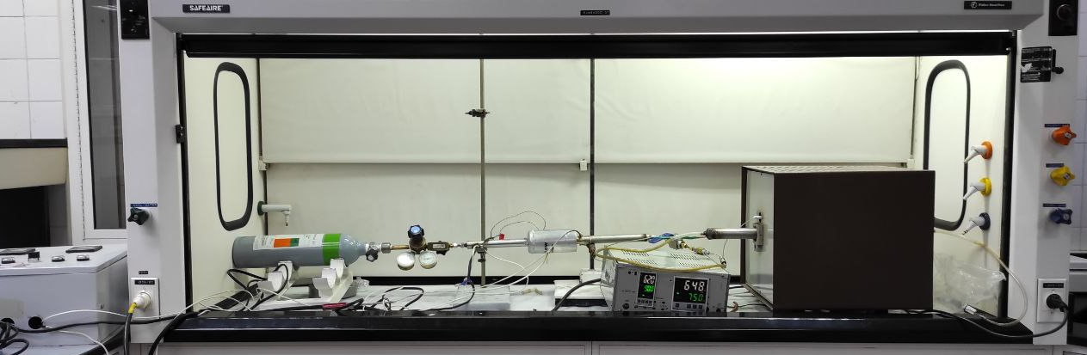

FIGURE 1. Laboratory setup for the synthesis of dimethyl ether from a mixture of hydrogen and synthesis gas.

A microcatalytic reactor designed for the synthesis of dimethyl ether from a mixture of synthesis gas and hydrogen (Figure 1) was used to study the processes of methanol formation and its subsequent dehydration to dimethyl ether over ZnO·CuO·Al₂O₃/bentonite and CuO·ZnO·Al₂O₃·ZrO₂·CaO/bentonite catalysts.
Catalyst activation was carried out in a nitrogen–hydrogen flow (≈2 vol.% H₂ in N₂, flow rate ≈2 L/h). For the catalytic experiments, the composition of the hydrogen–carbon monoxide mixture (vol. %) was: CO – 24; N₂ – 28; H₂ – 48. The contact time was determined according to the formula τ = 3600m/Vin, where m is the catalyst mass (kg) and Vin is the feed flow rate normalized to standard conditions (L/h).
The reactor consisted of a glass tube (inner diameter 8 mm, outer diameter 28 mm, length 75 mm) encased in an aluminum housing and placed inside a ceramic heater. The catalyst particles were placed inside the reactor tube in a mesh container and fixed with a small amount of glass.
RESULTS AND DISCUSSION
Qualitative and quantitative analyses of the reaction mixture were performed using a chromatographic method on a “Khromatek-Kristall-gaz 5000/9000NP” chromatograph equipped with a flame ionization detector. Hydrogen and synthesis gas were supplied from cylinders, and their purities were verified by chromatographic analysis. After the synthesis of dimethyl ether from the synthesis gas and hydrogen mixture, the resulting product mixture exiting the reactor was passed through a cooling system.
The qualitative and quantitative composition of the initial and reaction mixtures was analyzed using the “Kristall 5000.2” gas chromatograph. The concentrations of dimethyl ether, CO, CH₄, CO₂, methanol, higher alcohols, and water were determined using a Porapak T column (thermal conductivity detector) and a capillary column (flame ionization detector). Helium was used as the carrier gas. The optimal chromatographic conditions were as follows: column temperature, 140 °C; detector temperature, 200 °C; carrier gas (helium) flow rate, 30 cm³/min; and hydrogen and air flow rates, 30 cm³/min and 300 cm³/min, respectively. Under these conditions, the retention times were: dimethyl ether – 1.56 min, methanol – 1.82 min, CO – 1.35 min, H₂ – 1.25 min, CO₂ – 1.39 min, CH₄ – 1.30 min, and higher alcohols after 2.5 min.
For quantitative composition analysis, the internal standard method was used, and qualitative identification was performed by comparing retention times. The chromatogram is shown in Figure 2.
The total measurement error (Δ) did not exceed 13% in this study. To determine the optimal conditions for the separation process, the influencing factors considered included column dimensions (4 m × 2 mm), flow rate of the mobile phase (20–50 ml/min), particle size of the sorbent (0.150–0.500 mm), and column thermostat temperature (from room temperature to 120 °C). The degree of separation (Rs), which represents the resolution between components, was used as a criterion. Based on the experimental results, a regression equation describing the dependence of the degree of separation (Rs) on the influencing factors was derived, and the adequacy of the equation was evaluated.
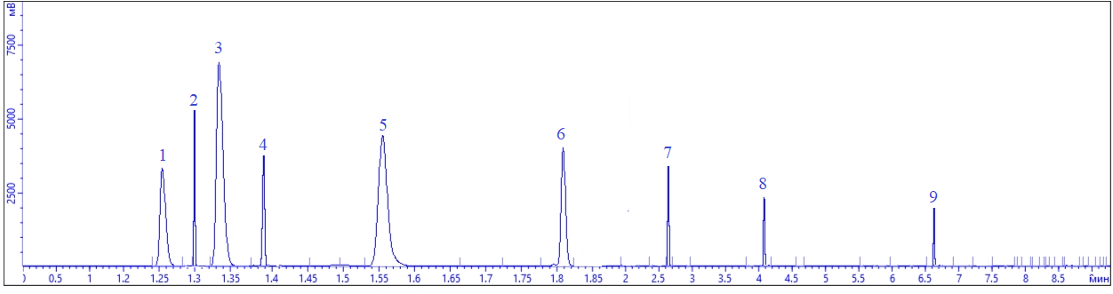
FIGURE 2. Chromatogram of products obtained from synthesis gas in the combined process: 1 – H₂, 2 – CH₄, 3 – CO, 4 – CO₂, 5 – CH₃OCH₃, 6 – CH₃OH, 7 – C₂H₅OH, 8 – C₃H₇OH, 9 – C₄H₉OH.
The optimal values of the factors ensuring a high degree of separation of the mixture components were determined using the simplex optimization method based on an adequate regression equation.
Preparation of Enriched and Activated High-Silica Bentonite Carriers
The following reagents were used to prepare the bentonite carriers and catalysts based on them: natural Navoi bentonite, sodium aluminate, sodium carbonate, hexamethylenediamine, citric acid, ethylene glycol, 25% aqueous solution of NH₄Cl, NaOH, liquid glass (29% SiO₂, 9% Na₂O, 62% H₂O), 2 M H₂SO₄, and 1.5 N HCl solutions.
Additional treatments were applied to further improve the adsorption properties of the bentonite. In the experimental work, natural alkaline bentonites from the Navbahor district of the Navoi region were used in the experiments. The results of the elemental analysis of three types of natural bentonite gels and processed bentonite gels were studied.
The analyses were carried out using a Rigaku NEX-DE X-ray fluorescence spectrometer and an IRAffinity-1S FTIR spectrometer (Shimadzu). The elemental composition of the natural bentonite and the corresponding oxide mass percentages are summarized in Table 1.
TABLE 1. Chemical composition of three different samples of natural alkaline bentonite, wt.%
Sample 1  % mass | SiO₂ | Al₂O₃ | CaO | Fе₂O₃ | K₂O | TiO₂ | P₂O₅
Sample 1  % mass | 52.9 | 12.6 | 26.7 | 5.00 | 1.59 | 0.352 | 0.867
Sample 2  % mass | SiO₂ | Al₂O₃ | CaO | Fе₂O₃ | K₂O | TiO₂ | P₂O₅
Sample 2  % mass | 61.8 | 15.5 | 13.2 | 6.50 | 1.95 | 0.487 | 0.549
Sample 3  % mass | SiO₂ | Al₂O₃ | CaO | Fе₂O₃ | K₂O | TiO₂ | P₂O₅
Sample 3  % mass | 72.5 | 15.2 | 2.60 | 6.46 | 1.74 | 0.461 | 1.04

According to the results, the first sample contained Fe₂O₃ (5.00%), SiO₂ (52.9%), Al₂O₃ (12.6%), CaO (26.7%), and K₂O (1.59%), with SiO₂ representing the largest mass fraction. The second sample contained Fe₂O₃ (6.50%), SiO₂ (61.8%), Al₂O₃ (15.5%), CaO (13.2%), and K₂O (1.95%), where SiO₂ and Al₂O₃ accounted for the majority. The third sample contained Fe₂O₃ (6.46%), SiO₂ (72.5%), Al₂O₃ (15.2%), CaO (2.60%), and K₂O (1.74%), with SiO₂ and Al₂O₃ dominating the composition.
For the preparation of bentonite-based catalysts, a high proportion of SiO₂ and Al₂O₃ combined with low Fe₂O₃ content is preferred. While the first sample demonstrated a relatively low Fe₂O₃ fraction, its SiO₂ content was also lower than that of the other samples. Thus, the second sample was identified as the most suitable sample.
The X-ray fluorescence (XRF) spectra obtained using a Rigaku NEX-DE spectrometer are shown in Figure 3 for the second sample.

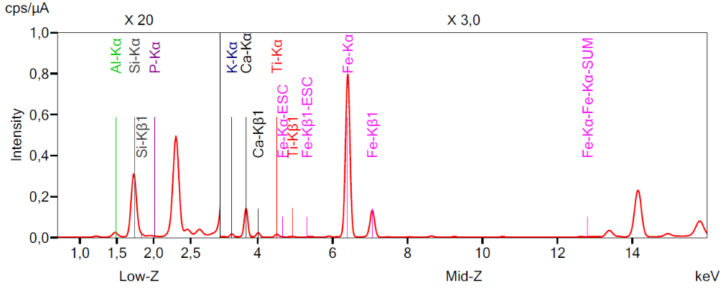
FIGURE 3. XRF spectrum of the second sample of natural bentonite
To investigate the effect of acid activation, 100 g of bentonite clay suspension was prepared. The suspension was allowed to settle at room temperature for 20 h, followed by centrifugation at 7500 rpm for 6 min to separate the saturated clay fractions. The obtained fraction was washed thoroughly with 1000 mL of distilled water to remove mineral impurities and dispersed particles. The clay fraction was then dried in air for 10 h and subsequently dried in an oven at 90 °C for 5 h. Before acid treatment, the bentonite was ground to a particle size of 0.08 mm. After treatment, the clay was filtered through a Büchner funnel with filter paper and washed with distilled water until the pH reached 5.5–5.9 pH. To remove residual moisture, the bentonite (together with the filter paper) was dried in an oven at 130 °C for 4 h.
For acid activation, bentonite was treated with 2.0 M H₂SO₄ and then with 1.5 N HCl at 125 °C for 1 h, followed by repeated washing with 200 mL of distilled water until neutrality was achieved. The suspension was centrifuged, and the sample was dried at 80 °C for 10 h.
Thermal treatment of modified Navbahor bentonite at temperatures above 700 °C led to the removal of interlayer water and irreversible collapse of the layered structure, accompanied by the deterioration of textural characteristics. However, in the range of 70–500 °C, no significant changes were observed in the porosity parameters of the initial bentonite samples.
The chemical composition and microstructure of Navbahor bentonite were also studied using a scanning electron microscope (SEM). The analysis was performed using a Zeiss SEM EVO MA instrument. The SEM micrograph and microanalysis of the second sample are shown in Figure 4.

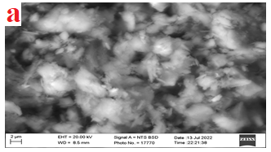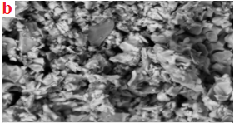
FIGURE 4. SEM micrographs of (a) natural bentonite and (b) acid-treated bentonite.
According to the analysis of the derivatographic curves of the activated bentonite, the TG (thermogravimetric) curve illustrates the logarithmic thermal gravimetric behavior, showing a decrease in the mass of bentonite over a specific initial time interval. The differential thermogravimetric (DTG) curve represents the variations in temperature-dependent mass loss. These results are shown in Figure 5.

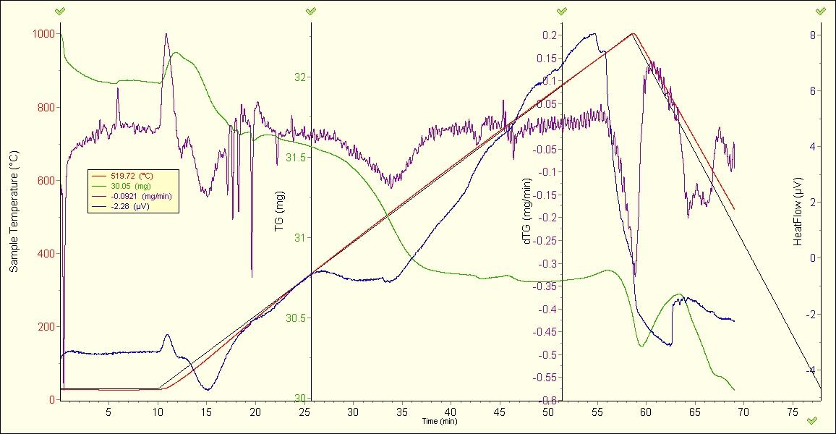
FIGURE 5. Derivatogram of the activated bentonite.
1 — temperature curve; 2 — dynamic thermogravimetric analysis (DTGA) curve; 3 — derivative of the dynamic thermogravimetric curve (DTGP); 4 — DSC curve.

The analysis of the DTGA curve (curve 2) shows that mass loss occurs predominantly in two intensive decomposition temperature ranges. The first decomposition range was 107–295 °C, and the second was 303–954 °C. The results indicate that the intensive decomposition process mainly occurs in the second range, where the mass loss amounts to 5.9% of the original mass. According to the derivatographic study, the principal mass loss occurred over the 161–913 °C interval, corresponding to 7.26% of the sample mass (i.e., a loss of 3.22 mg).
A detailed analysis of the DTGA and DSC curves is summarized in Table 2.

TABLE 2. Analysis of the DTGA and DSC curves of activated bentonite.
№ | Temperature (°C) | Mass loss (%) | Decomposition rate (mg/min) | Energy consumption (µV·s/mg)
1 | 60 | 0,225 | 0,136 | 1,46
2 | 100 | 0,885 | 0,555 | 2,54
3 | 200 | 1,055 | 0,653 | 2,21
4 | 300 | 1,135 | 0,487 | 3,22
5 | 400 | 1,685 | 1,147 | 2,02
6 | 500 | 2,069 | 0,455 | 3,03
7 | 600 | 1,815 | 1,499 | 1,65
8 | 700 | 1,521 | 2,156 | 1,21
9 | 800 | 1,812 | 1,244 | 1,77
10 | 900 | 1,958 | 2,622 | 2,02
11 | 1000 | 2,041 | 1,235 | 2,25

Mass loss occurs due to the release of structural water and the removal of other light volatile impurities. At this stage, the decrease in mass was mainly associated with the evaporation of carbonates and other volatile components.
Preparation of Catalyst by the Sol-Gel Method for the Catalytic Synthesis of Dimethyl Ether
In recent years, the sol-gel method has been widely used for the synthesis of inorganic and organo-inorganic matrices at relatively low temperatures. This method has several advantages, such as the simplicity of the equipment used, cost-effectiveness, environmental safety, low production cost, and high adaptability of the technology.
We developed a citrate-gel-based sol-gel method for synthesizing a ZnO·CuO·Al₂O₃/bentonite-based catalyst. Aluminum nitrate nonahydrate (Al(NO₃)₃∙9H₂O), copper nitrate trihydrate (Cu(NO₃)₂∙3H₂O), zinc nitrate hexahydrate (Zn(NO₃)₂∙6H₂O), bentonite, the complexing agent hexamethylenediamine, and citric acid were used as precursors.
The catalyst components were tested in various mass ratios, and the optimal composition was determined as follows (Table 3): ZnO, 14.5%; CuO, 7%; Al₂O₃, 32.5%; and bentonite (as the support), 46 wt. %. %.
Stoichiometric amounts of the initial components were dissolved in distilled water. Solutions of Al(NO₃)₃∙9H₂O, Cu(NO₃)₂∙3H₂O, and Zn(NO₃)₂∙6H₂O were added to the citric acid solution to form metal–citrate complexes. The resulting solution was evaporated at 70–80°C until a sol was formed, and then further evaporated at 120–130°C until gelation occurred. The obtained structured system, consisting of high- and low-molecular-weight compounds, appeared as a transparent mass. It was first dried in an oven at 200°C until the water was completely removed and then calcined in a KJ ELECTRIC MUFFLE FURNACE at 500–550°C.
Upon drying the gel at room temperature, solid amorphous materials with high porosity (15–50%), pore sizes in the range of 1–10 nm, and specific surface areas of 150–900 m²/g were obtained. These materials are easily pulverized and are suitable for use as catalysts.
TABLE 3. Chemical composition of the synthesized ZnO·CuO·Al₂O₃/bentonite catalyst
Chemical composition of the catalyst, wt.%
SiO₂ | Al₂O₃ | ZnO | CuO | K₂O | Fе₂O₃ | CaO
40.41 | 36.6 | 14.5 | 7 | 0.75 | 0.62 | 0.12

The ZnO·CuO·Al₂O₃/bentonite-based catalyst contains ZnO and CuO oxides, which play an important role in methanol production from synthesis gas. The elemental analysis spectra of the catalyst obtained by XRF are shown in Figure 6.
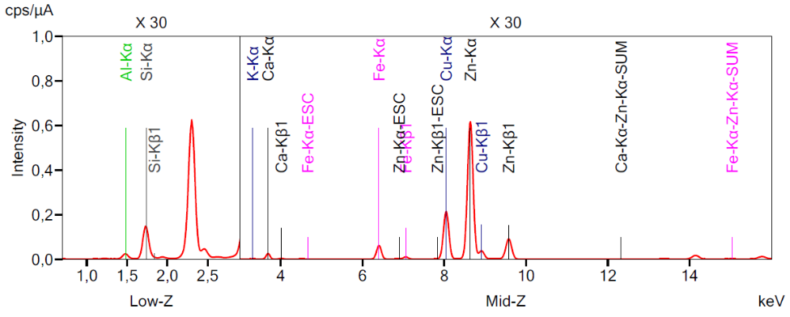
FIGURE 6. XRF spectra of the synthesized ZnO·CuO·Al₂O₃/bentonite-based catalyst.
In obtaining these results, the FTIR spectrometer IRAffinity-1S (Shimadzu) was used with the following parameters: tube voltage high – 35.0 kV, low – 6.5 kV; tube current high – 342 µA, low – 448 µA; response time – 100 seconds; end point high – 21.2%, low – 37.2%. The infrared analysis spectrum of the synthesized ZnO·CuO·Al₂O₃/bentonite-based catalyst is presented in Figure 7.

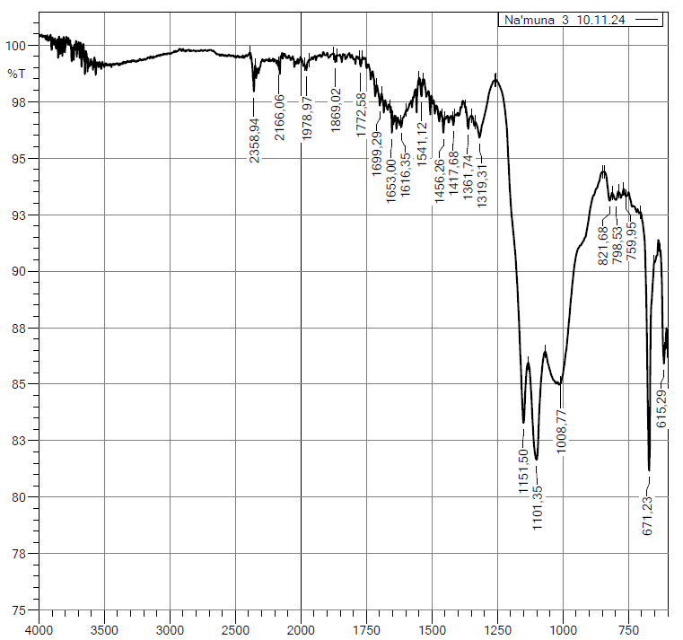
FIGURE 7. IR spectrum of ZnO·CuO·Al₂O₃/bentonite-based catalyst
The prospect of using nanoscale catalysts depends on two aspects. First, as the particle size decreases, a large proportion of atoms are located on the surface; therefore, a catalyst consisting of nanoparticles has a large surface area and is very active in heterogeneous reactions. Second, many properties of nanoparticles depend on their size (size effect); therefore, by changing the size of the nanoparticles, it is possible to control not only the activity but also the selectivity. When the size of the catalyst particles decreased, the reaction rate increased sharply. The composition and amount of the reaction products were determined using gas chromatography. The local raw material is natural bentonite, which is an effective material widely used in many technological fields, mainly in catalyst synthesis.
CONCLUSION
After the activation of bentonite, catalysts were prepared on their basis by the sol-gel method. The components of the ZnO·CuO·Al₂O₃/bentonite catalyst were taken in different mass ratios, and the most optimal variant was as follows: ZnO – 14.5%, CuO – 7%, Al₂O₃ – 32.5%, and the carrier bentonite – 46%.
By the suspension method, CuO·ZnO·Al₂O₃·ZrO₂·CaO/bentonite catalysts were prepared with the following mass ratios: CuO – 7%, ZnO – 4%, Al₂O₃ – 44%, ZrO2 – 2%, CaO – 1% as active components, and the carrier bentonite – 42%.
Thus, to develop an improved technology for the synthesis of dimethyl ether from syngas, a new type of catalyst was created. The porous structure and specific surface area of the catalysts were determined by the Brunauer, Emmett, Teller (BET) method on the Sorbi-M device using low-temperature nitrogen adsorption. The specific surface area was calculated from the nitrogen adsorption isotherm at 77 K. The pore volume and pore size of the catalysts were determined from desorption and adsorption isotherm data by the BJH (Barrett–Joyner–Halenda) method.
The study of the textural characteristics of ZnO·CuO·Al₂O₃/bentonite and CuO·ZnO·Al₂O₃·ZrO₂·CaO/bentonite catalysts by physicochemical methods (XRF, IR, BET, BJH, SEM, and DTA) showed that as a result of treatment in a hydrogen or helium flow, the specific surface area of ZnO·CuO·Al₂O₃/bentonite decreases from 159 to 108 m²/g and the average pore diameter increases from 28.45 to 35 nm, while the specific surface area of CuO·ZnO·Al₂O₃·ZrO₂·CaO/bentonite decreases from about 179.5 to 115 m²/g, but the average pore diameter of 23 nm is preserved.
The interaction of reagents and reaction products (H₂, CO, CO₂, CH₃OH, (CH₃)₂O, CH₄) with the surface of ZnO·CuO·Al₂O₃/bentonite and CuO·ZnO·Al₂O₃·ZrO₂·CaO/bentonite catalysts was studied, and a comparative evaluation was carried out. As a result, the spherical-shaped CuO·ZnO·Al₂O₃·ZrO₂·CaO/bentonite catalyst was found to be the most optimal variant.
REFERENCES
- Shukurov, J., & Fayzullaev, N. (2024). Direct synthesis of dimethyl ether from synthesis gas. AIP Conference Proceedings, 3045, 060042. https://doi.org/10.1063/5.0197641
- Shukurov, J. (2025). Modeling the production of dimethyl ether from natural gas. AIP Conference Proceedings, 3304, 040062. https://doi.org/10.1063/5.0269234
- Shukurov, J., & Fayzullaev, N. (2023). CATALYST SELECTION AND TECHNOLOGY FOR OBTAINING DIMETHYL ETHER. Universum Chemistry & Biology, 108(6). https://doi.org/10.32743/unichem.2023.108.6.15577
- Hosseini, Z., Taghizadeh, M., & Yaripour, F. (2011). Synthesis of nanocrystalline γ-Al2O3 by sol-gel and precipitation methods for methanol dehydration to dimethyl ether. Journal of Natural Gas Chemistry, 20(2), 128–134. https://doi.org/10.1016/s1003-9953(10)60172-7
- Mirzamaxmudov, U. et al., (2025). Control of chemical preparation concentrations in deresuscitation of mulberry silkworm larvae in cocoons. AIP Conference Proceedings, 3304, 030088. https://doi.org/10.1063/5.0269251
- Moradi, G., Nosrati, S., & Yaripor, F. (2006). Effect of the hybrid catalysts preparation method upon direct synthesis of dimethyl ether from synthesis gas. Catalysis Communications, 8(3), 598–606. https://doi.org/10.1016/j.catcom.2006.08.023
- Rad, S. J. H., Haghighi, M., Eslami, A. A., Rahmani, F., & Rahemi, N. (2016). Sol–gel vs. impregnation preparation of MgO and CeO2 doped Ni/Al2O3 nanocatalysts used in dry reforming of methane: Effect of process conditions, synthesis method and support composition. International Journal of Hydrogen Energy, 41(11), 5335–5350. https://doi.org/10.1016/j.ijhydene.2016.02.002
- Yaripour, F., Shariatinia, Z., Sahebdelfar, S., & Irandoukht, A. (2014). The effects of synthesis operation conditions on the properties of modified γ-alumina nanocatalysts in methanol dehydration to dimethyl ether using factorial experimental design. Fuel, 139, 40–50. https://doi.org/10.1016/j.fuel.2014.08.029
- Bedoya, J., Valdez, R., Cota, L., Alvarez-Amparán, M., & Olivas, A. (2021). Performance of Al-MCM-41 nanospheres as catalysts for dimethyl ether production. Catalysis Today, 388–389, 55–62. https://doi.org/10.1016/j.cattod.2021.01.010
- Fayzullaev, N., & Pardaeva, S. B. (2024). Cleaning of natural gas from sulphur preservative compounds. AIP Conference Proceedings, 3045, 060041. https://doi.org/10.1063/5.0197686

