Technology for Producing Materials Resistant to Aggressive Alkaline Environments Based on Basalt and Kaolin
Khudoyor Rakhmatov¹, Boburmirza Rakhmatov¹, Sharofat Masharipova²,
Ziyoda Axmedova³, Sherzod Korabayev^{4, a)}
¹Karshi State Technical University, Karshi, Uzbekistan
²Urgench State University named after Abu Raykhan Beruni, Urgench, Uzbekistan
³Central Asian Medical University, Fergana, Uzbekistan
⁴Namangan State Technical University, Namangan, Uzbekistan

^{a)}Corresponding author: sherzod.korabayev@gmail.com
Abstract: In this work, a resourceful approach to synthesis an energy-efficient alkali-resistant composite ceramics from two local minerals (Aydarkul basalt and Qarnab kaolin) is proposed. The raw material and final products were characterized by X-ray diffraction (XRD), thermogravimetric analysis (TGA), scanning electron microscopy (SEM) and Fourier-transfer infrared spectrum (FTIR). The experimental results showed that firing temperatures of 1350–1400 °C promote the formation of mullite and anorthite crystals, which further increases the resistance to alkaline environments. The mass loss of the composite after exposure to 10% NaOH solution for 90 days was only 0.5%, and the strength loss was only 4.6%. This indicates a good level of durability. This stability is based on a dense silicate-aluminosilicate network that does not allow hydroxide ions to penetrate. Thus, ceramics extracted from the Aydarkul basalt and Karnab deposits will be an excellent choice for protective and structural applications in chemically aggressive areas.
Keywords: basalt materials, kaolin, composite material, mullite, anorthite, thermal stability, aggressive environment
INTRODUCTION
The growth of the chemical industry in recent years has led to an increased demand for mechanically stable and, at the same time, chemically resistant materials, especially domestic raw materials. In this context, Basalt and Kaolin are identified as sustainable, low-cost mineral resources that can be used to develop composites. For both of these minerals, Uzbekistan holds 100 million tons of reserves. Damage-resistant materials that are resistant to alkali, acids, salts, and other chemicals are generally used in the chemical industry. There was, in fact, no shortage of research being done both within Uzbekistan and abroad, focusing on producing such chemically stable substances.
Through a series of experiments conducted by the authors, Dilnoza Jumaniyozova, and others, it was possible to create corrosion-resistant coatings using epoxy resin, zinc phosphate, and hexamethylenetetramine. Later studies showed that it is possible to develop coatings resistant to alkalis based on gossypol resin. The operation for the production of bitumen-polymer composites was optimized with the addition of 2% CaO at 220°C; previously, high CaO contents of 2.9% and 5.5% were required at low temperatures of 200 and 180°C, respectively. These RPs have been shown to protect metal structures and foundation elements from a number of factors, in particular aggressive factors, while maintaining mechanical requirements under typical conditions. Another study analyzed chemical generation of magnesite wastes from the Zinelbulak deposit in Uzbekistan’s Lower Amudarya place, whose predominant ingredients were as follows (by mass): 53.70% MgCO₃, 27.20% talc (3MgO∙4SiO₂∙H₂O), 10.01% kammererite (5MgO∙5Fe(O)Al₂(Si... each; and also at 7.75% en: dolomite-MgCO₃·CaCO₃ listed over CaCO₃) [1-6].
Researchers, Ren et al., in a series of experiments, found that when ceramics were treated with alkaline vapors at 1000°C to 1400°C, the pore volume was reduced from 18% to 9%, and the alkali resistance was improved by 1.7 times. Still other researchers, Bo et al., found that when the SiO₂ content was above 50% and about 40% Al₂O₃, the mass loss was less than 0.6%, and the strength loss after only 10% NaOH solution for 7 days was less than 5%. Ren et al. proved that the erosion of bauxite-SiC ceramics with the addition of andalusite decreased from 2.3% to 0.9%, and the mullite anorthite phases increased from 35% to 57%. Table 1 Composition of mixtures(M) based on wt.% Components Raw bauxite (RI) SiC Andalusite Mullie Anor tha Mass B (%) 64.8. Researchers led by Stjernberg in their experiments, exposed mullite/corundum-based ceramics with a recalculated mass A (%) to Na₂CO₃ at 1100°C for 48 hours and found that the cracking rate was 12%, which was reduced to 5% when only 3% ZrO₂ was added [7-10]
Experiments by Schaafhausen showed that SiC filter elements tested at 900–1000°C for 200 hours showed a mass loss of ≤1% and retained >96% structural integrity. Furthermore, Bläsing found in his experiments that the Na⁺ penetration depth did not exceed five μm due to the protective mullite surface layer at 950°C for 100 hours. The mass loss of mullite-based samples was 0.8%, compared to 1.1% for anorthite-based samples (fired in a Na₂CO₃–Na₂SO₄ environment at 1200°C/24 hours), and therefore indicates that the mullite phase improves alkali resistance by around 30% [11-12].
Overall, through the above studies, we can see that composite ceramics have increased alkali resistance due to low porosity and the production of pozzolanic products.
METHODS
The Aydarkul basalt and Qarnab kaolin samples used in this work were collected, reduced to powder size by ball milling, and sieved to 0.5 mm mesh. Their oxide composition was examined by XRF, which indicated that the major components of PSR are SiO₂, Al₂O₃, CaO, Fe₂O₃, and MgO. A homogenized powdery blend of 70% basalt and 30% kaolin was formed into disc-shaped specimens (20 × 20 mm), sintered in the temperature range of at least 1350 °C to about 1400 °C with a heating rate of at least about 10 °C/min and a holding time of at least about two hours. The cooling process was controlled to prevent the formation of microcracks.
The thermal properties and phase composition of the prepared new material can be characterized by X-ray diffraction (XRD) and thermogravimetric/differential thermal analysis (TGA/DTA). Surface morphology studies of the material, grain size and porosity measurements were performed by scanning electron microscopy (SEM), and the formation of silicate bonds was demonstrated by Fourier transform infrared spectrometry (FTIR).
The physical properties of the prepared samples (density, open porosity, and water absorption) were evaluated according to ASTM C373-88. The alkali resistance was tested by immersing the samples in a 10% NaOH solution for 90 days at 25 ± 2 °C, with the solution being renewed every 5 days. Specimens were dried for 30, 60, and 90 days at a temperature of about and weighed to evaluate mass loss, and tested under compression by UTM according to ISO1920-4.
All values are the mean of three independent experiments and were processed using OriginPro software. The relationship between mass reduction, decreased compressive strength, and exposure time was accordingly investigated.
RESULTS AND DISCUSSION
The initial phase of the research focused on analyzing the chemical composition and physical properties of Aydercole basalt and Qarnab kaolin. Seven samples were taken from each sediment and examined by X-ray fluorescence (XRF) spectroscopy. Seriously, the results of these analyses are shown in Tables 1 and 2 below.
TABLE 1. Chemical composition of Aydarkul basalt samples
Sample ID | Oxide content, wt.% |  |  |  |  |  |  | LOI
Sample ID | SiO₂ | Al₂O₃ | Fe₂O₃ | CaO | MgO | Na₂O | K₂O | LOI
AB-1 | 51.8 | 14.5 | 10.1 | 9.9 | 6.9 | 4.0 | 2.6 | 0.2
AB -2 | 51.2 | 14.8 | 10.3 | 9.3 | 7.2 | 4.2 | 2.7 | 0.3
AB -3 | 52.0 | 14.7 | 10.3 | 9.2 | 6.7 | 4.1 | 2.8 | 0.2
AB -4 | 50.5 | 14.4 | 11.2 | 9.0 | 6.8 | 5.0 | 2.6 | 0.5
AB 5 | 51.0 | 14.7 | 10.3 | 9.2 | 7.3 | 4.2 | 2.7 | 0.6
AB -6 | 51.8 | 13.9 | 10.7 | 9.4 | 7.2 | 4.3 | 2.5 | 0.2
AB -7 | 51.3 | 14.9 | 10.5 | 9.3 | 7.0 | 4.1 | 2.7 | 0.2
Average | 51.2 | 14.8 | 10.5 | 9.3 | 7.1 | 4.2 | 2.7 | 0.2
Based on the data presented in the tables, the chemical composition of the Aydarkule basalt samples shows relative stability: the SiO₂ content is between 50.5% and 52.0%, and the Al₂O₃ Content is approximately 14-15%, indicating the dominance of aluminosilicate phases. The presence of Fe₂O₃, CaO and MgO in the range of 7-11% confirms the formation of plagioclase, augite and olivine. The relatively low estimated content of Na₂O and K₂O (2-4%) indicates that the basalt is poorly saturated with alkaline oxides. The low ignition loss (0.2-0.6%) indicates the minimal volatile component of the samples and their high thermal stability. And oh yeah, Such a composition makes Aydarkul basalt a promising local raw material for the production of alkali resistant compounds. Likewise, X-ray fluorescence (XRF) analysis was performed on seven Qarnab kaolin samples to examine their chemical composition. From the above cases, it can be seen that the changes in oxide concentration are very small. This process confirms the geochemical stability and consistency of the deposit (see Table 2).
TABLE 2. Results of the chemical analysis of Qarnab kaolin
Sample ID | Oxide content, wt.% |  |  |  |  |  |  |  | LOI
Sample ID | SiO₂ | Al₂O₃ | Fe₂O₃ | CaO | MgO | Na₂O | K₂O | TiO₂ | LOI
KK-1 | 46,8 | 33,9 | 1,2 | 0,8 | 0,6 | 0,3 | 2,1 | 1,1 | 15
KK-2 | 47,4 | 34,6 | 1,4 | 0,3 | 0,4 | 0,3 | 2,3 | 1,3 | 12
KK-3 | 46,1 | 34,1 | 1,3 | 0,5 | 0,3 | 0,3 | 2,2 | 1,2 | 16
KK-4 | 47,5 | 34,8 | 1,5 | 0,8 | 0,4 | 0,5 | 2,3 | 1,2 | 11
KK-5 | 46,9 | 33,9 | 1,2 | 0,2 | 0,4 | 0,2 | 2,1 | 1,1 | 14
KK-6 | 47,3 | 34,5 | 1,4 | 0,6 | 0,4 | 0,3 | 2,2 | 1,3 | 12
KK-7 | 46,2 | 32,4 | 1,3 | 0,8 | 0,5 | 0,4 | 2,2 | 1,2 | 15
Average: | 47,0 | 34,0 | 1,3 | 0,6 | 0,4 | 0,3 | 2,2 | 1,2 | 13

According to the data given in the table, the main components of kaolin are SiO₂ (about 47%) and Al₂O₃ Al₂O₃ (about 34%), which confirms its aluminum silicate compositions. The low levels of Fe₂O₃, CaO, and MgO indicate that kaolin is composed mainly of light mineral phases. The relatively small amounts of Na₂O and K₂O in the composition indicate limited alkali oxide saturation. The loss on ignition (LOI) of 11% to 16% indicates the presence of aqueous hydroxyl groups and phases of water-bound in the composition.
To investigate how basalt-kaolin ratios affect the alkali resistance of composite materials, four different compositions of the B-K system were created. In these mixtures, the basalt content is between 70% and 88% and the kaolin is between 12% and 30%. Seriously, the samples were exposed to an alkaline environment for seven days, after which mass loss and a decrease in compressive strength were recorded. Table 3 summarizes the main results of these preliminary formulations.
TABLE 3. Results of the analysis of the stability of basalt–kaolin composites in an alkaline medium
№ | Composition | Basalt (%) | Kaolin (%) | Mass loss (%) | Strength reduction (%)
1 | B–K–1 | 70 | 30 | 0,8 | 7,5
2 | B–K–6 | 80 | 20 | 0,6 | 5,2
3 | B–K–7 | 82 | 18 | 0,5 | 4,6
4 | B–K–10 | 88 | 12 | 0,4 | 4,1

Analysis of tabular data shows that the ratio of basalt to kaolin directly affects the physical and chemical properties of the compounds. As the amount of basalt in the structure increases, the mass loss ratio decreases from 0.8 to 0.4 units, indicating improved thermal stability. You know what? This phenomenon is attributed to the presence of Fe₂O₃, CaO, and MgO oxides in the basalt, which promote sintering and condensation of the liquid phase. And yes, similarly, the decrease in the percentage of loss of compressive strength from 7.5 to 4.1 with increasing basalt content indicates an improvement in the mechanical strength of the composite.
In particular, the most balanced results can be seen with the B–K–7 formula (82% basalt and 18% kaolin), i.e., 0.5% mass loss and 4.6% strength loss, which indicates that it is the correct formula. With this formula, the formation of stable mullite and anorthite phases can be easily observed, which ultimately leads to a dense microstructure and increased alkali resistance. Thus, we can see that the composition of B–K–7 is the most promising among ceramic COMPOSITES in terms of alkali resistance, thermal stability and, at the same time, economic efficiency.
You know what? X-ray diffraction (XRD) was used to analyze the composites sintered between 950 °C and 1100 °C to detect phase changes as a function of temperature. Diffraction patterns clearly, clearly show how the crystalline phases develop with increasing temperature, especially the increased crystallinity of aluminosilicates and the appearance of new stable mineral phases (FIGURE 1).

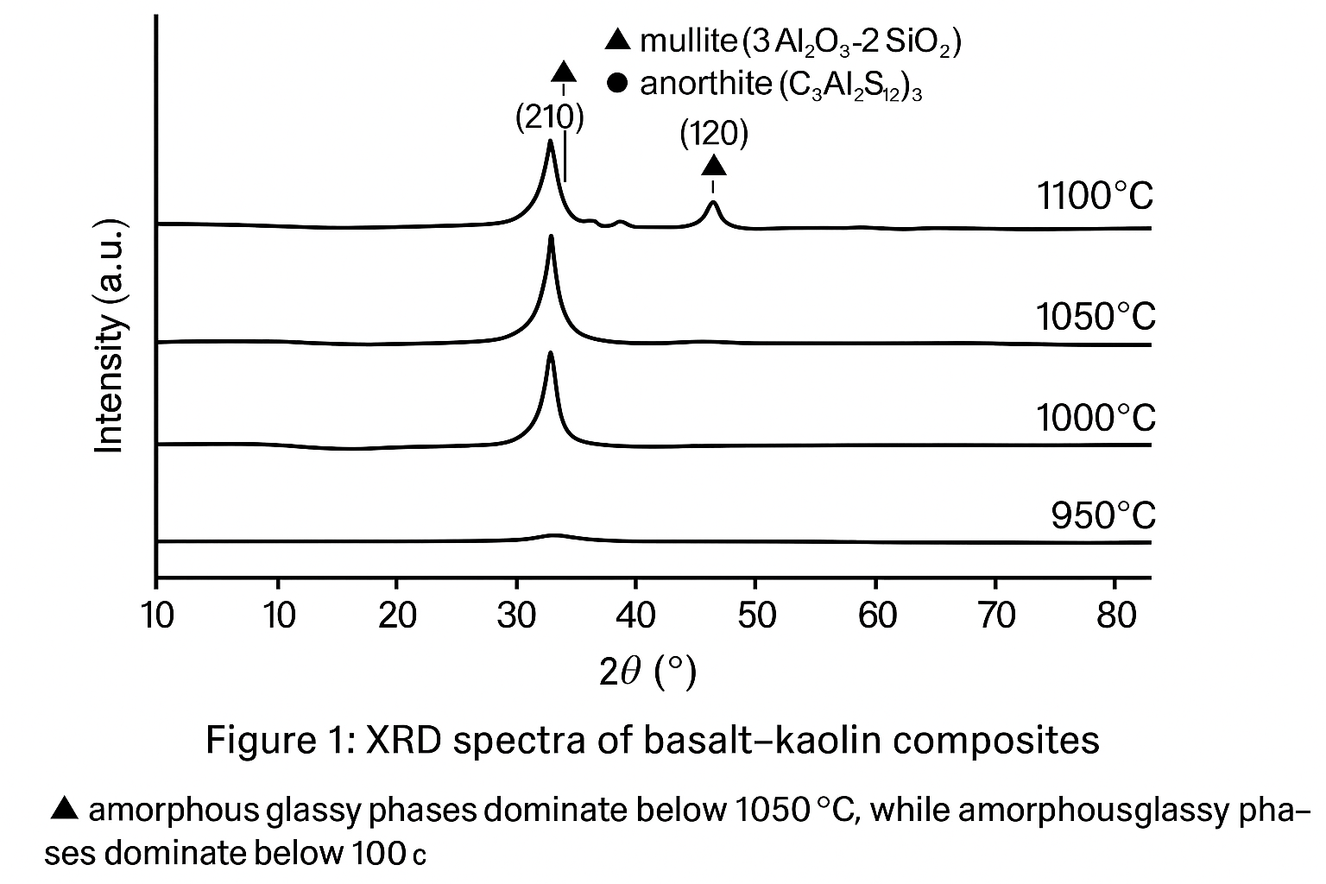
FIGURE 1. X-ray spectra of basalt-kaolin composites at several sintering temperatures (950–1100 °C)
X-ray diffraction (XRD) analysis shows that a gradual crystallization of aluminosilicate phases occurs between 950 and 1100 °C. During the initial heating to 950 °C, mainly amorphous glassy structures were formed. Peaks associated with anorthite (CaAl₂Si₂O₈) and mullite (3Al₂O₃·2SiO₂) begin to appear at approximately 1000 °C, and their intensity increases significantly at 1050 °C. When the temperature reaches 1100 °C, clear reflections from the (210) and (120) crystal planes appear, indicating the formation of stable crystal phases. Seriously, this suggests that the temperature range of 1050-1100°C is ideal for producing dense, durable ceramics.
Yes, these results can be confirmed by density measurements: the density of the material increases from 2.45 g/cm³ at 950 °C to 2.85 g/cm³ at 1150 °C, which is mainly due to particle coalescence and a decrease in porosity. For example, SEM analysis shows that with increasing temperature, the average grain size increases from 2-3 μm to 7-9 μm, and the pore size decreases from 10-12 μm to 1-2 μm. At 1100 °C, the microstructure of the structure becomes dense and uniform, which leads to an increase in mechanical strength and a decrease in water absorption.
Thermogravimetric analysis (TGA) and differential thermal analysis (DTA) show that the mass loss during the process is less than 2% up to 700 °C, indicating that the material has high thermal stability. We can see that the small endothermic peak between 250-300 °C is related to the elimination of the hydroxyl group, while the exothermic peak between 650-700 °C is related to the crystallization of the mullite and anorthite phases.
In addition, high MgO content indicated the formation of secondary phases such as diopside (CaMgSiO₆) and forsterite (Mg₂SiO₄). These phases contributed to improved structural integrity and limited diffusion of hydroxide ions in an alkaline environment (FIGURE 2).
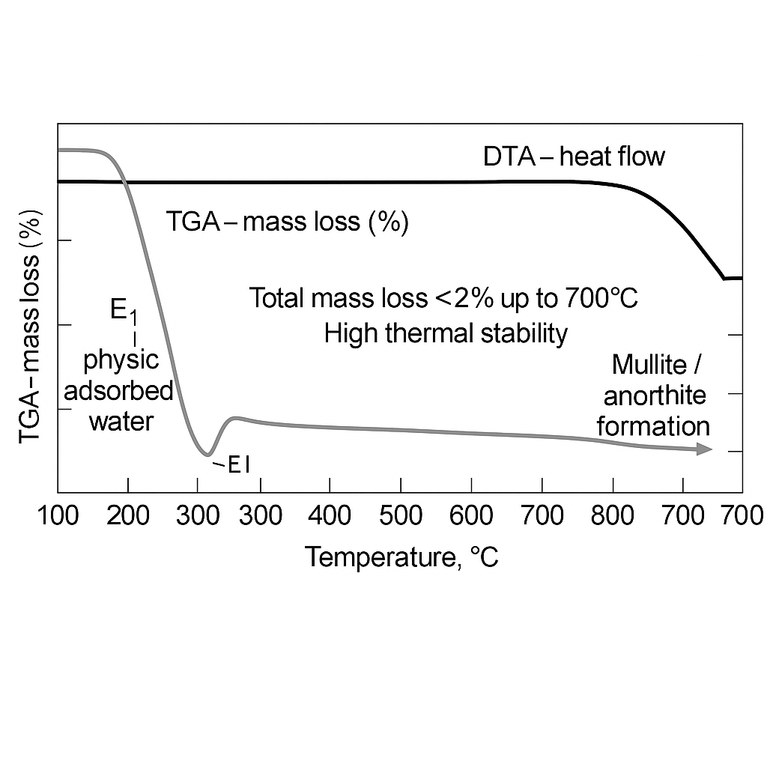
FIGURE 2. TGA-DTA curves of basalt-kaolin composites showing their mass loss and heat flow as a function of temperature
During the sintering process, liquid phase reactions occur in the range of 1050-1150 °C, which helps to increase the density and strengthen the crystal bonds. The phase of mullite contributes significantly to the chemical stability and mechanical strength of the material, while the phase of anorite served as a secondary bonding phase, thereby increasing the structural integrity. In addition, the formation of diopside (CaMgSiO₆) and forsterite (Mg₂SiO₄) phases increases the stiffness of the composite structure and effectively slows down the diffusion of ions in alkaline media (Table 4).

TABLE 4. Thermal processes, sintering activity, and phase formation behavior of basalt–kaolin composites at
different temperature ranges
Temperature Range (°C) | Main Processes | Sintering Activity | Main Phase or Compound | Effect and Characteristics
1000–1040 | Liquid-phase processes | Moderate | Mullite | Contributes to chemical stability and mechanical integrity
1040–1100 | Densification and crystalline bonding | High | Denrcife | Enhances densification and structural stability
1100–1200 | Crystalline phase formation | Stable | Diopside and Forsterite | Improve structural rigidity and retard ion diffusion in alkaline environments.

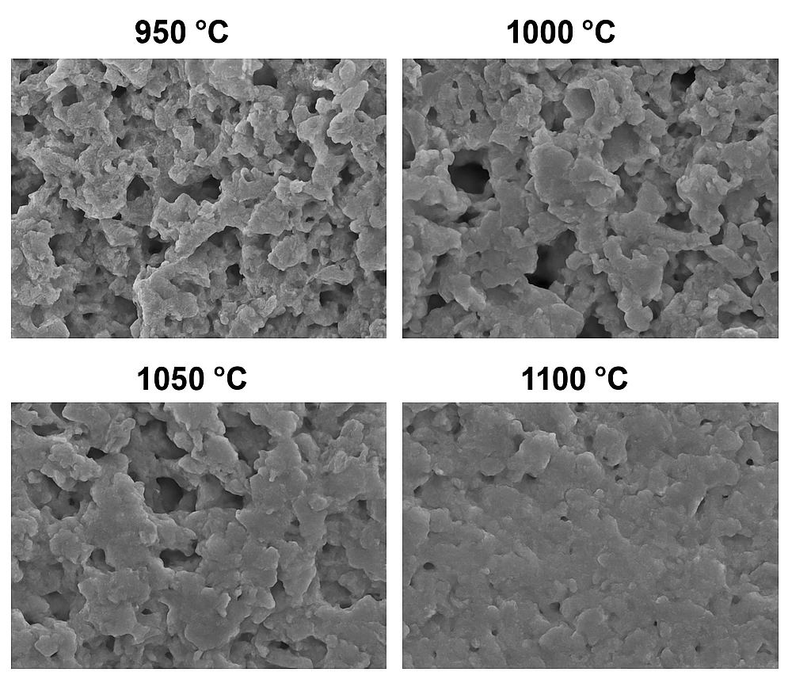
FIGURE 3. SEM microstructures of basalt-kaolin composites at several different temperatures (950–1100 °C)
If the sintering temperature is increased, it can be seen that the material density improves from 2.45 g/cm³ to 2.85 g/cm³. This improvement is attributed to the reduction of porosity and improved grain-to-grain bonding. Again, SEM micrographs taken at 950–1150 °C showed that the 2–3 μm pore size, loosely arranged particles, transformed into a densely packed structure and the grain size expanded to 7–9 μm. In addition, the pore size decreased significantly to about 1–2 μm. These morphological modifications contribute to the material's excellent mechanical strength and chemical stability.
Thus, the analyses confirm the phase stability, high heat resistance, and long-term alkali resistance of composite materials made from Aydarkull basalt and kaolin.The results showed that the optimized basalt-kaolin mixture (B–K–7) has strong technological potential in industrial ceramics, chemical-resistant coatings, and alkali-resistant structural materials.
CONCLUSION
This research established that elderberry basalt, basalt, and cauliflower kaolin are suitable raw materials for the production of alkali-resistant composite CERAMICS. Crystallization begins at 1000–1100 °C and forms a dense microstructure at 1350–1400 °C, consisting mainly of mullite and anorthite, with a density of about 1000 °C. And oh yeah, 2.85 g/cm3, porosity 8-10%. Seriously, the B–K–7 (82:18) mixture in 10% NaOH medium shows only 0.5% mass loss and 4.6% decrease in compressive strength after 7 days, while smaller decreases (≥4% and ≥8%) are observed after 90 days, confirming its long-term chemical stability.
This technology will reduce energy consumption by 15-18% and overall production costs by 20-25% compared to traditional ceramics. This is due to the early liquid phase sintering and the lower firing temperature of 150-200°C. Finally, it can be seen that these compounds are promising for protective coatings and structural parts in harsh alkaline environments.
Overall, the conclusions of this study are consistent with the experimental results of local addercole basalt and kaolin. And oh yeah, the results show that these local mineral resources enable the creation of alkali-resistant, high-performance, cost-effective composite materials suitable for import substitution in industrial applications.
REFERENCES
- Jumaniyazova, D., Jumaniyazov, M., Bekberganova, D., & Aitova, S. (2025). Acid-resistant anticorrosive coating based on epoxy resin, zinc phosphate, and hexamethylenetetramine. AIP Conference Proceedings, 3304, 040051. https://doi.org/10.1063/5.0270113
- Masharipova, S., Jumaniyazov, M., & Aitova, S. (2025). Improvement of the technology of obtaining mineral binders from loess-like rocks using mechanoactivation. E3S Web of Conferences, 633, 08004. https://doi.org/10.1051/e3sconf/202563308004
- Masharipova, S. M., Kadyrova, Z. R., Danilovich, D. P., Ataeva, F. A., & Masharipova, Z. A. (2024). Development of ceramic brick compositions for restoration of historical heritagesites based on Loess–Beet Lime composition. Glass and Ceramics. https://doi.org/10.1007/s10717-024-00682-1
- Masharipova, S., Jumaniyazov, M., Turkmenbaeva, M., & Kabulova, L. (2025). Study of physicochemical properties of hydrophobic calcite based on sugar factory defecates. E3S Web of Conferences, 633, 01003. https://doi.org/10.1051/e3sconf/202563301003
- Bo, R., Shaobai, S., Yawei, L., & Shengli, J. (2015). Correlation of pore structure and alkali vapor attack resistance of bauxite–SiC composite refractories. Ceramics International, 41(10), 14674–14683. https://doi.org/10.1016/j.ceramint.2015.07.190
- Bo, R., Yawei, L., Shengli, J., & Shaobai, S. (2017b). Correlation between chemical composition and alkali attack resistance of bauxite-SiC refractories in cement rotary kiln. Ceramics International, 43(16), 14161–14167. https://doi.org/10.1016/j.ceramint.2017.07.157
- Ren, B., Li, Y., Nath, M., Wang, Q., & Xu, Y. (2018). Enhanced alkali vapor attack resistance of bauxite-SiC refractories for the working lining of cement rotary kilns via incorporation of andalusite. Ceramics International, 44(18), 22113–22120. https://doi.org/10.1016/j.ceramint.2018.08.323
- Stjernberg, J., Olivas-Ogaz, M., Antti, M., Ion, J., & Lindblom, B. (2012). Laboratory scale study of the degradation of mullite/corundum refractories by reaction with alkali-doped deposit materials. Ceramics International, 39(1), 791–800. https://doi.org/10.1016/j.ceramint.2012.06.094
- Schaafhausen, S., Yazhenskikh, E., Heidenreich, S., & Müller, M. (2013). Corrosion of silicon carbide hot gas filter candles in gasification environment. Journal of the European Ceramic Society, 34(3), 575–588. https://doi.org/10.1016/j.jeurceramsoc.2013.10.011
- Bläsing, M., Schaafhausen, S., & Müller, M. (2013). Investigation of alkali induced corrosion of SiC filter candles at high temperature, in gasification environment. Journal of the European Ceramic Society, 34(4), 1041–1044. https://doi.org/10.1016/j.jeurceramsoc.2013.10.035
- Korabayev, S., Ergashev, O., Mahsudov, S. A., & Mamatova, S. (2024). Exploring common technical issues in modern technology. BIO Web of Conferences, 145, 03016. https://doi.org/10.1051/bioconf/202414503016
- Liu, C., Xiao, G., Chen, C., Xie, B., Ding, D., Lei, C., Parr, C., & Wöhrmeyer, C. (2025). Na 2 CO 3 –Na 2 SO 4 corrosion resistance of mullite castables. Journal of the American Ceramic Society, 108(7). https://doi.org/10.1111/jace.20463

