Possibilities for Enhancing the Physical and Mechanical Properties of Osmonsay-1 Basalt Through Ultrasonic Treatment
Khudoyor Rakhmatov¹, Boburmirza Rakhmatov¹, Sharofat Masharipova², Tursunoy Usmanova³, Sherzod Korabayev^{4, a)}
¹Karshi State Technical University, Karshi, Uzbekistan
²Urgench State University named after Abu Raykhan Beruni, Urgench, Uzbekistan
³Fergana State University, Fergana, Uzbekistan
⁴Namangan State Technical University, Namangan, Uzbekistan

^{a)}Corresponding author: sherzod.korabayev@gmail.com
Abstract: The effect of ultrasonic treatment of basalt from the Osmonsay-1 deposit in Uzbekistan was investigated. From the experimental results, it can be seen that the crystal structure of basalt remains intact. Ultrasound radiation serves to increase the density, compressive strength and surface activity of basalt. At the same time, the voids can form small bubbles that flash and burst very quickly. As a result, it becomes possible to close small surface cracks with smaller and denser particles. The ideal treatment parameters are a power density of 2 W/cm², a treatment time of 30 minutes, and a frequency of 25 kHz. Under such special conditions, the material shows its ideal physical and mechanical properties. The application of ultrasonic energy is safe, energy-efficient, and highly effective. In liquid-liquid processes, high-density conditions are used to produce materials, resulting in better physical and chemical properties than those achieved by other methods in the production of activated basalt powder. Like, this result confirms the effectiveness of this approach.
Keywords: basalt, ultrasound, Osmonsoy-1 deposit, cavitation, surface activation, physicochemical properties
INTRODUCTION
Basalt is a volcanic rock composed of the mineral’s olivine, pyroxene, and plagioclase. And at the same time, it has a very fine-grained structure and very high mechanical strength. This material also effectively withstands high temperatures. But its surface remains relatively inert, which limits its use in conditions where strong basic properties, such as adhesion or chemical interactions, are required. So, researchers are currently working to improve the physical and chemical properties of basalt.
During sonication, the microscopic bubbles in the liquid collapse through a process called cavitation. Like, during cavitation, these bubbles create a strong, high-velocity liquid stream, called a microjet, and shock waves from their collapse. For example, small beams and shock waves impact the surface of basalt. In this case, the targeted force compresses a small amount of material and changes the surface properties, thereby reducing open pores and increasing the adhesion surface of the basalt to other materials.
Despite these developments, basalt from the Osmonsay-1 deposit in Uzbekistan has not yet been investigated using ultrasonic processing. The aim of the study is to overcome this shortcoming. At the same time, in laboratory conditions, we will be able to evaluate the structural, morphological and mechanical changes that occur as a result of ultrasound irradiation.
Several studies in Uzbekistan today are aimed at extracting local mineral resources. For example, in the scientific works of the authors Gomanyazov M.J. et al. [1-4], it is mentioned that it is possible to improve the properties of silicate and aluminosilicate materials using flotation and physicochemical methods. Plus, A.Ruzmetova and Sh.Machanoff's studies show that acid bleaching increases the whiteness and purity of kaolin and feldspar deposits [5-6].
Chemical activation has attracted great interest. For example, the results of the research conducted by the authors Dergacheva and Babevskaya's team show that by treating basalt with phosphoric and mineral acids, it is possible to partially dissolve iron, magnesium and calcium oxides, creating new active surface sites. In addition, scientists Chapman and Lee used isotopic analysis and melting experiments to see how iron, copper, and other minerals redistributed during basalt melting. These results highlight the important role of pH and thermodynamic conditions [7–10].
In addition to chemical methods, biological methods were also investigated. Like Navarette and Cockel, their team demonstrated that microorganisms can extract minerals and rare earths from basalt. It is crucial that this method also works in microgravity, which expands its application possibilities [11, 12].
Today, ultrasound therapy (acoustic cavitation) is increasingly being recognized as an effective means of physical stimulation. The results of research by scientists McCollum, Hynek, Smith and Horgan show that acid sulfate and acoustic effects can modify both the microstructure and spectral properties of basalt. It is noteworthy that glassy and crystalline phases are considered particularly sensitive to these modifications [13-15].
And oh yeah, despite the extensive related research, the ultrasonic modification of basalt extracted from the Osmonsay-1 deposit is still not well known. The present study aims to clarify the structural, morphological, and mechanical changes induced by ultrasonic treatment and to determine the optimal processing conditions for possible industrial applications.
METHODS
The basalt sample obtained from the Osmonsay-1 deposit was initially crushed by mechanical means. After that, it was ground in a planetary mill for about an hour, yielding a fine, homogeneous powder. Under controlled laboratory conditions, the material was combined with distilled water and prepared for ultrasonic processing.
Ultrasound examinations were performed at frequencies of 15 and 22 kHz for 10, 20, 30, and 40 minutes. Seriously, the temperature was constantly maintained at 25 ± 2 °C. Did you know? This method enabled the observation of differences in the material's physico-chemical properties over time and across different ultrasonic treatment durations.
Like, the ultrasound therapy used a Hielscher UP400St system with a titanium alloy probe suitable for high-density cavitation. The device operates in the 20-30 kHz frequency range, but the experimental setting was fixed at 25 kHz. This ensures stable bubble formation and controlled cavitation collapse. The nominal output power of the generator is 600 watts. The effective energy density delivered to the basalt suspension was kept at 2 W/cm².
Like, the peak-to-peak ultrasonic vibration amplitude, which directly affects cavitation intensity, was kept in the range of 40-60 micrometers (µm), that is, one millionth of a meter. Seriously, this amplitude range facilitates the formation of cavitation bubbles. Their subsequent collapse produces small jets—localized high-speed fluid streams—that interact with the particles. This mechanism enhances mixing without fragmenting the particles. And oh yeah, Plus, an integrated displacement sensor continuously monitored the amplitude during the experiment.
The ultrasonic treatment was performed in a double-walled borosilicate glass, glass batch reactor with an internal diameter of 60 mm, a height of 120 mm, and a nominal capacity of 200 ml. The reactor is designed to ensure a uniform distribution of ultrasound acoustic pressure and to attenuate standing-wave nodes. During the experiment, the temperature of the suspension was maintained at 25 ± 2 °C using a closed and recirculating thermostatic water jacket. To improve the transmission of acoustic energy through the suspension of basalt particles, the ultrasonic probe (horn) was immersed 15–20 mm below the air–liquid interface.
After ultrasonic processing, the processed material was dried separately and then analyzed using advanced process characterization techniques. These include Fourier transform infrared spectroscopy (FTIR), scanning electron microscopy (SEM), and X-ray diffraction (XRD). And oh yeah, these methods enabled the identification of structural, morphological, and mineralogical changes, changes attributable to ultrasound exposure.
RESULTS AND DISCUSSION
The initial stage of our research concentrated on the physicochemical attributes of the Osmonsoy-1 basalt. X-ray fluorescence (XRF) analysis performed yielded a comprehensive elemental composition. And finally, clear peaks appear in the spectrum, corresponding to light, medium, and heavy elements.These peaks facilitate a clearer understanding of the material's mineralogical characteristics.
XRF results identify the basalt's main components and its chemical properties—silicon, aluminum, and magnesium are dominant, indicating a high concentration of silicate minerals. Calcium, iron, and several other trace elements indicate the extent to which plagioclases, pyroxenes, and alternative secondary phases contribute to the material. The low concentrations of transition metals indicate compositional stability in the Osmonsoy-1 basalt, suggesting the material is unlikely to undergo significant natural alteration, which is advantageous for subsequent structural modifications. During ultrasonic activation, microbubbles generated in the medium collapse near the stable basalt structure, producing localized shockwaves that may influence surface morphology without inducing widespread alteration.
FIGURE 1. X-ray fluorescence (XRF) spectrum of the Osmonsoy-1 basalt sample showing characteristic peaks of light, medium, and heavy elements across the energy range of 1–35 keV
The X-ray fluorescence (XRF) reveals the elemental composition of Osmonsoy-1 basalt... Seriously, it shows characteristic peaks across different energy ranges. In the low-energy region (1.5-3 keV), the lines corresponding to Mg, Al, Si, and S indicate a predominantly silicate composition. And oh yeah, the middle energy band (4-7 keV) shows low-intensity peaks for Ti, V, Cr, Mn, and Fe, indicating the presence of these oxides in small amounts. At higher incident energies (8-15 keV), smaller peaks are observed for heavy elements such as Y, Rb, Zr, Sr and Pb.
Seriously, the attached image shows an X-ray diffraction (XRD) analysis of the Osmonsoy-1 sample. Guess what? From the diffraction pattern, we can see the location of the crystalline phases based on the peak intensities and 2θ angle measurements. Do you know what? This mineral helps provide us with very important information that we need to determine structural features, phases, and indicators of hydrothermal alteration.

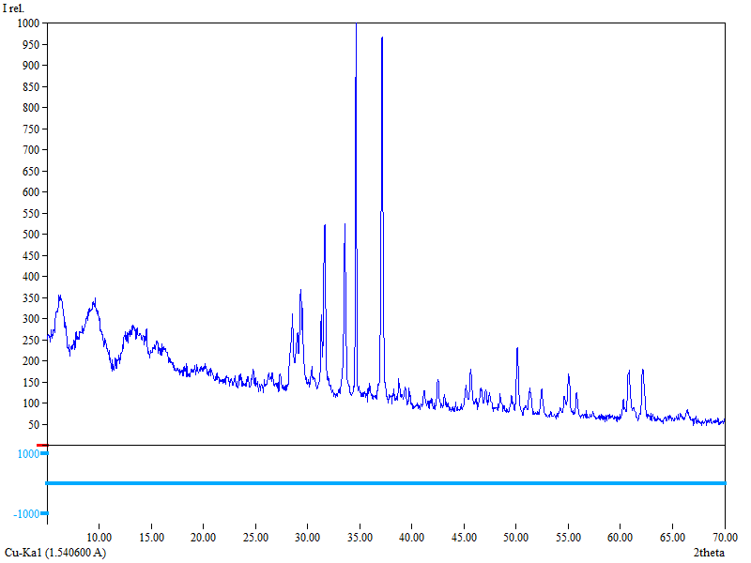
FIGURE 2. X-ray diffraction (XRD) distribution of crystalline phases in the range of 5–70° 2θ of a basalt sample from the Osmonsoy-1 deposit
An X-ray image of a basalt sample from the Osmonsoy-1 deposit shows several crystalline phases. For example, the most common mineral phase, plagioclase feldspar, shows peaks between 31–33° and 34–36°. Clinopyroxene (augite) produces additional peaks at 29-30°, 35-37°, and 51 fifty-52°. Small peaks observed in the temperature ranges of 36-37° and 41-42° indicate the presence of olivine. A weaker, weaker reflection between 32° and 33° and between 56° and 57° suggests the presence of iron oxide minerals such as ilmenite or magnetite. A broad, low-density hump of 15-25 degrees indicates a glassy, amorphous basalt phase common in volcanic rocks.
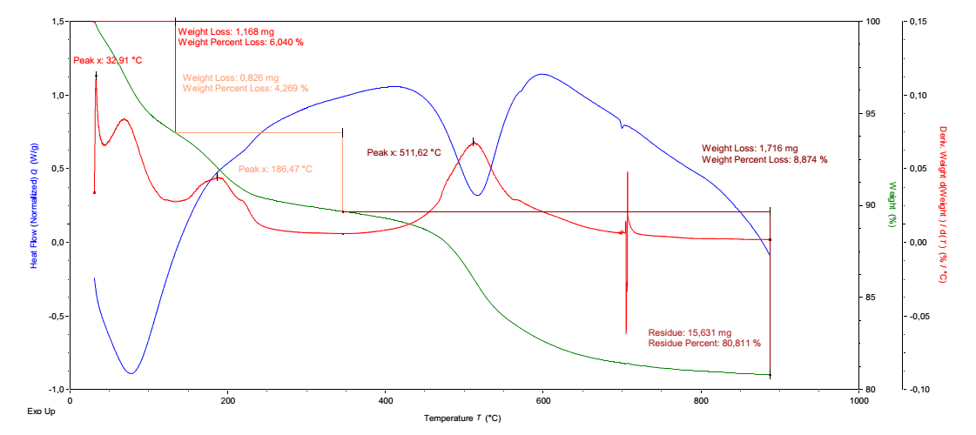
FIGURE 3. Thermogravimetric (TGA) and differential scanning calorimetry (DSC) analysis of basalt samples from the Osmonsoy-1 deposit
The TGA/DSC curve in Figure 1 shows three different thermochemical events occurring at 33.9 °C, 186.5 °C, and 511.6 °C. At low temperatures, the observed mass loss is due to adsorption of adsorbed water on the surface, which can generate microbubbles as water vapor escapes from the pores. In this case, the mass loss at 186.5 °C may be due to the release of structurally bound hydroxyl groups, which can be seen to contribute to gas evolution and microbubbles formation within the matrix. Then, at a temperature of around 511 °C, the first exothermic peak corresponds to the recrystallization of the amorphous phase, where it can be seen that residual microbubbles may be trapped or destroyed as silicate structures form. Basalt from the Osmonsoy-1 deposit has shown excellent stability at high temperatures in experiments. The results show that it retains approximately 80.8% of its original mass at temperatures up to 900-950 °C.
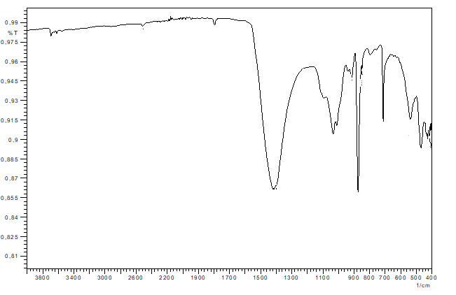
FIGURE 4. FTIR spectrum of basalt samples from the Osmonsoy-1 deposit
The FTIR absorption spectrum (Figure 4) shows several leading bands. The prominent features in the range 3420–3620 cm⁻¹ are due to the O–H stretching vibrations of hydroxyl groups, which help form microbubbles by absorbing and emitting water. The bands between 1630 and 1650 cm⁻¹ originate from H–O–H bending vibrations. The strong absorptions in the range 1030-1010 cm⁻¹ are related to vibrations of Si-O-Si and Si-O-Al bonds. Other bands in the range 870-470 cm⁻¹ are due to Al-O and Fe-O vibrations, indicating the presence of aluminosilicate minerals such as anorthite, augite, and olivine in the basalt. These minerals also provide places where microbubbles can form.

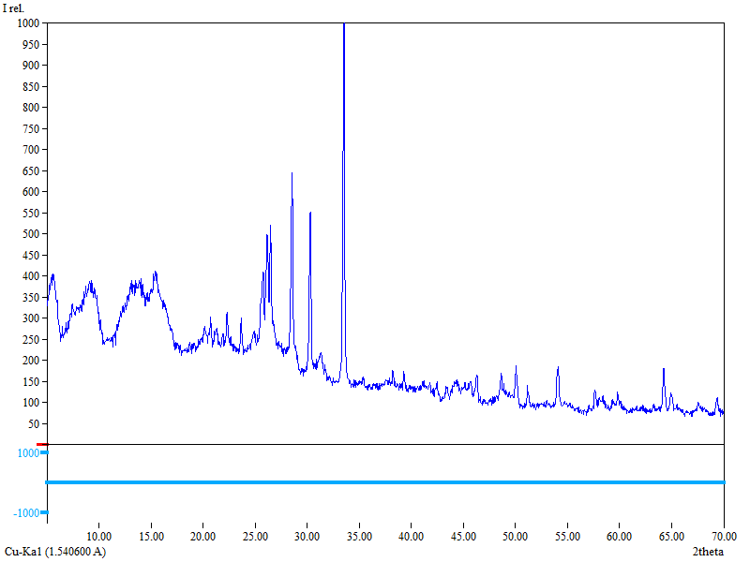
FIGURE 5. X-ray diffraction (XRD) analysis of basalt samples mined from the Osmonsoy-1 deposit
From the diffractogram in Figure 5, we can see clear peaks in the 2θ range of 27-36° and 41-47°, corresponding to mineral phases such as pyroxene, plagioclase, and magnetite. The high background intensity indicates the presence of an amorphous glassy phase, one of the main characteristics of a volcanic basalt sample.
The experimental results and thermogravimetric analysis confirm that the composition of the rocks is stable up to 900-950°C. FTIR spectra show the presence of aluminosilicate bonds, including Si-O-Al and Si-O-Si bonds, indicating that the basalt may melt uniformly rather than separating into separate components. This property makes the material suitable for the production of basalt fiber.
Due to its high, stable silicate content and beneficial lime-magnesium ratio, Osmonsoy-1 basalt is known as a promising raw material for the production of basalt fibers, thermal insulation boards, and refractory materials.
Scanning electron microscopy (SEM) provided convincing evidence of surface and surface morphological changes induced by ultrasound treatment. The untreated sample showed a rough surface, characterized by small cracks and visible pores. After ultrasound exposure, the surface became denser, smoother, and at the same time more uniform. Localized effects from cavitation bubble collapse removed surface debris and reduced the number of shallow pores, culminating in a more compact structural profile.
Increased particle cohesion, driven by reduced pore size, was observed, improving the strength and stability of the basalt material. Seriously, The decrease in pore size increased the contact surface of the particles, thus, thus increasing the mechanical interlocking. As can be seen from Fig.2, the ultrasonically treated basalt sample is clearly denser and has a more uniform microstructure, with significantly fewer microcracks both on the surface and below. This morphological improvement indicates that ultrasound energy promotes the redistribution of surface stresses, thereby increasing the compaction and structural integrity of the material.
These structural modifications are intricately linked to the localized pressure pulses and high-velocity microjets characteristic of cavitation phenomena. When cavitation bubbles collapse, they release short, intense bursts of energy that can remove weak spots in the basalt surface, seal more minor flaws, and dislodge loosely attached particles. The microscopic effects described above increase the density of the material by filling microscopic voids in the sample and strengthening the bonding between particles. As a result, the treated basalt exhibits improved density and excellent mechanical performance.

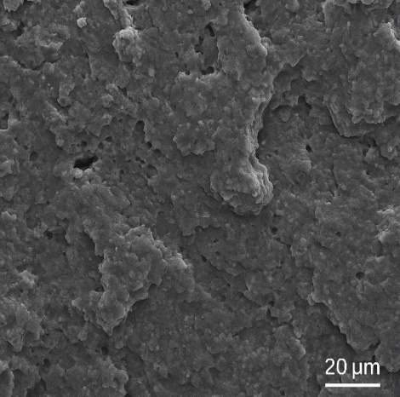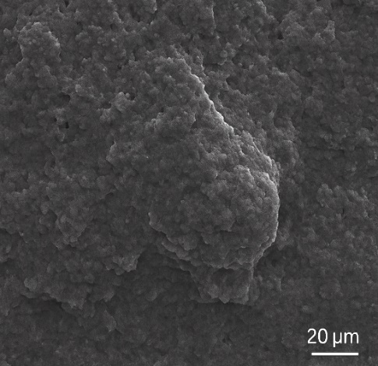
FIGURE 6. SEM micrograph of the surface of ultrasonically treated basalt from the Osmonsoy-1 deposit
Ultrasonic cavitation in a liquid medium rapidly destabilizes vapor-filled voids, creating localized regions of very high pressure (1-10 GPa) and high temperature. As a result, the velocity of the micro-streams during the collapse of the bubbles reaches 50-200 m/s, which provides sufficient kinetic energy to remove the fragile surface layers of the sample, close the micro-cracks in it and increase the surface density of the basalt sample. Experimental results show that at a power density of 2 W/cm² and a frequency of 25 kHz, cavitation can be highly effective in activating the particle surface without changing the internal crystal lattice. The synergistic effect of these physical phenomena on the sample increases the adhesion of particles in the sample, thereby resulting in a stronger and less porous material.
Seriously, the scanning electron microscope (SEM) images accurately depict the morphological changes induced by ultrasound treatment. For example, we can see from microscopic images that the surface of the treated basalt samples is denser, relatively smoother, and more compact. In general, although these small ridges and narrow grooves can still be distinguished from each other, the overall surface shows a greater degree of uniformity.
From our observations, it became clear that the intense cavitation generated during ultrasonic irradiation eliminates small surface defects and improves the structural integrity of the sample material. Microactive effects from bubble formation and collapse enhance cohesion by strengthening interparticle contact points and reducing pore size within the surface layer.
Ultrasonically treated basalt exhibits a noticeably smoother, denser morphology, significantly reducing microcracks at both the surface and the subsurface. These improvements are due to the local or native pressure waves and highly speed microjets generated during cavitation, which very effectively fill in surface irregularities and strengthen interparticle bonds.
Micrographs clearly demonstrate the combined physical and chemical changes induced by ultrasound. And oh yeah, the analysis confirms increased structural consolidation and enhanced surface activity, indicating that ultrasound irradiation is a particularly suitable method for basalt modification.
Fourier transform infrared spectroscopy (FTIR) enhances the identification of structural changes in the treated samples. The spectroscopic data show intense vibrations of the Si-O and Al-O bonds, indicating activation of the surface and surface layers, as well as partial reorganization of the silicate framework. These spectral differences indicate enhanced structural reactivity compared to untreated materials.
The differences between the absorption bands, bands in the 470-520 cm-1 and 950-1000 cm-1 regions, indicate an increase in silicate- and aluminum-silicate bonds. Such modifications indicate the formation of new reactive sites on the basalt surface and a significant increase in surface energy. These results confirm that sonication increases the chemical reactivity and structural organization of basalt (Figure 7).

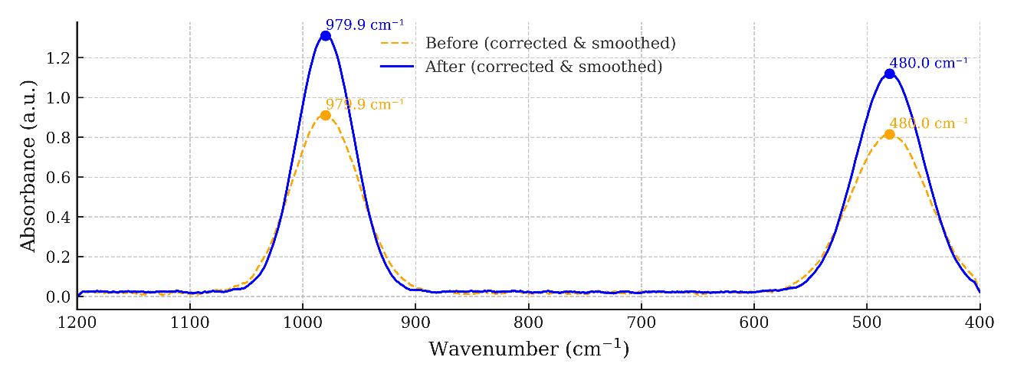
FIGURE 7. FTIR Spectrum – Increased Intensity of Si–O and Al–O Bonds in Ultrasonically Treated Basalt Samples

Fourier transform infrared (FTIR) spectroscopy shows that Osmonsoy-1 basalt undergoes structural modification after sonication. The spectra show intense vibrations within the Si-O and Al-O bonds, indicating increased activity of the silicate framework. From the results, we can see that the higher absorption peaks indicate the formation of previously unknown reactive sites on the surface of basalt samples and an increase in chemical reactivity compared to untreated samples. These results show that ultrasonication stimulates surface activation, thereby increasing the molecular reactivity of basalt.

These structural changes are associated with improvements in the physical properties of ultrasound-treated basalt. Density increased by about 6%, compressive strength by 10% and water absorption by about 9%. And oh yeah, these gains come from a denser surface layer, a stronger outer structure, and the removal of loose particles. Together, these changes make the material more durable and stable.

Our research shows that ultrasonic modulation mostly occurs through acoustic cavitation. Ultrasound stimulates the formation of microbubbles in the liquid, which then expand and collapse violently. And oh yeah, this collapse results in intense local pressure and small radii acting on the particle surfaces. These effects promote the removal of impurities, increase the surface energy, and create new reactive sites. As a result, the treated basalt exhibits increased density, increased chemical activity, and increased strength, while its internal mineral and mineral structure remain unchanged.

Physico-mechanical tests (see Table 1) show that ultrasonic activation significantly improves the material's properties. The data shows that when the compressive strength increases by 8-12%, this shows an improvement at high loads. As a result, water absorption decreases by 6-9%, which significantly reduces the possibility of open pores and moisture ingress. Density has increased by 5-7%, reflecting a tighter seal and reduced internal voids.

Like, these improvements can be attributed to the physical and chemical effects of cavitation. Seriously, when the bubbles collapse, they generate tiny, tiny jets and shock waves that push the microparticles into tiny vacuoles and seal microscopic defects, thus reducing porosity. Like, sealing surface cracks eliminates weak points that can lead to failure. Localized pressure pulsations promote a more compact molecular arrangement and strengthen the bonds between mineral grains. Together, these effects make basalt denser, stronger, and more stable over time, demonstrating that sonication is an effective means of improving its properties.

TABLE 1. Changes in the Physical and Mechanical Properties of Basalt from the
“Osmonsoy-1” Deposit After Ultrasonic Treatment
№ | Parameter Name | Unit of Measurement | Before Treatment | After Treatment | Change, % | Remark
1 | Compressive strength | MPa | 100 | 108–112 | +8–12 | Ultrasonic treatment eliminated microcracks and increased structural strength
2 | Water absorption | % | 10 | 9.4–9.1 | −6–9 | Decrease due to increased surface activity and particle density
3 | Density | g/cm³ | 2.60 | 2.73–2.78 | +5–7 | Cavitation effects led to structural consolidation and higher material density.

Looking at the data in Table 1, we can see that the physical and mechanical properties of all basalt samples were significantly improved by ultrasonic treatment. The compressive strength increased by 8–12%, which is associated with a decrease in microcracks and an increase in interparticle bonds. Thus, using the cavitation effect generated by ultrasonic waves, it becomes possible to generate pressure pulses that help close small defects and densify the structure.
If the water absorption is reduced by 6–9%, a decrease in porosity and an increase in surface activity can be observed. During the cavitation process, collapsing microbubbles create strong, localized forces that pull particles closer together and constrict capillary channels. These forces above physically compress and reshape the pore structure of the sample material, while reducing the open pore volume and limiting the ingress of water. As a result, this increases the material's resistance to moisture absorption, thereby increasing its durability and water resistance.
The density increased by 5–7%, confirming that the basalt's internal structure became more compact. The closure of microcracks and the tighter packing of particles led to a more uniform, more solid arrangement of mineral grains.
These changes above serve to increase the surface energy of the material and make it more uniform. Ultrasound waves cause rapid, localized changes in temperature and pressure, which activates interparticle bonds in the material and creates reactive sites where they were not previously present. In addition, these strong interparticle bonds make the sample material more stable, improve its cohesion, and greatly reduce the risk of deformation. Having fewer voids and microcracks also helps reduce water absorption and increase compressive strength.
A higher specific surface energy renders basalt more chemically reactive, thereby enhancing its suitability for applications such as fiber-reinforced composites and advanced ceramics. Generally, ultrasonic processing enhances both the mechanical and thermodynamic properties of the basalt microstructure.
The research methodology used in this study was carefully selected and applied by the authors. We carefully chose and applied our research methods. By using X-ray diffraction (XRD), scanning electron microscopy (SEM), and Fourier-transform infrared spectroscopy (FTIR), we were able to thoroughly and reliably analyze the material. This combined approach gave us accurate, repeatable results we could trust. Structural modifications induced by ultrasonic processing. They enable precise detection of alterations in lattice bonding, bulk density, and surface reactivity. This methodological principle applied in the protocol process can be seen in the reproducibility and consistency of the results. The data presented in Table 1 show that with the help ultrasonic treatment significantly improved the mechanical and physical properties of all basalt samples. When the compressive strength was increased by 8-12%, a reduction in microcracks and an increase in particle bonding were observed. Ultrasonic cavitation, in this case, serves to create pressure pulses that help close small defects and compact the structure.
And of course, when water absorption decreases by 6-9%, one can see a decrease in porosity and an increase in surface activity in the material. In addition, the collapse of microbubbles during cavitation creates very strong local forces that compress molecules and narrow capillary channels. These forces compress and reshape the material's pore structure, reducing the size of the open pores and limiting water ingress. This increases the material's ability to absorb moisture and also increases its water resistance.
In general, it was found that when the density increased by 5-7%, the internal structure of basalt materials became more compact. Seriously, the closing of the small, small cracks and the tighter compaction of the particles resulted in a more homogeneous and solid arrangement of the mineral grains.
These changes also increase the material's surface energy and make it more homogeneous. Ultrasound causes rapid local pressure and temperature changes, activates particle bonds, and creates new interaction sites. Stronger bonds between particles make the material more stable, improve cohesion, and reduce the risk of deformation. Fewer voids and microcracks minimize water absorption and increase compressive strength.
The higher specific surface energy makes basalt more chemically reactive, making it more suitable for applications such as fiber-reinforced composites and advanced ceramics. In general, ultrasonic treatment improves the mechanical and thermodynamic properties of the basalt microstructure.
Thoughtfully, the research method used in this study was carefully selected and applied. We have carefully studied all the above experimental results, selected these research methods, and applied them in practice. We were able to comprehensively and reliably analyze the material using X-ray diffraction (XRD), scanning electron microscopy (SEM), and Fourier transform infrared spectroscopy.
CONCLUSION
The results show that sonication changes the surface topology and physical properties of basalt extracted from the Osmonsoy-1 deposit. During sonication, microbubbles form and repeatedly collapse on the basalt surface, creating local high-pressure zones that modify the surface properties. The most significant improvement was observed after 30 minutes of ultrasound treatment with a power density of 2 W/cm² and a frequency of 25 kHz. In addition to these parameters, the basalt showed increased strength and reduced water absorption; However, its internal crystal structure remained unchanged.
The results show that ultrasonic activation is a safe, effective, and environmentally friendly method for strengthening basalt-based materials. This approach makes the material denser and improves its microstructure. It increases the surface reactivity without altering the mineral composition. And oh yeah, as a result, ultrasonic activation can be helpful, functional in applications such as high-performance building materials, ceramics, and composite systems.
REFERENCES
- Jumaniyazov M, Kurambayev Sh, Atashev E, Jumaniyozov A, & Buranova M. Determination of the composition of the Zinelbulak talc-magnesite deposit rock using modern physicochemical methods. E3S Web of Conferences. 2025; 633:06002. https://doi.org/10.1051/e3sconf/202563306002
- M. J. Jumanyazov, E. A. Atashev, Sh. K. Aitova, and H. A. Pirnapasova, Results of research on flotation of talc–magnesite raw materials from the Zinelbulak deposit, Research and Education, 3(8), 66–72 (2024). https://doi.org/10.5281/zenodo.13898527
- Buranova D, Matchanov Sh, Atashev E. Physicochemical and mineralogical characterization of Sultan Uwais feldspar for sustainable glass manufacturing in earth and environmental sciences. E3S Web of Conferences 633, 06001 (2025) https://doi.org/10.1051/e3sconf/202563306001
- 4.Buranova D.B. Main characteristics of quartz-feldspar sands from the Khiva deposit, and the physicochemical and technological fundamentals of obtaining an enriched concentrate. Mineral Resources. 2027; 340(1): 37-44. https://doi.org/10.31643/2027/6445.04
- 5.Ruzmetova A.Sh., Matchanov Sh.K., Yakubov Y.K., Matchanov Sh.Sh., Jumaniyazova Kh.Q. Research on Kaolin Bleaching of Khojakul Deposit // AIP Conference Proceedings. — Namangan, Uzbekistan: AIP Publishing, 2024. — Vol. 3304. — Paper presented at the International Conference on Physical Research & Engineering Technology Problems (PRETP 2024), October 3–5, 2024. https://doi.org/10.1063/5.0269851
- 6. Dergacheva N. P., Kochetkova N. V., Fomichev S. V., Krenev V. A. Basalt leaching with orthophosphoric acid. Inorganic Materials, 2009, vol. 45, no. 12, pp. 1366–1369. https://doi.org/10.1134/S0020168509120115.
- 7. Babievskaya I. Z., Dergacheva N. P., Fomichev S. V., Krenev V. A. Modifying the composition of gabbro basalts by leaching with hydrochloric and phosphoric acids. Theoretical Foundations of Chemical Engineering, 2010, vol. 44, pp. 580–583. https://doi.org/10.1134/S0040579510040391.
- 8. Chapman J. B., Mason T. F. D., Weiss D. J., Coles B. J., Wilkinson J. J. Iron isotope fractionation during leaching of granite and basalt by hydrochloric and oxalic acids. Geochimica et Cosmochimica Acta, 2009, vol. 73, n° 5, pp. 1312–1324. https://doi.org/10.1016/j.gca.2008.11.037.
- 9. Li D., Liu S.-A., Zhang R., Wang Z., Chen H. Copper isotope fractionation during basalt leaching at 25 °C and pH 0.3–2. Journal of Earth Science, 2022, vol. 33, no. 1, pp. 82–91. https://doi.org/10.1007/s12583-021-1499-7.
- 10. Navarrete J. U., Cappelle I. J., Schnittker K., Borrok D. M. Bioleaching of ilmenite and basalt in the presence of iron-oxidizing and iron-scavenging bacteria. International Journal of Astrobiology, 2013, vol. 12, no. 2, pp. 123–134. https://doi.org/10.1017/S1473550412000493.
- 11. Cockell C. S., Santomartino R., Finster K. et al. Space station biomining experiment demonstrates rare-earth element extraction in microgravity and on Mars. Nature Communications, 2020, vol. 11, article no. 5523. https://doi.org/10.1038/s41467-020-19276-w.
- 12. McCollom T. M., Hynek B. M. Experimental study of acid-sulfate alteration of basalt and implications for sulfate deposits on Mars. Journal of Geophysical Research: Planets, 2013, vol. 118, no. 7, pp. 1719–1751. https://doi.org/10.1002/jgre.20044.
- 13. Smith R. J., Horgan B. H. N., Cloutis E. A., Mann P., Christensen P. Acid weathering of basalt and basaltic glass. II. Effects of microscopic alteration textures on spectral properties. Journal of Geophysical Research: Planets, 2017, vol. 122, no. 1, pp. 203–226. https://doi.org/10.1002/2016JE005112.
- 14. Horgan B. H. N., Smith R. J., Cloutis E. A., Mann P., Christensen P. Acidic weathering of basalt and basaltic glass. I. Near-infrared and thermal infrared spectra and implications. Journal of Geophysical Research: Planets, 2017, vol. 122, no. 1, pp. 172–202. https://doi.org/10.1002/2016JE005111
- Masharipova, S., Jumaniyazov, M., & Aitova, S. (2025). Improvement of the technology of obtaining mineral binders from loess-like rocks using mechanoactivation. E3S Web of Conferences, 633, 08004. https://doi.org/10.1051/e3sconf/202563308004
- Korabayev, S., Ergashev, O., Mahsudov, S. A., & Mamatova, S. (2024). Exploring common technical issues in modern technology. BIO Web of Conferences, 145, 03016. https://doi.org/10.1051/bioconf/202414503016
- Masharipova, S. M., Kadyrova, Z. R., Danilovich, D. P., Ataeva, F. A., & Masharipova, Z. A. (2024). Development of ceramic brick compositions for restoration of historical heritagesites based on Loess–Beet Lime composition. Glass and Ceramics. https://doi.org/10.1007/s10717-024-00682-1
- Masharipova, S., Jumaniyazov, M., Turkmenbaeva, M., & Kabulova, L. (2025). Study of physicochemical properties of hydrophobic calcite based on sugar factory defecates. E3S Web of Conferences, 633, 01003. https://doi.org/10.1051/e3sconf/202563301003

