Coal Purification from Mercaptanes with Sorbents Obtained from Navbahor Bentonite
Mokhina Muhamadjonova¹, Normurot Fayzullaev¹, Jasur Shukurov^{1, a)}, Аbidjon Тillyaev¹, Sohiba Pardayeva², Rustam Sapayev³
¹Samarkand State University, Samarkand, Uzbekistan.
²Samarkand State Medical University, Samarkand, Uzbekistan
³Urgench State University, Urgench, Uzbekistan

^{a)}Corresponding author: shukjasni@gmail.com
Abstract. In this work, a two-stage technology for purifying coal from sulfur compounds — mainly H₂S and mercaptans — was studied. In the first stage, a physical desorption method was used, using nitrogen as the desorption gas. Gas-liquid interaction was studied in a glass column with a height of 450 mm and a diameter of 48 mm. The lattice structure was located in the lower layer of 2 mm, which ensured a uniform distribution of the gas flow. In the second stage, deep purification was carried out by absorbing H₂S and mercaptans from coal residues using a chemical reagent. In the study, a mesoporous zeolite synthesized from bentonite was used as an adsorbent, and its dynamic adsorption capacity with water vapor and n-heptane was studied. Its mineralogical and structural properties were determined through chemical composition, diffractogram, IR-spectrum and thermogravimetric analysis of bentonite obtained from Navbahor mine. The results showed that mesoporous zeolite has high adsorption activity and can be an effective adsorbent in the process of coal purification by desorption. The relationships between nitrogen flow rate, temperature, and coal mass in the column were analyzed graphically. As a result, it was found that the H₂S removal efficiency increases with increasing temperature and a corresponding increase in the desorption gas flow rate. The presented technology allows for the purification of coal from sulfur compounds in an economically profitable and environmentally safe way.
Keywords: bentonite, montmorillonite, hydrogen sulfide, coal, mercaptan, sorption.
INTRODUCTION
In the last decade, the technological pollution of the environment with sulfur dioxide has become a global threat. More than fifty percent of the global environmental pollution is due to sulfur dioxide [1-3]. Today, the total amount of sulfur in sulfur compounds in the atmosphere and hydrosphere is twice as much as in the previous period of technological development. Today, environmental analysis shows that the amount of sulfur compounds formed is twice as much as the amount released from the atmosphere. It is known that sulfur dioxide is oxidized in the atmosphere by oxygen, moisture and light [4-7].
The resulting sulfuric anhydride and sulfuric acid are highly reactive and have a negative impact on the environment, affecting photosynthetic processes, interfering with photosynthesis in plants, disrupting the water regime during the oxidation of photodynamic pigments, reducing the photochemical activity of chloroplasts, etc. [8-11].
It is known that hydrocarbon gases (along with natural gas and coal) consist mainly of hydrocarbons of the methane row, which contain variously aggressive impurities. These mainly include carbon disulfide, carbon dioxide, mercaptan, and others [12-13]. In addition, gases contain varying amounts of water vapor, which increases the aggressiveness of the gas. Since hydrogen sulfide is an acid, it causes chemical or electrochemical (because it is water) corrosion in technological devices. In such an environment, the corrosion process takes place in a specific way, the degree of corrosion depends on various factors [14-16]. Therefore, due to the presence of hydrogen sulfide and hydrocarbon raw materials in coal and gas facilities, many problems, accidents, fires, or explosions are observed during the exploitation process, and in many cases, cracks (when metals mix with sulfide), including embrittlement of metals in the presence of moisture. The peculiarity of sulphide corrosion is that they destroy the places where the mixture is connected. At first, the corrosion of heat-resistant compounds is local, then it separates into separate metals. But after that, gas corrosion penetrates deep into the metal. Thus, hydrogen sulfide is a catalyst for failure of ferrous metals and steel tools.
Coal activity decreases as a result of organic tars settling on its surface and polymer metals settling on the active part. Therefore, this method is not widely used in production. In addition, the disadvantage of this method is its periodicity and the cleaning device takes up a lot of spaces [17-21].
EXPERIMENTAL PART
Nitrogen was used as the desorption gas. The I-column was equipped with a glass grid with a height of 450 mm and a diameter of 48 mm, each grid section having a 2 mm fence at the bottom. The dynamic adsorption capacity of mesoporous zeolites synthesized from bentonite is determined using water vapor in laboratory conditions, the diagram of which is presented in Figure 1.
Measurements. Air is passed through a valve (1) to purify mechanical impurities and coal droplets, a cartridge (2) filled with activated carbon is passed through an air line or a laboratory gas blower, a rotameter (3) is used to humidify a thermostated Ivitsky flask (4) half filled with water.
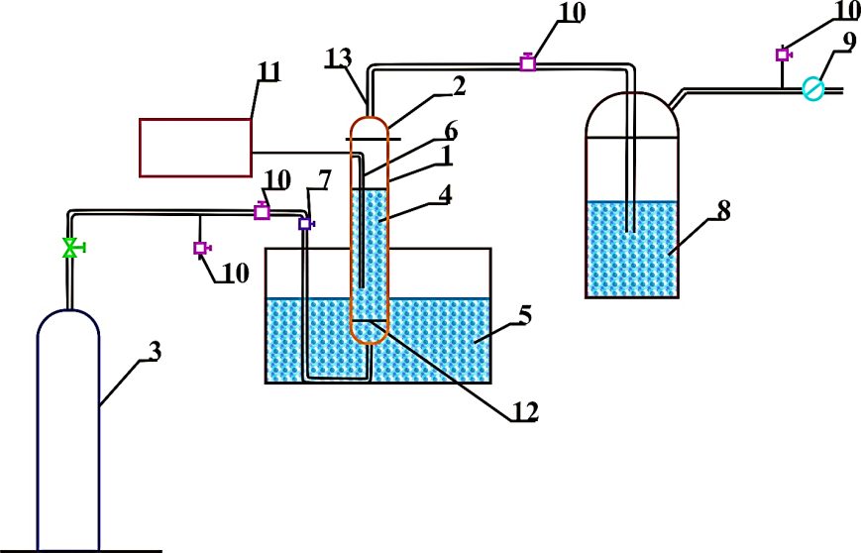
FIGURE 1. Diagram of a laboratory plant for oil gas purification
1-column, 2-glass nozzle, 3-nitrogen cylinder, 4- nozzle, 5- thermostat, 6- pocket for thermocouple 7- connector, 8- Drexel bottle 9-gas meter (gas indicator), 10-screw cap, 11-potentiometer 12-perforated plate 13-downpipe

Determination of the dynamic adsorption capacity of mesoporous zeolites synthesized from bentonite with water vapor and n-heptane.
Determination of the dynamic adsorption capacity of mesoporous zeolites synthesized from bentonite using water vapor.
Thermostating of the Ivitsky flask is carried out using a water bath (5), in which water circulates from a thermostat with a temperature of 20°C. The temperature of the water in the bath is measured with a thermometer.
Humidified air with a given moisture content of 13 to 15 mg / dm³ is supplied to the adsorber with the adsorbent under study (10) through a trap (7), a droplet separator cartridge (8) and a three-way valve (9). At the outlet of the adsorber, the dried air is divided into 2 streams using a three-way valve (11) and a clamp (12). The flow rate from 0.5 to 1.0 dm³/min is fed to the solution flow indicator (EOK) (14) to determine the boiling point. After the rheometer (15), it is connected to the main air stream with a three-way connection. The total flow is fed to the gas meter (19) and then released into the atmosphere.

RESULTS AND DISCUSSION
The chemical composition of bentonite obtained from Navbahor mine is presented in Table 1
TABLE 1. Chemical composition of Navbahor bentonite.
Oxide composition %
SiO₂ | TiO₂ | Al₂O₃ | Fe₂O₃ | FeO | CaO | Mg | Na₂O | K₂O | P₂O₅ | SO₃ | Ba | Additional products
57.7 | 1.04 | 13.75 | 5.36 | 0.2 | 2.49 | 3.13 | 1.74 | 0.24 | 0.16 | 0.65 | 0.08 | 13.4
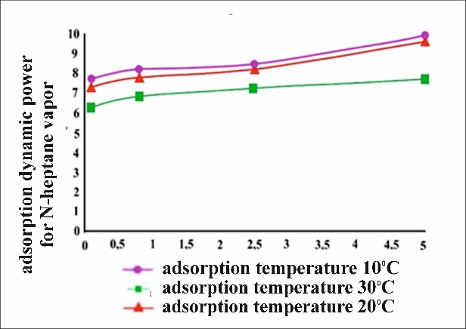 | 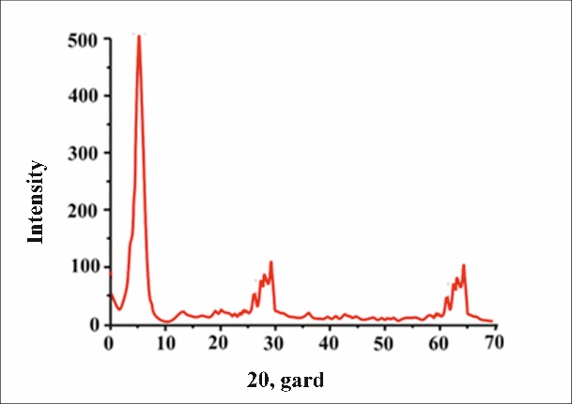
FIGURE 2. Dynamic adsorption СCcapacity of modified mesoporous zeolite for n-heptane vapors. | FIGURE 3. Diffractogram of Navbahor bentonite
TABLE 2. Deciphering the diffractogram of Navbahor bentonite
2Θ, рад. | d,Å | Mineral
7 | 12.6 | Montmorillonite
20.98 | 4.23 | Cristobalite
26.66 | 3.34 | Silica
28.67 | 3.11 | Plagioclase
29.44 | 3.03 | Calcite
39.66 | 2.27 | Calcite
47.55 | 1.91 | Calcite
56.76 | 1.62 | Plaster

The results of decoding of the diffractogram are presented in Table 2. The results obtained show that the composition of Navbahor bentonite consists of a loamy, wet polymineral. In the dispersed part of the sand and dust fraction, feldspar is present in the form of plagioclase (d=0.311nm). Montmorillonite is present in 3 fractions in the sample: 0.1-0.2μm, 0.5-0.6μm (the main part) and 2-4μm.

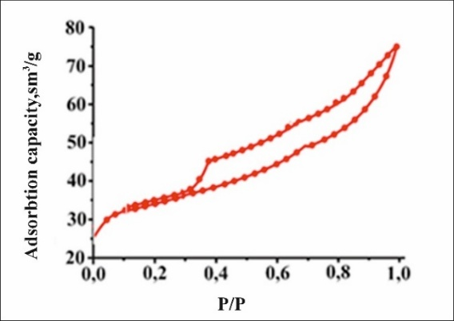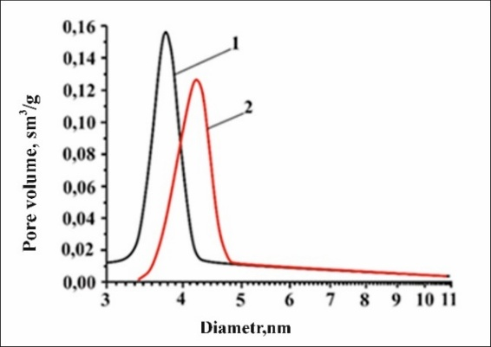
a) b)
FIGURE 4. Nitrogen adsorption-desorption isotherms (a) and pore size distribution curve (b)
Figure 4 shows the low-temperature nitrogen adsorption-desorption isotherm (a) for simple montmorillonite. The adsorption isotherm belongs to type IV according to the IUPAC classification, which is characteristic of these mesoporous materials and corresponds to the onset of a capillary-condensation hysteresis loop. The shape of the hysteresis loop corresponds to type H3 according to the IUPAC classification, which indicates the presence of cracks and flat parallel tracks in the structural layer of the material. It indicates that cracks mainly appear in the desorption network. When P/P≈1, the sorption curvature in the isotherm increases sharply, which indicates the presence of large particles in the montmorillonite composition, and the curvature (Fig. 4,b) indicates an increase in the particle size. Montmorillonite has a specific surface area of 98 m²/g and a variation range of 56-130 m²/g, which is typical of ordinary montmorillonite clay. The total volume of the particle is 0.25 cm³/g, and the particle diameter is 8.68 nm.
Technology of oil purification from H₂S and mercaptans by two-stage methods. The essence of coal purification from H₂S by a combined process is to pre-desorb the main volume of H₂S from the coal with sulfur dioxide gas, and then to purify the remaining volume of H₂S and mercaptans using a reagent absorber. Pre-purification of the main volume of H₂S from the coal with a desorption gas by a physical method allows to significantly reduce the cost of the reagent absorber used in the second stage; when purified only chemically, the cost of the reagent absorber is too high to remove H₂S from the coal. The second stage - additional chemical purification of oil provides a clear guarantee.
If the H₂S in the coal is more than 300 ppm. The use of this method is even greater in these situations, firstly, if there are reserves of natural gas, it can be used for desorption of H₂S. Secondly, if the oil drilling site has equipment used to clean the gas on the coal road, clean the remaining H₂S and mercaptans with a chemical reagent.

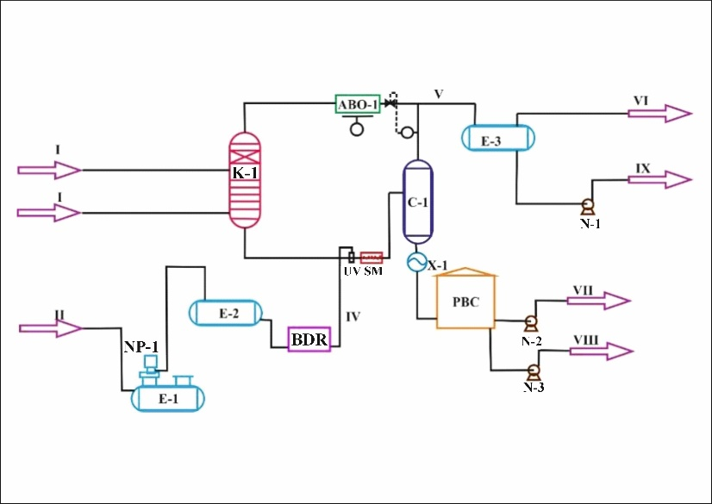
FIGURE 5. Flow diagram of combined purification of coal from sulfur compounds
Characteristics of flows:
I – dewatered and desalinated coal ;
II – gas used for purification of hydrocarbons;
III, IV – inlet streams of the “ASM” reagent;
V – gas separated from the desorption process;
VI – stream formed as a result of desorption of separated gas;
VII – initial crude coal;
VIII – water separated during the production process;
IX – gas condensate.
Main devices and equipment:
E-1 – underground container intended for receiving the reagent;
NP-1 – submerged pumping unit;
E-2 – temporary storage tank for the reagent;
BDR – reagent supply unit;
UV – disperser (a device for homogenizing the mixture particles);
SM – static mixer;
K-1 – desorption column;
ABO-1 – air cooling device;
C-1 – separator (phase separation equipment);
X-1 – cooler;
RVS – tank for storage and sale of finished petroleum products;
E-3 – gas condensate collection structure.
CONCLUSION
As a result of the conducted studies, it was proven that a two-stage method of cleaning coal from sulfur compounds, in particular H₂S and mercaptans, is effective. In the first stage, the main H₂S content in the coal was reduced using nitrogen gas through a physical desorption process. In the second stage, residual sulfur compounds were completely neutralized using a chemical reagent.
Mesoporous zeolite synthesized from bentonite is characterized by its high dynamic adsorption capacity as an adsorbent, its good absorption of water vapor and n-heptane, as well as thermal stability. Analysis of the composition and structure of Navbahor bentonite confirmed the possibility of using this material as a useful raw material in the synthesis of highly active zeolites.
The results show that the desorption system based on nitrogen gas is an energy-efficient, environmentally friendly and technologically efficient method for purifying coal from sulfur compounds. Implementation of this method in production conditions to increase the quality and purity of coal products.
REFERENCES
- Tkacheva, T., Ogurcov, N., Schepin, A., & Zhuravleva, D. (2018). EFFICIENCY TESTS OF DESULPHURIZING AGENTS IN OIL. Proceedings of Universities Applied Chemistry and Biotechnology, 8(2), 86–92. https://doi.org/10.21285/2227-2925-2018-8-2-86-92
- Kornetova, O., Vildanov, A., Korobkov, F., Aslyamov, I., & Nizamutdinova, G. (2020). Oxidation-catalytic procyess for on-site removal of H2S and low molecular wyeight mercaptans from oil. Neftânaâ Provinciâ., 4(24), 243–251. https://doi.org/10.25689/np.2020.4.243-251
- Bogatyryov, T. S., Kurachkin, A. V., Denil’khanov, M. N., & Kozlova, I. I. (2019). Study of oil desulfurization from hydrogen sulfide and mercaptans by vacuum separation method. Oil Refining and Petrochemistry: Scientific and Technical Achievements and Advanced Experience, (1), 33–37. https://doi.org/10.25689/NP.2019.1.33-37
- Jafar, S. A., Nawaf, A. T., & Humadi, J. I. (2021). Improving the extraction of sulfur-containing compounds from fuel using surfactant material in a digital baffle reactor. Materials Today: Proceedings, 42, 1777–1783. https://doi.org/10.1016/j.matpr.2021.02.719
- Shukurov J. Modeling the production of dimethyl ether from natural gas //AIP Conference Proceedings. – AIP Publishing LLC, 2025. – Т. 3304. – №. 1. – С. 040062. https://doi.org/10.1063/5.0269234
- Mamadoliev, I. I., et al. (2020). Optimization of the activation conditions of high silicon zeolite. International Journal of Advanced Science and Technology, 29(3), 6807–6813. https://doi.org/10.13140/RG.2.2.10602.72644
- Temirov, F. N., Khamroyev, J. K., Fayzullayev, N. I., Haydarov, G. S., & Jalilov, M. K. (2021). Hydrothermal synthesis of zeolite HSZ-30 based on kaolin. IOP Conference Series Earth and Environmental Science, 839(4), 042099. https://doi.org/10.1088/1755-1315/839/4/042099
- Khamroyev, J. K., et al. (2022). Mechanical activation of Navbahorsk bentonite and its textural and adsorption characteristics. News of the National Academy of Sciences of the Republic of Kazakhstan, Series of Geology and Technical Sciences, 1(451), 167–174. https://doi.org/10.32014/2022.2518-170X.163
- Sarimsakova, N. S., et al. (2020). Kinetics and mechanism of reaction for producing ethyl acetate from acetic acid. International Journal of Control and Automation, 13(2), 373–382. https://doi.org/10.47191/ijca/vol13iss2/105
- Shukurov J., Fayzullaev N. Direct synthesis of dimethyl ether from synthesis gas //AIP Conference Proceedings. – AIP Publishing LLC, 2024. – Т. 3045. – №. 1. – С. 060042. https://doi.org/10.1063/5.0197641
- Ibr Al-Hawary, I. S. S., et al. (2024). Synthesis of N, N′-alkylidene bisamides and Suzuki–Miyaura coupling reaction derivatives with Pd organometallic catalyst anchored to channels of mesoporous silica MCM-41. Scientific Reports, 14(1), 7688. https://doi.org/10.1038/s41598-024-58310-5
- Parsaee, F., et al. (2024). Co–Fe dual-atom isolated in N-doped graphydine as an efficient sulfur conversion catalyst in Li–S batteries. Journal of Alloys and Compounds, 988, 174136. https://doi.org/10.1016/j.jallcom.2024.174136
- Shukurov J. Modeling the production of dimethyl ether from natural gas //AIP Conference Proceedings. – AIP Publishing LLC, 2025. – Т. 3304. – №. 1. – С. 040062. https://doi.org/10.1063/5.0269234
- Mansurova, M., & Mirsalikhov, B. (2023). Distance learning as a special type of physics teaching. AIP Conference Proceedings, 2789, 050020. https://doi.org/10.1063/5.0145635
- Mahmoud, M. M. A., Fayzullaev, N., Ibrahem, R., Kanjariya, P., Bhanot, D., Ramesh, B., Yadav, Y., Mamory, T. R. A., & Hanoon, T. M. (2024). Fabrication of CF/WS2/MoS2 composite counter electrodes for enhancing efficiency in fiber-shaped dye-sensitized solar cells (FDSSCs). Journal of Alloys and Compounds, 1010, 177276. https://doi.org/10.1016/j.jallcom.2024.177276
- Yuldasheva, S., Fayzullaev, N., Khamdamova, S., Nazirova, R., Dilmurod, E., Mahmoud, H. M., & Nassar, M. F. (2024). Enhanced tetracycline degradation in pharmaceutical wastewater via S-scheme photocatalysis using graphydine quantum dots/Janus MoSSe heterostructures. Journal of Water Process Engineering, 68, 106470. https://doi.org/10.1016/j.jwpe.2024.106470
- Abohassan, M., et al. (2025). Supercritical extraction of salicin, aspirin precursor, from the willow bark: Laboratory optimization via response surface methodology and mathematical modeling. The Journal of Supercritical Fluids, 106540. https://doi.org/10.1016/j.supflu.2025.106540
- Hayek, S. S. Y., et al. (2025). High-efficiency fiber-shaped dye-sensitized solar cells with cost-effective ZnCo₂O₄/carbon fiber counter electrodes for low-light environments. Materials Science in Semiconductor Processing, 192, 109432. https://doi.org/10.1016/j.mssp.2025.109432
- Kornetova, O. M., Mazgarov, A. F., Vildanov, I. K., Khrushcheva, N. R., Ayupova, I. R., & Aslyamov, R. R. (2020). Oxidative-catalytic process for field purification of oil from hydrogen sulfide and low-molecular mercaptans. Oil Province, (4), 243–251. https://doi.org/10.25689/NP.2020.4.243-251
- Jafar, S. A., Nawaf, A. T., & Humadi, J. I. (2021). Improving the extraction of sulfur-containing compounds from fuel using surfactant material in a digital baffle reactor. Materials Today: Proceedings, 42, 1777–1783. https://doi.org/10.1016/j.matpr.2020.11.821
- Han, Y., et al. (2018). Molecular characterization of sulfur-containing compounds in petroleum. Fuel, 221, 144–158. https://doi.org/10.1016/j.fuel.2018.02.110

