Composite Sorbents Based on Wood Processing Wastes for the Extraction of Metal Ions and Petroleum Products
Sh. Nurillayev¹, I. Ruzmatov^{2, a)}, Lobar Sharipova², Anastasiya Shakirova², Sabina Yusufova², D. Saidmirzayeva³
¹Kimyo International University in Tashkent, Tashkent, Uzbekistan
²Branch of Kazan (Volga Region) Federal University in the city of Jizzakh, Jizzakh, Uzbekistan
³Jizzakh Polytechnic Institute, Jizzakh, Uzbekistan

^{a)}Corresponding author: ptlicispws2022@gmail.com
Abstract: In this work, we studied a scheme for the production of magnetic composite materials (MCMs) using them for the purification of wastewater from heavy metal ions (HMI) and petroleum products. Methods for treating wastewater (WW) have been studied to bring the quality of WW to regulatory requirements using sorption material (SM) obtained from wood processing waste containing cellulose. The advantages of such reagents compared to synthetic materials are determined by the chemical nature of the polymer matrix and its physicochemical characteristics, the presence of various functional groups. Large reserves, low cost, renewable raw material base and the possibility of recycling determine the economic feasibility of using these materials for purification of aquatic environments.
Keywords: magnetic sorption materials, wood fibers, wastewater, heavy metal ions, adsorption, wastewater, petroleum products, composite material, modification, hydrophilicity, principle of production.
INTRODUCTION
An analysis of literature data has shown that the most rational approach to the purification of wastewater (WW) of horse oil and petroleum products requires specific parameters and subsequent use in production and technological cycles is the sorption separation method. This circumstance will especially have a positive effect in industries where large amounts of fresh water are consumed, which, in turn, will stimulate environmental and resource-saving actions in production. At industrial enterprises in our republic and abroad, a large number of natural and synthetic sorption materials (SMs) are used for these purposes. However, the high cost of the latter significantly hinders their use for extracting oil and petroleum products from aquatic environments. Of particular interest in this case are the SMs obtained from wood processing industry waste containing cellulose [1-3]. Such SMs, in comparison with synthetic materials, are determined by the chemical nature of the polymer matrix and its physicochemical characteristics, the presence of various functional groups, as well as the availability of large reserves and low development costs [4-6].The use of various tree wastes (for example, poplar, linden, birch and beech) as sorption materials (SM) is due to a number of physicochemical properties. For analysis, an averaged sample was taken from the entire area of the SM surface structure using the SEM method. According to the micrographs obtained, the fiber is a system of randomly laid, freely distributed threads with a predominant size of 0.5-3.0 mm. Microphotographs showed that WFW samples have a developed structure with a large number of pores. From the experimental data obtained, it was found that WFW s have a more developed mesoporous structure and this was confirmed by X-ray phase analysis.
Таблица 1 – Свойства отходов древесного волокна

п/п Наименование показателя
The manufacturability of the use of sorption materials (SM) is determined by a number of physicochemical properties [1-4]. Unlike other materials, magnetic SMs have an important technological advantage, which is the convenience of removing waste material from a dispersion medium under the influence of a magnetic field. Magnetic media are used for contact purification of substances in pharmaceuticals, for the purification of wastewater (WW) from HMI, as well as for the collection of petroleum products from the surface of reservoirs [5-7]. The most widely used magnetic iron oxides for the production of MSM are magnetite (Fe3O4) (γ-Fe2O3)2, which are characterized by high strength and sorption capacity, as well as relatively low cost. However, despite the high sorption capacity, the possibility of their use as individual SMs is not widely considered. In this regard, the use of magnetic oxides as additives to other materials (for example, with wood fibers) and the synthesis of SM composite compositions have certain relevance [8-10].
RESULTS AND DISCUSSION
MCM was obtained by deposition on the surface of the EDV of ultra-disperse F_{e3}O₄ particles formed in an aqueous solution as a result of the exchange reaction: 2FeCl₃ + FeCl₂ + 8NH₃·H₂O → Fe₃O₄ + 8NH₄Cl + 4H₂O. Next, 150 cm3 of a 15% aqueous solution of NH3 was added dropwise into the vessel over 5 minutes under periodic stirring. The resulting materials were removed from the vessel and washed repeatedly with distilled water to a neutral environment, and then dried at a temperature of 110°C for 2 hours.
Analysis of the fiber sizes and surface structure of the SM was carried out using light microscopy on a Micromed Met microscope and a Jeol JСM-6000 scanning electron microscope in intermittent contact mode in the magnification range of 100x-1000x. To measure the magnetic characteristics of the MCM, a special automated complex was used, consisting of a Helmholtz coil and a Hall induction sensor. The cleaning efficiency (R, %) was calculated using the formula:
$R=\frac{C_{i}-C_{f}}{C}∙100$ (1)
Here
C_{i} – initial concentration of the analyte, mg/dm³;
С_{f} – final concentration of the analyzed substance, mg/dm³.
WFW was used to analyze the surface structure of the SM. According to the micrographs obtained (Fig. 1), the fiber is a system of randomly laid, freely distributed threads with a predominant size of 0.5-3 mm. The microphotographs show that WFW samples have a developed structure with a large number of pores. The next stage of the study was to determine the physicochemical characteristics of MCM. The process of obtaining the latter involved the deposition of Fe₃O₄ onto the surface of the WFW with ammonia water from a solution containing a mixture of FeCl₃ and FeCl₂ in a ratio of 2.25:1.
TABLE 1. Properties of waste wood fiber
№ | Indicators | Indicator value
№ | Indicators | WFW | AU-BAU-A | AU-DAK
1 | Humidity, % | 14,5 | 8,75 | 7,63
2 | Bulk density, g/cm3 | 0,148 | 0,234 | 0,219
3 | Ash content, % | 0,46 | 2,87 | 1,62
4 | Mechanical strength,% | 69 | 67 | 72
5 | Cellulose content, % | 61,2 | - | -
6 | Lignin content, % | 29,7 | - | -
7 | Sorption activity for iodine, % | 33,5 | 59,7 | 36,1
8 | Sorption activity for methylene blue, mg/g

According to the elemental analysis (Table 2), the main components of both the original and modified WFW samples are oxygen, carbon and nitrogen. There are small amounts of calcium, magnesium, silicon and iron compounds in the binding components during production, as well as the adhesion of mechanical particles. After modification, there is a noticeable increase in the mass fraction of iron compounds associated with the precipitation of Fe₃O₄.
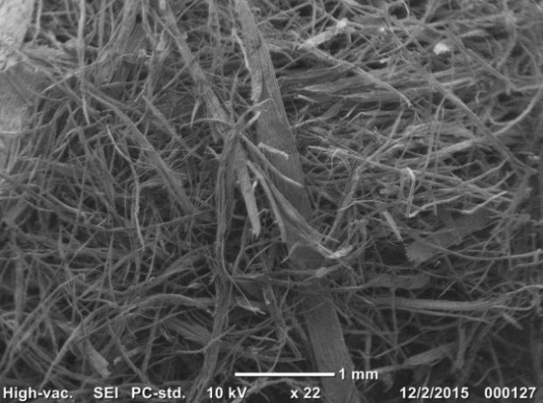 | 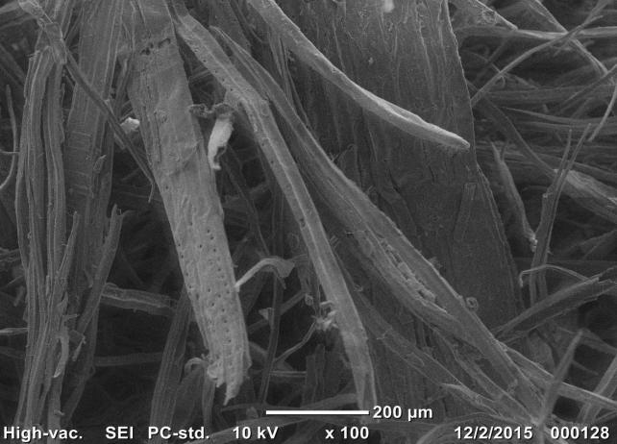
a) | b)
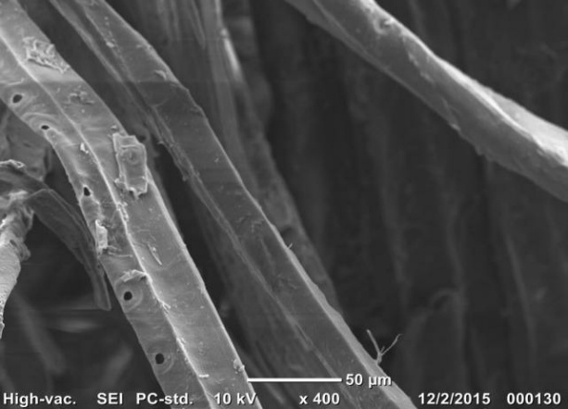 | 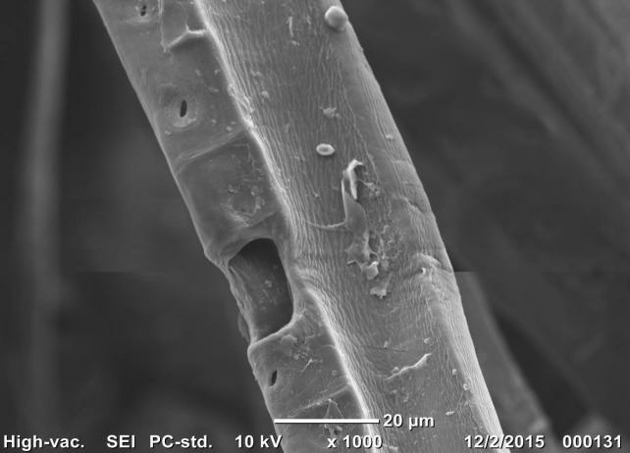
c) | d)
FIGURE 1. Surface images of waste wood fiber: a) An increase of 22 times; b) 100x magnification; c) Magnification 400 times; d) 1000 times magnification
TABLE 4. Elemental composition of the developed sorption materials based on wood fibers
№ | CSM | Mass fraction of elements, %
№ | CSM | O | C | N | Са | Mg | Si | Fe
1 | WFW | 39,1 | 35,6 | 24,5 | 0,26 | 0,23 | 0,06 | 0,14
2 | МСМ-1 | 38,7 | 35,4 | 24,1 | 0,24 | 0,21 | 0,03 | 1,12
3 | МСМ-5 | 38,3 | 33,5 | 22,3 | 0,21 | 0,19 | 0,04 | 5,35
4 | МСМ-10 | 36,3 | 32,2 | 20,9 | 0,15 | 0,13 | 0,02 | 10,2
5 | МСМ-25 | 30,7 | 26,3 | 17,2 | 0,09 | 0,05 | 0,01 | 25,4

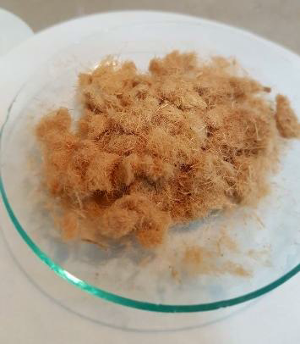 | 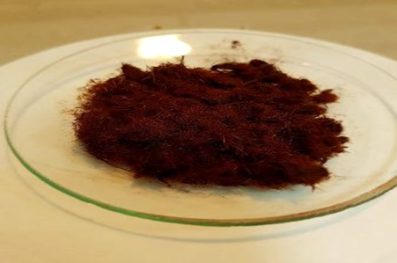
a) | b)
FIGURE 2. Appearance of sorption materials. a) wood fiber waste; b) magnetic composite sorption material
Figure 2 shows the appearance of WFW and МСМ and Table 3 shows the properties of MSM obtained under the influence of ultrasonic vibrations.
In order to select the most optimal conditions and establish possible mechanisms of the adsorption processes of HMI and OP, we conducted studies of the adsorption properties of SM МСМ in a static mode, and determined the influence of pH, temperature and contact time on the adsorption of HMI and OP. Preliminary experiments have determined that for effective treatment of wastewater contaminated with IFM, components and wood processing waste can be used as ICM. At the same time, several problems are solved: firstly, the use of waste as СМ elevates them to the rank of secondary material resources, and secondly, problems associated with the environmental consequences of the influence of polluted waters on ecosystems are solved. The characteristics of WF waste (WFW) are presented in Table 3. As can be seen from the data obtained, the low ash content of WFW indicates a high content of organic matter, which is an important condition for the disposal of spent SM by combustion.
TABLE 3. Some properties of wood fiber waste
№ | Indicator name | Sorption activity
№ | Indicator name | СSМ | AU-BAU-A | AU-DAK
1. | Humidity, % | 16,8 | 8,75 | 7,63
2. | Bulk density, g/cm3 | 0,098 | 0,234 | 0,219
3. | Ash content, % | 0,32 | 2,87 | 1,62
4. | Mechanical strength,% | 73 | 67 | 72
5. | Cellulose content, % | 68,8 | - | -
6. | Lignin content, % | 31, 7 | - | -
7. | Sorption activity for iodine, % | 30,9 | 59,7 | 36,1
8. | Sorption activity for methyl blue, mg/g | 86,8 | 44,6 | 62,5

From the experimental data obtained, it is clear that WFW s have a more developed mesoporous structure, as evidenced by fairly high values of sorption activity for methylene blue. As a comparison, Table 1 presents the characteristics of known AC sorbents. Isotherms of a similar type were obtained by varying the temperature and pH of the environment. It has been established that as the temperature increases, the adsorption capacity of the СSМ increases, which indicates the possible chemical nature of the forces holding the HMI on the surface of the composite. In an acidic environment, as well as with decreasing temperature, the adsorption capacity of СSМ decreases.

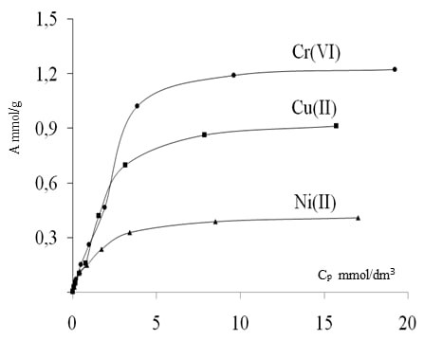 | 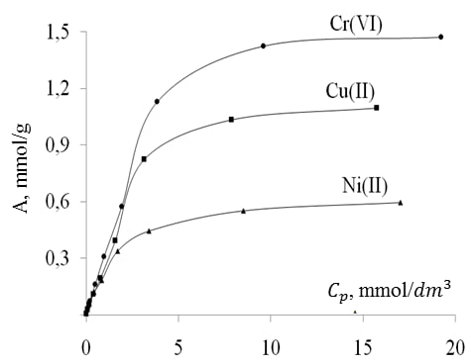
a) | b)
FIGURE 3. Adsorption isotherms of HMI on CM at a temperature of 25°C. a) in a neutral environment; b) in an acidic environment.
According to the Giles classification, the obtained adsorption isotherms of HMI on CSM belong to the Langmuir class and the adsorption isotherms belong to type 1, which describe the monomolecular adsorption of HMI. The calculations determined that in all cases the adsorption process is best described by the Langmuir model with approximation coefficients of more than 0.998. Based on the numerical values ​​of the calculated adsorption energy, one can assume the nature of the interaction forces between the HMI and the active centers of the CSM surface and make an assumption about whether the process under consideration is a physical interaction or a chemical reaction. It is believed that when the adsorption energy is less than 8 kJ/mol, physical adsorption occurs; at adsorption energy values from 8 to 16 kJ/mol–chemisorption. From the obtained values ​​of adsorption energies, it can be assumed that the processes of adsorption of HMI on CSM belong to the processes of chemical adsorption. The calculated values of activation energies (Ea, kJ/mol) for Ni (II) 12.9, Cu (II) 15.3 and for Cr (VI) 19.0) indicate that the adsorption of ITM on CSM occurs in a mixed diffuse mode, and internal diffusion is the stage that limits the adsorption process. Thus, it can be assumed that the adsorption of HMI on CSM is a complex process. At the initial stage, the penetration of HMI into the internal structure occurs due to diffusion and under the influence of a concentration gradient, and then the process of chemisorption occurs with the formation of complex iron compounds as a result of interaction with hydroxyl and carboxyl groups that are part of the composite.
The study of the adsorption of oil products (OP) was carried out in a static mode. Initially, the equilibrium concentration of dissolved components of diesel fuel (DF) was determined after 2 hours of contact of SM CM weighing 1 g with 50 cm3 of a model solution with a concentration of 13.9 mg/dm3 in a neutral environment and 14.3 mg/dm³ in an acidic environment at temperatures 15, 25 and 35°C. The calculated values of the adsorption capacity of SM CM in relation to OP are presented in Table 4.
TABLE 4. Adsorption capacity of the CSM sorption material in relation to oil products at different temperatures under static conditions

Т, °С | Adsorption capacity
Т, °С | Neutral environment  (рН = 6,8 ± 0,2) |  | acidic environment  (рН = 4,0 ± 0,2)
Т, °С | mg/g | mmol/g | mg/g | mmol/g
15 | 7,4±0,9 | 0,030±0,005 | 7,3±0,09 | 0,029±0,005
25 | 7,2±0,9 | 0,028±0,008 | 6,9±0,09 | 0,028±0,004
35 | 6,7±0,9 | 0,027±0,000 | 6,8±0,08 | 0,026±0,004
According to the data presented, it is clear that an increase in temperature leads to a decrease in the adsorption capacity, which indicates the probable physical nature of the forces that hold the OP on the surface of the SМ. In an acidic environment, the sorption capacity decreases. The obtained isotherm curves for the adsorption of OPs on SM СМ in a neutral environment at temperatures of 15, 25 and 35°C are presented in Fig.3.
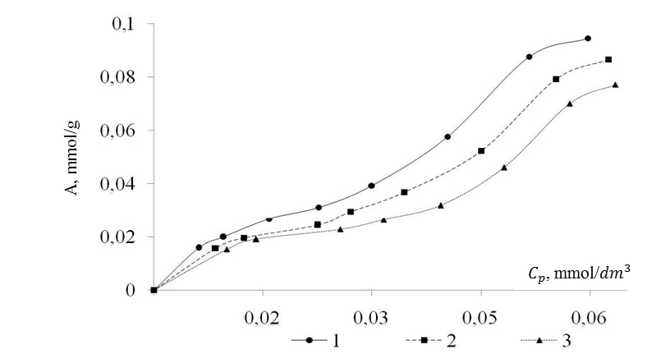
FIGURE 4. Isotherms of adsorption of oil products on sorption material at temperatures: 1 – 15°C; 2 – 25°C; 3 – 35°C.
According to the BDDT classification, the obtained isotherms belong to type 4 adsorption isotherms and describe polymolecular adsorption characteristic of porous SM. According to the Giles classification, isotherms belong to the L class (Langmuir class). At the initial stage, the isotherms are characterized by a concave line relative to the concentration axis; as the NP content in the solution increases, adsorption reaches saturation and leads to the formation of a plateau and the process of polymolecular adsorption until the second plateau is reached. Adsorption isotherms of NPs on SM MCM-5 were processed within the framework of the Langmuir, Dubinin–Radushkevich and Freundlich models. The calculations determined that in all cases the adsorption process is best described by the Dubinin–Radushkevich model and the adsorption energy (E, kJ/mol) was determined by processing the isotherms within the framework of the Dubinin–Radushkevich model.
For the production of MCM for purifying water from oil, a similar production concept is proposed, where after the washing baths an additional container with a water-repellent composition is placed in front of the drying chamber, the processing time is 5–10 minutes. A sample treated with a water-repellent agent, obtained under the influence of ultrasonic vibrations – MCM-1A – was used as a SM for purifying water from oil products. To simulate pollution with an oil product, 0.5 dm3 of diesel fuel with a density of 0.88 kg/dm³ were poured onto the surface of a puddle, and then MCM-1A SM was evenly applied to the oil product layer. After 30 minutes, using a magnetic disk, SM was collected from the surface of the puddle and the residual concentration of the oil product in the water was determined, which was 0.041 mg/dm³, while the complete absence of traces of SM and oil product was visually noted on the water surface.
СМ was investigated as a potential SM for purifying wastewater from oil products at local treatment facilities located in the Gallaaral district of the Jizzakh region. From the initial SW from the territory under consideration, it enters through mesh grids into a vertical settling tank, where coarse impurities are deposited. After the vertical settling tank, the waste water enters the storage tank. As the storage tank fills, the waste water is removed to treatment facilities. According to the measurement results, the total content of petroleum products in the storage tank was 6.5 mg/dm³. The purification of the considered SWs was carried out under dynamic conditions using a flow-through adsorber. The concentration of the petroleum product in the analyzed water after passing through the adsorber filled with SM MCM-1A was 0.018 mg/dm3 with a maximum permissible concentration of 0.05 mg/dm³.
TABLE 5. Results of wastewater treatment from petroleum products using MCM-1A
№ | Name of substance | MPC | Contents in wastewater
№ | Name of substance | MPC | Before cleaning | After cleaning
1. | Heptane, mg/dm³ | - | 0,91$±$0,18 | -
2 | Cyclohexane, mg/dm³ | 0,01 | 0,58$±$0,12 | -
3 | Propane, mg/dm³ | 0,05 | 0,26$±$0,05 | -
4 | Ethyl alcohol, mg/dm³ | 0,01 | 0,116$±$0,02 | -
5 | Benzene, mg/dm³ | 0,5 | 0,58$±$0,12 | -
6 | Methylbenzene, mg/dm³ | 0,5 | 0,13$±$0,03 | -
7 | Ethylbenzene, mg/dm³ | 0,001 | 0,058$±$0,012 | -
8 | 1.2 - dioxyethane, mg/dm³ | 0,25 | 0,026$±$0,012 | -

In addition to determining the total content of petroleum products by gas chromatography, an analysis of the extracts of the considered WW was carried out before and after purification using the MCM-1A SM. The results of the analyzes and chromatograms of the SW extracts are shown in Table 5.
CONCLUSION
Analysis of WW extracts before purification showed the presence in WW of saturated and aromatic hydrocarbons, ketones and alcohols that are part of automobile diesel fuels, additives and detergents. A comparison of chromatograms before and after purification of wastewater using MCM-1A showed that in the samples of used wastewater after purification there are no hydrocarbons contained in the wastewater before cleaning. Thus, the results of the tests confirm the feasibility of using the MCM-1A SM for purifying wastewater from oil products together with treatment facilities in operation at enterprises.

REFERENCES
- Kharlyamov, D. A., Albutova, D. A., Gafiyatova, S. R., Mavrin, G. V., & Scherbinin, N. S. (2019). Adsorption of heavy metals ions and oil products by magnetic composite sorbents based on waste of wood fiber. Journal of Computational and Theoretical Nanoscience, 16(1), 195–199. https://doi.org/10.1166/jctn.2019.7722
- Del Sole, R., Fogel, A. A., Somin, V. A., Vasapollo, G., & Mergola, L. (2023). Evaluation of Effective Composite Biosorbents Based on Wood Sawdust and Natural Clay for Heavy Metals Removal from Water. Materials, 16(15), 5322. https://doi.org/10.3390/ma16155322
- Šćiban, M., Radetić, B., Kevrešan, Ž., & Klašnja, M. (2006). Adsorption of heavy metals from electroplating wastewater by wood sawdust. Bioresource Technology, 98(2), 402–409. https://doi.org/10.1016/j.biortech.2005.12.014
- Al-Tohamy, R., Ali, S. S., Li, F., Okasha, K. M., Mahmoud, Y. A., Elsamahy, T., Jiao, H., Fu, Y., & Sun, J. (2022). A critical review on the treatment of dye-containing wastewater: Ecotoxicological and health concerns of textile dyes and possible remediation approaches for environmental safety. Ecotoxicology and Environmental Safety, 231, 113160. https://doi.org/10.1016/j.ecoenv.2021.113160
- Ibrahim, N. A., Abdellatif, F. H., Hasanin, M. S., & Abdellatif, M. M. (2021). Fabrication, characterization, and potential application of modified sawdust sorbents for efficient removal of heavy metal ions and anionic dye from aqueous solutions. Journal of Cleaner Production, 332, 130021. https://doi.org/10.1016/j.jclepro.2021.130021
- Liu, Y., Zhang, X., Du, Y., Du, X., Zhang, Y., Deng, L., Li, C., & Guo, J. (2025). Functionalization of Wood for the Removal of Heavy Metal Ions from Waster Water: A Review. Forests, 16(11), 1684. https://doi.org/10.3390/f16111684
- Vilavskiy Evgeny Igorevich, Masakbaeva Sofia Ruslanovna, Baimukhambetova Marya Grigoryevna Intensification of processes of flotation purification of industrial wastewater from oil products // Universum: technical sciences. 2016. No. 11 (32). URL: https://cyberleninka.ru/article/n/intensifikatsiya-protsessov-flotatsionnoy-ochistki-promyshlennyh-stochnyh-vod-ot-nefteproduktov
- Fayzullaev, N., Bobomuratova, S., Ergasheva, S., Xolliyev, S., & Kholmuminova, D. (2023). Possibility of application of high silicon keolitic catalyst with thermal and mechanochemical treatment for catalytic flavoring of the propane-butane fraction. E3S Web of Conferences, 402, 14028. https://doi.org/10.1051/e3sconf/202340214028
- Kurbanova, D., Fayzullaev, N., & Bobomurodova, S. (2023). Determination of optimal conditions and kinetic laws of hydrogen chloride separation reaction from simm-dichloroethane (1,2-dichloroethane). E3S Web of Conferences, 460, 10028. https://doi.org/10.1051/e3sconf/202346010028
- Bobomurodova, S., Kurbanova, D., Xaqberdiev, S., & Mamadiyorova, S. (2025). Specificity of reaction rate enhancers and carriers for oxidative chlorination of ethylene. AIP Conference Proceedings, 3304, 040106. https://doi.org/10.1063/5.0270933

