Studying the Solubility of the System
CuSO₄ – NH₄NO₃ − H₂O
Dilnoza Makhkamova^{1, a)}, Aysholpan Shamishova², Rayxan Saburova², Zokirjon Turayev¹, Ilhom Usmonov³
¹Namangan State Technical University, Namangan, Uzbekistan
²Karakalpak State University named after Berdaq, Karakalpakistan, Uzbekistan
³Karshi State Technical University, Kashkadarya, Uzbekistan

^{a)}Corresponding author: dilnozamaxkamova_7007@mail.ru
Abstract: The visually-polythermal method was used to study the solubility of the CuSO₄ – NH₄NO₃ – H₂O system within the temperature range of -13.6℃ to +98.0℃. The formation of a new double salt compound CuSO₄·NH₄NO₃·3H₂O and its crystallization area occupying a large area of the polythermal solubility diagram were determined by the visual polythermal method. After the compound was isolated, washed, and dried, it was characterized by X-ray diffraction, infrared spectroscopy, and thermogravimetric analysis. The optimal conditions for the formation of the new compound were determined by analyzing such physicochemical parameters as viscosity, density, pH, and crystallization temperature. The study of ammonium nitrate − copper sulfate − water systems in understanding phase equilibrium can serve as a theoretical and practical basis for the development of NPK-fertilizers containing microelements.
Keywords: Ammonium nitrate, copper sulfate, CuSO₄∙NH₄NO₃∙3H₂O, visual polytherm, quantitative analysis, X-ray phase analysis, IR spectrum, thermogravimetric analysis.
INTRODUCTION
In developed countries, the demand for high-quality food products is steadily increasing as the global population grows. Agricultural raw materials derived from plant sources are essential to large-scale food production, which necessitates the use of fertilizers to meet crops' nutritional requirements. Fertilizer management for agriculture involves the balanced application of mineral and organic fertilizers as well as the selection of optimal dosages tailored to each crop's specific nutrient requirements [1, 2].
It has become increasingly important in the agro-industrial sector to formulate scientific approaches to enhance soil fertility, improve crop yields, and ensure sustainable agricultural productivity due to the continuous reduction of cultivated land areas [3].
The nutritional value and overall quality of agricultural products are being continuously improved in order to meet human dietary needs and promote health [4].
Micronutrients are absorbed in trace amounts by plants, but their presence significantly affects crop quality and productivity [5]. Each micronutrient performs a distinct biochemical function in the metabolism of plants, animals, and humans, and its deficiency cannot be compensated by other elements [6].
Accordingly, in order to meet the micronutrient requirements of plants and to determine the optimal dosage and limits for adding micronutrients to NPK components [7, 8], the solubility of the NH₄NO₃ – CuSO₄ – H₂O system was studied using the visual-polythermal method over the temperature range from the complete freezing point of -13.6℃ to 98.0℃ across nine internal sections, with the objective of determining the concentration and temperature ranges of the ion-exchange reactions and the regions of component stability within the system. Based on the solubility polytherms of the binary systems and the internal sections, a polythermal solubility diagram was constructed, which is characterized by the presence of crystallization regions of ice, NH₄NO₃, CuSO₄∙5H₂O, CuSO₄, and a new phase CuSO₄∙NH₄NO₃∙3H₂O.
METHODS
Water, ammonium nitrate, and copper sulfate are the objects of research. In our research, we used chemically pure ammonium nitrate (GOST 22867-77) and copper sulfate salt (GOST 4165-78). Our experimental measurements included X-ray phase analysis (LabX XRD-6100, Japan) [9], Infrared spectroscopic analysis (Specord IR-75) [10], and thermal analysis (DTG-60, Japan). The research employed the visual-polythermal method [11] using a TN-6 glass mercury thermometer with a measurement range of -30°C to 60°C, as well as the pycnometric method (GOST 31992.1-2012) [12]. The content of CuSO₄∙NH₄NO₃∙3H₂O was determined by elemental analysis for nitrogen, copper, hydrogen, and sulfur was carried out according to (Zeiss EVO MA10) [13]. A VPZh viscometer was used to measure the viscosity of the solutions, and a FE20 METTLER TOLEDO pH meter was used to measure the pH value of the solutions.
RESULTS AND DISCUSSION
Isotherms were plotted on the polythermal state diagram at intervals of every 10℃. Projections of the polythermal solubility curves were constructed on the lateral sides of the NH₄NO₃-H₂O and CuSO₄-H₂O systems.
TABLE 1. Double and triple points of the NH₄NO₃ − CuSO₄ − H₂O system
Composition of the liquid phase, % |  |  | Temperature, ^{о}С | Solid phase
NH₄NO₃ | CuSO₄ | H₂O | Temperature, ^{о}С | Solid phase
48.4 | 2.5 | 49.1 | -9.0 | NH₄NO₃ + CuSO₄∙NH₄NO₃∙3H₂O
42.7 | - | 57.3 | -16.8 | ice + NH₄NO₃
38.8 | 1.7 | 59.5 | -14.0 | ice+NH₄NO₃+CuSO₄∙NH₄NO₃∙3H₂O
29.6 | 1.9 | 68.5 | -11.0 | ice + CuSO₄∙NH₄NO₃∙3H₂O
19.6 | 3.2 | 77.2 | -8.0 | ice + CuSO₄∙NH₄NO₃∙3H₂O
9.3 | 7.9 | 82.8 | -5.0 | ice + CuSO₄∙NH₄NO₃∙3H₂O
6.8 | 9.2 | 84.0 | -4.0 | ice + CuSO₄∙NH₄NO₃∙3H₂O
3.2 | 19.3 | 77.5 | -3.0 | ice + CuSO₄∙NH₄NO₃∙3H₂O
- | 11 | 89.0 | -2.8 | ice + CuSO₄·5H₂O
3.3 | 20.4 | 76.3 | -2.7 | ice+CuSO₄·5H₂O+CuSO₄∙NH₄NO₃∙3H₂O
3.6 | 28.9 | 67.5 | +29 | CuSO₄·5H₂O + CuSO₄∙NH₄NO₃∙3H₂O
- | 21 | 79.0 | +35 | CuSO₄·5H₂O + CuSO₄
3.7 | 30.8 | 65.5 | +35 | CuSO₄·5H₂O+CuSO₄+CuSO₄∙NH₄NO₃∙3H₂O
4.1 | 38.4 | 57.5 | +55 | CuSO₄ + CuSO₄∙NH₄NO₃∙3H₂O
Sections I-IV are drawn from the top of NH₄NO₃ to the side of CuSO₄ - H₂O, and sections V-IX are drawn from the top of CuSO₄ to the side of NH₄NO₃ - H₂O.
The system is characterized by the presence of three triple points and three double points. The equilibrium compositions of the solutions at the double and triple points of the system, as well as their corresponding crystallization temperatures, were determined (Table 1). The first triple point corresponds to a composition containing 38.8% ammonium nitrate, 1.7% copper sulfate, and 59.5% water, with a crystallization temperature of -14℃. Under these conditions, the solid phase consists of ammonium nitrate, ice, and a new phase.
The composition of the second triple point corresponds to 20.4% copper sulfate, 3.3% ammonium nitrate, and 76.3% water. The crystallization temperature at this point is -2.7℃, and the solid phase consists of copper sulfate pentahydrate, ice, and the compound CuSO₄∙NH₄NO₃∙3H₂O.
The composition of the third triple point corresponds to 3.7% ammonium nitrate, 30.8% copper sulfate, and 65.5% water. The crystallization temperature at this point is 35℃, and the precipitate consists of copper sulfate pentahydrate, copper sulfate, and the compound CuSO₄∙NH₄NO₃∙3H₂O.
Chemical analysis of the compound gave the following results (mass %): Cu − 21.47; SO₄ − 32.46; N − 9.46. Elemental analysis yielded: Cu=23.0; N=10.6; S=10.5; O=56.0.
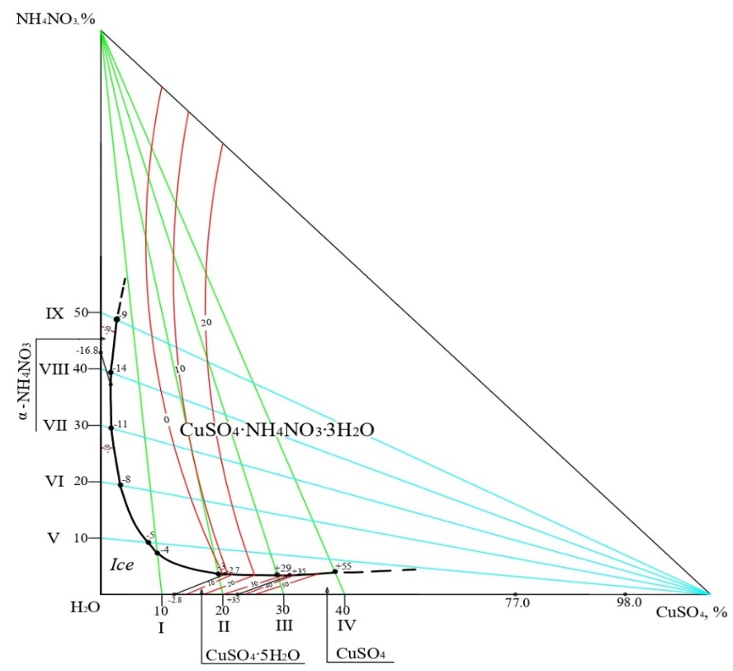
FIGURE 1. Solubility of components in the NH₄NO₃ – CuSO₄ – H₂O system
Elemental analysis revealed a molar ratio of Cu:S:N:O=1.04:1.0:2.38:10.67, which is slightly higher than the chemical analysis data. The isolated compound corresponds to the molecular formula CuSO₄∙NH₄NO₃∙3H₂O. Theoretically, this compound contains 21.64% Cu, 10.90% S, 9.54% N, 54.51% O, and 3.41% H.

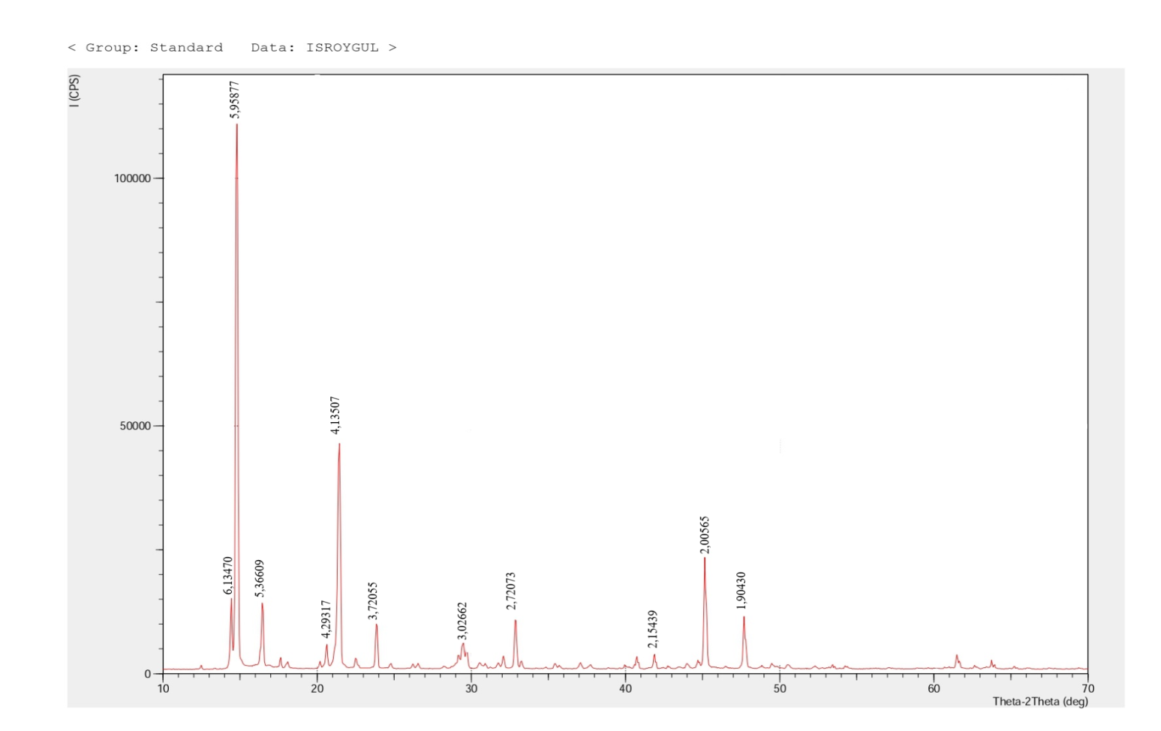
FIGURE 2. X-ray diffraction pattern of the compound CuSO₄∙NH₄NO₃∙3H₂O
In the X-ray diffraction pattern of CuSO₄·NH₄NO₃·3H₂O 5.95877; 4.13507; 2.00565; 2.72073; 1.90430; 5.36609; 3.72055; 6.13470; 3.02662; 4.29317; 2.15439 Å and the corresponding maximum values ​​are 100; 57; 23; 14; 13; 11; 10; 9; 7; 6; 4% (Fig. 2.). The diffraction changes 5.95877; 4.13507; 2.00565; 2.72073 Å are the highest and correspond to the data presented in the literature. At the same time, all diffraction changes confirm that CuSO₄·NH₄NO₃·3H₂O is an individual compound.
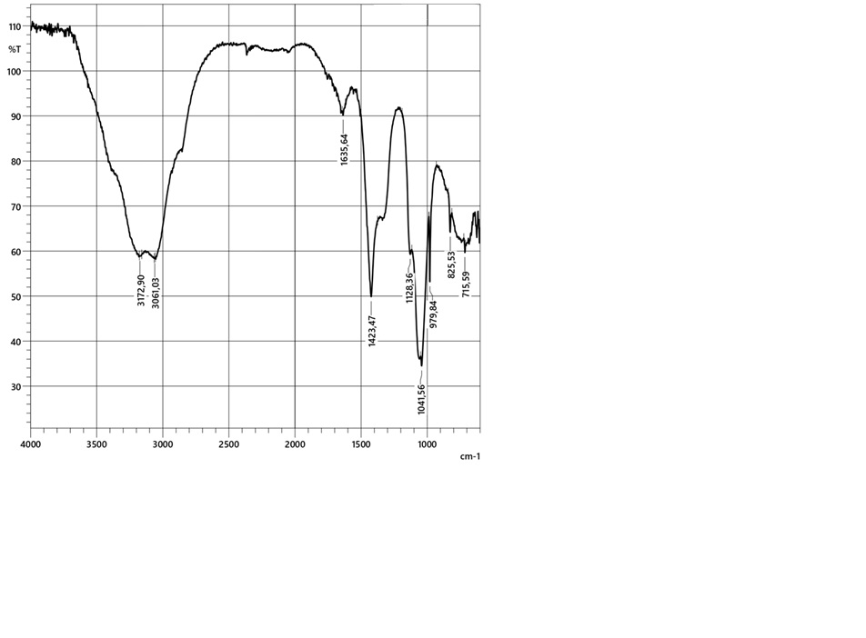
FIGURE 3. IR-spectrum of the compound CuSO₄∙NH₄NO₃∙3H₂O.
In the study of absorption bands by infrared spectroscopy of various functional groups in the crystal structure of CuSO₄∙NH₄NO₃∙3H₂O, it was observed that the O-N group, strongly bonded with hydrogen, is represented by absorption bands at 3172.90 cm⁻¹ and 3061.03 cm⁻¹. In the infrared absorption spectra, the frequency range at 1423.47 cm⁻¹ corresponds to the degenerate deformation vibration of the NH₄⁻ group, while the wavelength region between 400 and 600 cm⁻¹ represents Cu-O vibrations. The asymmetric stretching bands at 1041.56 cm⁻¹ and 1128.36 cm⁻¹, together with the symmetric stretching band of SO₄⁻² at 979.84 cm⁻¹ and the absorption band at 825.53 cm⁻¹ corresponding to the NO₃⁻ functional group, were identified. The analyzed IR spectral data confirm the individuality of the new compound CuSO₄·NH₄NO₃·3H₂O.
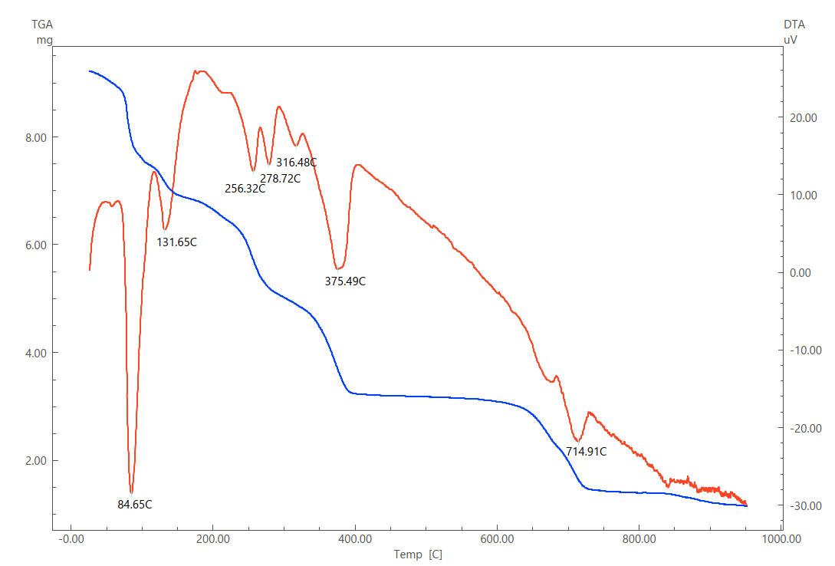
FIGURE 4. Derivatogram of the compound CuSO₄·NH₄NO₃·3H₂O
Thermal analysis of the compound CuSO₄·NH₄NO₃·3H₂O was carried out in the temperature range of 0-1000℃ over a period of 90 minutes. The thermal analysis revealed seven endothermic effects corresponding to endothermic peaks at 84.65℃, 131.65℃, 256.32℃, 278.72℃, 316.48℃, 375.49℃, and 714.91℃. As the temperature increased, the decomposition of the initial substance amounted to 26.37% at 84.65℃ and 87.53% at 714.91℃. During the thermal analysis of the CuSO₄·NH₄NO₃·3H₂O compound, no mass loss was observed in the temperature range from 714.91℃ to 1000℃ due to the presence of CuO. Differential thermal analysis (DTA) and thermogravimetric (TG) analyses were performed on a Shimadzu DTG-60 synchronous thermal analyzer at a heating rate of 10℃/min using a porcelain crucible.
CONCLUSION
The solubility of the CuSO₄ − NH₄NO₃ − H₂O system was systematically investigated using the visual-polythermal method within the temperature range from -13.6℃ to 98.0℃. As a result of the study, a new double salt, CuSO₄·NH₄NO₃·3H₂O, was identified, and its crystallization field was established on the polythermal solubility diagram. The compound was isolated in a pure crystalline form and comprehensively characterized by X-ray diffraction, infrared spectroscopy, and thermogravimetric analysis. The diffraction pattern confirmed that CuSO₄·NH₄NO₃·3H₂O represents an individual crystalline phase, while the IR spectral and thermal analysis data verified its composition, hydration degree, and structural stability. Variations in the solubility of the system components and the physicochemical parameters of the solutions − such as density, viscosity, crystallization temperature, and pH − enabled the determination of the optimal conditions for compound formation. This research provides practical guidance for the development of micronutrient-containing NPK-fertilizers and the creation of advanced material technologies.
REFERENCES
- Steffen, W., Richardson, K., Rockström, J., Cornell, S. E., Fetzer, I., Bennett, E. M., Biggs, R., Carpenter, S. R., De Vries, W., De Wit, C. A., Folke, C., Gerten, D., Heinke, J., Mace, G. M., Persson, L. M., Ramanathan, V., Reyers, B., & Sörlin, S. (2015a). Planetary boundaries: Guiding human development on a changing planet. Science, 347(6223), 1259855. https://doi.org/10.1126/science.1259855
- Pogrzeba, M., Rusinowski, S., Sitko, K., Krzyżak, J., Skalska, A., Małkowski, E., Ciszek, D., Werle, S., McCalmont, J. P., Mos, M., & Kalaji, H. M. (2017). Relationships between soil parameters and physiological status of Miscanthus x giganteus cultivated on soil contaminated with trace elements under NPK fertilisation vs. microbial inoculation. Environmental Pollution, 225, 163–174. https://doi.org/10.1016/j.envpol.2017.03.058
- Bagci, S. A., Ekiz, H., Yilmaz, A., & Cakmak, I. (2007). Effects of zinc deficiency and drought on grain yield of field‐grown wheat cultivars in Central Anatolia. Journal of Agronomy and Crop Science, 193(3), 198–206. https://doi.org/10.1111/j.1439-037x.2007.00256.x
- Wang, Z., Li, S., & Malhi, S. (2007). Effects of fertilization and other agronomic measures on nutritional quality of crops. Journal of the Science of Food and Agriculture, 88(1), 7–23. https://doi.org/10.1002/jsfa.3084
- Tavakoli, M. T., Chenari, A. I., Rezaie, M., Tavakoli, A., Shahsavari, M., & Mousavi, S. R. (2014). The importance of micronutrients in agricultural production. Advances in Environmental Biology, 31-36. http://www.aensi.org/aeb.html
- Shukla, A. K., Tiwari, P. K., & Prakash, C. (2018). Micronutrients in soils, plants, animals and humans. Indian Journal of Fertilisers, 14(3), 30–54.
- Makhkamova, D., Turayev, Z., & Kucharov, B. (2024). Research on the effect of microelement salt with fertilizer. In E3S Web of Conferences (Vol. 486, p. 01012). EDP Sciences. https://doi.org/10.1051/e3sconf/202448601012
- Turayev, Z. (2024). STUDYING THE SOLUBILITY OF THE SYSTEM ZnSO 4-KNO 3-H 2 O. Journal of Chemical Technology & Metallurgy, 59(1). https://doi.org/10.59957/jctm.v59.i1.2024.16
- Liopo, V.A., Nikitin, D.A., Struk, V.A., Nikitin, A.V. Nanomeasure mineral modificator of polymeric composite materials / X–ray diffraction & crystal chemistry of minerals. St. Petersburg. 2003. – P.339-340.
- Nakamoto, K. (1966). Infrared spectra of inorganic and coordination compounds. Moscow: Mir Publishers.
- Trunin, A. S., & Petrova, D. G. (1977). Visual-polythermal method. Kuibyshev: Kuibyshev Polytechnic University (KPU).
- Zdanovsky, A. B. (1972). Hallurgy. Leningrad: Chemistry Publishing House.
- Charlot, G. (1969). Methods of analytical chemistry: Quantitative analysis of inorganic compounds. Moscow: Chemistry Publishing House.
- Sherkuziev, D. S., Aripov, K. S., Alimov, U. K., & Maxmudova, M. A. (2020). Research of agrochemical and mechanical properties of soils processed with hydrogel. IOP Conference Series Earth and Environmental Science, 614(1), 012121. https://doi.org/10.1088/1755-1315/614/1/012121

