Production of Binding Materials from Waste Phosphates of Central Kyzylkum
Maftuna Akhtamova^{a)}, Tulkin Nurmurodov, Dilafruz Shermatova,
Manzura Muratova, Kamola Rakhmonova
Navoi State University of Mining and Technologies, Navoi, Uzbekistan

^{a)}Corresponding author: akhtamova.17@gmail.com
Abstract: Phosphate sludge is a byproduct formed during the treatment or processing of phosphate ores, containing phosphorus oxides and other mineral components. This sludge can be employed as a feedstock in the manufacture of refractories. To prepare phosphate sludge, it is purified and ground to a powder. A phosphate binder (such as sodium orthophosphate or other phosphates) is then added to the sludge, and fillers may also be added to improve its properties. For molding, the mixture is pressed into a brick shape. The brick is then dried and fired at high temperatures (usually 1000–1300°C), which results in the formation of refractory compounds. During firing, the phosphate binder polymerizes, forming glassy or crystalline phases that fill the pores and ensure low porosity and chemical resistance of the brick. As a result, reactions between the components of the mixture and the phosphate binder produce a dense, heat-resistant and chemically stable material – phosphate refractory brick.
Keywords: phosphate waste, sludge, phosphogypsum, binders, heat-resistant, fertilizers.
INTRODUCTION
Intensive agriculture requires the use of relatively large quantities of fertilizers. Phosphorus-containing mineral fertilizers play a special role in restoring soil fertility, regulating the phosphate status of soils. Today, the lion's share of phosphorus-containing mineral fertilizers is produced using wet-process phosphoric acid.
Due to the growing global population and the need to meet its demand for agricultural products, the production of phosphorus-containing mineral fertilizers has now reached truly gigantic proportions, which has led to the byproduct formation for large-scale production of phosphogypsum. The problem of using phosphogypsum for economic purposes arose for researchers already at the development stage of processes for producing phosphogypsum. However, the implementation of these technological processes for processing phosphogypsum was often hampered by the widespread availability and low cost of natural gypsum [1].
So far, extensive research and development have been carried out in various fields concerning the direct utilization of phosphogypsum and its conversion into other products. The technical and economic viability of using phosphogypsum as a substitute for conventional raw materials in the national economy has been demonstrated [2].
The main uses of phosphogypsum can be summarized as follows:
1. Production of gypsum binders and products made from them: High-strength and composite autoclaved gypsum binders based on α-calcium sulfate hemihydrate or anhydrite, which are used:
– in construction: direct use of binders with and without additives as plaster and putty material, for self-leveling floor screeds, for the production of building products (partition slabs and panels, acoustic and decorative slabs, bricks and blocks for external building enclosures, etc.);
– in coal mines and other industries: filling of reinforced spaces and laying out protection strips during non-core mining;
– in low-temperature wells in the oil and gas industry and in geology: production of oil well cement;
– calcined binders based on β-calcium sulfate hemihydrate, which are used in construction: as plaster and putty gypsum, for the production of building products (partition boards and panels, gypsum plasterboards, gypsum fiber and gypsum particle boards, sound-absorbing and decorative boards, etc.).
2. Cement industry: additive to raw mix as a mineralizer, additive to cement clinker before grinding as a regulator of cement setting time.
3. Agriculture: Calcium-sulfur-containing fertilizer; Additive for producing organomineral fertilizers by composting; Ameliorant for chemical amelioration of solonetzic soils; Ameliorant mixed with lime materials for chemical amelioration of acidic soils.
4. Sulfuric acid production with the associated production of a number of products (cement, lime, silicate materials).
5. Production of building materials using untreated phosphogypsum includes: blocks and panels made from a mixture of phosphogypsum, fly ash (from electrostatic precipitators), and lime; bricks produced by pressing phosphogypsum combined with a gypsum binder; and products fabricated from phosphogypsum blended with organic binders (e.g., urea resin).
6. Fertilizer and salt production: Ammonium sulfate and chalk; Potassium sulfate and chalk; NS fertilizers (mixed with urea or ammonium nitrate); Complex sulfur-containing fertilizers: NPS, NPKS, and PKS fertilizers.
7. Use as a filler in various industries: paper production, paint and varnish industry, plastics production, road construction.
Despite the wide range of applications for phosphogypsum, its production in large quantities, taking into account transportation costs, the need in some cases for its purification from contaminants, and competition with traditionally used natural resources, leads to a limited market for phosphogypsum and its processed products [3].
METHODS
Operational industrial plants for the production of calcined thermal concentrate have demonstrated the low efficiency of this method. After calcination, the concentrate retains 15-17% free CaO, resulting in a high calcium modulus of CaO:P₂O₅ = 1.96-2.0, leading to increased sulfuric acid consumption. To produce 1 ton of P2O5 as ammophos from apatite concentrate, 2.5-2.7 tons of sulfuric acid in the form of monohydrate are required; from Kyzylkum phosphorites, 3.5-3.7 tons. Ammophos production consumes 4.3-4.1 tons of washed calcined phosphorite concentrate from Central Kyzylkum. Phosphogypsum waste disposal requires the same amount. Due to the high cost of roasted phosphate concentrate, the cost of ammophos based on it also increases significantly.
The process of ore dressing itself is a set of sequential operations, the purpose of which is to increase the content of useful components by separating sludge from the feedstock. The end products of phosphate processing are concentrate with the main part of ore useful substances and processing waste. As the research shows, during the enrichment process, the mineral composition of the ore practically does not change, and only mechanical distribution is carried out.
The production of gypsum binders is based on the thermal dissociation of calcium sulfate dihydrate. By losing some of its water of crystallization, dihydrate gypsum transforms into hemihydrate, which is chemically active with water under normal conditions, allowing this product to be used as a binder [4].
RESULTS AND DISCUSSION
Thermal and mass spectrometric analyses revealed distinct variations in the thermal behavior of the examined phosphorite samples, influenced by their origin and the type of gaseous atmosphere used. During the thermal treatment of phosphorites, the release of physically adsorbed water, dehydration of gypsum, thermo-oxidation of organic matter, dehydroxylation of goethite and muscovite, and the thermo-oxidative decomposition of pyrite occur, along with the release of structural (constitutional) water from the phosphorite matrix. These processes continue up to 500–550 °C in an oxidizing atmosphere and up to 600–650 °C in a neutral gaseous environment.
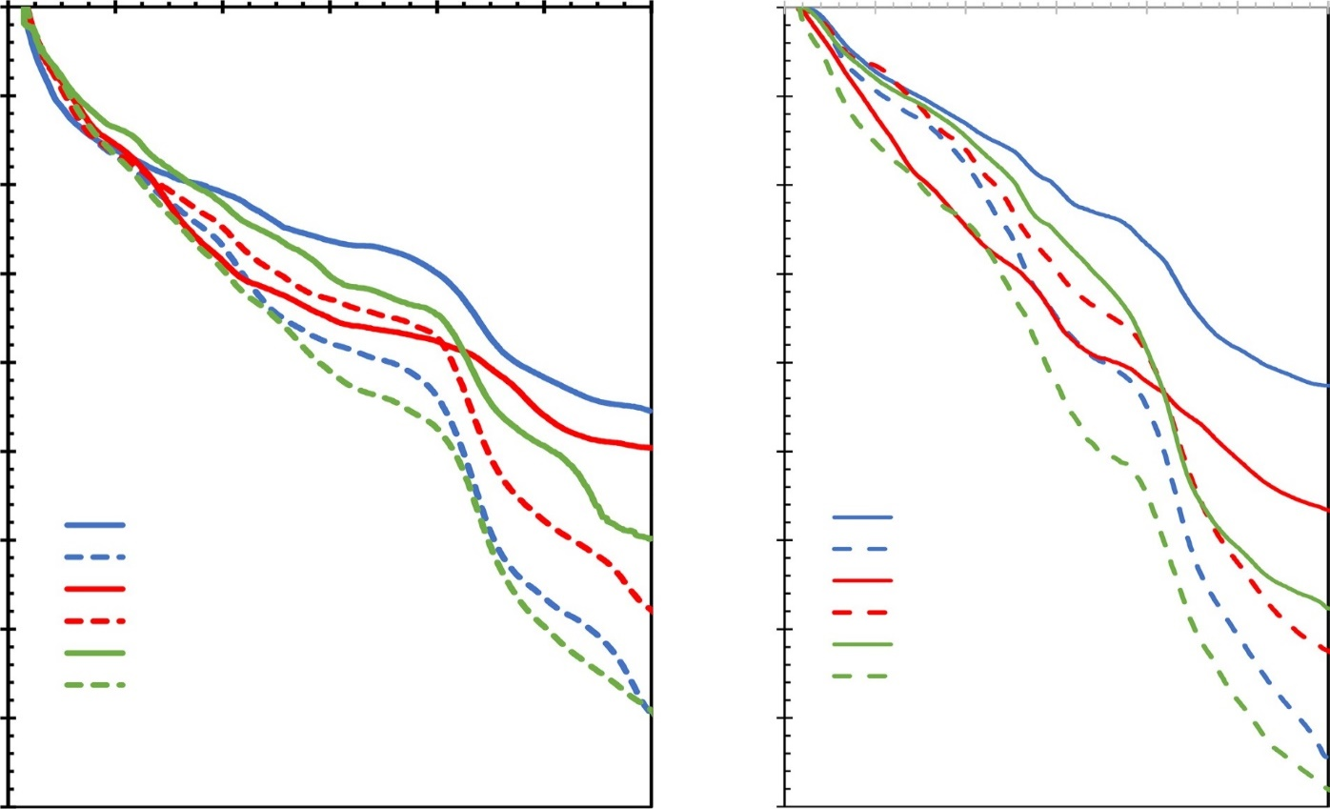
0
0
200
400
600
800
1000
1200
0
200 400 600 800 1000 1200
– 1
– 2
– 3
4.2%
4.5%
– 4
– 5
– 6
– 7
– 8
7.8%
8.7%
– 9
FIGURE 1. Thermal behavior of the phosphorite samples varies according to their geological origin.
At temperatures exceeding 1050–1100 °C, SO₂ emission begins as a result of anhydrite decomposition. The presence of oxygen in the gaseous environment inhibits the release of carbonate and sulfate groups from the francolite structure.
FTIR solid-state and XRD analyses provided insight into the structural transformations of francolite during thermal treatment under different gaseous atmospheres. The SO₄²⁻ group was detected in the FTIR spectra of Aznek phosphorite both in its raw form and in samples treated at 500 °C and 950 °C.
A systematic study of the solubility of key components (P₂O₅, CaO, Fe₂O₃, and SO₄²⁻) in 2% citric acid, along with the changes in physical properties such as specific surface area (SSA) and porosity at varying treatment temperatures, helped to clarify the interrelationship among these parameters—an important factor for the effective utilization of phosphorite.
The findings serve as a foundation for optimizing the technological parameters of phosphorite thermal processing.
Above 550–650 °C, further modifications occur in the francolite crystal structure, accompanied by CO₂ release, which is more pronounced in a neutral gaseous atmosphere than in an oxidizing one. In a neutral atmosphere, SO₂ emission was also observed in Aznek phosphorite, suggesting sulfur incorporation into the francolite structure at lower temperatures—or possibly during earlier geological processes. This represents the first clear evidence of sulfur integration into francolite during thermal treatment.
Consequently, variations in SSA, pore volume, and solubility of constituent elements in 2% citric acid clearly demonstrate the interconnection between solubility, surface area, and porosity characteristics of the studied phosphorite samples [6-9].

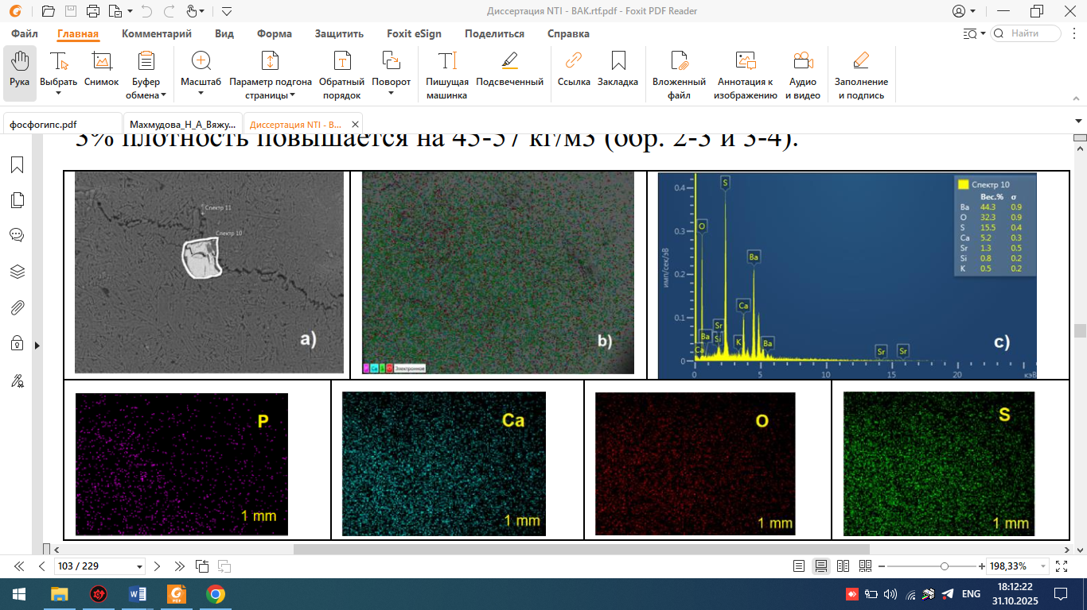
FIGURE 2. Multi-element surface map of phosphogypsum obtained using a scanning electron microscope with an EDS analyzer. a – electron image of the surface; b – total distribution of elements on the surface; c – total spectrum of the surface map.
Microscopic studies show that the formation of CaSO₄∙2H₂O occurs near phosphorite grains, where maximum calcium sulfate supersaturation occurs. Individual thin, plate-like crystals of small thickness, 70-120 µm long and 10-30 µm wide, are observed. The bulk (approximately 90%) consists of crystals with dimensions of 25-40 x 7-10 µm. The appearance of intergrowths and druses is observed.
It should be noted that at the points of the studied samples, where the Ca content is lowest, the maximum barium contents were found (44.3), sulfur (15.5), and oxygen (32.3). Thus, at this point, as shown in the SEM images of the phosphorites, well-formed, uniform calcium sulfate dihydrate crystals are formed at the end of the process. These crystals have the following dimensions: γ = 110-170 μm, β = 40-90 μm, and δ = 5-4 μm.
The proportion of these crystals accounts for about 75–80% of the total mass of the phosphogypsum precipitate. According to the analysis results of wet-process phosphoric acid (WPA) and phosphogypsum for various component contents, the magnesium level varies throughout the entire range. Nearly all of the P₂O₅ in the recycled WPA is transferred to the liquid phase, and the MgO concentration in the wet phosphoric acid samples is directly proportional to the P₂O₅ content. The Fe₂O₃ and Al₂O₃ impurities present in the nitric–magnesium sludge complex (NMSC) are removed by 82–91% along with the phosphogypsum precipitate in the form of intermediate phosphates. During the extraction process, fluorine from the phosphate feedstock is distributed as follows: 60–70% enters the product acid, 10–20% remains in the phosphogypsum, and a small fraction (8–12%) is released into the gas phase.
CONCLUSION
The utilization of phosphogypsum in the national economy contributes to reducing the anthropogenic impact on the environment by lowering the need for mineral extraction (such as gypsum and anhydrite) from the Earth’s crust and minimizing the accumulation of chemically precipitated calcium sulfate in storage sites. Comparative studies of crop yields on various soils, both with and without phosphogypsum application, indicate that phosphogypsum can effectively serve as a substitute for natural gypsum, provided that both are applied in equivalent amounts based on their CaSO₄·2H₂O content.
In this research work, phosphate sludges are dried and ground to the desired fineness. The optimal ratio of components for the mixture is determined. A phosphate binder is then added to the powder—usually a phosphate glue solution or powder. Filler materials (sand, refractory clays, etc.) can be added to the mixture to improve the structure. The mixture is thoroughly mixed until smooth. Bricks are formed by pressing (hydraulic press) or casting. The formed bricks are then first dried at moderate temperatures (about 100–150 °C) to remove moisture. They are then fired at high temperatures (usually 1100–1300 °C) in kilns. During firing, the phosphates chemically react with the oxides, forming strong compounds. Phosphate sludges often contain a high percentage of phosphates, which makes them suitable as a base for refractory binders.
REFERENCES
- Azeko, S. T., et al. (2022). Mechanical and thermal properties of sustainable composites incorporating phosphogypsum. ASCE Journal of Materials in Civil Engineering. https://doi.org/10.1061/(ASCE)MT.1943-5533.0004021
- Novytskyi, Y., Topylko, N., Marushchak, U., & Turba, Y. (2024). Composite materials based on phosphogypsum for constructive layers of road pavement. Chemistry & Chemical Technology, 18(1), 7–14. https://doi.org/10.23939/chcht18.01.007
- Li, W., Ma, L., Qiu, S., Yin, X., Dai, Q., & Du, W. (2024). Sustainable utilization of phosphogypsum in multi-solid waste recycled aggregates: Environmental impact and economic viability. Sustainability, 16(3), 1161. https://doi.org/10.3390/su16031161
- Qin, X., Cao, Y., Guan, H., & Hu, Q. (2023). Resource utilization and development of phosphogypsum-based materials in civil engineering. Journal of Cleaner Production, 387, 135858. https://doi.org/10.1016/j.jclepro.2023.135858
- Chernysh, Y., Yakhnenko, O., Chubur, V., & Roubík, H. (2021). Phosphogypsum recycling: A review of environmental issues, current trends, and prospects. Applied Sciences, 11(4), 1575. https://doi.org/10.3390/app11041575
- Kaljuvee, T., Tõnsuaadu, K., Traksmaa, R. et al. Thermal behaviour of Estonian phosphorites from different deposits. J Therm Anal Calorim 142,437–449(2020). https://doi.org/10.1007/s10973-019-09056-0
- Huang, R., et al. (2023). Investigation of workability and mechanical properties of phosphogypsum-based construction material reinforced with PVA fibers. Materials, 16(12), 4244. https://doi.org/10.3390/ma16124244
- Wang, Q., Lou, Y., Peng, Y., Wang, W., Luo, X., & Smith, A. S. J. (2025). Investigation into improving the water resistance and mechanical properties of calcined gypsum from phosphogypsum composites. Materials, 18(12), 2703. https://doi.org/10.3390/ma18122703
- Zahra, M., Essahbi, S., Taktak, M., & Haddar, M. (2025). Physicochemical and mechanical characterization of phosphate sludge for sustainable concrete-based composites. Jordan Journal of Mechanical and Industrial Engineering, 19(2), 287–296. https://doi.org/10.59038/jjmie/190204

