Development and Electrochemical Evaluation of Environmentally Friendly Green Inhibitors Based on Citrullus Lanatus for Protection against Corrosion of Ferroalloys
Latofat Kurbanova^{1, a)}, Mamajon Pozilov, Feruza Karimova¹,
Shoira Toshbaeva², Nodira Eshmamatova³, Khamdam Akbarov³
¹Jizzakh Polytechnic Institute, Jizzakh, Uzbekistan
²Gulistan State University, Gulistan, Uzbekistan
³National University of Uzbekistan, Tashkent, Uzbekistan

^{a)}Corresponding author: latofat.qurbanova@gmail.com
Abstract: Today corrosion in the world over time leads to the loss of the natural state of metal materials and environmental pollution. As a result of adsorption interaction with metal, one of the urgent tasks today is the development of new effective inhibitors as a result of studying how its protective properties manifest themselves at different temperatures and reaction mechanisms. Iron-based alloys, which are the main materials of modern equipment and technologies, undergo corrosion as a result of the influence of moisture, atmospheric oxygen, nitrogen, sulfur oxides, and other chemically active substances. In the world, the growing demand for inhibitors that increase the effectiveness of metal corrosion protection, the creation of new inhibitors based on the type of protection, technical and economic aspects, is one of the urgent tasks of today. From an ecological point of view, chemically synthesized inorganic and organic corrosion inhibitors are distinguished by the fact that they do not cause significant environmental damage. As a result, interest and demand for green corrosion inhibitors are growing worldwide. Green inhibitors have several advantages: they do not harm the environment, are free from harmful toxins, and also retain their beneficial properties. They are inexpensive synthesized inhibitors. Therefore, in this work, the corrosion-inhibiting properties of green citrullus lanatus extracts based on local raw materials were studied. It was observed that these citrullus lanatus green inhibitors reduce metal corrosion and have high effectiveness, further increasing protection due to the duration of the inhibitor's effect. Based on the conducted electrochemical and gravimetric methods, such parameters as corrosion current, braking coefficient, corrosion rate, degree of protection as well as optimal temperature and concentration using green inhibitors, were determined.
Keywords: corrosion, inhibitor, adsorption, electrochemical, corrosion rate, degree of protection, braking coefficient.
INTRODUCTION
As a result of adsorption interaction with metal, one of the urgent tasks today is the development of new effective inhibitors as a result of studying how its protective properties manifest at different temperatures and reaction mechanisms. Iron-based alloys, which are the main materials of modern equipment and technologies, undergo corrosion as a result of the action of moisture, oxygen in the air, nitrogen, sulfur oxides and other chemically active substances [1]. In the chemical industry, large-scale measures are being implemented to organize scientific research at a high level in the direction of developing the production of new types of products and providing the local market with import-substituting chemical reagents, and certain results are being achieved. For this reason, the demand for economically inexpensive, harmless inhibitors obtained from local raw materials is growing. In this work the corrosion-inhibiting properties of green inhibitors obtained from local raw materials were studied [2].
It is known that almost all natural extracts are mainly composed of organic compounds with complex molecules, which maintain their integrity through various chemical bonds. N, O, S and sometimes P are heteroatomic in there molecules. Elements exist in various functional forms, are divided into different groups in molecules, and form chemical substances. Based on the electron-donor-acceptor mechanism, it is observed that Fe2+ ions are adsorbed on the metal surface owing to π-bonds with the participation of electron pairs of Fe atoms and ions, protecting it from external influences [3].
METHODS
In this work were used such methods as IR spectroscopy, optical emission spectrometry, high-performance liquid chromatography, electrochemical and gravimetric methods, open electron potential change, the polarization curves, the polarization resistance, the gravimetriy, analysis of kinetic study results, adsorption isotherms of inhibitors, and adsorption thermodynamics.
It is known that the inhibitory properties are stronger in compounds containing the functional groups
-NH2, =NH, CN, N=O, C=C, –C=O, OH, P–O-H, P=O, COO-; in some metals. The protective effects of inhibitors based on organic compounds are very diverse, and each has its own unique mechanism [4].
The IR spectrum of the Citrullus lanatus sample extract in Figure 1 show that the functional groups in the sample exhibit stronger protective properties as a result of the adsorption interaction of the inhibitor with the metal. In the IR spectrum of watermelon extract (YI-1), signals belonging to the NH2 group can be seen in the region of 3354.47 cm-1; OH group at a frequency of 2976.27 cm-1; low-intensity vibrations belonging to CH2 in the region of 2929.33 cm-1; vibrations belonging to OH in the regions of 2898.93 cm-1; –C=O at a frequency of 1647.69 cm-1; symmetrical C=C bonds in the regions of 1452.58-1418.94; and deformation-changing symmetrical vibrations belonging to C-H in the region of 1382.47-1327.89 cm-1. Valence vibrations belonging to –P=O in the region of 1274.46 cm-1; In the 1086.27-1044.26 cm-1 region, asymmetric signals belonging to
the C-N-C bond were observed; in the 878.21 cm-1 region signals belonging to the P-O-P bond were observed.
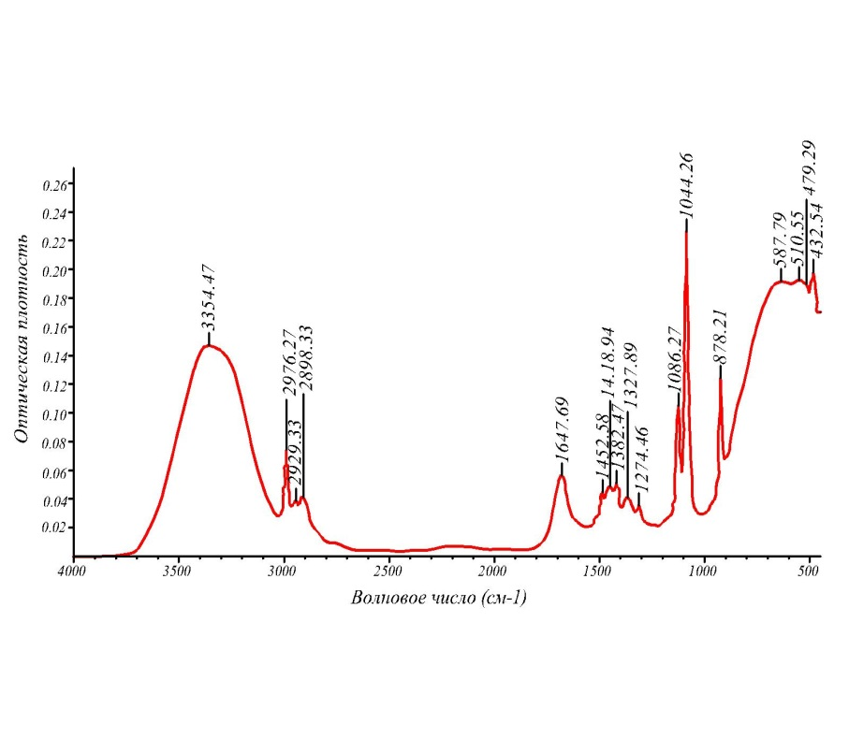
FIGURE 1. IR spectrum of Citrullus lanatus sample extract
Depending on the structure and composition of the medium, inhibitors can be in the form of cations, anions, and neutral molecules. They interact electrostatically or chemically with the metal surface, strengthening the layers as a result of physical adsorption or chemisorption, which leads to a slowdown in the corrosion process. It has been found that these properties usually lead to sufficiently effective results due to the presence of atoms or functional groups in the molecules that provide an active adsorption center for the inhibitor to interact with the metal. They may contain nitrogen, phosphorus, oxygen, and carboxyl groups, which adsorb on the metal due to donor-acceptor and hydrogen bonds. It can be expected that the small ionization potential of electron-donating molecules, their opposite charges, the protonated state of the nitrogen atom center, and the somewhat positively charged hydrogen atom with the metal surface, due to coordination or hydrogen bonds, are the best inhibitors [5]. The addition of these compounds to the solution protects metals from corrosion and prevents the formation of excess salts. The inhibitory effect is believed to be stronger in compounds containing the functional
groups -NH2, =NH, CN, N=O, –P=O on some metals.
In this work, the results of the determination of macro and microelements in the content of samples of melon crops Citrullus lanatus were obtained using the AVIO 200 (ISP – OES) optical emission spectrometric method. The amounts of metals and non-metals in Citrullus lanatus extracts from green inhibitor samples were determined by elemental analysis. The analysis showed that the content of nitrogen and phosphorus in Citrullus lanatus was somewhat higher, and these results were consistent with those obtained using the IR spectroscopy method, meaning that the functional groups identified from the extract samples once again confirm the data.
TABLE 1. Elemental analysis of non-metals determined by optical emission spectrometry in Citrullus lanatus extract
Sample name | P 313.617  (mg/10g) | N  397.197  (mg/10g) | S  181.975  (mg/10g) | C  378.421  (mg/10g) | H  278.577  (mg/10g) | O  324.245  (mg/10g)
Citrullus lanatus | 55,144 | 42,364 | 1,958 | 58,997 | 7,244 | 78,147

The presence of several different functional groups in each sample makes its inhibitory effectiveness stronger and its duration of action longer. Elemental analysis analysis allows you to determine what atoms (elements) the substance under investigation is composed of. Elemental analysis is one of the most important tasks in studying the properties and characteristics of any chemical reagent. The elemental composition of a substance must be known to control the raw materials used in any production, as well as to analyze the extracted samples [6].
TABLE 2. Elemental analysis of metals determined by optical emission spectrometry in Citrullus lanatus extract
Name | Cu 327.393  (mg/10g) | Co 228.616  (mg/10g) | Si 251.611  (mg/10g) | Mg 285.213  (mg/10g) | K  766.490  (mg/10g) | Mn 257.610  (mg/10g) | Fe 238.204  (mg/10g) | Na 589.592  (mg/10g) | Zn 206.200  (mg/10g)
Citrullus lanatus | 0,036 | 0,003 | 1,842 | 15,395 | 242,394 | 0,095 | 0,799 | 12,014 | 0,146

The element analysis laboratory is of great importance in obtaining environmentally friendly, low-toxic reagents, especially for the use of inhibitors in various metiums to protect equipment from corrosion in ferrous and non-ferrous metallurgy, oil production, refining, agriculture and many other industries. The effectiveness of the inhibitors was investigated using electrochemical methods.
The curves of Citrullus lanatus extract samples were obtained by the open electron potential change method. Tap water (Fon-3), pH=6.7, was selected as the corrosive medium. 45 steel samples were used in this process. Open circuit potential (OCP) refers to the potential difference between a working electrode and a reference electrode in the absence of an applied current. Monitoring OCP is important in determining the required immersion time to reach steady state before performing electrochemical experiments.
During the research, tests were conducted with a sample of steel 45. It was observed that when a green inhibitor was introduced, the efficiency of the system was higher compared to the background solution.
We can see these results in Figure 2. The results shown indicate a significant increase in OCP potency for the three inhibitors. After about 40 and 50 seconds, the potentials reach stable maximum values, which represents a quasi-stationary state that remains unchanged. The stabilization of the open-chain potential confirms the effective adsorption of inhibitors onto the carbon-containing steel surface. The results of the change in the open electron potential of steel grade 45 in an aqueous medium with the addition of various inhibitors at a concentration of 30 mg/l. Citrullus lanatus inhibitor samples were studied in a medium with background (3).
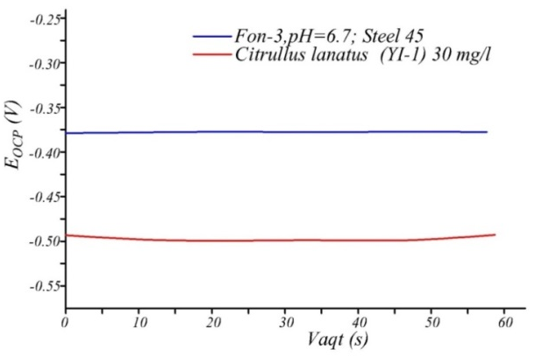
FIGURE 2. Open electrode potential change of steel 45 sample upon introduction of citrullus lanatus inhibitor
The difference between the corrosion potentials (Ecorr) for the inhibited and uninhibited systems was less than 0.420 mV, indicating that the introduced green inhibitors were of mixed type[6]. It is concluded that the inhibitor chemically and physically adsorbed on the metal surface and can form a protective layer. In addition a change in the EOCP potential is observed after the addition of inhibitors. This change indicates the protective effect of inhibitors, that is, they prevent the interaction and binding of ions contained in the inhibitor to the metal surface. Thus, the ability of inhibitors to form a protective network plays an important role in increasing the corrosion resistance of the CS electrode.
This study highlights the importance of OCP measurements, as they help to understand the initial interactions between inhibitors and the metal surface, which provides insight into their effectiveness in preventing corrosion.
The polarization curve method is considered one of the express methods for determining the effectiveness of inhibitors, helping to obtain faster results than gravimetric methods, and is included in the group of electrochemical methods. Analysis of polarization curves can be used to describe the electrochemical corrosion of metals in various environments.
In this work, the change in corrosion current and potential was analyzed in a steel 45 sample. In this case, using the polarization curve method, a sample of steel 45 with pH=6.7 was studied in an aqueous medium with the addition of 30 mg/l of the inhibitor (Fon-3) compared to citrullus lanatus. From the polarization curves of the green inhibitors, we can see that their corrosion potential shifted somewhat and the corrosion current decreased sharply.
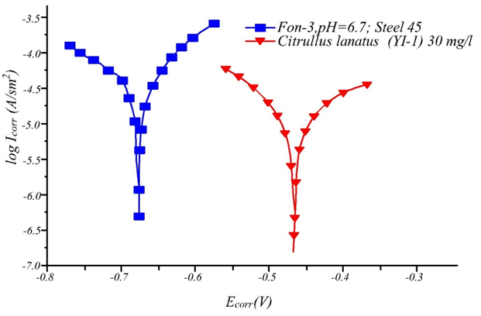
FIGURE 3. Results obtained using the polarization curve method when the citrullus lanatus inhibitor was
added to the steel 45 sample (Fon-3)
The polarization curve method helps to obtain results in complex conditions including differa corrosive mediums. To do this, the peaks in the corrosion current dependence are obtained by changing the curves in the cathodic and anodic processes. A potentiostat, programmer and voltmeter are used to obtain these results. Various mineral compositions of water have been used as corrosive medium.
TABLE 3. Results of the effectiveness of inhibitors determined by the method of polarization curves in
solution at 25ºC (Fon-1)
Inhibitor | С, (mg/l) | i, (mА/sm²) | γ | θ
(Fon-1) | 30 | 0,68 | – | –
Citrullus lanatus | 30 | 0,054 | 12,59 | 0,92
(Na-KMS+DEAF) | 30 | 0,061 | 11,15 | 0,91
(Na-KMS+AF) | 30 | 0,074 | 9,18 | 0,89
NaKMS·Na₅P₃O₁₀ | 30 | 0,102 | 6,66 | 0,85
Na-KMS·H₃PO₄ | 30 | 0,122 | 5,57 | 0,82

Polarization curves can be automatically monitored by potentiostats with a given electrode potential or programmed changes over time, gradually changing their speed while maintaining given electrode value [7,8]. At determination the degree of complete coverage, green inhibitors were found to be the best inhibitors. It can be seen that the value of the degree of full coverage increased to 0.82-0.92. If the value of the degree of complete coverage approaches 1.0, then this confirms the high effectiveness of the introduced inhibitors.
In the research work, electrochemical resistance spectroscopy (ECS) or the polarization resistance method were used for 45 steel samples. In this work, a corrosive medium with citrullus lanatus in a system with the introduction of an inhibitor pH=6.7 was used. The obtained curves show how the electrochemical kinetic parameters of the corrosion and inhibition processes on the metal surface change.
Protective layer is formed on the metal surface as a result of changes in the electrochemical kinetic parameters of the corrosion and inhibition processes. This is explained by the presence of nitrogen and phosphorus in the composition of green inhibitors. As a result of these formed bonds, the metal surface can be inhibited and protected by a film. This effectiveness can be explained by the formation of a thin protective layer of nitrogen- and phosphorus-containing green inhibitors in the steel sample, which, in turn, coat the steel surface and slow down or stop the rate of corrosion decomposition.
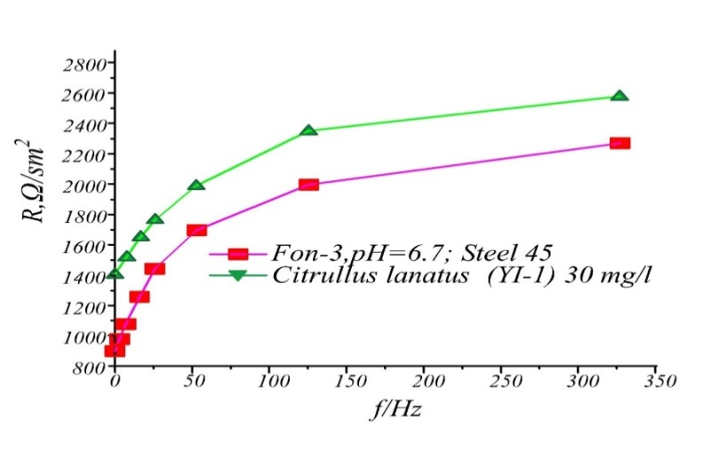
FIGURE 4. Citrullus lanatus (Green inhibitor-1) with a steel 45 electrode and change in polarization resistance (Fon-3)

These curves show that citrullus lanatus has good inhibitory properties. The difference between the maximum and minimum values of the phase angle curves obtained in the inhibited and uninhibited systems is significantly increased. From the resistance values, it can be seen that a protective layer is formed on the metal surface with the introduction of the inhibitor Citrullus lanatus. The idea that the mechanism of inhibition in aqueous media can only be judged approximately, and that it proceeds according to a specific mechanism, leads to incorrect conclusions. This result can be explained by the formation of a thin protective layer on the steel surface, which, in turn, blocks it and inhibits the corrosion decomposition rate.

RESULTS AND DISCUSSION
Gravimetric results
The influence of concentration on the inhibition efficiency was studied. In his work, conducting experiments to determine the effectiveness of inhibitors by gravimetric method in different temperature ranges and at concentrations provides a lot of information about the mechanism of inhibition. To determine the optimal concentration of the study objects in background solutions, studies were conducted at various concentrations of inhibitors. According to the results of the conducted research, the optimal concentration of inhibitors was 30 mg/l. According to the results of the study conducted at concentrations of 10, 20, 30, 40 mg/l, it was observed that with increasing concentration, the degree of protection and the degree of surface coverage initially increased significantly and subsequently remained practically unchanged (Table 4). Therefore, inhibitors were obtained at a concentration of 30 mg/l. According to the results of the study of the concentration dependence of the degree of protection in the working solution (Fon-3), the objects showed a higher degree of protection compared to the working solutions (Fon-1) and (Fon-2). The Citrullus lanatus inhibitor showed high effectiveness (93.01%).

TABLE 4. Concentration dependence of the degree of protection of inhibitors in solution at a temperature of 298 K (Fon-3)
C, mg/l | Ingibitorlar samaradorligi, %
C, mg/l | Na-KMS∙H₃PO₄ | Na-KMS∙Na₅P₃O₁₀ | Citrullus lanatus
10 | 69,95 | 73,08 | 77,78
20 | 83,45 | 86,01 | 88,12
30 | 87,42 | 88,12 | 93,01
40 | 87,69 | 88,29 | 93,17
Using the gravimetric method, the duration of the inhibitor's action was determined from 15 to 30 days.
The results obtained during the study were carried out in various background solutions, which are presented in Table 5, and the corrosion rate, braking coefficient (γ) and degree of protection (Z) were determined. It was noted that nitrogen and phosphorus-containing green inhibitors reduce metal corrosion and have high effectiveness, and owing to the duration of the inhibitor's effect, it’s protection is further enhanced.

FIGURE 5. Dependence of the degree of protection of inhibitors in the background-3 solution on the
concentration (T=298 K).

This can be explained by the fact that the compounds used as inhibitors have a high degree of protection against the action of active particles of metal surfaces and corrosive media. By selecting the composition of the inhibitor, the passivation of the medium causing metal corrosion and the decrease or cessation of high adsorption activity of the metal surface are achieved. This effect can be explained by the formation of a thin protective layer on the steel, which blocks the steel surface and reduces the rate of corrosion damage.
TABLE 5. The values of the inhibitor braking coefficient (γ), degree of protection (Z), determined by gravimetric method in various working solutions at T=298 K for 15 and 30 days
Inhibitor | K,  g/ (cm2•hour) | γ | Z, % | K,  g/ (cm2•hour) | γ | Z, (%)
Fon-1 (pH=5,3) | 15-day result |  |  | 30-day result
Fon-1 (pH=5,3) | 2,61 | - | - | 2,43 | - | -
(C₂H₅)₂NH∙ H₃PO₄ | 0,450 | 5,8 | 82,73 | 0,398 | 6,10 | 83,65
C₆H₅NH₂∙ H₃PO₄ | 0,335 | 7,79 | 87,15 | 0,271 | 8,96 | 88,83
Na-KMS∙H₃PO₄ | 0,272 | 9,66 | 89,55 | 0,231 | 10,52 | 90,46
Na-KMS∙Na₅P₃O₁₀ | 0,246 | 10,61 | 90,57 | 0,204 | 11,91 | 91,58
Citrullus lanatus | 0,212 | 12,43 | 91,87 | 0,182 | 13,3 | 92,48
F-2(pH=8,9) | 3,84 | - | - | 3,57 | - | -
(C₂H₅)₂NH∙H₃PO₄ | 1,030 | 3,72 | 73,17 | 0,899 | 3,97 | 74,81
C₆H₅NH₂∙H₃PO₄ | 0,667 | 5,75 | 82,61 | 0,591 | 6,04 | 83,44
Na-KMS∙H₃PO₄ | 0,590 | 6,50 | 84,62 | 0,491 | 7,27 | 86,24
Na-KMS∙Na₅P₃O₁₀ | 0,567 | 6,84 | 85,23 | 0,456 | 7,83 | 87,21
Citrullus lanatus | 0,367 | 10,46 | 90,44 | 0,319 | 11,19 | 91,06
Fon-3 | 2,97 | - | - | 2,73 | - | -
(C₂H₅)₂NH∙H₃PO₄ | 0,605 | 4,90 | 79,61 | 0,540 | 5,05 | 80,21
C₆H₅NH₂∙H₃PO₄ | 0,577 | 5,15 | 80,56 | 0,517 | 5,28 | 81,04
Na-KMS∙H₃PO₄ | 0,472 | 6,29 | 84,09 | 0,343 | 7,96 | 87,42
Na-KMS∙Na₅P₃O₁₀ | 0,427 | 6,96 | 85,62 | 0,352 | 7,75 | 88,12
Citrullus lanatus | 0,227 | 13,08 | 92,35 | 0,191 | 14,29 | 93,01

It should be noted that the change in the value of the corrosion rate indicates on increasing in the number of functional groups on the active surface of the metal during the experiment. In some aggressive and even passive states, a sufficiently high rate of corrosion was observed, which slowed down with the introduction of green inhibitors into the system [9,10]. Through experiments conducted in weakly acidic and alkaline mediums, it was established that among the investigated compounds there are corrosion inhibitors that effectively protect steel samples, such inhibitors include (C₂H₅)₂NH∙H₃PO₄, C₆H₅NH₂∙H₃PO_{4,} Na-KMS∙H₃PO₄, Na-KMS∙Na₅P₃O₁₀, citrullus lanatus. The constant influence of the medium on the inhibitory properties of compounds is explained by their adsorption properties, which depends on the electron density of nitrogen and phosphorus atoms. The inhibitors effectivness depends on concentration and a high degree of coating of the surface area of steel in the solution is clearly demonstrated on the formation of monolayers as a result of adsorption [11-13]. According to the results of the study conducted in the Fon-3 solution at a concentration of
30 mg/l, the subjects of the study varied from 79.61 to 92.35% for 15 days and to 80.21 for 30 days. Indicated a degree of protection up to 93.01%. Fon-3 solution in both Fon-1 and Fon-2 solutions was observed (Table 5).
The kinetic and thermodynamic parameters of green inhibitors, the corrosion rate and surface coverage levels were determined at various concentrations and temperatures (Table 6). Increasins in the degree of inhibitor protection (Z%) and the degree of surface coverage (θGrav.) was observed with increasing concentration. Owing to large number of inhibitor molecules close more corrosion centers and reduce corrosion. As a result, the corrosion rate (K) decreases.
Using the presented tables, the influence of temperature on the corrosion rate and the degree of protection in systems without inhibitors and with green inhibitors was studied. With increasing temperature, the corrosion rate of steel 45 samples in systems without inhibitors increased sharply, what be explained by the fact that as a result of the increased influence of the aggressive medium on the metal surface, Fe easily was oxidized. At using the inhibitor Citrullus lanatus, the corrosion rate decreased compared to the medium without the inhibitor. With increasing temperature, the corrosion rate and the degree of protection of the inhibited system decreased. At a temperature of 298 K and a concentration of 10-40 mg/l, the degree of protection was
80.05-93.01%, respectively, while at a temperature of 308 K The Z% value was 77.17-90.81%, at 318 K it was 71.29-83.19%, and at 328 K it was 63.58-74.98%. A decrease in the degree of protection with increasing temperature is associated with the adsorption of the inhibitor on the metal surface.
TABLE 6. Anti-corrosion effectiveness of the Citrullus lanatus inhibitor in Fon-3 solution at various temperatures and concentrations
Ingibitor | Т, К | C_{ing}, mg/l | K, mg/cm2∙h | γ | Z, % | θ_{Grav}
Citrullus lanatus | 298 | - | 2,730 | - | - | -
Citrullus lanatus | 298 | 10 | 0,545 | 5,0125 | 80,05 | 0,8005
Citrullus lanatus | 298 | 20 | 0,331 | 8,244 | 87,87 | 0,8787
Citrullus lanatus | 298 | 30 | 0,191 | 14,29 | 93,01 | 0,9301
Citrullus lanatus | 298 | 40 | 0,174 | 15,69 | 93,62 | 0,9362
Citrullus lanatus | 308 | - | 3,010 | - | -
Citrullus lanatus | 308 | 10 | 0,687 | 4,3802 | 77,17 | 0,7717
Citrullus lanatus | 308 | 20 | 0,319 | 9,4251 | 89,39 | 0,8939
Citrullus lanatus | 308 | 30 | 0,277 | 10,881 | 90,81 | 0,9081
Citrullus lanatus | 308 | 40 | 0,241 | 12,484 | 91,99 | 0,9199
Citrullus lanatus | 318 | - | 3,310 | - | -
Citrullus lanatus | 318 | 10 | 0,950 | 3,4842 | 71,29 | 0,7129
Citrullus lanatus | 318 | 20 | 0,770 | 3,4842 | 76,74 | 0,7674
Citrullus lanatus | 318 | 30 | 0,460 | 3,4842 | 82,53 | 0,8253
Citrullus lanatus | 318 | 40 | 0,556 | 3,4842 | 83,19 | 0,8319
Citrullus lanatus | 328 | - | 3,590 | - | -
Citrullus lanatus | 328 | 10 | 1,307 | 2,7457 | 63,58 | 0,6358
Citrullus lanatus | 328 | 20 | 1,140 | 3,1496 | 68,25 | 0,6825
Citrullus lanatus | 328 | 30 | 0,917 | 3,917 | 74,47 | 0,7447
Citrullus lanatus | 328 | 40 | 0,898 | 3,9968 | 74,98 | 0,7498

Inhibitor molecules are adsorbed on the metal surface through chemical and physical adsorption. In physical adsorption, with increasing temperature, the electrostatic interactions between the inhibitor molecules and the steel surface decrease, which leads to a decrease in the values of Z% and θGrav. In general, a decrease in θGrav. indicates that desorption is higher than adsorption. The stability of the degree of protection with increasing temperature without a sharp decrease (93.01-74.98%) is the result of chemical adsorption.
These results confirm that the citrullus lanatus inhibitor effectively protects the 45 steel sample at temperatures of 298-328K. Among the objects of the study, citrullus lanatus samples showed high effectiveness as a green inhibitor. To obtain more information about the coating of the steel surface of the inhibitor and its protection mechanisms, the temperature dependence of the degree of protection of the citrullus lanatus inhibitor was studied.
Analysis of the results of kinetic research
Adsorption isotherms and adsorption thermodynamics of inhibitors
To obtain complete information about the mechanism of adsorption of citrullus lanatus green inhibitors on the steel surface, which have shown high efficiency, Frumkin, Tyomkin and Langmuir isotherms were obtained at various temperatures and concentrations.

FIGURE 6. Frumkin isotherms for the adsorption of Citrullus lanatus inhibitor (Fon-3) on the metal surface in solution
To obtain the Frumkin isotherm, a graph of the dependence of lg [θ/ (1-θ) ] on lg Cing was constructed
(Fig. 6). The values of the correlation coefficient for each temperature (for Citrullus lanatus 0.9768; 0.933; 0.9636; 0.9501).

FIGURE 7. Tyomkin isotherms for the adsorption of Citrullus lanatus inhibitor (Fon-3) on the metal surface in solution
A graph of the dependence of the value of θ on lg Cing for the Tyomkin isotherm was constructed (Fig. 7). The values of the correlation coefficient for each temperature (for Citrullus lanatus 0.9694; 0.8904; 0.9704; 0.9558). The fact that the values of the correlation coefficients according to the Frumkin and Tyomkin isotherms are not close to one indicates that the adsorption of the inhibitor on the metal surface does not proceed according to these theories.

FIGURE 8. Langmuir isotherms for the adsorption of Citrullus lanatus inhibitor
(Fon-3) on the metal surface in solution
From the dependence of C/θ on Cing, the Langmuir isotherm was obtained (Fig. 8). The value of the correlation coefficient of the experimental results obtained from the linear form of the Langmuir isotherm, close to one, showed that the process obeys to theory of monomolecular adsorption.
The monomolecular adsorption theory, based on the Langmuir isotherm, provides more information about the mechanism of interaction between the steel surface and the inhibitor. Using the Kads value determined by the Cing and Cing/θ dependence on the isotherm, the standard Gibbs energy of adsorption ∆Gads value 293 - 323K (Fig. 9). As a result of the experiment, it was established that the Gibbs energy decreases with increasing temperature, which indicates a spontaneous process. Compared to the rate of interaction of the steel surface with water, the chaos increases due to the high rate of complex formation when interacting with inhibitor molecules.

FIGURE 9. Temperature dependence of ∆Gads on the inhibitor Citrullus lanatus
Therefore, the adsorption entropy has a positive value (Table 7). With negative enthalpy, an exothermic process is observed during adsorption.
TABLE 7. Thermodynamic functions of the adsorption process of Citrullus lanatus inhibitors in a background-1 solution
Citrullus lanatus | Т, К | К_{ads} | R² | ∆G_{ads,} | ∆H_{ads,} kJ/g | ∆S_{ads,} J/(g*K)
Citrullus lanatus | 298 | 42,4448 | 0,9782 | -26,39 | -12,289 | 47,6
Citrullus lanatus | 308 | 38,3142 | 0,9782 | -27,01 | -12,289 | 47,6
Citrullus lanatus | 318 | 33,1126 | 0,9782 | -27,50 | -12,289 | 47,6
Citrullus lanatus | 328 | 26,983 | 0,9782 | -27,81 | -12,289 | 47,6
The effectiveness of the inhibitor has increased with increasing it’s concentration, but it was found that its action is limited. In this case, the duration of the inhibitor's action and lifespan are limited. In addition, owing to the interaction of the inhibitor with conductive ions in the metal solution, as well to the formation of refractory products and protective layers, they stop or slow down the corrosion process.
CONCLUSION
In conclusion, it can be said that highly effective green corrosion inhibitors based on citrullus lanatus have been identified. Based on the conducted electrochemical and gravimetric methods, such parameters as corrosion current, braking coefficient, corrosion rate, degree of protection as well as optimal temperature and concentration using green inhibitors, were determined.
The most suitable protection mechanism of the developed inhibitors is the adsorption equilibrium constant and the degree of complete coverage due to the formation of poorly soluble compounds with iron ions and the formation of a layer. The effect of intramolecular synergism of green inhibitors based on Citrullus lanatus due to the presence of various functional groups was observed, and it was shown that such inhibitors form dense layers on the metal surface what lead to an increasing in the inhibiting effect.
REFERENCES
- Holla, B. R., Mahesh, R., Manjunath, H., & Anjanapura, V. R. (2024). Plant extracts as green corrosion inhibitors for different kinds of steel: A review. Heliyon, 10(14), e33748. https://doi.org/10.1016/j.heliyon.2024.e33748
- Galleguillos Madrid FM, Soliz A, Cáceres L, Bergendahl M, Leiva-Guajardo S, Portillo C, Olivares D, Toro N, Jimenez-Arevalo V, Páez M. Green corrosion inhibitors for metal and alloys protection in contact with aqueous saline. Materials. 2024 Aug 11;17(16):3996. https://doi.org/10.3390/ma17163996
- Zeng C, Zhou ZY, Mai WJ, Chen QH, He JB, Liao BK. Exploration on the corrosion inhibition performance of Salvia miltiorrhiza extract as a green corrosion inhibitor for Q235 steel in HCl environment. Journal of Materials Research and Technology. 2024 Sep 1;32:3857-70. https://doi:10.1016/j.jmrt.2024.09.003
- Mamudu U, Santos JH, Umoren SA, Alnarabiji MS, Lim RC. Investigations of corrosion inhibition of ethanolic extract of Dillenia suffruticosa leaves as a green corrosion inhibitor of mild steel in hydrochloric acid medium. Corrosion Communications. 2024 Sep 1;15:52-62. https://doi.10.1016/j.corcom.2023.10.005
- Zeng XQ, Jiang ZN, Duan JM, Li YR, Peng SY, Dong CF, Zhang GA. Developing a novel amino acid derivative as high-efficient green corrosion inhibitor for mild steel in acidic solution: experiments and first-principles calculations. Industrial Crops and Products. 2024 Apr 1;210:118032. https://doi.org/10.1016/j.indcrop.2024.118032
- Barboza GK, de Oliveira MC, Neves MA, Echevarria A. Justicia brandegeeana as a green corrosion inhibitor for carbon steel in sulfuric acid. Green Chemistry Letters and Reviews. 2024 Dec 31;17(1):2320254.
- N. B. Eshmamatova, L. M. Qurbanova, A. M. Khamidov. Inhibition of Metal Corrosion Based on Nitrogen and Phosphorus Containing Organic and Oligomeric Salts. International Journal of Materials and Chemistry 2024, 14(5): 86-96. https://doi:10.5923/j.ijmc.20241405.02
- AL Salihi HA, Mahdi RR, Al‐Amiery A, Al‐Azzawi WK, Kadhum AA. Exploring the efficacy of polysaccharides as green corrosion inhibitors: A comprehensive review. Starch‐Stärke. 2024 Jul;76(7-8):2300234. https://doi.org/10.1002/star.202300234
- Elhady S, Zaki EG, El-Azabawy OE, Fahim IS. Electrochemical evaluation of green corrosion inhibitor based on ground coffee waste in Petroleum fields. Results in Engineering. 2024 Mar 1;21:101880. https://doi.org/10.1016/j.rineng.2024.101880
- Wan R, Zhao W, Sun X, Wang Z, Gong Z, Guo L, Marzouki R, Luo M, Li A, Ma Y, Tan B. N, S‑carbon quantum dots as a green corrosion inhibitor for brine heaters in multistage flash desalination systems. Sustainable Materials and Technologies. 2025 Jul 9:e01531. https://doi.org/10.1016/j.susmat.2025.e01531
- Hussein SA, Khadom AA. Okra leaves extract as green corrosion inhibitor for steel in sulfuric acid: Gravimetric, electrochemical, and surface morphological investigations. Results in Chemistry. 2024 Jun 1;8:101566. https://doi.org/10.1016/j.rechem.2024.101566
- Gnedenkov AS, Sinebryukhov SL, Nomerovskii AD, Marchenko VS, Ustinov AY, Gnedenkov SV. Carboxylates as green corrosion inhibitors of magnesium alloy for biomedical application. Journal of Magnesium and Alloys. 2024 Jul 1;12(7):2909-36. https://doi.org/10.1016/j.jma.2024.07.004

