Evaluation of Zinelbulak Talc–Magnesite in Industrial Networks by Integrated Analysis of Rocks
Maxsud Jumaniyazov, Sherzod Kurambayev, Hilola Pirnapasova, Dilnoza Shamuratova, Arslon Jumaniyozov^{a)}
Urgench State University named after Abu Rayhan Beruni, Urgench, Uzbekistan

^{a)}Corresponding author: arslonjumaniyozov077@gmail.com
Abstract: In this study, chemical, mineralogical, morphological and spatial structure of talc–magnesite rocks from the Zinelbulak deposit of the Republic of Karakalpakstan by modern methods of physicochemical analysis - XRF, XRD, IQ, SEM and TGA / DTA were studied in depth by the methods of modern physicochemical analysis. According to the results of the analysis, talc (Mg₃Si₄O₁₀(OH)₂) and magnesite (MgCO₃) were identified as the main phases in the sample, and it was noted that their crystalline and morphological parameters are mutually consistent. The XRF results showed that SiO₂ was 37.6%, MgO was 29.1% and Fe₂O₃ was 8.9%. XRD and IQ spectra expressed Si–O–Si oscillations at 1010 cm⁻¹ and valent oscillations of OH-groups at 3676 cm⁻¹, confirming the formation of free amorphous SiO₂. SEM analysis revealed that the mean diameter of the particles is 60 μm, aspect ratio is 2.2, and circularity is 0.60. The TGA/DTA curves showed that at 610–780 °C, magnesite decomposes and forms active MgO. The results were scientifically proven that Zinelbulak talc–magnesite raw material is a promising domestic feedstock for the production of magnesia binders, ceramics, adsorbents, catalysts, cosmetics and polymer composites.
Keywords: morphological composition, talc, amorphous silica, flotation, IQ spectroscopic analysis, SEM images, IQ spectroscopic analysis, rengenofluorocent, nano-SiO₂ adsorbents
INTRODUCTION
Zinelbulak, Kyzylsoy and Kazgansai talc-magnesite rocks that are widely used in various industries on the territory of the Republic of Uzbekistan are considered by their chemical and mineralogical composition to be considered as promising raw materials for the construction, chemical, ceramic, metallurgical and pharmaceutical industries. It is noteworthy that to date, perfect technologies for processing the above raw materials have not been created, and on their basis the production of isthematic materials has not been launched. Based on this, the main purpose of our research is to scientifically substantiate the possibilities of using Zinelbulak talc magnetic minerals in the production of fertilizers such as calcium-magnesium phosphate, magnesium phosphate, magnesium nitrate, MgCl₂ defoliant, amorphous crenisem and various products based on talc.
Although there has been much research on effective flotation methods for magnesium-sparing minerals worldwide, the fact that the basic theoretical concepts in this field have not yet been fully established prevents the full and effective use of magnesium-sparing minerals. An individual approach is needed for each magnesium conserving source in the study. It is necessary to take into account the latest scientific developments on the crystalline chemical and surface properties of minerals contained, the nature of ions involved in the flotation of these minerals, the mechanism of interaction between minerals and flotation reagents.
There is a lot of information in the world literature about the composition of talc-magnetite minerals, methods of processing, on its basis the possibility of obtaining materials that can be used in various sectors of the national economy.
The properties of talc-magnesite samples from the Zinelbulaq deposit were studied by Mirabbos Hojamberdiev et al. using X-ray difraction, differential thermal analysis, infrared spectroscopy and optical microscopy. The mineralogical composition of Zinelbulak talc-magnesite is 52 mass. %talk, 43 Mass. % carbonates and 5 mass. % iron-preserving minerals -magnetite, siderite, and chlorite. Latest news the enrichment ability of zinelbulak talc-magnesite has been tested using conventional gravitational separation, flotation, and electromagnetic separation methods [1-2].
In the scientific study published below, the elemental and oxide content of talc-magnesite raw materials obtained from the Zinelbulak deposit was investigated using X-ray fluorescence analysis method. According to the results of the study, the following compounds were found in the sample relative to the total mass: talc (3MgO∙4SiO₂∙H₂O) - 60.97%, magnesite (MgCO₃) - 27.74%, dolomite (MgCO₃∙CaCO₃) - 2.90%, chlorite (5MgO∙5FeO∙Al₂(SiO₃)₃∙H₂O) - 8.01% and calcite (CaCO₃) - 0.38%. The results of IQ-spectral analysis of the specimen, X-ray fluorescence and X-ray phase analysis confirmed the above results [3].

The article published by E.A. Atashev described the processes of decay in sulfuric acid of magnesite waste, which is formed during flotational enrichment of the Zinelbulak talc-magnesite deposit. As a result of the research, influence of concentration and temperature of reaction media on the melting of magnicite in H₂SO₄ solution was investigated and the degrees of decay were determined. Based on the data obtained, a mathematical model of the process was developed. Through experimental and model analysis, optimal conditions such as temperature (81,45°C), acid concentration (74,05%), decomposition efficiency (Y_{max} = 93,57%) were determined [4].
A paper published by Yingli Chen et al. investigated the extraction of magnesium from a solution of sulfuric acid of serpentine and the high purity of Mg(OH)₂ and 4MgCO₃· The process of melting–purification–precipitation applied to the synthesis of Mg(OH)₂·4H₂O compounds is described. Fe, Al and Cr ions in the solution were isolated by the oxidative precipitation method using an active MgO precipitator and an H₂O₂ oxidizer. Ni, Co and Mn elements were separated by precipitation with Na₂S to obtain a pure MgSO₄ solution. Mg²⁺ ions are first NH₃· Mg(OH)₂ was precipitated with H₂O solution, followed by 4MgCO₃· using NH₄HCO₃ The compound Mg(OH)₂·4H₂O has been synthesized. During the two-stage deposition process, the rate of magnesium decomposition was found to be 96.3% [5].
The natural flotation behavior of a pure talc mineral by Ahmed Yehia and Mohamed Al-Wakeel was studied by measuring its contact angle, flotation result, and zeta-potential. Polypropylene glycol has been used as a foaming agent (flotator) to intensify the flotation process in a short time. This study aims to obtain suitable talc concentrates for talc carbonate ore enrichment and application in various industrial fields. The influence of pH value and flotator quantity on the flotation process has been determined. The first (cherry) concentrate contains about 60% talcum and a product with a recovery rate of 90%. The concentrate was ground to 100% −125 μm and re-flotated under predetermined optimal flotation conditions. The result was a 70% recovery and 93.5% purity talc concentrate from ore containing 48.69% talc [6].
In the process of studying the material composition of talc ore samples, Azizbek Normurodov includes chemical, spectral, optical-emission spectral, granulometric, X-ray structural-phase, physical-mechanical and mineralogical analysis. And the content of silicon oxide is noted to be greater in fine fractions. In order to isolate the light fraction from heavy minerals, gravitational enrichment was performed for classes of different sizes. When dry electromagnetic separation is applied, magnetic and nongnite fractions at a current strength of 5 A are obtained. The output of the nonmagnetic fraction was 82.8%, and the output of the magnetic fraction was 17.2%. In the talc sample, up to 65.7% of the iron-sparing free minerals were isolated by electromagnetic separation method. The amount of talc in the remains (tails) reached 77.2%, and its regeneration rate was 90.7% [7].
It was noted by Haoran Sun, Yulian Wang, Yulian Wang that the isolation of silicon from magnesium by reverse flotation method (desilification) is important in the development of complex and less rich sources of magnesium raw materials. The key issue in this process is the selection of efficient and selective flotation collectors. For this purpose, for the first time, the cation active surface material, stearylamine acetate (SAA), was used as collector for the separation of magnesite and quartz. Micro-flotation experiments have shown that quartz can be separated from magnesite at a pH value of 5.0 and at a concentration of 70 mg/l SAA with a high efficiency with a Godin selectivity index of 6.51. According to the results of the zeta-potential and contact angle measurements, SAA selectively increased the level of surface membrane and hydrophobic on the quartz surface. Scanning electron microscopy (FESEM/EDS) and atomic force microscopy (AFM) studies have found that SAA has a much higher adsorption density to quartz surface than to magnesite. At the same time, selective adsorption of SAA on quartz surface from a quartz–magnesite mixture was confirmed by the Time of Flight secondary ion mass spectrometry (TOF-SIMS) and FTIR spectroscopy. In addition to electrostatic effects, selective adsorption has been found to be associated with the formation of a hydrogen bond between the –N–H group of SAA and the O–Si–O group on the quartz surface [8].
Ahmet Atasoy's article investigated processing of waste from open pit magnesite by wet high-intensity magnetic separation process. The resulting specimen is described physically, chemically, thermally, and spacely. The tested magnesite waste sample contained 77.69% MgCO₃ and a significant amount of 3.14% Fe₂O₃. The result was obtained the production of silicon dioxide, iron and high-quality magnesite. After the non-gnite portion of the treated sample was separated twice at an area strength of 1.8 T, a highly purified magnesite was formed. By magnetic separation method, it is possible to increase the amount of magnetite up to 91.03% and reduce the iron content up to 0.32%. It has been proved that the final product obtained can be used in chemical and metallurgical fields where high magnesium oxide content is required [9].
In subsequent publications, it was found that talc–magnesite rocks extracted from the Zinelbulak deposit contain mainly talc (Mg₃Si₄O₁₀(OH)₂) and magnesite (MgCO3) minerals, in addition to which it was found to contain mixtures of dolomite, chlorite, kemmererite and amorphous silica. This complex of minerals is distinguished by its high thermal stability, chemical inertness, smooth and platelet morphology, as well as dielectric properties. Therefore, it is possible to use talc–magnesium raw material on a large scale in cosmetics, pharmaceuticals, polymers, ceramics, flame retardants, magnesite binders, paint and paper, and magnesium fertilizers [10].
Umirov's scientific research noted that the Zinelbulak deposit is the only talc stone reserve in Central Asia at about 200 million tons. Chemical, X-ray phase, IQ-spectrospic, differential thermal and gamma-spectrometric methods were used to determine the qualitative and quantitative mineralogical composition of talc-magnesite ore. According to the results of the study, the main minerals of this talc-magnesite are talc and magnesite, which contain high magnesium content (31.7% by weight in extreme cases) and contain iron-sparing additives. It is a raw material suitable from the morphology and hardness properties of minerals, free from foreign particles, and suitable for multi-industrial use. Co-occurrence of serpentine, enstatite, quartz, hematite, and magnetite along with talc-magnesite has been recorded. The results of the research on the production of magnesium chloride and chlorate by firing zinelbulak ore at 500–700 °C and processing with hydrochloric acid (HCl) are presented [11].
METHOD
In the analysis, modern physicochemical analysis methods were used. SEM and particle morphology analysis have been studied to be particle size, circular in shape, or angular ("angular") in particle shape in rocks such as talc magnesite, -brainerite [12–13]. Depending on the shape of the talc mineral particles, its hydrophobic property was analyzed [13–16].
XRF with a high performance of X-ray fluororescence analyses. ZSX Primus III NEXT (Rigaku. Japan) spectrometer. The rengenograms were performed on computer-controlled XRD-6100 (Shimadzu, Jaran) powder diffractometer with CuKα radiation. Samples were analyzed using the ASTM American Card Index and Xgenometric Tables of Minerals compiled by Giller and Mikheev [17 – 20].
IQ spectrometric analyses were detected on the IRTraser-100 Fure spectrometer device (SHIMADZU SORR., Japan, 2017) with spectral range wavenumbers 4000÷400 ^{cm-1}, signal sensitivity ratios 60,000:1, scanning speed 20 spectra / s. The obtained spectrometric indicators were analyzed on the basis of spectrometric tables of minerals [21-23].
RESULTS AND DISCUSSION
Modern physicochemical analyzes were carried out in order to determine the use of this raw material as a raw material in various industrial productions. As we know, talc-magnesite type ores differ from other talc ores by having a high mass fraction of MgO.
The Zinelbulak talc-magnesite deposit in the lower Amudaruo area of the Republic of Uzbekistan consists mainly of talc - minerals - Mg₃Si₄O₁₀(OH)₂) and magnesium - MgCO₃. Also in raw materials such impurities as serpentine, enstatite, quartz, hematite and magnetite are found in small quantities [1]. The mineral talc is distinguished by its softness of 1 on the Moss scale and its high hydrophobic property, while magnesite, on the contrary, is somewhat harder than talc, with a Moss scale length of 3.5–4.5 and is hydrophilic [1–2].
For the purpose of modern physical-chemical analysis of samples, they were ground in laboratory conditions, first in jaw grinder CP-200 brand or ball mills IBMU-100-2 HT Machinery to <75 μm. The fractional extraction of crushed samples was performed in the ASV-200 brand vibratory sieve analyzer.
In order to study the chemical composition of this crude sample prepared in laboratory conditions, XRF. ZSX Primus III NEXT (Rigaku. Japan) was analyzed in an extended manner on an X-ray fluorescent spectrometer device (Fig. 1).

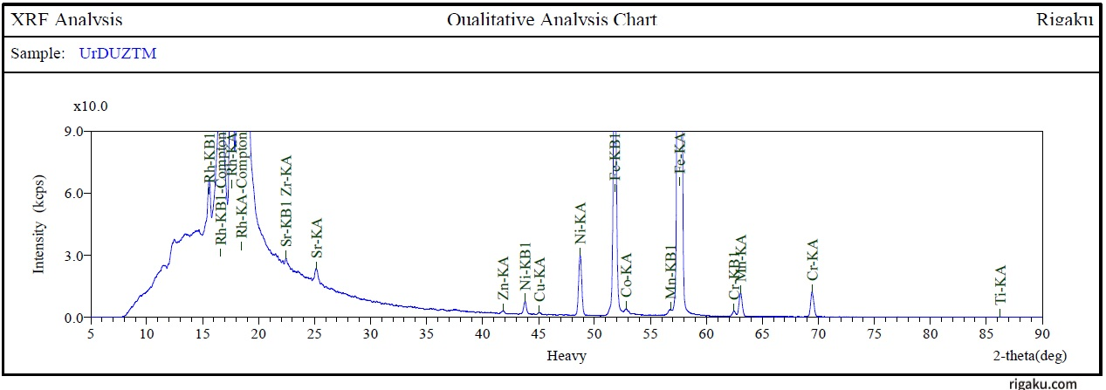
FIGURE 1. Zinelbulak talk-magnezit xomashyosini rengenoflyuorosentli tahlil.
According to the results of the analysis, the chemical composition, quantity, wt.% of the sample; SiO₂ – 37.6; MgO - 29.10; Fe₂O₃ - 8.90; A1₂O₃-1.05; CaO - 1.00; SO₃ - 0.08; MnO - 0.13; ZrO₂ - 0.15; NiO - 0.20; Cr₂O₃-0.14 and burn losses were found to be -15.84%. In our previous studies [1;6;7] X-ray and IQ spectroscopic analysis were performed in order to learn more deeply about the composition of these raw materials (Fig. 2).
According to the results of the analysis (Figure 2-a), it was determined that the strongest intensity was mainly for magnesite at peaks 2.74 d,Ǻ, and talc at peaks 3.10 and 9.21 d,Ǻ.
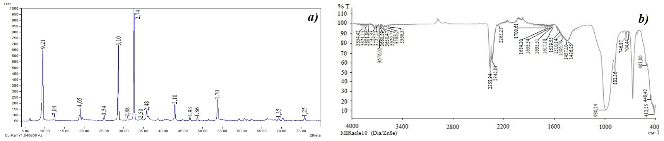
FIGURE 2. X-ray (a) and IQ spectroscopic analysis of Zinelbulak talc-magnesite raw material (b)
In IQ spectroscopic analyses (Fig. 2b), the OH oscillations of talc 3676–3670 cm⁻¹ are the valent oscillations; 3425–3450 cm⁻¹ - expression of O–H vibrations pertaining to adsorbed water molecules. At wavelengths of 2358–2360 cm⁻¹, C=O valent oscillations in carbonate anions were observed.
Deformation oscillations of water molecules have been observed at wavelengths of 1635–1640 cm⁻¹. Wavelengths of 1010–1008 cm⁻¹ and 982 cm⁻¹ indicate the presence of Si–O–Si bonds of talc and silicon. Mg–O exhibits specific bonds for magnesite structure at wavelengths of 464–450 cm⁻¹[1].
The oscillations of Si–O–Si at 1010 cm⁻¹ in the IQ spectrogram indicate the formation of free-amorphous SiO₂ in the composition, which explains the use of this raw material for the preparation of adsorbents, catalyst bases and sorbent materials. shows. And these properties underlie the use of talc raw materials as medicinal powders, skin creams and cosmetics.
When obtaining an enriched talc concentrate from zinelbulak talc-magnesite raw material, its high hydrophobic property is taken into account. Talc ore particle morphology (shape and surface texture) has a significant impact on the kinetics as well as the final result of the flotation process [1;7].
Particle morphology indices were analyzed to efficiently assess the intake of talc concentrate from Zinelbulak talc-magnesite raw material (Fig. 3).
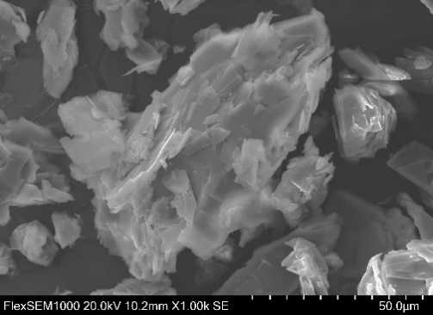 | 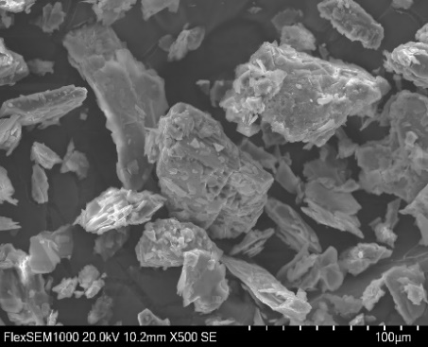 |  | 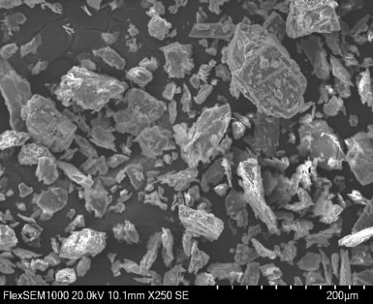
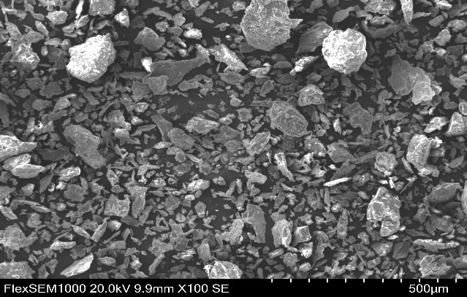 |  | 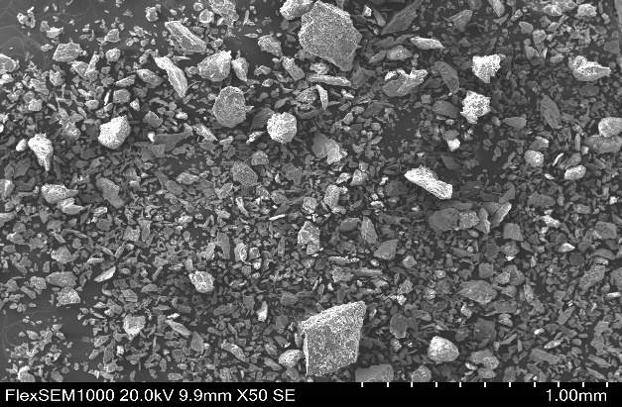
FIGURE 3. SEM images of raw material specimen of different sizes
Average sample preparation from crushed ores was carried out using the method of quartzing. To determine the particle morphology indications of the sample prepared for analysis were used Zeiss EVO 50 scanning electron microscope (SEM) and image analysis software. Using illustrative analysis, the following main parameters were calculated for the sample:
Equivalent diameter is the diameter of a circle having an area equal to the surface of a particle projection;
Aspect ratio () is the diameter of the long axis of a particle, expressed in proportion to the diameter of its short axis, and is evaluated as ≥1, relatively isometric if it is close to 1, and elongated if it is large; $A_{r}=\frac{L}{W}$
Circularity (Cy) is a coefficient indicating the degree of proximity of a shape to a circle, calculated by its formula depending on the projection area-A and P-perimeter of a particle. This Circularity indicator is theoretically an ideal circle when it is equal to 1, and conversely, it means that the shape is elongated or uneven if the value is small. On the basis of the results studied, the particles in the sample are much smaller and the diameter e $C_{y}=\frac{4πA}{P^{2}}$ is on average - 60 μm and is very irregularly shaped, dominated by thin plate particles with a length 2 times larger than the width and an aspect ratio of −2.2.
The specimen is very elongated or angular, that is, circularity is −0.60. This is evidenced by the high proportion of talc in the sample composition, since the crystalline structure of the talc mineral is layered and, when crumbled, tends to form in the form of a thin plate or plate, layered structure, thin-thin sheets, which provides hydrophobicity.
According to morphological analyses, the fact that the sample is a small particle has a positive effect on the decomposition of talc, since the abundance of small particles ensures that the hydrophobic surfaces of talc are more present in the liquid environment. But particle fineness can decompose with foam unnecessarily during flotation or increase the viscosity of the pulp.
For this later step of the study, we investigated processes to evaluate the industrial application of the specimen through the sample size and particle distribution. The sample particle size distribution was determined by laser diffraction on a Shimadzu SALD-7500 instrument (WingSALD II: Version 3.4.1) (Fig. 4).

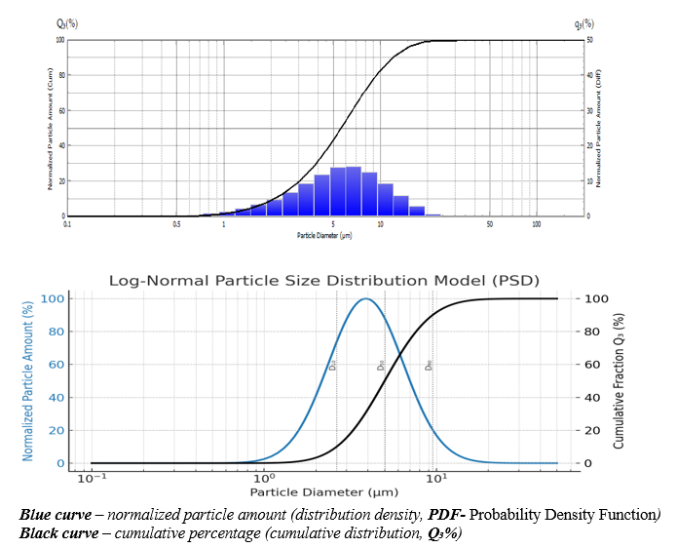
FIGURE 4. Particle distribution analysis histogram of crushed talc-magnesium feedstock.
The particle size distribution of the sample was recorded in the range of 0.1–100 μm. The results in the diagram show that sample particles belong to small to medium fractions. According to the analysis, we can see that the basic distribution range is 1–10 μm, the modal value is 5.2 μm, and the cumulative distribution is 90% point is 10 μm. These results indicate that the specimen belonged to the homomodal distribution type, that the grinding and screening process is stable controllable and that the monodispersion rate is high. This sample flotation and significance in the flotation enrichment process is that when particles smaller than 90% are smaller than 10μm, it allows for the selective separation of talc and magnesite phases on surface properties. Such a small particle size in thermal treatment processes improves thermal conductivity and ensures complete decarbonization of the carbonates contained mainly magnesite. Given that the particles have an average diameter of 5μm, this results in a large special surface area. This enhances the MgCO₃ decomposition kinetics by speeding up diffusion processes [1]. Also, the Si–O–Si in the talk facilitates the transition of links to the active state. Particles of this size also enable them to be used as starting material, since the amorphous SiO₂ synthesis causes a homogeneous amorphosis of the silica phase.
Justification for the preparation of magnesia binders based on differential thermal analysis: By determining the mass change and thermal effect of a material with increasing temperature, it is possible to express the production of refractory materials and magnesian binders from it, for this purpose, thermogravimetric (TGA) and differential thermal analysis (DTA) analyses of the sample were obtained (Fig. 3) [1].
From these analyses, it can be seen that mass loss, i.e., thermogravimetry, is basically brogan in 3 steps. The first phase was observed at temperatures 16-420°C, during which mainly decomposition of moisture and adsorbed water was observed, and no crystalline changes did not take place.
In the second stage, i.e. 420-750°C, one of the most active zones, during this phase magnesite (MgCO₃) breaks down and CO₂ breaks down. At the same time, a partially amorphous silicate formation process was observed in the talc structure. The third stage was observed at temperatures of 750-1000 °C, during which the decomposition of OH- groups in the talc follow-up is observed, and MgO and SiO₂ interact, forming a silicate phase and crystallization of Mg₂SiO₄ - forsterite. DTA substantiates the feasibility of extracting active magnium binders from these raw materials by calcination at temperatures of 610–780 °C.

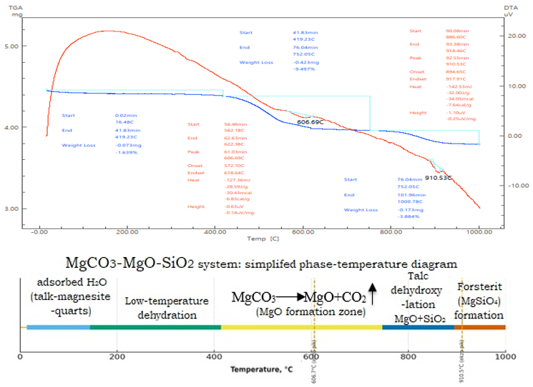
FIGURE 2. TG-DTA Analysis of Talc-Magnesite Feedstock
CONCLUSION
The composition of minerals of the Zinelbulak talc-magnesite deposit was elucidated using modern physical-chemical methods. As a result of an extended analysis of this raw material in an X-ray fluorescence spectrometer device, the chemical composition, quantity, mass of the raw material. In % account; SiO₂ – 37.6; MgO - 29.10; Fe₂O₃ - 8.90; A1₂O₃-1.05; SaO - 1.00; SO₃ - 0.08; MnO - 0.13; ZrO₂ - 0.15; NiO - 0.20; Cr₂O₃-0.14 and burn losses were found to be -15.84%.
XRD and IQ analyses of the raw material confirmed that the sample composition mainly contained talc, magnesite, amorphous silica, small amounts of chlorite, and dolomite. The results of the radinographic analysis were fully confirmed by the results of the IQ spectrographic analysis. The oscillations of Si–O–Si at 1010 cm⁻¹ in the IQ spectrogram indicate the formation of free-amorphous SiO₂ in the composition, which explains the use of this raw material for the preparation of adsorbents, catalyst bases and sorbent materials. softness, slipping properties and chemical inertia. And these properties underlie the use of talc raw materials as medicinal powders, skin creams and cosmetics.
In the analysis of SEM images of this sample, the abundance of much smaller (60 μm) and elongate-flat (AR 2.2, circularity 0.60) particles in the raw material sample was indicated by the richness of the talc mineral. According to morphological analyses, the fact that the sample is a fine particle has a positive effect on the flotation of talc because the abundance of small particles ensures that the hydrophobic surfaces of talc are more present in the liquid environment. This means that the reduction in particle size has a positive effect on the decay of talc. This substantiated that grinding the talc-magnesite feedstock to 0.1 mm is the most acceptable result.
The results of the TGA/DTA analysis clearly showed the major phase changes that occur with the increase in temperature in the talc magnesite raw material. Based on the analysis of these phase changes, he theorizes the possibility of decarbonizing this raw material to obtain magnesian binders containing active MgO.
Also, the high hydrophobicity of this raw material and the hardness of 1-2 on the Moos scale provide the grinding of 90% of the sample to particles smaller than 20μm. This substantiates the fact that Zinelbulak talc-magnesium feedstock can be used as a feedstock for rubber, plastics and ceramics industries, and paint and varnish industries.
Based on the numerous studies that have been conducted, we can conclude as follows.
Zinelbulak talc–magnesite ore is by definition as a composite material, thermally stable and reactive phase material. Based on the XRD, FTIR and TGA/DTA results, it was determined that active MgO, amorphous SiO₂ and talc phases can be formed by the decay of magnesite. PSD analyses have shown that small particle fractions can increase the reaction rate and make the flotation process more efficient. Based on these characteristics, magnesia binders, heat-resistant materials, nano SiO₂ adsorbents and cosmetics can be produced from Zinelbulak ores.
REFERENCES
- Mirabbos Hojamberdiev, Pulat Arifov, Kamil Tadjiev. Characterization and processing of talc-magnesite from the Zinelbulak deposit. May 2010. Mining Science and Technology (China)20(3):415-420. TWO:10.1016/S1674-5264(09)60218-0
- Hojamberdiev M., Arifov R., Tadjiev K., and Yun-hua Xu. Processing of refractory materials using various magnesium sources derived from Zinelbulak talc-magnesite // International Journal of Minerals, Metallurgy and Materials Vol.18, Number 1, February 2011, Page 105 DOI: 10.1007/s12613-011-0408-y
- Jumaniyazov, M., Kurambayev, S., Atashev, E., Jumaniyozov, A., & Buranova, M. (2025). Determination of the composition of the Zinelbulak talc-magnesite deposit rock using modern physicochemical methods. E3S Web of Conferences, 633, 06002. https://doi.org/10.1051/e3sconf/202563306002
- E.A. Atashev. Decomposition of Magnesite-Sparing Waste in Sulfuric Acid with a High Concentration: Empirical Modeling and Determination of Optimal Conditions. Kompleksnoe ispolzovanie mineralnogo syra. Vol. 339 NO. 4 (2025-06-17): Complex Use of Mineral Resources,339(4), 71–78. https://doi.org/10.31643/2026/6445.41
- Yingli Chen, Xiyun Yang, Linglong Wu, Lirong Tong, Jing Zhu. Recovery of Mg from H2SO4 Leaching Solution of Serpentine to Precipitation of High-Purity Mg(OH)₂ and 4MgCO3· Mg(OH)₂·4H2O. Minerals 2023, 13, 318. https://doi.org/10.3390/min13030318.
- Ahmed Yehia, Mohamed Al-Wakeel. Role of ore mineralogy in selecting beneficiation route for magnesite-dolomite separation. Physicochem. Probl. Miner. Process. 49(2), 2013, 525−534. DOI:10.1016/S0892-6875(99)00154-5
- Otaboev, K., Sherkuziev, D., Namazov, S., Radjabov, R., & Seytnazarov, A. (2021). Flow of simple superphosphate using two-stage decomposition of phosphorite. IOP Conference Series Earth and Environmental Science, 939(1), 012055. https://doi.org/10.1088/1755-1315/939/1/012055
- Haoran Sun, Yulian Wang, Yulian Wang. Selective control of surface characteristics of magnesite and quartz by a novel silicophilic collector stearylamine acetate. Applied Surface Science Volume 680, 30 January 2025, 161288. TWO:10.1016/j.apsusc.2024.161288
- Ahmet Atasoy. The wet high intensity magnetic separation of magnesite ore waste. Hemijska industrija 73(00):26-26. January 2019. DOI:10.2298/HEMIND181010026A
- Jumaniyazov, M., Kurambayev, S., Atashev, E., Aitova, S., & Pirnapasova, H. (2025). The extraction of talc from Zinelbulak talc-magnesite raw materials. AIP Conference Proceedings, 3304, 040043. https://doi.org/10.1063/5.0269064 .
- Umirov F. E., Shodikulov Zh. M., Aslonov A. B., Sharipov S. Sh. Material composition of talc-magnesite rocks of the Zinelbulak deposit in Uzbekistan. Obogashchenie Rud. 2023. №4. DOI:10.17580/or.2023.04.05
- Upstate Medical University, n.d. Particle composition by backscattered electron imaging. Available at: https://www.upstate.edu/pathenvi/basics/particle_composition_bei.php [Accessed 10 November 2025].
- Liang, C., Jia, Z., & Chen, R. (2023). An automated particle size analysis method for SEM images of powder coating particles. Coatings, 13(9), 1547. https://doi.org/10.3390/coatings13091547
- Upadhyay, R.K. (2025). Evaluation of Mineral Deposits. In: Geology and Mineral Resources. Springer Geology. Springer, Singapore. https://doi.org/10.1007/978-981-96-0598-9_11. Pp 725-798.
- Li, P., Dai, S., Sun, W. et al. Study on regulators of purifying magnesite ore by cationic reverse flotation. Sci Rep 11, 16987 (2021). https://doi.org/10.1038/s41598-021-96549-4
- Pawlik, M. Correction to: Fundamentals of froth flotation. ChemTexts 8, 20 (2022). https://doi.org/10.1007/s40828-022-00173-2
- Downs, R. T., & Hall-Wallace, M. (2003). The American Mineralogist crystal structure database. American Mineralogist, 88, 247-250.
- Belkly, A., Helderman, M., Karen, V. L., & Ulksh, R. (2002). New developments in the Inorganic Crystal Structure Database (ISSD): Assessability in the field of materials research and design. Acta Crystallographica Section B: Structural Science, 58(3), 364-369.
- Agarwal, B. K. (1991). X-ray stress analysis. Berlin, Heidelberg, New York: Springer.
- Monina, L. M. (2017). Radiography: Qualitative X-ray analysis. Moscow: Prospekt.
- Böcker, Yu. (2017). Mir Khimii. Spectroscopy. Moscow: Technosphere.
- Nyquist, R. A., & Kagel, R. O. (1971). Infrared spectra of inorganic compounds (3800-45 cm⁻¹). New York: Academic.
- Zschornack, G. (2007). Spravochnik po roentgenovskim dannim. Berlin, Heidelberg: Springer-Verlag.
- Mamutov, B., Butkov, E., Hamzayev, A., Sherkuziev, D., Aripov, K., Ergasheva, F., & Ismoilova, K. (2021). Application of mineral fertilizers to increasing soil moisture and growth of forest seedlings for creation forest crops in Western Tien-Shan. E3S Web of Conferences, 304, 03007. https://doi.org/10.1051/e3sconf/202130403007
- Farmonovich, I. A. (2020). Synthesis and optical-dimensional properties of hybrid CDSE/ZNS nanocrystals. Journal of Advanced Research in Dynamical and Control Systems, 12(SP7), 2201–2205. https://doi.org/10.5373/jardcs/v12sp7/20202344
- Zhumaniyazov, M. Z., Beglov, B. M., Khodzhaev, O. F., & Yuldashev, N. K. (2004). Solubility Polytherm of the Ternary system Hexamethylenetetramine-Ammonium dihydrogen Phosphate-Water. Russian Journal of General Chemistry, 74(7), 1001–1004. https://doi.org/10.1023/b:rugc.0000045855.52134.25
- Masharipova, S., Jumaniyazov, M., Turkmenbaeva, M., & Kabulova, L. (2025). Study of physicochemical properties of hydrophobic calcite based on sugar factory defecates. E3S Web of Conferences, 633, 01003. https://doi.org/10.1051/e3sconf/202563301003
- Jumaniyazov, M., Masharipova, S., Bekchanov, B., Masharipova, Z., & Kudiyarova, K. (2025). Obtaining the composition of ceramic bricks based on the color characteristics of the original sample. AIP Conference Proceedings, 3304, 040046. https://doi.org/10.1063/5.0269042

