Preliminary Studies on Obtaining Magnesium Phosphate Fertilizer from Local Raw Materials
Maxsud Jumaniyazov, Hilola Pirnapasova, Oyshajon Madraximova, Tabassum Omanboyeva, Arslon Jumaniyozov^{a)}
Urgench State University named after Abu Rayhan Beruni, Urgench, Uzbekistan

^{a)}Corresponding author: arslonjumaniyozov077@gmail.com
Abstract: This study on the development of scientific and technological foundations of synthesis of environmentally stable magnesium phosphate fertilizers on the basis of natural phosphate and magnesite raw materials, available in Uzbekistan. Mechanisms of formation of synthesis of Mg–P products from magnesite-sparing raw materials formed from flotation of high-carbonate low-grade Central Kyzylkum phosphorites and Zinelbulak talc-magnesite rocks were analyzed. In the processes, the processes of decomposition of magnesite-sparing waste in sulfuric acid were carried out on the basis of its empirical modeling and determination of optimal conditions. Based on model calculations, the acid treatment of 75% sulfuric acid concentration solution for 40 min at a temperature of 85°Σ with a content of 110% compared to the stichometric volume was established. A sample containing magnesium sulfate preserving and soluble magnesium with an acidity (pH) of 1.04 was neutralized with low-grade high-carbonate Central Kyzylkum phosphorites in a ratio of MgO um / P2O5um = 1.20. The degree of solubility of products in water andneuthral ammonium-citrate solution, the total P₂O₅ and MgO content was determined, and their agronomic potential was evaluated. The results showed that in the samples, magnesium phosphate fertilizer was obtained with a water-soluble form of MgO of 10.15%, a total of _{P2O5} of 11.02% and an imtenent form of 6.66%. The results of the research form an important scientific basis for the effective use of local mineral resources, the development of cheap import-substituting fertilizers Mg-P and the expansion of opportunities for their agroecological application.
Keywords: magnesium phosphate fertilizer, local feedstock, magnesium, phosphate rock, calcination, solubility, agroecological efficiency
INTRODUCTION
Nutrients are important for the growth and development of all plants. Depending on the soil composition of the cultivated area and the types of plants being grown, their demand for nutrients can also be different. In the conditions of Uzbekistan, soils in more than 90% of total arable land do not contain an insufficient amount of nutrients. Therefore, the demand of plants for nutrients is mainly met by injecting various mineral fertilizers, including -macro and -microelements, into the soil.
Globally, the main major producers of nitrogen, phosphorus and potash fertilizers, the most important of which are mineral fertilizers, are China (25%), India (13%), the USA (25%) and Russia (8%). Nitrogen fertilizers account for 59% of the mineral fertilizer market, 24% of phosphorus, and 17% of potash fertilizers, and globally, 37% of phosphorus fertilizers are produced in China, 12% in the USA, 10% in India, 6.5% in Morocco and Russia [1-5].
At present, Zher-Sardora, Karakat and Yetim-Dag deposits of the Central Kyzylkum Phosphorite Basin in the Republic are the main raw material base of phosphorus fertilizers. In the Tashkura section of the Jer-Sardor deposit by scientists from Uzbekistan, Turkmenistan and Tajikistan (VNIIgeolnerud, GIGXC, CAIGIMC, IX AN RUz) in 1975-1985. The mine has two phosphate beds 1.0-1.3 meters thick. The phosphorus dioxide content in the layers is 16-19% in the first layer, and 21-23% in the second layer [1; 2; 6].
After nitrogen, phosphorus, potassium and calcium, sulfur and magnesium are among the most important nutrients. The main stage in the development of magnesium plants is involved in the process of photosynthesis. The formation of chlorophyll grains in the leaf is the main central element [7]. The element magnesium occupies the 3rd place in terms of the amount of minerals in sea waters in the terrestrial hydrosphere, and the 8th place as an element in the lithosphere, accounting for 2.1%. Its share in the soil of up to 0.6% is found mainly in the composition of minerals such as magnesite, dolomite, muscovite, biotite, and in the form of simple salts in the state absorbed into soil colloids (such as MgSO₄, MgS1) [8-10].
Today there are a huge number of complex fertilizers that contain dietary components of various proportions. In the production of magnesium fertilizers, the raw material base is very large, and in nature there are more than 200 magnesium-sparing ores, the main of which are carbonate ores (dolomite- MgCO₃∙CaCO₃, magnesite - MgCO₃), natural salts (carnalite-KCl· These include MgCl₂·6H₂O, cainite-KCl∙MgSO₄∙3H₂O, polyhalite-K₂Ca₂Mg[SO₄]₄·2H₂O), and talc-Mg₃Si₄O₁₀(OH)₂ and talc-magnesite rocks [8; 9].
In the Republic, magnesium-rich talc, talc-magnesite, and serpentinite raw material deposits are discovered in the central part of the Sultan Uwais mountain range in the northwestern part of the Republic and in the Jizzakh region. Talc and talc-magnesium-rich deposits are mainly located in the Sultan Uwais mountain range in the Republic of Karakalpakstan, conditionally divided into three deposits: Kyzylsoy, Kazgansoy and Zinelbulak. [8-14].
The main purpose of this work is empirical modeling of the process of neutralization of magnesium phosphate fertilizers by processing with sulfuric acid and neutralizing the magnesium sulfate-retaining strait with low-grade high-carbonate phosphorites of the Central Kyzylkum region and neutralizing the magnesium sulfate-containing sediments with phosphorites of the Central Kyzylkum obtained.
There are a number of scientific papers on the extraction of magnetite from talc-magnetite minerals.

Magnesite deposit contains a small amount of chalcopyrite – cobalt mineralization and a series of separation steps were performed in order to evaluate the possibility of separation of two auxiliary minerals. Although the amount of Cu–Co (>0.01% Co, >0.1% Cu) in the deposit is significantly lower than the normal norm for economic use, the main valuable mineral extracted from this deposit and the inclusion of cobalt as an important raw material, as well as its high market price, can compensate for additional beneficiation steps. The deposit was first crushed and then dissected into fractions of –100 μm and +100–400 μm. Microfraction was enriched by the foam flotation method in the laboratory flotation cell. The coarse fraction was subjected to multi-stage separation processes - silkymatic table gravitational separation, magnetic separation and corona electrostatic separation.
Work was carried out on the characterization and enrichment of a sample of magnesite-dolomite. The role of mining mineralogy in selecting the optimal concentration method for the separation of magnesite-dolomite is of decisive importance. Microscopic analyses show that dolomite is contaminated with goethite and lepidocactite (low-magnetic minerals), while magnesite is contaminated with hematite and magnetite (highly magnetic minerals). To separate the dolomite from the magnesite, a dry magnetic separation method was used. As a result of magnetic separation of the sample, a concentrate of magnetite with a CaO content of 1.12% and a recovery rate of 46.02% was obtained, in which the ratio of CaO/SiO₂ mole is 1.62. This magnesite product is suitable for manufacturing a basic shoe (basic) fire-resistant material. In addition, a medium fraction containing 44.63% magnesite and 10.95% dolomite was also obtained. This product is considered suitable for the production of low-loss forsterite dielectrics.
In this paper, the method of smelting with sulfuric acid was used for the direct isolation of magnesium and silicon from low-quality magnesite. According to the results of the study, under conditions with reaction time of 2 hours, reaction temperature 150 °C, ratio of acid and magnetite 3:1 (ml:g), acid concentration of 70%, magnesium spillover rate was 96.2%. Post-acid treatment residue was analyzed via both XRD and SEM methods. The main component of the residue is SiO₂, which contains a small amount of talc phase. The residual structure has a cellular form, while the structure of the magnesite particles remains intact.
In the scientific work of Gilbert E., the areas of application of magnesite or magnesium carbonate are cited, caustic calcined magnesite (CCM), deep-burned magnesite (DBM), and hardened magnesite (FM) intermediates have different physical, chemical, and thermal properties, which are related to temperature levels in the calcination process and other factors. For example, the reactivity and other properties of the (CCM) product make it attractive for use in many fields. These industries include paper, plastics, building materials, ceramics, glass, cosmetics, agriculture (fertilizers and animal feed), and environmental industries (water treatment and degassing systems). On the other hand, due to the chemical inertia and other properties of (DBM) and (FM) products, they are used as fire-resistant materials in large industrial areas such as iron and steel furnaces. These diverse and important application areas have driven the demand for magnesite, especially the need for high-purity magnesia (MgO) and low-pollution intermediates.
Separation of magnesite from minerals containing calcium by flotation method has always been a complex issue in the field of mineral processing. In this study, the blocking effects of carboxymethylcellulose (CMC), sodium lignosulfonate, polyaspartic acid (PASP), and sodium silicate on the flotational behavior of magnesite, dolomite, and calcite were investigated. This research serves as a guide for the development of reagents in magnesite flotation. The micro-flotation results showed that among these four blocking agents, sodium silicate exhibited the highest selectivity, as it had the largest recovery difference. By the application of sodium silicate as a blocker, it has been established that it is possible to successfully separate magnesite from dolomite and calcite. Contact angle measurements showed that when sodium silicate is added, the differences in the surface wetting ability of the three minerals are greatest, which is consistent with the micro-flotation results. In addition, images from zeta-potential tests, Fure infrared spectroscopy (FT-IR), and atomic force microscopy (AFM) were used to reveal the blocking mechanism of sodium silicate. The results showed that the main component of sodium silicate — SiO(OH)₃⁻ — can be adsorbed to the mineral surface. This adsorption had virtually no influence on the adsorption of NaOL (sodium oleate) on the surface of magnesite, but decreased the adsorption of NaOL on dolomite and calcite surface. Through this, the selectivity of flotation increased.
In this article the issue of recovery of valuable components by processing mineralized mining waste generated from magnesite processing processes is considered. Two types of mineralized waste were analyzed. Commercial concentrates obtained by sorting had a MgCO₃ level of 94–97% with a yield of around 46%; If concentrate is mixed with medium fraction (middling), the yield increases to 58–64%, but the degree is slightly reduced, reaching 91–94%. The results obtained on the drowning-drowning method were also satisfactory, with a water separation of 2.88 degrees and a yield of 95% and a yield of 45%. However, some problems arise due to the fact that the density difference between magnesite and side minerals (gangs) is very small. Magnetic separation results were slightly lower, with levels being in the range of about 80–85%, and output in the range of 33–65%. These results are probably due to insufficient particle separation and a sufficiently strong magnetic field is required. In the magnetic coating method, the effects of pH, collector concentration, and paraffin content in individual minerals were primarily studied. Best results were obtained in conditions with pH=9, dodecylamine solution concentration 4.5×10⁻⁵ M and paraffin consumption 2.5 l/t. As a result of tests under optimal conditions and separation with a magnetic field of 0.8 A, an ungnitious product with a MgCO₃ content above 99% was obtained. The same parameters were also studied in the co-agglomeration / magnetic separation test. In individual minerals, the best conditions for co-agglomeration were found to be pH = 8, dodecylamine consumption was 2 kg/t and paraffin 4 l/t. Tests on mineral alloys have demonstrated that MgCO₃ levels increased as dodecylamine content increased, but yield declined.
METHODS
In the analysis, modern physicochemical analysis methods were used. The necessary X-ray analysis to determine the space state and mineralogical composition of the research objects was carried out on computer-controlled diffractometer XRD-6100 (Shimadzu, Jaran) with radiation CuKα. Samples were analyzed using the ASTM American Carrot Index and X-genometric tables of minerals compiled by Giller and Mikheev.
All forms of P₂O₅ in the samples in accordance with the requirements of GOST 20851.2-75 were determined by the diffuse photometic method. These analysis processes were performed in photocolorimeter KFK-3-01 «30M3» at wavelengths λ=440 nm. The results were determined using formula 1 below.
$C_{P_{2}O_{5}}=\frac{a×250×100}{g×V×1000}$ (1)
Here: the amount of α-P₂O₅ found on the basis of the graph, mg; g- the sample quantity to be analyzed, g and V-solution volume, cm³.
Calcium and magnesium oxides contained in the compound were performed by titration in a solution of 0.05 N trilon-B in the presence of chromium black-blue. The obtained results were calculated on the basis of the formulas (Figures 2) below.
$C_{CaO}=\frac{a×0.0014×50×100}{g×V×50}$ (2)
$C_{MgO}=\frac{(b-a)×0.001×250×250×100}{g×V×50}$ (3)
Where: the volume of trillion-B spent in determining the amount of a-calcium, ml; the amount of trilon-B spent in determining the amount of β-magnesium, ml; g- sample quantity to be analyzed, g and V-solution volume, cm³.
Magnesium in magnesium preservatives separated from talc-magnesite was carried out in accordance with the requirements of GOST 19728.8-2001 and calcium oxide in accordance with the requirements of GOST 19728.7-2001 by titration with trilon-B solution of 0.05 normal, using xpom black-blue and fluorexone indicators. The results obtained are determined by the following calculation formulas (4 and 5).
$X_{CaO}=\frac{{VCV}_{1}100}{V_{2}m}$ (4)
$X_{MgO}=\frac{{VCV}_{1}}{V_{2}m}×100-0,719X_{1}$ (5)
Here: V-trilon-B volumetric consumption, cm³; C- trilon-B concentration, g/cm3; V1- total volume of solution, cm³; V₂- the volume of the obtained solution for titration, cm3; m-sample volume, g and X1-mass fraction of calcium oxide, %.
The granulometric composition of magnetic precipitates was determined according to the requirements of GOST 19728.20-2001 based on the method of fractionation of sample grains by sieving in a vibratory sieve analyzer brand ASV-200 and calculation of the obtained fractions as a percentage of the initial sample.
The moisture content was achieved by drying eca to a constant mass in a drying cabinet branded 30-1060 of Memmert GmbH + Co of Memmert GmbH + Co of Hepmania to a constant weight at 105±5°Σ as required by GOST 19728.19-2001.
RESULTS AND DISCUSSION
We used as a feedstock for the production of magnesium fertilizer, magnesite waste, which is formed during flotation and beneficiation of Zinelbulak talc magnesite rock. Zinelbulak talc-magnesite rock and its quantitative composition formed during flotation enrichment in % We studied their substance composition by comparing IQ spectroscopic and radiographic analyses to scientifically substantiate the formation of magnetic waste with magnesite - MgCO₃ - 53.70%, talc - 27.20%, kemmererite - 10.01%, dolomite- MgCO₃∙CaCO₃ 7.75% and calcite - CaCO₃ 1.34% (Fig. 1).

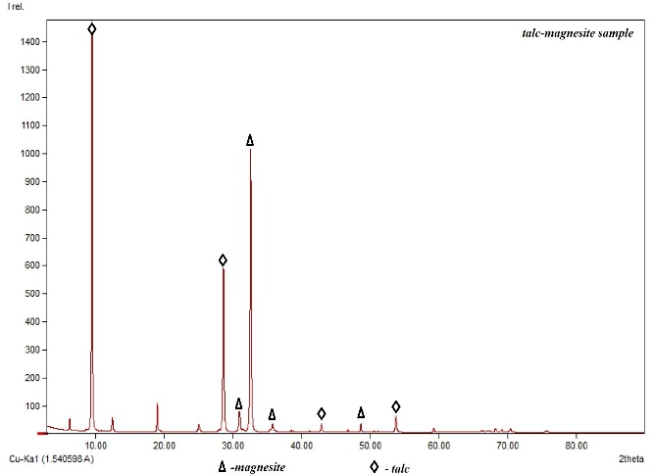 | 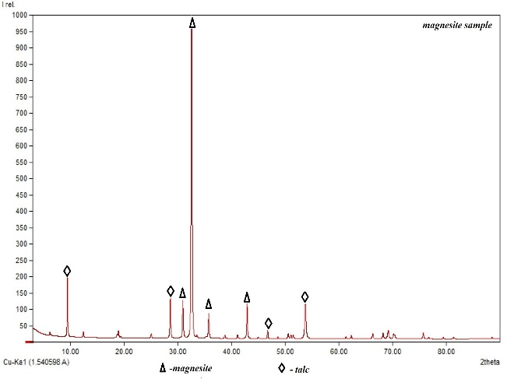
FIGURE 1. X-rays of talc-magnesite feedstock and magnesite waste.
In Figure 2 below, talc-specific OH groups in the talc-magnesite sample analysis were found to be missing in the wavelengths of 3675–3680 cm⁻¹ and the magnesite sample analyses of 1004 cm⁻¹ Si–O bonds. This confirmed the above X-ray analysis results as well as the sample's IQ spectrum analysis results (Fig. 2).

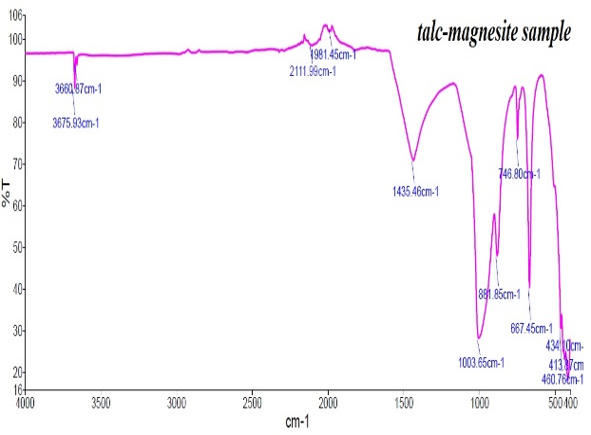 | 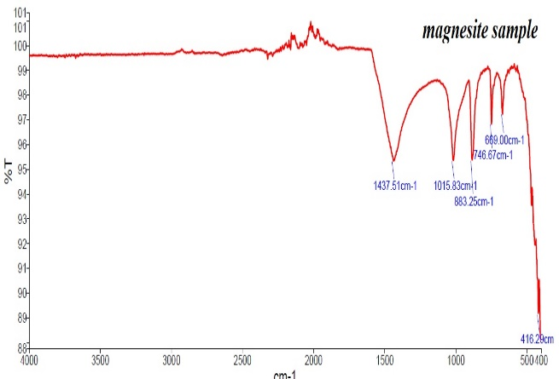
FIGURE 2. IQ spectrograms of talc-magnesite feedstock and magnesite emissions.
Based on the results of radiographic radiographic analysis of the resulting specimen, mineralogical qualitative and quantitative composition of samples was determined by the BGMN / Rrofex Rietveld software set. It was determined that the composition of the analyzed sample relative to the main components was magnesite - MgCO₃ 53.70%, talc - 3MgO∙4SiO₂∙H₂O 27.20%, kemmererite - 5MgO∙5FeO∙Al₂(SiO₃)_{3∙}H₂O 10.01%, dolomite - MgCO_{3∙}CaCO₃ 7.75% and calcite - CaCO₃ 1.34%.
An emperical model of static chemical dissolution of this raw material at concentrations of sulfuric acid solution of 20–96% was developed. Based on these results, it is stated that the yield of the main nutritional components in the obtained samples is P2O5overall -11.38% and its digestible form is 6.83%, MgOoverall -10.99%, its water-soluble form is 9.65%, and the digestible form CaOabs - 16.80% was achieved [9].
In the author's opinion, it is effective to use a quadratic regression model depending on the C-acid concentration (%) and T-process temperature (°C) independent variables for predicting in order to determine the optimal conditions for the sulfuric acid decomposition process of this magnesitic waste. From a mathematical point of view, the creation of a mathematical model is based on coefficients, which can be determined based on experimental data.
Using the mathematical model presented in this literature, we determine the magnetic emitter by solving conditions (1) and (2) the required acid concentration and temperature conditions in the range of concentrations of 20-96% (C) and 30-100°C (T).
The model determination coefficient is determined by this (3) formula. Through this statistical analysis, we write the following form of quadratic regression $R^{2}=1-\frac{T_{dis}}{R_{des}}$
$Y=-27,721+0,6257C+2,4094T-0,023C^{2}-0,0035CT-0,0132T^{2}=5780,88$ (4)
Since the planned experiments are carried out in an acid solution at a temperature of 20-96%, that is, in an acidic solution of 9 different concentrations, and each solution of concentration in a temperature range of 30-100°C, that is, at a temperature of 8 °C, the number of results will be n = 72.
Based on these given magnitudes, we determine the mean value of the values of the decomposition levels calculated according to the model using the formula (5) and calculate that it is 80.29%.
Following the calculation, we determine the required acid concentration and optimal temperature conditions by formulas 1 and 2 given above and find that the temperature is T = 81.45°Σ and the acid concentration required for the process is C = 74.05%.
In the study on these data, we carried out acid treatment for 40 minutes at a temperature of 85°Σ with a content of 110% of a concentrated solution of 75% of magnesite waste sulfuric acid with a concentration of 75% of magnesium – MgCO3, talc - 3MgO∙4SiO₂∙H₂O 27.20%, kemmererite – 5MgO∙5FeO∙Al₂(SiO₃)₃∙H₂O 10.01%, dolomite - MgCO₃∙CaCO₃ 7.75% and calcite - CaCO₃ 1.34%.
The process resulted in a sour magnesium pulp containing magnesium sulfate with a water-soluble form of 19.16% and a total form of 22,545 bo. The decomposition rate of this acid processing process was found to be
k p=85%.
At the next stage of the study, we neutralized a sample with a magnesium preservative and soluble magnesium acidity (pH) of 1.04 treated with 75% acid, with low-grade high-carbonate Central Red Sand phosphorites with a content of P₂O₅um−13.94%, CaO−43.78%, CO₂−19.10%, MgO−2.11%, Fe₂O₃−1.78%, Al₂O₃−1.48%, SO₃−2.10%, F−0.42% and H₂O−1.17%.
In the analysis, when MgOum/P₂O₅um = 1.20, i.e. in fully neutralized samples, magnesium phosphate fertilizer was obtained with the water-soluble form of MgO by 10.15%, the total amount of P₂O₅ by 11.02% and the variable form by 6.66%.
CONCLUSION
As the object of the study, magnesite waste formed as a result of flotation enrichment of Zinelbulak talc–magnesite rocks were chosen. This waste is formed by flotation enrichment of talc–magnesite rocks. Its mineratic structure was studied on the basis of a comparative analysis of the samples of basic raw materials using modern physical-chemical methods such as radiography and IQ spectroscopic methods. Based on the results determined, its mineralogical composition is % of magnesite - MgCO₃ is 53.70%, talc - 27.20%, kemmererite - 10.01%, dolomite- MgCO₃∙CaCO₃ is 7.75% and calcite - CaCO₃ is 1.34%.
On the basis of previous research, the optimal acid treatment of a solution of 75% concentration of sulfuric acid for 40 minutes at a temperature of 85°Σ with a content of 110% of the stichometric volume was determined based on the model created to determine the possibility of processing magnetic waste in sulfuric acid under optimal conditions.
Based on the results of assays, magnesium phosphate fertilizer was obtained with water-soluble form of MgO by 10.15%, total P₂O₅ by 11.02% and viscous form by 6.66%.
The results of the research form an important scientific basis for the effective use of local mineral resources, the development of cheap import-substituting fertilizers Mg-P and the expansion of opportunities for their agroecological application.
REFERENCES
- Atashev, E., Jumaniyazov, M., & Tadjiev, S. (2021). RESULTS OF X-RAY PHASE AND IR-SPEC ASE AND IR-SPECTRAL AN TRAL ANALYSIS OF AZOSUPERPHOSPH OSUPERPHOSPHATES OBTAINED ON THE BASIS OF AINED ON THE BASIS OF PHOSPHORITES OF CENTRAL KIZILKUM. Technical Science and Innovation, 2021(3), 19–26. https://doi.org/10.51346/tstu-02.21.3-77-0015
- Otaboev, K., Sherkuziev, D., Namazov, S., Radjabov, R., & Seytnazarov, A. (2021). Flow of simple superphosphate using two-stage decomposition of phosphorite. IOP Conference Series Earth and Environmental Science, 939(1), 012055. https://doi.org/10.1088/1755-1315/939/1/012055
- Sherkuziev, D. S., Aripov, K. S., Alimov, U. K., & Maxmudova, M. A. (2020). Research of agrochemical and mechanical properties of soils processed with hydrogel. IOP Conference Series Earth and Environmental Science, 614(1), 012121. https://doi.org/10.1088/1755-1315/614/1/012121
- Jumaniyazov, M., Masharipova, S., Bekchanov, B., Masharipova, Z., & Kudiyarova, K. (2025). Obtaining the composition of ceramic bricks based on the color characteristics of the original sample. AIP Conference Proceedings, 3304, 040046. https://doi.org/10.1063/5.0269042
- Jumaniyazov, M., Kurambayev, S., Atashev, E., Jumaniyozov, A., & Buranova, M. (2025). Determination of the composition of the Zinelbulak talc-magnesite deposit rock using modern physicochemical methods. E3S Web of Conferences, 633, 06002. https://doi.org/10.1051/e3sconf/202563306002
- Masharipova, S., Jumaniyazov, M., Turkmenbaeva, M., & Kabulova, L. (2025). Study of physicochemical properties of hydrophobic calcite based on sugar factory defecates. E3S Web of Conferences, 633, 01003. https://doi.org/10.1051/e3sconf/202563301003
- Jumaniyazov, M., Kurambayev, S., Atashev, E., Aitova, S., & Pirnapasova, H. (2025). The extraction of talc from Zinelbulak talc-magnesite raw materials. AIP Conference Proceedings, 3304, 040043. https://doi.org/10.1063/5.0269064
- Farmonovich, I. A. (2020b). Synthesis and optical-dimensional properties of hybrid CDSE/ZNS nanocrystals. Journal of Advanced Research in Dynamical and Control Systems, 12(SP7), 2201–2205. https://doi.org/10.5373/jardcs/v12sp7/20202344
- Abdullayeva, O. S., Muhammadjonov, A. O., & Xusayinova, G. A. (2023). Modeling the Development of Department Activities in Higher Education Institutions: Enhancing the Management System with Quantum Communication and Cryptography%. 2023 International Conference on Sustainable Emerging Innovations in Engineering and Technology, ICSEIET 2023, 7, 588–591. https://doi.org/10.1109/icseiet58677.2023.10303039
- Hojamberdiev M., Arifov R., Tadjiev K., and Yun-hua Xu. Processing of refractory materials using various magnesium sources derived from Zinelbulak talc-magnesite // International Journal of Minerals, Metallurgy and Materials Vol.18, Number 1, February 2011, Page 105 DOI: https://doi.org10.1007/s12613-011-0408-y
- Brezáni, I., Sisol, M., Marcin, M., Sýkora, M., Maťašovský, M., & Varga, P. (2019). Beneficiation of Talc-Magnesite Ore with Cu-Co Mineralization. Inżynieria Mineralna, 1(1). https://doi.org/10.29227/im-2019-01-26
- Yehia, A., & Al-Wakeel, M. (2013). Role of ore mineralogy in selecting beneficiation route for magnesite-dolomite separation. Physicochemical Problems of Mineral Processing, 49(2), 525–534. https://doi.org/10.5277/ppmp130213
- Seil, G. E., & Staff, N. (1943). STUDY OF LIT ER ATURE ON SEPARATION OF MAGNESIA FROM LIME IN DOLOMITE AND SIMILAR MATERIALS*. Journal of the American Ceramic Society, 26(7), 218–236. https://doi.org/10.1111/j.1151-2916.1943.tb15823.x
- Koukoulis, N., & Anastassakis, G. (2022). Reprocessing of magnesite beneficiation waste to recover mineral value and minimise environmental footprint. SUSTAINABLE EXTRACTION AND PROCESSING OF RAW MATERIALS, 3(3), 49–55. https://doi.org/10.58903/c16182118

