EPR Spectroscopic Investigation of Thermal Stabilization of Polyvinyl Chloride with Alkyloxycarbamate Derivatives
Ilhom Juraev^{1, a)}, Bakhodir Mukhiddinov¹, Kamola Khudoyberdieva¹,
Bakhtiyor Ganiev², Shohizamon Rajabov²
¹Navoi State University of Mining and Technologies, Navoi, Uzbekistan
²Bukhara State University, Bukhara, Uzbekistan

^{a)}Corresponding author: b-ba90@mail.ru
Abstract. This study presents the results of the study of the thermal stability of polyvinyl chloride (PVC) stabilized with alkyloxycarbamate derivatives by EPR spectroscopy. Initially, compositions containing PVC and various concentrations (0.1; 0.5; 1; 2 and 3 wt.%) of the stabilizer N,N'-hexamethylene bis[(methoxy)carbamate] (XM-20) were prepared. Then, thermal decomposition was carried out in glass capillary tubes in a muffle furnace at a temperature of 220°C for 5-20 minutes. The results were regularly recorded on an EPR spectrometer. Derivatographic analysis of the substances was carried out on a DTG-60 Shimadzu device in the range of 30-700°C at a rate of 5 degrees/min. Based on the results obtained, it was found that with an increase in the concentration of the XM-20 stabilizer, the intensity of the paramagnetic signal significantly increased, and in PVC samples with the addition of 0.1% and 0.5% stabilizer, the paramagnetic center was determined at a magnetic field width of 336.893 mT and 338.395 mT. In the thermal decomposition of the XM-20 stabilizer itself, a very weak paramagnetism (162.448 mT) was determined, which was 13.2 times less than that of the PVC + 3% XM-20 sample. Also, based on derivatographic analyses, it was determined that the thermal stability at 500°C changed from 79.18% to 58.40% by mass depending on the stabilizer concentration. In conclusion, according to the results of the study, the XM-20 stabilizer effectively serves to increase the thermal stability of PVC.
Keywords: polyvinyl chloride, EPR, paramagnetic center, g-factor, thermal analysis, alkyloxycarbamate, stabilizer.
INTRODUCTION
According to the literature, thermal and thermo-oxidative destruction of polyvinyl chloride (PVC) occurs in two directions: firstly, at low temperatures, the main product is hydrogen chloride, and at high temperatures, with the rupture of -C-C- bonds, hydrocarbons of various bond lengths are formed. More than 170 products of aliphatic (C1-C7), aromatic and chlorine-containing hydrocarbons have been identified [1-3]. Benzene is formed at comparatively low temperatures and is the main product of aromatic compounds. Styrene and naphthalene are formed together with benzene. With increasing temperature, toluene, ethylbenzene, o-xylene, naphthalene, indene, anthracene, and various chlorobenzenes are formed. As a rule, at temperatures up to 377-527 °C, aromatic hydrocarbons are released in greater quantities than aliphatic ones. Above 527°C, the opposite picture is observed [4].
According to the literature, the formation of molecular radicals from degraded plastic samples is presented based on the following scheme 1, and the EPR spectrum of this radical was studied at a magnetic field width of 3328 gauss (332.8 mT) [5].
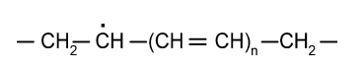
FIGURE 1. Molecular radical of degraded plastic samples
In another literature review, EPR spectroscopic studies of poly(vinyl chloride) irradiated at medium and high doses were conducted at a magnetic field width of 350 ± 10 mT, and the radical formation as a result of irradiation was explained according to Scheme 2 [6]. It was also analyzed that the g-factor value in the EPR spectra as a result of irradiation was in the range of 1.997-2.0076, which was explained by the composition of various minerals containing Ca(OH)₂, CaCO₃ and Mn⁺², which affected the irradiation.

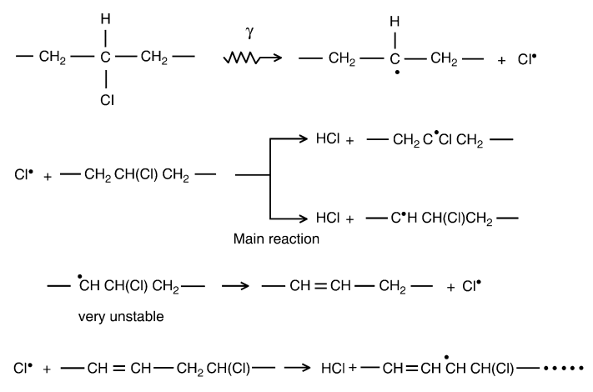
FIGURE 2. Reactions that can change the structure of PVC under the influence of radiation
The degradation of both PVC and styrene-based polymers and copolymers was studied at 180°C, and previous studies showed no evidence of competing side reactions, and poly(vinylchloride) was rapidly dehydrochlorinated (10%/h) [7]. The samples were decomposed in thin-walled glass tubes under vacuum to various reaction rates, and then quenched rapidly in liquid nitrogen.

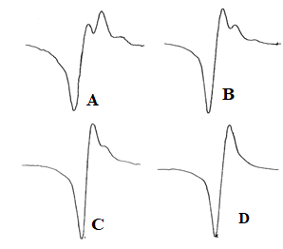
FIGURE 1. EPR spectra of dehydrochlorinated poly(vinylchloride):
(A) 5%, (B) 10%, (C) 20%, (D) 40%.
The results of the EPR spectroscopic analysis are discussed in detail in the results analysis section of the article. In this study, EPR spectra were recorded for the time interval 0–15 min (Figure 2) as the dehydrochlorination of poly (vinylchloride) varied from 10% to 40% (Figure 1), but the precise conclusion and important implications of these results were not elucidated [7, 9].
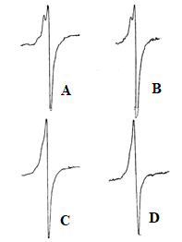
FIGURE 4. Time dependence of the EPR spectrum of poly(vinylchloride):
(A) 0 time; (B) 5 min; (C) 10 min; (D) 15 min.
In our study, samples prepared based on PVC and stabilizers of various compositions were decomposed in glass capillary tubes in a muffle furnace at a temperature of 220ºC for 5-20 minutes [8] and cooled to room temperature (30ºC), after which the EPR spectra of the samples were recorded.
MATERIALS AND METHODS
Thermal properties of polymer composites were studied under dynamic conditions using a Shimadzu DTG-60 Differential Thermal Analyzer derivatograph in the temperature range of 30-700°C at a heating rate of 5°C/min. Samples were weighed 0.1g and used spectrally pure alumina as the inert substance. Derivatographic analysis of the samples was performed using a Labsys evo SETARAM TG DTA DSC+1600 instrument in the temperature range of 30-700°C at a heating rate of 5°C/min. Effective kinetic indices of degradation of stabilized samples were calculated using the Freeman and Carroll method based on TGA data. The polymer degradation rate is:
dW/dt = (Ao/RH)e-E/RTWn
where: RH is the heating rate, W is the polymer mass, AO is the pre-exponential factor, N is the yield of the reaction composition, and e is the effective activation energy for thermal degradation of the polymer. From the equation for the tangential angle of deviation of the logarithmic curve, the reaction order n is found and the effective activation energy for thermal degradation is determined from the cross-section intersecting the ordinate axis.
EPR spectra of samples with PVC and various stabilizer composites were obtained at the N.A. Parpiev Scientific Research Laboratory “Chemistry of Coordination Compounds” under the Department of Chemistry and Oil-Gas Technologies of Bukhara State University using a SPINSCAN X spectrometer from ADANI (now Advin), Belarus. All EPR spectral characteristics of these samples were recorded at room temperature using a cylindrical cavity with a microwave bridge at an operating frequency of 9.44 GHz. Additional operating parameters of the spectrometer were as follows: time constant = 460 ms, modulated frequency = 10 kHz, modulation amplifier = 100 mT, microwave frequency = 9.44 GHz, signal gain = 21, spectral paramagnetic detection time = 60 s and sample temperature = 30. These instrumental parameters were carefully selected to maximize signal intensity.
RESULTS AND DISCUSSION
When introducing alkyloxycarbamate derivatives into the PVC composition, the thermal stability of the composition increases. For example, in polyvinyl chloride compositions containing 0.5; 1.0; 2.0 and 3.0 wt.% alkyloxycarbamate derivatives, the thermal stability of the composition with an increase in the content of thermal stabilizers at 500 ºC is 79.18; 78.18; 73.88 and 58.40 wt.%, respectively. This is apparently due to the fact that with an increase in the content of alkyloxycarbamate derivatives, which leads to an increase in the thermal stability of the PVC composition [10], associated with the inhibition of radical-chain processes by methyl, alkoxy, mobile hydrogen atoms and other radicals formed during the thermal decomposition of the thermal stabilizers themselves - alkyloxycarbamate derivatives.
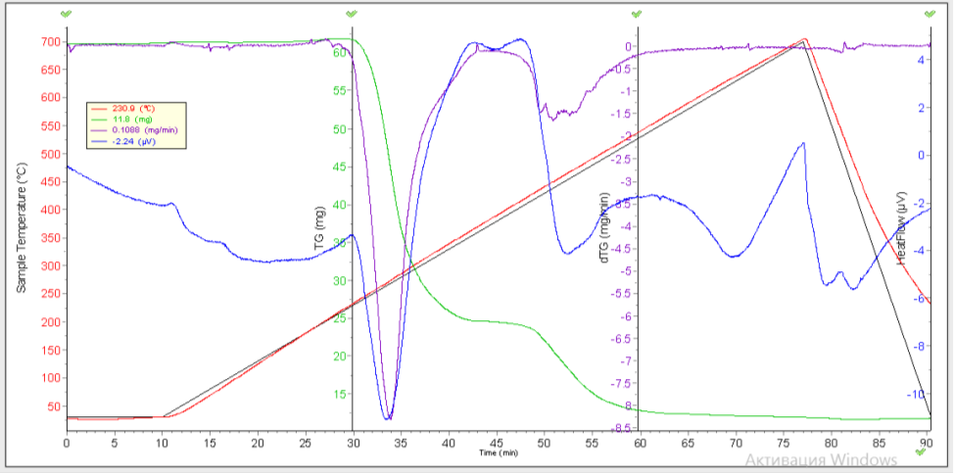
3
2
1
FIGURE 5. Derivatogram of polyvinylchloride compositions containing 2.16 mol/kg N,N1-hexamethylene bis[(methoxy)carbamate]: 1 - DTGA curve; 2 - TGP curve; 3 - DSK curve

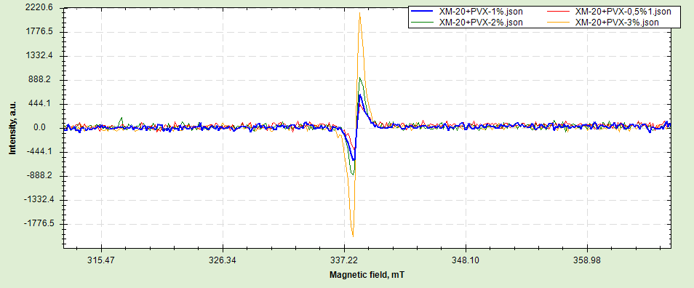
FIGURE 6. EPR spectra of samples with added PVC and XM-20 stabilizers (0.5; 1; 2 and 3 %).
When the EPR spectra of the samples with added PVC and XM-20 stabilizers were studied, it was observed that, depending on the change in the paramagnetic center, when the concentration of XM-20 stabilizers added to PVC was increased from 0.5% to 3%, an increase in the signal intensity of one line obtained in the EPR spectra of a radical with paramagnetic properties formed as a result of the same thermal decomposition of polymer composites at a temperature of 160ºC was observed (Fig. 4). However, in the EPR spectra of PVC with 0.1% and 0.5% XM-20 stabilizers, the paramagnetic center lines were observed at magnetic field widths of 336.893 mT and 338.395 mT, which means that the radical paramagnetic center formed during thermal decomposition was recorded in the lower field region due to the small amount of stabilizer (Fig. 5). In the thermal decomposition of the XM-20 stabilizer, a very weak paramagnetic signal was detected, the signal intensity of which is 162.448 mT, which is 13.2 times higher than the paramagnetic signal detected in the EPR spectrum obtained from the thermal decomposition of PVC and 3% added XM-20 stabilizer. This result once again proves that the thermal stability of PVC depends on the concentration of added XM-20 stabilizer (Table 1).

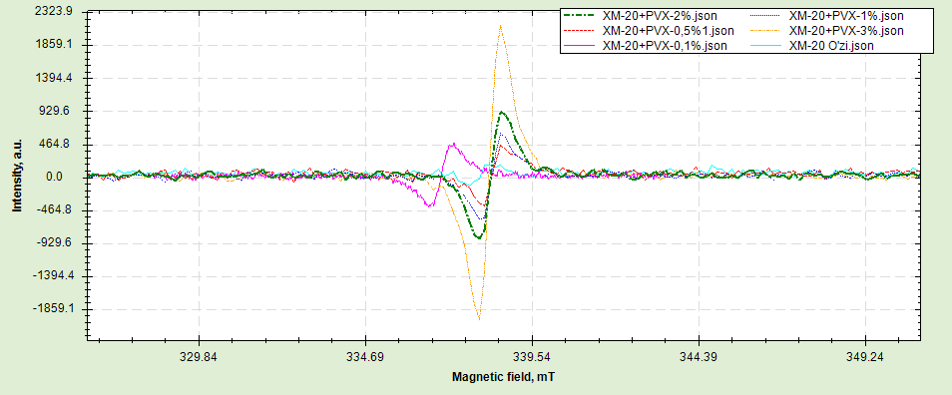
FIGURE 5. EPR spectra of samples with added PVC and XM-20 stabilizers (0.1; 0.5; 1; 2 and 3 %)
Table 1 presents the EPR spectral line intensities and g-factor values of PVC and XM-20 stabilizer added in various percentages.
TABLE 1. EPR spectroscopic characteristics of polyvinyl chloride with various
XM-20 stabilizer concentrations (0.1-3 wt%)
Sample | High signal intensity | Lower signal intensity | Average signal intensity | g-factor
XM-20 3% | 2145,500 | -2031,167 | 4143 | 1,9964
XM-20 2% | 964,108 | -834,92 | 1799 | 1,9966
XM-20 1% | 640,631 | -611,083 | 1216 | 1,9966
XM-20 0,5% | 417,861 | -414,184 | 868 | 1,9962
XM-20 0,1% | 485,925 | -428,248 | 910 | 2,0047
XM-20 itself | 162,448 | -132,900 | 317 | 1,8415
CONCLUSION
The results of the study made it possible to effectively assess the thermal stability of PVC stabilized with alkyloxycarbamate derivatives using the EPR spectroscopy method. With an increase in the concentration of the XM-20 stabilizer from 0.1% to 3%, the intensity of the paramagnetic signal increased steadily, which indicates the effective inhibition of radical-chain processes. The EPR spectra of the paramagnetic radicals formed during thermal decomposition at a temperature of 220°C clearly confirm the effect of the stabilizer, and the magnetic field width was recorded in the range of 336.893-338.395 mT. The results of derivatographic analysis showed a direct dependence of the thermal stability at 500°C on the amount of stabilizer, and the mass loss decreased from 79.18% to 58.40%. The XM-20 stabilizer itself has a low paramagnetism (162.448 mT), and the high signal intensity observed in the composite samples is due to its strong interaction with PVC. The results obtained scientifically substantiate the possibility of using alkyloxycarbamate derivatives as effective thermal stabilizers for PVC and will be an important basis for the development of new polymer composites in the future.
REFERENCES
- Starnes, W. (2002). Structural and mechanistic aspects of the thermal degradation of poly(vinyl chloride). Progress in Polymer Science, 27, 2133-2170. https://doi.org/10.1016/s0079-6700(02)00063-1.
- Alshaikh, A., Ezendu, S., Ryoo, D., Shinde, P., Anderson, J., Szilvási, T., Rupar, P., & Bara, J. (2024). PVC Modification through Sequential Dehydrochlorination–Hydrogenation Reaction Cycles Facilitated via Fractionation by Green Solvents. ACS Applied Polymer Materials. https://doi.org/10.1021/acsapm.4c01453.
- Zhou, J., Liu, G., Wang, S., Zhang, H., & Xu, F. (2020). TG-FTIR and Py-GC/MS study of the pyrolysis mechanism and composition of volatiles from flash pyrolysis of PVC. Journal of The Energy Institute, 93, 2362-2370. https://doi.org/10.1016/j.joei.2020.07.009.
- Wilkie, Charles, J. Summers, and Ch Daniels. "Polyvinyl chloride." Professiya, St. Petersburg (2007).
- Morsy M. A., Shwehdi M. H. Electron spin resonance spectral study of PVC and XLPE insulation materials and their life time analysis //Spectrochimica Acta Part A: Molecular and Biomolecular Spectroscopy. – 2006. – Т. 63. – №. 3. – С. 624-630. https://doi.org/10.1016/j.saa.2005.06.011
- Colombani, J., Raffi, J., Gilardi, T., Troulay, M., Catoire, B., & Kister, J. (2006). ESR studies on poly (vinyl chloride) irradiated at medium and high doses. Polymer degradation and stability, 91(7), 1619-1628. https://doi.org/10.1016/j.polymdegradstab.2005.09.013
- Hay J. N. Study of the thermal dehydrochlorination of poly (vinylidene chloride) and poly (vinyl chloride) by ESR spectroscopy //Journal of Polymer Science Part A‐1: Polymer Chemistry. – 1970. – Т. 8. – №. 5. – С. 1201-1212. https://doi.org/10.1002/pol.1970.150080513
- Juraev, I., Karimov, M., Rustamov, M., & Mukhiddinov, B. (2024). Investigation of the structure and morphology of modified materials based on polyvinyl chloride. E3S Web of Conferences, 525, 02024. https://doi.org/10.1051/e3sconf/202452502024
- Ilhom Juraev, Bakhodir Mukhiddinov, Shokhruh Juraev, Nigina Sabirova; Development of polyvinyl chloride compositions with polyphenylene ether and investigation of their properties. AIP Conf. Proc. 24 February 2025; 3268 (1): 040035. https://doi.org/10.1063/5.0261271
- Edraki, M., Sheydaei, M., Alinia-Ahandani, E., & Nezhadghaffar-Borhani, E. (2021). Polyvinyl chloride: chemical modification and investigation of structural and thermal properties. Journal of Sulfur Chemistry, 42(4), 397-409. https://doi.org/10.1080/17415993.2021.1895996

