Development of a Technology for Obtaining NPS Fertilizers by Activating Kyzylkum Phosphates with Ammonium Sulfate Using Sulfur
Tulkin Urozov^{1, a)}, Alisher Aslanov¹, Orifjon Kuldoshev¹, Abdikhakim Karjavov², Jonibek Javxarov³
¹Samarkand State University, Samarkand, Uzbekistan
²Samarkand State Medical University, Samarkand, Uzbekistan
³Kattakurgan State Pedagogical Institute, Kattakurgan, Uzbekistan

^{a)}Corresponding author: tulik.uzb@mail.ru
Abstract. The results of the study showed that the values obtained as a result of the activation of phosphate rock samples with sulfur in the presence of ammonium sulfate can be easily used as a scientific basis for creating a technology for processing. It was suggested that it is possible to obtain new types of nitrogen-phosphorus-sulfur fertilizers. In order to process high-carbonate Central Kyzylkum phosphate rocks and obtain NPS fertilizers, they were processed with ammonium sulfate containing nutrients in the presence of sulfur. The process was studied by taking phosphorite:sulfur:ammonium sulfate in mass ratios from 9:1:1 to 1:1:8. For example, when the ratio of the components (phosphorite:sulfur:ammonium sulfate) in the mixture was 8:1:1, 5:1:4, and 2:1:7, the conversion of diphosphorus pentoxide increased by 24.08%, 58.03%, and 74.32%, respectively, compared to the phosphorite sample without sulfur and ammonium sulfate. These values indicate that the second sample of phosphorite, when compared to the mineralized mass of phosphorite, has a higher content of diphosphorus pentoxide by 7.73%, 8.72%, and 9.09%, respectively.
Keywords: fertilizer, NPS, sulfur, enrichment, phosphorite.

INTRODUCTION
Currently, technological systems are being developed to process the high-carbonate Central Kyzylkum phosphate samples in various ways to obtain fertilizers with a high phosphorus content. Nowadays, the technology for obtaining phosphorus fertilizers in the production process mainly involves the processing of phosphate raw materials in the presence of inorganic mineral acids. However, when phosphates are processed with inorganic mineral acids, the presence of additives such as carbonate minerals and some d-metal oxides significantly reduces the efficiency of the industry. The reason is that most of these substances pass into the liquid phase. This negatively affects their physicochemical and rheological properties.
One of the most effective ways to use low-grade phosphates is to chemically activate them without mineral acids to obtain a slow-acting complex phosphorus fertilizer. In particular, world scientists have studied the possibilities of effectively using a small fraction of phosphate ores (less than 10 mm) in the production of phosphorus fertilizers. The study used mechanical and mechanochemical activation methods using the “Activator 4” mill. As a result, the amount of usable phosphorus (P₂O₅) in composite fertilizers increased significantly through the activation of small fractions. This innovative technology allows for the production of acid-free and waste-free phosphorus fertilizers compared to existing acidic technologies, which is more environmentally and economically efficient [1].
Also, an effective and environmentally friendly method of cleaning medium and low-grade phosphorite by mechanical-chemical cleaning of phosphate rocks was studied. The study investigated the solubility and structural properties of phosphorite mechanically-chemically activated in citric acid using high-speed grinding equipment. Activation time up to 30 minutes leads to an increase in solubility (57.51%), and in 50 minutes it reaches a maximum (59.03%). As a result of particle size reduction, decrease in crystallinity and increase in structural defects, carbonate-fluoroapatite turns into a mixture of hydroxyapatite, fluorocarbon hydroxyapatite and carbonate apatite. Mechanical-chemical activation significantly increases the solubility of phosphorus [2].
The possibilities of using fluorapatite obtained from phosphate deposits of Mongolia as a phosphorus fertilizer through mechanical processing were studied. Due to the low solubility of natural fluorapatite in soil, chemical methods are used to prepare fertilizers from it, but these methods cause environmental and health problems. Therefore, for the preparation of fertilizers by the dry method, fluorapatite is ground in a vibrating ball mill. As a result, mechanical activation triples the solubility of fluorapatite in citric acid solution to 18%, which is equivalent to the solubility of superphosphate fertilizers [3]. The processing of phosphate rocks with the participation of salts using non-traditional methods is considered a new stage in the conversion of local raw materials into phosphorus fertilizers. It also opens the way to the possibility of organizing their production at the places of their use. In the industry, technologies are being proposed for activating phosphates or processing them with low standards without using inorganic mineral acids.
The Central Kyzylkum phosphates of Uzbekistan are considered to be low in chemical composition and have a high carbonate content. At the same time, their unique feature is that their ability to enter into chemical reactions is much easier and higher than that of other phosphate raw materials of this type.
From the point of view of agrochemistry, we know that the soils of our Republic are neutral and carbonate. This raw material cannot be used without further processing and enrichment. Taking this into account, scientific research has been carried out to activate the Central Kyzylkum phosphates in the presence of ammonium sulfate salt, which is used in practice as a fertilizer. The high carbonate content of phosphates in terms of their chemical composition, as well as their high ability to enter into chemical reactions, make it possible to activate them in the presence of salts and sulfur.
Scientific studies have investigated the effect of sulfur (S) fertilizers on cadmium solubility in soils contaminated with cadmium, specifically in calcareous (Calc) and non-calcareous (Ncalc) soils. Three types of S fertilizers were used in the study: elemental sulfur(S⁰), potassium sulfate (K₂SO₄), and ammonium sulfate((NH₄)₂SO₄. The effect of S⁰ on Cd solubility was minimal because it was not well oxidized to sulfate. K₂SO₄ also had little effect on Cd solubility. On the contrary, (NH₄)₂SO₄ increased Cd solubility in both soils. In the non-calcareous soil (Ncalc), nitrification of (NH₄)₂SO₄ decreased pH and increased the solubility of metals such as Cd, aluminum (Al), manganese (Mn), and nickel (Ni). In calcareous soils (Calc), the effect of (NH₄)₂SO₄ is more complex and is associated with the transformation of Cd-containing carbonate phases as a result of ammonia (NH₃) volatilization. Research shows that the choice of sulfur fertilizers should be made carefully when growing cereals in Cd-contaminated soils, as some fertilizers can increase the availability of Cd to plants [4]. Furthermore, from an agrochemical point of view, in carbonate soils, the available phosphorus also becomes non-available carbonates. The sulfur applied during the activation process also serves to protect the phosphorus that has fallen into the soil from being converted to carbonates. This reduces the ability of phosphorus fertilizers to gradually reduce their effectiveness and reduce the possibility of blocking.
The study compared the effects of sulfate fertilizers and mixtures of elemental sulfur (S⁰) and sulfate on the yield and nitrogen (N) and sulfur (S) uptake in perennial rye. The study showed that mixtures of sulfate and S showed similar efficiency to sulfate fertilizers alone, helping to reduce sulfate consumption. Plants were supplemented with fertilizers such as S⁰, K₂SO₄, MgSO₄ and (NH₄)₂SO₄, and the fresh and dry weight, N and S content of each piece were determined. The yield of plants fertilized with sulfur was 25% to 94% higher than that of unfertilized plants, and the increase in dry matter was also significant. As a result of sulfur fertilization, the amount of S in plants increased and its assimilation improved, while in the second and third samples, the amount of N and total N absorption decreased. In conclusion, mixtures of S⁰ and sulfate can be used as effective fertilizers to eliminate sulfur deficiency in the soil [5].
Sulfur preparations are considered less toxic than other substances used as fungicides, insecticides and acaricides. In this sense, they also have a lower impact on the ecology and environment than other substances. However, the use of sulfur in powder form is somewhat ineffective. Because its application leads to mass loss due to its fine powdery nature and hydrophobicity. At the same time, the more it is ground, the higher its efficiency, but the grinding technology requires a large amount of energy and time. The addition of various additives and the complexity of the technology for converting sulfur into a hydrophilic form lead to an increase in its cost [6-8].
The study analyzed the changes in the content of nitrogen, phosphorus, potassium and sulfur in soybeans, as well as the accumulation of dry matter at different sulfur levels. The results showed that the amount of sulfur significantly affects the nutrient composition and dry matter accumulation in the plant. Soybean plants achieved the best results at a sulfur concentration of 80 mg/l, at which the dry matter content and nutrients (N, P, K, S) were maximized. This study provides important recommendations for the rational use of sulfur fertilizers in soybean crops.
The effect of phosphorus and sulfur fertilizers on the taste of potato tubers when applied separately and together was also studied. The study analyzed the taste characteristics and volatile compounds of potatoes using different fertilization methods. The results showed that the content of linoleic and linolenic acids, starch, and reducing sugars significantly increased when phosphorus and sulfur fertilizers were applied together. Compounds such as (E,E)-2,4-nonadienal and decanal fatty acids, which improve the oily taste, and dimethyl and trimethyl sulfides, also increase, but these compounds slightly weaken the taste of potatoes. Optimal fertilization rates (phosphorus 180 kg/ha and sulfur 90 kg/ha) are recommended to improve and enrich the fried taste of potatoes, which is important for producing quality potatoes.

MATERIALS AND METHODS
In current study, it was found that the unenriched (P₂O₅ _{(tot)}. – 17.65%, P₂O₅ _{(sol)}. – (1.34%) (CaO–42.50%, MgO–1.64%, CO₂–15.12%, P₂O₃-2.43%, SO₃-2.18%, F-2.10%, H₂O-1.17%) and mineralized mass (MM) (P₂O_{5(tot)}. – 15.76%, P₂O₅ _{(sol)} – 1.27%, CaO-43.79%, MgO-2.08%, CO₂-13.23%, P₂O₃-3.20%, SO₃-1.95%, F-1.42%, H₂O-1.17%) phosphate rock flours produced by the “Kyzylkum Phosphorite Complex” was taken. Also, for the processing of phosphate rock samples, sulfur (sulfur - 99.50%, organic matter - 0.25%, ash - 0.20%, acid content - 0.01%) separated during gas processing by the “Shurtan Gas Chemical Complex” LLC in the Kashkadarya region, as well as substances containing essential nutrients in agriculture - ammonium sulfate, urea, potassium chloride, and sulfuric acid, were used.
Phosphorite raw material and all forms of P₂O₅, the main constituent of phosphorus fertilizers (total, plant-soluble and water-soluble forms of P₂O₅ were calculated. Determination of P₂O₅ in fertilizers was carried out on an Operation manual UV7/V7 series single beam UV-VIS Spectrophotometer at a wavelength of λ=430 nm. The error of the results obtained is ±1%. The analysis of water-soluble and plant-soluble forms of P₂O₅ was determined using standard methods.
The total nitrogen content of the obtained fertilizer samples was determined using the distillation method (Kjeldahl method). Usually, the distillation method can also be used as an accelerated method for controlling the production of additives. The sulfur content was determined using the gravimetric method in the presence of barium chloride. The CaO and MgO contents of the fertilizer containing calcium and magnesium were determined using the complexometric method. In the analyses, the solutions are titrated with 0.05N Trilon-B solution in the presence of fluorescein and chrome dark blue indicators. The amount of CaO in the precipitated form is determined with 0.1N hydrochloric acid. Oxides such as Al₂O₃ and Fe₂O₃ are also analyzed using the complexometric method.
The determination of the amount of CO₂ in raw materials and fertilizer samples is carried out using a volumetric method. The essence of this method is that dolomite or limestone, which is part of the phosphate minerals, is finely decomposed, or reacts, under the influence of chloride acid. In this process, carbon dioxide is released. This is determined by the difference between the total volume of the gas and air mixture and the volume of carbon dioxide in the air with a concentrated solution of KCl or NaCl. The composition of products and raw materials was analyzed using several methods (X-ray diffraction and thermal, thermal).

RESULTS AND DISCUSSION
Scientific research was conducted to convert calcium phosphorapatite contained in phosphate rocks into plant-soluble phosphate salts and obtain complex nitrogen-phosphorus-potassium-sulfur fertilizers from them that gradually act in the soil. The process of activating phosphate rock samples with sulfur in the presence of salts such as ammonium sulfate, urea, and potassium chloride, which are used as fertilizers, was studied. Because most of these salts are currently used in agriculture as mineral fertilizers.
In order to process the Central Kyzylkum phosphates and obtain fertilizers, they were processed into phosphate raw materials with salts such as ammonium sulfate, urea, and potassium chloride in the presence of sulfur.
To implement this process, the initial components of phosphate rock, gold and sulfur, and salts were taken in weight ratios from 9:1:0 to 1:1:8, and the processing process was carried out. This processing process was carried out in a ball mill. The duration of the process was 25-35 minutes. Upon completion of the processing, the total, soluble, and water-soluble P₂O₅ content of the samples was analyzed.
At the same time, the sulfur, CO₂, and CaO contents of the prepared mixtures were studied. The results of the studies are presented in Table 1.
The results show that phosphates are definitely needed in an activated form. Since most of our soils are carbonate, phosphates in the activated form begin to turn into a passive form after they fall into the soil. If we recycle phosphates with inorganic mineral salts such as ammonium sulfate, urea, potassium chloride, and sulfur, the inorganic salts and sulfur increase the plant uptake of phosphates. At the same time, some of the sulfur remains in the fertilizer in elemental form, which prevents the carbonation and passivation of phosphorus that has fallen into the soil. Another important aspect of this process is that the sulfur in the mixture becomes soluble in water.

TABLE 1. Activation of unenriched phosphate rock with ammonium sulfate in the presence of sulfur

F:S:(NH₄)₂SО₄ | P₂O₅ content, % |  | N,  % | СО₂,  % | CаО content, % |  | К_{decar},  % | $$\frac{СаО_{abs. .}}{СаО_{tot. }},$$  % | $\frac{Р_{2}О_{5 abs.}.}{Р_{2}О_{5 gen.}},$ %
F:S:(NH₄)₂SО₄ | total | absorbable | N,  % | СО₂,  % | total | absorbable | К_{decar},  % | $$\frac{СаО_{abs. .}}{СаО_{tot. }},$$  % | $\frac{Р_{2}О_{5 abs.}.}{Р_{2}О_{5 gen.}},$ %
10:0:0 | 17.96 | 2.24 | - | 13.63 | 43.25 | 1.14 | 11.42 | 2.64 | 12.46
9:1:0 | 16.38 | 3.37 | - | 10.89 | 39.45 | 1.68 | 22.35 | 4.27 | 20.56
8:1:1 | 14.79 | 4.81 | 2.22 | 7.88 | 35.63 | 2.36 | 37.81 | 6.62 | 32.54
7:1:2 | 12.97 | 5.73 | 4.46 | 6.09 | 31.24 | 2.47 | 45.14 | 7.92 | 44.16
6:1:3 | 11.19 | 6.19 | 6.72 | 3.94 | 26.94 | 3.21 | 58.93 | 11.92 | 55.37
5:1:4 | 9.31 | 6.19 | 8.95 | 2.52 | 22.41 | 3.94 | 68.34 | 17.58 | 66.49
4:1:5 | 7.39 | 5.33 | 11.10 | 1.67 | 17.79 | 3.77 | 73.62 | 21.19 | 72.12
3:1:6 | 5.49 | 4.28 | 13.20 | 1.01 | 13.22 | 3.67 | 78.63 | 27.79 | 77.98
2:1:7 | 3.62 | 3.00 | 15.20 | 0.50 | 8.72 | 2.87 | 83.74 | 32.92 | 82.87
1:1:8 | 1.79 | 1.55 | 17.20 | 0.18 | 4.30 | 1.54 | 88.13 | 35.76 | 86.59

From the results in the table, it can be seen that only 8.47% of the total diphosphorus pentoxide in unenriched phosphorite is available for plant uptake. This value is only 1.32% in low-quality phosphorite. The addition of 10% sulfur to the fertilizer samples and an increase in the amount of ammonium sulfate leads to an increase in the amount of diphosphorus pentoxide. For example, when the ratio of the components (phosphate rock:sulfur:ammonium sulfate) in the mixture was 8:1:1, 5:1:4, and 2:1:7, the conversion of diphosphorus pentoxide increased by 24.08%, 58.03%, and 74.32%, respectively, compared to the phosphate rock sample without sulfur and ammonium sulfate. These values indicate that the second sample of phosphorite has a higher diphosphorus pentoxide content of 7.73%, 8.72%, and 9.09%, respectively, compared to the low quality phosphorites. The results obtained in the studies are presented in Table 2.

TABLE 2. Activation of mineralized mass (phosphorite) with ammonium sulfate in the presence of sulfur

F:S:(NH₄)₂SО₄ | P₂O₅ content, % |  | N,  % | СО₂,  % | CаО content, % |  | К_{decar},  % | $$\frac{СаО_{abs. }}{СаО_{gen. }},$$  % | $\frac{Р_{2}О_{5 abs.}.}{Р_{2}О_{5 gen.}},$ %
F:S:(NH₄)₂SО₄ | total | absorbable | N,  % | СО₂,  % | total | absorbable | К_{decar},  % | $$\frac{СаО_{abs. }}{СаО_{gen. }},$$  % | $\frac{Р_{2}О_{5 abs.}.}{Р_{2}О_{5 gen.}},$ %
10:0:0 | 15.96 | 1.81 | - | 12.20 | 44.34 | 0.14 | 9.26 | 0.32 | 11.34
9:1:0 | 14.50 | 2.55 | - | 9.96 | 40.30 | 1.34 | 18.52 | 3.32 | 17.59
8:1:1 | 13.07 | 3.24 | 2.19 | 7.32 | 36.33 | 1.96 | 33.54 | 5.39 | 24.81
7:1:2 | 11.49 | 4.04 | 4.42 | 5.55 | 31.89 | 2.17 | 42.63 | 6.81 | 35.16
6:1:3 | 9.89 | 4.59 | 6.66 | 3.73 | 27.48 | 2.65 | 55.21 | 9.64 | 46.41
5:1:4 | 8.24 | 4.76 | 8.87 | 2.42 | 22.88 | 3.54 | 65.09 | 15.47 | 57.77
4:1:5 | 6.55 | 4.20 | 11.02 | 1.62 | 18.20 | 3.63 | 70.74 | 19.95 | 64.18
3:1:6 | 4.87 | 3.20 | 13.12 | 1.04 | 13.54 | 3.53 | 74.79 | 26.08 | 65.78
2:1:7 | 3.22 | 2.38 | 15.17 | 0.56 | 8.95 | 2.78 | 79.23 | 31.06 | 73.78
1:1:8 | 1.59 | 1.27 | 17.16 | 0.21 | 4.43 | 1.41 | 84.21 | 31.93 | 79.87

The transformation of phosphorites into a plant-soluble form is certainly facilitated by sulfur and ammonium sulfate. In the process, the modification of phosphorite and sulfur changes due to the low-energy activation of Kyzylkum phosphorites in the presence of sulfur.
Also, the main minerals of phosphorite (fluoroapatite and calcite) are decomposed by ammonium sulfate. An exchange reaction occurs between the activating reagent and the components of the phosphorite. As a result of the dissociation of ammonium sulfate into ions in the system, an acidic environment is formed in the solution.
(NH₄)₂SО₄ + Н₂О 2NH₄⁺ + SО₄²⁻
The resulting acid ions first react with the calcite (exocalcite) mineral. In the next step, sulfate ions penetrate the fluorocarbonatapite and “endocalcite” minerals, accelerating the diffusion process and increasing their surface area of effect. The P₂O₅ form of phosphate minerals, which is absorbed by plants, is formed.
As we know, sulfur is insoluble in water and does not hydrate. This is the biggest drawback of its use in agriculture. In the conducted scientific studies, sulfur is converted into a wettable form. When phosphorite is processed with salts in the presence of sulfur and the resulting mixture is mixed with water, sulfur precipitates along with the remaining mass that is not dissolved in water. In this process, it is possible to observe in a simple visual way that sulfur does not float to the surface of the water, but settles and turns into a wettable form.
At the same time, the amounts of calcium oxide in various forms in the fertilizers obtained were also analyzed. The amount of calcium oxide in the fertilizer composition also increases with the amount of sulfur and ammonium salts in the mixture.
We can see that the second sample of our phosphate rock, i.e., low-quality phosphate rock, does not differ much from the first sample of unenriched phosphate rock in the presence of ammonium sulfate. Due to the high content of marl compounds in low-quality phosphate rock samples and their different grain sizes, some of their values ​​are 1.15-1.30 times lower than in unenriched phosphate rock.
Scientific studies have shown that potassium chloride and urea also increase the plant-available fraction of phosphate rock. We can see that this value is up to 1.11 times higher than the remaining salts in ammonium sulfate.
The fertilizers obtained as a result of the activation of Central Kyzylkum phosphates with sulfur in the presence of inorganic salts such as ammonium sulfate, potassium chloride, and urea were examined by X-ray diffraction and thermal analysis methods, which are physicochemical methods.
Based on the results of X-ray diffraction analysis, it can be seen that the main components of the phosphate mineral are phosphate minerals, various carbonates, and silicate minerals. The X-ray diffraction results of the resulting fertilizers also confirm that when phosphate rock samples are activated in the presence of sulfur, the phosphate raw material is converted into a form that can be absorbed by plants. The X-ray diffraction patterns of the studied substances are presented in Figures 1 and 2.

FIGURE 1. X-ray diffraction pattern of phosphorite samples activated by sulfur (F:S=8:2)

In both plots 1 and 2, many peaks are visible at angles from 20° to 60°, indicating the presence of crystalline materials. The main peaks in the plot between 20° and 30° are also strong in this range but with slightly less intensity than in X-ray pattern 1. This peak at d=3.8570 is characteristic of apatite and is visible to the left of the peak in X-ray pattern 1. This indicates a change in the degree of crystallinity. d=3.0384 is a peak characteristic of calcite, in the same position as in X-ray pattern 1 and with the same peak, but with less intensity. d=3.4479, d=3.3409, d=3.2290 are other peaks characteristic of apatite.
Peaks in the range of 30-50° d=2.7744, d=2.6947, d=2.6240 are typical peaks of calcite and apatite, which were also observed in X-ray pattern 1. d=2.4840, d=2.3425, d=2.2839, d=2.1139, d=2.0934 Peaks belonging to other mineral phases, but their intensity is lower than in X-ray pattern 1. d=1.9932, d=1.9111, d=1.8754, d=1.8371 are peaks of qpatite. d=1.7882, d=1.7623, d=1.7422, d=1.7345, d=1.6252, d=1.6035, d=1.4382, d=1.4212 Peaks belonging to other mineral phases.
The peaks of apatite in both X-ray diffraction patterns 1 and 2 show strong peaks characteristic of apatite. In the sample obtained with the presence of ammonium sulfate, the peaks of apatite are slightly shifted to the left compared to those in X-ray diffraction pattern 1, and are also less intense. This indicates a change in the crystal structure.
The peaks of calcite in both X-ray diffraction patterns 1 and 2 show peaks characteristic of calcite, but their intensity is significantly lower in X-ray diffraction pattern 2. The intense peaks of calcite in the first X-ray diffraction pattern 1 are brighter, which indicates that the phosphorite activated with sulfur contains more calcite.
During the activation process with the presence of ammonium sulfate, the amount of calcite decreased compared to the first X-ray diffraction pattern 1. This indicates that calcite reacts with ammonium sulfate and turns into other substances.

FIGURE 2. X-ray diffraction pattern of phosphate rock samples activated with ammonium sulfate in the presence of sulfur (F:S:(NH₄)₂SО₄ = 5:1:4)

When activated with ammonium sulfate, the crystallinity of apatite changed. The apatite peaks were less intense, slightly shifted to the left, and slightly broader. The appearance of new peaks in the second ammonium sulfate X-ray diffraction pattern indicates that new substances may be formed under the influence of sulfur and ammonium sulfate. When ammonium sulfate reacted with calcite and apatite, new sulfate substances were also formed.
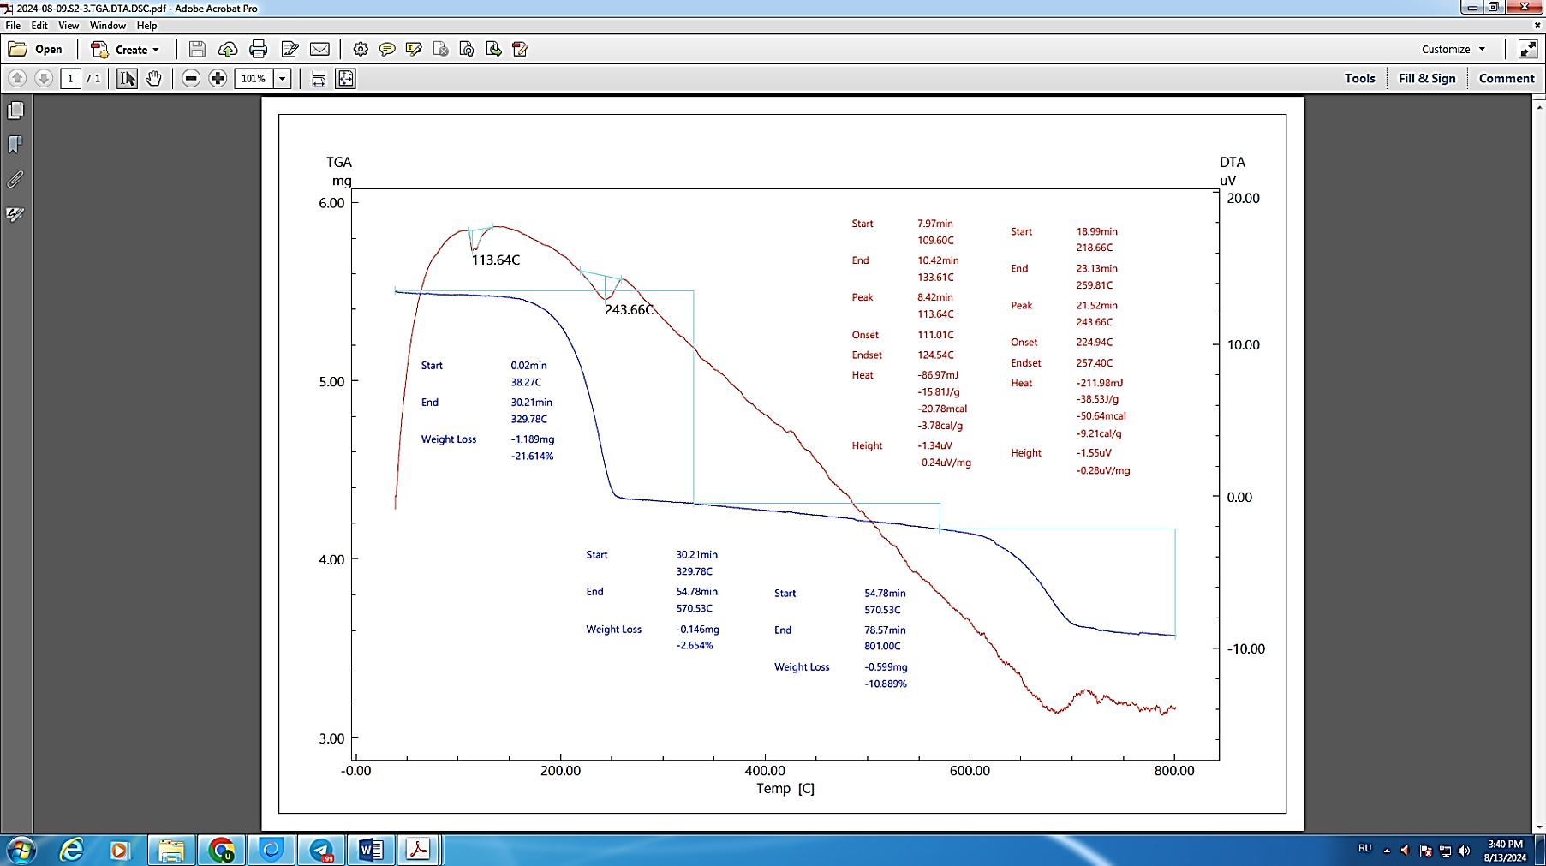
FIGURE 3. Derivatogram of fertilizers activated by the presence of sulfur in phosphate rock samples (F:S= 8:2)

Different activating substances had different effects on the crystal structure and amount of apatite and calcite in the phosphorite. Ammonium sulfate had the greatest effect, reducing calcite and changing the apatite structure. Potassium chloride and urea had moderate effects. But they also caused the formation of new substances.
The appearance of new compounds formed after the addition of activating substances indicates that these substances reacted with phosphorite. Activation of phosphorite with various activating substances leads to changes in its mineral composition. Ammonium sulfate reduces calcite the most and changes apatite, while potassium chloride and urea cause less changes. In these processes, new mineral phases are formed. In order to study the various thermal processes that occur in a certain temperature range of substances, thermal analysis of the obtained fertilizers was carried out (see Fig. 3 and 4).
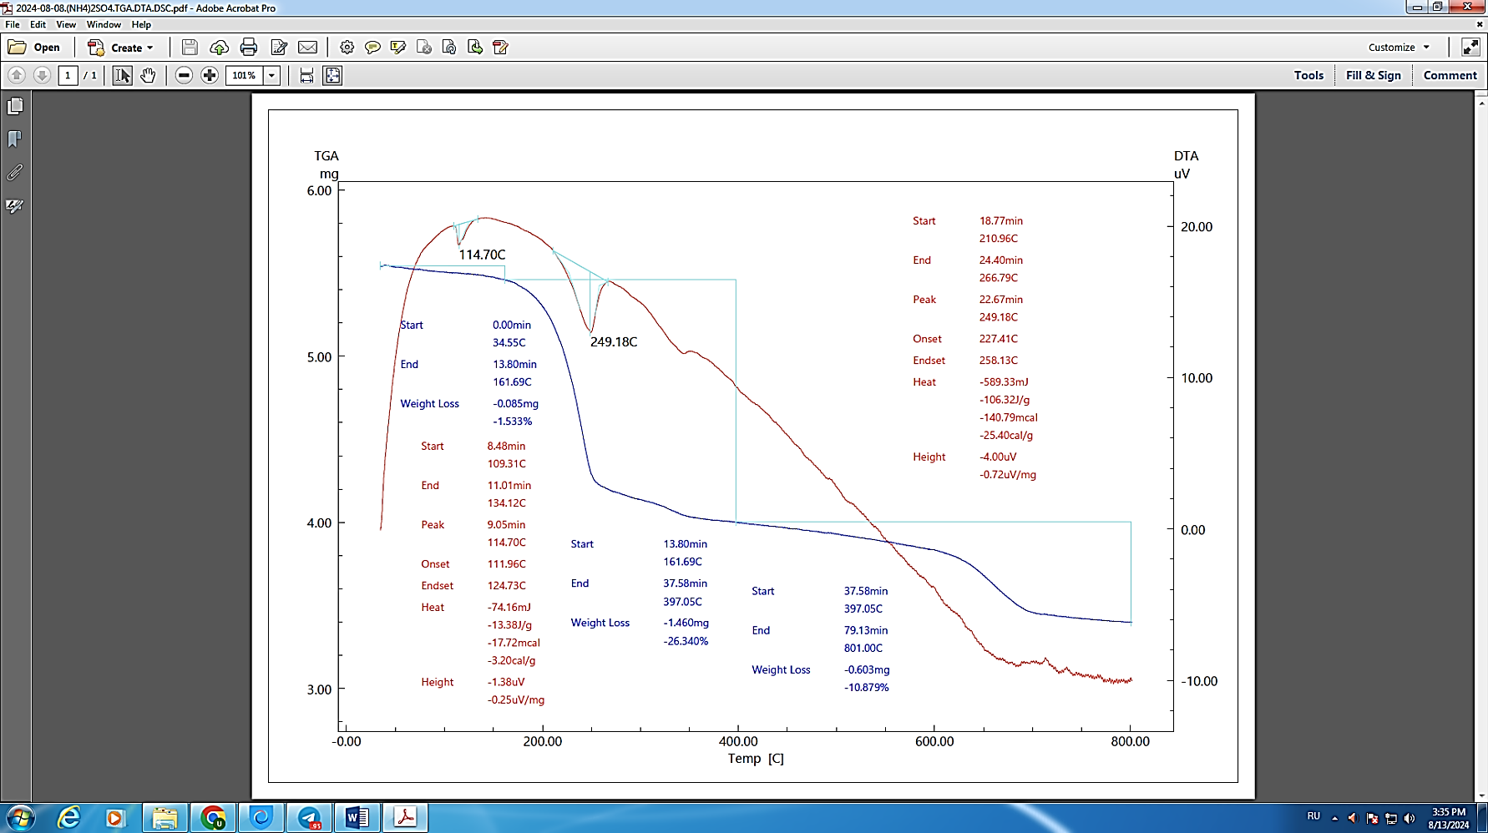
FIGURE 4. Derivatogram of phosphate rock samples activated with ammonium sulfate in the presence of sulfur (F:S:(NH₄)₂SО₄ = 7:1:2)

When samples of phosphate rock activated in the presence of sulfur were thermally analyzed, the endo effect was observed in the derivatogram obtained at 113.64 °C and 243.66 °C. The first change is observed in the range of 38.27 °C to 329.78 °C, with a mass loss of 21.614%, and the second change is observed in the range of 329.78 °C to 570.53 °C, with a mass loss of 2.654%. The final change is observed in the range of 570.53 °C to 801.00 °C, with a mass loss of 10.889%. A three-stage decomposition is observed over the temperature range. The first stage is a weight loss in the range of 100–150°C. This is due to the separation of moisture and crystal water. The second stage is a significant weight loss (DTA peak) around 200–250 °C due to the decomposition of phosphorus compounds. The third stage is a relatively large weight loss in the range of 500–600°C. Activation with sulfur allows the release of substances from phosphorite in a short temperature range.
In the derivatogram of phosphate rock samples activated with ammonium sulfate in the presence of sulfur (F:S:(NH₄)₂SО₄ = 7:2:1), an endo effect was observed at 114.70 °C and 249.18 °C. In the first change, mass loss was observed in the range from 34.55 °C to 161.69 °C and the mass loss was 1.533%, and in the second change, in the range from 161.69 °C to 397.05 °C. The mass loss is 26.340%. The final mass change is observed between 397.05 °C and 801.00 °C, and the mass loss is 10.879%. The first stage is the loss of crystal water in the range of 100–170 °C. The second stage is the DTA peak and weight loss in the range of 240–290 °C, which is associated with the thermal decomposition of ammonium sulfate and the thermal decomposition of SO₄²⁻ ions. The third stage is the residual thermal decomposition of phosphorite in the region up to 600 °C. Ammonium sulfate accelerates the decomposition of phosphates in phosphorite, and the DTA peaks are clearly expressed. This indicates that sulfur and ammonium sulfate interact synergistically under the influence of heat.

CONCLUSION
The results of the research showed that the values obtained as a result of the activation of phosphate rock samples with sulfur in the presence of ammonium sulfate can be easily used as a scientific basis for creating a technology for processing. It is recommended that new types of nitrogen-phosphorus-sulfur fertilizers be obtained. Because agricultural products grown in our republic are grown in different climatic and soil conditions. In order to process the high-carbonate Central Kyzylkum phosphorites to obtain NPS fertilizers, they were processed with salts containing nutrients, such as ammonium sulfate, in the presence of sulfur. Phosphorite:sulfur:ammonium sulfate was taken in mass ratios of 9:1:1 to 1:1:8, and the processing process was studied.
For example, when the ratio of the components (phosphate rock:sulfur:ammonium sulfate) in the mixture was 8:1:1, 5:1:4, and 2:1:7, the conversion of diphosphorus pentoxide increased by 24.08%, 58.03%, and 74.32%, respectively, compared to the phosphate rock sample without sulfur and ammonium sulfate. These values indicate that the second sample of phosphorite has a higher diphosphorus pentoxide content of 7.73%, 8.72%, and 9.09%, respectively, compared to the lower-quality phosphorite.
As a result of activating phosphate rock samples with sulfur in the presence of ammonium sulfate, a portion of the remaining elemental sulfur in the fertilizer composition ensures that phosphate rocks continue to be used by microorganisms, or sulfur-oxidizing bacteria, even after the sulfur has reached the soil. The conversion of phosphate minerals in phosphorus fertilizers that do not contain elemental sulfur into carbonates that are not absorbed by plants in carbonate soils has long been studied in agrochemical science.
In addition, the influence of microorganisms present in the soil that oxidize sulfur on this process is also significant. Under these conditions, the remaining elemental sulfur in the fertilizer oxidizes and, in the presence of moisture, creates an acidic environment that activates the remaining phosphate. Therefore, scientific research has studied the amount of sulfur in a wide range.

REFERENCES
- Bazhirova, K., Zhantasov, K., Bazhirov, T., Kolesnikov, A., Toltebaeva, Z., & Bazhirov, N. (2024). Acid-Free Processing of Phosphorite Ore Fines into Composite Fertilizers Using the Mechanochemical Activation Method. Journal of Composites Science, 8(5), 165. https://doi.org/10.3390/jcs8050165
- Fang, N., Shi, Y., Chen, Z., Sun, X., Zhang, L., & Yi, Y. (2019). Effect of mechanochemical activation of natural phosphorite structure as well as phosphorus solubility. PLoS ONE, 14(11), e0224423. https://doi.org/10.1371/journal.pone.0224423
- Minjigmaa, A., Oyun-Erdene, G., Zolzaya, T., Davaabal, B., Amgalan, J., & Temuujin, J. (2016). Phosphorus fertilizer prepared from natural Burenkhaan phosphorite (Mongolia) by a mechanical activation. Geosystem Engineering, 19(3), 119–124. https://doi.org/10.1080/12269328.2015.1137501
- Vidal, A., Nguyen, C., Janot, N., Eon, P., Coriou, C., & Cornu, J. (2024). Effects of sulfur fertilizers applied at agronomic rates on cadmium availability in agricultural soils: Insights from a batch experiment. Pedosphere, 35(6), 995–1004. https://doi.org/10.1016/j.pedsph.2024.07.009
- Kulczycki, G., Sacała, E., Koszelnik-Leszek, A., & Milo, Ł. (2023). Perennial Ryegrass (Lolium perenne L.) Response to Different Forms of Sulfur Fertilizers. Agriculture, 13(9), 1773. https://doi.org/10.3390/agriculture13091773
- Quldoshev, O., Urazov, T., Tillayev, S., & Asalanov, A. (2021). Production of complex fertilizers from Central Kyzylkum phosphorites according to phosphoro-sulfur-survey and nitrogen-phosphorus-sulfur insecticide. Egyptian Journal of Chemistry, 0(0), 0. https://doi.org/10.21608/ejchem.2021.94546.4444
- Wei, X., Zhao, W., Sun, Y., & Dong, S. (2024). The impact of sulfur fertilizer concentration on the nutrient concentration of parts of the soybean plant. Phyton, 93(8), 1851–1873. https://doi.org/10.32604/phyton.2024.051671
- Li, K., Li, M., Zhou, J., & Guo, H. (2023). The impact of the individual and combined application of phosphorus and sulfur fertilizers on potato tuber flavor. Foods, 12(20), 3764. https://doi.org/10.3390/foods12203764

