Development of a Binder-Free Synthesis Method of
NatriyA Aluminum
Sohiba Pardayeva¹, Jasur Shukurov^{2, a)}, Nargiza Tursunova²,
Shamsiddin Kholliyev², Samida Ernazarova², Shokhista Salimova³
¹Samarkand State Medical University, Samarkand, Uzbekistan
² Samarkand State University, Samarkand, Uzbekistan
³Samarkand State University, Samarkand, Uzbekistan

^{a)}Corresponding author: shukjasni@gmail.com
Abstract. It is shown in the work that it is possible to include 32% granules (granules), NatriyA, it is possible to obtain 99%, and if there are no additives - the hydrosodalite phase. To increase the binder-free crystallinity of mesoporous artificially obtained aluminosilicate NatriyA to ~99%, we developed a method synthesized from highly active metakaolin of the same structural type as a loosening additive for highly dispersed to be used in combination with contains a ratio of 32-72/72-32%, into solids from reaction mixtures: Al₂O₃(3.0-3.5)∙Na₂O(2.3-2.6)∙SiO₂(60-80)H₂O in the automatic adsorbometer “ASAB-2020”. The purpose of the study is to carry out NatriyA aluminosilicate without binders and the synthesis of highly dispersed mesoporous aluminosilicates based on kaolin.
Keywords: aluminosilicate NatriyA, aluminosilicate NatriyX, crystallization, kaolin, metakaolin, sodium metasilicate, mesoporous.
INTRODUCTION
In this regard, special attention is paid to the creation of catalysts with high productivity, selectivity, stability, stable, strong, active and relatively cheap, minimal coking property for the process of catalytic dehydroaromatization of methane, as well as to study the laws of the process. In the next decade, pollution of the technological environment with sulfur dioxide poses a global threat. More than 50% of global environmental pollution is caused by sulfur dioxide [1]. Today, the total amount of sulfur in sulfur compounds in the atmosphere, as well as in the hydrosphere, is twice as large as in the period of previous technical development. Currently, environmental analysis shows that the amount of sulfur compounds produced is twice the amount emitted from the atmosphere. It is known that sulfur dioxide is oxidized by atmospheric oxygen under the influence of moisture and light [2].
The resulting sulfur dioxide and sulfuric acid are highly reactive and have a negative impact on the environment, affect photosynthesis processes, interfere with photosynthesis processes in plants, disrupt the water regime during photodynamic oxidation of pigments, reduce the photochemical activity of chloroplasts, etc [3].
It has been established that the main parameters that accelerate the process of corrosion of technological devices, including gas pipelines, are the concentration of hydrogen sulfide in hydrocarbon gas, humidity, temperature, pressure and gas flow rate [4]. Studies have shown that in the presence of hydrogen sulfide, corrosion of metals due to moisture is accelerated a hundred times compared to the absence of moisture. The process of hydrogen sulfide corrosion is significantly affected by humidity and temperature; at low temperatures, the deterioration is greater, since condensation vapor in a gas enriched with hydrogen sulfide at low temperatures. Hydrogen sulfide corrosion also accelerates with increasing pressure [5].
The adsorption process is divided into two groups: methods based on the oxidation of hydrogen sulfide to simple sulfur, and methods that form sulfur-oxygen compounds. This process is a selective oxidation of sulfur compounds; mixed oxidation does not occur. The adsorption process is rarely used in natural gas purification. This method is used only in some cases for purifying gases with low hydrogen sulfide content, but can also be used for deep gas purification. One of the methods for purifying gas from hydrogen sulfide is the dry cleaning method, in which hydrogen sulfide is adsorbed by activated carbon prepared from coal semi-coke during industrial gas purification. The activity of coal decreases as a result of the deposition of organic resins on its surface and polymer metals on the active part. Therefore, this method is not widely used in production. In addition, the disadvantage of this method is that it is periodic and the cleaning device takes up a lot of space [6-7].
An analysis of domestic and foreign literature on the purification of hydrocarbon gases from hydrogen sulfide shows that the main direction for the coming decades is the search for new sorbents, elimination of technological shortcomings, improvement of the composition of absorbent solutions, improvement of technological, technical-economic and environmental indicators. Improving the next technological state in chemisorption gas purification is aimed at effective regeneration of absorbers, its improvement from an economic and technological point of view.
MATERIALS AND METHODS
Catalytic dehydroaromatization reaction of methane (purity of methane 99.9%) without the participation of oxidants in a tubular reactor made of quartz, size dxl=12x250 mm, particle size 0.5-1.0 mm, volume 1 cm³ filled with a catalyst in a flow reactor operating under differential reactor conditions was carried out under the following optimal conditions: reaction temperature 750 ℃, pressure 0.1 MPa, methane:nitrogen = 1:1 volume ratio, volume velocity 500-1500 h⁻¹.
Mono- and polymetallic Mo-retaining systems prepared on the basis of zeolites and modified with various compounds are the best catalysts for the catalytic dehydroaromatization reaction without the participation of methane oxidizers. Catalytic dehydroaromatization reaction of methane without oxidizing agents and studying the properties of various catalysts was carried out in the above device operating at atmospheric pressure sample granules in a 250 cm³ glass flask and added 150 cm³ of distilled water. The flask was stirred for 24 h in an AVU-6 device at 120 rpm. After drying, the adsorbent was passed through a sieve of 0.5 and 0.25 mm, and the mechanical and physicochemical characteristics of the samples that passed through the sieve of 0.5 mm and remained on the sieve of 0.25 mm were studied. We ground the soils to a size of 0.08 mm before acid treatment. The distribution of pores in terms of surface area and size was determined by the method of low-temperature desorption of nitrogen in the automatic adsorbometer "Saptome-2020". Sedimentation analysis was carried out in different dispersion mediums in water and water-glycerol mixture according to Oden's method.
The Branauer-Taylor-Emmett (BTE) method was used to determine the relative surface area of solid samples. This method used the following BTE equation:
$\frac{1}{W∙(\frac{P_{0}}{P}-1)}=\frac{1}{W_{m}∙C}+\frac{C-1}{W_{m}∙C}∙\frac{P}{P_{0}}$ (1)
420 g of the dried sample was taken and placed in a measuring cylinder with a capacity of 500 ml, and its volume V1 was measured. Then we compacted the sorbent to a constant level by gently knocking the bottom of the cylinder and again measured the volume V2.
The bulk density of the sorbent was determined according to the following formula:
$γ_{1}=\frac{P}{V_{1}};$ $γ_{2}=\frac{P}{V_{2}}$; g/sm³ (2)
in this P- mass of sorbent; $γ_{1}$, $γ_{2}$- bulk density before and after densification of the sorbent, g/cm³.
RESULT AND DISCUSSION
Considering that it is impossible to synthesize granular artificially obtained aluminosilicate without a binder with high properties, artificially obtained highly dispersed artificially obtained aluminosilicate NatriyA in granules (granules) only from kaolin, we use kaolin as the main source of silicon and aluminum. developed the synthesis of dispersed aluminosilicate NatriyA we offered to go out. For this purpose, we have developed a method for obtaining artificially obtained highly dispersed aluminosilicate NatriyA.
The practice of industrial use of absorbents for gases and liquids, containing mesoporous artificially obtained aluminosilicate, has shown that one of the main conditions.
There is very little information about the laws of formation as the main source of aluminum oxide and silicon (IV) oxide are described. At the same time, mesoporous artificially obtained aluminosilicate A obtained without a binder has a low degree of hardness (70-80%), does not have phase purity (5% admixture of the sodalite phase), but from mesoporous artificially obtained aluminosilicate of the same structure granulated with a binder, its is at the level of adsorption capacity.
Taking into account that it is impossible to synthesize granular (granular) mesoporous, artificially obtained aluminosilicate without adding fine dispersed mesoporous, artificially obtained aluminosilicate A to the granular (granules) obtained only from the kaolin from the "Karnab Ota" mine, without a highly characteristic binder, silicon (IV) oxide aluminum kaolin obtained from the "Karnab ota" mine as a source of oxide and the main material we made a proposal for the development of synthesis of artificially obtained aluminosilicate A with finely dispersed mesoporous. For this purpose, we have developed artificially obtained aluminosilicate A with. Based on the experimental data obtained by experiment, the technology of aluminosilicate production of mesoporous granular NatriyA without binder was developed (see Fig.1).
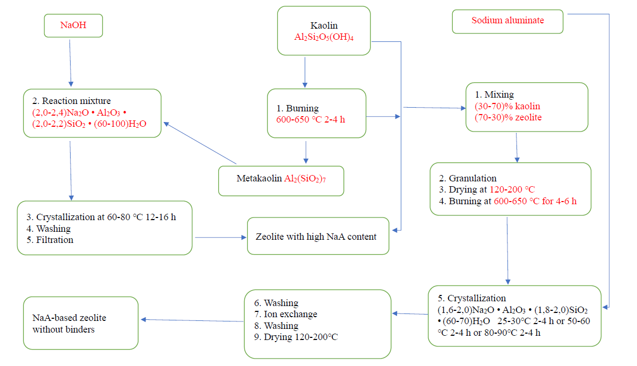
FIGURE 1. The main block diagram of the production process of artificially obtained aluminosilicate A, highly dispersed and binder-free granular (granules) mesoporous.

A to ~100%, we developed a method synthesized from highly active metakaolin with the same structural type as a loosening additive for highly dispersed mesoporous artificially obtained aluminosilicate kaolin obtained from the Karnab ota mine. to be used in combination with Contains a ratio of 30-70/70-30%. The introduction of mesoporous, artificially obtained aluminosilicate not only increased the purity of the phase, but also made it possible to significantly reduce the duration of synthesis. A significant acceleration of crystallization is apparently achieved due to the highly dispersed mesoporous, artificially obtained solid aluminosilicate A incorporated into the granules. The crystallization process is accompanied by a change in the secondary pore structure due to the transformation of granules containing a mechanical mixture of mesoporous synthetic aluminosilicate and highly active metakaolin particles into single aggregates of mesoporous synthetic aluminosilicate solids. .
Mesoporous, artificially obtained aluminosilicates cannot be solidified directly. Therefore, kaolin obtained from the "Karnab Ota" mine undergoes thermal dehydration, which leads to the formation of metakaolin, which is a reactive raw material for the synthesis of mesoporous, artificially obtained aluminosilicates. On the basis of kaolin obtained from the "Karnab Ota" mine, a number of methods have been developed in our country and abroad for obtaining granular (granules) mesoporous, artificially obtained A aluminosilicates without binders. Taking into account that it is impossible to synthesize high-dispersed, with high characteristics, granular (granule) mesoporous, artificially obtained aluminosilicate A without binders, silicon (IV) as the main source oxide aluminum oxide is highly dispersed using metakaolin with high activity we made a proposal to develop a method for obtaining mesoporous, artificially obtained aluminosilicate A.
The laws of obtaining and formation of highly dispersed mesoporous NatriyA artificially obtained aluminosilicates from Al₂Si₂O₇ were studied.
However, the mesoporous synthetic aluminosilicate X has a smaller average solids volume than the high activity metakaolin particles. into solids from reaction mixtures: Al₂O₃(3.0-3.5)∙SiO₂∙ Na₂O(2.3-2.6)∙ (60-80)∙H₂O.
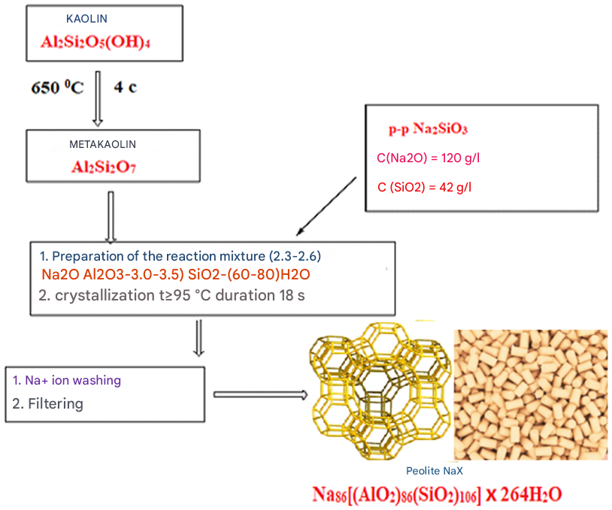
FIGURE 2. Synthesis of artificially produced aluminosilicate NaX with highly dispersed mesoporous kaolin obtained from the "Karnab ota" mine.

It should be noted that at high temperature, the amount of sodium per unit mass or volume decreases by a greater amount than at low temperature. This fact indicates a greater depth of interaction between metakaolin with high activity and solution. The amount of silica (IV) oxide alumina per unit mass or volume in the liquid phase increases during the first 4-8 hours of processing and reaches a maximum level. It should be noted that at 30 °C the amount of silicon (IV) oxide per unit mass or volume of alumina is greater than at 60 and 98 °C.
Highly active metakaolin solidified in aqueous solutions of sodium metasilicate with 50.0 to 150.0 g/L of Na₂O and 90.5 g/L of SiO₂. The compositional associations of PC varied in the following ranges Na₂O(2.0-2.2)∙ SiO₂(150-160) ∙ H₂O∙ Al₂O₃(6.0-6.5) mainly from salt and sodium metasilicate solutions freshly precipitated aluminum hydroxide. the same constituent compounds used in the synthesis of highly dispersed mesoporous synthetic aluminosilicate Y used.
CONCLUSION
Thus, it is shown in the work that it is possible to include NatriyA, it is possible to obtain and if there are no additives, it is possible to obtain a hydrosodalite phase. into solids from reaction mixtures: (60-80)Na₂O*(2.3-2.6)Al₂O₃ *(3.0-3.5)SiO₂ *H₂O. Thus, the textural characteristics of the catalyst were studied. pore structure of the tested samples, adsorption measurements were carried out. The main adsorption-structural characteristics of HSZ’s - by liquid nitrogen desorption isotherm. Before the adsorption measurement, the sample was thermally treated in vacuum at 320 ℃ for 40 minutes. Desorption was measured at room temperature. Adsorption equilibrium was established for 20 min. The relative surface area of the samples was 360÷400 m²/g. The relative error was 3%. The sum of pore adsorption volumes for nitrogen was determined when P/P0=0.99, with a determination error of 6%.
REFERENCES
- Shukurov, J., & Fayzullaev, N. (2024b). Direct synthesis of dimethyl ether from synthesis gas. AIP Conference Proceedings, 3045, 060042. https://doi.org/10.1063/5.0197641
- Hosseini, Z., Taghizadeh, M., & Yaripour, F. (2011b). Synthesis of nanocrystalline γ-Al2O3 by sol-gel and precipitation methods for methanol dehydration to dimethyl ether. Journal of Natural Gas Chemistry, 20(2), 128–134. https://doi.org/10.1016/s1003-9953(10)60172-7
- Moradi, G., Nosrati, S., & Yaripor, F. (2006b). Effect of the hybrid catalysts preparation method upon direct synthesis of dimethyl ether from synthesis gas. Catalysis Communications, 8(3), 598–606. https://doi.org/10.1016/j.catcom.2006.08.023
- Rad, S. J. H., Haghighi, M., Eslami, A. A., Rahmani, F., & Rahemi, N. (2016b). Sol–gel vs. impregnation preparation of MgO and CeO2 doped Ni/Al2O3 nanocatalysts used in dry reforming of methane: Effect of process conditions, synthesis method and support composition. International Journal of Hydrogen Energy, 41(11), 5335–5350. https://doi.org/10.1016/j.ijhydene.2016.02.002
- Yaripour, F., Shariatinia, Z., Sahebdelfar, S., & Irandoukht, A. (2014b). The effects of synthesis operation conditions on the properties of modified γ-alumina nanocatalysts in methanol dehydration to dimethyl ether using factorial experimental design. Fuel, 139, 40–50. https://doi.org/10.1016/j.fuel.2014.08.029
- Ochilov, A., Vaslitdinov, J., Urunboeva, M., Abdikamalova, A., Abdullayev, A., & Ergashev, O. (2025). Effect of dispersing methods and surfactant concentration on epoxy resin emulsion stability. AIP Conference Proceedings, 3304, 040007. https://doi.org/10.1063/5.0269279
- Bedoya, J., Valdez, R., Cota, L., Alvarez-Amparán, M., & Olivas, A. (2021b). Performance of Al-MCM-41 nanospheres as catalysts for dimethyl ether production. Catalysis Today, 388–389, 55–62. https://doi.org/10.1016/j.cattod.2021.01.010

