Adsorption Analysis of N-Heptane Molecules on Hybrid Diacetate Cellulose-Silica Bionanocomposite Using Various Adsorption Models
Akhror Yarkulov^{1, a)}, Nilufar Qachchorova¹, Sardorbek Otajonov¹,
Jayhun Mamatov¹, Hemdan S.H. Mohamed², Khamdam Akbarov¹
¹National University of Uzbekistan, Tashkent, 100034, Uzbekistan
²Physics Department, Faculty of Science, Fayoum University, Fayoum 63514, Egypt

^{a)}Corresponding author: a.yarkulov80@gmail.com
Abstract: The adsorption isotherm of n-heptane molecules on a hybrid diacetate cellulose-silica bio nanocomposite at 303 K was analyzed. Adsorption parameters were calculated using Freundlich, Langmuir and Dubinin-Radushkevich adsorption models, as well as Aranovich's equilibrium constant and the micropore volume filling theory (MVFT) equations. It was determined that the adsorbent structure consists of microporous layers lacking active sites with uniform energy, and the adsorption process corresponds to the Freundlich adsorption model. The Dubinin-Radushkevich adsorption energy confirmed the occurrence of physical adsorption. The high equilibrium constant (K_{A}) in Aranovich's model indicated the formation of a polymolecular layer during the adsorbate-adsorbent interaction. According to the MVFT equation, micropore volume constitutes 80% of the total pore volume, with a pore radius of 1.57 nm.
Keywords: Hybrid, adsorption, isotherm, bionanocomposite, diacetatecellulose, silica, n-heptane, Freundlich, Langmuir, Dubinin, MVFT.
INTRODUCTION
The sorption–structural characteristics of porous materials — namely the BET surface area, total pore volume, micropore volume, and pore size distribution — are key parameters that determine their adsorption efficiency [1]. These parameters are typically evaluated using nitrogen (77 K) or argon adsorption [2]. However, such standard testing conditions do not always match the actual adsorbate types and temperature conditions encountered in many industrial processes. Therefore, evaluating the true working performance of an adsorbent under realistic molecular and thermal conditions is of significant scientific and technological importance.
Non-polar molecules — such as n-hexane, n-heptane, and benzene — are characterized by high volatility, hydrophobicity, and chemical inertness [3]. Their adsorption, either from the vapor phase or in liquid environments, can be used not only for removing environmental pollutants but also as a convenient model for determining the true sorption–structural parameters of adsorbents. Analysis with non-polar molecules can provide additional information about the surface energy heterogeneity, micropore volume, and pore shape of the material [4].
In recent years, the synthesis of cellulose/silica hybrid bionanocomposites by the sol–gel method [5-8] and their application as environmentally friendly, renewable, and mechanically stable adsorbents has attracted significant attention [9-11]. The silica component provides high surface area and porosity, while the cellulose fraction contributes flexibility, biodegradability, and the potential for chemical modification. Studies have demonstrated that the adsorption of non-polar molecules such as benzene and n-hexane is highly sensitive for probing the true porous structure and surface characteristics of silica-based composites [12].
Research Objective: The objective of this study is to determine the true sorption–structural parameters of cellulose/silica hybrid bionanocomposites using the adsorption of non-polar molecule (n-heptane) and to analyze the results by applying various adsorption isotherm models. This approach aims to provide a scientific basis for the development of environmentally safe and highly efficient sorbents in the future.
METHODS
Experimental Section: A universal high-vacuum precision adsorption-calorimetric apparatus, equipped with a Tian-Calve DAK-1-1A differential microcalorimetric system, was used to measure the adsorption isotherms of n-heptane vapor on the hybrid diacetate cellulose-silica bionanocomposite.
The following adsorption models were used in the study:
Freyndlix:
$a={kp}^{1/n}$ (1)
Here, a represents adsorption in mmol/g, p is the pressure at adsorption equilibrium, and k and 1/n are constants specific to the experimentally determined isotherm.
Langmyur:
$a=a_{m}\frac{kp}{1+kp}$ (2)
Here, a represents adsorption in mmol/g, a_{m} is the maximum adsorption in mmol/g, p is the pressure at adsorption equilibrium, and k is the equilibrium constant for monomolecular adsorption. Dubinin-Radushkevich:
$a=a_{m}exp⁡(-kɛ^{2})$ (3)
Here, a represents the amount of adsorbate (mmol/g), a_{m} is the saturation capacity of the adsorbate (mmol/g), k_{D-R} is the Dubinin-Radushkevich isotherm constant (mol²/J²), and ɛ is the Dubinin-Radushkevich isotherm parameter.
Aranovich:
$a=a_{m}\frac{KP/P_{s}}{[1+KP/P_{s}]{(1-{P/P}_{s})}^{0,5}}$ (4)
Here, a represents adsorption in mmol/g, a_{m} is the maximum adsorption in mmol/g, K is the equilibrium constant for polymolecular adsorption, P is the vapor pressure at a given temperature, and Ps is the saturation vapor pressure at the same temperature. Dubinin:
$a=a_{0}exp⁡[-{(A/E)}^{n}$ (5)
Here, a represents adsorption in micropores (mmol/g), a₀ is the adsorption limit (mmol/g), E is the adsorption energy associated with the microporous structure of the adsorbent, and n is a parameter related to the pore structure of the adsorbent. The n values are represented by whole numbers (1, 2, 3, 4).
E and n are temperature-independent parameters. Adsorption energy is a function of micropore size. The adsorption energy E₀ is measured in kJ/mol⁻¹, while pore size is measured in nanometers (nm).
RESULTS AND DISCUSSION
It is well known that the adsorption capacity of different adsorbents significantly depends on their crystalline, amorphous, capillary-porous structures, and the molecular folding of macromolecules. The adsorption capacity of adsorbents is evaluated based on various adsorption models and their corresponding parameters. In this study, adsorption models [13-16] such as Freundlich, Langmuir, Dubinin-Radushkevich, Aranovich and the micropore volume filling theory were used to analyze these parameters.

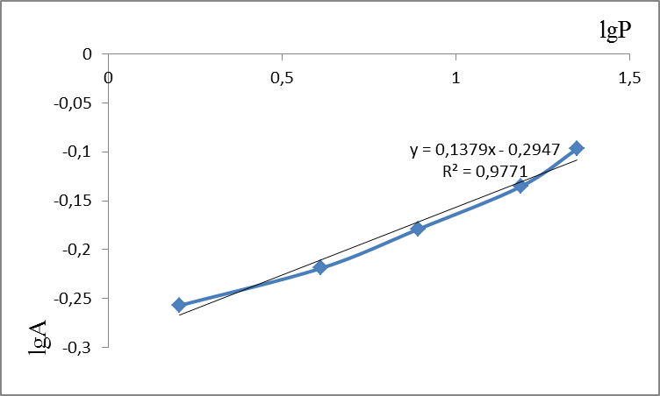
FIGURE 1. Adsorption isotherm of n-heptane vapor on a hybrid diacetate cellulose-silica
bionanocomposite in Freundlich equation coordinates.

The obtained isotherms were analyzed using the Freundlich equation, and the corresponding parameters were calculated. The Freundlich model is typically used to describe adsorption properties on heterogeneous surfaces. At a constant temperature, the relationship between the amount of gas or dissolved substance adsorbed on the solid adsorbent surface and the adsorbent mass is expressed by the Freundlich adsorption equation.
In Figure 1, the Freundlich adsorption isotherm was used to determine the corresponding Freundlich constants. As is well known, the Freundlich equation is analyzed based on the values of the constants K_{F} and 1/n. These constants, K_{F} and 1/n, are experimentally determined values. K_{F} is the Freundlich constant, which expresses the adsorption capacity and is dependent on the nature of the adsorbed substance.
From Table 1, it can be seen that the isotherm for the studied bionanocomposite takes a value of n greater than one, which, according to theory, corresponds to physical adsorption, as the nature of the adsorbate-adsorbent interaction aligns with physical adsorption. Likewise, the value of the Freundlich adsorption equilibrium constant K_{F} (which is 0.5073) also corresponds to this value of n. It is well known that the larger the value of K_{F}, the stronger the interaction between the adsorbate and the adsorbent.
TABLE 1. Freundlich parameters calculated from the adsorption isotherms of n-heptane molecules on the hybrid diacetate cellulose-silica bionanocomposite at 303 K
Freundlich Parameters | n | K_{F} | R²
n-heptane | 7,2516 | 0,5073 | 0,9771

The correlation coefficient obtained from the linear Freundlich equation is R² > 0.97, which indicates that physical adsorption is occurring between the adsorbate and adsorbent. As mentioned earlier, the Freundlich model provides a good fit for adsorption studies on heterogeneous surfaces and under average pressure conditions. For adsorption at very high or very low pressures, other models, including the Langmuir model, are applied.
Based on the research conducted by the American physicist-chemist and Nobel laureate Irving Langmuir, a new theory of adsorption was proposed. According to this theory:
- Adsorbate molecules do not adsorb across the entire adsorbent surface but are adsorbed at specific sites, known as active centers.
- The adsorption forces act at a distance equivalent to the size of a single molecule (monomolecular adsorption).
- The adsorbed molecules do not interact with each other.

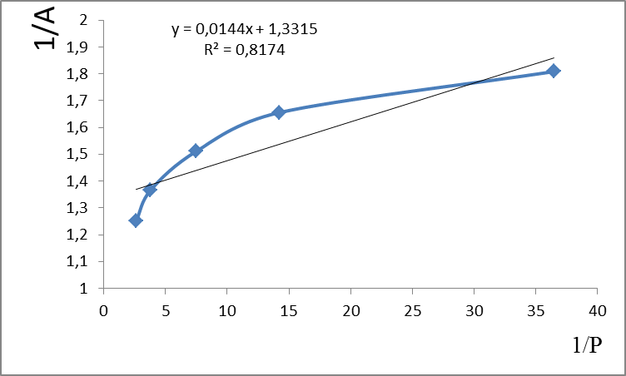
FIGURE 2. Adsorption isotherm of n-heptane vapor on a hybrid diacetate cellulose-silica
bionanocomposite in Langmuir equation coordinates.

The Langmuir theory accurately reflects adsorption at both low and high pressures. When the pressure is very low, the term 1 + K_{L} can be neglected, representing the first straight line in the isotherm. At high pressures, K_{L} = 1, and when adsorption reaches its maximum (a = a_{m}), further increases in pressure do not change the adsorption.

TABLE 2. Langmuir parameters calculated from the adsorption isotherms of n-heptane molecules on the
hybrid diacetate cellulose-silica bionanocomposite at 303 K
Lengmyur Parameters | a_{m} mmol/g | K_{L} | R²
n-heptane | 0,7510 | 92,4652 | 0,8174

From Table 2, it can be observed that the monolayer capacity of the molecule (a_{m}) is small, while the Langmuir constant (K_{L}) is large. It is known that the Langmuir constant K_{L} expresses the interaction energy between the adsorbent and the adsorbate.
The value of K_{L}, which represents the strength of the interaction between the adsorbent and the adsorbate, is directly related to the intensity of this interaction. From the table, we can conclude that despite the small number of active sites (monolayers) with the same energy in the adsorbent composition, the adsorbent interacts quite strongly with the adsorbate. The correlation coefficient also indicates a monomolecular adsorption process (R² > 0.8).
As it is known, Langmuir's theory describes the monomolecular adsorption process. The Langmuir model provides accurate results for both physical and chemical adsorption processes with minimal error. Moreover, Langmuir tested his formula using homogeneous (smooth-surfaced) adsorbents for the adsorption of molecules. However, this theory cannot explain adsorption occurring in the small pores of adsorbents. The adsorption processes occurring in these micropores are better explained by Dubinin’s theory of micropore volume filling, which was developed following his research and collaboration with several scientists.
In microporous adsorbents, adsorption follows the mechanism of volumetric filling of the pores. Using Polyani's theory and integrating numerous experimental studies, Russian scientist Mikhail Mikhailovich Dubinin, with his scientific school, provided a detailed explanation of the adsorption process in microporous adsorbents and proposed the micropore volume filling theory. According to this theory, the interaction of adsorbate molecules with micropores is stronger than with larger pores, and adsorption is more pronounced at lower relative pressures.

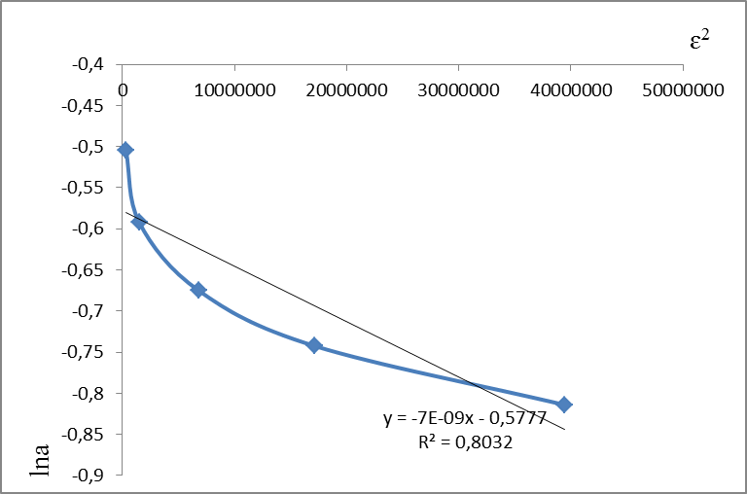
FIGURE 3. Adsorption isotherm of n-heptane vapor on the hybrid diacetate cellulose-silica bionanocomposite in Dubinin-Radushkevich equation coordinates at 303 K.

The Micropore Volume Filling Theory expresses all information regarding the micropore sizes of the adsorbent and is widely used in practice to determine the equilibrium of adsorption in micropores. The Dubinin-Radushkevich isotherm is typically applied to describe the adsorption mechanism on a heterogeneous surface using the Gaussian energy distribution [17-19].
Dubinin and Radushkevich believed that the shape of the adsorption isotherm curve is related to the structure of the sorbent's pore system. To distinguish whether the adsorption occurring in the pores is physical or chemical in nature, Dubinin-Radushkevich developed the Polanyi potential theory, which is used to analyze the adsorption process. The theory helps to determine the energy distribution of adsorption sites and provides insights into the nature of the adsorption process based on the characteristics of the micropores.

TABLE 3. Dubinin-Radushkevich parameters calculated from the adsorption isotherms of n-heptane molecules on the hybrid diacetate cellulose-silica bionanocomposite at 303K
D-R parametrs | a_{m} mmol/g | K_{D-R} | E, J/mol | R²
n-heptane | 1,0 | 7,0*10⁻⁹ | 8,45*10³ | 0,8032

From the above 3rd table, it can be observed that the saturated adsorption capacity (a_{m}) is higher. This indicates that the adsorbent is rich in micropores. K_{D}-R is the constant representing the average adsorption energy in the Dubinin-Radushkevich equation. This is a constant parameter that depends only on the adsorbate type. K_{D}-R affects the adsorption capacity of the pores and their size, meaning that as the micropore size increases, the adsorbent-adsorbate interaction will have a higher maximum binding energy.
The free energy of the adsorbate molecules (E) is the energy required for the motion of the adsorbate molecules on the adsorbent surface. The value of E indicates the nature of the adsorption, whether physical or chemical. In this study, the adsorption energy E was found to be 8.45 kJ/mol, which is close to 8 kJ/mol, indicating that the adsorption process at 303 K is a physical adsorption process. According to Dubinin-Radushkevich data, the correlation coefficient (R²) is greater than 0.80.
Thus, based on the analysis of the adsorption of n-heptane molecules on the DAS-silica bionanocomposite using the Freundlich, Langmuir, and Dubinin-Radushkevich adsorption models, it can be concluded that the Freundlich adsorption model best describes the adsorption of n-heptane molecules onto the hybrid bionanocomposite. This is because the Freundlich model showed the best representation of all adsorption parameters, where the values of KF changed accordingly with n, and it had the highest correlation coefficient (R²). The Langmuir and Dubinin-Radushkevich models showed discrepancies in the adsorption parameters, and their correlation coefficients (R²) were lower compared to the Freundlich model.
In 1992, Aranovich proposed a polimolecular adsorption equation that satisfied experimental data over a wide range of relative pressures. He retained the basic assumptions of BET theory (such as the adsorbent surface being flat and uniform, and no longitudinal interactions between adsorbed molecules; the adsorption energy in the second and subsequent layers being the same).
In contrast to BET theory, Aranovich accepted a new assumption that molecules can desorb not only from the adsorbent surface but also from any point in the adsorbed layer.
Thus, based on the conducted research, Aranovich proposed a new model to describe polimolecular adsorption in macroporous adsorbents.

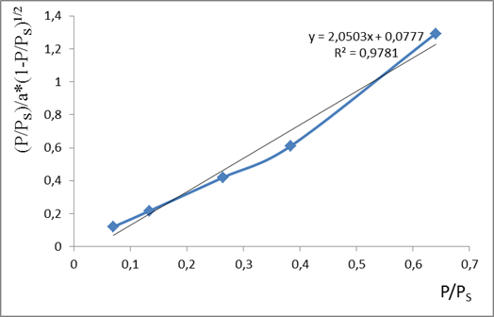
FIGURE 4. The adsorption isotherm of n-heptane vapor on a hybrid DAS-silica bionanocomposite at 303 K in the coordinates of the Aranovich equation.

From the Aranovich adsorption isotherm in Figure 4, the corresponding Aranovich constants were determined. From Table 4, the monolayer capacity, specific surface area, pore radius, and Aranovich equilibrium constants of the bionanocomposite in n-heptane molecules were determined according to the Aranovich theory.

TABLE 4. Aranovich parameters calculated from the adsorption isotherms of n-heptane molecules on the hybrid
DAS-silica bionanocomposite at 303 K.
Aranovich parameters | a_{m}, mmol/g | S_{A}, m²/g | r_{k}, nm | K_{A} | R²
n-heptane | 0,4877 | 168,2417 | 10,152 | 26,3874 | 0,9781

The equilibrium constant K_{A} of the Aranovich adsorption isotherm has a high value, indicating that in the interaction between the adsorbent and adsorbate, a polymolecular layer forms on the adsorbed molecules. The correlation coefficient is greater than R²>0.97. Despite the thermodynamic correctness, accuracy, and advantages of Aranovich's polymolecular adsorption model, the process of replacing the BET model with this model has been slow in practice so far.
It is well known that the adsorption capacity of adsorbents depends on factors such as the number of active centers, adsorption forces, and the size of macro, micro, and mesopores, as well as the surface area. Studying their textural properties, which affect adsorption characteristics, is one of the important tasks of colloid chemistry.
M.M. Dubinin developed the potential theory method and proposed the volume filling theory of micropores to determine [18,19] the micropore sizes in adsorbents. Figure 5 shows the adsorption isotherm of n-heptane vapor on the hybrid DAS-silica bionanocomposite in the coordinates of the MVFT equation.

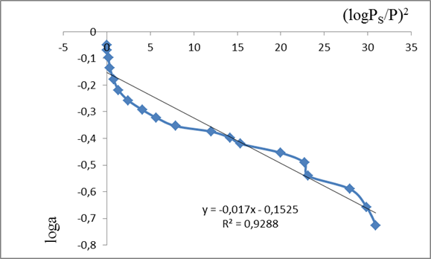
FIGURE 5. The adsorption isotherm of n-heptane vapor on the hybrid DAS-silica bionanocomposite at 303 K in the coordinates of the MVFT equation.

The structure of adsorption characteristics at various relative pressures, determined based on the adsorption isotherm of n-heptane vapor on the adsorbent according to the MHTN equation, is of significant importance in the thermodynamics of adsorption. These characteristics are presented in Table 5.

TABLE 5. MVFT parameters (cm³/g) calculated from the adsorption isotherm of n-heptane molecules on the hybrid
DAS-silica bionanocomposite at 303 K.
Adsorbate | A₀ | V_{s} | W₀ | W_{mez} | r, nm
n-heptane | 0,7040 | 0,1320 | 0,1043 | 0,0277 | 1,5696

From the table, it can be seen that the bionanocomposite contains both micro and mesopores. In the case of the adsorbate n-heptane, it was determined that the volume of micropores in the hybrid DAS-silicabionanocomposite accounts for 80% of the total pore volume, and the micropore radius is 1.57 nm.
Thus, it can be concluded that based on the adsorption isotherms of n-heptane molecules on the DAS-silica bionanocomposite, the adsorption parameters of Freundlich, Langmuir, and Dubinin-Radushkevich were calculated, and the sorption-structure indicators were obtained using the Aranovich and MVFT equations. Among the adsorption models studied, the Freundlich model (with the highest R²) proved to be the most suitable. The structure characteristics of adsorption at various relative pressures were found using the Aranovich and MVFT equations. These results revealed the specific surface area of the hybrid DAS-silica bionanocomposite and the volume of micro and mesopores. Furthermore, it was shown that the hybrid DAS-silica bionanocomposite does not contain layers with uniform energy in the pores and active centers, but rather has micropores on the surface, where physical adsorption mainly occurs, and the process involves polymolecular adsorption.
CONCLUSION
The adsorption isotherm of n-heptane molecules on the hybrid diacetate cellulose-silica bionanocomposite was used to calculate the adsorption parameters of Freundlich, Langmuir, and Dubinin-Radushkevich, as well as sorption-structure indicators using the Aranovich and MVFT equations.
The adsorption energy of Dubinin-Radushkevich was found to be E=8.45 kJ/mol, which is close to 8 kJ/mol, indicating that the process involves physical adsorption. The equilibrium constant K_{A} for Aranovich’s adsorption model was high, suggesting that a polymolecular layer forms on the adsorbed molecules during adsorbent-adsorbate interactions. According to the MVFT equation, the micropore volume of the hybrid DAS-silica bionanocomposite accounts for 80% of the total pore volume, and the radius of the micropores is 1.57 nm.
Among the studied adsorption models, the adsorption process of n-heptane molecules on the hybrid DAS-silica bionanocomposite was found to be most consistent with the Freundlich adsorption model.
The adsorption of n-heptane molecules on the hybrid DAS-silica bionanocomposite indicates that the adsorbent consists of microporous layers, which do not contain active centers with uniform energy, and that the adsorption process involves polymolecular adsorption.
REFERENCES
- Thommes, M., Kaneko, K., Neimark, A. V., Olivier, J. P., Rodriguez-Reinoso, F., Rouquerol, J., & Sing, K. S. W. (2015). Physisorption of gases, with special reference to the evaluation of surface area and pore size distribution (IUPAC Technical Report). Pure and Applied Chemistry, 87(9–10), 1051–1069. https://doi.org/10.1515/pac-2014-1117
- Rouquerol, F., Rouquerol, J., Llewellyn, P., Maurin, G., & Sing, K. S. W. (2013). Adsorption by powders and porous solids: Principles, methodology and applications (2nd ed.). Academic Press.
- Speight, J. G. (2017). Environmental organic chemistry for engineers. Butterworth-Heinemann.
- Dubinin, M. (1975). Physical adsorption of gases and vapors in micropores. In Progress in surface and membrane science (pp. 1–70). https://doi.org/10.1016/B978-0-12-571809-7.50006-1
- Shange, M. G. (2024). Factors affecting silica/cellulose nanocomposite prepared via the sol–gel technique: A review. Materials, 17(9), 1937. https://doi.org/10.3390/ma17091937
- Beaumont, M., et al. (2022). Facile preparation of mechanically robust and functional silica/cellulose nanofiber gels reinforced with soluble polysaccharides. Nanomaterials, 12(6), 895. https://doi.org/10.3390/nano12060895
- Xie, K., et al. (2009). Synthesis and characterization of cellulose/silica hybrid materials with chemical crosslinking. Carbohydrate Polymers, 78(4), 799–805. https://doi.org/10.1016/j.carbpol.2009.06.019
- Vasquez-Zacarias, L., et al. (2018). Hybrid cellulose–silica materials from renewable secondary raw resources: An eco-friendly method. Global Challenges, 1700119. https://doi.org/10.1002/gch2.201700119
- Wang, Q., Liu, S., Liu, J., Sun, J., Zhang, Z., & Zhu, Q. (2022). Sustainable cellulose nanomaterials for environmental remediation – Achieving clean air, water, and energy: A review. Carbohydrate Polymers, 285, 119251. https://doi.org/10.1016/j.carbpol.2022.119251
- Portugal, I., Dias, V. M., Duarte, R. F., & Evtuguin, D. V. (2010). Hydration of cellulose–silica hybrids assessed by sorption isotherms. The Journal of Physical Chemistry B, 114(11), 4047–4055. https://doi.org/10.1021/jp911270y
- Kocherbitov, V., Ulvenlund, S., Kober, M., Jarring, K., & Arnebrant, T. (2008). Hydration of microcrystalline cellulose and milled cellulose studied by sorption calorimetry. The Journal of Physical Chemistry B, 112(12), 3728–3734. https://doi.org/10.1021/jp711554c
- Carrott, M. R., Candeias, A., Carrott, P., Ravikovitch, P., Neimark, A., & Sequeira, A. (2001). Adsorption of nitrogen, neopentane, n-hexane, benzene and methanol for the evaluation of pore sizes in silica grades of MCM-41. Microporous and Mesoporous Materials, 47(2–3), 323–337. https://doi.org/10.1016/S1387-1811(01)00394-8
- Aranovich, G. L., & Donohue, M. D. (1995). Adsorption isotherms for microporous adsorbents. Carbon, 33(10), 1369–1375. https://doi.org/10.1016/0008-6223(95)00080-W
- Riazi, M. R., & Khan, A. R. (1999). A thermodynamic model for gas adsorption isotherms. Journal of Colloid and Interface Science, 210, 309–319. https://doi.org/10.1006/jcis.1998.5911
- Fomkin, A. A., & Petukhova, G. A. (2020). Features of gas, vapor, and liquid adsorption by microporous adsorbents. Russian Journal of Physical Chemistry A, 94, 516–525. https://doi.org/10.1134/S0036024420030097
- Calzaferri, G., Gallagher, S. H., & Brühwiler, D. (2022). Multiple equilibria describe the complete adsorption isotherms of nonporous, microporous, and mesoporous adsorbents. Microporous and Mesoporous Materials, 330, 111563. https://doi.org/10.1016/j.micromeso.2021.111563
- Hutson, N. D., & Yang, R. T. (1997). Theoretical basis for the Dubinin–Radushkevitch (D–R) adsorption isotherm equation. Adsorption, 3, 189–195. https://doi.org/10.1007/BF01650130
- Yarkulov, A., Umarov, B., Rakhmatkarieva, F., Kattaev, N., Akbarov, K., & Berdimurodov, E. (2022). Diacetate cellulose–silicon bionanocomposite adsorbent for recovery of heavy metal ions and benzene vapours: An experimental and theoretical investigation. Biointerface Research in Applied Chemistry, 12(3), 2862–2880. https://doi.org/10.33263/BRIAC123.28622880
- Yarkulov, A., Sobitov, M., Umarov, B., Rakhmatkarieva, F., Sagdullaev, B., & Akbarov, K. (2024). Thermodynamics of adsorption of heptane molecules by hybrid bionanocomposite diacetate cellulose–silica. AIP Conference Proceedings, 3045, 030062. https://doi.org/10.1063/5.0197594

