Oxidative Condensation Process of Methane in the Participation of (Mn₂O₃)_{Х}•(Na₂MoO₃)_{Y}•(Zro₂)_{Z}-based Catalysts
Nargiza Tursunova^{1, a)}, Baxriddin Shukurov¹, Shamsiddin Xolliyev¹,
Jasur Shukurov¹, Gulnora Salaydinova ¹, Hasan Fozilov²
¹Samarkand State University, University Boulevard 15, Samarkand, 140104, Uzbekistan
²Bukhara State Technical University, Bukhara, Uzbekistan

^{a)}Corresponding author: t-nargiza2019@mail.ru

Abstract. In this work, the process of producing ethane and ethylene through oxidative condensation (OC) of methane in the presence of atmospheric oxygen was studied. The main goal of the research was to determine the composition of effective catalysts that ensure the conversion of methane into products with high selectivity and productivity and to study their structure-activity relationship. The experiments tested catalysts prepared on supports such as (Mn₂O₃)_{х}·(Na₂MoO₄)_{y}·(ZrO₂)_{z}, silica gel and high-silica zeolite (HSZ). The degree of conversion of methane to ethane and ethylene, selectivity and productivity of total C₂ hydrocarbons were determined by varying the catalyst granule size, temperature, methane-air ratio and contact time. As a result of adsorption studies, it was possible to effectively accumulate ethylene in zeolite and desorb it through atmospheric air. The phase composition, pore structure and active centers of the catalysts were studied using IR-spectroscopy and X-ray diffractometry methods. According to the results, Mn₂O₃-based catalysts prepared on silica gel provided high selectivity and conversion, achieving up to 52.6% methane conversion and 81.4% C₂ selectivity at around 800°C. In the case of catalysts on a HSZ support, a decrease in selectivity was observed at high temperatures (750°C), which was found to be associated with the formation of deep oxidation products such as CO and CO₂. The decrease in the diameter of the catalyst particles indicated that the reaction was not diffusion-limited and that the process was kinetic in nature. The results of the study confirmed that OKM technology can be considered as a promising method for converting methane into a leading chemical raw material.
Keywords: methane, ethane, ethylene, oxycondensation, adsorption.
INTRODUCTION
The oxidative condensation reaction of methane in the presence of air oxygen, aimed at replacing (at least partially) the traditional ethylene production technologies, has been widely studied by the scientific community.
The technology of oxidative condensation of methane in the presence of atmospheric oxygen can be proposed to expand the raw materials used for the production of hydrocarbons with high added value [1-3]. The goal is to move the chemical industry towards decarbonization, which will lead to a more sustainable and less CO₂-emitting method of producing valuable hydrocarbons and reduce dependence on oil [4].
In addition, the oxidative condensation process of methane in the presence of atmospheric oxygen is generally strongly exothermic, and a large amount of heat is released during the reaction. If measures are not taken to effectively organize heat exchange, introduce a proper cooling system, and maintain a stable temperature regime in the reactor designed for this process, the even distribution of temperature within the reactor volume may be disturbed. Such temperature anomalies not only negatively affect methane conversion and ethylene selectivity, but also cause rapid catalyst degradation, coke formation, and ultimately a decrease in reactor productivity. Scientific studies and experimental results show that the formation of high-temperature local zones was also observed in reactors of various designs designed for the oxidation condensation reaction of methane. Therefore, accurate calculation of heat release in the technological system, optimization of reactor geometry and application of rapid cooling methods are of crucial importance in ensuring the efficiency of this process [5-6]. There are many alternatives proposed in the literature to solve it [7] and they require a deeper understanding of the mass and heat transfer in the system in order to appropriately modify the reactor designs designed for the conventional methane oxidation condensation reaction in the presence of atmospheric oxygen [8-10]. On the other hand, the heat generated in the oxidative condensation reaction system of methane in the presence of atmospheric oxygen can be an advantage if used properly, as the released energy can be used for power/heat generation, reducing the need to import electricity [11-13].
The search for selected catalysts for the oxidative condensation of methane in the presence of atmospheric oxygen, which can be active at low temperatures, has become relevant in recent years [15-20]. Another possibility to increase the efficiency of the oxidative condensation of methane with the participation of air oxygen is the use of membrane methane oxidation condensation reactor technology, which has emerged in recent years as a fast and feasible alternative to the reactor configuration for the oxidative condensation of methane with the participation of air oxygen to increase the profitability of the process.
EXPERIMENTAL PART
Experimental studies were carried out in a laboratory flow-type setup to investigate the process of competitive adsorption of OKM process products (see Fig. 1).
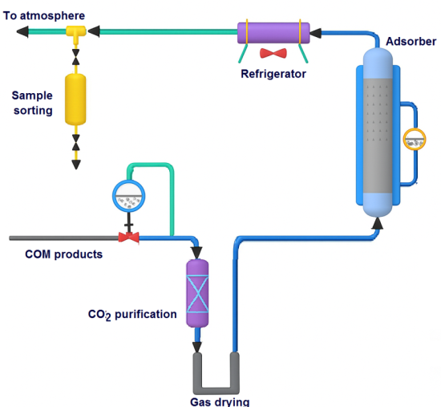
FIGURE 1. Adsorption installation diagram

The raw material is fed to the adsorber from the laboratory device to study the oxidative dimerization of methane. The gas mixture is first passed through an absorber containing a hydroxide solution to remove carbon dioxide and a dryer to remove water. The adsorber is a quartz tube 300 mm long and 25 mm in diameter, with a perforated mesh at the bottom for the adsorbent and a pocket for a thermocouple. The temperature in the absorber is maintained by an electrically heated oven and regulated by the TRM-201 device.
During the experiment, a mixture consisting mainly of C₂H₄, C₂H₆, H₂, and CH₄ was passed through an adsorber filled with 10 cm³ of zeolite at a constant linear velocity. The adsorption cycle was carried out by controlling the ethylene concentration in the exhaust gas until the zeolite was completely saturated. During the desorption cycle, the adsorption was removed from the zeolite by increasing the temperature in the adsorber to 3500C and the bed was purged with a gas stream. In laboratory tests, atmospheric air was used as the desorbent.
RESULTS AND DISCUSSION
According to the results of the study, the highest ethylene production efficiency — 13.6% — was recorded in experiments conducted at a methane/air ratio of 0.238, a contact time of 1.0 s, and a temperature of 790°C. Under these conditions, an optimal balance was observed between the selective formation of ethylene and the overall conversion rate during the oxidative condensation of methane. However, when the temperature is increased to 800°C and above, although the reaction conversion increases to a certain extent, the selectivity of ethylene begins to decrease.
The main reason for this situation is the activation of parallel and auxiliary oxidation reactions at high temperature, as a result of which the formation of high oxidation products such as CO and CO₂ increases. In particular, an increase in CO concentration is one of the main factors that reduce ethylene selectivity, since the complete oxidation direction of the reaction is partially realized at the expense of target products (see Fig. 2). Therefore, optimal control of the temperature regime and limitation of excessive oxidation processes at high temperatures are important to ensure reaction efficiency.

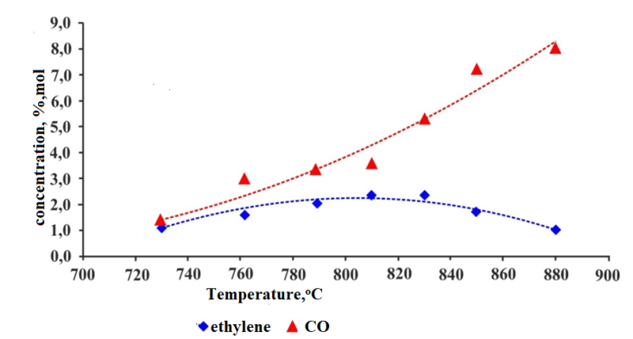
FIGURE 2. 2/1 methane/air ratio = change in concentration of process products at 2/1.

The diffractogram shown in Figures 3-4 showed that the first sample had a high content of Mn₂O₃ crystals.

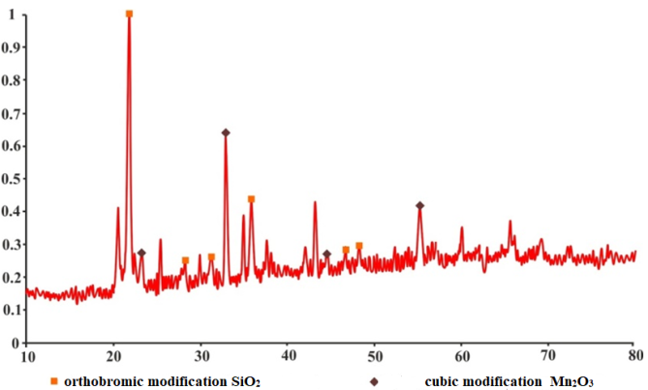
FIGURE 3. Diffractogram of catalyst with (Mn₂O₃)_{x}∙(Na₂MoO₄)_{y}∙(ZrO₂)_{z}/SiO₂ composition.

Figure 3 shows the results of X-ray diffraction (XRD). The red line is the diffraction spectrum obtained from the sample under analysis, in terms of intensity (Y axis) and 2θ angle (X axis). Various high peaks are visible in the graph - they correspond to the characteristic phases of crystalline substances in the sample. The sample was found to contain SiO₂ (orthorhombic form) and Mn₂O₃ (cubic form) crystalline substances. Strong peaks in the range of 20°–40° are mainly indicative of the main phases. Small peaks in the spectrum may possibly indicate additional or mixed phases.
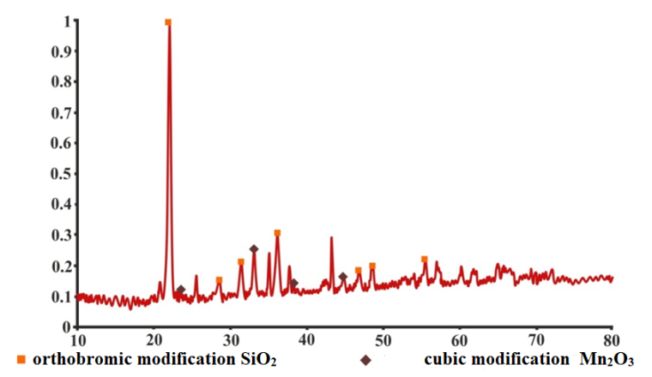
FIGURE 4. Diffractogram of catalyst with (Mn₂O₃)_{x}∙(Na₂MoO₄)_{y}∙(ZrO₂)_{z}/HSZ composition.

The activity of this catalyst is 40% higher. This can be explained by the low content of Mn₂O₃ in the crystalline form, which allows us to conclude that the active phase in the presented catalytic systems is Mn₂O₃ in the amphoteric form. Abscissa (x-axis, 2θ angle): The interval from 10° to 80°. These values correspond to the crystal lattice spacings. Ordinate (y-axis, intensity): Indicates the strength of the X-ray diffraction. The higher the intensity, the greater the proportion of that phase or the higher the degree of crystallinity. The high-intensity peak around 20° is mainly due to SiO₂ in the orthorhombic modification, meaning that the main composition of the sample is silicon dioxide. A series of small peaks in the 30–50° range are associated with the cubic modification of Mn₂O₃ and indicate the presence of manganese oxide in the sample. Peaks of moderate intensity in the 40–60° range also confirm the Mn₂O₃ phase.
Study of the properties of samples of the (Mn₂O₃)_{x}∙(Na₂MoO₄)_{y}∙(ZrO₂)_{z}/HSZ system.
At a typical heating temperature of 900°C, the NaNO₃ and Mn(CH₃COO)₂ salts decompose completely (see Fig. 5), which is confirmed by the almost complete absence of the main absorption lines corresponding to the CH₃COO⁻ and NO₃- groups (1390 cm⁻¹) in the IR spectra. It should be noted that the spectra of samples obtained from sodium nitrate and manganese acetate both (curve 2) and sequentially (curves 1 and 3) are suitable for silica gel.

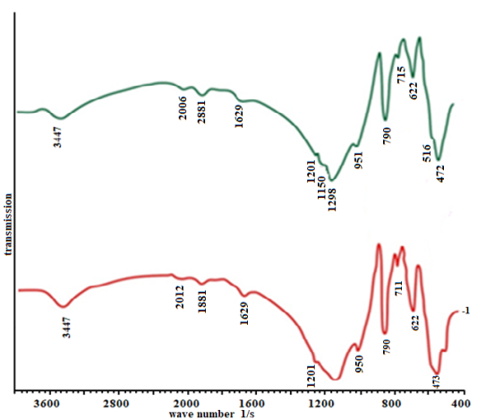
FIGURE 5. IR spectrum of (Mn₂O₃)_{x}∙(Na₂MoO₄)_{y}∙(ZrO₂)_{z} /SiO₂ catalyst (curve 1),
(Mn₂O₃)_{x}∙(Na₂MoO₄)_{y}∙(ZrO₂)_{z} /HSZ catalyst (curve 2) catalyst (curve 2)

TABLE 1. Properties of the catalyst composed of (Mn₂O₃)_{x}∙(Na₂MoO₄)_{y}∙(ZrO₂)_{z}/HSZ
Indicator | Value
Pore Volume | 0,496
Surface | 0,24
Bulk Density | 1,08
True Density | 2,46
Particle Diameter | 0,25-0,5
From Table 1, it can be seen that the pore volume is = 0.496 cm³/g. This value indicates a moderately large porosity. Such a volume improves the use of active centers, which are convenient for diffusion. Surface area = 0.24 m²/g. Surfaces are often around 100–500 m²/g based on HSZ. Particle diameter = 0.25–0.5 mm. Therefore, the catalyst is more porous, gasses can easily enter and exit, and the use of active centers is improved. Particle size provides a balance between ΔP and diffusion in the reactor.
The activity of the sodium molybdate catalyst is presented in Figure 6.
As can be seen from Figure 6, the effect of temperature on the process was investigated in the range of 680–800 °C. Although methane conversion is high (70–72%) at 680–707 °C, the selectivity for C₂-hydrocarbons is moderate (≈50%). At around 750 °C, the selectivity for ethylene reaches high values (e.g., 6.63 ml/s methane, 2.68% air – 61.8%). At 800 °C, the conversion decreases (41–64%) and the C₂ selectivity also slowly decreases, while the yield increases to some extent with increasing temperature, then decreases again. The optimal temperature range is 700–750 °C, where both conversion and selectivity for ethylene are high.

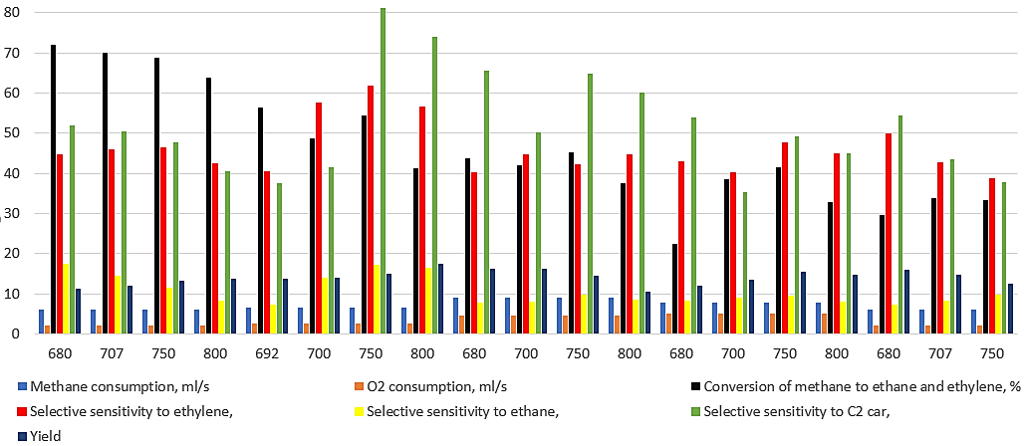
FIGURE 6. Results of testing of the (Mn₂O₃)_{x}∙(Na₂MoO₄)_{y}∙(ZrO₂)_{z}/HSZ catalyst, which has high catalytic activity, selectivity and productivity, selected for the oxidative condensation of methane

A series of experiments were conducted on different catalyst grain diameters to investigate the effect of internal diffusion. The results are presented in Table 2.

TABLE 2. Analysis of the effect of catalyst particle size
Diameter of catalyst particles, mm | Temperature, ºC | Conversion of methane to ethane and ethylene, % | Ethylene selectivity,% | Ethane selectivity, % | C₂ ugl. selective exposure to | yield
0,25 | 705 | 41,6 | 60,6 | 10,0 | 66,6 | 14,8
0,25 | 750 | 52,7 | 60,5 | 17,4 | 77,9 | 11,9
0,25 | 810 | 42,3 | 57,1 | 15,9 | 72,7 | 9,7
0,25 | 850 | 43,4 | 62,3 | 14,2 | 76,5 | 31,7
0,35 | 705 | 31,4 | 57,5 | 10,0 | 67,5 | 17,9
0,35 | 750 | 43,5 | 57,0 | 12,6 | 69,6 | 27,8
0,35 | 810 | 43,8 | 51,1 | 11,6 | 62,7 | 11,3
0,35 | 850 | 32,6 | 59,5 | 8,5 | 68,0 | 15,2
0,45 | 705 | 32,7 | 57,0 | 9,6 | 66,6 | 15,0
0,45 | 750 | 42,4 | 56,3 | 9,7 | 66,0 | 8,7
0,45 | 810 | 32,4 | 58,3 | 8,8 | 67,1 | 17,5
0,45 | 850 | 33,2 | 51,3 | 6,3 | 57,6 | 16,0

The table shows the effect of catalyst particle diameter (0.25 mm; 0.35 mm; 0.45 mm) on the oxidative condensation reaction of methane to ethane and ethylene. For 0.25 mm particles, methane conversion is 41.6% at 705 °C, increases to 52.7% at 750 °C, and then decreases at 810 °C. So, the smaller the catalyst particles, the faster the reaction. Conversion is lower (around 31–43%) for 0.35 mm and 0.45 mm particles. As the particles get larger, the gas-diffusion limitations increase, so the reaction efficiency decreases.
Ethylene selectivity: the highest values were observed for 0.25 mm particles (up to 62.3%); for 0.35 mm and 0.45 mm particles, ethylene selectivity was in the range of 51–59%, decreasing with larger particles. Ethane selectivity: ethane selectivity is high (up to 17.4%) for small particles (0.25 mm); it remains around 6–10% for large particles (0.45 mm).
The selectivity for C₂ hydrocarbons is also highest at 0.25 mm particles (76–78%). The yield of C₂ hydrocarbons at 0.25 mm particles has a large variability: 14.8 → 31.7 (increased sharply at 850 °C).
Fine particles (0.25 mm) provide high conversion of methane and high selectivity for S₂ products. This situation indicates high catalyst activity and low diffusion limitations for gas-derived products.
In large particles (0.45 mm), the reaction efficiency decreased, both selectivity and yield decreased. This is explained by the increase in internal diffusion resistance.
The optimal conditions are observed in the range of 0.25–0.35 mm particles and 750–810 °C temperatures, as high values of C₂ selectivity and yield are achieved in this range.
Thus, our investigations lead to the conclusion that the OKM process occurs kinetically. This conclusion is consistent with the data presented in the literature.
CONCLUSION
Within the framework of this scientific research, the possibility of converting methane contained in natural gas into valuable C₂ hydrocarbons such as ethane and ethylene through the process of oxidative condensation (OKM) in the presence of air oxygen was extensively studied. The main focus was on the activity, selectivity, and productivity of catalysts based on manganese-molybdate oxides (Mn₂O₃)_{x}∙(Na₂MoO₄)_{y}∙(ZrO₂)_{z} and their various supports (SiO₂, HSZ, Al₂O₃), as well as the adsorption purification and processing processes of the products.
The results of the study gave the following main conclusions:
Catalyst efficiency: The (Mn₂O₃)_{x}∙(Na₂MoO₄)_{y}∙(ZrO₂)_{z}/HSZ catalyst exhibited high activity and selectivity. At around 750°C, the maximum selectivity for ethylene and ethane reached 81.4%, while the methane conversion was 52.6%.
Effect of the carrier: It was found that with increasing temperature in the catalysts based on HSZ, the selectivity of C₂ products decreased and the formation of deep oxidation (CO, CO₂) increased. The catalyst prepared on silica gel was confirmed to have a more stable and selective activity.
Adsorption process: Ethylene was collected on zeolite-based adsorbents and desorbed with atmospheric air at 350°C. This process was shown to be important for ethylene recovery and subsequent processing.
Catalyst particle size: High activity and selectivity were observed in experiments with particles with diameters of 0.25–0.5 mm. These results indicate that the OKM process is kinetic in nature and not limited by internal diffusion.
Catalyst structure: Based on IR spectroscopy and X-ray phase analysis, it was determined that the active phase in the catalyst composition was formed by crystalline or amorphous Mn₂O₃.
Porous structure and Si/Al effect: Zeolites with mesoporous structures (Si/Al=10÷25) were distinguished by their high selectivity and capacity. This provides the opportunity to organize the OKM process more efficiently using modified zeolites.
In general, this study proved that catalyst composition, carrier type, granule size, reaction parameters, and product adsorption conditions are important for achieving high conversion and selectivity in OKM process. This work serves to develop environmentally safe, energy-efficient and economically acceptable technological solutions for valuable hydrocarbons obtained from methane - ethane and ethylene derivatives.
REFERENCES
- Lomonosov, V. I., & Sinev, M. Y. (2016b). Oxidative coupling of methane: Mechanism and kinetics. Kinetics and Catalysis, 57(5), 647–676. https://doi.org/10.1134/s0023158416050128
- Aseem, A., Jeba, G. G., Conato, M. T., Rimer, J. D., & Harold, M. P. (2017). Oxidative coupling of methane over mixed metal oxide catalysts: Steady state multiplicity and catalyst durability. Chemical Engineering Journal, 331, 132–143. https://doi.org/10.1016/j.cej.2017.08.093
- Baerns, M., & Kondratenko, E. V. (2008). Oxidative coupling of methane. In G. Ertl, H. Knözinger, F. Schüth, & J. Weitkamp (Eds.), Handbook of heterogeneous catalysis (pp. 3010–3023). Wiley-VCH.
- Sarsani, S., West, D., Liang, W., & Balakotaiah, V. (2017b). Autothermal oxidative coupling of methane with ambient feed temperature. Chemical Engineering Journal, 328, 484–496. https://doi.org/10.1016/j.cej.2017.07.002
- Schwarz, H. (2015b). Thermal hydrogen-atom transfer from methane: A mechanistic exercise. Chemical Physics Letters, 629, 91–101. https://doi.org/10.1016/j.cplett.2015.04.022
- Ogo, S., Iwasaki, K., Sugiura, K., Sato, A., Yabe, T., & Sekine, Y. (2017b). Catalytic oxidative conversion of methane and ethane over polyoxometalate-derived catalysts in electric field at low temperature. Catalysis Today, 299, 80–85. https://doi.org/10.1016/j.cattod.2017.05.013
- Pirro, L., Mendes, P. S. F., Vandegehuchte, B. D., Marin, G. B., & Thybaut, J. W. (2020). Catalyst screening for the oxidative coupling of methane: from isothermal to adiabatic operation via microkinetic simulations. Reaction Chemistry & Engineering, 5(3), 584–596. https://doi.org/10.1039/c9re00478e
- Koerts, T. T., Deelen, M., & Santen, V. R. R. (1992). Hydrocarbon formation from methane by a low-temperature two-step reaction sequence. Journal of Catalysis, 138(1), 101–114. https://doi.org/10.1016/0021-9517(92)90010-f
- Palmer, M. S., Neurock, M., & Olken, M. M. (2002). Periodic Density Functional Theory Study of Methane Activation over La2O3: Activity of O2-, O-, O22-, Oxygen Point Defect, and Sr2+-Doped Surface Sites. Journal of the American Chemical Society, 124(28), 8452–8461. https://doi.org/10.1021/ja0121235
- Daneshpayeh, M., Khodadadi, A., Mostoufi, N., Mortazavi, Y., Sotudeh-Gharebagh, R., & Talebizadeh, A. (2009). Kinetic modeling of oxidative coupling of methane over Mn/Na2WO4/SiO2 catalyst. Fuel Processing Technology, 90(3), 403–410. https://doi.org/10.1016/j.fuproc.2008.11.001
- Koerts, T. T., Deelen, M., & Santen, V. R. R. (1992b). Hydrocarbon formation from methane by a low-temperature two-step reaction sequence. Journal of Catalysis, 138(1), 101–114. https://doi.org/10.1016/0021-9517(92)90010-f
- Wegener, E. C., Wu, Z., Tseng, H., Gallagher, J. R., Ren, Y., Diaz, R. E., Ribeiro, F. H., & Miller, J. T. (2017). Structure and reactivity of Pt–In intermetallic alloy nanoparticles: Highly selective catalysts for ethane dehydrogenation. Catalysis Today, 299, 146–153. https://doi.org/10.1016/j.cattod.2017.03.054
- Karakaya, C., & Kee, R. J. (2016). Progress in the direct catalytic conversion of methane to fuels and chemicals. Progress in Energy and Combustion Science, 55, 60–97. https://doi.org/10.1016/j.pecs.2016.04.003
- Galadima, A., & Muraza, O. (2016). Revisiting the oxidative coupling of methane to ethylene in the golden period of shale gas: A review. Journal of Industrial and Engineering Chemistry, 37, 1–13. https://doi.org/10.1016/j.jiec.2016.03.027
- Kondratenko, E. V., Peppel, T., Seeburg, D., Kondratenko, V. A., Kalevaru, N., Martin, A., & Wohlrab, S. (2016). Methane conversion into different hydrocarbons or oxygenates: current status and future perspectives in catalyst development and reactor operation. Catalysis Science & Technology, 7(2), 366–381. https://doi.org/10.1039/c6cy01879c
- Vandewalle, L. A., Van De Vijver, R., Van Geem, K. M., & Marin, G. B. (2018). The role of mass and heat transfer in the design of novel reactors for oxidative coupling of methane. Chemical Engineering Science, 198, 268–289. https://doi.org/10.1016/j.ces.2018.09.022
- Vandewalle, L. A., Lengyel, I., West, D. H., Van Geem, K. M., & Marin, G. B. (2018). Catalyst ignition and extinction: A microkinetics-based bifurcation study of adiabatic reactors for oxidative coupling of methane. Chemical Engineering Science, 199, 635–651. https://doi.org/10.1016/j.ces.2018.08.053
- Spallina, V., Velarde, I. C., Jimenez, J. a. M., Godini, H. R., Gallucci, F., & Van Sint Annaland, M. (2017). Techno-economic assessment of different routes for olefins production through the oxidative coupling of methane (OCM): Advances in benchmark technologies. Energy Conversion and Management, 154, 244–261. https://doi.org/10.1016/j.enconman.2017.10.061
- Fayzullayev, N., Tursunova, N., Nazarova, N., & Rakhmatov, S. (2023). Study of methane oxycondensation reaction (mn2o3)x∙ (na2moo4)y ∙ (zro2)z and textural characteristics of the catalyst. E3S Web of Conferences, 452, 02002. https://doi.org/10.1051/e3sconf/202345202002
- Tursunova, N. S. (2025). Selection of optimal catalyst composition for obtaining ethylene by heterogeneous catalytic oxidation of methane. AIP Conference Proceedings, 3304, 040035. https://doi.org/10.1063/5.0269948

