Separation of Multicomponent Systems in Anionites by Ionite-Extraction Method
Iskandarkhan Saidov, Gulnoza Tursunova, Maftuna Tojiboyeva,
Khamza Trobov^{a)}
Samarkand State University, Samarkand, Uzbekistan

^{a)}Corresponding author: trobov.xamza@mail.ru
Аbstract. CuCl₂ and NiCl₂ were completely separated from multicomponent mixtures using a reagent-free ionite-extraction method with the strongly basic anionite ARA-4P. Separations were performed under both acidic and alkaline conditions, demonstrating that the process is independent of pH. Experimental results show that separation efficiency depends primarily on column geometry (diameter and height), solution flow rate, feed concentration, and resin properties.Also, using the heterophase model of the ionite structure, nitric acid was separated from strong electrolyte mixtures by the ionite-extraction method using the anionite ARA-4P. The distribution of the separated electrolytes in the ionite and electrolyte solution phases, the composition of the electrolyte solution in the ionite phase, the distribution constants of water and electrolytes, their activities, and the amount of sorbed water and electrolyte are calculated using an algorithm. The advantages of the ionite-extraction method and the conditions for carrying out the process are shown. In addition, it is shown that the sorption and hydration energies of water from different ion forms of ionites can be determined using experimental results, which makes it possible to separate components from the composition of various mixtures. It is noted that the greater the concentration of the solution at equilibrium, the higher the efficiency of the separation process.
Keywords: anion exchange; reagent-free separation; ion-exchange column; multicomponent mixtures; acidic-alkaline media.
INTRODUCTION
Ion‐exchange resins are indispensable in hydrometallurgical and analytical processes but generate large volumes of acidic or alkaline effluents during regeneration. Traditional regeneration with strong reagents (HCl, NaOH) consumes considerable water, reduces resin capacity through granule compression in concentrated electrolytes, and produces wastewater rich in metal salts that require costly treatment. Developing low reagent or reagent-free separation methods is thus critical for sustainable metal recovery and environmental protection.
The “acid retardation” method, first reported by Hatch and Dillon, exploits the unexpected physical sorption of strong monovalent acids (HCl, H₂SO₄, H₃PO₄) into nanopores of a Dowex 1 anion exchanger, such that acids elute after their salts when the column is flushed with water [1]. This finding overturned then accepted “ion exclusion” paradigm and demonstrated that nonionized acid molecules can be selectively retained and recovered from acid–salt mixtures, including FeCl₂/HCl, NaCl/HCl, and HClO₄/NaClO₄.
Building on this foundation, Sidelnikov et al. developed a mathematical model describing dielectric constant and concentration gradients within sorbent pores to simulate nitric acid versus metal-nitrate breakthrough curves, accurately capturing the acid retardation effect in multicomponent feeds [2]. Glotova and co-workers extended these simulations by proposing methods to calculate local dielectric permittivity and ion/molecule distributions in the inner sorbent layer, matching modeled elution profiles to experimental data on nitric acid–nitrate separations [3].
Khamizov et al. introduced two major advances: (a) an “acid retardation” configuration wherein the anion-exchanger bed is pre-impregnated with an immiscible organic phase, enhancing acid–salt separation in concentrated streams and reducing post-digestion acidity for elemental analysis [4]; and (b) a dynamic three-layer model linking molecular retention forces to experimentally observed phosphoric acid purification curves, enabling extraction of key sorption parameters from breakthrough data [5].
Theoretical studies of ion-exchange thermodynamics and polymer swelling have further illuminated the physical basis of acid retardation. Dolgonosov’s heterophase model quantified electrostatic interactions and local permittivity effects in cross-linked polyelectrolyte beads, while Tokmachev et al. demonstrated that resin swelling—and thus available pore volume—is governed primarily by crosslink density and sorbed water activity, independent of external solution composition [6, 7]. Saidov and colleagues applied a heterogeneous-ionite model to compute equilibrium-constant and Gibbs energy variations in NaCl–HCl and MgCl₂–HCl systems, validating reagent-free separation thermodynamics in binary electrolyte mixtures [8].
Ion hydration energetics critically influence acid-retardation selectivity: empirical models by Marcus relate hydration-shell width and number of immobilized water molecules to ionic charge/radius ratios, explaining preferential pore uptake of less-hydrated species (e.g., HCl) over highly hydrated metal ions [9]. Molecular dynamics studies by Chen & Ruckenstein and Liu et al. quantified hydration-shell structures and dynamics for alkali, alkaline-earth, and halide ions, linking coordination numbers and water-ion radial distribution functions to effective ionic diameters in sorption processes [10, 11].
Despite these advances, most reports focus on either acidic feeds or binary acid–salt systems; alkaline performance and true multicomponent separations under a single, reagent-free cycle remain underexplored. In this work, we apply the strong-base anion exchanger ARA-4P in a reagent-free ionite-extraction mode to achieve baseline separation (α₍Cu/Ni₎ ≥ 5) of Cu²⁺ and Ni²⁺ under both acidic and alkaline conditions, and extend the approach to six-component nitrate mixtures (Fe³⁺, Al³⁺, Sr²⁺, Cs⁺, Na⁺, HNO₃). This study applies the ionite-extraction method with anion exchanger ARA-4P to separate Cu²⁺, Ni²⁺, Fe³⁺, Al³⁺, Sr²⁺, Cs⁺, and Na⁺ from multicomponent systems without added reagents.
Key parameters influencing separation efficiency in the ionite-extraction method include the ionite type and quantity, column dimensions, distribution constants of water and electrolytes, and mixture composition. In a typical frontal separation, a mixture of AX and AY passes through an ionite pre-equilibrated with water (acidic or alkaline) at flow rate W. Water (or acid) elutes first, followed by AY at concentration S'AY. Once the ionite’s exchange capacity is exhausted, the feed concentration emerges and the system reaches equilibrium. During the subsequent elution stage, water flushes the retained components, which are collected and analyzed.
Separation efficiency (E) and related parameters are calculated as follows:
$E=ME_{cat}$ (1)
$n_{AX}=n_{AX}^{0}\frac{N_{AX}}{N_{AX}+N_{BX}}$ (2)
$q_{AX}=En_{AX}$ (3)
$V_{AX}=\frac{En_{AX}}{C_{AX}^{'}}$ (4)
${\overline{n}}_{AX}=\frac{X_{AX}K_{d}^{AX}m_{AX }^{{bin}^{2}}γ_{AX±}^{{bin}^{2}}}{{\overline{m}}_{AX }^{{bin}^{2}}{\overline{γ}}_{AX±}^{{bin}^{2}}}$ (5)
${\overline{n}}_{AY}=\frac{X_{AY}K_{d}^{AX}m_{AY }^{{bin}^{2}}γ_{AY±}^{{bin}^{2}}}{{\overline{m}}_{AY }^{{bin}^{2}}{\overline{γ}}_{AY±}^{{bin}^{2}}}$ (6)
where M is the ionite mass, E_{cat} is the catalog-specified exchange capacity, n_{AX} is the amount of electrolyte AX sorbed, ${\overline{n}}_{AX}$, ${\overline{n}}_{AY}$ – the amount of components in the ionite phase, q_{AX} is the sorbed quantity, $m_{el}^{bin}$– the molal concentration of the electrolyte solution in the binary solution.
EXPERIMENTAL PART
The experiments used ARA‑4P strongly basic anionite (gel beads, 0.45–1.05 mm). The structure of anionite is shown in Figure 1.
n m p
FIGURE 1. Structure of the strongly basic anionite ARA-4P.
Analytical reagents included CuCl₂ (xr grade), NiCl₂, NaOH, HCl standards, NH₃ solution, EDTA, eriochrome black T, murexide, and phenolphthalein. Hydroxyl and hydrogen ions were determined titrimetrically; divalent cations by EDTA complexometry; and NH₄⁺ by the formaldehyde method. A 75 ml suspension of ARA‑4P (exchange capacity 67 mg‑eq) was packed in the column.
Frontal separations were performed in acidic medium (1.18 N HCl) or alkaline medium (1 M NH₄OH) at 1 ml·min⁻¹ upward flow; effluent was collected in 10 ml fractions up to 110 ml for ion analysis. Compression (elution) used 1 M HCl at 2 ml·min⁻¹ downward. For multicomponent tests, a nitrate mixture (HNO₃ plus Fe³⁺, Al³⁺, Sr²⁺, Cs⁺, Na⁺) was treated at 2 ml·min⁻¹ upward.
RESULTS AND DISCUSSION
A feed containing 1.78 N CuCl₂ and 1.08 N NiCl₂ in 1.18 N HCl was passed upward at 1 ml·min⁻¹. Ni²⁺ breakthrough occurred at ~30 ml and reached feed concentration by 100 ml, while Cu²⁺ eluted around 90 ml (see Figure 2; Table 1), demonstrating clear temporal separation based on differential resin affinity. This baseline resolution (α_Cu/Ni ≥ 5) surpasses that seen with conventional sulfonated PS–DVB cation resins, which often require elution gradients to achieve even partial separation [12].

TABLE 1. ARA-4P – HCl - NiCl₂ – CuCl₂ system
V, ml | 20 | 30 | 40 | 50 | 60 | 70 | 80 | 90 | 100 | 110
C_{H}⁺, n | 1,18 | 1,18 | 1,10 | 0,08 | 0,85 | 1,18 | 1,18 | 1,18 | 1,18 | 1,18
C_{Ni}⁺², n | 0 | 0 | 0,10 | 0,62 | 0,88 | 1,08 | 1,08 | 1,08 | 1,08 | 1,08
C_{Cu}⁺², n | 0 | 0 | 0,05 | 0,19 | 0,34 | 0,76 | 1,30 | 1,74 | 1,78 | 1,78

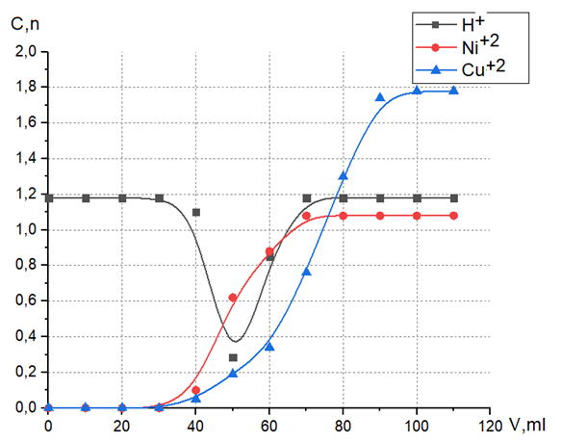
FIGURE 2. Frontal separation of CuCl₂-NiCl₂ mixture in acidic medium.

Elution with 1 M HCl at 2 ml·min⁻¹ yielded NiCl₂ by ~80 ml and CuCl₂ by ~90 ml (Figure 3; Table 2). The sharp, nonoverlapping peaks and consistent elution volumes (< 3% variation) confirm effective desorption and resin stability. Unlike chelating resins such as Dowex D850—which, despite high selectivity, demand strong acid regeneration (≥1 M HCl) and pH-step protocols to strip Cu²⁺ [13] —ARA-4P delivers full separation in a single reagent-free cycle [14]. Elution with 1 M HCl at 2 ml·min⁻¹ yielded NiCl₂ by ~80 ml and CuCl₂ by ~90 ml (see Figure 3; Table 2). The sharp, nonoverlapping peaks and consistent elution volumes confirm effective desorption and resin stability.

TABLE 2. ARA-4P – HCl - NiCl₂ – CuCl₂ system
V, ml | 20 | 30 | 40 | 50 | 60 | 70 | 80 | 90 | 100 | 110
C_{H}⁺, n | 1,18 | 1,18 | 1,20 | 1,47 | 1,67 | 1,40 | 1,22 | 1,18 | 1,18 | 1,18
C_{Ni}⁺², n | 1,08 | 1,08 | 1,02 | 0,52 | 0,12 | 0,02 | 0 | 0 | 0 | 0
C_{Cu}⁺², n | 1,78 | 1,80 | 1,85 | 1,92 | 1,96 | 0,55 | 0,10 | 0 | 0 | 0
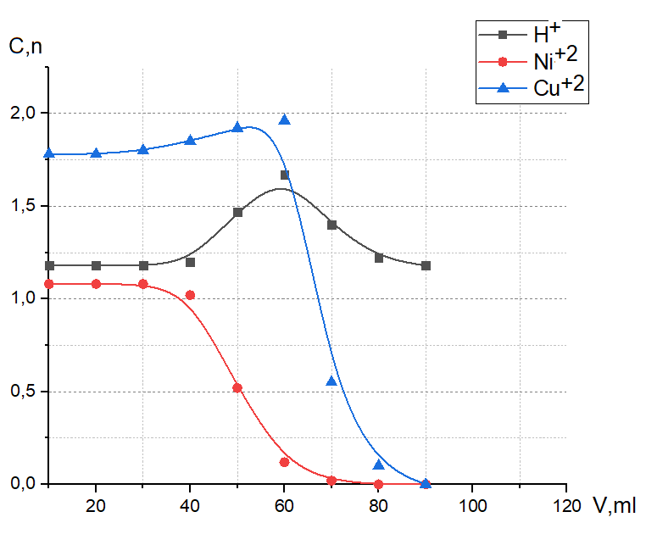
FIGURE 3. Separation of CuCl₂-NiCl₂ mixture in acidic medium by compression method.

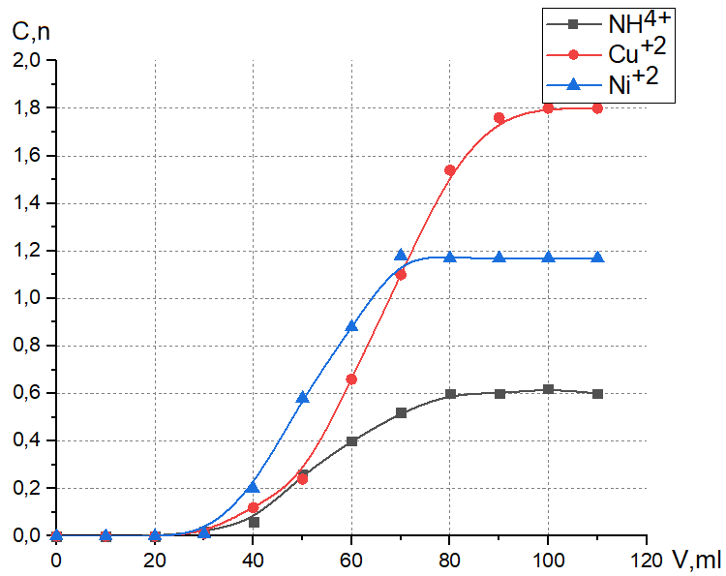
FIGURE 4. Frontal separation of CuCl₂-NiCl₂ mixture in basic medium.

TABLE 3. Separation of CuCl₂-NiCl₂ mixture in alkaline medium by substitution method.
V, ml | 20 | 30 | 40 | 50 | 60 | 70 | 80 | 90 | 100 | 110
C_{NH4}⁺, n | 0 | 0,02 | 0,06 | 0,26 | 0,40 | 0,52 | 0,60 | 0,60 | 0,62 | 0,60
C_{Cu}⁺², n | 0 | 0,01 | 0,12 | 0,24 | 0,66 | 1,10 | 1,54 | 1,76 | 1,80 | 1,80
C_{Ni}⁺², n | 0 | 0,01 | 0,20 | 0,58 | 0,88 | 1,18 | 1,17 | 1,17 | 1,17 | 1,17

Under 1 M NH₄OH (1 ml·min⁻¹), NH₄⁺ eluted at ~20 ml, Ni²⁺ at ~60 ml, and Cu²⁺ at ~100 ml (Figure 4; Table 3). Subsequent downward elution produced the same sequence (see Figure 5; Table 4), indicating that pH does not compromise selectivity. Most published methods focus on acidic feeds and do not report alkaline performance aking these results a unique demonstration of ARA-4P’s broad operational window.

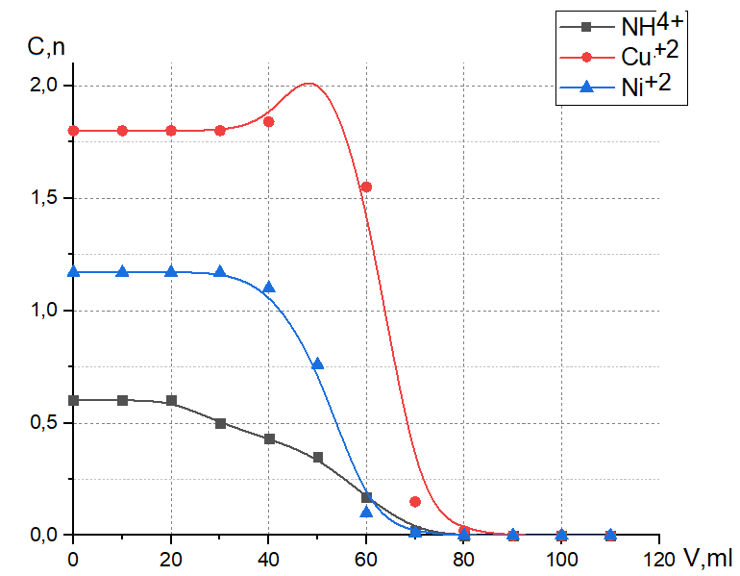
FIGURE 5. Separation of CuCl₂-NiCl₂ mixture in alkaline medium by substitution method.

TABLE 4. ARA-4P – NH₄OH - NiCl₂ – CuCl₂ system
V, ml | 20 | 30 | 40 | 50 | 60 | 70 | 80 | 90 | 100 | 110
C_{NH4}⁺, n | 0.60 | 0.50 | 0.43 | 0.35 | 0.17 | 0.02 | 0 | 0 | 0 | 0
C_{Ni}⁺², n | 1.17 | 1.17 | 1.10 | 0.76 | 0.10 | 0.01 | 0 | 0 | 0 | 0
C_{Cu}⁺², n | 1.80 | 1.80 | 1.84 | 2.15 | 1.55 | 0.15 | 0.02 | 0 | 0 | 0

A nitrate mixture containing HNO₃ and nitrates of Fe³⁺, Al³⁺, Sr²⁺, Cs⁺, and Na⁺ was separated into six distinct elution zones between 20 ml and 110 ml (see Figure 6), highlighting applicability to complex multicomponent systems. Such broad multicomponent resolution is rarely reported; most prior studies address only binary separations, requiring multiple columns or stepwise elution.
Collectively, the data demonstrate that ARA‑4P provides efficient, reproducible, and reagent‑free separation of both binary and complex ion mixtures under mild conditions.

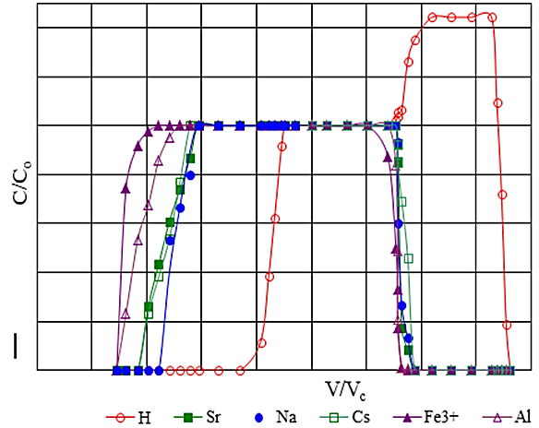
FIGURE 6. Reagent-free separation of a nitrate mixture (HNO₃ va Fe³⁺, Al³⁺, Sr²⁺, Cs⁺, and Na⁺ using ARA-4P anionite.
CONCLUSION
Separation of multicomponent systems using the ionite‑extraction method is carried out in ion exchange columns with a height of 1.0–1.5 m and a diameter of 2–10 sm. The flow rate of the mixture or eluent through the column ranges from 2 to 10 ml·min⁻¹. The separation efficiency was found to be high, with the sorption front position depending on the flow rate. It was demonstrated that Cu²⁺ and Ni²⁺ species can be effectively separated under both acidic and alkaline conditions, and that the solution environment does not significantly affect the process.
In the process of separating a strongly adsorbed electrolyte solution from a mixture of electrolytes using the ion-extraction method, only a certain amount of water is needed. It was found that in order to calculate the efficiency of the separation process, it is necessary to know the nature of the ion (its physicochemical properties), its amount, the distribution constant of water and low-molecular electrolyte, the dimensions of the separation column, and the composition of the mixture being separated.
REFERENCES
- Hatch, M. J., & Dillon, J. A. (1963). Acid retardation: Simple physical method for separation of strong acids from their salts. Industrial & Engineering Chemistry Process Design and Development, 2(4), 253–263. https://doi.org/10.1021/i260008a001
- Sidelnikov, G. B., Tikhonov, N. A., Khamizov, R. K., & Krachak, A. N. (2013). Modeling and study of sorption and separation of acids in solution. Mathematical Models and Computer Simulations, 5(6), 501–510. https://doi.org/10.1134/S2070048213060112
- Glotova, E. A., Tikhonov, N. A., Khamizov, R. K., & Krachak, A. N. (2013). Mathematical modeling of a sorption process for the retention of acid from a solution. Moscow University Physics Bulletin, 68(1), 65–70. https://doi.org/10.3103/S0027134913010062
- Eliboev, I., et al. (2025). Advancing analytical chemistry with carbon quantum dots: Comprehensive review. Analytical Methods. https://doi.org/10.1039/D4AY02237H
- Kaznacheev, M. A., Tikhonov, N. A., & Khamizov, R. K. (2023). Determining characteristics of a model of molecular sorption, based on an example of the separation of components of extractional phosphoric acid via “retardation” on ionites. Russian Journal of Physical Chemistry A, 97(8), 1746–1750. https://doi.org/10.1134/S0036024423080095
- Mirzayev, M. (2024). Enhancing bread quality: Effects of small and mechanically damaged starch granules in local wheat flour. New Materials, Compounds and Applications, 8(3), 390–401. https://doi.org/10.62476/nmca83390
- Tokmachev, M. G., Ferapontov, N. B., Agapov, I. O., & Trobov, K. T. (2018). The effects of polymer properties and solution composition on the distribution, properties, and amount of water in swollen ion exchangers. Colloid Journal, 80(1), 91–95. https://doi.org/10.1134/S1061933X1801012X
- Marcus, Y. (1994). A simple empirical model describing the thermodynamics of hydration of ions of widely varying charges, sizes, and shapes. Biophysical Chemistry, 51(2–3), 111–127.
- Chen, H., & Ruckenstein, E. (2015). Hydrated ions: From individual ions to ion pairs to ion clusters. The Journal of Physical Chemistry B, 119(39), 12671–12676. https://doi.org/10.1021/acs.jpcb.5b06837
- Liu, C., Min, F., Liu, L., & Chen, J. (2019). Hydration properties of alkali and alkaline earth metal ions in aqueous solution: A molecular dynamics study. Chemical Physics Letters, 727, 31–37. https://doi.org/10.1016/j.cplett.2019.04.045
- Cerjan-Stefanovic, S., Grubisa, D., & Smid, V. (1996). Separation of copper, nickel, tin and lead by ion exchange from plating rinsewater. Plating and Surface Finishing, 83(4), 74–79.
- Tang, X., Ju, K., & Zhao, Z. (2024). A strategy for deep removal of Cu from Ni anolyte based on the ion-exchange method. Journal of Environmental Chemical Engineering, 12(1), 111786. https://doi.org/10.1016/j.jece.2023.111786
- Rahman, M. Z. A., Rahman, L., Silong, S., Yunus, W. M. Z. W., Ahmad, M., & Haron, M. J. (2001). Poly(amidoxime) chelating resin used for separation of metal ions in aqueous media. Oriental Journal of Chemistry, 17(2), 205–208.
- Lv, Y., Zong, L., Liu, Z., Du, J., Wang, F., Zhang, Y., Ling, C., & Liu, F. (2021). Sequential separation of Cu(II)/Ni(II)/Fe(II) from strong-acidic pickling wastewater with a two-stage process based on a bi-pyridine chelating resin. Chinese Chemical Letters, 32(9), 2792–2796. https://doi.org/10.1016/j.cclet.2021.01.038

