Kinetics of the Synthesis of Pentodecylonitrile from
Primary Alcohol and Ammonia
Dilafruz Muradova^{1, a)}, Nurali Mukhamadiev², Kadir Muradov²,
Tohirjon Anvarov³
¹Jizzakh Statе Pеdagogical Univеrsity, Jizzakh city, Uzbеkistan
²Samarkand Statе Univеrsity, Samarkand city, Uzbеkistan
³Samarkand Statе Mеdical Univеrsity, Samarkand city, Uzbеkistan

^{a)}Corresponding author:ozod-11-87@mail.ru
Abstract. In this work, kinetic and macrokinetic aspects of the cyanidation reaction of high-molecular aliphatic alcohols with ammonia are investigated. The influence of such parameters as the linear velocity of the gas flow, partial pressure of the alcohol and external diffusion limitations remains insufficiently studied. In particular, little information is available on the regularities arising during the synthesis of high-molecular nitriles and their dependence on the structure of the initial alcohols and the characteristics of the catalyst. Twice-distilled pentadecyl alcohol was used as the initial alcohol. The industrial catalyst NTK-4 v was used in the work. Under conditions of a differential reactor in a flow reactor, the influence of the gas flow rate and the catalyst grain size was studied in order to identify the kinetic region of the reaction. As a result of the studies, the conditions of the kinetic region characterized by the following parameters were identified: the gas mixture flow rate is above 2.5 cm / sec. when there is no external diffusion inhibition, the catalyst grain size is 3-5 mm. The influence of alcohol pressure and concentrations of ammonia, nitrile and hydrogen on alcohol conversion was studied under kinetic region implementation conditions. Kinetic experiments showed that alcohol pressure exerts an extreme influence on conversion, while water reduces the reaction rate. The influence of partial pressure of ammonia, nitrile and hydrogen does not significantly affect the process rate. Comparison of calculated and experimental data confirmed the applicability of the proposed kinetic equation for describing the process in a wide range of conditions. The obtained results are consistent with previously identified mechanisms for the synthesis of aromatic and aliphatic nitriles and can be used to optimize industrial processes for producing high-molecular nitriles.
Keywords: nitril, ammonia, Kinetica, synthesis, mechanism, alcohol, reaction rate, catalyst.

INTRODUCTION
The development of efficient methods for the synthesis of high-molecular nitriles from higher aliphatic alcohols with ammonia is of great scientific and practical interest, since nitriles are widely used in the chemical, pharmaceutical and polymer industries [1-3]. Their use as starting materials for the synthesis of monomers, pesticides, flocculants, corrosion inhibitors and specialized polymers makes the study particularly relevant [4-8]. Despite significant progress in this area, issues related to the optimization of reaction kinetics, the influence of the linear velocity of the gas flow, the partial pressure of the alcohol and the composition of the catalyst remain insufficiently studied. Understanding these factors makes it possible to increase the efficiency of the process, minimize diffusion limitations and ensure a high degree of conversion of the starting materials. The findings hold significance for advancing novel industrial methods for nitrile creation, refining catalytic setups, and incorporating resource-efficient operations within manufacturing. Presently, the production of nitriles from aliphatic alcohols alongside ammonia is receiving considerable attention within organic synthesis and heterogeneous catalysis research [9-13]. The fundamental processes involved in the cyanidation reaction, plus the impact of temperature and catalyst makeup on nitrile production, have been examined extensively. Investigations have also explored optimizing reaction rates using diverse catalysts, including metal sulfides and transition metal oxides. Nonetheless, despite the existing body of knowledge, the impact of aspects like gas flow rate, alcohol partial pressure, and external diffusion constraints remains relatively unexplored. Specifically, data concerning the behavior observed during the synthesis of larger nitriles and their relation to the structure of the starting alcohols and catalyst properties is scarce. Consequently, additional investigation of these elements is vital for refining nitrile synthesis and boosting their industrial performance. This work focuses on analyzing the kinetic and macrokinetic behaviors of the cyanidation reaction involving high-molecular aliphatic alcohols with ammonia to yield high-molecular-weight nitriles. Pentadecyl alcohol was used as a model, and industrial NTK-4 was used as a catalyst.

METHODS
Experimental studies were carried out in a flow glass reactor with an internal diameter of 8 mm, in which NTK-4 with a particle size of 1-1.5 mm was used as a catalyst. The resulting liquid reaction products were analyzed by gas-liquid chromatography using a Chromatec-Crystal 5000 device equipped with a capillary column and a flame ionization detector for accurate determination of the composition of the reaction products.
Currently, the scientific record lacks data concerning how the gas flow's linear speed and catalyst granule dimensions influence the cyanidation of higher alcohols. This deficiency, combined with the utilization of a notably efficient catalyst in this investigation, prevents any reasonable prediction of the ideal conditions required to maintain reactions within the kinetic range. Consequently, a comprehensive examination of the impact of the gas flow's linear velocity and catalyst grain size on the cyanidation process of higher alcohols, using the NTK-4 catalyst, is necessary. Figure 1 presents findings from an analysis of how the gas flow's linear velocity affects the extent to which the starting alcohol is transformed into a nitrile.

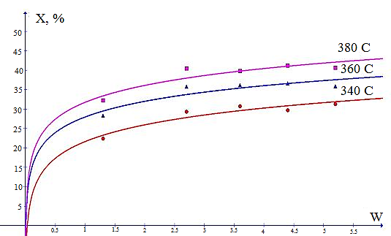
FIGURE 1. Effect of linear velocity of gas flow on the degree of conversion of alcohol to nitrile

The presented data demonstrates that raising the gas flow's linear velocity between 1.3 and 2.5 cm/sec results in a distinct rise in the alcohol's conversion to nitrile. Nevertheless, additional increases in velocity produce little change in product output. This suggests that, within this velocity range (1.3–2.5 cm/sec), the reaction’s speed is restricted by the movement of reactants toward the catalyst granules' exterior. At velocities of 2.5 cm/sec and beyond, external diffusion limitation is absent. Experimentally, it’s found that using catalyst grain sizes from 0.5 to 3 mm allows the reaction to proceed within the kinetic region [14].
When studying kinetic patterns in a flow reactor, carrying out the reaction at high conversion rates of the starting materials causes a concentration gradient to appear along the catalyst bed. Under such conditions, the kinetic equation takes an integral form [15].
Haugen and Watson suggested employing an extremely slender catalyst layer, leading to negligible shifts in reactant conversion and the gas mixture's makeup. A key benefit of conducting trials at reduced conversion levels lies in the capacity to ascertain the reaction rate directly from the gathered data, obviating the necessity to integrate the differential kinetic equation. Because data regarding the process rate, expressed differentially, are secured under circumstances of minimal concentration and temperature variations, they evolve into dependable physicochemical constants for a specific conversion level.
Kinetic investigations were performed within a flow-through glass reactor, featuring an 8 mm internal diameter, utilizing NTK-4 catalyst pellets ranging from 1 to 1.5 mm in diameter, and operating under conditions approximating those of a differential reactor. In order to reduce the effect of heat released during the reaction, the catalysts used in the experiments are mixed with crushed glass in a 1:1 volume ratio. This technique ensures that the reactions proceed isothermally. The results of the experiment conducted to determine the differential reactor area of the process are presented in Table 1.

TABLE 1. A study of the effect of volume velocity of alcohol on the cyanation reaction at different temperatures
Volumetric velocity of spit  mol/kg. cat. hour | Temperature, ⁰С | The degree of conversion of alcohol to nitrile , % | Total turnover rate, %
396 | 330 | - | -
306 | 330 | 3,5 | 11,4
197 | 330 | 6,0 | 13,0
143 | 330 | 7,5 | 12,2
110 | 330 | 9,0 | 11,7
396 | 330 | 6,0 | 25,0
306 | 330 | 7,0 | 22,8
197 | 330 | 10,5 | 22,9
143 | 330 | 14,0 | 22,8
396 | 370 | 9,0 | 37,4
306 | 370 | 11,5 | 37,5
197 | 370 | 17,5 | 38,0

The data presented in Table 1 show that differential reactor conditions exist in the flow with a volume flow rate of alcohol in the range of 130-416 mol/kg.cat.h on the $\frac{1}{V}$-х coordinate of alcohol.
To study the effect of partial pressures of the starting materials and reaction products, special experiments were conducted to investigate the effect of volumetric flow rate on the degree of conversion of alcohol to nitrile at different temperatures (330–370 °C). The experimental data obtained on the conversion of the starting alcohol are presented in Figs. 2–4.

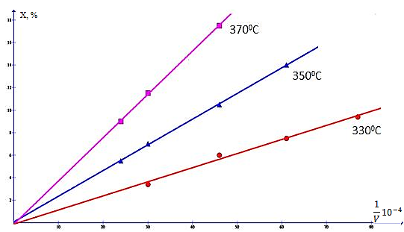
FIGURE 2. Graph of the dependence of the degree of conversion of alcohol into nitrile on the space velocity at different temperatures. P – 0.1 MPa, P_{ROH}– 0.007 MPa, P_{NH3} – 0.078 MPa.

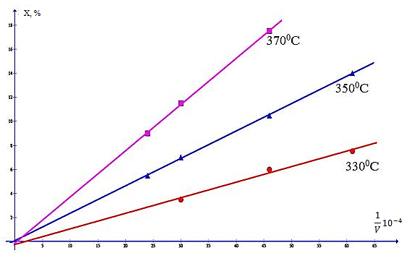
FIGURE 3. Graph of the dependence of the degree of conversion of alcohol into nitrile on the space velocity at different temperatures. P – 0.1 MPa, P_{ROH}– 0.014 MPa, P_{NH3} – 0.078 MPa.

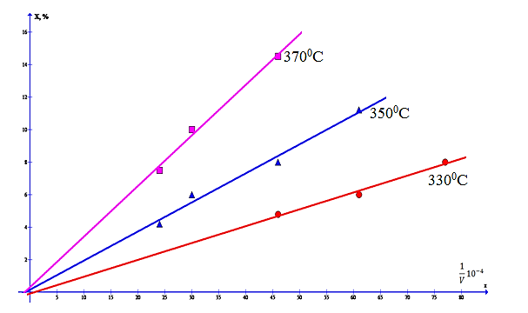
FIGURE 4. Graph of the dependence of the degree of conversion of alcohol into nitrile on the space velocity at different temperatures. P – 0.1 MPa , P_{ROH}– 0.019 MPa, P_{NH3} – 0.078 MPa.
According to the experimental data, an increase in the partial pressure of alcohol from 0.007 to 0.019 MPa leads to a decrease in the degree of its conversion into nitrile in the entire studied range of temperatures and specific feed rates. In this regard, it became necessary to study in more detail the effect of the partial pressure of the initial alcohol on the degree of conversion in an extended range at a constant specific volumetric feed rate. The experiments were carried out in the range of partial pressures of alcohol from 0.002 to 0.009 MPa at temperatures of 330–350 °C. The results obtained are shown in Fig. 5.

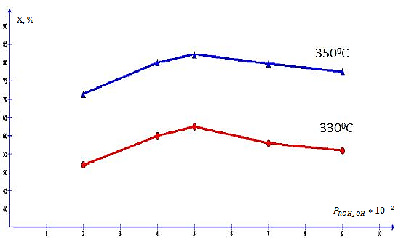
FIGURE 5. The effect of partial pressure of alcohol on the degree of its conversion into nitrile at a constant specific feed rate. V=15,38 mol/kg.cat.hour , $Р_{NH_{3}}-$ 0,078 МРа.
Observations from trials show that the extent to which alcohol transforms into a nitrile is highly sensitive to its partial pressure when the feed rate remains consistent. This behavior in reaction kinetics suggests processes involving at least two adsorbed species or the need for at least two active sites on the catalyst's surface. To investigate, researchers examined how partial pressures of different reactants—ammonia, nitrile, hydrogen, and water—influenced the alcohol’s conversion to nitrile.
Kinetic analysis indicated that a rise in the partial pressure of pentadecyl alcohol resulted in a slower nitrile formation rate, and the nitrile yield’s relationship with alcohol partial pressure, when the volumetric feed rate was held steady, exhibited an extreme pattern. Altering the levels of ammonia, nitrile, and hydrogen had little impact on the alcohol-to-nitrile conversion, but water noticeably slowed down the cyanidation process. Comparable results were observed when studying aliphatic nitrile synthesis with an iron sulfide catalyst, and when benzyl alcohol was cyanidated with ammonia using the industrial catalyst SNM-1 [19, 20].
The collected information suggests that, despite variations in the initial alcohol’s structure and the catalyst’s makeup, the mechanism behind the creation of large-molecule nitriles from alcohols and ammonia aligns with previously defined mechanisms for synthesizing aliphatic and aromatic nitriles [20-21].
The above-mentioned regularities correspond to the following kinetic equation, taking into account the degree of conversion of the original alcohol:
$W=\frac{k K_{RCH_{2}OH}P_{0}(1-x)}{[1+K_{RCH_{2}OH}P_{0}\left(1-x\right)+K_{H_{2}O}P_{0}x]^{2 }}$ (1)
P₀ - partial pressure of the initial alcohol, MPa;
x − degree of conversion of alcohol into nitrile.
For a very thin catalyst layer, the following equation is applicable:
$Fdx=Wdy$ (2)
where F is the rate of alcohol feed into the reactor, mol/hour;
where, F – rate of alcohol supply to the reactor, mol/hour;
y – amount of immersed catalyst, kg.
Then:
$\frac{y}{F}=τ=\frac{1}{v}\int_{0}^{x}{\frac{dx}{dW}}=\int_{0}^{x}{\frac{[1+K_{RCH_{2}OH}P_{0}\left(1-x\right)+K_{H_{2}O}P_{0}x]^{2 }}{k K_{RCH_{2}OH}P_{0}(1-x)}}$ (3)
v-volumetric velocity of alcohol, mol/kg.h;
τ-contact time, sec.
After integrating equation 2 we obtain the following equation;
$τ=\frac{1}{v}=\frac{1}{k K_{RCH_{2}OH}}\left\{\begin{aligned}\frac{(1+P_{0}K_{H_{2}O})^{2}}{P_{0}}\ln{\frac{1}{1-x}}-\left(K_{H_{2}O}-K_{RCH_{2}OH}\right)* \\ \left(2+K_{H_{2}O}P_{0}+K_{RCH_{2}OH}P_{0}\right)x-0,5P_{0}x^{2}(K_{H_{2}O}-K_{RCH_{2}OH})^{2} \\ \end{aligned}\right\}$ (4)
To confirm the applicability of equation 3 for describing the kinetics of cyanidation of higher alcohols with ammonia at high conversion levels, additional experiments were carried out. The experiments were carried out in the temperature range of 330–370 °C and partial pressure of alcohol of 0.007–0.009 MPa. Figure 6 shows the results of experimental data and calculations at a temperature of 350 °C, which demonstrate the agreement between theoretical predictions and experimental observations.

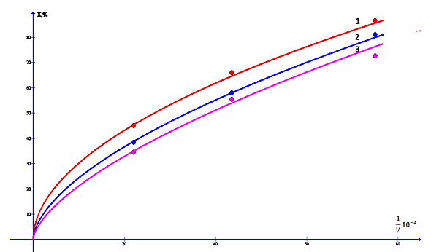
FIGURE 6. Comparison of calculated and experimental data. Dots – experimental, solid – calculated, (t=350⁰С, Рtotal. - 0.1 MPa, Р_{NH3}-0.078 MPa); 1 - P_{ROH}– 0.007 MPa, 2 - P_{ROH}– 0.014 MPa, 3 - P_{ROH}– 0.019 MPa.

As can be seen from the data in Fig. 6, the calculated and experimental results demonstrate good agreement, which confirms the applicability of equation 1 for describing the kinetics of the cyanidation reaction of higher alcohols with ammonia in a wide range of conversion degrees. Thus, it was found that the degree of conversion of higher aliphatic alcohols into nitrile depends on the linear velocity of the gas flow and the partial pressure of the alcohol, while in the velocity range from 1.3 to 2.5 cm/sec the reaction kinetics is limited by the transport of reagents to the catalyst surface. It was experimentally confirmed that at gas flow velocities above 2.5 cm/sec there is no external diffusion inhibition, and the reaction occurs in the kinetic region with catalyst particle sizes from 0.5 to 3 mm.

CONCLUSION
Thus, it has been established that the degree of conversion of higher aliphatic alcohols into nitrile depends on the linear velocity of the gas flow and the partial pressure of the alcohol, while in the velocity range from 1.3 to 2.5 cm/sec the reaction kinetics is limited by the transport of reagents to the catalyst surface. It has been experimentally confirmed that at gas flow velocities above 2.5 cm/sec there is no external diffusion inhibition, and the reaction occurs in the kinetic region with catalyst particle sizes from 0.5 to 3 mm. The effect of the partial pressure of the alcohol on the degree of conversion is extreme, which indicates a complex reaction mechanism involving adsorbed particles on the catalyst surface. The concentrations of ammonia, nitrile and hydrogen do not significantly affect the yield of nitrile, while water significantly reduces the reaction rate. Comparison of the calculated and experimental data showed good agreement, confirming the applicability of the proposed kinetic equation in a wide range of conversion degrees. The obtained results are consistent with previously identified patterns for aliphatic and aromatic nitriles, which suggests the universality of the reaction mechanism for various alcohols and catalysts. These studies open up prospects for optimizing the technological process of synthesizing high-molecular nitriles by selecting optimal reaction conditions and catalyst characteristics.

REFERENCES
- Miller, J. S., & Manson, J. L. (2001). Designer magnets containing cyanides and nitriles. Accounts of Chemical Research, 34(7), 563–570. https://doi.org/10.1021/ar0000354
- Fleming, F. F., Yao, L., Ravikumar, P. C., Funk, L., & Shook, B. C. (2010). Nitrile-containing pharmaceuticals: Effective roles of the nitrile pharmacophore. Journal of Medicinal Chemistry, 53(22), 7902–7917. https://doi.org/10.1021/jm100762r
- Jagadeesh, R., Junge, H. & Beller, M. Green synthesis of nitriles using non-noble metal oxides-based nanocatalysts. Nat Commun 5, 4123 (2014). https://doi.org/10.1038/ncomms5123
- Wang, L., Wang, G., Zhang, J., Bian, C., Meng, X., & Xiao, F. (2017). Controllable cyanation of carbon-hydrogen bonds by zeolite crystals over manganese oxide catalyst. Nature Communications, 8(1), 15240. https://doi.org/10.1038/ncomms15240
- Jia, X., Ma, J., Xia, F. et al. Carboxylic acid-modified metal oxide catalyst for selectivity-tunable aerobic ammoxidation. Nat Commun 9, 933 (2018). https://doi.org/10.1038/s41467-018-03358-x
- Anbarasan, P., Schareina, T., & Beller, M. (2011). Recent developments and perspectives in palladium-catalyzed cyanation of aryl halides: synthesis of benzonitriles. Chemical Society Reviews, 40(10), 5049. https://doi.org/10.1039/c1cs15004a
- Ma, Z., Huo, C., Zhou, D., Zhang, J., Kong, H., Ren, W., Qu, F., Liu, T., Chen, H., & Wang, X. (2025). Nickel-Catalyzed Cyanation of Aryl Halides. Molecules, 30(16), 3440. https://doi.org/10.3390/molecules30163440
- Oishi, T., Yamaguchi, K., & Mizuno, N. (2009). Catalytic Oxidative Synthesis of Nitriles Directly from Primary Alcohols and Ammonia. Angewandte Chemie International Edition, 48(34), 6286–6288. https://doi.org/10.1002/anie.200900418
- Martin, A., & Kalevaru, V. N. (2010). Heterogeneously catalyzed ammoxidation: a valuable tool for One‐Step synthesis of nitriles. ChemCatChem, 2(12), 1504–1522. https://doi.org/10.1002/cctc.201000173
- Ishida, T., Watanabe, H., Takei, T., Hamasaki, A., Tokunaga, M., & Haruta, M. (2012). Metal oxide-catalyzed ammoxidation of alcohols to nitriles and promotion effect of gold nanoparticles for one-pot amide synthesis. Applied Catalysis a General, 425–426, 85–90. https://doi.org/10.1016/j.apcata.2012.03.006
- Dornan, L. M., Cao, Q., Flanagan, J. C. A., Crawford, J. J., Cook, M. J., & Muldoon, M. J. (2013). Copper/TEMPO catalysed synthesis of nitriles from aldehydes or alcohols using aqueous ammonia and with air as the oxidant. Chemical Communications, 49(54), 6030. https://doi.org/10.1039/c3cc42231c
- Jagadeesh, R. V., Junge, H., & Beller, M. (2014). Green synthesis of nitriles using non-noble metal oxides-based nanocatalysts. Nature Communications, 5(1), 4123. https://doi.org/10.1038/ncomms5123
- Tohirjon Anvarov, Kadir Murodov, Dilafruz Muradova, Ismoil Ergashev, Sevinch Toirova; Thermodynamics of the cyanation reaction of octyl alcohol with ammonia. AIP Conf. Proc. 27 November 2024; 3244 (1): 050009. https://doi.org/10.1063/5.0241828
- Hamill, C., Driss, H., Goguet, A., Burch, R., Petrov, L., Daous, M., & Rooney, D. (2015). Mild temperature palladium-catalyzed ammoxidation of ethanol to acetonitrile. Applied Catalysis a General, 506, 261–267. https://doi.org/10.1016/j.apcata.2015.09.030
- Shang, S., Wang, L., Dai, W., Chen, B., Lv, Y., & Gao, S. (2016). High catalytic activity of mesoporous Co–N/C catalysts for aerobic oxidative synthesis of nitriles. Catalysis Science & Technology, 6(14), 5746–5753. https://doi.org/10.1039/c6cy00195e

