Influence of Dust Equivalent Size on
Cleaning Efficiency
Xushnudbek Xomidov^{1, a)}, Azizjon Isomidinov², Zokirjon Abdullayev¹,
Shukurjon Bobonazarov¹, Rustamjon Ummatov¹, Qunduzxon Mamatqulova¹
¹Kokand State University, Kokand, Uzbekistan
²Fergana State Technical University, Fergana, Uzbekistan

^{a)}Corresponding author: xomidovxushnudbek@207gmail.com
Abstract. The article presents the study done on the physicochemical examination of dusty gases released into the environment during the manufacture of construction materials, which is a current topical subject. The object of the study was the dusty gases generated in the production processes of LLC “TERRA NOVA CEMENT,” and the analysis of dust cleaning devices was presented. The dispersion analysis of the resulting dust particles was conducted, and the average median size of the dust was determined. In the experiments conducted to determine the cleaning efficiency, the following factors were used as the gas consumption Q_{h} =140÷990 m³/h with an intermediate step of Q_{h} =285 m³/h, gas velocity ω_{gas} = 5÷35 m/s with an intermediate step of ω_{gas} = 10 m/s, filter thickness δ_{f} =2,3,4 mm, filter frame diameter d_{fd} = 130, 140 and 150 mm, The gas density ρ was chosen to be 1.29 kg/m³ for air. The experiments were conducted at a temperature of 20±2 °C for the gas and water systems.
Keywords: dust, cement, slurry, cyclone, bag filter, filter material, sieve, microscopy, basalt fiber, glass fiber, aerodynamic resistance, drag coefficient, gas velocity, density, particle diameter.
INTRODUCTION
Cement is produced more efficiently using the dry method, which uses no water at all throughout any of the processes. The technological system used in this cement production method is several times more productive than others. The use of this strategy is growing in popularity. In particular, Uzbekistan’s dry cement production method is expanding rapidly these days; since 2020, it has increased by more than 1.2 times. In addition to the aforementioned benefits, this approach has certain disadvantages, such as a relatively low kiln utilization coefficient (0.7–0.8%), a considerable amount of dust emission on all technological fronts, and the difficulty of adhering to sanitary standards (TRECh) and environmental protection regulations [1].
The percentage of dusty gases released by cement manufacturing companies alone rose by 5% from 2021, and its environmental impact grew by almost 1.8 Ph, according to the Republican Committee for Ecology and Environmental Protection. Compared to sanitary requirements, this is 1.2 times greater. The average median size of the dust particles produced determines how effective the current dust cleaning equipment is. The physical and chemical characteristics of dusty gases produced during cement production processes were examined based on the information above. Investigations were carried out on the dusty gases produced during TERRA NOVA CEMENT LLC's production procedures [2, 3].
ANALYSIS RESULTS
A structural diagram of the zones of dusty gas formation in the enterprise's manufacturing processes was first created (see Fig. 1), and the dust's adherence to sanitary standards was examined.
According to GOST 12.1.005-83 [2, 4], which specifies the allowable concentration limits of dust in the air, expressed in mg/m³, a method was used to calculate the number of particles per unit mass of dust during the investigations. Perchlorovinyl fabric of the FPP brand (fabric mounted on a paper protective ring) was used as the filtering material in a conical plastic tube that served as the filter cartridge for a special analytical aerosol aspirator of the AFA type (Aspirator M-822) [5, 6, 7].

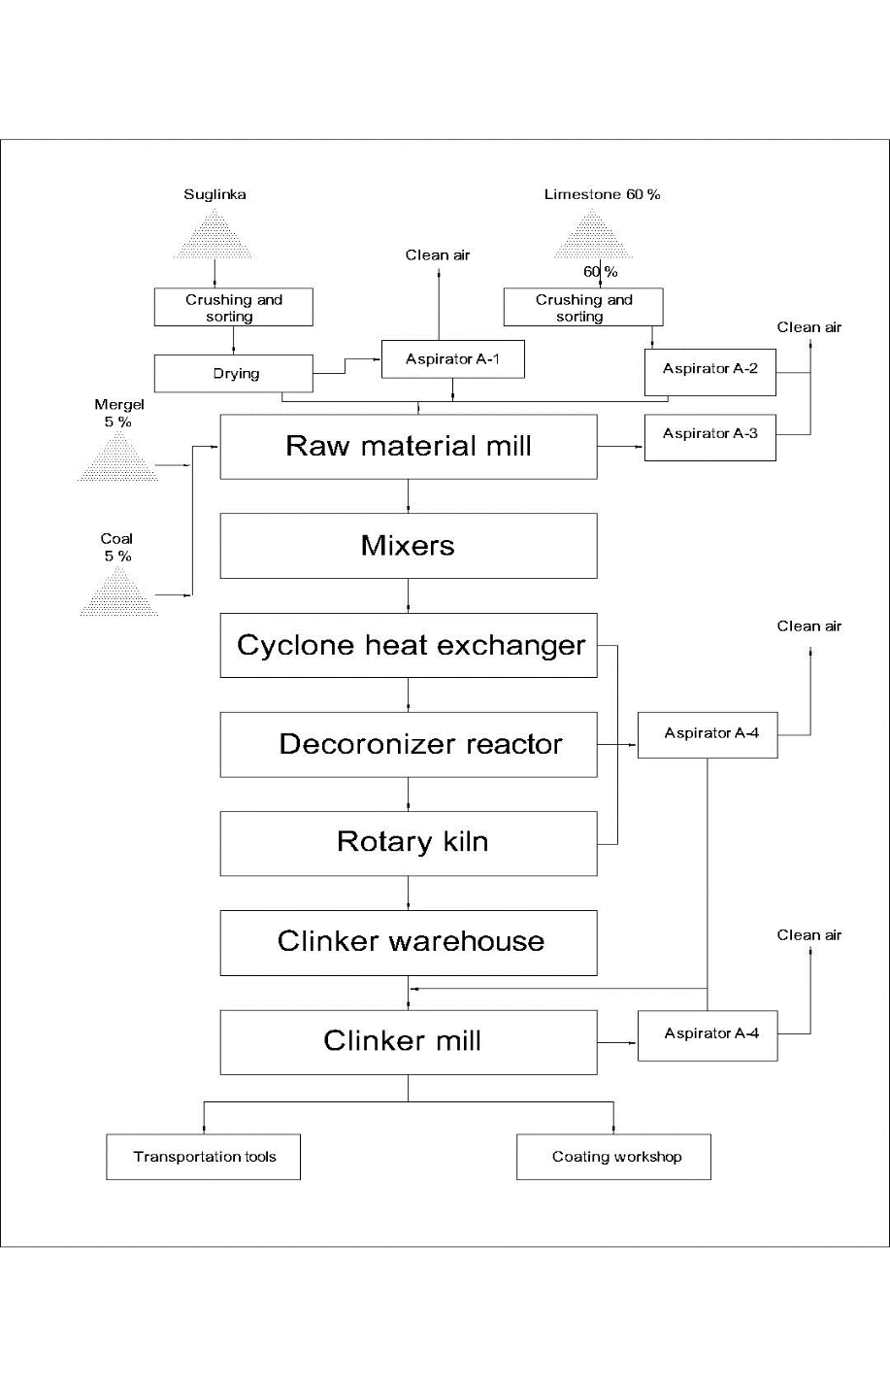
FIGURE 1. Structural diagram of dusty gas generation zones in the technological process of dry cement production.

After installing the aspirator M-822 on the dust collector’s input and output pipes, the existing state of affairs was examined and the results were obtained. Table 1 displays the findings.

TABLE 1. The existing state of affairs results
Dust extraction zone | Dust cleaning device | Sanitary standard, mg/m³ | Dust content at the entrance to the device, mg/m³ | Dust content at the device outlet, mg/m³
The process of drying the suglinka  (Aspirator A-1) | Cyclone | 430 | ≈1560 | 1140
The process of drying the suglinka  (Aspirator A-1) | Sleeve filter | 430 | ≈1140 | 231.3
Limestone crushing and sorting  (Aspirator A-2) | Cyclone | 300 | ≈360 | 45.75
Raw material mill  (Aspirator A-3) | Sleeve filter | 480 | ≈1010 | 265.6
Cooking process  (Aspirator A-4) | Sleeve filter | 480 | ≈1781 | 101.6
Clinker grinding mill  (Aspirator A-5) | Cyclone | 380 | ≈970 | 682
Clinker grinding mill  (Aspirator A-5) | Sleeve filter | 380 | ≈682 | 93.71

Table 1 shows that dust levels in all emission zones exceed sanitary (PDK) standards. The dispersion of dust during slurry drying was studied using sieve and microscopy methods to inform aspiration redesign.
Following five minutes of sieving in a laboratory model of the LM-2E sieve (begun), the powders underwent five minutes of five-stage screening in a laboratory model of the RETSCH DIN-ISO 3310/1 sorting sieve. The following sieve mesh sizes were chosen: 5, 20, 40, 63, and 100 μm. The powders were separated into fractions in percentage terms based on the results. Below are the laboratory analytical results, production conditions, and the chemical characteristics of the powder samples chosen as model materials.
The distribution of dust particles, according to laboratory analysis, was as follows: 12% for 1–5 μm, 45% for 5–20 μm, 10% for 20–40 μm, 23% for 40–63 μm, and 10% for 63–100 μm. Each fraction's quantitative distribution and matching dust device removal effectiveness are shown in Table 2.

TABLE 2. The amount of soot dust by fraction and the efficiency of the installed dust removal device
Fraction size, μm | Fraction share, % | Bag filter cleaning efficiency, %
1-5 | 12 | 65
5-20 | 45 | 82
20-40 | 10 | 98.7
40-63 | 23 | 100
63-100 | 10 | 100

The dispersed composition of the powders was ascertained using an optical microscope in the second approach; a relative inaccuracy of ±1.5% is obtained from particle analysis under a biological microscope. A relative inaccuracy of ±3.4 percent is obtained by averaging the sizes.
Every sample of mineral powder is photographed using optical microscopy. The size of the dispersed powder is determined by a hair fiber, which is then separated into fractions in percentages. It was estimated that the typical median size of the hair fiber was 40 μm.
Given their solubility in a liquid media, the powders chosen for the sample were not combined with water. A DSM-310 camera and a LANGDORPSSESTENGER-1603201 SM001-CYANS biological microscope were used for the photography. An exposure computer was used to process the images. The percentage of the powder size in the 1÷100 μm range was measured at a 400x magnification in relation to the hair fiber size (see Fig. 2).

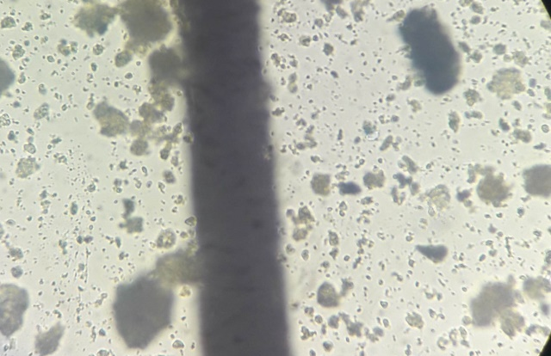
FIGURE 2. View of the dust sampled under the SM001-SYANS microscope at 400x magnification.

According to it, the amount of felt dust up to 1÷5 μm was 15%, up to 5÷20 μm was 42%, up to 20÷40 μm was 13%, up to 40÷63 μm was 18%, and up to 63÷100 μm was 12%.
A graph comparing the distributed content of dusts was created (see Fig. 3) based on the laboratory analysis findings obtained using sieve and microscope methods. The average median size of the chosen dust sample was also calculated.
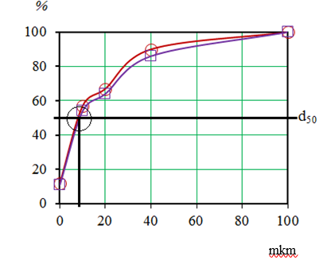
FIGURE 3. Comparison graph of the dispersed composition of suglinka dust: 1 - sieve analysis; 2-microscopic analysis

Between the sieve and microscope procedures, the laboratory analytical error was 5.4%. Therefore, the average median size of crushed particles may be considered as d50 = 9.35 mkm for cement dust in experimental tests to estimate the cleaning effectiveness of a bag filter.
According to the findings of the sieve and microscope investigation, a significant percentage of dust particles are found in the 5÷20 mkm range. Furthermore, there is a noticeably greater percentage of dust particles in the 40–100 mkm range. We may infer that a cyclone device can be utilized for primary cleaning of dust particles up to 40÷100 mkm in order to lessen the burden on the bag filter. This raises the device's cleaning level and guarantees that dust particles up to 1÷40 mkm can enter the bag filter, reducing the number of dust particles in the air that enter by an average of 20%.
RESEARCH OBJECT
Specifically, the goal of this study project was to employ a fabric composed of glass fiber and basalt to enhance the sleeve of resource-saving, import-substituting bag filters used in the cement manufacturing business. Based on the aforementioned, research was done to find out how well a fabric composed of glass fiber and basalt could remove dust from a bag filter. Figure 3 depicts the fabric's look.

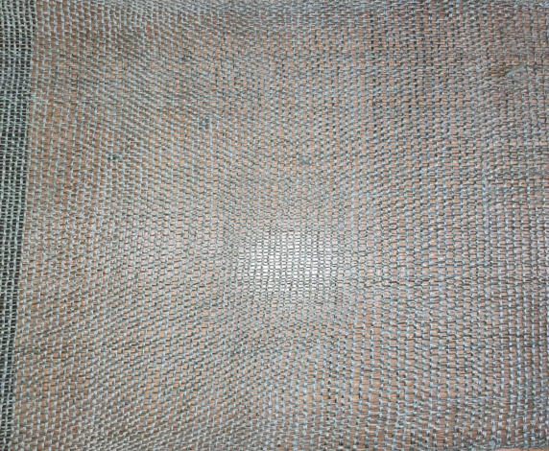
FIGURE 4. Appearance of a woven fabric based on basalt and glass fiber.
METHODOLOGY
Object of research as «TERRA NOVA CEMENT» The dust emitted into the atmosphere from the cement production plant was collected, and the recommended filter was used under production conditions.
The following parameters of the changing factors during the experiments were: gas consumption Q_{h} =140÷990 m³/h with an intermediate step of Q_{h} =285 m³/h, gas velocity ω gas = 5÷35 m/s with an intermediate step of ω gas = 10 m/s, filter thickness δ_{f} =2,3,4 mm, filter frame diameter d_{fd} = 130, 140 and 150 mm, The gas density ρ was chosen to be 1.29 kg/m³ for air. The experiments were conducted at a temperature of 20±2 °C for the gas and water systems.
One of the primary features of bag filter devices at the first stage is the selection of ideal values for the loads operating on the device's working bodies on the flow of dusty gas inside the bag filter devices. This feature establishes the device’s aerodynamic resistance as well as the maximum quantity of heat that may exit the device with the purified gas. The following are the findings of the computation. The device’s total resistance coefficient was found to be ζ = 2.4 at a basalt fabric filter thickness of δ_{f} = 2 mm, ζ = 2.7 at δ_{f} = 3 mm, and ζ = 3.2 at δ_{f} = 3 mm. For various characteristics of the identified resistances, the device’s cleaning effectiveness was examined.
EXPERIMENT RESULTS
Aerodynamic resistance's cleaning effectiveness is by quantitatively moving the dust samples through a screw feeder that was positioned in the dusty gas suction pipe of the device’s fan. The cleaning effectiveness of the device was assessed for different parameters of the variable factor in the investigation of the impact of dust samples. The air flow line entering the apparatus had a condenser fitted during the testing, and the flow temperature was set at ta = 200, 300, and 400 º C. According to the PDK requirement and GOST12.1.005-38, the gas density for a combination of air and cement dust is ρ_{g} = 3.2 kg/m3, with 1860 mg/m3 of cement dust in 1 m³ of air. It was shown that the average median particle size for cement dust is δ₅₀ = 16.7 μm. The water and gas system’s temperature was set at 20 0C ± 2 during the trials, accounting for the impact of the surrounding environment. A unique analytical aerosol aspirator of the AFA type (Aspirator M-822) was used to measure the cleaning efficiency. The filtering material was FPP brand perchlorovinyl fabric, which is fabric placed on a paper protective ring. The filter cartridge was a conical plastic tube [6, 7].
Experiments for low and high loads were carried out, and comparison graphs were created, taking into consideration the multifactorial character of the study.
The experimental results are presented in Figures 4 and 5.

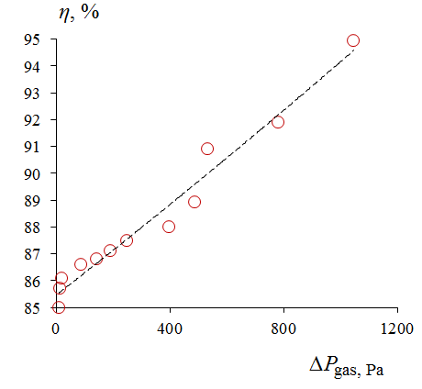
FIGURE 5. Device aerodynamic resistance ∆P _{gas} The cleaning efficiency of η dependency
graph. d_{fd} = 150 mm and t_{a}= 200 ºC const.
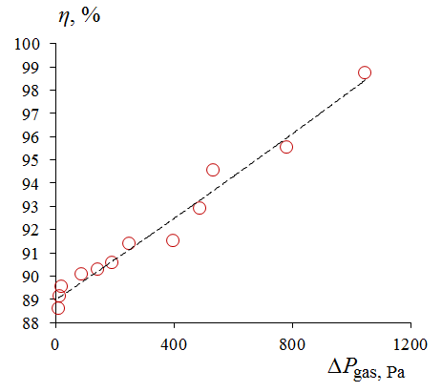
FIGURE 6. Device aerodynamic resistance ∆P _{gas}, the cleaning efficiency of η dependency
graph, d_{fd} = 130 mm and t_{a}= 400 ºC const.

It is evident from graphs 4 and 5 that the cleaning efficiency decreases as the temperature of the air delivered to the device rises. The cleaning efficiency is also greatly impacted by the variable elements of gas velocity, filter material thickness, and filter frame diameter.. For example, in the graphical dependence in Figure 2, it was observed that the cleaning efficiency increased to η = 87.8÷99.9 % in the lower layer of variable parameters , while in the graphical dependence in Figure 3, the cleaning efficiency increased to η = 85.6÷94 % in the upper layer of variable parameters .
The error between the theoretical and experimental studies was 3%.
Using the least squares method to fit the graphical relationships presented in Figures 4 and 5, the following empirical formulas were obtained that adequately represent the parameters;
For minimum temperature:
$y = 94.915e 0.5x$ $R² = 0.9875$ (1)
For maximum temperature: 1- When δ_{f} =4 mm.
$y = 85.906e 0.5x$ $R² = 0.9997$ (2)
Changing the location or design of the parts controlling the gas flow in the apparatus raises the cleaning level, according to the results of studies done to measure the aerodynamic resistance and examine its impact on cleaning efficiency. It does, however, result in higher operating energy consumption. Furthermore, variations in the apparatus's gas supply's temperature, density, and speed have a big impact on the aerodynamic resistance. Although cleaning efficiency rose due to the increase in aerodynamic resistance, cleaning dusty gas required more energy. Thus, it is crucial to maximize cleaning effectiveness while minimizing aerodynamic resistance. The figures demonstrate that when the device's temperature rises, the physical and chemical characteristics of the filtering material deteriorate, lowering the filter's lifespan and raising its cost. It is advised to consider the median size and temperature of dust released by industrial firms while building an industrial version of the filter.
CONCLUSION
Changing the filter thickness leads to increased aerodynamic resistance and improved cleaning efficiency.
The resistance coefficient rises as the filter fabric’s closed zone and thickness both increase. Limited intermediate values of Δk must be included when designing industrial copies of the device in order to choose the best settings for the closed and open zones.
The experiment's findings on the local resistance coefficients in the diffuser, the cleaned gas outlet pipes, and the dusty gas input pipes demonstrate that, even throughout a variety of gas velocity and flow regimes, the resistance coefficient values are rather near to one another. Following mathematical processing of the calculated resistance coefficient values, the dusty gas intake and cleaned gas outlet pipes resistance coefficients were calculated to be 0.54 and 0.3, respectively, with enough precision and average value.
The degree of cleaning may be increased by altering the location or design of the components influencing the gas flow in the apparatus, according to the studies done to measure the aerodynamic resistance and examine its impact on cleaning efficiency. It does, however, result in higher operating energy consumption. Furthermore, variations in the apparatus’s gas supply’s temperature, density, and speed have a big impact on the aerodynamic resistance.
REFERENCES
- Wu, Z., Zhang, X., & Wu, M. (2015). Mitigating construction dust pollution: state of the art and the way forward. Journal of Cleaner Production, 112, 1658–1666. https://doi.org/10.1016/j.jclepro.2015.01.015
- Luo, Q., Huang, L., Liu, Y., Xue, X., Zhou, F., & Hua, J. (2021). Monitoring Study on Dust Dispersion Properties during Earthwork Construction. Sustainability, 13(15), 8451. https://doi.org/10.3390/su13158451
- Bakke, B., Stewart, P., & Eduard, W. (2002). Determinants of dust exposure in tunnel construction work. Applied Occupational and Environmental Hygiene, 17(11), 783–796. https://doi.org/10.1080/10473220290096032
- State Committee for Standards of the USSR. (1989). GOST 12.1.005-88: Occupational safety standards system. General sanitary and hygienic requirements for air in the working zone. Moscow: Standartinform.
- Federal Agency on Technical Regulation and Metrology. (2019). GOST 31826-2012: Gas cleaning and dust collecting equipment. Bag filters and wet dust collectors. Safety requirements. Moscow: Standartinform.
- Cheriyan, D., & Choi, J. (2020). Estimation of particulate matter exposure to construction workers using low-cost dust sensors. Sustainable Cities and Society, 59, 102197. https://doi.org/10.1016/j.scs.2020.102197
- Cohen, A. J., Anderson, H. R., Ostro, B., Pandey, K. D., Krzyzanowski, M., Künzli, N., Gutschmidt, K., Pope, A., Romieu, I., Samet, J. M., & Smith, K. (2005). The global burden of disease due to outdoor air pollution. Journal of Toxicology and Environmental Health, 68(13–14), 1301–1307. https://doi.org/10.1080/15287390590936166 .

