Sustainable Gypsum Board Production Using
Recovered Industrial Dust
Davron Karimov, Mamuraxon Abidova, Dilshodkhon Kodirova,
Safie Ortikova^{a)}, Dilmurod Ergashev
Fergana State Technical University, Fergana, Uzbekistan

^{a)} Corresponding author: ortikova.sofiya@mail.ru
Abstract. In this article the efficiency of dust removal, hydraulic resistance, and process optimization were systematically analyzed. Experimental results showed that the proposed “cyclone + scrubber” configuration increased dust collection efficiency to 98–99%, surpassing conventional systems by 14%. The recovered fibrous-mineral mass was successfully utilized as an organomineral additive in gypsum board manufacturing, replacing up to 10–20% of primary raw materials. Physical and mechanical tests confirmed that the produced gypsum boards met GOST 6266–97 standards. The developed technology demonstrates environmental and economic advantages by reducing airborne pollution, minimizing waste disposal, and promoting circular resource utilization in construction material production.
Keywords: scrubber, cyclone, hydraulic resistance, drywall, mineral dust
INTRODUCTION
For a long time, local atmospheric pollution was relatively quickly diluted by masses of clean air. Dust, smoke, gases were dispersed by air currents and fell to the ground with rain and snow, neutralized, reacting with natural compounds. Now the volumes and speed of emissions exceed nature’s ability to dilute and neutralize them. Therefore, special measures are needed to eliminate dangerous air pollution. The main efforts are now aimed at preventing emissions of pollutants into the atmosphere. Dust collection and gas cleaning equipment is installed at existing and new enterprises. Currently, the search for more advanced ways to clean them continues. A large number of modern chemical technological processes are associated with crushing, grinding and transportation of bulk materials. In this case, inevitably, some of the materials go into an aerosol state, forming dust, which is released into the atmosphere with process or ventilation gases. Currently, several hundred different designs of devices for purifying gases from dust are known. Despite the diversity, they are all hardware options that use a few basic principles of sedimentation or retention of suspended phase [1-3].
One of the technical solutions for deep air purification may be the use of scrubbers with a movable nozzle, which are characterized by lower energy costs compared to air purification devices. In this regard, the development of a new scheme for installing two-stage dust cleaning, consisting of a cyclone and a scrubber, based on intensifying the process of deposition of fibrous and mineral particles, is an urgent scientific and technical task [4-5].
Taking into account the mechanism for producing the smallest particles, 4 classes of industrial dust are distinguished: mechanical - formed during grinding of dry materials, grinding, crushing or other technological operations. This could be, for example, metal chips or cement dust, wood shavings, various types of other emissions; fly ash - non-combustible residues present in flue gases in suspension, are formed when burning fuel that contains mineral impurities; sublimates - particles formed during abundant condensation of vapors or when air is cooled, passing through technological equipment; soot – industrial emissions in the form of solid highly dispersed carbon. Are the result of high-temperature decomposition or incomplete combustion of hydrocarbons. The main characteristic of suspended particles is their diameter. The “dust” category includes solid particles with a cross section of 0.1–850 microns. Crumbs of 0.5–5.0 microns are more dangerous for people, animals or the environment [6].
Today, there are the following methods for purifying gases from aerosols: mechanical, electrostatic, as well as purification through sonic and ultrasonic coagulation [7].
Mechanical cleaning methods include capturing contaminants using wet and dry methods: gravitational sedimentation; inertial and centrifugal dust collection; filtering [8].
Cleaning the air from harmful and toxic dust and recycling the collected mass is one of the most pressing problems in the world. Today, dust and particulate matter contained in manufacturing plants pollute the environment, and this dust causes great harm to the environment because the dust masses are not disposed of. Fine mineral dust emitted by cotton mills contains up to 28% free silicon dioxide (SiO2), which causes respiratory failure. Therefore, it is important to develop a comprehensive technology for cleaning dust emitted into the atmosphere and recycling the remaining mass, as well as obtaining secondary products from them. Justification of the following scientific solutions in the field of cleaning and disposal of dust emitted into the air in the world: improvement of technology for deep purification of atmospheric air from harmful dust; obtaining secondary products from the remaining mass; development of new technologies for producing binders for plasterboard in the construction industry from fibrous dust (pux) emitted by cotton gins, and disclosure of legislation; it is necessary to develop and improve a technological line for producing additional material for plasterboard from foam plastic.
Many people today strive to create a comfortable, environmentally friendly living environment for themselves, both in the workplace and at home. This is usually expressed in changing the interiors of serial buildings, with a fundamental replacement of the materials once used by the builders. It is often very difficult to combine a design dream, the environmental safety of the material and the manufacturability of construction work. Drywall is ideal for solving this triune task. Drywall successfully combines the highest quality of raw materials and a demanding approach to the consumer properties of the finished product. The main components of plasterboard production are building gypsum, cardboard and a number of additives that regulate the properties of gypsum. Construction plaster is odorless and safe for health. It quickly gains strength and easily adheres to other building materials; easily takes the shape of materials in contact with it. All these qualities contribute to the widespread use of gypsum in the construction industry, including in the production of plasterboard [9].
Drywall is a universal material for finishing work of any complexity. Several years ago, drywall established itself as a good and high-quality finishing material.
In fact, a plasterboard sheet is a kind of sandwich, consisting of two outer layers of cardboard and an inner gypsum component, distributed in a ratio of 93/6% (the remaining percentage is made up of various components that improve the performance properties of the material, added during the production process). For example, glass fiber added to a gypsum mixture makes it possible to increase the density of the mass (sometimes reinforcing additives are used instead). To ensure reliable adhesion between the layers of plasterboard “sandwich”, a special kind of adhesive composition is used [10].
It is no longer possible to imagine modern construction without it. Today, plasterboard is an indispensable material for the construction of interior partitions, wall cladding, flooring, suspended ceilings and the manufacture of decorative and sound-absorbing products. Drywall allows you to follow the “clean construction” technology, since it allows you to completely eliminate the use of all kinds of wet cement and concrete mixtures necessary to create structures [11].
In order to obtain plasterboard products, a number of research methods have been developed. The invention relates to the production of plasterboard sheets, namely to a gypsum suspension for the production of plasterboard sheets with improved adhesion between layers. Gypsum suspension for the production of plasterboard sheets with improved adhesion between layers, including gypsum, oxidized starch, foaming agent, plasticizer, paper pulp, water and additionally alkaline starch paste with a concentration of commercial starch from 1% to 25%, in an amount from 0.001% to 0.2% by weight of gypsum. A method for producing plasterboard sheets with improved adhesion between layers includes the following stages: preparation of an alkaline starch paste, preparation of an aqueous suspension of paper pulp, dosing all the components of the gypsum suspension into the mixer, mixing the components of the gypsum suspension, molding the plasterboard sheet with the required edge shape and thickness, cutting the resulting plasterboard sheet into strips, сушку в сушильной камере, резку и торцовку полос на требуемую длину. Technical result - improved adhesion of cardboard to the gypsum core, increased strength characteristics of plasterboard sheets without increasing the mass of 1 m² [12].
The production of drywall is very simple, this is due to the fact that almost all stages of production are performed by a machine, that is, the process is almost completely automated. The technological production process includes the following stages: the first stage of drywall production consists of preparing a gypsum mixture, which consists of water and powder mixed in a gypsum mixer; as soon as the machine prepares the mixture, cardboard sheets - top and bottom - will begin to be fed onto the belt; a gypsum mixture will be applied to the bottom sheets of cardboard, and the top ones will be coated with glue, after which the bottom sheets will be covered with them; the formed sheets are placed under a press and then cut to a given size; when the sheets have already been formed into the desired shape and size, they are sent for drying; after the sheets have dried (their humidity should not exceed 7%), they will be sent to a special machine to trim the edges [13].
In the work of A.V.Volzhensky, A.V.Ferronskaya et al. have shown that the most effective way to solve the problem of increasing the water resistance of building materials based on gypsum binders is to introduce hydraulic and active mineral additives into the composition of the binder complex. A.V.Ferronskaya, V.F.Korovyakov first developed a new generation of waterproof composite gypsum binders, which are obtained by mixing gypsum binder with an organo-mineral modifier [14, 15].
For the correct selection of dust collection equipment, the development of new and improvement of existing dust collection devices, as well as for carrying out technological measures to reduce dust formation and dust emission, it is necessary to know the basic properties of dust [16, 17].
Depending on the method of separating dust from the air flow, dry dust collection equipment and wet dust collection equipment are used, in which the separation of particles from the air flow is carried out using liquids. Dry centrifugal dust collectors are used in processes of drying, roasting, agglomeration, fuel combustion, cleaning aspiration air, operation of limestone crushers, mills, pneumatic transport systems for bulk materials, in asphalt concrete, ceramic, refractory production, ferrous and non-ferrous metallurgy, in the production of carbon black for the tire industry, in food technology, etc. [18].
To correctly select dust separators in accordance with the nature of the collected dust, the required cleaning efficiency, and to take into account the economic indicators of dust collection, we proceed from the main characteristics of dust separators. Dust removal equipment can be classified according to the basic principle of operation. It should be noted that there are practically no devices that would work using only one physical or chemical phenomenon. Therefore, we are talking about the basic principle of operation [19]. The cleaning methods are based on the dominant type of forces, the type of filter material, the working agent and the basic principle of the operating forces. Based on the principle of operation, dust collection equipment is divided into groups. Equipment for dry dust collection is divided into four groups: gravitational, inertial, filtration, electric. Equipment for wet dust collection is divided into three groups: inertial, filtration, and electric [20].
The main methods of air purification from dust are as follows: dust deposition under the influence of gravity in dust-sedimentation chambers (gravity dust separators); dust separation under the influence of inertial forces in centrifugal dust separators (cyclones) or louver-inertial dust separators and ejector dust concentrators; dust separation by filtration of dusty air in filters of various designs (fabric bag filters, gravel or crushed stone filters) [21].
Filters form an independent group of dry cleaning devices. Filters are usually divided into three classes: fine filters, filters for atmospheric air purification and industrial filters. Filter materials in filters of the first two classes usually cannot be regenerated, but must be replaced. These filters are single-use devices, they are designed to work with a very low initial dust concentration (the first - less than 1 mg/m3, the second - less than 50 mg/m³) and are used for air purification in supply ventilation and air conditioning systems. Industrial filters designed for purification of gases and aspiration air. Industrial fabric filters are among the most effective dust collection devices. Modern filters, due to the automation of the regeneration mechanisms in them, are very reliable in operation. The use of fabric filters is complicated by the lack of space for their placement in existing production conditions, as well as the possibility of condensation of water vapor on the fabric; the use of fabric filters is complicated by the lack of space for their placement in existing production conditions, as well as the possibility of condensation of water vapor on the fabric [22-24].
MATERIALS AND METHODS
Based on the above, an experimental setup was assembled, consisting of a cyclone with a coagulator and a scrubber with a movable nozzle. The main purpose of the two-stage experimental stand is to study the influence of various technological parameters on the degree of air purification from fibrous and fine mineral particles.
A diagram of a two-stage installation is shown in Fig. 1. In the installation, primary air purification from fibrous and fine mineral particles is carried out in a cyclone with a coagulator, and deep cleaning (second stage) is carried out in a scrubber with a movable nozzle. The dust concentration in the air flow entering the pilot plant is in the range of 3500÷6000 mg/m³.
The experimental installation (see Fig. 1) consists of a cyclone 4, a screw 6, a scrubber 7, a tank for collecting sludge 11 and two fans 13 and one pump. The main parts of the experimental cyclone are a cylindrical-conical body, pipe (air duct) 1 for supplying dusty air flow, where the partition 2, exhaust pipe 3 and airlock 5 are installed.

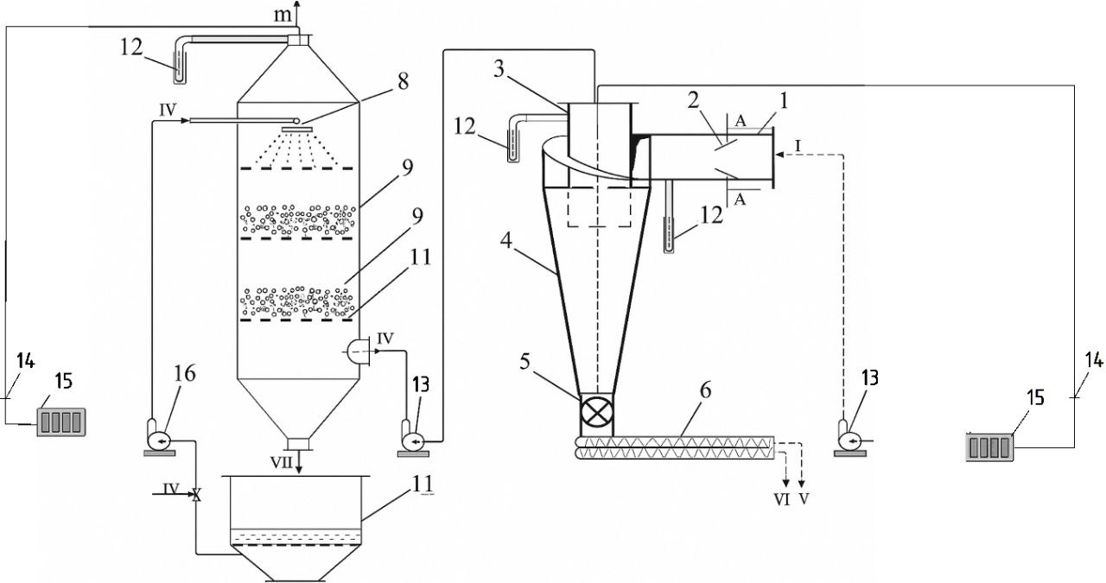
FIGURE 1. Schematic diagram of an experimental setup for two-stage purification of dusty air: 1- air duct; 2-partition; 3- exhaust pipe; 4- cyclone; 5- sluice gate; 6-screw; 7- scrubber; 8- spray nozzle; 9- movable nozzle; 10- support grid; 11 - tank for collecting sludge; 12 micromanometers; 13- fans; 14- AFA filter cartridge; 15 - rotameter, 16 - pump; process flows: I and II - dusty air; III - purified air; IV - water for irrigation; V - caught fluff; VI—trapped mineral particles; VII- contaminated water

The cylindrical scrubber with a conical bottom mainly contains nozzles for spraying water 8 and a support grid 10 for the nozzle layer 9. The installation is equipped with control and measuring instruments - 12 micromanometers, 14 AFA filter cartridge and 15 rotameter.
Dusty air containing fibrous and fine mineral particles enters the cyclone through partition 3. When passing through the partitions, the dust-air flow becomes highly turbulent. In such an environment, fibrous particles contained in the dust-air flow adhere to each other and coagulate, forming stable aggregates. As a result, the efficiency of air purification in the cyclone increases, since the number of large fractions increases, and fine dust is captured by large units.
Study of the process of air purification from cotton dust in production conditions
Pilot tests were carried out to clean the air from cotton dust. Overall dimensions of the scrubber: height – 4400 mm; length – 3900 mm; width – 2700 mm. The main geometric dimensions of the second cleaning apparatus (cyclone): total height - 3700 mm; apparatus diameter – 1200 mm; exhaust pipe diameter – 650 mm.
The purpose of the tests was: to produce plasterboard sheets using an organomineral additive from the captured mass; studying the operation of a dust collecting apparatus consisting of a cyclone and a scrubber; determination of the effectiveness of devices in cleaning the air from cotton dust.
Experiments were carried out under production conditions to study the effectiveness of a two-stage apparatus for purifying atmospheric air from cotton dust. The speed of the dusty flow varied in the range of 20-25 m/s.
Production of plasterboard sheets and production flow diagram using organomineral additives
The production of samples of plasterboard sheets and physical and mechanical tests were carried out in accordance with the requirements of GOST 6266-97.
In the manufacture of sample plasterboard sheets with a length of (450±5) mm, a width of (150±5) mm, a thickness of (8±0.5) mm, building gypsum according to GOST 125-89 grade “G-7” was used as a binding material.
Fiber mass for deep purification of air emissions from cotton ginning plants was used as an organomineral filler additive.
Material composition of the molding mass for the manufacture of samples,%: building gypsum – 90; organomineral supplement -10.
The water-to-solid ratio of the molding mass is 0.46.
Cardboard and liquid glass were used to cover the surface of the samples.
After molding with pre-pressing, the samples were cured in air conditions at a temperature (35-40˚C) for 1 day, and then dried at a temperature (50-60˚C) to a moisture content of no more than 2% by weight.
After drying, samples of plasterboard sheets were subjected to physical and mechanical testing in accordance with GOST 6266-97.
Laboratory and technological tests have established that the fibrous mass can be used as an organomineral filler additive in the production of gypsum plasterboard sheets of the type And according to GOST 6266-97.
The technological scheme for the production of plasterboard sheets using organomineral additives, shown in Fig. 2, was developed by analogy with the existing production of plasterboard sheets and taking into account the results of research and testing carried out during the implementation of the work program of this project.
The technology for the production of plasterboard sheets involves the following operations:
- separate dosing of gypsum binder and organomineral additive in a given mass ratio;
- grinding of organomineral additives;
- homogenization of dry molding mass in a mixer;
- preparing the molding mass by moistening it to a workable consistency;
- preparation of the top and bottom cover layers of cardboard. Cardboard rolls are placed on two levels;
- cardboard strips are unwinded from rolls in a horizontal position, pass through guides and brake devices and arrive at the forming table. Before this, the edges of the bottom tape are slightly trimmed to form the correct bend when forming the sheet. The edges of the top cardboard strip are first sanded and then an adhesive is applied to them;
- molding a plasterboard sheet of a given thickness (distribution of wet molding mass on the bottom layer of cardboard with simultaneous covering with the top layer of cardboard and compaction of the sheet);
- hardening of plasterboard on a conveyor;
- cutting hardened plasterboard into sheets of a given size;
- drying plasterboard sheets in a tunnel dryer to a moisture content of no more than 2% by weight.
- storage of dried plasterboard sheets;
- shipment of finished products (sheets) to the consumer.

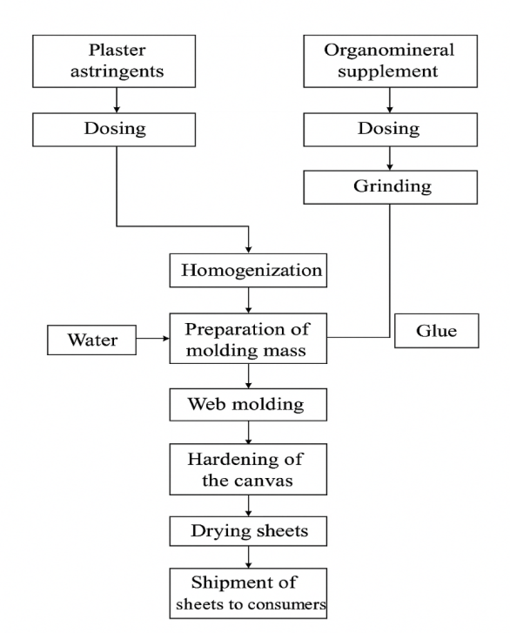
FIGURE 2. Technological scheme for the production of plasterboard sheets using organomineral filler additives
RESULTS AND DISCUSSION
The results of the studies carried out in industrial conditions are shown in Fig. 3 and Fig. 4.
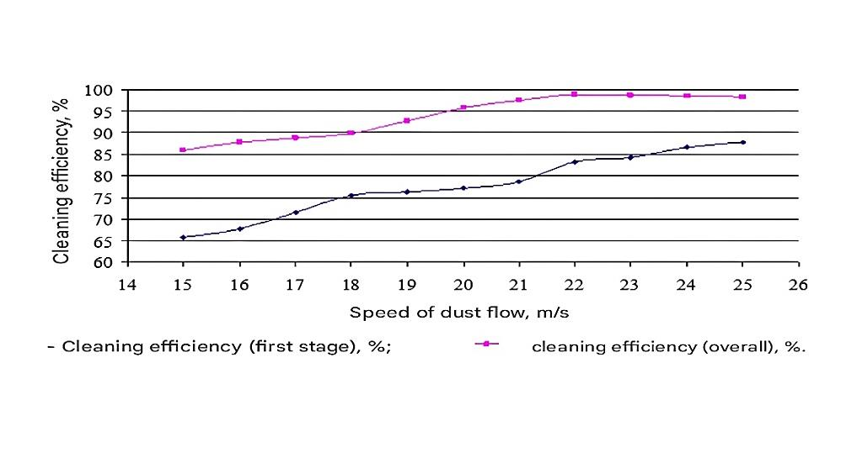
FIGURE 3. The efficiency of dust collection depends on the speed of the dust-air flow

From Fig. 3 it is clear that with a change in the speed of the dusty flow from 15 m/s to 25 m/s the cleaning efficiency after the first cleaning varies within the range of 65.75÷84.12%. At a dusty flow speed of 18 m/s, 75.47%, and at 20 m/s, the efficiency of the two-stage apparatus was 77.18%; further increasing the flow speed to 25 m/s, the cleaning efficiency was 84.2%. The cleaning efficiency after the second cleaning is much greater than the first stage, i.e. at 15 m/s this figure was 85.9%, and at a speed of 20 m/s 95.8%, During the experiments, the optimal flow rate was determined, i.e. 22 m/s, while the cleaning efficiency was 98.8%. Further increase in flow speed from 23 m/s to 25 m/s the cleaning efficiency gradually decreased from 98.7% to 98.3%. This is explained by the fact that with an increase in flow speed, the order of distribution of irrigation water inside the scrubber is destroyed, and this affects the efficiency of the device.
During production tests, the efficiency of dust collection was determined depending on the hydraulic resistance of the two-stage apparatus (see Fig. 4).

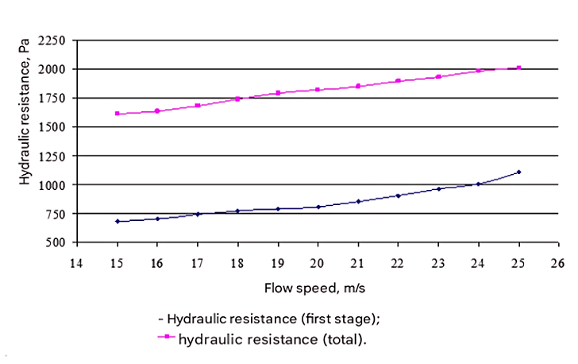
FIGURE 4. Dust collection efficiency depending on the hydraulic resistance of a two-stage apparatus

From Fig. 4 it is clear that at a dusty flow speed of 15 m/s, the hydraulic resistance of the centrifugal apparatus after the first stage was 680 Pa, and after the second stage the hydraulic resistance (total) was 1615 Pa. With an increase in air flow speed to 20 m/s, the hydraulic resistance after the first stage was 806 Pa, and after the second cleaning 1824 Pa, a further increase in speed to 25 m/s the hydraulic resistance of the two-stage apparatus was 2015 Pa.
During production tests, it was determined that the technological line for air purification from cotton dust has the following indicators:
TABLE 1. Performance of air purification systems
Name of indicators | Operating two-stage installation “cyclone + cyclone” (TSS-6) | Proposed cyclone+scrubber production line
Hydraulic resistance, Pa | 1200-1300 | 1895
Dust collection efficiency, % | 80-85 | 98-99
Dust concentration in purified air, mg/m³ | 400 | 36
The table shows that, in comparison with existing installations, the proposed technological line differs: efficiency is 13-14% higher, the dust concentration in purified air in the existing installation is 80-85 mg/m³, the proposed line is 36 mg/m³.
Thus, the proposed technological line for purifying atmospheric air from cotton dust has a relatively high efficiency of 98-99% and provides air purification within the requirements of sanitary standards of 80 mg/m³.
CONCLUSION
Laboratory and technological tests have established that the fibrous mass can be used as an organomineral filler additive in the production of gypsum plasterboard sheets of the type And according to GOST 6266-97.
Conducted industrial tests indicate that the proposed “cyclone + scrubber” technology increased the degree of air purification to 98-99% and the degree of purification was 14% higher compared to the existing installation.
After the calculations were carried out, a large-scale transition from a laboratory to an industrial installation was carried out and a technological scheme was proposed; in order to obtain plasterboard products, a number of research methods were developed. Gypsum suspension for the manufacture of plasterboard sheets improves adhesion between layers, including gypsum, oxidized starch, foaming agent, plasticizer, paper pulp, water and additionally alkaline starch paste with a concentration of commercial starch from 1% to 25%, in an amount from 0.001% to 0 .2% by weight of gypsum; to increase the hydrophobic properties of plasterboard products, it is advisable to use 20% fibrous mass; purification of atmospheric air from various impurities has been sufficiently studied, in which solid particles have a geometric shape. For such particles, scientific and industrial confirmed indicators have been established for the calculation of dust cleaning devices; At the moment, the cotton ginning plants of the republic use centrifugal and gravitational devices, which are ineffective for cleaning the atmospheric air from cotton dust; industrial test results show that single-stage devices for collecting fine particles are ineffective (up to 70%); obtaining plasterboard products with mineral additives.
REFERENCES
- Central Research Institute of Cotton Industry (TsNIIKhprom). (2001). Development of a settler-unloader for capturing the coarse fraction of cotton dust contained in the exhaust air (Final report No. 0002, pp. 8–21). Tashkent.
- Belousov, V. V. (1988). Theoretical foundations of gas cleaning processes. Moscow: Metallurgiya.
- Romankov, P. G., & Kurochkina, M. I. (1974). Hydromechanical processes of chemical technology (2nd ed., rev. and enl.). Leningrad: Khimiya.
- Khurmamatov, A. M. (2008). Study of the influence of regime-design parameters of the cyclone on the efficiency of air purification from fibrous particles. Uzbek Chemical Journal, (3), 114–117.
- Salimov, Z. S., Yuldashev, N. Kh., & Khurmamatov, A. M. (2007). Study of the settling velocity of fibrous particles in a centrifugal field. Uzbek Chemical Journal, (3), 45–47.
- Uzhov, V. N., Valdberg, A. Yu., & Myagkov, B. I. (1981). Industrial gas cleaning from dust. Moscow: Khimiya.
- Pirumov, A. I. (1981). Air dust removal. Moscow: Stroyizdat.
- Hansen, S., & Sadeghian, P. (2020). Recycled gypsum powder from waste drywalls combined with fly ash for partial cement replacement in concrete. Journal of Cleaner Production, 274, 122785. https://doi.org/10.1016/j.jclepro.2020.122785
- Sudakova, I. G., Levdansky, A. V., & Kuznetsov, B. N. (2021). Methods of chemical and thermochemical processing of hydrolytic lignin. Journal of Siberian Federal University Chemistry, 263–275. https://doi.org/10.17516/1998-2836-0236
- Klimenko, V. G. (2009). X-ray phase analysis of gypsum raw materials of various genesis and products of its thermal processing. Izvestiya VUZov. Construction, (10), 26–31.
- Klimenko, V. G., & Pogorelova, A. S. (2005). Influence of temperature-time conditions of natural gypsum dehydration on its properties. Izvestiya VUZov. Construction, (6), 29–33.
- Khamzin, R. R., & Fedorov, O. V. (2012). Gypsum plasterboards with improved interlayer adhesion (Russian Patent No. RU2502696C1).
- Jafari, A., & Sadeghian, P. (2024). Applications of Recycled Gypsum from Waste Drywalls in the Construction Industry: A Review. Lecture Notes in Civil Engineering, 817–832. https://doi.org/10.1007/978-3-031-34027-7_54
- Volzhensky, A. V., Rogovoy, M. I., & Stambulko, V. I. (1960). Gypsum-cement and gypsum-slag binders and products. Moscow: Gosstroiizdat.
- Bazhenov, Yu. M., Korovyakov, V. F., & Denisov, G. A. (2003). Technology of dry building mixtures. Moscow: ASV Publishing.
- Shtokman, E. A. (1977). Air dust removal in food industry enterprises. Moscow: Pishchevaya Promyshlennost.
- Shtokman, E. A., Shilov, V. A., & Boguslavskiy, E. I. (1986). Ventilation in oil and fat industry enterprises. Moscow: Agropromizdat.
- Research Institute of Industrial Gas Purification (NIIOGAZ). (1971). Guidelines for the design, manufacturing, installation and operation of cyclones. Yaroslavl.
- Shtokman, E. A. (1999). Air cleaning: A textbook for universities. Moscow: ASV.
- Veselov, S. A. (1974). Design of ventilation installations for grain storage and processing. Moscow: Kolos.
- Ahmed, A., Ugai, K., & Kamei, T. (2011). Laboratory and field evaluations of recycled gypsum as a stabilizer agent in embankment construction. SOILS AND FOUNDATIONS, 51(6), 975–990. https://doi.org/10.3208/sandf.51.975
- Fenner, J., Luh, J., Yagmurlu, B., & Goldmann, D. (2025). Development of a Recycling Process for the Recovery of Gypsum Stone from Stockpile Material. Recycling, 10(1), 12. https://doi.org/10.3390/recycling10010012
- Hansen, S., & Sadeghian, P. (2020b). Recycled gypsum powder from waste drywalls combined with fly ash for partial cement replacement in concrete. Journal of Cleaner Production, 274, 122785. https://doi.org/10.1016/j.jclepro.2020.122785
- Jafari, A., & Sadeghian, P. (2024b). Applications of Recycled Gypsum from Waste Drywalls in the Construction Industry: A Review. Lecture Notes in Civil Engineering, 817–832. https://doi.org/10.1007/978-3-031-34027-7_54

