Influence of Nature, Type and Content of Organomineral Fillers on Adhesion Strength in the Formation of Coatings
Sharifjon Rakhmanov^{a)}, Khadicha Khuramova, Sohiba Atamirzaeva,
Nematzhan Muminjonov
Namangan State Technical University, Namangan, Uzbekistan

^{a)}Corresponding author: raxmanovsharif10@gmail.com
Abstract. This article discusses the results of studies of the regularities of the formation of adhesion characteristics of materials depending on the nature, type, content and ratio of organo-mineral ingredients introduced into compositions and their physicochemical modification in order to regulate the properties, and to obtain effective polymer, composite, paint and varnish materials and coatings based on them with high adhesion, physical and mechanical properties and durability used in various Industries.
Keywords: polymer, plasticizer, elasticity, modifier, ingredient, stabilizer, pigment, particle, filler.
INTRODUCTION
Coatings made of pure polymers in most cases have certain disadvantages: increased brittleness, reduced elasticity, adhesion, etc. To improve the properties of coatings, plasticizers, modifiers, stabilizers, fillers, pigments and other ingredients are introduced into the polymer.
Fillers and some other additives have a significant impact on the adhesion of polymers to the substrate. The introduction of titanium dioxide and talc reduces the adhesion strength of polyurethane, and Fe₂O₃, on the contrary, causes an increase in adhesion [1].
The effect of the filler on the adhesion strength depends on the shape of its particles. It has been suggested that fillers change the wetting ability of polymer coatings in relation to metal. In addition, it is necessary to take into account the influence of fillers on the course of polymer formation reactions, and, consequently, on its structure [2].
The paper [3] covers the issues of improving the adhesive strength of rubbers based on various rubbers and steel grade 3.
METHODS
Epoxydian, furan and shale polymers ED-16, ED-20, (GOST 10587-93), FAED-20 (TU 59-02.039.13-78) and EIS-1 (TU38-1091-76), as well as powdered elastomers PE-Sh (rough) and PE-E (extrusion) were chosen as the object of the study, plasticizer dibutyl phthalate (DBP), hardener polyethylene polyamine (PEPA). It should be noted that FAED-20 furanoepoxy resin is obtained by combining 80 m.h. of furfuralocetone monomer FA and 20 m.h. epoxy oligomer ED-16. One of the FAED-20 has high adhesion strength, water, and thermal and chemical resistance.
To test the strength of adhesive compounds of polymers and compositions based on ED-16, ED-20, FAED-20, and EIS-1, samples were obtained as follows. The required amount of epoxy, furanoepoxy and epoxy schist oligomers was dried in a drying oven at 370 K for 2 hours. Then the required amount of DBP plasticizer, polymer and orgon-mineral fillers was first introduced into the oligomers, then the hardener (ED: PEPA 10:1). After the introduction of each ingredient, the composition was stirred for 10 minutes with a mechanical stirrer at 300 K. The finished mixture was poured into molds pre-treated with an anti-adhesive substance. The reactive mass was cured at 300 K (FAED-20 at 350 K) for 10 hours. The ED and EIS samples were heat treated at 373 K for 4 hours, and the FAED-at 400 K samples were heat treated for 6 hours.
The adhesive strength of the coatings, on the basis of the obtained compositions, was determined by the method of separation of fungi connected to each other by a binder on the FP-100/1 (GDR) tensile machine. The microhardness of composite polymer coatings was determined by a device, a device for pressing the indenter into the test material under a certain static load. The impact strength of polymer coatings was determined on the U-2 device, which is a vertical pile driver. The thickness of the coatings was measured with a TYPE-10 magnetic thickness gauge.
RESULTS AND DISCUSSION
The results of the study of the dependence of the strength of the adhesive compound (PAS) of epoxy compositions (EIS-1: E-181) on the polyethylene content are presented in figure 1.
As the studies have shown (see Fig. 1), the concentration dependence of the strength of the adhesive compound (PAS) on the polyethylene content is extreme. With a further increase in the polyethylene content, a monotonous decrease in the PAS is observed. In the first case, the increase in the PAW can be explained by a decrease in the fragility of the matrix, a decrease in its internal stresses.
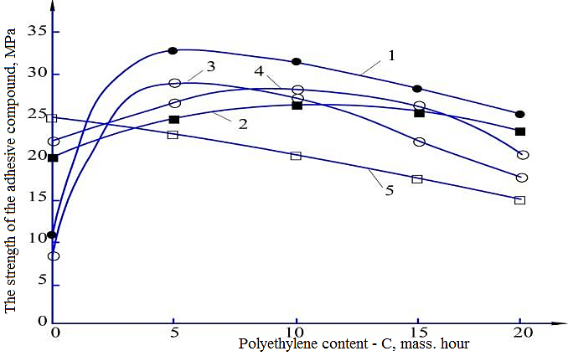
FIGURE 1. Dependence of the strength of the adhesive compound of epoxy compositions (EIS-1: E-181) on the polyethylene content: 1 - 0 weight hours; 2 - 5 weight hours; 3 - 10 weight hours; 4 - 15 weight hours; 5 - 20 weight hours

With a higher content of polyethylene, the viscosity of the system increases significantly, and with a content of 20 wt/h of polyethylene, the composition acquires the properties of a compound. In all likelihood, with a low density of polyethylene, it occupies a large volume in the matrix and reduces the actual contact area of the matrix with the substrate in accordance with the ratio of the proportional degree of filling of the composition, which, in all likelihood, is the prevailing factor in reducing the PAS. It should be noted that for matrix systems, the rule of changing the adhesion strength with a change in the deformation rate is violated.
Figure 2 shows the dependences of the adhesive strength of compositions based on epoxydian oligomers on the content of powdered elastomer.

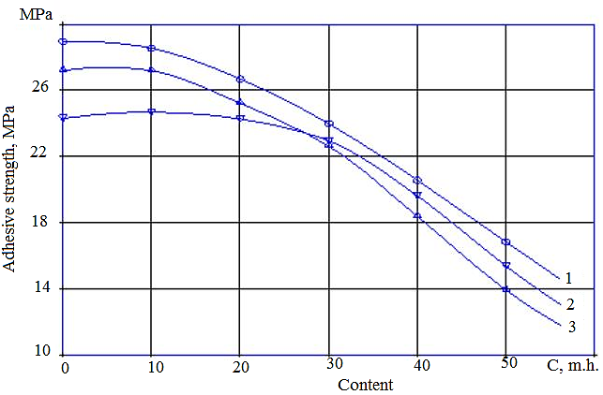
FIGURE 2. Dependence of the adhesive strength of compositions based on epoxydian oligomers on the content of powdered elastomer: 1 - ED-16; 2 - EIS-1; 3 - FAED-20
As can be seen from Figure 2, with an increase in the content of powdered elastomer to 10 mh, σA of the studied compositions has a stable state, and then a sharp decrease is observed The nature of the change in σA in all cases does not change.
It is known [4] that the nature of the adhesion interaction and the strength of the adhesive compound is determined by the adsorption processes occurring at the polymer-substrate interface.
The main difference between adsorption of polymers and adsorption of low-molecular substances is that, due to the large molecular weight of the molecules to be adsorbed, only a relatively small part of the macromolecule segments binds to the surface of the adsorbent in most cases, while most of it extends from the surface to the polymer and is not bound by adsorption forces to the surface. From this point of view, the decrease in σA of the composition when fillers are introduced into it is due to the deterioration of the adsorption interaction of the binder with the surface of the substrate. Thus, with an increase in the content of the filler, the proportion of binder interacting with the surface of the substrate decreases, most of the polymer is spent on wetting the surface of the fillers [5].
The data presented in Figure 3 also fully confirm the above assumptions.

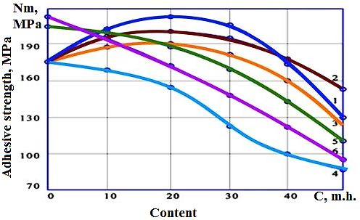
FIGURE 3. Dependence of the adhesive strength of the composition based on the ED-16 oligomer on the content of single and mineral dispersed fillers: 1 - graphite; 2 - kaolin; 3 - talc; 4 - RP; 5 - kaolin-20+RP; 6 - RP+Graphite-20 by weight

It can be seen (see Fig. 3) that with an increase in the number of fillers of mineral origin up to 20 wt.h., there is a slight increase in σA of the epoxy composition based on the ED-16 oligomer.
A further increase in the content of fillers causes a sharp decrease in σA of the compositions. It should be noted that the addition of rubber powder in any amount to the epoxy polymer of a single filler contributes to a decrease in σA of the composition. This is due to the fact that the particles of powdered elastomer, having less surface energy than mineral fillers, do not affect the formation of the network structure of the epoxy polymer, but, on the contrary, worsen the adsorption interaction of the binder with the substrate and, as a result, the σA system decreases.
Increase in σA of the composition when filled with dispersed fillers up to 20 wt.h. is due to the influence of the high surface energy of mineral fillers on the processes of structuring the binder. Filler particles serve as active gelation sites, and the formation of a mesh structure is accelerated.
Analysis of the data presented in Figure 2 shows that the addition of polymer filler - rubber powder to the compositions filled with mineral fillers causes, as expected, a decrease in σA of the system.
Thus, it has been established that with the content of polymer fillers - graphite, kaolin and talc, the adhesive strength of epoxy coatings improves, and with a further increase in their content, the adhesive strength significantly decreases. As for rubber powder and kaolin, their combination significantly reduces the adhesion strength of the polymer coating.
There is insufficient data on the effect of modifying and structuring additives on the adhesion properties of coatings in the literature. In this case, the change in adhesion properties is only recorded in the work [6]. More work is available on the study of the effect of stabilizers on adhesion properties.
It has been shown that some stabilizers, by reducing the degree of thermal oxidation of polymers, reduce their adhesion to metals (diaphene NN, phenyl-β-naphthylamine, etc.), others - sulfur and sulfur-containing stabilizers - increase adhesion strength, although they can cause corrosion of some metals, for example, magnesium alloys.
To increase the adhesion properties of highly stabilized coatings, adhesive-active sublayers can be used or active fillers can be introduced into the polymer.
The considered methods for increasing the adhesive strength of polymer coatings are based on increasing the contact area between the protective film and the surface of the product or the growth of functional groups at the interface. Other ways to increase adhesion strength are also possible, for example, by reducing the values of internal stresses, which are directed against adhesion forces. This is achieved by introducing various activated fillers into the polymer. With the help of fillers, you can also adjust the thixotropic properties of adhesives. The introduction of fillers into adhesive compositions contributes to better filling of the gaps between the surfaces to be glued with glue, which saves adhesive materials.
It should be noted that when using metal powders and other organo-mineral ingredients, it is possible to increase the thermal conductivity, electrical conductivity and strength properties of polymer, paint and varnish and composite materials and coatings based on them.
We have studied the effect of finely ground quartz on the adhesion strength and on the physical and mechanical characteristics of the epoxyphenol paint coating on the surface of steel (St.3kp), in order to increase its protective properties. As you know, quartz has high chemical resistance, acid resistance, affects the reduction of internal loads in coatings, and also has adsorption activity in relation to polymers.
Figure 4 shows the dependence of the adhesive strength of the paint and varnish of the epoxyphenol coating based on epoxy resin ED-20 on the content of the filler - ground quartz.

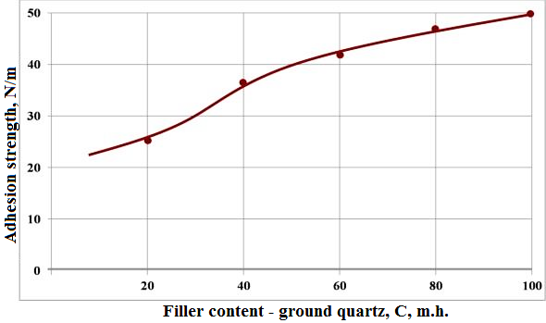
FIGURE 4. Dependence of adhesion strength of epoxyphenol paint coating depending on filler content - ground quartz (average of 5 measurements at each point)

With an increase in the content of the filler in the range of 10... 100 wt. An increase in adhesion to the steel surface of the substrate from 22.1 to 52.2 N/m was observed (see Fig. 4). Adhesion to the steel surface of St.3kp has more than doubled, which proves the effect of the filler, but at the same time, an increase in the amount of filler leads to an increase in the viscosity of the paint composition.
The adhesion of the coatings was determined by peeling from a flexible plate (GOST 15140-78). The content and method of pre-treatment of the filler varied.
In the initial composition, the particle size of the filler was 25-30 μm. Various amounts of filler were added to the epoxydian oligomer ED-20, after which the hardener was introduced. Curing mode of samples: 24 hours at 20 ^{°C.}
Further increase in adhesive strength is associated with the adjustment of the parameter of the coating process, the use of an increased amount of solvent and the use of various methods of polymer coating modification.
Figure 5 shows the results of a study of the effect of the dispersion of the filler on the adhesive strength of the paint coating. It has been established that with an increase in the dispersion of fillers, the adhesive strength of paint and varnish films increases markedly.

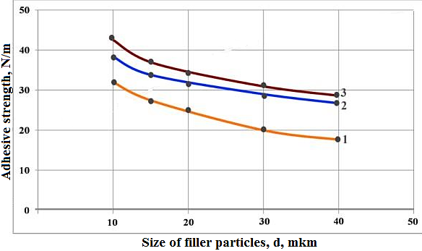
FIGURE 5. Dependence of adhesive strength on the size of filler particles (ground quartz) at different levels of it in the epoxyphenol composition

Note: ground quartz with a dispersion of 10, 30 and 50 μm was used to obtain samples. The adhesion strength of the samples was measured after the samples had been dried for 48 hours.
The highest efficiency of inoculation is achieved when using diethylene glycol. When carrying out the process of polymer modification, a number of problems also arise, one of which is the uneven distribution of the additives introduced in the volume of the polymer matrix. It can be seen from Figure 5 that the smaller the particle size, the more noticeable the increase in the adhesive strength of the coating with the substrate.
The study found that the finer the size of the filler particles, the more uniform their distribution in the volume of films and the increase in interaction with the film-forming substance. Similar confirmatory results were obtained by the authors.
It has been established that the properties of coatings are influenced by the surface activity of polymer fractions that differ in molecular weight and the content of polar functional groups. It has been established that an increase in the dispersion of the filler contributes to an increase in the adhesive interaction of the coating with the base, which predetermines an increase in the durability of the coating.
Chemical modification of the filler surface not only improves the cohesive strength, but also increases the adhesion strength of the film to the substrate. Modification of the filler surface provides stronger intermolecular and chemical interactions at the interfacial interface, both polymer-filler and adhesive-substrate. Changes in the adhesive strength of an epoxyphenol composition with different contents and types of chemically modified fillers are shown in Figure 6.
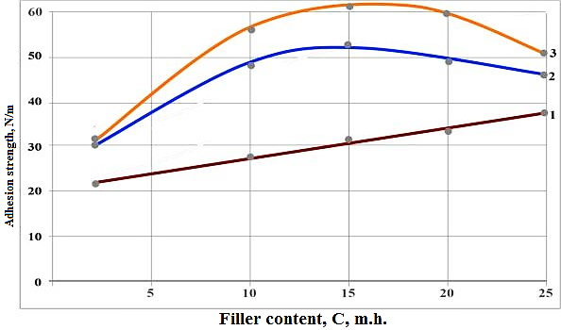
FIGURE 6. Dependence of adhesive strength on filler content when epoxy glues of fungi are separated from steel: 1 - not modified; 2 - filled with butysol B-2; 3 - modified diethylene glycol

An unmodified filler has a straightforward relationship to the filler content (see Figure 6). An extreme concentration of filler where adhesion strength has the maximum value has been determined. The type of silica also affects the adhesion strength.
Thus, it has been established that the introduction of organomineral highly dispersed modified fillers makes it possible to increase the adhesive strength of the epoxyphenolic composite, and thereby explains the increase in the adhesive strength of the polymer coating to the substrate.
At the same time, it seems that the mechanism of growth of adhesive strength is explained by an increase in cohesive interaction as a result of better packaging of macromolecular chains by a modified filler surface, selective adsorption of low-molecular fractions, and increased intermolecular interaction at the interfacial boundary.
CONCLUSION
All the studies carried out show that with the content of polymer fillers - graphite, kaolin and talc, the adhesive strength of epoxy coatings improves, and with a further increase in their content, the adhesive strength significantly decreases. As for rubber powder, kaolin, their combination significantly reduces the adhesion strength of the polymer coating. Increased adhesive strength is achieved by introducing various activated fillers into the polymer.
REFERENCES
- Zhang, Z., Liu, X., Ban, X., Ji, J., Tian, P., & Yang, Y. (2024). The influence of filler types and content on the curing behavior and properties of a bio-based polyurethane engineered sealant. International Journal of Adhesion and Adhesives, 136, 103866. https://doi.org/10.1016/j.ijadhadh.2024.103866
- Miturska, I., Rudawska, A., Müller, M., & Valášek, P. (2020). The Influence of Modification with Natural Fillers on the Mechanical Properties of Epoxy Adhesive Compositions after Storage Time. Materials, 13(2), 291. https://doi.org/10.3390/ma13020291
- Saienko, N. V., Bikov, R. A., Popov, Y. V., Demidov, D. V., & Younis, B. (2020). The effect of silicate fillers on adhesion and adhesion strength properties of Water-Based coatings. Key Engineering Materials, 864, 73–79. https://doi.org/10.4028/www.scientific.net/kem.864.73
- Guchait, A., Saxena, A., Chattopadhyay, S., & Mondal, T. (2022). Influence of nanofillers on adhesion properties of polymeric composites. ACS Omega, 7(5), 3844–3859. https://doi.org/10.1021/acsomega.1c05448
- Rakhmanov, S., & Nishonov, U. (2024). Study of thermal state, water absorption and strength properties of composite polymerpolymer binders. E3S Web of Conferences, 486, 05012. https://doi.org/10.1051/e3sconf/202448605012
- Rakhmanov, Sh. V. (2023). Study of physical and mechanical properties of composite binders based on urea-formaldehyde and polyacrylonitrile and melamine. Journal of Interdisciplinary Innovations and Scientific Research in Uzbekistan, 2(18), 761–770.

